MODULE CODE: BMIH4005 REWORK

MARKETING PLAN

STUDENT NAME: Laura Balu
STUDENT ID:2232556
LECTURER: Chris Wilkin

WORD COUNT:1298

Introduction
This marketing plan analyses premium hotel business Six Senses and suggests solutions. The plan analyses the marketing mix, establishes goals, and specifies KPIs using the 5Cs framework. In order to grow into new areas, the marketing mix is adjusted and internet presence is improved and the RACE framework communicates the brand's value proposition, and measurements and KPIs are stressed. The objective is to revive the brand's reputation and stay competitive.

Situation Analysis
In order to gain a comprehensive understanding of the current business landscape, it is essential to conduct a situation analysis Six Senses. The 5C’s framework encompasses various aspects of the business environment, including the company, customers, competitors, collaborators, climate, and marketing mix (Luxury resorts, spa escapes - six senses, 2023). By analyzing each of these elements, organizations can identify strengths, weaknesses, opportunities, and threats, and make informed decisions for strategic planning.
SWOT Analysis (see appendices)

Customers: Segmentation and Targeting
The Six Sense Hotel, Resort, and Spa's target segmentation is broken down into geographic, demographic, and psychographic groups. Six Senses regulars are a well-traveled group with a built-in interest for the globe. The brand enables visitors to indulge their desire for high-end luxury residences in the world's most magnificent places while simultaneously satisfying a rising need for sustainable stays. They seek the unexpected through out-of-the-ordinary stays that live long in the memory (IHG, 2023). The company reaches its target market through a variety of channels, including advertising, social media, and word-of-mouth.

Competitors: Bowman's strategy clock
The competitive position of Bowman's Strategy Clock is determined by price and value. The Six Senses Hotel is upscale. As a luxury hotel, it advocates for luxury and holistic wellness. It stands out because of holistic treatments, ecological methods, and upscale experiences. Six Senses uses a distinctive strategy to appeal to customers who like luxury (Piuchan and Prachansit, 2019, p.375). Personalized experiences and a focus on niche target markets may go hand in hand with focused distinctiveness. With this strategy, Six Senses draws customers looking for premium and distinctive experiences.

Collaborators: B2B Relationships, Partnerships, Franchises
B2B relationships
- The company has a number of B2B relationships with suppliers, distributors, and retailers.
- These relationships are important for the company to be able to get its products to market and to provide a good customer experience (Srivastava et al., 2019, p.34).
Partnerships
- The company has a number of partnerships with other companies.
- These partnerships allow the company to offer its customers a wider range of products and services (Sikand, 2020).
Franchises
Owners get to invest in gorgeously designed, cutting-edge, sustainable homes that coexist in harmony with their surroundings thanks to IHG's strong digital infrastructure, knowledgeable personnel, and top loyalty program.

Climate: PESTLE Analysis (see appendices)

Marketing Strategy

The primary marketing approach used by Six Senses Hotels Resorts Spas is environmentally friendly. They put a lot of emphasis on socially and ecologically conscious sustainable marketing that satisfies current consumer and company demands while also considering future generations of consumers. (Sustainability. (n.d.)). Additionally, Six Senses makes sure that its marketing strategy incorporates not just internal and interactive marketing but also conventional external marketing employing the 4Ps (product, price, place, and promotion).

Product
- The company offers a variety of products that are designed to meet the needs of its target market.
- The company's products are high quality and are competitively priced (Stombelli, 2020, p,525).
Price
- The company's prices are competitive and are based on the cost of production, the target market, and the competition.
Place
- The company's products are available through a variety of channels, including online, in stores, and through distributors.
Promotion
- The company uses a variety of promotional methods to reach its target market, including advertising, social media, and word-of-mouth (Similar Web)

Objectives
In six months, the marketing plan seeks 5000 website views and 8000 social media followers. Website analytics, social media engagement metrics, and follower counts will measure these goals. Traffic KPIs include unique visitors, page visits, session time, and bounce rate. These measures may assess the website traffic-driving marketing activities Followers, post reach, engagement, likes, comments, and shares are social media KPIs. The social media advertising and content attract and retain followers. Monthly marketing plan review assures timeliness. (March. L, 2021)

Strategy
The five-star hotel Six Senses aims to strengthen its reputation after receiving negative reviews. They introduce their unique products in an effort to find new markets for them. To draw in clients who share their interests, Six Senses intends to grow and modify its marketing strategy (Zhang, Xiong and Lee, 2020). Pricing adjustments, online reservations, social media participation, and website upgrades will increase their online presence. The accessibility and exposure of new resorts, local luxury shops, and travel agents will increase. By focusing on luxurious experiences and holistic wellness, Six Senses intends to rekindle its relationship with customers.

Tactics
The RACE (Reach, Act, Convert, Engage) architecture and Communications Mix will improve situational analysis and Six Senses' brand reputation.
- Reach: The company will target audiences across platforms. Promoting the brand with renowned travel and hospitality bloggers and celebrities. Negative reviews will target internet advertising.
- Act: The company will update its website to attract clients. Internet-only Six Senses experiences. Virtual tours and live chat help vacationers.
- Convert: Website visitors book via email marketing. These adverts target unbooked Six Senses properties. Incentivize conversions.
- Engage: Customer engagement increases experience and connections. Customer complaints will be resolved rapidly on social media. Social networking improves brand health. Visitor feedback and success stories will emphasize exceptional experiences. These communication methods attempt to boost Six Senses' brand image, attract new clients, and retain old ones.

Action - Gantt Chart (see appendices)

Control
In order to measure the success of Six Senses' marketing efforts, several metrics and key performance indicators (KPIs) will be utilized. The chosen metrics/KPIs for each channel are as follows:
Social Media Channels
- Metrics/KPIs: Increase in followers, engagement rate (likes, comments, shares), reach, and brand mentions.
- Justification: These metrics indicate the growth and engagement of the brand's social media community, reflecting increased brand awareness, customer interest, and positive word-of-mouth (Siddiqui, M.S. et al. 2021)
Influencer Partnerships
- Metrics/KPIs: Increase in brand mentions, reach, engagement generated by influencers.
- Justification: By monitoring the number of brand mentions and analyzing the reach and engagement driven by influencers, the effectiveness of influencer partnerships in amplifying brand messaging and generating interest can be assessed (Pankka, Caro 2019)
- Online Advertising
- Metrics/KPIs: Click-through rate (CTR), conversion rate, cost per click (CPC).
- Justification: CTR measures the effectiveness of ad creative and messaging, while conversion rate indicates the success of online advertising in driving bookings or other desired actions. Monitoring CPC helps optimize ad spend efficiency.
Email Marketing Campaigns
- Metrics/KPIs: Open rate, click-through rate, conversion rate.
- Justification: Open rate and click-through rate reflect the effectiveness of email subject lines and content in capturing recipients' attention. Conversion rate measures the success of email campaigns in driving desired actions, such as bookings or engagement.
- Content Marketing
- Metrics/KPIs: Website traffic, time spent on site, bounce rate, lead generation.
- Justification: Website traffic indicates the success of content marketing efforts in driving visitors to the site (Papaioannou, 2022). Time spent on site reflects engagement and interest, while a low bounce rate indicates content relevance. Lead generation measures the effectiveness of content in capturing potential customer information.

Conclusion
In conclusion, Six Senses employs the 5Cs and SWOT analysis to understand the company environment and make strategic decisions. The company's SWOT informed the marketing approach. Goals, marketing mix, and KPIs were established. Market development, marketing mix modifications, and online presence refreshed the brand. Measurements and KPIs dominated the control phase, and RACE increased communication. These methods will help Six Senses attract new customers, rebrand, and compete in luxury hotels.

Reference List
Chaffey D, Smith PR - Digital Marketing Excellence: Planning, Optimizing and Integrating Online ... Google Cărți
Development, Six Senses https://development.ihg.com/hotel-brands/six-senses
History, https://www.sixsenses.com/en/about-us/history
https://pro.similarweb.com/#/digitalsuite/websiteanalysis/traffic-overview/*/999/3m/?category=no-category&webSource=Total&key=sixsenses.com
Luxury resorts, spa escapes - six senses. 2023. Luxury Resorts, Spa Escapes - Six Senses About Us. Available at: https://www.sixsenses.com/en/about-us (Accessed: May 16, 2023).
March, L. 2021. Unique Visitors: Understanding and Targeting Your Competitors’ Audience https://www.similarweb.com/blog/research/market-research/unique-visitors/
Pankka, Caro (2019) The Key Performance Indicators of Influencer Marketing https://www.theseus.fi/handle/10024/262883?show=full
Papaioannou, M., 2022. Learning and knowledge management mechanisms during internationalisation: a hotel chain development perspective (Doctoral dissertation, Sheffield Hallam University).
Pham, Q.M., Dhir, M. and Carrier Guillomet, T., 2022. How do corporate charitable and economic social responsibility practices help to improve the quality of work life for employees?. Worldwide Hospitality and Tourism Themes, 14(3), pp.300-311.
Piuchan, M. and Prachansit, S., 2019. Hotel pioneers' leadership styles: A case study on the founders of Oberoi Group and Soneva and Six Senses Resort and Spa. Tourism: An International Interdisciplinary Journal, 67(4), pp.375-388. ok
Scully, E., Douma, F., Krishnan, V., Seeley, J., Neher, K. and Obeid, M., 2021. Rebooting customer experience to bring back the magic of travel.
Siddiqui, M.S. et al. (2021) ‘Creating Electronic Word of Mouth Credibility through Social Networking Sites and Determining Its Impact on Brand Image and Online Purchase Intentions in India’, Journal of Theoretical and Applied Electronic Commerce Research, 16(4), pp. 1008–1024. doi:10.3390/jtaer16040057
Srivastava, A., Jodhana, L.S., Chourasia, S. and Verma, B.L., 2019. Analyzing the Effect of Social Media Influencers on the Purchase Decision of Consumers. GURUGRAM UNIVERSITY BUSINESS REVIEW (GUBR), p.34. X
Sikand, H., 2020. Exploring The Importance Of Service Quality Attributes For Millennials At Boutique Budget Hotels.
Sousa, B.B., Magalhães, F.C. and Soares, D.B., 2021. The role of relational marketing in specific contexts of tourism: A luxury hotel management perspective. In Building consumer-brand relationship in luxury brand management (pp. 223-243). IGI Global.
Stombelli, V.M., 2020. Corporate Social Responsibility in hospitality: are sustainability initiatives really sustainable? Case examples from Citizen M, Lefay and Six Senses. Worldwide Hospitality and Tourism Themes, 12(5), pp.525-545.
Sustainability. (n.d.). Retrieved from http://www.sixsenses.com/en/sustainability.
Urmila, N.P.W.D., Astuti, N.N.S. and Triyuni, N.N., 2023. The Implementation of Zero Waste Concepts in Operational Six Senses Uluwatu, Bali. Journal of Business on Hospitality and Tourism, 8(2), pp.345-352.
Zhang, Y., Xiong, Y. and Lee, T.J., 2020. A culture-oriented model of consumers’ hedonic experiences in luxury hotels. Journal of Hospitality and Tourism Management, 45, pp.399-409.

Appendices:

PESTLE Analysis
Factors | Influence On Six Senses
Political | - Stable political environment in Six Senses Hotel operating countries.  - Minimal political risks affecting company operations.  - Supportive governments for tourism in all operating countries.
Economical | - Growing global economy benefits the tourism industry.  - Positive economic growth in Six Senses Hotel operating countries.  - Competitive advantage due to low business costs in operating countries.
Social | - Growing global population boosts the tourism industry.  - Expanding the middle class in operating countries benefits Six Senses Hotel (Sousa,Magalhães and Soares, 2021).  - Increasing demand for wellness and sustainability favors Six Senses Hotels offerings.
Technological | - New technologies enhance customer experience at Six Senses Hotel.  - Technology improves operations, including data analytics for marketing.  - Utilizing artificial intelligence and virtual reality for enhanced customer satisfaction.

Company: SWOT analysis
Strengths | Weaknesses
- Strong brand recognition  - Loyal customer base  - Experienced management team  - Strong financial position | - High costs  - Limited product line  - Competition from new entrants
Opportunities | Threats
- Growing market  - New product development  - Expansion into new markets | - Economic downturn  - Changes in consumer preferences  - New regulations

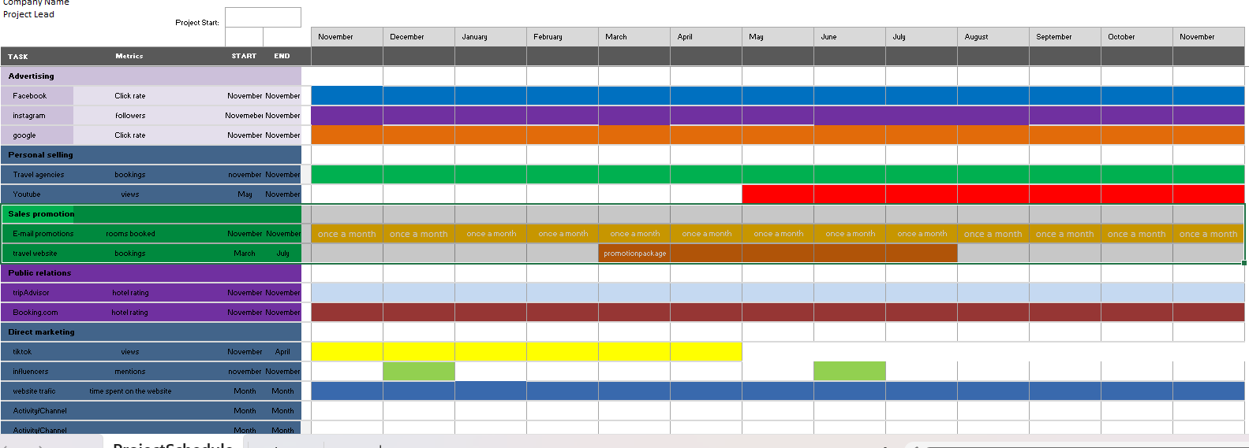

Presentation slides

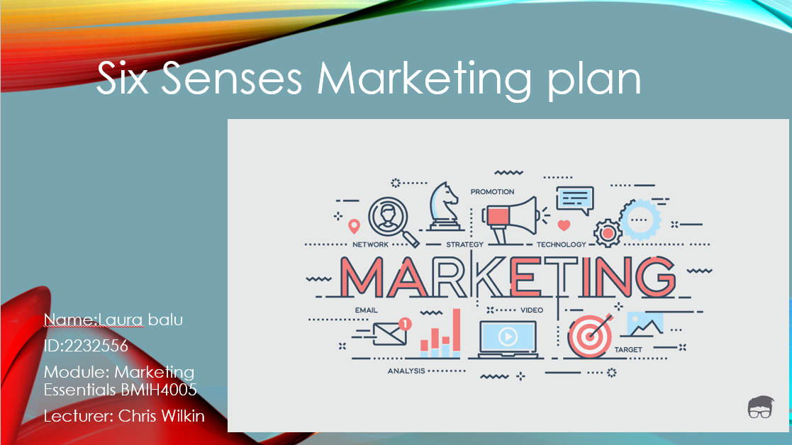
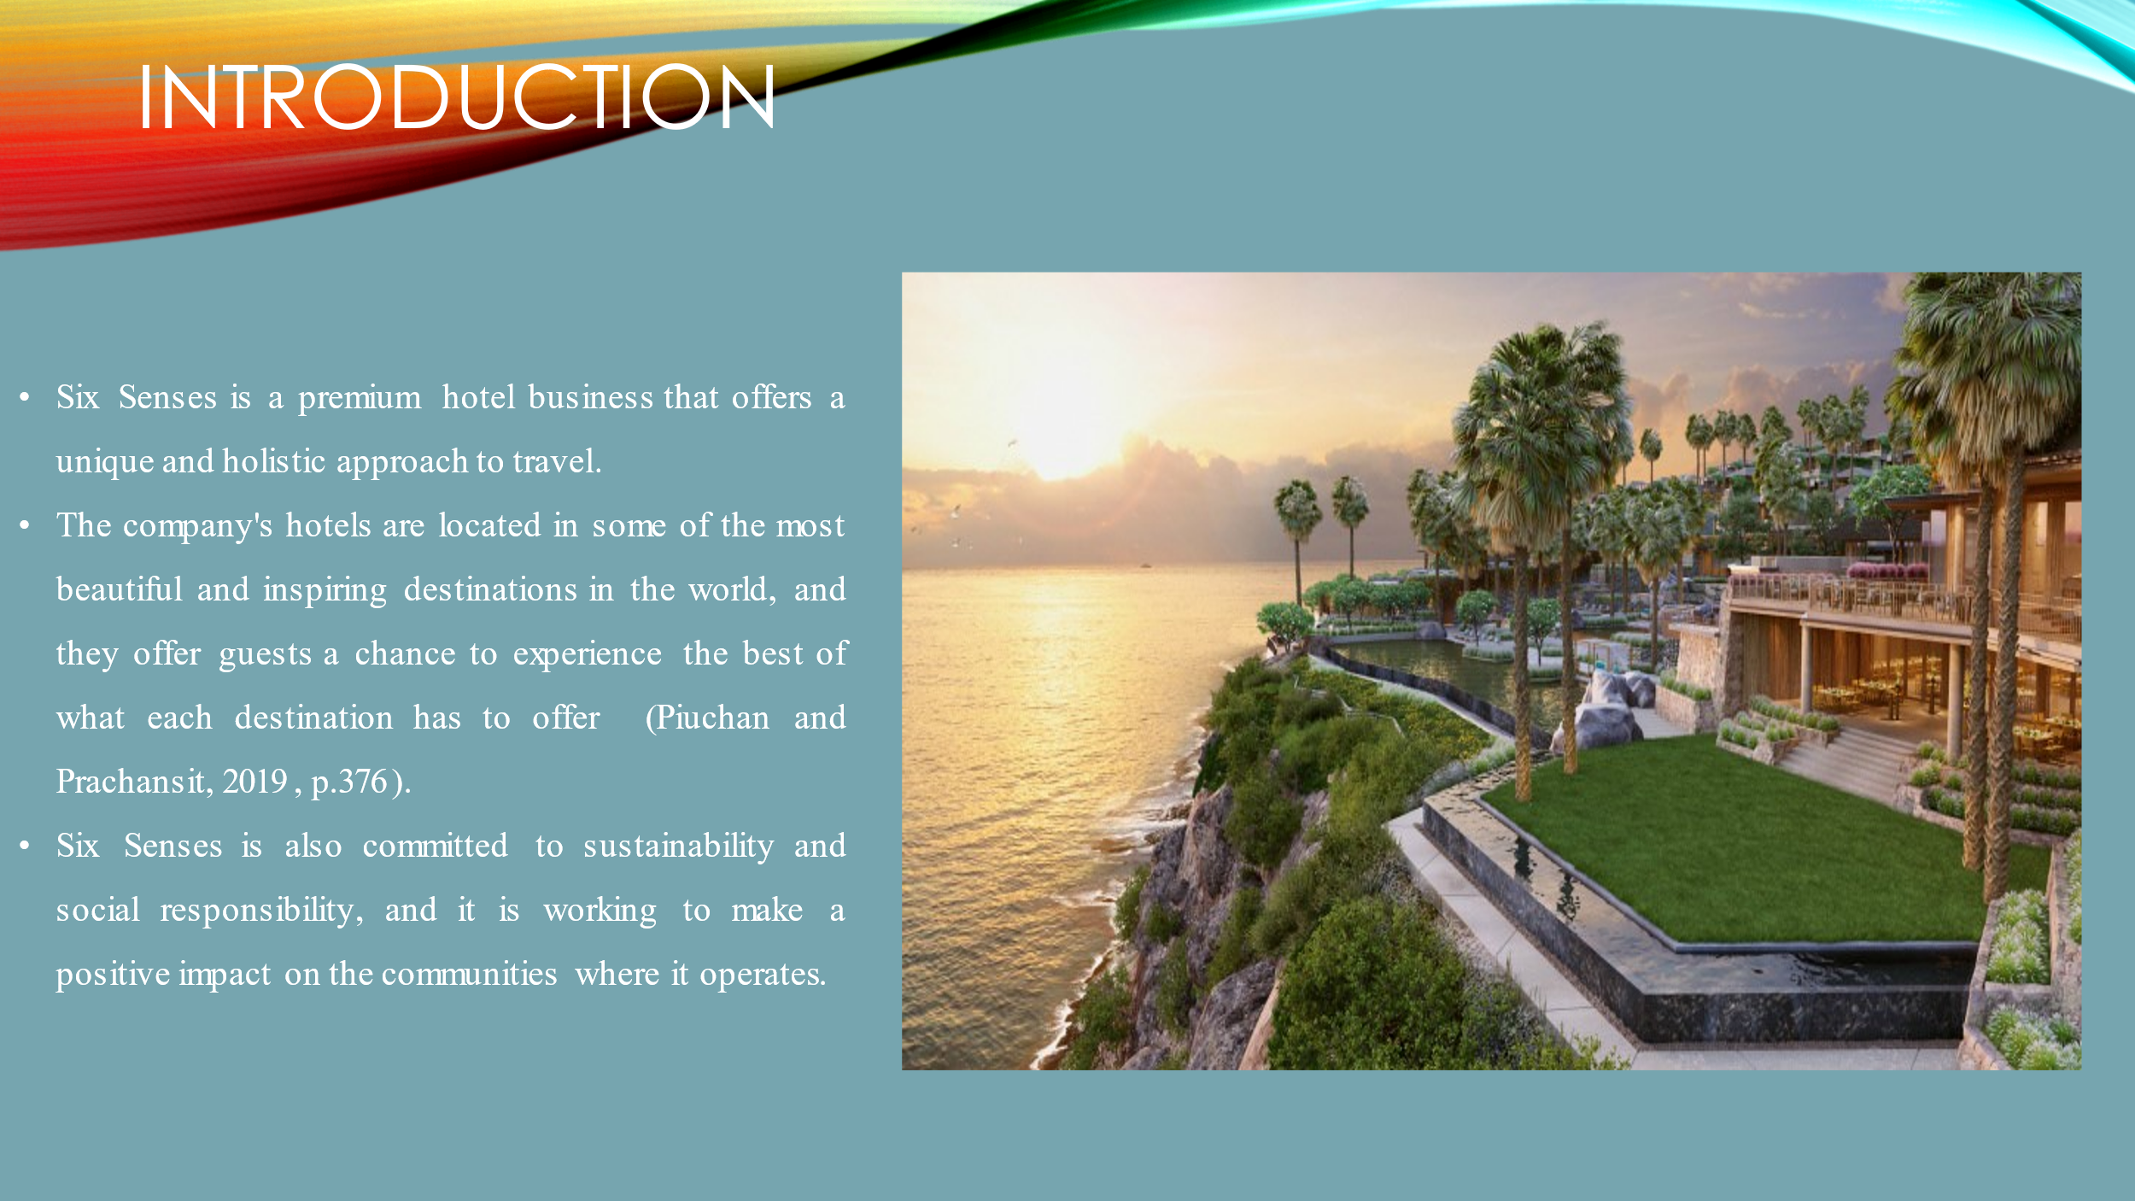
A premium hotel and resort chain called Six Senses was established in 1995. The company is renowned for emphasizing sustainable luxury and health at its 21 hotels spread across 17 nations. In the premium market, Six Senses provides a unique offering centered on convenience, sustainability, and wellbeing. (Six Senses,History)

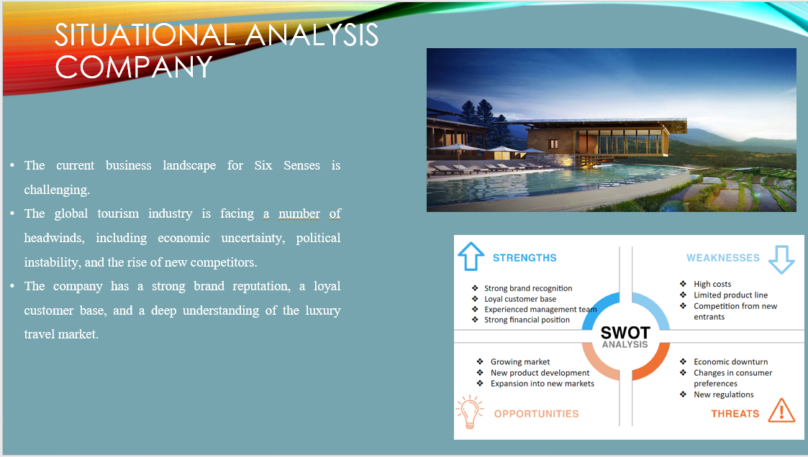
Six Senses' competitors finds that the company is highly known worldwide for its health and sustainability initiatives and has received recognition as the greatest hotel group and top hotel brand. Because its engagement with sustainability Six Senses faces low threats and has more opportunities for development
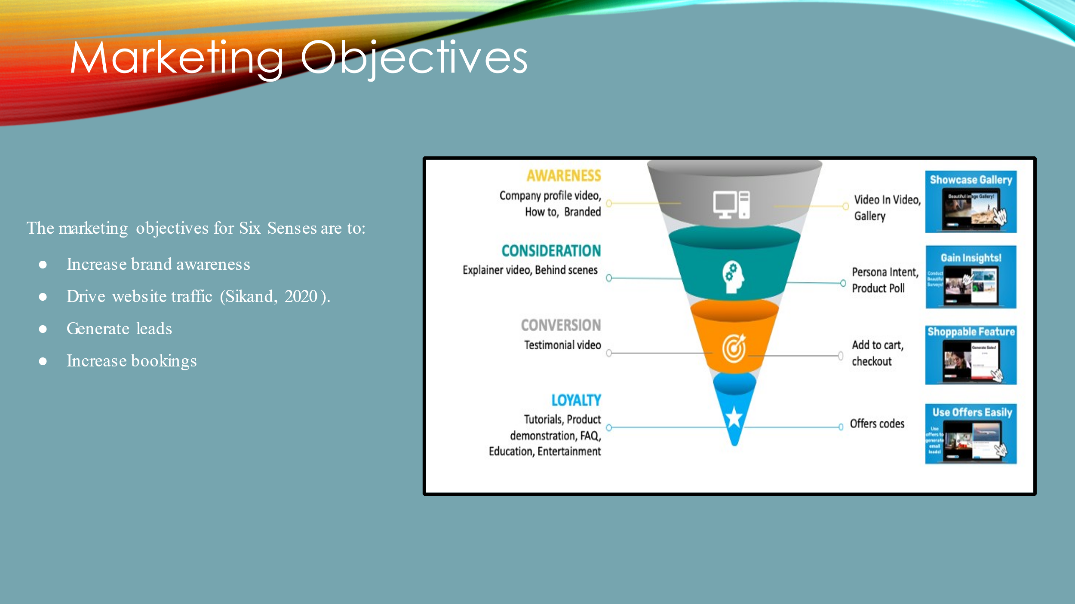

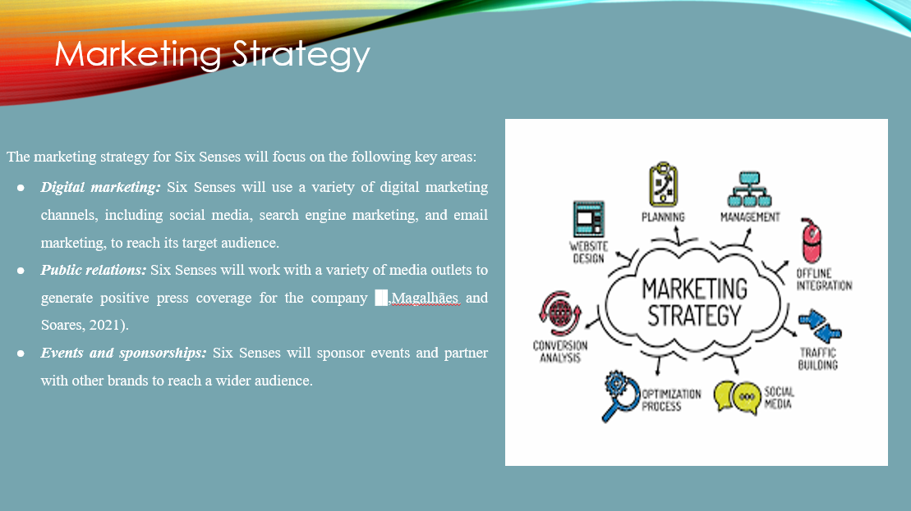
The fundamental marketing approach of Six Senses is social-focused, promoting sustainable marketing that is environmentally as well as socially ecologically responsible, addressing the demands of customers and companies in the present while also taking into account future generations.

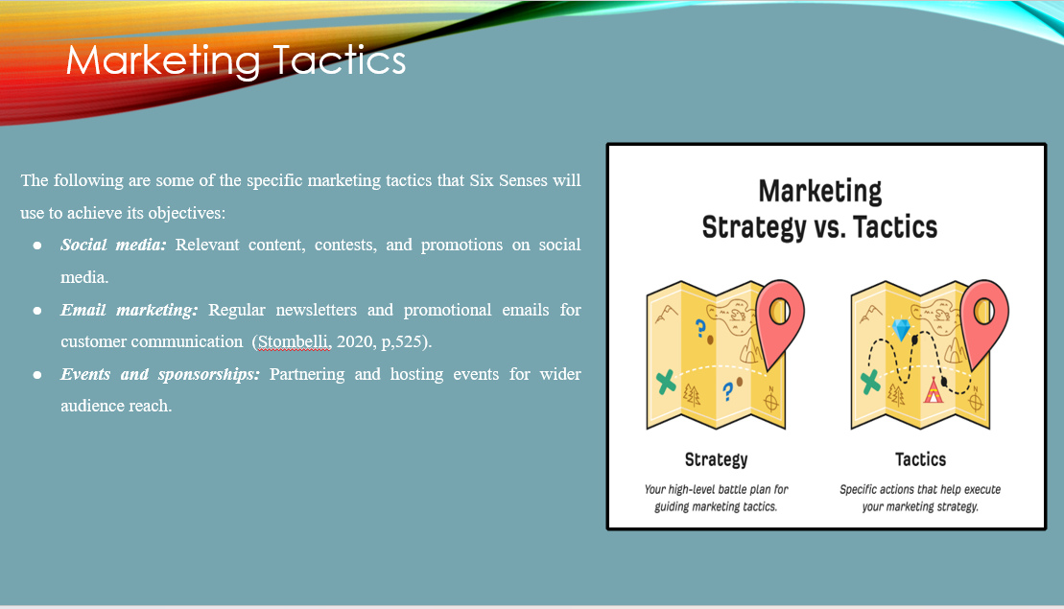

The RACE architecture and communication mix will improve brand`s reputation by targeting audience across the platform, update the website and increasing customer engagement service

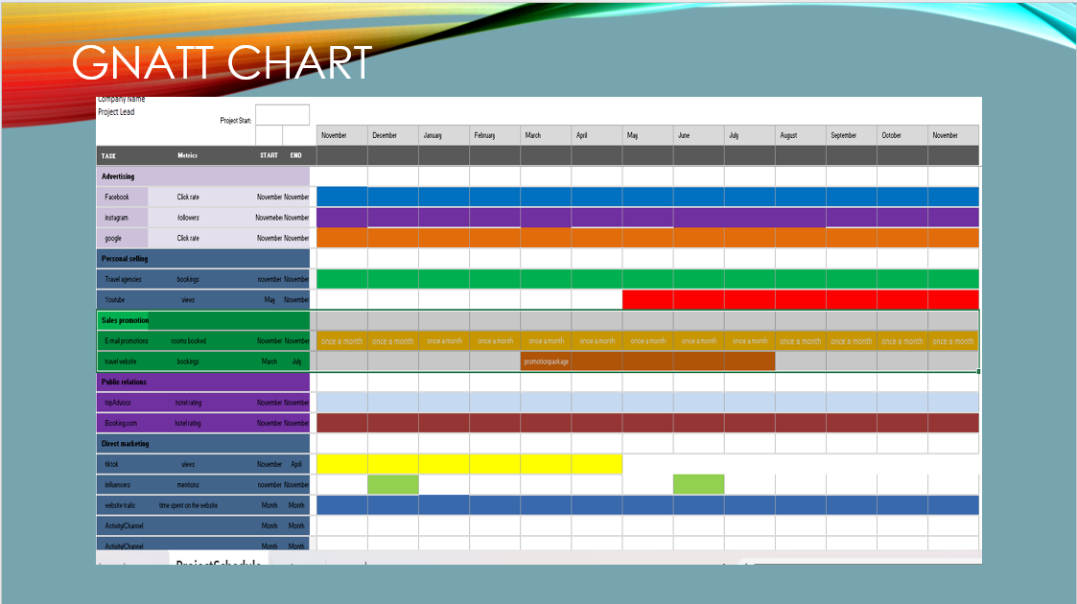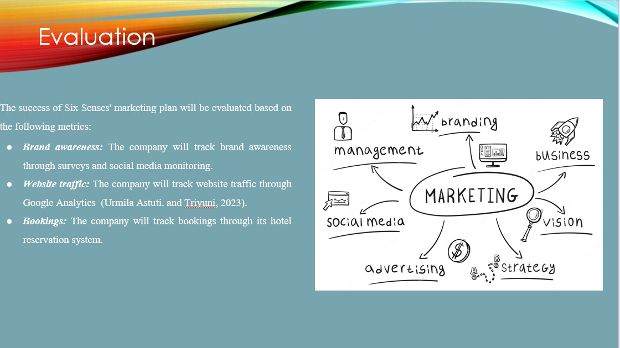

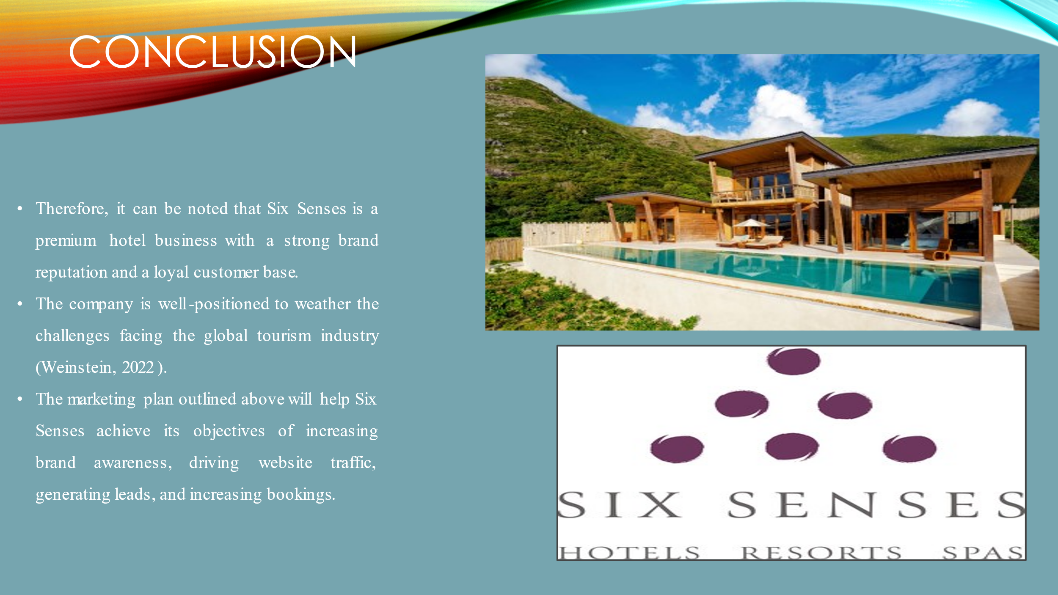 In conclusion it should be mentioned that Six Senses is a high-end hotel company with solid brand recognition and a loyal clientele of committed guests.
The business is well-positioned to handle the problems facing the international travel and tourism sector.
The marketing strategy described above will assist Six Senses in achieving its goals of raising brand recognition, boosting website traffic, creating leads, and raising bookings.



