HTML and CSS Web Development
Student Name: Rhys Davies
Student Number: 152694
HND Computing



Table of Contents
Table of Figures 2
Introduction 3
Requirements 3
Implementation 3
Validation 12
Evaluation 15
Usability 15
Accessibility 16
Search engine optimisation 17
References 18
Appendix 18

Table of Figures
Figure 1 - Top half of index page 4
Figure 2 - Bottom half of index page 4
Figure 3 - Top of Standard_Pistols page 5
Figure 4 - Bottom of Standard_Pistols page 6
Figure 5 - Top of Revolvers page 7
Figure 6 - Bottom of Revolvers page 8
Figure 7 - Top of Special_Pistols page 9
Figure 8 - Bottom of Special_Pistols page 10
Figure 9 - Unique_Pistols page 11
Figure 10 - Recommendations page 12
Figure 11 - index validation results 13
Figure 12 - index validation results after alterations 14
Figure 13 - CSS validation results 14
Figure 14 - CSS validation results warnings 15
Figure 15 - Colours of the website in colour blindness tool 17

Introduction
This document will contain information regarding the planning and creation of a website. The website will also be documented and evaluated. The website will be created in html and use cascading style sheets to hold information related to design and theme. The html pages and CSS has been created with the use of “Visual Studio Code”, which is a software designed for advanced text editing and code writing. The code for the html and CSS pages will be placed in an appendix situated at the bottom of the document. [1]

Requirements
Rhys Davies is the creator of the website. His first plan was to create a website which would act as a Wikipedia for pistol style weapons in the game Fallout 76, which was created by Bethesda Game Studios, the “award-winning creators of Skyrim and Fallout 4”. However, due to time constraints and the large amount of work which would be required to create a Wikipedia, Rhys decided that this idea was something which he wasn’t capable of creating at this moment in time. [2]
He still wanted to create something close to his original idea. He decided that he wanted to create a website which would provide an introduction to each pistol in Fallout 76, with tips, Rhys’ opinions and reviews of the weapons and general advice around using pistols in the game. This idea could still allow Rhys to convey important and basic information regarding the pistols, but with less detail and leaving out as much irrelevant information as possible. Additionally, other websites exist which go into the stats and details of weapons in Fallout 76, such as Fandom’s “Fallout Wiki”. The website which Rhys has planned will contain a mixture of information which can’t be found on other sites and information which has been made easier to understand. [3]
The relevancy of his website should turn out to be decent as there are few players in the game which use pistols, so information regarding them is scarce. Due to players typically using other weapons in game, such as heavy guns or rifles, the target audience of this website will actually be very small. The target audience will be anyone who uses pistols in the game or anyone who wants to start using pistols but doesn’t know much about them. Although, the website will be targeted more towards those who aren’t pistol users as the information will be quite basic, likely things which pistol users would already know.

Implementation
Figures 1 to 10 show screenshots of Rhys’ website. The majority of the pages are very long, so a few had to be screenshotted in a thinner window and zoomed out in the browser. Quite a few pages include two screenshots, one showing the top of the page and another showing the bottom. Even then, the entire pages weren’t able to fit into two screenshots. Still, the screenshots provide a visualisation of what the website looks like in a browser and how it copes with being resized. Figures 1 to 10 are listed below.
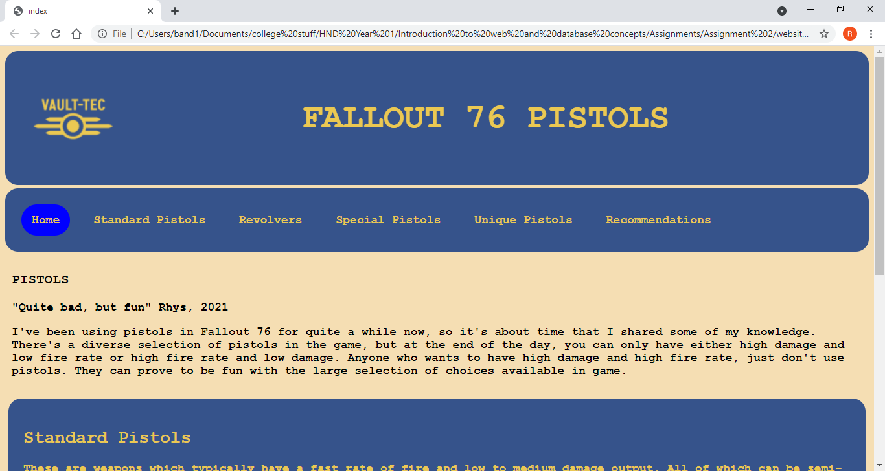
Figure 1 - Top half of index page
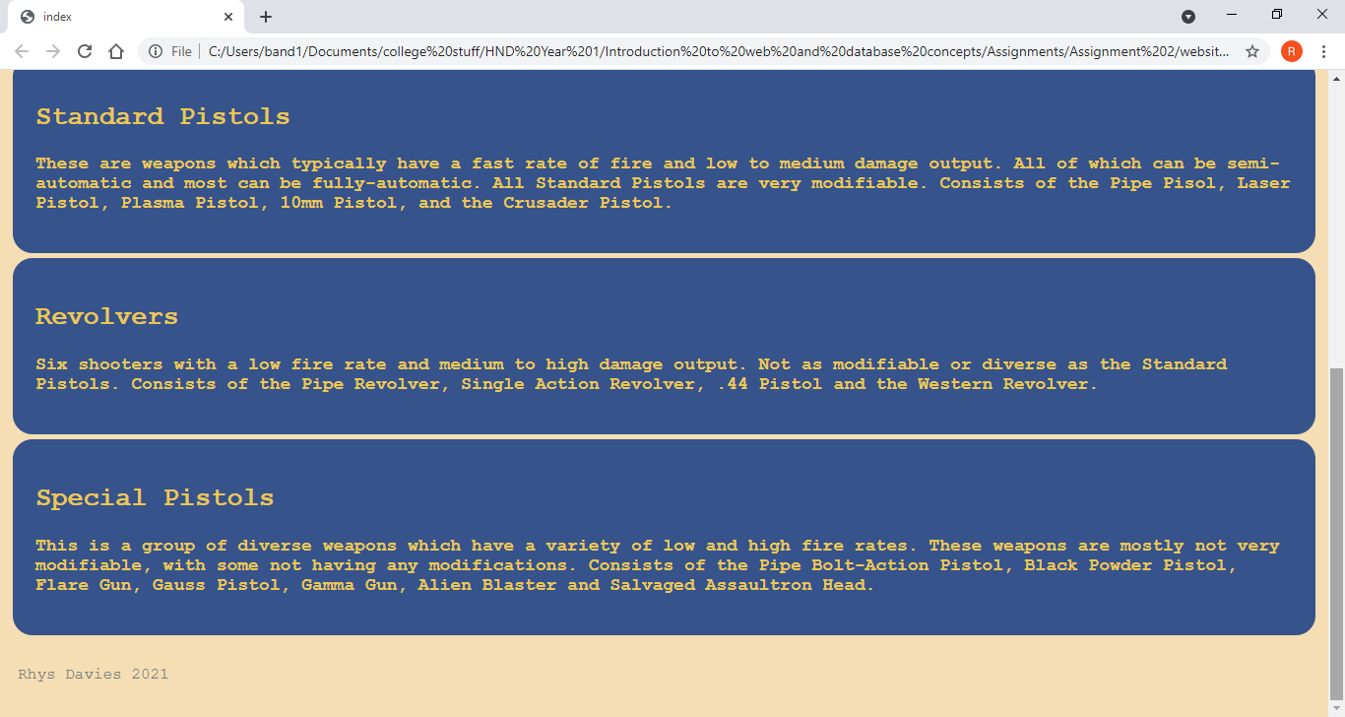
Figure 2 - Bottom half of index page
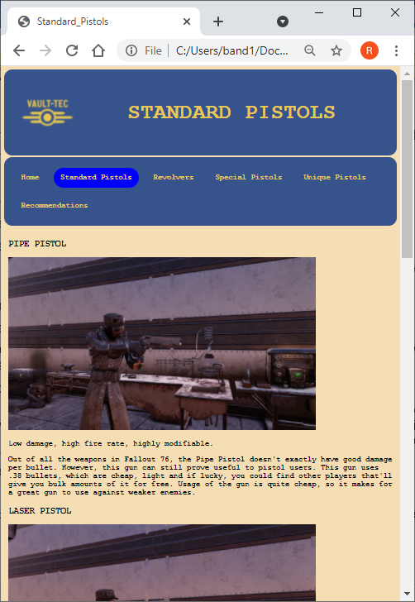
Figure 3 - Top of Standard_Pistols page
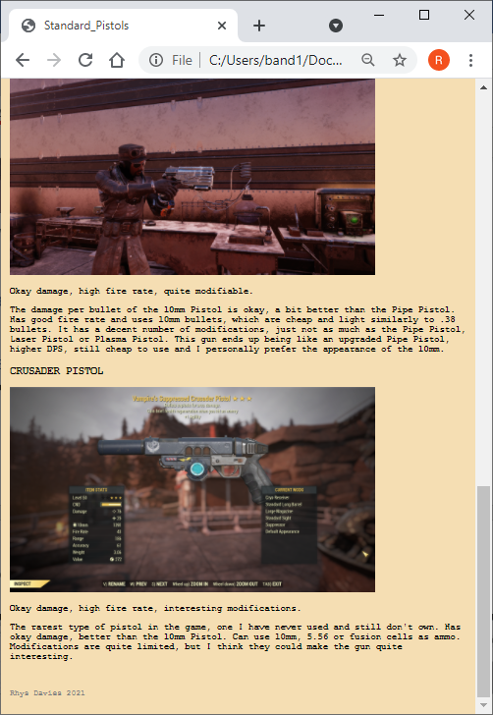
Figure 4 - Bottom of Standard_Pistols page
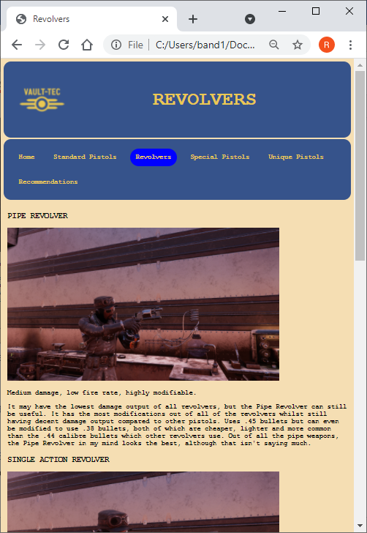
Figure 5 - Top of Revolvers page
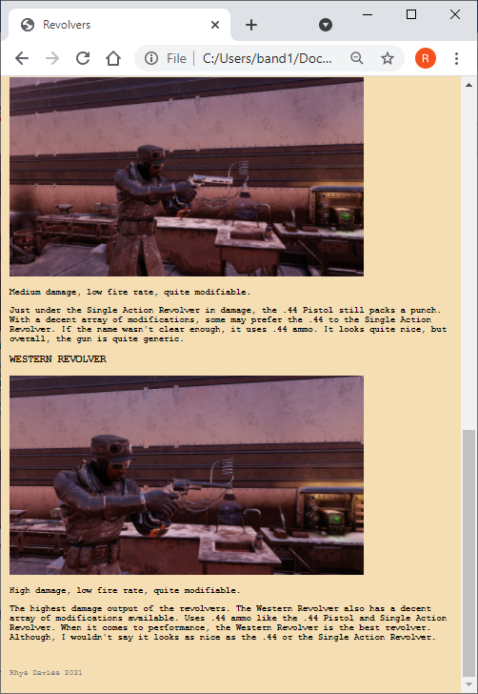
Figure 6 - Bottom of Revolvers page
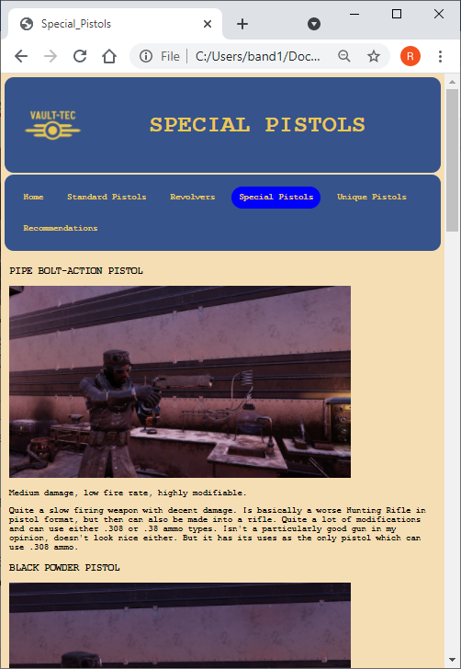
Figure 7 - Top of Special_Pistols page
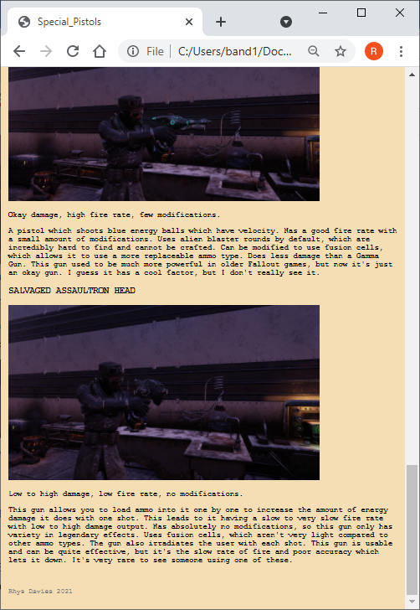
Figure 8 - Bottom of Special_Pistols page
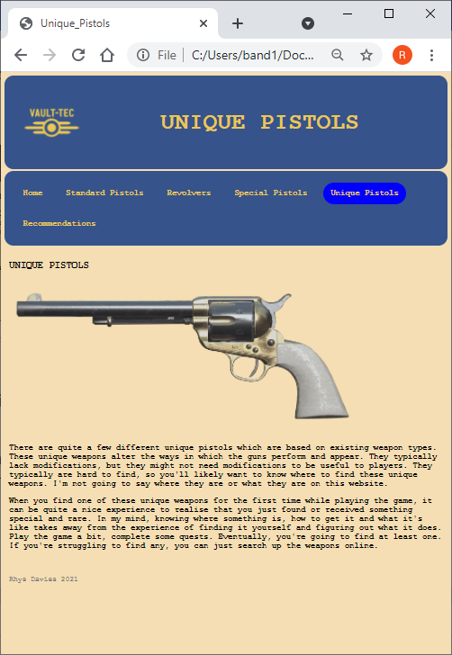
Figure 9 - Unique_Pistols page
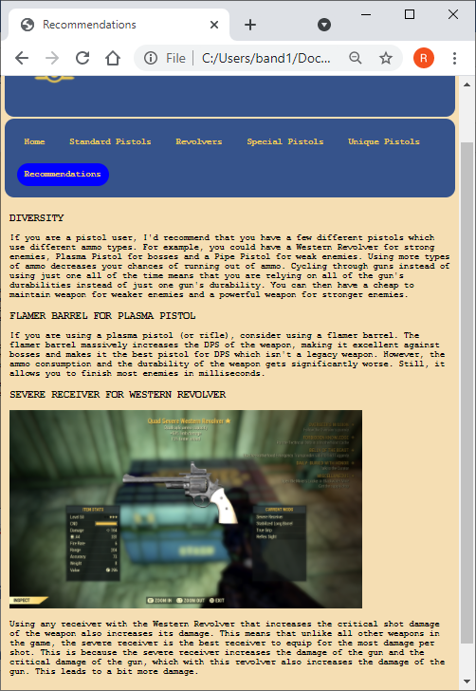
Figure 10 - Recommendations page

Validation
Validation can be carried out with a website to ensure that the website follows typical web standards. The index page and CSS have been validated to identify if there were any issues with them. They were validated with the use of the “Html Checker” and the “CSS Validation Service”. The test results can be seen in the figures below. [4] [5]
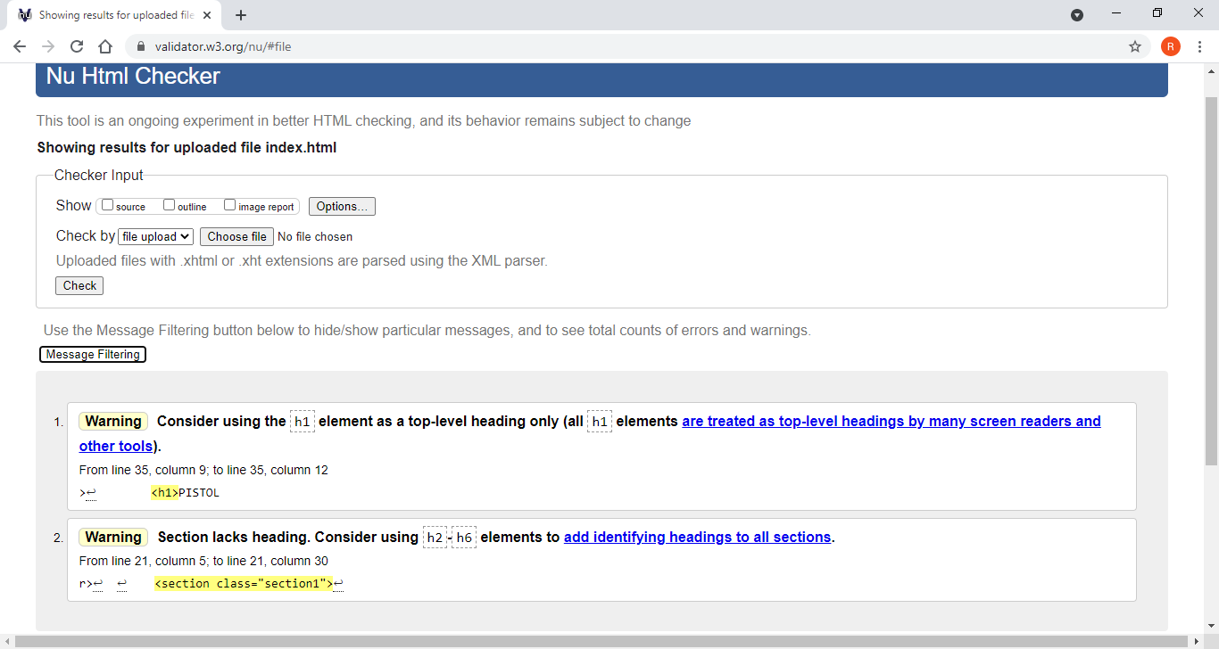
Figure 11 - index validation results
For the index page, there were two warnings, which can be seen in figure 11. The first warning was to do with only using the first and main heading as a h1 element, which was not done on Rhys’ website. The main heading was actually set as a h2 element, while other headings in the page were set to h1 elements. This was fixed by changing the main heading of the page to a h1 element and changing the other headings to h2 elements. This issue carried through all of the html pages due to the others being based on the original index page, so all other pages had to be altered too. Fixing this issue has resulted in the titles of the webpages becoming larger than they were before, which doesn’t seem to cause any issues. Rhys personally prefers the look of the smaller titles, which is probably why the main titles had h2 elements in the first place.
The second warning was related to a section called “section1” which did not have a corresponding header. The contents of section1 were the navigation bar and the text before the div tags. Sections can be used in webpages to apply different styles to the contents of the section. Section1 was completely unused within this website, so it did not have any alternate style applied to it, yet it was still included into all of the html pages. To fix this warning, section1 was removed from the code as there was no point of it being there. It was removed from all web pages. It featured in all html documents as all were heavily influenced by the original index page, which was created first, with the section1 likely being some kind of experimentation within the designing process of the website which was never removed.
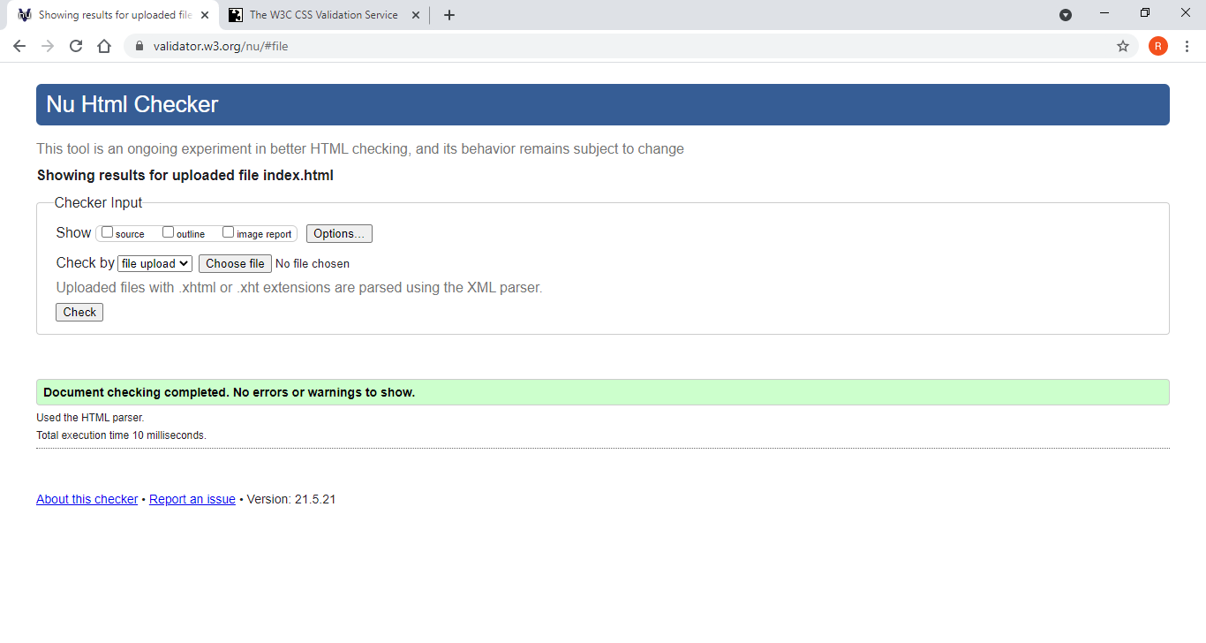
Figure 12 - index validation results after alterations
Figure 12 shows the results of the validation check on the index page which was taken after alterations had been made to the index and other pages. This was done to check whether issues had been made while making the corrections after the last validation check. As seen in figure 12, there were no errors or warnings to be displayed. Rhys thinks the layout of the pages and their basic design were a major factor in the pages not having many issues.
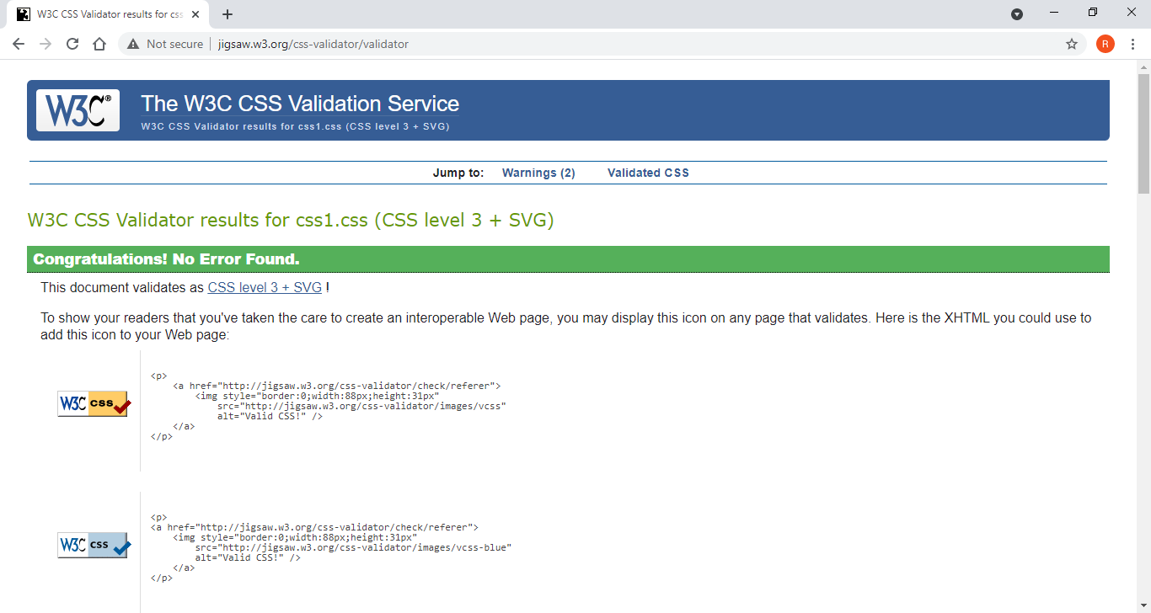
Figure 13 - CSS validation results
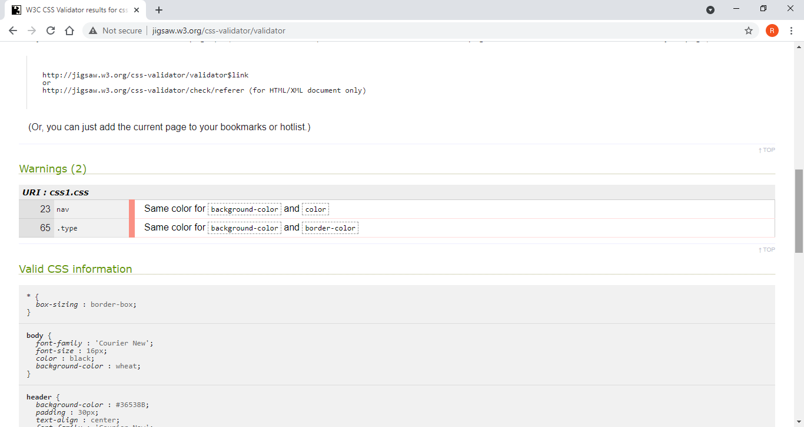
Figure 14 - CSS validation results warnings
Figures 13 and 14 show the validation results of the CSS validation. Figure 13 shows that there were no errors in the CSS, which is nice considering that all of the webpages use and rely on it. However, the CSS still had some warnings. The first warning was related to the background colour and the font colour of the navigation bar being the same colour. This doesn’t actually cause any issues on the webpages as there is no text directly in the navigation bar, but text is situated in items located in the navigation bar which have their own related style in the CSS which changes the font colour. This warning can be fixed by just removing the “color” definition in the nav bar or changing the colour to a different colour. Rhys decided to just delete it, but it could be a good idea to set it to a different colour just in case a webpage is added with text directly in the navigation bar.
The second warning can be ignored. Rhys needed to define a border on the div tags in order to get the rounded edges which he wanted on them, which can be seen in the index page. He did not want to actually have a visible border around the div tags, so setting them to the same colour as the background of the div tags hid the border. Rhys doesn’t plan on fixing this warning as it was made to ensure that the div tags were in line with Rhys’ design ideas.

Evaluation

Usability
Each website should have good functionality, design and relevance. These are important aspects of a website which together would strengthen the usefulness of the website and how usable it is to the target audience. “Do not waste resources providing easy access and good usability to the wrong content. One study found that content is the most critical element of a Web site. Other studies have reported that content is more important than navigation, visual design, functionality, and interactivity”. To Rhys, this is completely true. However, the navigation, visual design, functionality and interactivity are also quite important to ensure that the website has good usability for users. [6]
So, how good is the content of the website? Rhys thinks that the information to be found on the website is alright, but he feels that once people have read the information, there’ll likely be no need for them to return to the website. With that in mind, the website’s usability with just the information considered isn’t great and it is likely not worth Rhys’ time to put more effort into the website unless the information is updated. As much as it might be useful information, it is unlikely that users would return to the site after the first visit. If there was a lot more information, the website could be more useful, and people could return to look for information repeatedly.
The functionality side of the website seems to work well in Rhys’ opinion. There’s not a lot to go wrong with such a simplistic concept for a website, with the most technical aspect of the website being the navigation bar. Rhys has carried out a decent amount of testing towards the navigation bar and is quite confident towards it working as intended. He isn’t fully confident due to the fact that he hasn’t carried out the testing in a structured manner, with a testing table to ensure that every link to and from every webpage works. As for design, Rhys thinks the site looks good. He’s used the vault tec theme, which is a theme related to a made-up company in the Fallout franchise that consists of yellow and blue. He thinks that the design of the website is aesthetically pleasing and relevant. A more complex design could improve the usability of the site, such as animations and fancy graphics.

Accessibility
Websites should conform to the W3C recommendations to ensure that they are properly accessible. These are guidelines to aid web developers when trying to make their website as accessible as possible. W3C’s WCAG 2.1 guidelines aren’t perfect, with the site saying, “Although these guidelines cover a wide range of issues, they are not able to address the needs of people with all types, degrees, and combinations of disability”. With this guide most likely being the best around, it is likely not possible to create a website that is fully accessible to all. Rhys has considered aspects of these guidelines in the making of his website. [7]
His main considerations have been impairments. The main four impairments which Rhys has tried to consider are “Vision”, “Mobility”, “Auditory” and “Cognitive”. Severe impairments have not been heavily considered as the target audience of the website would be people who play the game Fallout 76, if they had severe impairments, they might actually struggle to play it. If they don’t play the game, they’ll likely not care about the website’s information. For vision impairments, text sizes have been kept decently large, with an alright font used. Rhys admits that it isn’t the best font for readability, but it’s definitely acceptable. [8]
Colour blindness has also been considered for this website. “Coloring for Colorblindness” is an online tool which has been used by Rhys to visualise what the colours that he has picked in his website look like in “protanopia, deuteranopia, or tritanopia” colour blindness types. It is also a nice information resource regarding colour blindness. In figure 15, you can see the colours of Rhys’ website inserted into the online tool, allowing us to see what those colours would look like in the three main types of colour blindness. It’s nearly perfect with almost every colour being unique in each type. In the tritanopia simulator, the yellow and cream colours are quite similar, but this is alright due to the layout of the website as the yellow and the cream never meet. So, the website should be fine for colour blindness, or at least those three types. [9]
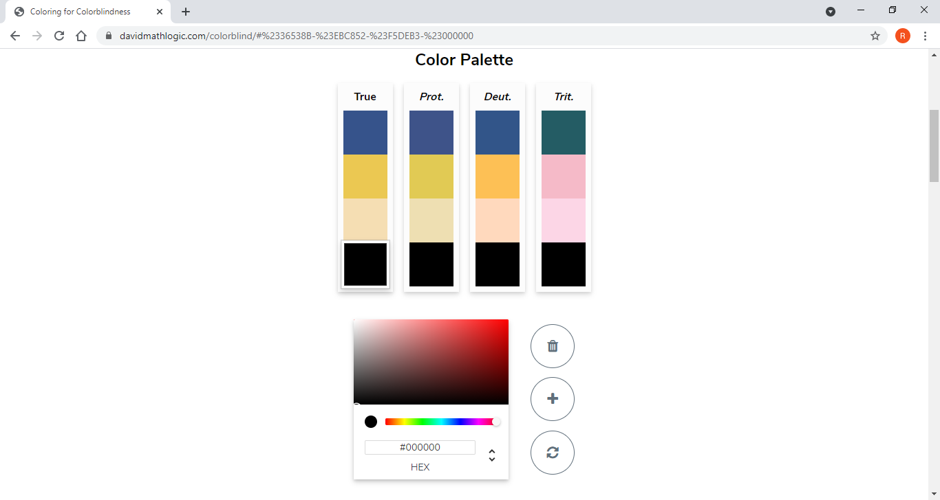
Figure 15 - Colours of the website in colour blindness tool
Mobility should also work fine with Rhys’ website. Due to the site being written in html, there will likely not be any issues with mobility. People who need specialised equipment to browse the internet would be using equipment that’s designed to work with html pages online, so there shouldn’t be any issues there. There is also the consideration of people who have a lack of equipment or different equipment, such as using a computer with a keyboard but without a mouse or using a mobile or touchscreen device. Rhys has used and navigated the website successfully with just a mouse and just his keyboard. He claimed that using just the keyboard was a bit quirky, but it was very much possible with the use of the up and down arrow keys to scroll up and down, holding the alt key while pressing the left and right arrow keys to change web pages and pressing the alt key to navigate the browser’s functionality. As for touchscreen devices, Rhys has not tested them, but they should work as the touchscreen devices and browsers are designed to work with html websites.
Auditory impairment was easy, there just isn’t any use of sound on the website. It’s the simple yet effective method. Yes, sound can enhance the experience, but most people just get irritated by usage of sounds on websites, so Rhys thought that not including sound was a good idea. Cognition is actually where it gets hard for Rhys to work with. The website’s layout helps, it’s very simplistic and easy to understand. The information on the website is questionable though. Rhys tried to ensure that he was writing in a simplified and easy to understand way, but he is unsure whether the website is effective for cognition. He thinks he could have used bullet points to list features and details of pistols in those sections, which could have helped with cognition but might have worsened the aesthetic appeal of the website depending on how it was managed. More research and reading into cognition of websites could have helped before making the website.

Search engine optimisation
Search engine optimisation is quite simple, how can you make your website get more attention and users? There are three main ways to improve your website’s chances of success, “Improve Title Tags”, “Master Keyword Research” and “Understand Your Competition”. By utilising these three considerations, you could achieve better search engine optimisation. [10]
The title tags on Rhys’ website are actually quite good. With all of the title tags put together, you get fallout 76, pistols and all of the pistols in the game. A search for a specific weapon or pistols could very well bring Rhys’ website nearer to the top in the selection of websites someone would see with a search. Rhys’ keywords on the website are terrible, this is because there aren’t any. Adding key words would definitely improve the website’s search engine optimisation. For competition, Rhys doesn’t actually have much. From Rhys’ research, there doesn’t appear to be any websites out there dedicated to pistols in fallout 76, with the closest competitor likely being Fandom’s Fallout wiki, which was mentioned before. Looking at what they do to get an advantage in search engine results could help Rhys to understand what he could do to get to the top.

References

[1] | “code.visualstudio.com,” [Online]. Available: https://code.visualstudio.com/. [Accessed 2021].
[2] | “fallout.bethesda.net/en/games/fallout-76,” Bethesda Game Studios, [Online]. Available: https://fallout.bethesda.net/en/games/fallout-76. [Accessed 2021].
[3] | “fallout.fandom.com/wiki/Fallout_76,” [Online]. Available: https://fallout.fandom.com/wiki/Fallout_76. [Accessed 2021].
[4] | “validator.w3.org,” [Online]. Available: https://validator.w3.org/nu/#file. [Accessed 2021].
[5] | “jigsaw.w3.org,” [Online]. Available: http://jigsaw.w3.org/css-validator/#validate_by_upload. [Accessed 2021].
[6] | H. S. U. S. G. S. A. United States. Department of Health, in Research-based Web Design & Usability Guidelines, United States Govt Printing Office, 2006, p. 2.
[7] | “www.w3.org/,” [Online]. Available: https://www.w3.org/TR/WCAG21/#background-on-wcag-2. [Accessed 2021].
[8] | J. N. Robbins, “Learning Web Design,” in Learning Web design: a beginner's guide to HTML, CSS, JavaScript, and web graphics, O'REILLY, 2012, p. 41.
[9] | D. Nichols, “davidmathlogic.com,” [Online]. Available: https://davidmathlogic.com/colorblind/#%230182E7-%23FFFFFF-%232B2E7F-%23535456. [Accessed 2021].
[10] | J. K. BROWN, “www.practicalecommerce.com,” 6 may 2020. [Online]. Available: https://www.practicalecommerce.com/10-do-it-yourself-seo-tips-to-save-money. [Accessed 2021].

Appendix
<!DOCTYPE html>
<html lang="en">
<head>
<meta charset="UTF-8">
<meta name="viewport" content="width=device-width, initial-scale=1.0">
<title>index</title>

<!--This is the index page-->

<link rel="stylesheet" href="css/css1.css" type="text/css" />

</head>
<body>

<header>
<img src="images/logo.jpeg" alt="Logo" style="float:left" width="150" height="150">
<h1>FALLOUT 76 PISTOLS</h1>
</header>

<nav>

<ul>
<li><a class="active" href="index.html"><b>Home</b></a></li>
<li><a href="Standard_Pistols.html"><b>Standard Pistols</b></a></li>
<li><a href="Revolvers.html"><b>Revolvers</b></a></li>
<li><a href="Special_Pistols.html"><b>Special Pistols</b></a></li>
<li><a href="Unique_Pistols.html"><b>Unique Pistols</b></a></li>
<li><a href="Recommendations.html"><b>Recommendations</b></a></li>
</ul>
</nav>

<article>
<h2>PISTOLS</h2>
<p><b>"Quite bad, but fun" Rhys, 2021</b></p>
<p><b>I've been using pistols in Fallout 76 for quite a while now, so it's about time that I shared some of my knowledge. There's a diverse selection of pistols in the game, but at the end of the day, you can only have either high damage and low fire rate or high fire rate and low damage. Anyone who wants to have high damage and high fire rate, just don't use pistols. They can prove to be fun with the large selection of choices available in game.</b></p>
</article>

<div class="div-container">
<div class="type">
<article>
<h2>Standard Pistols</h2>
<p><b>These are weapons which typically have a fast rate of fire and low to medium damage output. All of which can be semi-automatic and most can be fully-automatic. All Standard Pistols are very modifiable. Consists of the Pipe Pisol, Laser Pistol, Plasma Pistol, 10mm Pistol, and the Crusader Pistol.</b></p>
</article>
</div>

<div class="type">
<article>
<h2>Revolvers</h2>
<p><b>Six shooters with a low fire rate and medium to high damage output. Not as modifiable or diverse as the Standard Pistols. Consists of the Pipe Revolver, Single Action Revolver, .44 Pistol and the Western Revolver.</b></p>
</article>
</div>

<div class="type">
<article>
<h2>Special Pistols</h2>
<p><b>This is a group of diverse weapons which have a variety of low and high fire rates. These weapons are mostly not very modifiable, with some not having any modifications. Consists of the Pipe Bolt-Action Pistol, Black Powder Pistol, Flare Gun, Gauss Pistol, Gamma Gun, Alien Blaster and Salvaged Assaultron Head.</b></p>
</article>
</div>
</div>

<footer>
<p>Rhys Davies 2021</p>
</footer>

</body>
</html>

<!DOCTYPE html>
<html lang="en">
<head>
<meta charset="UTF-8">
<meta name="viewport" content="width=device-width, initial-scale=1.0">
<title>Standard_Pistols</title>

<link rel="stylesheet" href="css/css1.css" type="text/css" />

</head>
<body>

<header>
<img src="images/logo.jpeg" alt="Logo" style="float:left" width="150" height="150">
<h1>STANDARD PISTOLS</h1>
</header>

<nav>

<ul>
<li><a href="index.html"><b>Home</b></a></li>
<li><a class="active" href="Standard_Pistols.html"><b>Standard Pistols</b></a></li>
<li><a href="Revolvers.html"><b>Revolvers</b></a></li>
<li><a href="Special_Pistols.html"><b>Special Pistols</b></a></li>
<li><a href="Unique_Pistols.html"><b>Unique Pistols</b></a></li>
<li><a href="Recommendations.html"><b>Recommendations</b></a></li>
</ul>
</nav>

<article>
<h2>PIPE PISTOL</h2>
<img src="images/pipe_pistol.png.png" alt="PIPE PISTOL" width="80%">
<p><b>Low damage, high fire rate, highly modifiable.</b></p>
<p><b>Out of all the weapons in Fallout 76, the Pipe Pistol doesn't exactly have good damage per bullet. However, this gun can still prove useful to pistol users. This gun uses .38 bullets, which are cheap, light and if lucky, you could find other players that'll give you bulk amounts of it for free. Usage of the gun is quite cheap, so it makes for a great gun to use against weaker enemies.</b></p>

<h2>LASER PISTOL</h2>
<img src="images/laser_pistol.png.png" alt="LASER PISTOL" width="80%">
<p><b>Energy damage, high fire rate, highly modifiable.</b></p>
<p><b>A highly modifiable energy gun which shoots lasers. Damage can vary based on the modifications made to it but is typically decent. Uses fusion cells, which aren't very light or cheap in comparison to other ammo types. The modifications of this gun are what makes it special, it's an okay choice of weapon.</b></p>

<h2>PLASMA PISTOL</h2>
<img src="images/plasma_pistol.png.png" alt="PLASMA PISTOL" width="80%">
<p><b>Energy damage, high fire rate, highly modifiable.</b></p>
<p><b>A highly modifiable energy gun which shoots plasma projectiles. Damage is typically better than a Laser Pistol, but at the cost of projectiles having velocity, gliding through the air until it hits a target or surface. Uses plasma cartridges, which are heavy and quite expensive compared to other ammo types. I don't particularly like this gun, although using the flamer barrel modification makes the DPS very high.</b></p>

<h2>10MM PISTOL</h2>
<img src="images/10mm_pistol.png.png" alt="10MM PISTOL" width="80%">
<p><b>Okay damage, high fire rate, quite modifiable.</b></p>
<p><b>The damage per bullet of the 10mm Pistol is okay, a bit better than the Pipe Pistol. Has good fire rate and uses 10mm bullets, which are cheap and light similarly to .38 bullets. It has a decent number of modifications, just not as much as the Pipe Pistol, Laser Pistol or Plasma Pistol. This gun ends up being like an upgraded Pipe Pistol, higher DPS, still cheap to use and I personally prefer the appearance of the 10mm.</b></p>

<h2>CRUSADER PISTOL</h2>
<img src="images/crusader_pistol.png" alt="10MM PISTOL" width="80%">
<p><b>Okay damage, high fire rate, interesting modifications.</b></p>
<p><b>The rarest type of pistol in the game, one I have never used and still don't own. Has okay damage, better than the 10mm Pistol. Can use 10mm, 5.56 or fusion cells as ammo. Modifications are quite limited, but I think they could make the gun quite interesting.</b></p>

</article>

<footer>
<p>Rhys Davies 2021</p>
</footer>

</body>
</html>

<!DOCTYPE html>
<html lang="en">
<head>
<meta charset="UTF-8">
<meta name="viewport" content="width=device-width, initial-scale=1.0">
<title>Revolvers</title>

<link rel="stylesheet" href="css/css1.css" type="text/css" />

</head>
<body>

<header>
<img src="images/logo.jpeg" alt="Logo" style="float:left" width="150" height="150">
<h1>REVOLVERS</h1>
</header>

<nav>

<ul>
<li><a href="index.html"><b>Home</b></a></li>
<li><a href="Standard_Pistols.html"><b>Standard Pistols</b></a></li>
<li><a class="active" href="Revolvers.html"><b>Revolvers</b></a></li>
<li><a href="Special_Pistols.html"><b>Special Pistols</b></a></li>
<li><a href="Unique_Pistols.html"><b>Unique Pistols</b></a></li>
<li><a href="Recommendations.html"><b>Recommendations</b></a></li>
</ul>
</nav>

<article>
<h2>PIPE REVOLVER</h2>
<img src="images/pipe_revolver.png.png" alt="PIPE REVOLVER" width="80%">
<p><b>Medium damage, low fire rate, highly modifiable.</b></p>
<p><b>It may have the lowest damage output of all revolvers, but the Pipe Revolver can still be useful. It has the most modifications out of all of the revolvers whilst still having decent damage output compared to other pistols. Uses .45 bullets but can even be modified to use .38 bullets, both of which are cheaper, lighter and more common than the .44 calibre bullets which other revolvers use. Out of all the pipe weapons, the Pipe Revolver in my mind looks the best, although that isn't saying much.</b></p>

<h2>SINGLE ACTION REVOLVER</h2>
<img src="images/single_action_revolver.png.png" alt="SINGLE ACTION REVOLVER" width="80%">
<p><b>Medium damage, low fire rate, very few modifications.</b></p>
<p><b>Has the second highest damage output per bullet out of the revolvers. It has very few modifications, so legendary effects are desirable for this gun to alter the performance. Uses .44 calibre bullets, which are alright for weight and cost. I consider this the nicest looking revolver, but it has a really long reload time due to the need of reloading each individual bullet into the gun, unlike the other revolvers.</b></p>

<h2>.44 PISTOL</h2>
<img src="images/44_pistol.png.png" alt=".44 PISTOL" width="80%">
<p><b>Medium damage, low fire rate, quite modifiable.</b></p>
<p><b>Just under the Single Action Revolver in damage, the .44 Pistol still packs a punch. With a decent array of modifications, some may prefer the .44 to the Single Action Revolver. If the name wasn't clear enough, it uses .44 ammo. It looks quite nice, but overall, the gun is quite generic. </b></p>

<h2>WESTERN REVOLVER</h2>
<img src="images/western_revolver.png.png" alt="WESTERN REVOLVER" width="80%">
<p><b>High damage, low fire rate, quite modifiable.</b></p>
<p><b>The highest damage output of the revolvers. The Western Revolver also has a decent array of modifications available. Uses .44 ammo like the .44 Pistol and Single Action Revolver. When it comes to performance, the Western Revolver is the best revolver. Although, I wouldn't say it looks as nice as the .44 or the Single Action Revolver.</b></p>

</article>

<footer>
<p>Rhys Davies 2021</p>
</footer>

</body>
</html>

<!DOCTYPE html>
<html lang="en">
<head>
<meta charset="UTF-8">
<meta name="viewport" content="width=device-width, initial-scale=1.0">
<title>Special_Pistols</title>

<link rel="stylesheet" href="css/css1.css" type="text/css" />

</head>
<body>

<header>
<img src="images/logo.jpeg" alt="Logo" style="float:left" width="150" height="150">
<h1>SPECIAL PISTOLS</h1>
</header>

<nav>

<ul>
<li><a href="index.html"><b>Home</b></a></li>
<li><a href="Standard_Pistols.html"><b>Standard Pistols</b></a></li>
<li><a href="Revolvers.html"><b>Revolvers</b></a></li>
<li><a class="active" href="Special_Pistols.html"><b>Special Pistols</b></a></li>
<li><a href="Unique_Pistols.html"><b>Unique Pistols</b></a></li>
<li><a href="Recommendations.html"><b>Recommendations</b></a></li>
</ul>
</nav>

<article>
<h2>PIPE BOLT-ACTION PISTOL</h2>
<img src="images/bolt_action_pipe_pistol.png.png" alt="PIPE BOLT-ACTION PISTOL" width="80%">
<p><b>Medium damage, low fire rate, highly modifiable.</b></p>
<p><b>Quite a slow firing weapon with decent damage. Is basically a worse Hunting Rifle in pistol format, but then can also be made into a rifle. Quite a lot of modifications and can use either .308 or .38 ammo types. Isn't a particularly good gun in my opinion, doesn't look nice either. But it has its uses as the only pistol which can use .308 ammo.</b></p>

<h2>BLACK POWDER PISTOL</h2>
<img src="images/flintlock_pistol.png.png" alt="BLACK POWDER PISTOL" width="80%">
<p><b>High damage, very low fire rate, not modifiable.</b></p>
<p><b>Deals lots of damage with a very long reload, reloads one bullet with every reload. Has absolutely no modifications, but that doesn't make this a bad weapon. With legendary effects, the high damage can become higher and the slow reload can be improved. Uses .50 calibre balls, which are heavy but quite cheap. Can work well with stealth or skilled players.</b></p>

<h2>FLARE GUN</h2>
<img src="images/flare_gun.png.png" alt="FLARE GUN" width="80%">
<p><b>Terrible damage, low fire rate, not modifiable.</b></p>
<p><b>Has really low damage and can only be found or crafted as a level 1 weapon. It has a low fire rate due to needing a reload after each shot and cannot be modified. The flare gun uses the flare ammo type and is the only weapon to do so. It isn't an effective option for a weapon, but people still use it for fun.</b></p>

<h2>GAUSS PISTOL</h2>
<img src="images/gauss_pistol.png.png" alt="GAUSS PISTOL" width="80%">
<p><b>Low to high damage, low fire rate, some modifications.</b></p>
<p><b>Shots need to be charged up, with a longer charge resulting in higher damage. Can reach high damage with very slow shots and low damage with fast shots. Has a few modifications which affect the gun's performance. Uses 2mm electromagnetic cartridges, which are really heavy for pistol ammo and quite hard to craft in bulk due to the quantity of lead and steel needed. I don't particularly enjoy using this weapon, it is good, but I find it tedious to use.</b></p>

<h2>GAMMA GUN</h2>
<img src="images/gamma_gun.png.png" alt="GAMMA GUN" width="80%">
<p><b>Okay damage, high fire rate, few modifications.</b></p>
<p><b>An interesting gun which shoots balls of radiation which have velocity. Can irradiate the user if not careful. Has a decent fire rate but only has a few modifications. Uses gamma rounds and is the only gun to use gamma rounds. The damage may be good, however due to it being radiation damage, some enemies are resistant to radiation, such as ghouls. Therefore, it is not advised to use a gamma gun against ghouls. Is still quite a good weapon depending on who or what you use it on.</b></p>

<h2>ALIEN BLASTER</h2>
<img src="images/alien_blaster.png.png" alt="ALIEN BLASTER" width="80%">
<p><b>Okay damage, high fire rate, few modifications.</b></p>
<p><b>A pistol which shoots blue energy balls which have velocity. Has a good fire rate with a small amount of modifications. Uses alien blaster rounds by default, which are incredibly hard to find and cannot be crafted. Can be modified to use fusion cells, which allows it to use a more replaceable ammo type. Does less damage than a Gamma Gun. This gun used to be much more powerful in older Fallout games, but now it's just an okay gun. I guess it has a cool factor, but I don't really see it.</b></p>

<h2>SALVAGED ASSAULTRON HEAD</h2>
<img src="images/assaultron_head.png.png" alt="SALVAGED ASSAULTRON HEAD" width="80%">
<p><b>Low to high damage, low fire rate, no modifications.</b></p>
<p><b>This gun allows you to load ammo into it one by one to increase the amount of energy damage it does with one shot. This leads to it having a slow to very slow fire rate with low to high damage output. Has absolutely no modifications, so this gun only has variety in legendary effects. Uses fusion cells, which aren't very light compared to other ammo types. The gun also irradiates the user with each shot. This gun is usable and can be quite effective, but it's the slow rate of fire and poor accuracy which lets it down. It's very rare to see someone using one of these.</b></p>

</article>

<footer>
<p>Rhys Davies 2021</p>
</footer>

</body>
</html>

<!DOCTYPE html>
<html lang="en">
<head>
<meta charset="UTF-8">
<meta name="viewport" content="width=device-width, initial-scale=1.0">
<title>Unique_Pistols</title>

<link rel="stylesheet" href="css/css1.css" type="text/css" />

</head>
<body>

<header>
<img src="images/logo.jpeg" alt="Logo" style="float:left" width="150" height="150">
<h1>UNIQUE PISTOLS</h1>
</header>

<nav>

<ul>
<li><a href="index.html"><b>Home</b></a></li>
<li><a href="Standard_Pistols.html"><b>Standard Pistols</b></a></li>
<li><a href="Revolvers.html"><b>Revolvers</b></a></li>
<li><a href="Special_Pistols.html"><b>Special Pistols</b></a></li>
<li><a class="active" href="Unique_Pistols.html"><b>Unique Pistols</b></a></li>
<li><a href="Recommendations.html"><b>Recommendations</b></a></li>
</ul>
</nav>

<article>
<h2>UNIQUE PISTOLS</h2>
<img src="images/unique_pistols.png" alt="UNIQUE PISTOLS" width="80%">
<p><b>There are quite a few different unique pistols which are based on existing weapon types. These unique weapons alter the ways in which the guns perform and appear. They typically lack modifications, but they might not need modifications to be useful to players. They typically are hard to find, so you'll likely want to know where to find these unique weapons. I'm not going to say where they are or what they are on this website.</b></p>
<p><b>When you find one of these unique weapons for the first time while playing the game, it can be quite a nice experience to realise that you just found or received something special and rare. In my mind, knowing where something is, how to get it and what it's like takes away from the experience of finding it yourself and figuring out what it does. Play the game a bit, complete some quests. Eventually, you're going to find at least one. If you're struggling to find any, you can just search up the weapons online.</b></p>

</article>

<footer>
<p>Rhys Davies 2021</p>
</footer>

</body>
</html>

<!DOCTYPE html>
<html lang="en">
<head>
<meta charset="UTF-8">
<meta name="viewport" content="width=device-width, initial-scale=1.0">
<title>Recommendations</title>

<link rel="stylesheet" href="css/css1.css" type="text/css" />

</head>
<body>

<header>
<img src="images/logo.jpeg" alt="Logo" style="float:left" width="150" height="150">
<h1>RECOMMENDATIONS</h1>
</header>

<nav>

<ul>
<li><a href="index.html"><b>Home</b></a></li>
<li><a href="Standard_Pistols.html"><b>Standard Pistols</b></a></li>
<li><a href="Revolvers.html"><b>Revolvers</b></a></li>
<li><a href="Special_Pistols.html"><b>Special Pistols</b></a></li>
<li><a href="Unique_Pistols.html"><b>Unique Pistols</b></a></li>
<li><a class="active" href="Recommendations.html"><b>Recommendations</b></a></li>
</ul>
</nav>

<article>
<h2>DIVERSITY</h2>
<p><b>If you are a pistol user, I'd recommend that you have a few different pistols which use different ammo types. For example, you could have a Western Revolver for strong enemies, Plasma Pistol for bosses and a Pipe Pistol for weak enemies. Using more types of ammo decreases your chances of running out of ammo. Cycling through guns instead of using just one all of the time means that you are relying on all of the gun's durabilities instead of just one gun's durability. You can then have a cheap to maintain weapon for weaker enemies and a powerful weapon for stronger enemies.</b></p>

<h2>FLAMER BARREL FOR PLASMA PISTOL</h2>
<p><b>If you are using a plasma pistol (or rifle), consider using a flamer barrel. The flamer barrel massively increases the DPS of the weapon, making it excellent against bosses and makes it the best pistol for DPS which isn't a legacy weapon. However, the ammo consumption and the durability of the weapon gets significantly worse. Still, it allows you to finish most enemies in milliseconds.</b></p>

<h2>SEVERE RECEIVER FOR WESTERN REVOLVER</h2>
<img src="images/severe_receiver.png" alt="PIPE REVOLVER" width="80%" >
<p><b>Using any receiver with the Western Revolver that increases the critical shot damage of the weapon also increases its damage. This means that unlike all other weapons in the game, the severe receiver is the best receiver to equip for the most damage per shot. This is because the severe receiver increases the damage of the gun and the critical damage of the gun, which with this revolver also increases the damage of the gun. This leads to a bit more damage.</b></p>

</article>

<footer>
<p>Rhys Davies 2021</p>
</footer>

</body>
</html>

* {
box-sizing: border-box;
}

body {
font-family: 'Courier New';
font-size: 16px;
color: #000000;
background-color: #f5deb3;
}
header{
background-color: #36538B;
padding: 30px;
text-align: center;
font-family: 'Courier New';
font-size: 35px;
color: #EBC852;
border-radius: 20px;
margin-bottom: 5px;
}
nav{
background-color: #36538B;
padding: 15px;
font-size: 16px;
border-radius: 20px;
}
nav ul{
list-style-type: none;
padding: 0;
font-size: 18px;
margin: 0;
overflow: hidden;
background-color: #36538B;
border-radius: 10px;
}
nav li {
float: left;
}
nav li a{
display: block;
color: #EBC852;
text-align: center;
padding: 14px 16px;
text-decoration: none;
margin: 10px;
border-radius: 50px;
}
.active{
background-color: blue;
}
nav li a:hover:not(.active){
background-color: blue;
}

article {
padding: 10px;
font-size: 18px;
}
.div-container {
display:block;
}
.type {
background-color: #36538B;
color:#EBC852;
border-color: #36538B;
border-style: solid;
border-radius: 20px;
margin: 5px;
padding: 10px;
}

footer {
padding: 10px;
text-align: left;
color: gray;
}

