Assignment 2: Menu Engineer
Food& Beverage Operations (BMIH 4002)
Student Name Oana Simona Ungureanu (2209544)
Tutor Name : Ffion Cumberpatch

Valentine’s Menu
Hotel Trinity
Welcome to Hotel Trinity’s Valentine’s Menu – an unforgettable culinary experience!


Starters
Baked Camembert ......................................................................................... £7.50 A whole Camembert cheese, oven-baked and served with a selection of artisan pieces of bread and a balsamic glaze. Soup of the Day ........................................................................................... £5.50 A hearty, seasonal soup made with locally sourced ingredients.
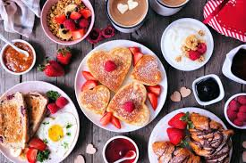

Mains
Valentine’s Surf and Turf ............................................................................ £22.50 Our signature dish is served with king prawns and succulent steak, roasted potatoes, and wild garlic and herb butter. Salmon Wellington ...................................................................................... £20.50 A puff pastry-wrapped salmon fillet served with a tarragon cream sauce. Vegetarian Option ........................................................................................ £15.50 Roasted vegetable en croute, served with garlic and parsley butter.
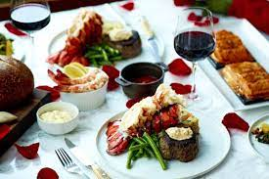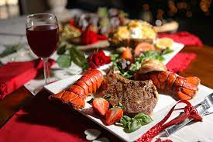

Desserts
Chocolate Fondant ...................................................................................... £7.50 A molten chocolate canter served with a scoop of vanilla ice cream. Strawberry Cheesecake ............................................................................. £7.50 A classic New York-style cheesecake topped with fresh strawberries.
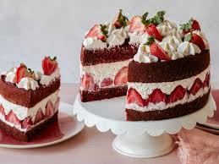

Drinks
Cocktails ....................................................................................................... £7.00 Our selection of classic and contemporary cocktails. Mocktails ...................................................................................................... £5.00 Our selection of non-alcoholic mixed drinks. Wines ........................................................................................................... £4.50 White, red and rose wines, available by the glass. Beers and Ales ............................................................................................ £4.00 A range of local beers and ales. Soft Drinks .................................................................................................... £2.50
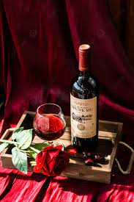
A selection of soft drinks and juices.
Drinks Packages Romantic Package ....................................................................................... £20.00 Bottle of Prosecco, two cocktails and two mocktails. Luxury Package ............................................................................................ £40.00 Bottle of Champagne, two cocktails and two mocktails. This menu is available from 6pm until 10pm on 14th February 2021.
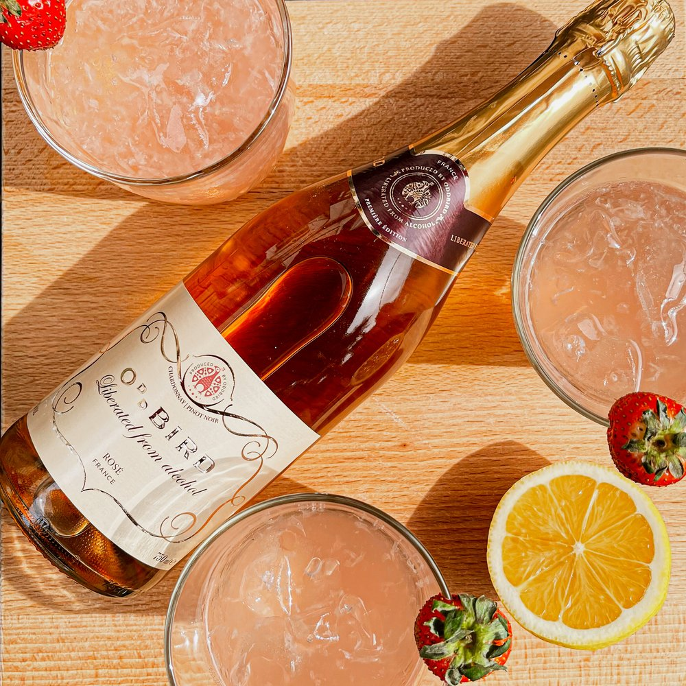

References
Celhay, F., Cheng, P., Masson, J. and Li, W. (2020). Package graphic design and communication across cultures: An investigation of Chinese consumers’ interpretation of imported wine labels. International Journal of Research in Marketing, [online] 37(1), pp.108–128. doi:https://doi.org/10.1016/j.ijresmar.2019.07.004.
Google Books. (2023). The Diner’s Dictionary. [online] Available at: https://books.google.co.ke/books?hl=en&lr=&id=NoicAQAAQBAJ&oi=fnd&pg=PP2&dq=Camembert+cheese,+oven-baked+and+served+with+a+selection+of+artisan+pieces+of+bread+and+a+balsamic+glaze&ots=NcgCmAlk-g&sig=TyR4WvcGEDI5kGkXiOoS3bp3FA8&redir_esc=y#v=onepage&q&f=false [Accessed 16 Feb. 2023].
Google Books. (2020). The Geeky Chef Cookbook. [online] Available at: https://books.google.co.ke/books?hl=en&lr=&id=We_RDwAAQBAJ&oi=fnd&pg=PP1&dq=Our+signature+dish+is+served+with+king+prawns+and+succulent+steak,+roasted+potatoes,+and+wild+garlic+and+herb+butter.+Salmon+Wellington&ots=TH3LTXo2hQ&sig=mIc3mpta3XtdTwb3T3tPG8Zry84&redir_esc=y#v=onepage&q&f=false [Accessed 16 Feb. 2023].
Clossen, A., Donovan, C., Egler, P., Pullman, E., Schriftman, L. and Smith, D. (2023). Restaurants of the ’Burgh: Popular spots and hidden gems in Downtown Pittsburgh. College & Research Libraries News, [online] 84(2). doi:https://doi.org/10.5860/crln.84.2.69.
Garaus, M. and Halkias, G. (2019). One color fits all: product category color norms and (a)typical package colors. Review of Managerial Science, [online] 14(5), pp.1077–1099. doi:https://doi.org/10.1007/s11846-018-0325-9.
‌

‌

‌

‌

