Web Development Report
This report has been written as an assignment to Web Development course at T.S.D. University, London Campus

EAST ACTON UNIVERSITY WEBSITE
Realised by

Biancamaria Di Napoli

--TABLE OF CONTENT--

Research Section---------------------------------------------pg. 3
Introduction Section----------------------------------------pg. 5
Testing Section----------------------------------------------pg. 11
Evaluation Section-----------------------------------------pg. 14
Reference----------------------------------------------------pg. 15

Appendix----------------------------------------------------pg. 16

RESEARCH SECTION
PHP FRAMEWORK

A website creation involves planning activity of both, the contents and the most suitable tools to present them. Front end and back end are the two main components, their functionalities are closely related and they play a fundamental role in the web development. The front end is the graphical interface designed for user interaction and the back end is the invisible part that allows it. Different programming languages can be used: for the front end is used Html, Css and JavaScript; for the back end is used Php, Ruby on Rails and Python. In addition to these languages, there are several tools that can ease and speed up programming: the frameworks. These are software that include in a single package the entire set of libraries and tools useful for the design a website. Choosing a framework is a very delicate process, it is not just a matter of comparing functionality and features, but also choose the one that best suits the knowledge.
Why frameworks are so useful?
The frameworks allow organizing the code correctly from the start and in this way it is much easier to control it. Besides, thanks to a more orderly structure, the frameworks consent to quickly find the file needed. Another very advantageous function is that they provide solutions for most of the problems that arise during web development.
All existing frameworks have several functions, such as:
● MVC (Model View Controller) architecture;
● user authentication, access control levels, sessions, cookies ...;
● directory and module structures;
● management of requests and responses (POST, GET, Webservices);
● management of the validation of forms and data;
● location and language management.
Finally, the frameworks have some functions that applied to PHP, to ensure the input and output control data to protect the website from potential attacks. And as far as you can manually perform these actions, doing it is complex.

PHP FRAMEWORK
LOGO | FEATURES | MCV | DATABASE  MODEL | EASE OF  USE | PROJECT  DIMENSION | SECURITY
 | LARAVEL | YES | OBJECT  RELATIONAL  MAPPING  (ORM) | COMPLEX | MEDIUM/  LARGE | PACKAGE ENCRIPTION
 | CODEIGNITER | YES | OBJECT  ORIENTED | EASY | LARGE | STRONG
 | CAKE PHP | YES | OBJECT  RELATIONAL  MAPPING  (ORM) | SIMPLE | SMALL/  MEDIUM | XSS, SQL, INJECTION CSRF
 | SYMPHONY | NO | OBJECT  RELATIONAL  MAPPING  (ORM) | EASY | LARGE | STRONG
 | ZEND | YES | OBJECT  ORIENTED | COMPLEX | MEDIUM/  LARGE | STRONG

MOST DOWNLOADED PHP FRAMEWORK
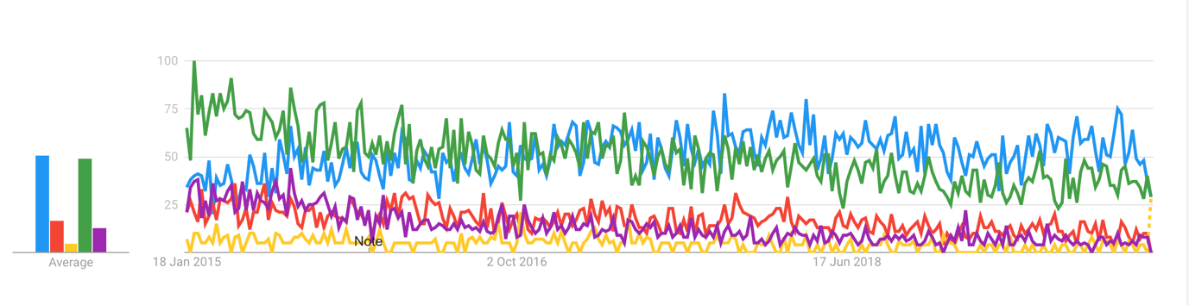
Figure 1. Download Php Framework trend,(source: Google Trends)
INTRODUCTION SECTION
EAST ACTON UNIVERSITY WEBSITE

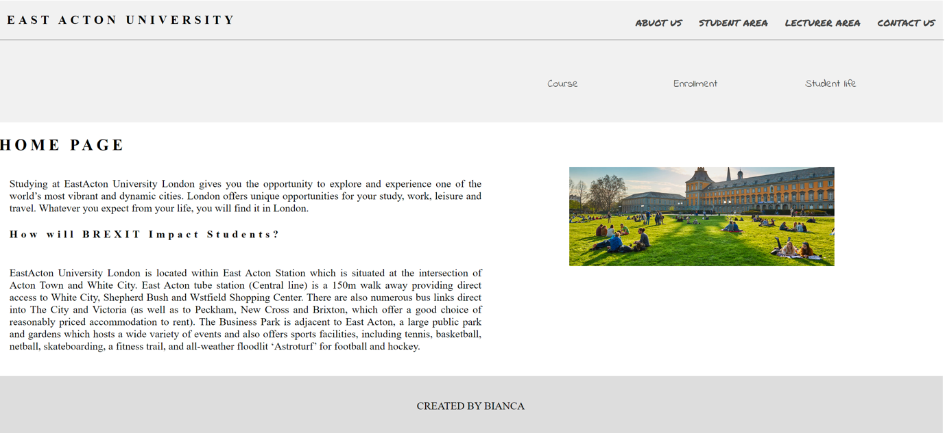
Figure 2. East Acton University Home Page

No framework has been used to project the East Acton University website. Designing this kind of website entailed having to include the main features required from the early stages of project for both the front end and the back end.
The back end has been created using PHP and SQL languages and phpMyAdmin has been used to build a normalised database. The database design has been after to the ERD diagram plan where all the relationships between the tables has been established:

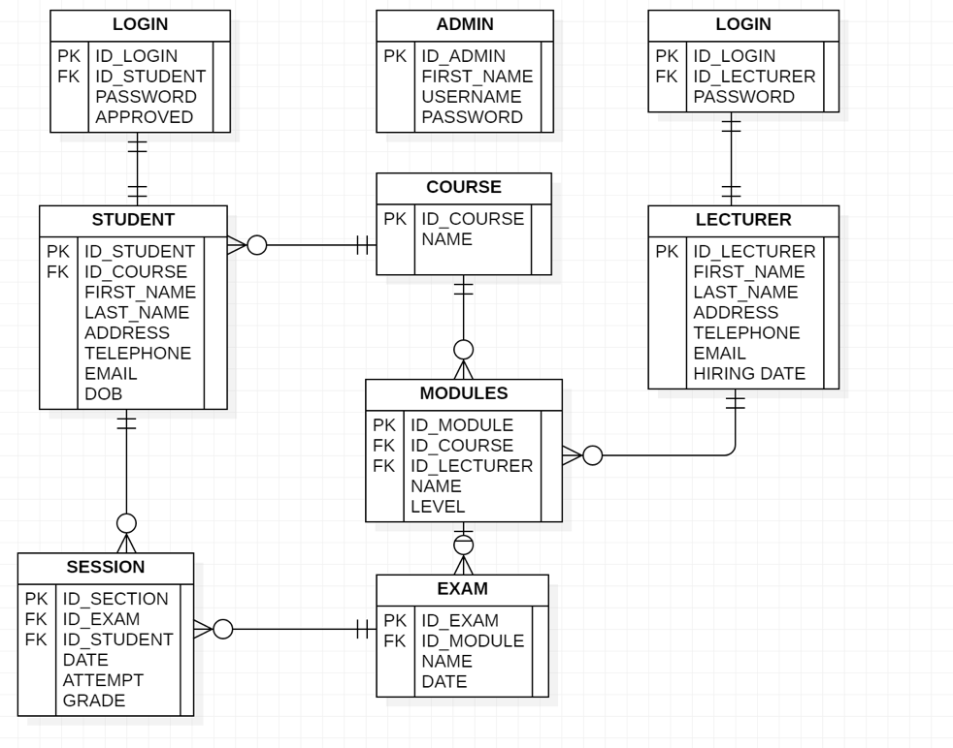
Figure 3. ERD East Acton University,(source: author)
By assumption, every module is specific for a course and it can be taught by only one lecturer.
The database creation has been fundamental to manage all the site functions, in fact, starting from the personal area for students and lecturer, two tables collect the data access, in this circumstance, Student / Lecturer ID and password. Two tables have been created because, following the home page structure, there are two different access areas to login page: one reserved to the student and the other reserved for the lecturer. Another features provided it is the option that users have to enrol online, therefore the requirement is to collect data in a specific table to be able to direct the student in his study path with its modules and dedicated exams area. Following the automatic insertion of the student data in the Student table, a Student_ID and a Password are then generated and they are entered in the corresponding Login table.
The front end has been created exclusively with the use of Html and CSS languages, and it is the user interface, that permits interaction. Basically, two areas has been foreseen in its design, a public area, in which all users can have access to search for information, and a private area, reserved for registered and authorized users, in which there are more specific pieces of information.

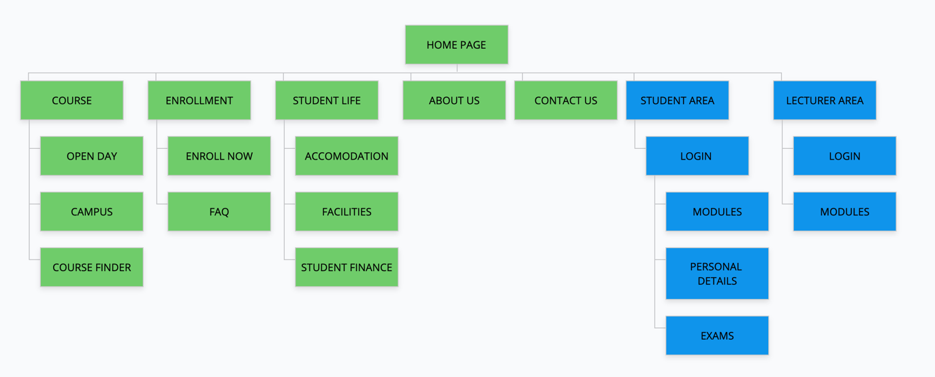
Figure 4. East Acton University Site Map,(source: author)

So the areas highlighted in green, represent the pages that can be viewed by all users, where they can get info on the courses offered by the university, the campus location, useful contacts and other relevant material and they can also register directly from the site in the Enroll now section. Indeed, on the corresponding page, a form appears in which the user must enter his personal data and choose the type ,of course, he would like to attend.

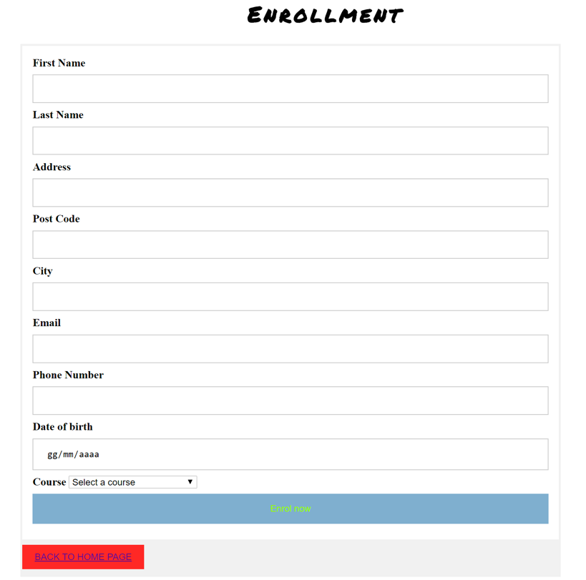
Figure 5.Enrollment Form(source: author)

The form has been designed in a way that all fields must be filled in and some checks are also performed such as for instance, it verifies that the email address is not already in the database to ensure that the user is not already enrolled or that the date of birth entered it is referred to an individual of at least eighteen years old. Once all the parameters have been entered and confirmed by clicking on the Enroll now button, they will be transferred to the connected database thanks to the "<form method =" post > function and the user will be provided with the Student ID and a Password that will then allow him to Login his personal area.

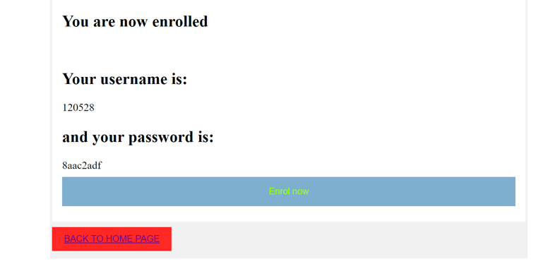
Figure 6. Enrollment,(source: author)

Before the student is allowed to access to his area, he has to be authorised from the admin, that has to review all his data and then approve him in the login table in the column Approved, replacing 0 with 1:

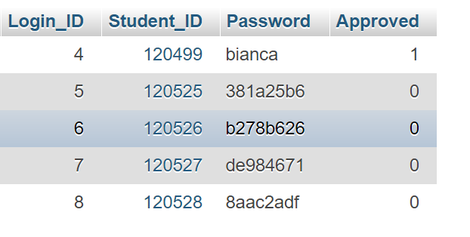
Figure 7. Student Login Table, (source: author)

Through the login form, available in the Student Area for students and Lecturer Area for Lecturer, it is possible to have access to the dashboard. The user authentication process takes place by comparing the data entered with those in the database. So the form after being filled in, clicking on the login button, the data is redirected to another page where PHP performs the necessary checks to be able to redirect the user. If the checks are successful, the user has access to the Student board if he is a student, or to the Lecturer board if he is a lecturer.

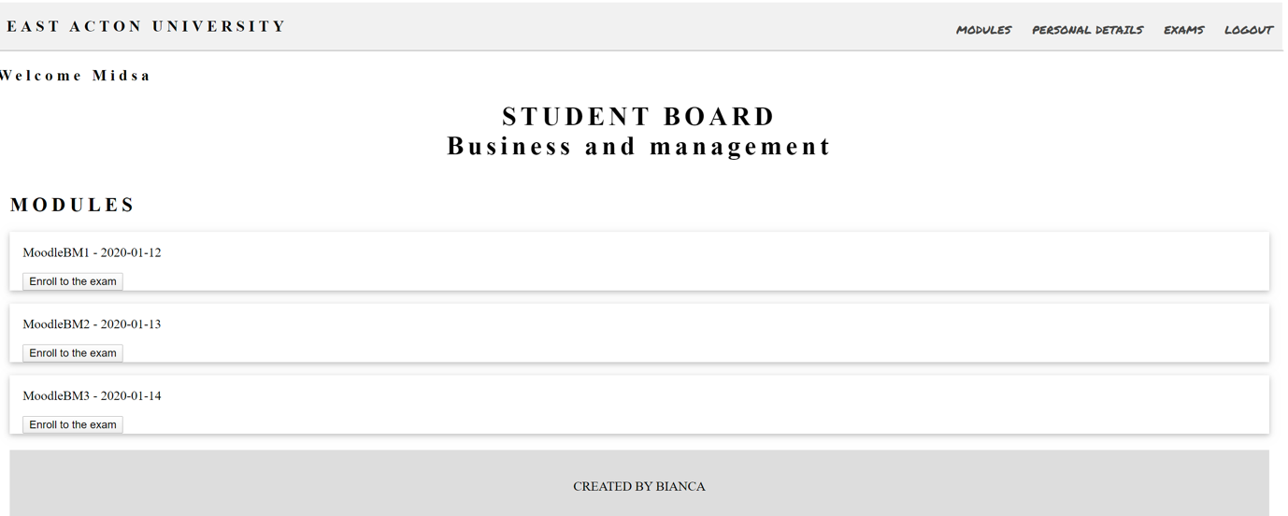
Figure 8. Student Board,(source: author)

The student board is designed to recognise and welcome the student by his first name; the php code, indeed, from the Student ID, associated to the Start Session ,goes up through an SQL query, to his first name and the enrolled course. In the same way in the section modules are updated all his module and he can also enrol to the correspondent exam through the Enroll the exam button. This function transmits to the page exam-enroll.php where a PHP function checks how many attempts the student did for that exam, because if he already failed two times he is not able to enrol anymore, so basically PHP compares the new input with the value in the Session table:

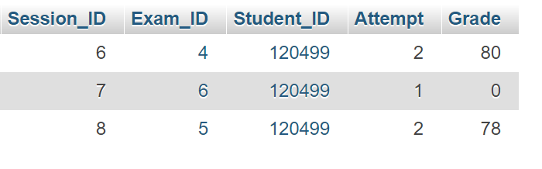
Figure 9. Session Table,(source: author)
This student is allow to enrol only one more time to the exam to the MooduleBM3.
From the Student Board the student can also have access to his Personal Details and check his Exam grade:

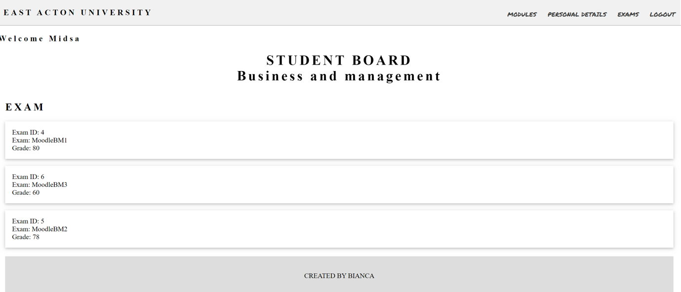
Figure 10. Student Board Exam Section,(source: author)

Clicking on Logout the student is redirected to the Home Page and the session, previously opened, is destroyed.
The Administrator can have access to his Login page inserting admin.php page in the browser address bar. The authentication process is the same already explained before.
The Admin Board is designed with the same function to recognise and welcome the Admin using his first name and it is organised in two different areas.

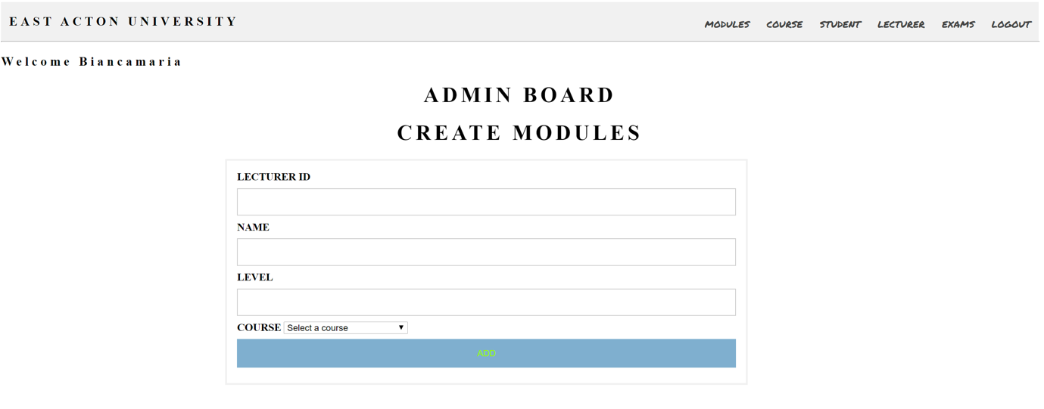
Figure 11. Admin Board-Create Modules,(source: author)

The first part is the Create Modules Section, where the Admin can create new modules for the different courses. The Add button redirect to create_module.php page, where PHP checks all the values and update them in the database in the Modules Table.
The second part is the Modules Edit-Delete Section where the Admin can edit or delete modules.

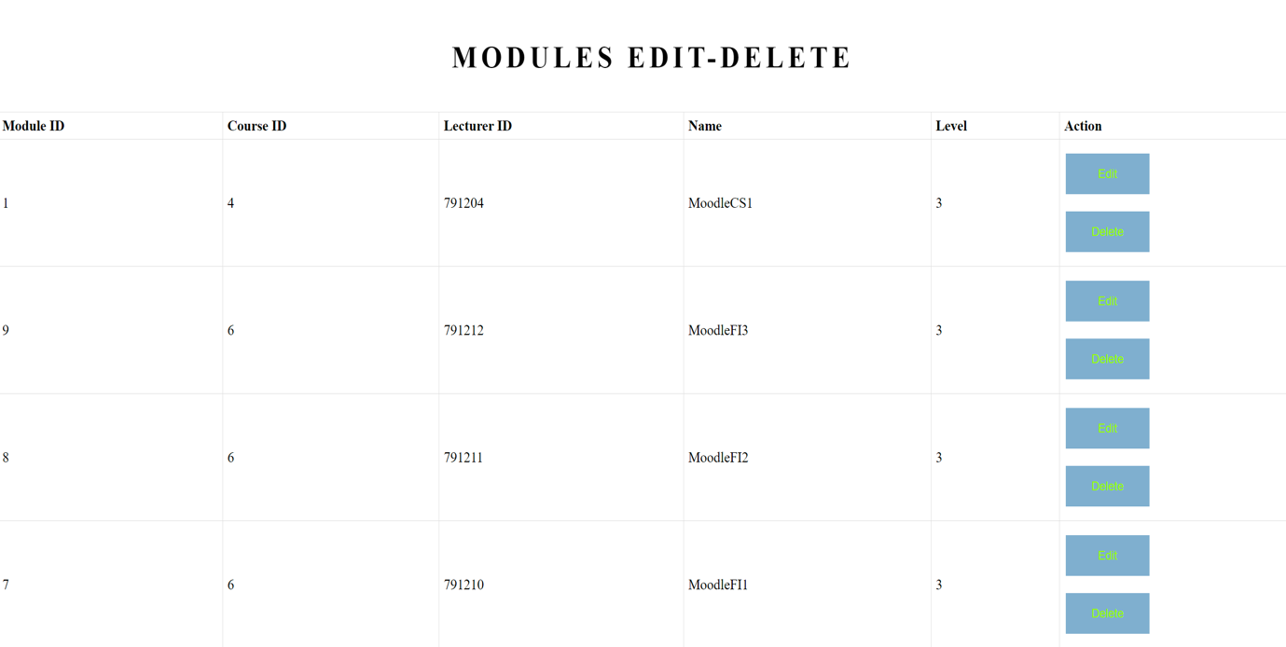
Figure 12. Admin Board- Module Edit-Delete Section,(source: author)

Both processes redirect to the process_module.php page that checks if the action parameter is edit or delete. If the parameter is Edit, a form is printed with the module data to be modified. This form is connected through the edit button to the edit_process.php page that contains the query to update the database. If the action parameter is Delete, it directly executes the query to delete the report from the database.
The add, edit and delete function has been performed only for the module section, for a lack of available time, but it could be implemented in the same way for Course, Student, Lecturer and Exams Sections.

TESTING SECTION

TEST PLAN
CASE N. | ACTION | INPUT | EXPECTED OUTPUT | TEST RESULT | SCREENSHOT
#1 | LOGIN:  correct Student ID and Password | Student ID:  120499  Password:  bianca | Login into the Student Board | Pass | Appendix 1.
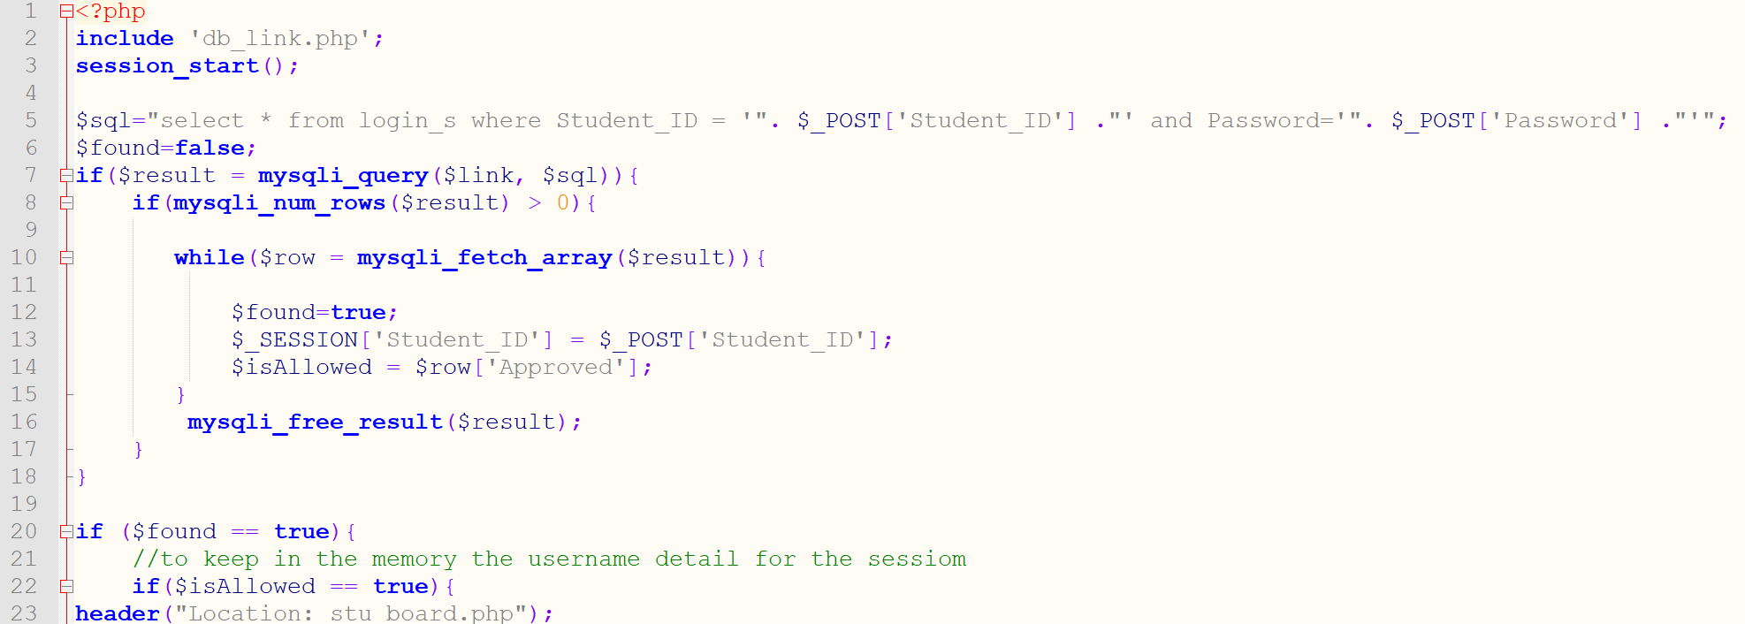
CODE EXPLANATION |  | Line number 5 has the SQL query to check if there is a correspondence between the value inserted to the user and the value inside the student login table. If the result is found true(lines 12 and 13)and above all, if the student has been approved by the Admin(line 14), the login is successful and there is the redirect at line 23 to the Student Board.
CASE N. | ACTION | INPUT | EXPECTED OUTPUT | TEST RESULT | SCREENSHOT
#2 | EARLY LOGIN:  correct Student ID and Password | Student ID:  120525  Password:  381a25b6 | Redirect to Login Page | Pass | Appendix 2.
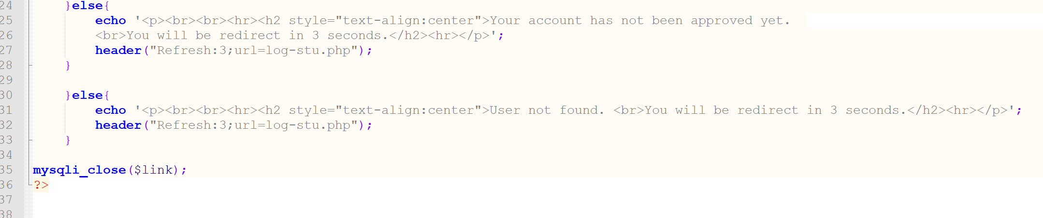
CODE EXPLANATION |  | In this case the student has not been approved yet to the admin so the code does all the check controls of previous case but it found the result false because of the Approved row, so redirect the student to the login page after an explanation message has been displayed.
CASE N. | ACTION | INPUT | EXPECTED OUTPUT | TEST RESULT | SCREENSHOT
#3 | ENROLLMENT:  mail already in the Database | USER DATA  MAIL:  patty@gmail.com | Error Message | Pass | Appendix 3.
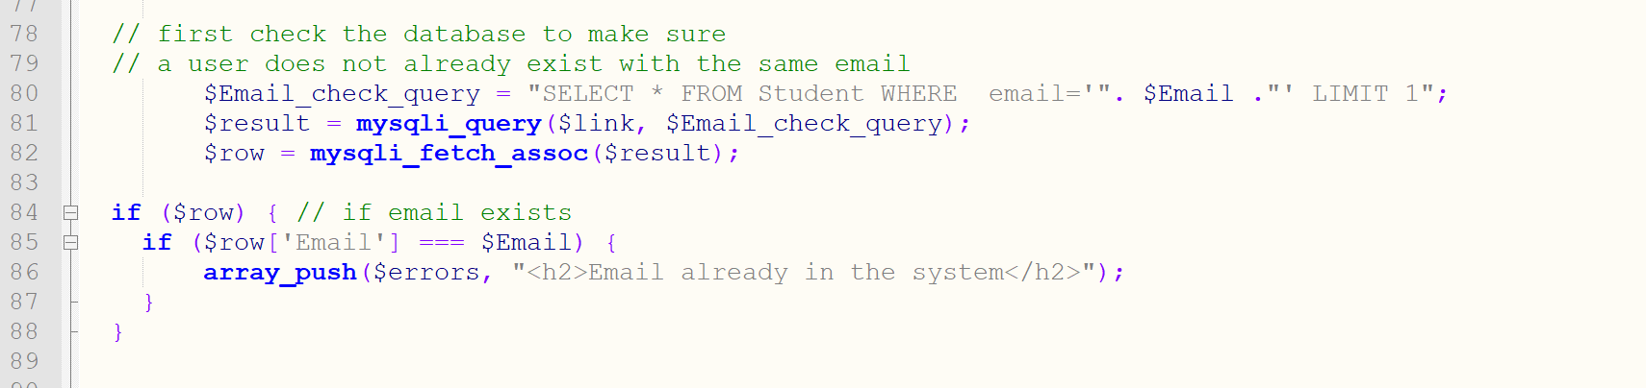
CODE EXPLANATION |  | In this case the check result find in the line 85 that the email inserted is already in the database so an error message is printed following line 86.
CASE N. | ACTION | INPUT | EXPECTED OUTPUT | TEST RESULT | SCREENSHOT
#4 | ENROLLMENT:  wrong dob | USER DATA  DOB:12/04/18 | Error Message | Pass | Appendix 4.
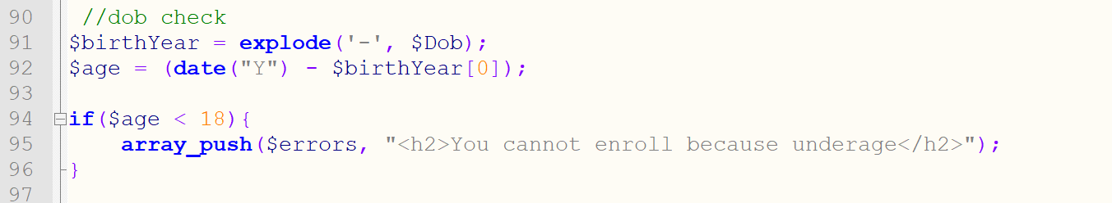
CODE EXPLANATION |  | In this case PHP execute a check on the user age based on the value insert in the Enrollment form. In line 91 the Explode function split the dob string in smallest parts so it is possible to isolate the Year value. In line 92 the age is calculate comparing the Current Year with the data function and the year inserted by the user. In our case the age value is < of 18 so the error is displayed following the line 95.
CASE N. | ACTION | INPUT | EXPECTED OUTPUT | TEST RESULT | SCREENSHOT
#5 | EXAM ENROLLMENT AFTER SECOND APTEMPT | Student ID:  120499  Password:  bianca  Exam:MoodleBM1 | Error Message | Pass | Appendix 5.
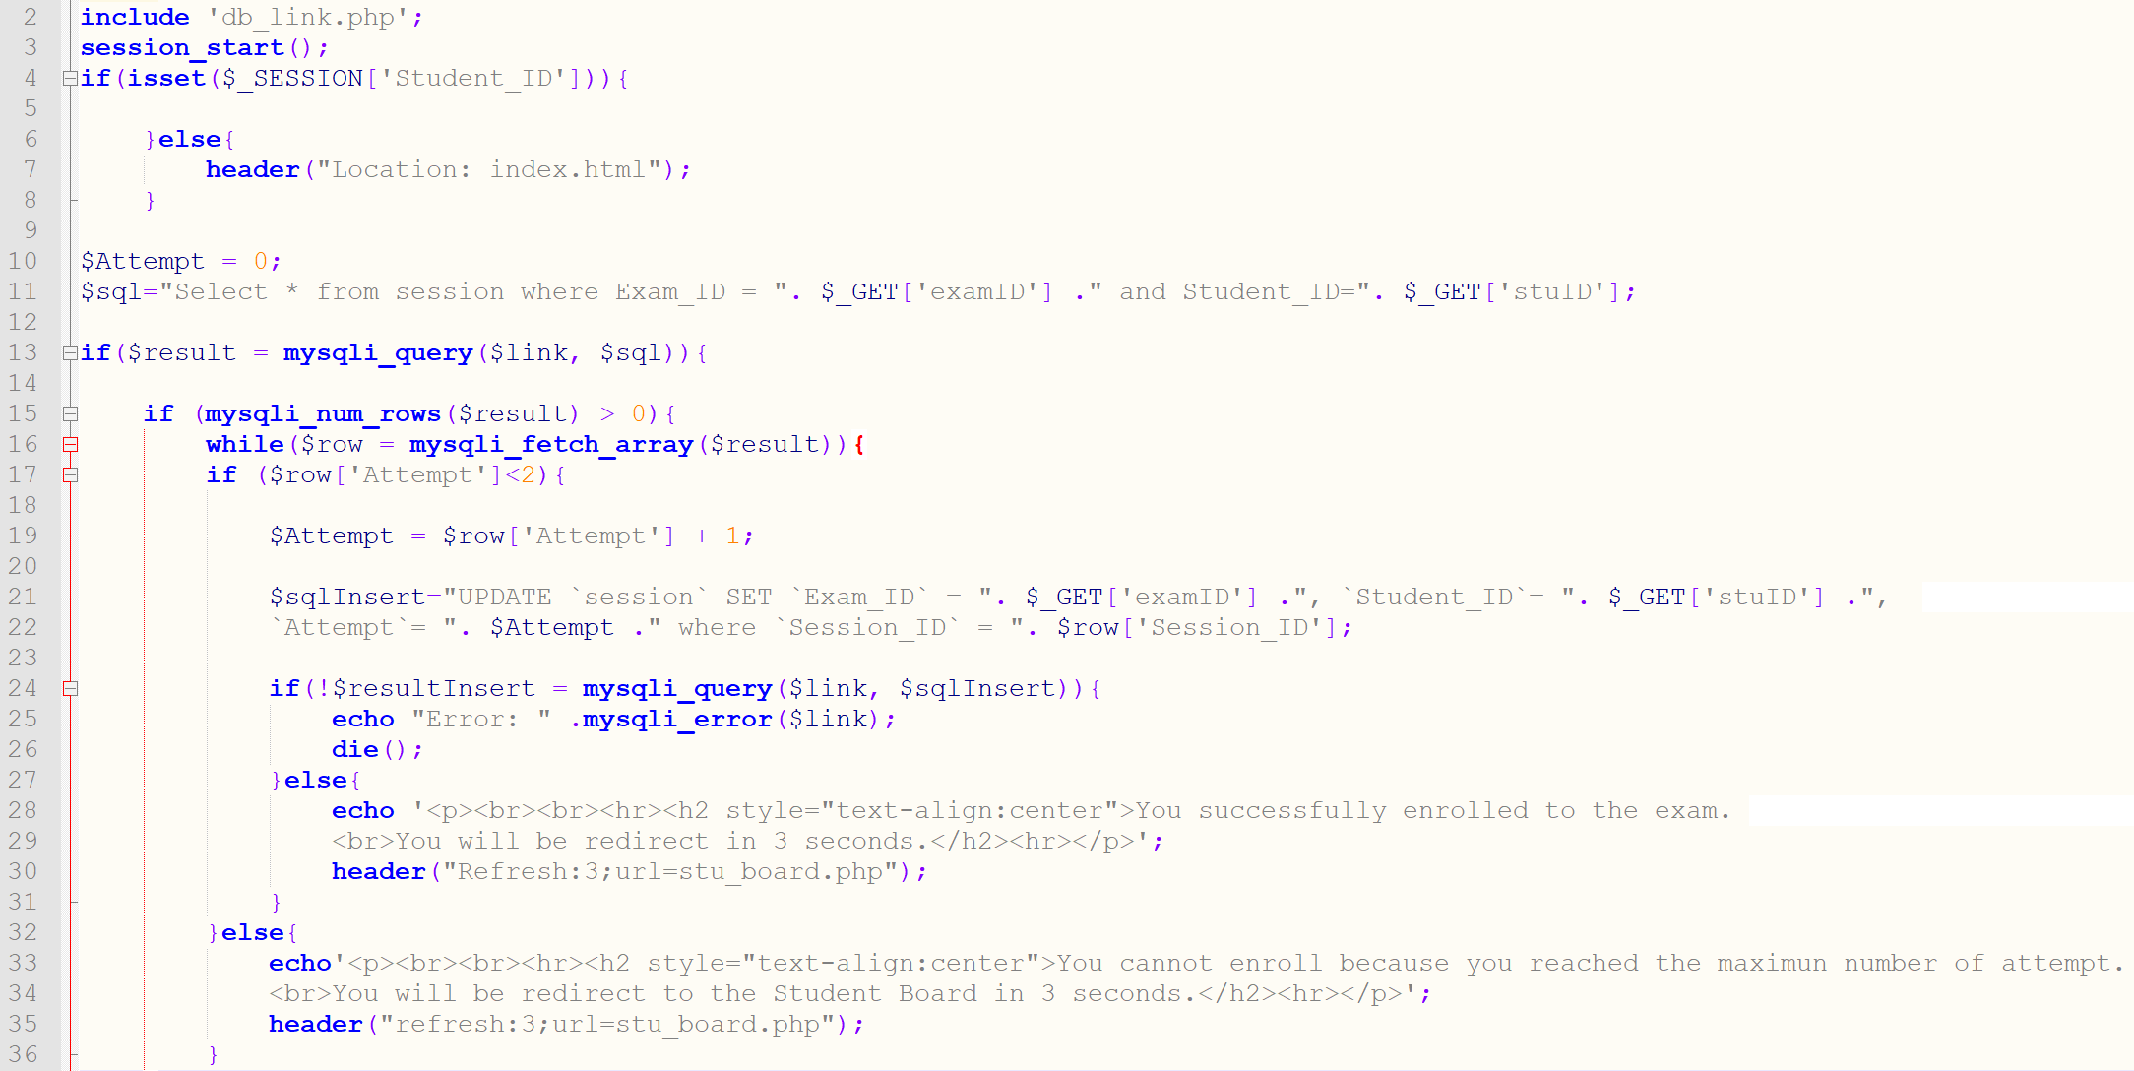
CODE EXPLANATION |  | In line 17 there is the check for the number of attempts, if the number is less than 2, PHP execute from line 19, where there is also the auto increment, until line 31. If the statement is found false, as in our case, PHP execute from line 32 to 35.

EVALUATION SECTION

The Website has been developed on the main functionalities requested from the assignment and it could be initially adapted to a small University reality. All the functions have been designed considering Security features as well. Indeed, PHP Session has been used for the sessions management, in those pages where has been necessary to remember the user's login data, since HTTP is stateless: it is not able to keep track of any choices or particular data transmitted between client and server. This mechanism is also useful to protect access to restricted areas by trying to circumvent the login form, by entering the address directly in the browser's address bar. Another type of system that has been used to implement site security is the .HTACCESS file that avoids the display of the site structure by the browser and limits access to certain types of files. The site could be further implemented by adding the add, edit and delete functions to the other sections of the area dedicated to admin activities. In fact, now all these functions are performed manually from the admin by accessing to the database. The database could also be implemented by encrypting the password.

REFERENCE

DifferenceBetween.net,2020, Difference Between Frontend and Backend, Available at. http://www.differencebetween.net/technology/difference-between-frontend-and-backend/
(Accessed 03/01/2020)

Morris, S.M.(2019), FULL STACK, FRONT END, BACK END—WHAT DOES IT ALL MEAN?, Slillcrush blog Available at https://skillcrush.com/2017/02/27/front-end-back-end-full-stack/ (Accessed 03/01/2020)

CodersEye,(2018), 11 Best PHP Frameworks for Modern Web Developers in 2020, Available at https://coderseye.com/best-php-frameworks-for-web-developers/ (Accessed 05/01/2020)

Sagar, S.B.(2019), Best PHP Frameworks for Web Development, Available at https://hackr.io/blog/best-php-frameworks (Accessed 03/01/2020)

Google trends,(2020), Compare, Available at https://trends.google.com/trends/explore?q=laravel,Symfony,%2Fm%2F02qgdkj,CakePHP,Zend(Accessed 14/01/2020)

w3schools.com,(2019), Html Tutorial, Available at https://www.w3schools.com/html/default.asp (Accessed 03/11/2019)

w3schools.com,(2019), Css Tutorial, Available at https://www.w3schools.com/css/default.asp (Accessed 10/11/2019)

w3schools.com,(2019), Php Tutorial, Available at https://www.w3schools.com/php/default.asp (Accessed 15/11/2019)

Stackoverflow,(2020), Explode to array and print each element as list item, Available at https://stackoverflow.com/questions/16257063/explode-to-array-and-print-each-element-as-list-item/16257088 (Accessed 03/01/2020)

Php,(2020),Session start, Available at https://www.php.net/manual/en/function.session-start.php (Accessed 05/01/2020)

APPENDIX

1.
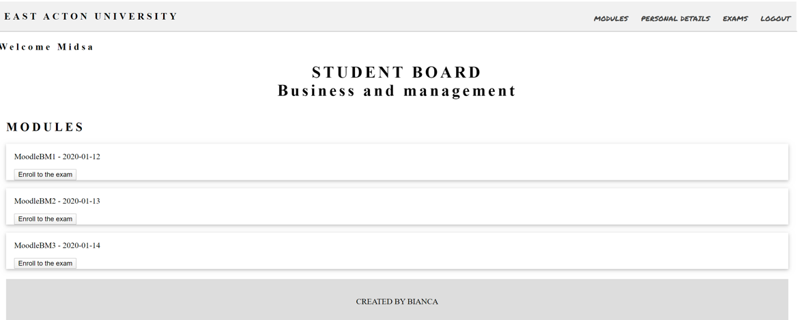

2.
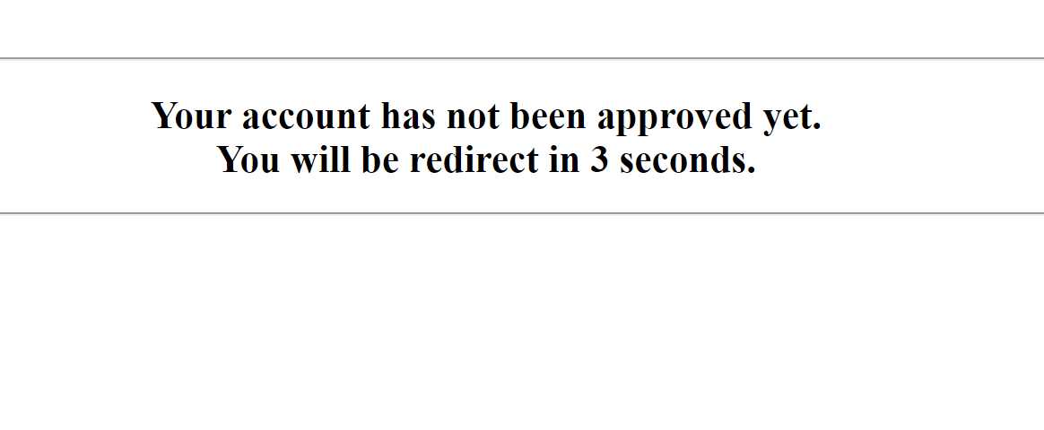

3.
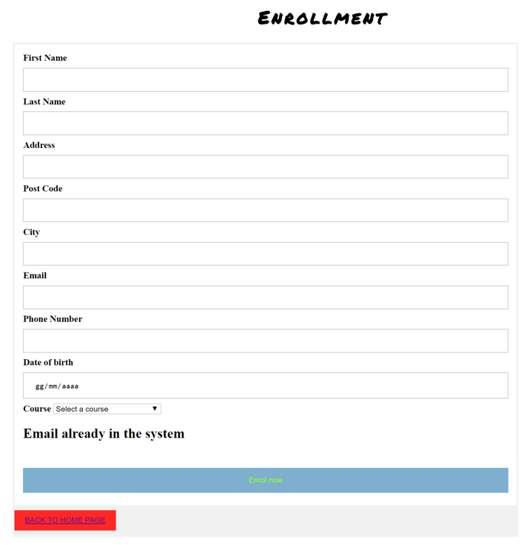

4.
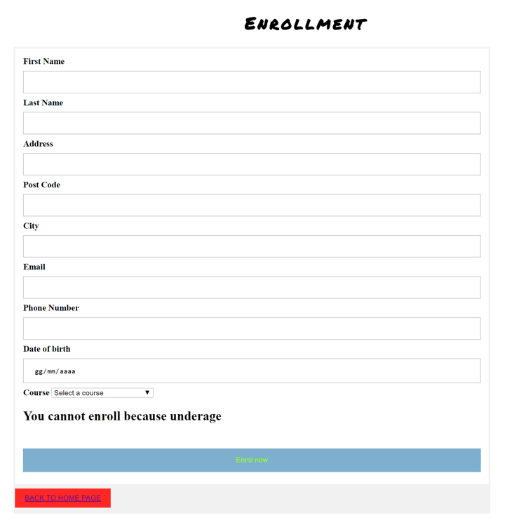

5.


