Student name – Jannat dad
Student number – 2309162
Module name – changemakers: creativity and value creation
Module code – BMPH 5014
Lecturer name- zahra ahmed

Task 1 – Concept Map
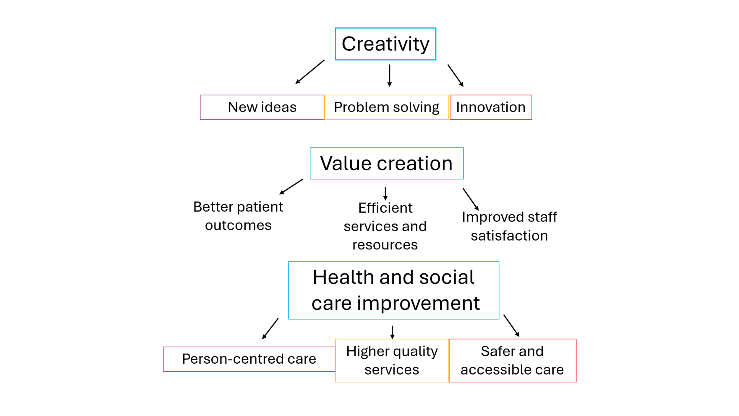
In health and social care settings, innovation, value generation, and improvement are strongly related. Being creative means coming up with fresh concepts, methods, and answers to problems that patients, service providers, and healthcare professional’s encounter. Using digital technology, creating patient-centered care plans, or creating cutting-edge communication strategies to assist people with complicated needs are some examples of creative approaches in health and social care. People use creativity to create new technology, compose stories, design structures, create medical cures, and enhance their quality of life.
By assisting people in adjusting to shifting conditions and resolving difficult problems, it promotes creativity and advancement in society. People use creativity to create new technology, compose stories, design structures, create medical cures, and enhance their quality of life. By assisting people in adjusting to shifting conditions and resolving difficult problems, it promotes creativity and advancement in society. The effectiveness and Caliber of services, creative thinking helps create value. Organizations can decrease waiting times, enhance patient experiences, and maximize resource utilization by implementing new practices. When healthcare services improve patient outcomes while simultaneously promoting employee well-being and organizational performance, value is created. Improvements in the health and social care systems follow from the development of value. Better services are more sensitive to the requirements of various groups, safer, and easier to obtain. For example, telemedicine services can improve rural communities' access to care while lowering hospital expenses and strain. These ideas are always interacting. Innovation is fueled by creativity, value is produced by innovation, and value promotes sustained progress. Better services, in turn, foster more innovation by encouraging healthcare workers to learn, work together, and engage in reflective practice. This cycle enables health and social care organizations to provide high-quality, person-centered care while adapting to changing patient demands.

Task 2 - Self-Reflection of Group Activity
Gibbs' Reflective Cycle (1988) provides a structured way to think about experiences by exploring six stages: description, feelings, evaluation, analysis, conclusion, and an action plan. Using this model helped me reflect more deeply on the convergent and divergent paperclip thinking activity.
Throughout the exercise, our group was instructed to come up with as many applications for a paperclip as they could (divergent thinking), then assess and choose the most useful concepts (convergent thinking). At first, I enjoyed the divergent stage since it promoted innovation and gave everyone the freedom to contribute without fear of repercussions. Our group came up with a variety of ideas, ranging from practical applications like holding papers together to more out-of-the-ordinary ones like making tiny tools or creative designs.
During brainstorming, I felt confident and involved because the process fostered an open atmosphere where many viewpoints were respected. I did observe, though, that certain members made more frequent contributions than others. Our group had to evaluate the concepts and choose which were the most practical and practical throughout the convergence stage. We had to establish a consensus and defend our decisions, which called for critical thinking and excellent communication. I made different shapes out of the paperclips such as hearts, a plus sign, equal sign, chains, and necklaces
The exercise made clear how crucial it is to strike a balance between evaluation and inventiveness. I discovered that while convergent thinking assists in identifying the most workable solutions, divergent thinking fosters creativity by producing a variety of options. I'll make sure everyone has a chance to contribute and encourage more reserved group members to voice their opinions in next assignments. This will enhance teamwork and produce more varied results. The exercise improved my comprehension of creative problem-solving and showed how many ways of thinking may cooperate to facilitate sound decision-making.

Task 3 - Case Study of a UK innovation
The NHS Virtual Wards program is a cutting-edge healthcare project that uses digital technology, interdisciplinary clinical support, and remote monitoring to give patients hospital-level care in the comfort of their own homes. Virtual wards, which were introduced to alleviate the growing strain on hospital capacity and provide patient-centered care, show how innovation can revolutionise healthcare delivery.
the conventional wisdom that acute care must be provided in hospital settings, creativity was crucial to the creation of virtual wards. By integrating wearable monitoring devices, video consultations, home visits, and digital health technology into a single integrated care model, NHS executives and healthcare professionals used a creative approach to service redesign. Redesigning clinical workflows, communication systems, and patient monitoring procedures required creative thinking and marked a substantial departure from traditional healthcare methods.
Both divergent and convergent thinking can be seen in the initiative. While convergent thought was employed to assess and put into practice the best solutions, divergent thinking was clearly visible in the investigation of alternate methods of providing treatment outside of hospitals. The NHS innovatively used technology and current clinical experience to develop a flexible and scalable service instead of constructing new hospital facilities. Healthcare providers were able to meet rising demand while upholding safety and quality standards thanks to this strategy.
Patients have benefited greatly from the value provided. Virtual wards lessen the worry and disturbance that come with being admitted to the hospital by allowing patients to get care in familiar settings. Patients can continue to receive routine clinical monitoring while maintaining more independence and being near to family members. Additionally, the strategy has supported faster discharge, decreased the risk of hospital-acquired infections, and decreased needless hospital hospitalisations. These advantages lead to better patient outcomes and experiences.
Finally, the NHS Virtual Wards project serves as an example of how innovation may lead to significant improvements in the healthcare industry such as drive change within healthcare. The NHS has produced substantial benefits for patients and the healthcare system by reconsidering conventional care delivery models and incorporating technology into patient care, highlighting the significance of innovation in tackling contemporary healthcare issues.

Task 4 - Research Task
Mental health stigma remains a major issue in health and social care. Although awareness of mental health has improved, many people still face negative attitudes and discrimination because of their condition. This can prevent individuals from seeking help and accessing the support they need.
One study by Watson, Ottati and Corrigan (2003) explored why stigma towards people with mental illness continues to exist. The researchers found that society often holds negative stereotypes about people with mental health conditions, such as believing they are dangerous, unpredictable, or unable to contribute to society. These beliefs are often influenced by media portrayals and a lack of understanding about mental illness. As a result, individuals experiencing mental health problems may be treated unfairly or excluded from social opportunities. The study suggests that misinformation and fear are key reasons why mental health stigma remains a problem.
A second study by Corrigan, Druss and Perlick (2014) examined how stigma affects people's willingness to seek treatment. The researchers found that many individuals avoid asking for help because they fear being judged by others. Some people also develop self-stigma, meaning they begin to believe the negative stereotypes associated with mental illness. This can lower self-esteem and reduce confidence in seeking professional support. The study also highlighted structural stigma, where policies or systems unintentionally create barriers to accessing mental health services. These factors can discourage people from receiving timely treatment and support.
Overall, both studies show that mental health stigma is caused by negative social attitudes, misunderstanding, and fear of discrimination. These issues can prevent people from accessing healthcare services and achieving positive mental health outcomes. Reducing stigma through education, awareness campaigns, and supportive policies is essential to improving health and social care services for individuals experiencing mental illness.
These research collectively demonstrate that misconceptions, unfavourable perceptions, and fear of discrimination all contribute to mental health stigma. People may suffer in quiet instead of seeking assistance, which might have negative consequences. Health and social care agencies should keep encouraging mental health education, awareness, and candid discussions in order to lessen stigma. People's general quality of life can be enhanced by fostering an atmosphere that is more encouraging and welcoming.
.

Task 5 - Podcast
Record a two-minute Podcast introducing your idea for component 2 using https://www.rev.com/onlinevoicerecorder The MP3 audio must be downloaded and embedded as a file (see guidance video on how to do this here: https://www.youtube.com/watch?v=D21isId0agw) or an accessible OneDrive link if using a chromebook (make accessibility – anybody) before inserting into your portfolio. Check the accessibility of the link before submitting.
Please click above

Task 6 - NHS Leadership Framework Analysis
The NHS Leadership Framework was developed to help individuals at all levels of healthcare understand and improve their leadership skills. It recognises that leadership is not limited to senior managers; everyone working in the NHS can demonstrate leadership in their daily role. The framework focuses on behaviours that help create high-quality patient care and effective teamwork.
The framework is built around nine dimensions. These include demonstrating personal qualities, working with others, managing services, improving services, setting direction, creating a shared purpose, engaging the team, evaluating information, and developing capability. Together, these components encourage leaders to communicate effectively, build positive relationships, make informed decisions, and support continuous improvement.
A key aim of the framework is to ensure that leadership contributes to better outcomes for patients. It promotes collaboration, accountability, and innovation across healthcare settings. By encouraging staff to reflect on their practice and develop leadership skills, the framework helps create a culture where employees feel valued and motivated. Ultimately, the NHS Leadership Framework provides guidance for delivering safe, effective, and patient-centred care while supporting professional development and organisational success.
One important component of the NHS Leadership Framework is Improving Services. This involves looking for ways to make healthcare services more effective, efficient, and responsive to patient needs. A leader can use this component to encourage creativity by creating an environment where staff feel comfortable sharing ideas and suggesting improvements.
For example, a ward manager might hold regular team meetings where employees can discuss challenges and propose new solutions. Staff who work directly with patients often have valuable insights into how services can be improved. By listening to these ideas and involving staff in decision-making, leaders can promote innovation and teamwork.
Creative approaches may include introducing new technologies, redesigning care pathways, or developing more flexible ways of delivering services. When employees feel their contributions are valued, they are more likely to engage in problem-solving and continuous improvement. This can lead to better patient experiences, improved outcomes, and a more efficient healthcare service overall.

Task 7 - Self-Reflection Journal Entry
Throughout this module, I have developed a much deeper understanding of creativity and value creation within health and social care. At the beginning, I viewed creativity mainly as coming up with new ideas. However, I now understand that creativity is also about finding practical solutions to challenges, improving services, and enhancing the experiences of patients and service users.
Using Gibbs' Reflective Cycle has helped me think more deeply about my learning. Rather than simply describing what happened in class, I have learned to reflect on how I felt, what went well, what I could improve, and how I can apply these lessons in the future. This process has encouraged me to become more aware of my strengths and areas for development.
One of the most valuable lessons I learned was that creativity can be applied at all levels of health and social care, not just by senior leaders or managers. Small changes in communication, service delivery, or teamwork can make a significant difference to the quality of care provided. Learning about innovative NHS initiatives, such as virtual wards, showed me how creative thinking can improve patient outcomes while making services more efficient.
The module also helped me understand the importance of value creation. I now recognise that value is not only measured by financial outcomes but also by patient satisfaction, wellbeing, accessibility, and quality of care. Creating value means ensuring that services meet the needs of individuals in a safe, effective, and person-centred way.
This learning has informed my professional practice by encouraging me to be more open-minded, reflective, and proactive when solving problems. In the future, I will be more confident in sharing ideas, working collaboratively with colleagues, and looking for opportunities to improve services. Overall, this module has shown me that creativity and innovation are essential skills for delivering high-quality health and social care.

Reference List
NHS Leadership Academy (2013) Healthcare Leadership Model: The Nine Dimensions of Leadership Behaviour. Leeds: NHS Leadership Academy.
West, M., Eckert, R., Collins, B. and Chowla, R. (2017) Caring to Change: How Compassionate Leadership Can Stimulate Innovation in Health Care. London: The King's Fund.
Corrigan, P.W., Druss, B.G. and Perlick, D.A. (2014) ‘The Impact of Mental Illness Stigma on Seeking and Participating in Mental Health Care’, Psychological Science in the Public Interest, 15(2), pp. 37–70.
Watson, A.C., Ottati, V. and Corrigan, P.W. (2003) ‘From Whence Comes Mental Illness Stigma?’, International Journal of Social Psychiatry, 49(2), pp. 142–157.
NHS England (2024) Virtual Wards. Available at: https://www.england.nhs.uk/virtual-wards/ (Accessed: 2 June 2026).
NHS England (2023) Virtual Wards Operational Framework. Available at: https://www.england.nhs.uk/long-read/virtual-wards-operational-framework/ (Accessed: 2 June 2026).
Learning by Doing Gibbs, G. (1988). Learning by Doing: A Guide to Teaching and Learning Methods. Oxford: Oxford Polytechnic.

