Module Code: LCBB4002
Module Title: Community Engagement

Student’s ID:

Table of Contents
Introduction 3
Relationship of A Renewable Energy Certificate Program with The Stakeholders 4
Different Eras of The Renewable Energy Certificate Program 5
The Renewable Energy Certificate Program in 21st Century 5
The Renewable Energy Certificate Program in Modern Time 5
The Renewable Energy Certificate Program and Use of Social Media Platforms 6
Training and development for The Renewable Energy Certificate Program 7
Need of Forward-Looking Approach in Training 8
Conclusion 8
Recommendation 8
References 10

Introduction
Community engagement refers to any activity with the involvement of the community (Dostilio and Welch, 2019). Starting from a large corporate giant to a third sector organization, everyone does more or less community engagement program to increase the community’s involvement with the organization and work collaboratively for the betterment of society (Dostilio and Welch, 2019). As a prospective source of energy and certification, the renewable energy certificate program is mostly connected with the community along with its different stakeholders. These programs have numerous benefits that the community can avail for the betterment of society. So, his report is prepared to analyse the best practices of community engagement in the transition renewable energy certificate program. To do such, the author first described its relationship with the different stakeholders and interaction. Then the Author discussed different eras of this certificate program. Later on, the author showed how this program reached the prospective audience through using various social media platforms. In the end, the author described various training and development program required for the certification and some recommendations that this program can incorporate to make the service available to the community.

Relationship of A Renewable Energy Certificate Program with The Stakeholders
A renewable energy certificate program is a series of courses in the field of science and policy that are created based on various renewable energy technologies and policies (Energy UK, 2021). These programs are arranged to provide technical skills, project development and management skills that would be useful in participants carrier. These courses may have a various subset that enables the student to pursue a carrier in a diversified field like industry, technology, policymaking etc (Hitt, Miller and Colella, 2018). These programs have various kinds of stakeholders who help to conduct the certificate program and take over various roles in the energy projects. Relationship with the stakeholders also helps to conduct project and raise the use of renewable energy. So, the different types of relationships are:
1. Project developer: The project developer is the designer of the project. The rule of project developer in the renewable energy certificate program crucial because this person is behind the making of this program, designing how to offer the program to expected participants, securing sustainability and safety of the program and carry out the public consultation process (Kitisittichai and Aruninta, 2015).
2. Local community: Implementation of the program is much dependent on the local community as all kinds of participants, landowners, investors come from the community. Various project for the program is conducted with the help of the community.
3. Financiers: Financiers are people who provide finance for the projects and certificate program. Starting from acquainted people, financiers can be large banks or financial institutions which provide finance and invest in the projects (Marchenko, 2018).
4. Supply chain and support network: To conduct a program, there needs reliable renewable technologies, accessories, spare parts and equipment for the certificate program. These all things come from the specified supply chain and support network.
5. Legal or policy framework: Renewable energy programs are needed to be assisted legally and through policymaking (Pons-Seres de Brauwer and Cohen, 2020). This program needs assistance in the forms of benefits, subsidy, exemption, tax benefits etc. Supportive authority needs to support the programs through various means to make them competitive with fossil energies.

Different Eras of The Renewable Energy Certificate Program

The Renewable Energy Certificate Program in 21st Century
The concept of the renewable certificate program is relatively new. A decade ago, no one expected that renewable energy is going to be the global power source of energy in the next couple of years. From the mid-1990s, the use of renewable energy was started through contribution to the electricity plant in the UK (Destek and Aslan, 2020). Later on, other renewable successes like wind power, solar power, ocean power, hydroelectric, geothermal power are been included in the renewable energy source. Just in 1964, 88% of electricity generation is conducted from coal and oil for 11% (Energy UK, 2021). As there was high demand for energy and coal was not sufficient to meet the demand, renewable energy sources were the first target to be implemented to meet demand. The use of hydroelectric power station can be traced back to 1966 in Scotland (Marchenko, 2018). Later on, the use of energy was rising at a higher rate and fossils fuels were unable to supply the demand. There were also some raising concerns about the environmental impact of fossil fuels.

The Renewable Energy Certificate Program in Modern Time
At the end of the 20th century and the beginning of the 21st century, focus and consideration for renewable energy programs have been rising. Just in the period from 1990 to 2013, the share of renewables sources in electricity production has risen by around 13% (Pons-Seres de Brauwer and Cohen, 2020). It increased from 2% in 1990 to 14.9% in 2013 (Pons-Seres de Brauwer and Cohen, 2020). From the very beginning of the 21st century, renewables
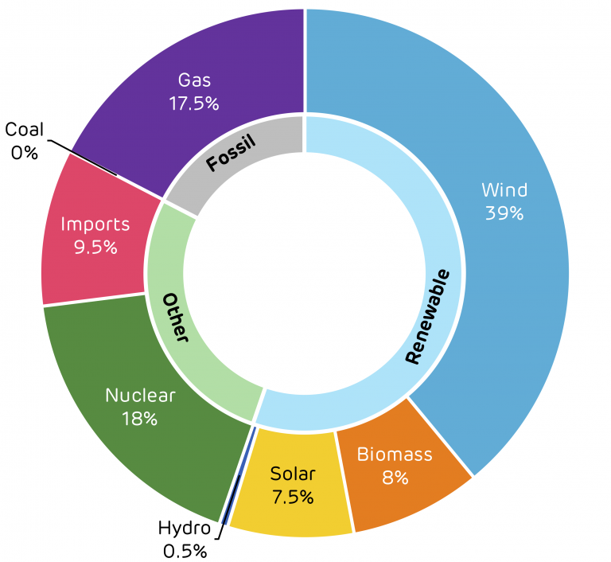
Figure: Use of energy in UK (Staffell, 2019)
obligations were initiated for the supplier to supply a specific portion of the total supply from renewable sources. It is started with a 3% requirement in 2002 and by 2016 the target ends with 15.4% (UK Renewable Energy Strategy, 2015). The UK has managed to produce 8.3% of the total energy sources from renewable energy by 2015 (UK Renewable Energy Strategy, 2015). Due to the increase in the use of low carbon energy, the UK's proportion of electricity generation from renewable sources grew to 33% by 2018 (UK Renewable Energy Strategy, 2015). Due to the awareness of the environmental impact of fossil fuels, energy generation from renewable success is now at an all-time high as 40.2% of total electricity production and 6% of total energy generation in the UK are from renewable sources as of December 2020 (Energy UK, 2021).

The Renewable Energy Certificate Program and Use of Social Media Platforms
With more than 3.5 billion active users across various platforms, social media is now a giant hub for people to share information, emotion, interaction (Environmentalleader.com, 2021). Users in these platforms are also increasing which making it a crucial place to conduct analysis, receive user reviews, get customer feedback and provide services. Besides conventional business plan, various campaigns and trends across this platform are being conducted to increase awareness and increase the use of certain products (Environmentalleader.com, 2021). In the case of renewable energy programs, social media can be used as an effective way to outreach a large audience in a short time. The program developers and renewable energy service providers can use social media platforms in the following ways:
1. Social media can be used as two-way traffic. It can be used to raise awareness about the environmental effect of fossil fuels and the importance of renewable energy. At the same time, it can be used to receive feedback and suggestions from people about program planning and campaigns (Environmentalleader.com, 2021). Also, renewable energy provider used these platforms to provide services to the customers and introduce innovative products.
2. This platform can be used as an effective way of making a connection to the community. The use of an informal tone of language will help to bridge the gap between the service provider and the audience (sdg.iisd.org, 2021). The use of hashtags on Facebook and Twitter make the communication process easier. Like, in 2017, international renewable energy agency Irena launched a social media campaign named #renewables4climate (sdg.iisd.org, 2021).
3. Combination of text, picture, videos make initiatives more understandable to the audience. It is very necessary to make the audience understand various environmental impacts and the prospect of renewable sources. So, the service provider oftentimes makes camping videos, graphical presentation to depict the importance of renewable energy sources.
4. Social media platforms are used as effective marketing tools by the producers and service conductor (Dostilio and Welch, 2019). It is now very easy to conduct promotional activities and offers about any product through this platform. This instant information sharing makes product introduction faster and instant feedback from the audience can also be used to modify the product as per demand.

Training and development for The Renewable Energy Certificate Program
The renewable energy certificate program is mostly connected with the community as its users, program developer, energy projects are conducted in the community (Dostilio and Welch, 2019). While conducting the programs, various socio-cultural issues may arise which needs to be handled effectively with using communication and leadership skills. To build these skills, organizations and service providers arrange various training and development programs which are discussed below.
Communication is a must for any role or responsibility. Most of the energy service program is related with the community and people. While developing a training program, the organizer should focus on increasing interpersonal and communication skills among the participants (Arepoconsult.com, 2021). These skills will help them to connect with the people, increase awareness about renewable energy sources and certificate programs, know their lacking and provide resources as per their need. After communication, the employees need to have proper managerial skills to manage the projects and certificate programs (Dostilio and Welch, 2019). Starting from the suppliers, various stakeholders need to be managed to effectively provide certificate and run any energy projects.
Technical skills are an important aspect of this program as most of its work and projects are related to technical activities. Proper technical know-how also helps to get employment as it is expected that by 2028, the jobs in this sector will grow by 63% (Altenergymag.com, 2021).

Need of Forward-Looking Approach in Training
In developing the training program, the organizers should follow a fast forward approach as the sector has high potentiality to grow and engage with the community (Marchenko, 2018). A fast forward approach will make the training sustainable that could be used in the upcoming booming market (Kitisittichai and Aruninta, 2015). When the market of renewable energy gets maturity, it might face new challenges from any sectors. These challenges may come before maturity like in growth or introduction period which can interrupt the process (Marchenko, 2018). So, keeping these challenges in consideration, the training and development program should be arranged in a fast forward manner that could deal with the new challenges and increase the markets here of renewable energy and its certificate programs.

Conclusion
Lastly, to get a larger market and audience, the certificate program should be arranged with the involvement of the community and exercise best practices. Keeping a good relationship with the stakeholders and making them aware of the program will increase its acceptability and usefulness (Marchenko, 2018). The organizers related to this program should use social media platforms to outreach to a large audience as these platforms are now turned into a hub for large active users (Environmentalleader.com, 2021). Using these platforms, the organizer would be able to reach that prospective audience very effectively and raise awareness about the environmental impact of non-sustainable energy sources. Training and development programs are very much needed to make sure effective skills are in place to conduct the certificate program and provide renewable technologies and services to the new users (Altenergymag.com, 2021).

Recommendation
The use of renewable energy sources and certificate programs are increasing day by day. Due to the awareness-raising program about the environmental impact of fossil fuels and the benefit of renewable energies, people are becoming more positive to use and implement renewable energy sources (Malamatenios, 2016). To grab these opportunities and increase energy market share, the service and certificate providers should incorporate the following recommendations.
The first things that need to be done are to make renewable energy sources available to the public. Mass use of non-sustainable energies happened due to the availability of its sources (Pineda and Bock, 2016). The same thing should be applied in renewable success to increase its usefulness.
Above all, price matters. The service providers should keep the low price for renewable energy products. Low prices will help to increase the need and demand of the market (Marchenko, 2018). The long-term goal of renewable energy can be gained by making it affordable.
Besides providing certificate programs, the program organizer should initiate a campaign or similar activities to raise awareness among the people about the climate effect and benefit of renewable energy. Before competing, a successful awareness program could help in the rapid growth of the sector along with a high demon in the market.

References
Altenergymag.com. 2021. Altenergymag.com. [online] Available at: <https://www.altenergymag.com/article/2020/08/what-training-do-you-need-to-work-in-renewables/33668> [Accessed 27 April 2021].
Arepoconsult.com. 2021. Arepoconsult.com. [online] Available at: <https://arepoconsult.com/wp-content/uploads/2019/11/2016_giz-thailand_community-based-renewable-energy.pdf> [Accessed 27 April 2021].
Buchanan, D. and Huczynski, A., 2019. Organizational behaviour. 10th ed. New York: Pearson Education Limited.
Destek, M. and Aslan, A., 2020. Disaggregated renewable energy consumption and environmental pollution nexus in G-7 countries. Renewable Energy, 151, pp.1298-1306.
Dostilio, L. and Welch, M., 2019. The Community Engagement Professional's Guidebook. Bloomfield: Campus Compact.
Energy-uk.org.uk. 2021. Energy UK. [online] Available at: <https://www.energy-uk.org.uk/energy-industry/renewable-generation.html#:~:text=Renewable%20technologies%20use%20natural%20energy,%2C%20hydro%2C%20biomass%20and%20solar.&text=Renewables%20produce%20more%20than%2020,increase%20to%2030%25%20by%202020.> [Accessed 27 April 2021].
Environment + Energy Leader. 2021. Environmentalleader.com. [online] Available at: <https://www.environmentalleader.com/2011/05/social-media-in-the-renewable-energy-world/> [Accessed 27 April 2021].
Hitt, M., Miller, C. and Colella, A., 2018. Organizational behaviour. Hoboken: Wiley.
Hub, I., 2021. IRENA Launches Social Media Campaign, Releases Report to Increase NDC Ambition on Renewable Energy | News | SDG Knowledge Hub | IISD. [online] Sdg.iisd.org. Available at: <http://sdg.iisd.org/news/irena-launches-social-media-campaign-releases-report-to-increase-ndc-ambition-on-renewable-energy/> [Accessed 27 April 2021].
Kitisittichai, P. and Aruninta, A., 2015. Best Management Practices for Sustainability in a Small-scale Community Renewable Energy: Sathya Sai School, Thailand. Applied Environmental Research, pp.93-105.
Malamatenios, C., 2016. Renewable energy sources: Jobs created, skills required (and identified gaps), education and training. Renewable Energy and Environmental Sustainability, 1, p.23.
Marchenko, O., 2018. Modeling of a green certificate market. Renewable Energy, 33(8), pp.1953-1958.
Pineda, S. and Bock, A., 2016. Renewable-based generation expansion under a green certificate market. Renewable Energy, 91, pp.53-63.
Pons-Seres de Brauwer, C. and Cohen, J., 2020. Analysing the potential of citizen-financed community renewable energy to drive Europe's low-carbon energy transition. Renewable and Sustainable Energy Reviews, 133, p.110300.
Renewable Energy Focus, 2015. UK launches Renewable Energy Strategy. 9(4), p.15.
Staffell, D., 2019. Britain’s power system has never been closer to being fossil-free - Drax. [online] Drax. Available at: <https://www.drax.com/energy-policy/britains-power-system-has-never-been-closer-to-being-fossil-free/> [Accessed 27 April 2021].
van der Schoor, T. and Scholtens, B., 2015. Power to the people: Local community initiatives and the transition to sustainable energy. Renewable and Sustainable Energy Reviews, 43, pp.666-675.

