Student Name: Mirela Florentina Anghel
Student Number: 2506357
Module Code: LCLM4005
Module Title: Employability and Career Development
Lecturer Name: Essa Bah
Assignment Title: Portfolio of Written Tasks

Table of Contents

1. Task A – Compare Two Job Adverts and Identify Key Skills……. p. 3-4
2. Task B – Self Assessment and Evidence or Readiness…………. p. 4-8
- Self-Assessment
- SWOT Analysis
- Evidence of Readiness for Employability and Personal Advancement
3. Task C – Employment Goals and Personal Development Plan…p. 8-10
4. Reference List………………………………………………………. p. 11

Task A – Compare Two Job Adverts and Identify Key Skills
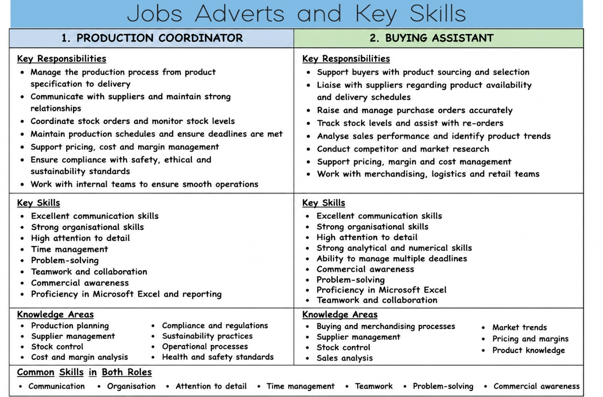
This assessment compares two job roles within the business and operations sector: Production Coordinator and Buying Assistant (see image above). Both roles require strong organisational abilities, effective communication, and excellent attention to detail. although the responsibilities differ slightly, there are several important similarities in the skills and knowledge required (CIPD, 2023).
The Production Coordinator role focuses mainly on managing the production process from product specification to delivery. Responsibilities include supplier communication, coordinating stock orders, maintaining production schedules, supporting pricing and cost management, and ensuring compliance with safety, ethical, and sustainability standards. This role requires understanding of production planning, supplier management, compliance, and sustainability practices.
The Buying Assistant role focuses more on supporting product sourcing, stock management, supplier communication, and sales analysis. Responsibilities include raising purchase orders, monitoring stock levels, tracking deliveries, supporting cost management, and assisting with market research. This role requires expertise of buying processes, supplier relationships, stock control, and commercial awareness.
After comparing both job adverts, several common skills can be identified. These include communication skills, organisation, time management, problem-solving, teamwork, commercial awareness, and attention to detail. Both roles require working with suppliers and internal departments, which makes communication a critical skill. Both roles also involve handling multiple tasks and deadlines, making organisation and time management essential (Indeed, 2024).
One key skill that stands out is communication. Communication is highly important in both roles because employees need to work with suppliers, managers, logistics teams, and other departments to ensure operations run smoothly. Poor communication can lead to delays, misunderstandings, and costly mistakes. Effective communication also improves collaboration and workplace productivity (Robbins and Judge, 2019).
In my future career, I believe communication will be one of the most important skills I will use. In a Production Coordinator role, effective communication will help me manage supplier relationships, solve problems quickly, and ensure all teams are aligned. My previous work experience at Kohler Mira LTD and Hotel Du Vin had already helped me develop strong communication skills through teamwork, problem-solving and supporting operational efficiency. I consider these experiences have prepared me well for future roles in production and operations.
Task B – Self Assessment and Evidence or Readiness
Self-assessment
Self-assessment is an important process for identifying strengths and areas for improvement in career development. It helps individuals understand their abilities, recognise development needs, and improve employability. A SWOT analysis is a useful tool for evaluating personal strengths, weaknesses, opportunities, and threats in relation to career goals (Helms and Nixon, 2010). This analysis focuses on my readiness for employment withing production, operations, and supply chain roles.

SWOT Analysis
Strengths | Weaknesses
• Strong work ethic and reliability developed through over 8 years of employment. | • Limited direct experience in production coordination and administrative roles.
• Excellent attention to detail gained through quality inspections, testing and assembly work at Kohler Mira Showers. | • Limited experience with production scheduling, supplier coordination and reporting systems.
• Strong communication and teamwork skills developed in both manufacturing and hospitality environments. | • Confidence can be lower when working in unfamiliar professional environments.
• Leadership and delegation experience gained as a Housekeeping Supervisor at Hotel du Vin. | • Advanced Microsoft Excel and reporting skills require further development.
• Adaptable and able to work effectively under pressure while meeting deadlines. | • I sometimes set very high expectations for myself, which can lead to taking on too much work independently.
• Committed to continuous learning through higher education and professional development.

Opportunities | Threats
• Current university studies provide opportunities to develop business knowledge and employability skills. | • Competitive job market with applicants who have more direct coordinator experience.
• Growing demand for Production Coordinators, Operations Coordinators and Supply Chain professionals. | • Rapid technological developments require continuous learning and upskilling.
• Training courses in Excel, business systems and supply chain management can improve career prospects. | • Economic uncertainty may reduce recruitment opportunities within some industries.
• Opportunities to progress into senior roles through professional development and experience. | • Increased use of digital systems means technical skills must continually be updated.

Strengths
One of my main strengths is my strong work ethic and reliability. Throughout my employment, I have consistently shown commitment and professionalism. In my current role as an Assembly Operator at Kohler Mira Showers, I work in a fast-paced manufacturing environment where accuracy and meeting deadline are essential.
Another strength is attention to detail. My role involves product assembly, testing, inspections, and quality checks. This has strengthened my ability to identify issues quickly and maintain high standards. Attention to detail is considered an essential employability skill, especially in operational and manufacturing environments where accuracy affects productivity and quality (CIPD, 2023).
Teamwork and communication are also key strengths. At Mira Showers, teamwork is essential to meet production targets. In my previous role as Housekeeping Supervisor at Hotel Du Vin, communication and coordination were important to ensure smooth daily operations. Effective teamwork is recognised as a critical skill in modern workplaces as it improves collaboration and performance (Robbins and Judge, 2019).
Adaptability is another strength. Working across manufacturing and hospitality has helped me become flexible and able to adjust to new environments and challenges. Adaptability is increasingly important in today’s fast-changing work environment (Indeed, 2024).
Weaknesses
One weakness is limited direct experience in production coordination and administrative roles. Although I have strong manufacturing experience, I have less experience with production scheduling, supplier coordination, and reporting system.
Another weakness is confidence in unfamiliar professional environments. While I work well in teams, I sometimes need more confidence in new situations.
My IT skills, especially advance Excel and reporting tools, also need improvements as there are increasingly important in operational roles. Continuous development of technical skills is important to remain competitive in today’s job market (Cottrell, 2019).
Additionally, I sometimes place very high expectations on myself and try to manage too many responsibilities independently. This can create unnecessary pressure and affect efficiency.

Opportunities
My university studies at the University of Wales Trinity Saint David provide a major opportunity for professional development. Studying Business Kills for the Workplace is helping me improve business knowledge, communication, and problem-solving skills.
There are also growing career opportunities in production, operations, and supply chain management. Training in Excel, administration, and business systems will further improve my employability. Career development opportunities such as education and professional training can improve long-term employability and progression (Hillage and Pollard, 1998).
Training and professional development opportunities are a significant advantage as well. By completing courses in Excel, administration, and supply chain processes, I can strengthen my employability and career prospects.
Threats
A major threat is the competitive job market, especially from candidates with more direct coordinator experience.
Another challenge is the rapid development of technology and business systems. Production and supply chain industries rely on software, automation, and data analysis. Continuous learning is therefore necessary to remain competitive.
Economic uncertainty may also affect recruitment and career progression opportunities.
Evidence of Readiness for Employability and Personal Advancement
Through the combination of practical work experience, academic learning, and ongoing personal development, I believe I have acquired the knowledge, skills, and attributes necessary to support my employability and future career progression.
My current role at Kohler Mira has given me valuable experience in manufacturing operations. I have developed skills in product assembly, quality control, process compliance, and meeting production targets. This experience had improved my attention to detail, problem-solving, and ability to work under pressure.
My previous role as Housekeeping Supervisor at Hotel du Vin gave me leadership experience. I was responsible for coordinating staff, delegating tasks, and ensuring deadlines were met. This strengthened my leadership, organisation, and communication skills.
My academic journey also shows readiness for employability. Returning to education while balancing work and personal responsibilities demonstrates commitment, discipline, and determination. Through my studies, I am developing valuable business knowledge and improving my communication and decision-making skills.
Employability is often defined as a combination of skills, knowledge, and personal qualities that enable individuals to gain and maintain employment (Yorke, 2006). Based on my experience, education, and willingness to learn, I believe I have developed strong foundations for career progression. I actively seek opportunities to develop new skills and expand my professional knowledge.
Overall, my work experience, academic development, and personal commitment to learning demonstrate that I am well prepared to progress into future roles within production and operations, and business-related environments.
Task C – Employment Goals and Personal Development Plan
Based on my SWOT analysis, I have identified short-term and long-term employment goals to support my career development. Setting clear goals is important because it provides direction, motivation, and a structured path for professional growth. (Locke and Latham, 2002).
Employment Goals
My short-term goal is to secure a role in production coordination, operations, or supply chain management. This will allow me to build on my manufacturing experience while gaining valuable exposure to planning, coordination, and business processes.
Another short-term goal is to improve my technical skills, particularly in Excel and reporting systems, as these are essential for career progression in operational roles. Developing technical and employability skills is important in today’s competitive job market (Cottrell, 2019).
My long-term goal is to progress into a senior role such as Senior Production Coordinator or Operation Manager. Within five years, I would like to develop strong expertise in production planning, supplier management, and business operations.
These goals are important because they align with my ambition for professional growth, increased responsibility, and long-term career success. Career planning helps individuals identify future opportunities and develop the skills needed to achieve professional goals (Hillage and Pollard, 1998).
Personal Development Plan
A personal development plan (PDP) is a useful tool for identifying development needs, setting goals, and monitoring progress over time (Megginson and Whitaker, 2007). Based on my weaknesses, I have created the following development plan:
Weakness | Action Plan | Timeline | Resources | Success Measure
Limited coordinator experience | Apply for coordinator roles | 6–12 months | CV, job applications | Secure interviews/employment
Limited Excel skills | Complete Excel training | 3–6 months | Online courses | Improved confidence
Confidence in new environments | Practice communication/interviews | Ongoing | Mock interviews, feedback | Increased confidence
- I recognise that roles such as Production Coordinator or Buying Assistant require exposure to planning, scheduling, and supplier management.
- Building confidence in unfamiliar environments is an important area of focus.
- I plan to complete an online Excel training course and regularly practise using spreadsheets for data analysis and reporting.
- I will continue practising interview techniques, improving communication skills, and challenging myself to step outside of my comfort zone whenever possible. This will support both my personal and professional growth.
Overall, this personal development plan provides a clear path for improving my weaknesses and building on my strengths. By focusing on continuous leaning and professional development, I will be better prepared to achieve my short-term and long-term career goals within production and operations management (CIPD, 2023).

Reference List
CIPD (2023) Employability and skills. London: Chartered Institute of Personnel and Development.
Cottrell, S. (2019) Skills for Success: Personal Development and Employability. 4th edn. London: Red Globe Press.
Helms, M.M. and Nixon, J. (2010) ‘Exploring SWOT analysis – where are we now?’, Journal of Strategy and Management, 3(3), pp. 215–251.
Hillage, J. and Pollard, E. (1998) Employability: Developing a Framework for Policy Analysis. London: Department for Education and Employment.
Indeed (2024) Top employability skills employers look for. Available at: https://uk.indeed.com (Accessed: 9 July 2026).
Locke, E.A. and Latham, G.P. (2002) ‘Building a practically useful theory of goal setting and task motivation: A 35-year odyssey’, American Psychologist, 57(9), pp. 705–717.
Megginson, D. and Whitaker, V. (2007) Continuing Professional Development. London: Chartered Institute of Personnel and Development.
Robbins, S.P. and Judge, T.A. (2019) Organizational Behavior. 18th edn. Harlow: Pearson.
Yorke, M. (2006) Employability in Higher Education: What it is – What it is not. York: Higher Education Academy.

