
Applying The Principles And Practices Of Data Security, Governance And Compliance Based On A Given Scenario
Gemma Dunlop (1801285)

January 8, 2022
University of wales trinity saint david
Software Engineering and Artificial Intelligence

Table of Contents
I. Introduction 2
II. A Comparison of ISO 27000, ITIL and COBIT 2
I. ISO/IEC 27000 2
I. Benefits 3
II. Disadvantages 4
II. ITIL 4
I. ITIL Versions 4
II. ITIL Management Practices 5
III. ITIL Certification Levels 6
IV. Benefits of ITIL 7
V. Comparison with ISO 7
VI. COBIT 8
I. COBIT Principles 8
II. Benefits 9
III. Disadvantages 10
IV. Comparison of COBIT with ITIL and ISO 10
III. Designing an approach to meet the need of the company CoffeeBlue 12
A. Compliance (Laws and Ethics) 12
I. COBIT and ISO 17799 12
B. Governance and Strategic Planning for Security 13
I. ISO 38500:2005 15
C. Strategic planning 16
I. ISO 9001:2015 16
D. Security Policies 17
I. ISO 27001 17
E. Risk Management 17
I. ISO 31000 17
II. COBIT 18
III. ITIL 19
F. Security Management Models and Practices 21
G. Contingencies Planning 21
I. ISO 22301 21
II. ITIL 23
H. Protection Mechanisms 23
I. Service Level Agreement 24
I. ITIL 4 24
References 26

Table of Figures
Figure 1: ISMS Family of Standards Relationships 3
Figure 2: Timeline of ITIL Versions [8] 5
Figure 3: ITIL V3 Processes [9] 5
Figure 4: ITIL 4 Practices [11] 6
Figure 5: ITIL 4 Certification Scheme [12] 7
Figure 6: Five Core Components of COBIT [15] 9
Figure 7: COBIT 5 Principles [16] 10
Figure 8: Graphical representation of the COBIT 5 maturity model [21] 14
Figure 9: 5 Focus Areas in IT Governance [23] 14
Figure 10: COBIT 5 Areas and Domains [25] 15
Figure 11: COBIT 5 Processes [26] 16
Figure 12: Six Principles for Good IT Governance in ISO 38500 [29] 17
Figure 13: Strategic Plan Process [31] 17
Figure 14: ISO Risk Management Framework, Principles and Process [33] 18
Figure 15: Two Perspectives on Risk [35] 19
Figure 16: A Simple Risk Management Process [37] 20
Figure 17: Risk Categorization Matrix [39] 20
Figure 18: ISO 22301 Business Continuity Management Lifecycle [45] 22
Figure 19: Enterprise Information Threats (REF) 23

INTRODUCTION
Governance frameworks assist organisations and businesses in implementing best practises in their respective sectors. They promote the adoption of proven techniques, aid in accordance with all relevant standards, and can help decrease risk and operational costs. ITIL (Information Technology Infrastructure Library), ISO 27001 (International Standards Organization), and COBIT (Control Objectives for Information and Related Technology) are the most broadly recognised and widely utilised governance frameworks worldwide. All three frameworks provide a combination of guidance, advice, and practical instruments. Each has its own focus, although they may be utilised in unison. However, for several reasons, each framework may not always be suitable with the architecture of all organisations. This report aims to critique, analyse, compare the three frameworks, and discusses why it is good practice to constantly have new or updated regulations and standards. Part 2 of this report uses the research gathered in part 1 to help design a security approach to meet the needs of a Caribbean coffee company named CoffeeBlue.

PART 1 – A COMPARISON OF ISO 27000, ITIL AND COBIT

ISO/IEC 27000
ISO/IEC 27000 is a family of standards published and developed by the International Organization for Standardization (ISO) and the International Electrotechnical Commission (IEC) [1] which aims to provide best practises for the implementing, maintaining, and managing the Information Security Management System (ISMS). The standards seek to create best practises in several elements of information security management, with a heavy emphasis on continual improvement and mitigation of risks.
The series is made up of 46 specific standards, including ISO 27000, which serves as an introduction to the family while also defining essential terms and concepts.
ISO 27001 is the mainstay of the series and lays out the requirements that can be used to audit an organization's ISMS (Information Security Management System) [2]. If a company wants to certify its Information Security Management System (ISMS), it must meet all the ISO 27001 standards. ISO 27001 helps enterprises to show that they satisfy information security regulatory standards and that the business is dedicated to protecting sensitive and confidential data.
ISO 27002 focuses on examples, principles, and a code of conduct for individuals within a company. It specifies a set of best practises for ISMS implementation via 114 controls organised into 14 domains and 35 control objectives. Since ISO 27002 isn't a management system standard, companies cannot get certified against it.
Figure 1 provides a short description of each of the main ISO standards, grouped into standard types.
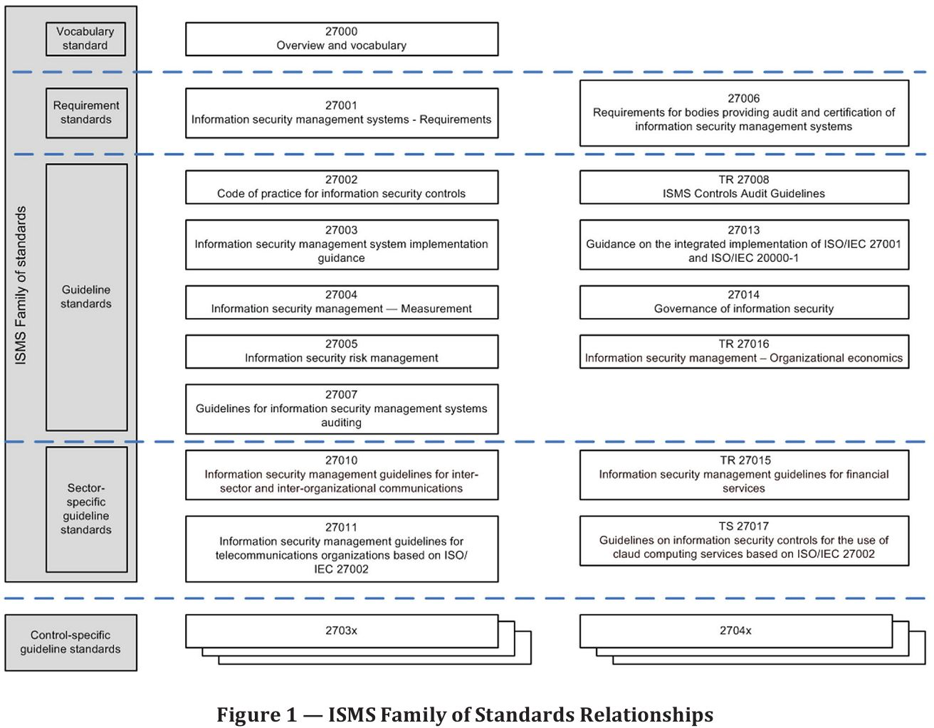[3]
Figure 1: ISMS Family of Standards Relationships

Advantages of ISO 27000

Helps prevent hefty fines and loss of reputation
The Information Commissioner's Office (ICO) in the United Kingdom can now issue fines of up to 4% of a company's annual revenue, or €20 million (whichever is larger), for the most serious data violations under the EU's General Data Protection Regulation (GDPR) [4].
The influence on the reputation of businesses that receive negative press due to penalties or even warning notices should be carefully considered as it will have a long-term detrimental impact on the profit margins of the company. ISO 27001 allows businesses to avoid the severe fines that come with non-compliance with data protection regulations, as well as the financial losses that come with data breaches.

Improved Processes and Strategies
ISO 27001 prioritises cyber strategy in its certification. Qualified auditors work to reduce security breaches by addressing business risks. They will establish data security responsibilities throughout the business's team by mapping out goals and objectives in an actionable method. The certification procedure will also assist businesses in developing documentation that can be used as a reference and updated over time.

Disadvantages of ISO 27000

Personal opposition
During the implementation and maintenance phases, some individuals may believe it is a waste of time and resources [5].

ITIL
ITIL is a governance framework which was developed in the 1980s by the CCTA (Central Computer and Telecommunications Agency) and has been owned by AXELOS, a partnership between Capita and the UK Cabinet Office, since 2013 [6]. It is a set of detailed processes and functions for selecting, planning, delivering, and maintaining IT as a service and improving IT service levels and support to meet business needs. One of ITIL's primary aims is to guarantee that IT services correspond with business objectives, even when those objectives change [7].

ITIL Versions
Figure 2 shows a timeline for each ITIL version.
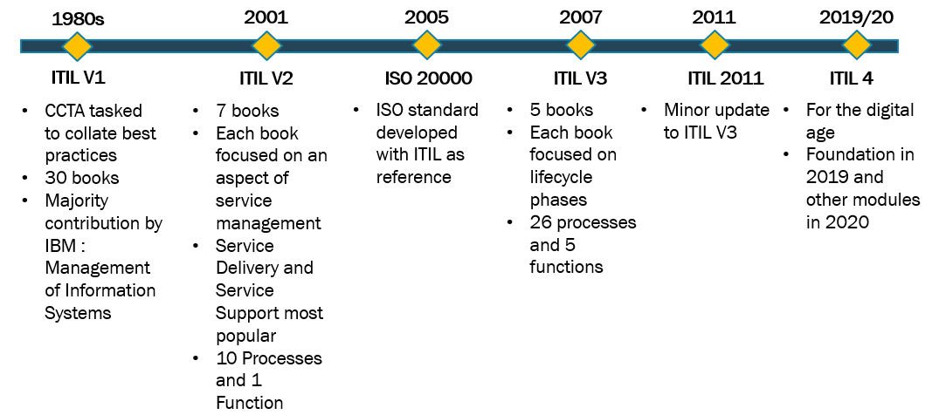
Figure 2: Timeline of ITIL Versions [8]

ITIL Management Practices
ITIL V3 is built around 26 processes which fall within five service lifecycle stages, shown in Figure 3, that describe the ITSM (IT service management) stage.
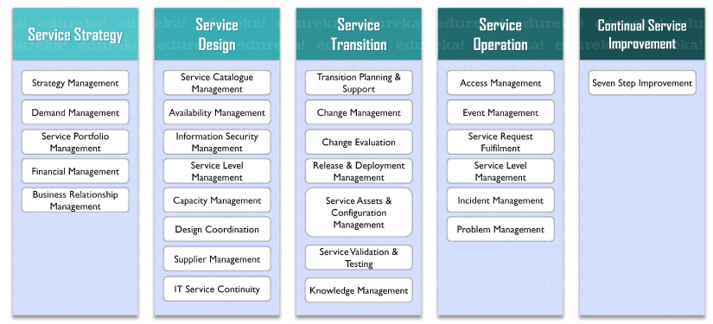
Figure 3: ITIL V3 Processes [9]
Each of the five stages is dedicated to a different aspect of the service lifecycle [10]:
- ITIL Service Strategy – comprehends company goals and customer requirements.
- ITIL Service Design – transforms the service strategy into a plan for achieving the company's goals.
- ITIL Service Transition – generates and enhances capabilities for bringing supported environments new services.
- ITIL Service Operation – is responsible for the management of services in supported environments.
- ITIL Continual Service Improvement – makes small-scale and large-scale improvements to services.
ITIL 4 on the other hand, is made up of 34 practices that relate to what you can do with the correct resources.
In contrast to ITIL v3 processes, which were solely focused on managing IT services, ITIL 4 management practises are broader in scope and incorporate data management, technology, and culture as well. The ITIL 4 practices were developed in response to the fact that today's enterprises are increasingly diversified and dynamic. ITIL 4 practices are:
- General management practices
- Service management practices
- Technical management practices
The table in Figure 4 highlights the ITIL 4 practices.
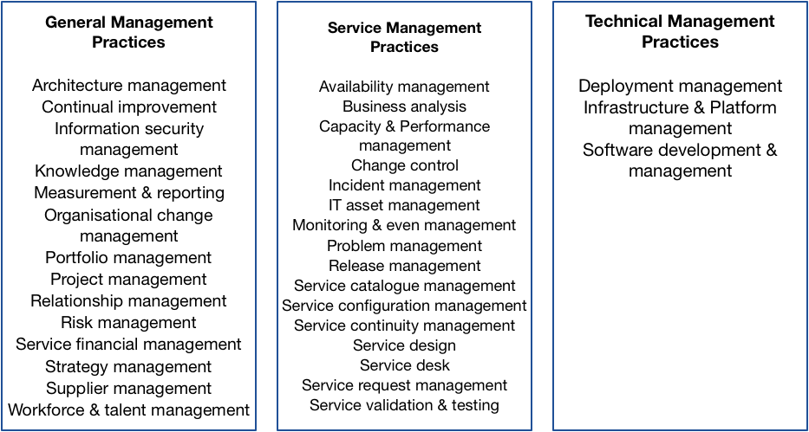
Figure 4: ITIL 4 Practices [11]

ITIL Certification Levels
ITIL certification usually consists of a set of qualifications designed to equip an individual with a grasp of various ITIL best practises to varying degrees of detail and depth of knowledge.
ITIL 4 has 4 certification levels.
- ITIL Foundation
- ITIL Managing Professional
- ITIL Strategic Leader
- ITIL Master
Information about the ITIL 4 certification scheme is shown in Figure 5.
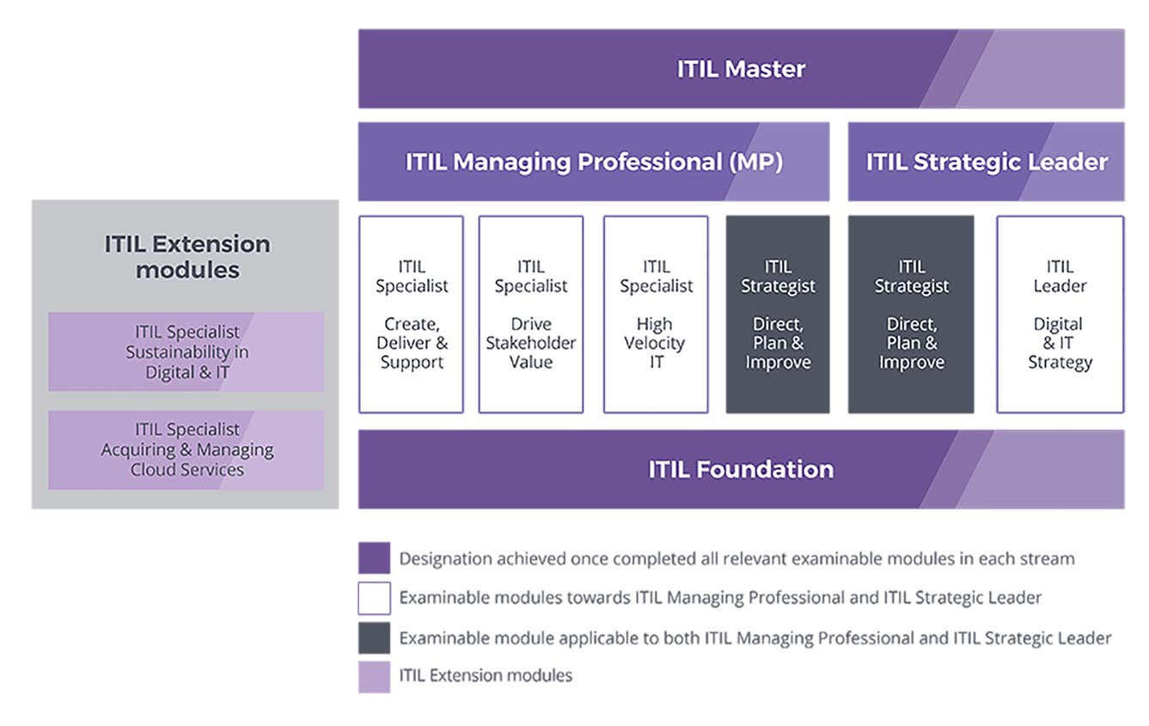
Figure 5: ITIL 4 Certification Scheme [12]

Advantages of ITIL

Service quality
ITIL offers protocols for managing business relationships and service levels, as well as the ability to effectively manage customer expectations by guaranteeing that IT services are highly accessible.

Stronger alignment between IT and the business.
ITIL brings together business and IT. Most of the time, IT is solely concerned with resolving technical difficulties, but with ITIL, this is no longer the case. ITIL guarantees that IT and business problems are intertwined, fostering greater communication and a deeper commitment to service.

COBIT
First released in 1996, COBIT is a governance framework developed by the ISACA (Information Systems Audit and Control Association & Foundation) to ensure risk management and regulatory compliance [13]. It aids businesses in developing, monitoring, and implementing information management and governance.
COBIT is an open system which provides inspectors, chiefs, and clients a wide variety of measures, markers, and best practises to assist them in utilising IT in the best way possible [14]. These are based on the idea that IT is essential for overseeing exchanges, data, and information to be beneficial. It provides top management with authoritative structures and procedures that ensure the organization's IT continues to broaden the organization's methodologies and goals.
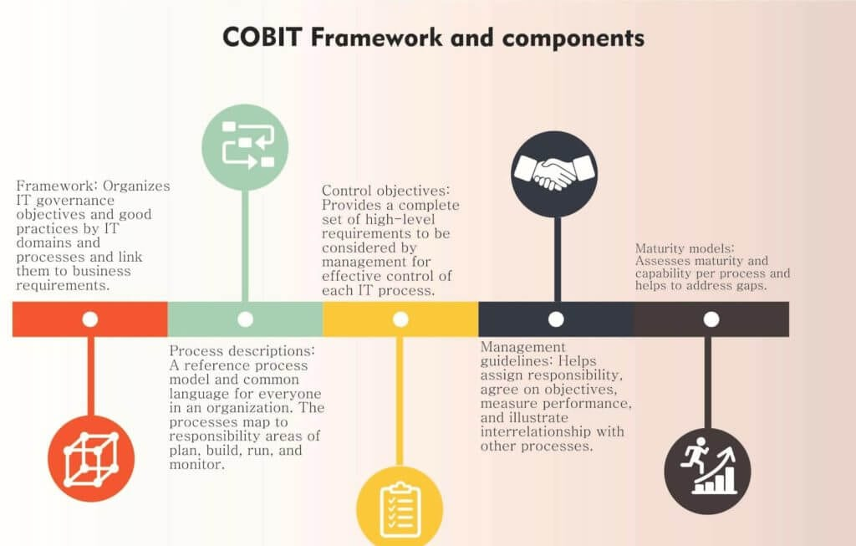
Figure 6: Five Core Components of COBIT [15]

COBIT Principles
COBIT is comprised of five basic principles that guide IT governance and management within a business. The principles are shown in Figure 6.
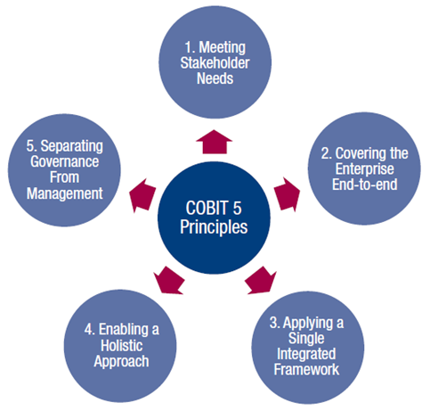
Figure 7: COBIT 5 Principles [16]
Organizations use seven enablers to support the five principles of COBIT, shown in Figure 7.
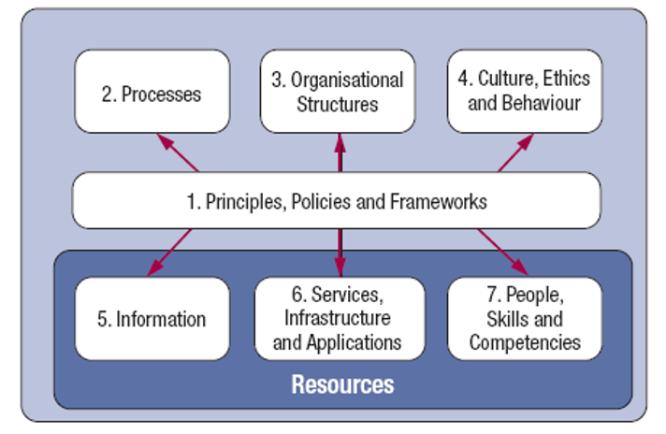
Figure 8: COBIT Seven Enablers [14]

Advantages of COBIT

Productivity and efficiency.
COBIT is built on universally recognised concepts for increasing IT efficiency and effectiveness [17]. This means the same tools and approaches may be used to process delivery and improve systems across sectors and organisations of all sizes. This enables an organisation to develop and diversify its services while remaining confident that the same COBIT tools and concepts will apply to its operations as it grows and expands.

IT is aligned with company goals.
COBIT is intended to guarantee that an organization's IT is in line with its business goals. Since this is not an easy procedure, COBIT 5 allows businesses to incorporate IT goals into wider business goals. COBIT practitioners' responsibility is to guarantee that IT investments support business goals by building controls and tools that IT management can readily utilise. They also assist organisations in filling gaps in the application of IT to meet business objectives. The most recent COBIT training is intended to prepare professionals to fulfil enterprise performance goals by maximising the value of information systems.

Disadvantages of COBIT
According to several experts [18], the main disadvantage of COBIT is that it takes a significant degree of expertise to comprehend its structure before it can be used as a tool to assist IT governance. According to the Global Status Report on the Governance of Enterprise It (Geit)—2011 [19], the use of COBIT has fallen from 14 percent in 2008 to 12.9 percent in 2010. This pattern supports the claim that COBIT is not as simple to implement as was previously assumed.

Comparison of COBIT, ITIL and ISO 27000
While the goal of ISO 20000 is to ensure that information technology services are provided at a specific level of service, continuity, quality, speed, and cost, COBIT prioritises the business requirements and nature of the organisation and prefers to shape IT needs appropriately. The ISO 20000 standards are based on industry best practises in IT. COBIT, on the other hand, explains how IT will be utilised to achieve business objectives. COBIT is often favoured by organisations that have moved all their processes to an IT environment and whose business operations rely on data security.
While ISO 27001 standards analyse the supporting principles, procedures, processes, improvements, and requirements required for effective and successful ISMS in depth across all topics, ITIL does not in such depth.
COBIT practices are often adopted with funds from the auditing budget, whereas ITIL and ISO 27001 practises are typically implemented with funds from the IT budget. As a result, management policy will often determine which standard will be prioritised.
ITIL practices are significantly easier to adopt than COBIT and ISO 27001 procedures because they may be implemented individually at various periods, whereas partial implementations of COBIT and ISO standards are complex.

Why It Is Good Practice to Constantly Have New or Updated Regulations and Standards.
Regulations are in place to assist businesses in improving their information security strategy by offering recommendations and best practises based on the industry and kind of data maintained. Non-compliance with these standards can result in significant fines or, worse, data breaches. If policies are not constantly updated, they may fail to comply with new laws and regulations.

DESIGNING AN APPROACH TO MEET THE NEEDS OF THE COMPANY COFFEEBLUE

Compliance (Laws and Ethics)
In terms of IT governance, CoffeeBlue must foster an ethical compliance culture in order to accomplish successful IT governance. This is beneficial for avoiding and identifying behaviour that may jeopardise IT governance objectives, especially the alignment of business and IT goals. As a result, this aspect is critical in reaching the CoffeeBlue’s capital goals of effective IT governance.
To achieve an effective compliance ethic or culture, CoffeeBlue must establish a code of conduct, adopt and implement (at least partially) a comprehensive compliance framework, provide adequate ethical training for employees, and provide a reporting mechanism.

COBIT and ISO 17799
COBIT 5 will enable CoffeeBlue to match many existing controls with other standards and regulatory compliance needs. Implementing COBIT with ISO 27001 will allow CoffeeBlue to meet the GDPR's and other data protection regimes' privacy and information security requirements, as well as demonstrate that organisation has management arrangements in place for "appropriate technical and organisational measures" to protect the personal data processed and uphold data subjects' rights, in accordance with the Regulation's accountability principle [20].
The use of COBIT 5 alongside ISO will help establish and measure IT control effectiveness.
COBIT 5 offers five maturity models to assist CoffeeBlue in determining where they are on the path to total compliance, shown in Figure 8.
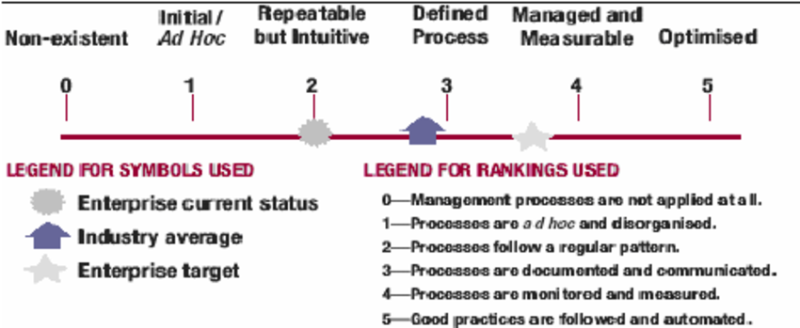
Figure 8: Graphical representation of the COBIT 5 maturity model [21]

IT Governance
IT governance is an essential component of a company's framework. This framework comprises of the leadership, organisational structures, and procedures that guarantee that CoffeeBlue's IT supports the company's business strategy and goals.
Failure to adopt IT Governance can result in the deployment of ineffective and inefficient technologies, increasing the risk of security and control over technology, lowering the integrity and dependability of information management and finance, and increasing the audit risks.
There are five key areas to look at when implementing IT governance [22], as shown in Figure 8.
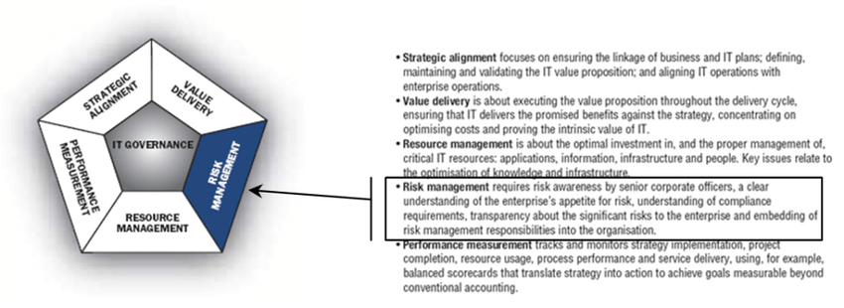
Figure 9: 5 Focus Areas in IT Governance [23]
The IT Governance focus areas are essential in addressing IT Governance management across CoffeeBlue. This is required by operational management in order to organise and modify ongoing procedures for the purpose of the company's IT continuity.

COBIT
COBIT has gained widespread recognition and acceptance as a tool for IT governance. The COBIT 5 Guide specifies common guidelines for each focus area.
COBIT 5 defines 37 processes that are organised into five areas. One domain for governance (EDM) and four domains for management (PBRM) [24].
- EDM (Evaluate, Direct, and Monitor) guarantees that stakeholder requirements are appraised by establishing and agreeing on objectives to be reached, which are directed by prioritising, and that performance against objectives is also reviewed.
- PBRM (Plan, Build, Run, and Monitor) guarantees that actions are monitored and confirmed to be aligned with those defined in the governance set.
The COBIT 5 structure for enterprise IT governance is depicted in the two figures below. Figure 10 depicts the general COBIT structure (five domains), and Figure 11 how the 37 processes are assigned to these domains.
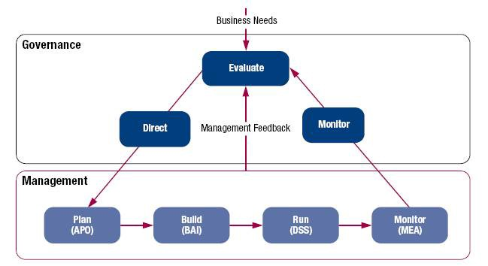
Figure 10: COBIT 5 Areas and Domains [25]

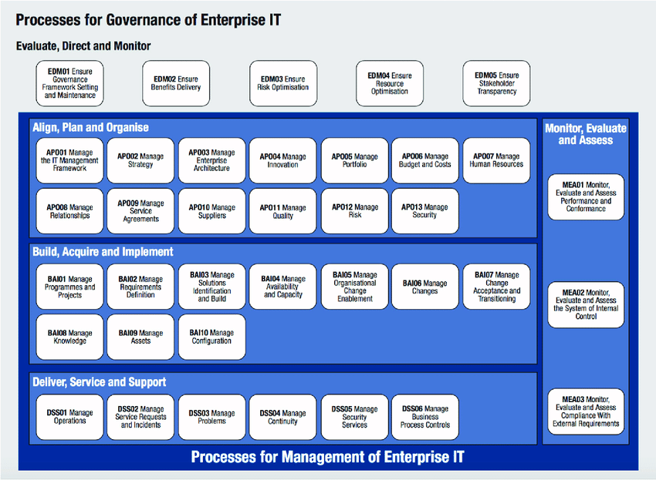
Figure 11: COBIT 5 Processes [26]

ISO 38500:2005
ISO 38500:2008 helps to clarify IT governance by defining it as the means by which directors demonstrate to all stakeholders and compliance bodies their effective stewardship over IT resources by ensuring the existence of an appropriate governance and security framework for all IT activities [27]. CoffeeBlue should develop principles ahead of time for implementing strong IT governance. ISO 38500 includes six principles to help the directors and executives of CoffeeBlue accomplish their jobs [28], which are described in Figure 12:
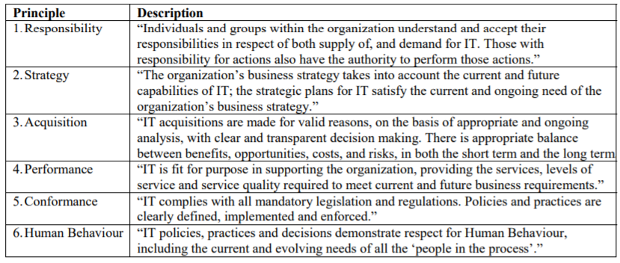
Figure 12: Six Principles for Good IT Governance in ISO 38500 [29]

Strategic planning

ISO 9001:2015
ISO 9001:2015 introduced the most effective tool for executing strategic processes for risk management and change management [30]. Figure 13 shows critical stages of the strategic plan process using ISO 9100.
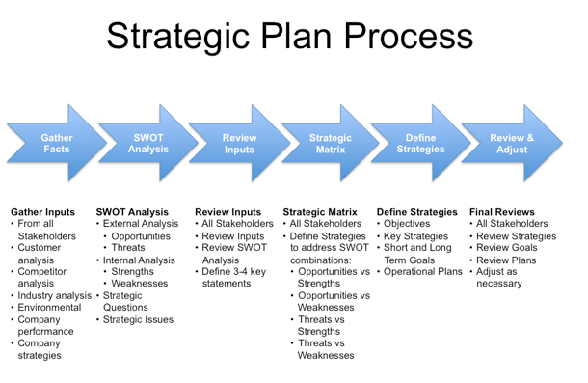
Figure 13: Strategic Plan Process [31]

Security Policies

ISO 27001
Any ISO 27001 certification must have an ISO 27001 Information Security Policy, as stated in clause 5.2 of the standard. It is one of the most important documents and it is part of the ISO 27001 information security policy framework [32]. Clause 5.2 describes how policies should be written in the ISMS and how they should be evaluated for compliance.

Risk Management

ISO 31000
ISO 31000 establishes principles, guidelines and a framework to help manage risk. The document includes parts of the RM (Risk Management) framework as well as crucial stages in the RM process, as shown in Figure 14.
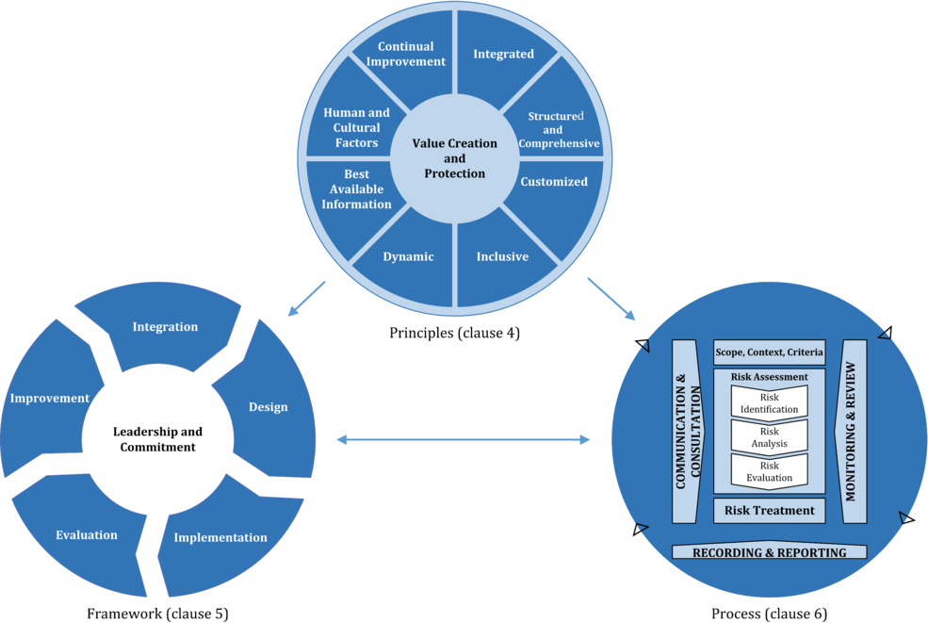
Figure 14: ISO Risk Management Framework, Principles and Process [33]
CoffeeBlue may use ISO 31000 to enhance the probability of accomplishing goals, enhance the identification of opportunities and risks, and allocate and manage resources for the treatment of risks more effectively.
ISO 31000 cannot be used for certification but can give recommendations for internal and external auditing programmes [34].

COBIT
COBIT was first developed as a set of information technology control goals to assist financial businesses with IT auditing. COBIT's uses have grown over time, and it currently includes information governance and IT management methodologies, as well as information to aid risk management.

Cobit 5 for risk
The ISACA publication COBIT 5 for Risk addresses two perspectives on risk – risk function perspective, and risk management perspective – which are outlined in the publication, shown in Figure 15.
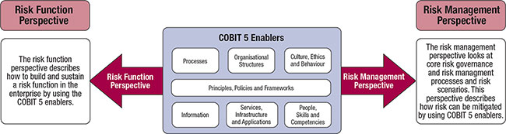
Figure 15: Two Perspectives on Risk [35]

ITIL
Using ITIL’s Risk Management process will help CoffeeBlue to discover, analyse, and prioritise possible business risks.
The Risk Management specification in ITIL contains several gaps. Although ITIL states that risk must be recognised, quantified, and mitigated, it is unclear how to go about doing so; no concrete process is defined on how to manage risk. To address this, CoffeeBlue should map the M_o_R (Management of Risk) framework in ITIL, mapping all M_o_R processes in ITIL, which will result in a strong risk management framework in ITIL that is based on concrete principles, without needing to modify the framework [36].
Having a basic Risk Management process in place will serve as an excellent foundation for implementing the M_o_R framework.
IT risk management is a never-ending process with its own lifecycle. Although experts differ on which stages should be included in the IT risk management process, a simple process typically comprises the features depicted in Figure 14.
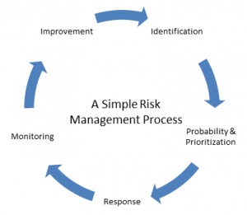
Figure 16: A Simple Risk Management Process [37]
Step 1 – Identification
A risk matrix will identify potential risks as well as identify the level of hazard it poses [38]. A sample matrix that can be used by CoffeeBlue is shown in Figure 15.
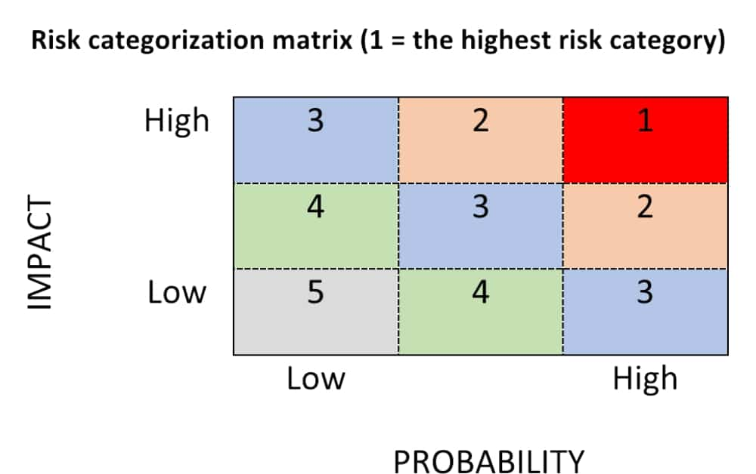
Figure 17: Risk Categorization Matrix [39]

Step 2 – Prioritising Risk
The risk categorisation matrix helps classify the probability of each risk. Determining the probability of each risk occurring aids in prioritising which hazards require response plans (covered in step 3) and the sequence in which each response plan should be constructed.
Step 3 – Risk Response Planning
One of the following strategies can be used by IT departments to establish a response plan for dealing with hazards.
- Avoidance
- Mitigation
- Planned contingency
- Shifting the risk
- Acceptance of risk.
Step 4 – Monitor Risk
It is critical to identify and monitor risk triggers that cause a reaction.
Step 5 – Improvement
Improvement is implemented in the ITIL framework through the Continual Service Improvement practice of the ITIL Service Lifecycle.

Security Management Models and Practices
ISO/IEC 27002 focuses on a comprehensive overview of security issues, offering information on 127 controls across ten categories, and ISO/IEC 27001 focuses on how to put ISO/IEC 27002 into practice and how to build up an ISMS.
The SANS SCORE (Security Consensus Operational Readiness Evaluation) Audit Checklist [40], which is based on 17799:2005, is one technique to verify how closely a company complies with ISO 27002.

Contingencies Planning

ISO 22301
A contingency plan is a road map developed by management to assist an organisation in responding to an event that may or may not occur in the future [41]. It is critical for business continuity, risk management, and disaster recovery. It will assist CoffeeBlue in remaining prepared for unexpected incidents and minimising the impact of them. It also offers a strategy for enabling normal corporate activities to be resumed following the disaster.
There are two distinct ISO standards that deal with contingency planning:
- ISO 22301 for Business Continuity Management (BCM)
- ISO 31000 for Risk Management (detailed in Risk Management Section of this report)
ISO 22301 is a BCM management systems standard that can be implemented by businesses of all sizes and types [42].
A business continuity plan is defined by ISO 22301 as “documented procedures that guide organizations to respond, recover, resume, and restore to a pre-defined level of operation following disruption.” (Clause 3.5) [43]
The business continuity management (BCM) lifecycle, shown in Figure 18 encompasses industry best practises as well as some of ISO 22301's key standards [44]. These practises provide a firm basis for resilience while also allowing the business to respond to changes.
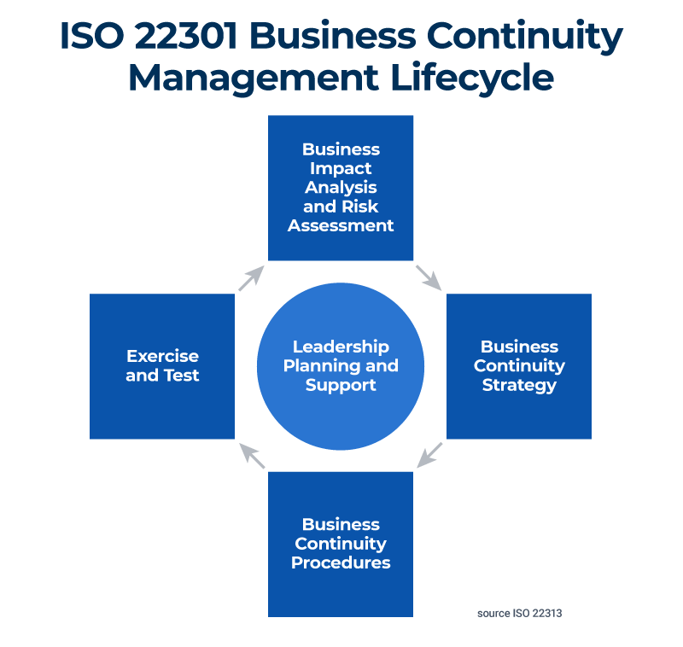
Figure 18: ISO 22301 Business Continuity Management Lifecycle [45]
Developing an efficient BCM plan and gaining ISO 22301 certification assures stakeholders that doing business with CoffeeBlue is a prudent and safe decision – and that they can rely on the company.

Protection Mechanisms
Endpoints are vulnerable to information threats not just from the outside world, but also from the inside environment. To accomplish endpoint security, three key protection steps should be undertaken:
- information threat classification
- verify infection source
- activate suitable protection mechanism
Figure 16 shows the core management steps of endpoint management based on the ITIL framework.
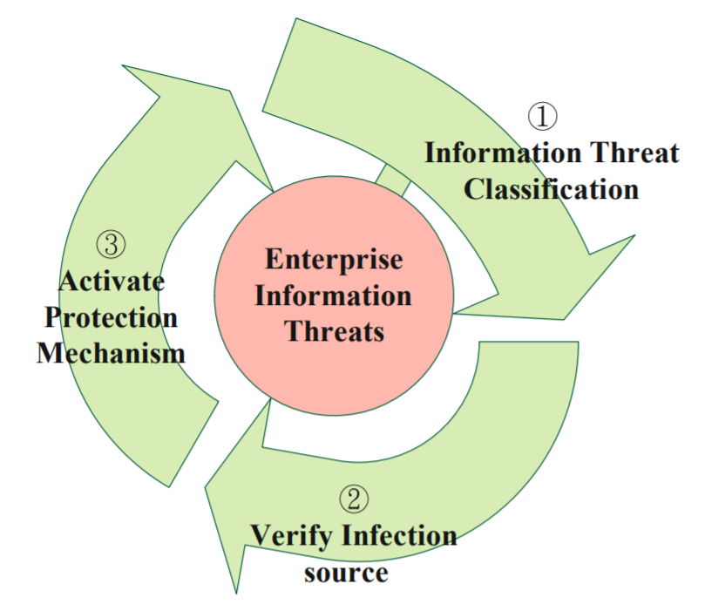
Figure 19: Enterprise Information Threats [46]
Monitor, block, and analysis are three treatment steps that can be used against the information threat. Monitoring different endpoint information first, then verifying the categorization of information threat. The endpoint management system should next adopt information security policies to prevent internal system vulnerabilities, such as delivering hot fixes and enforcing password rules. Finally, a periodical report should be given to evaluate efficacy, such as continual attacked or infected endpoints being classed as an abnormal occurrence.

Service Level Agreement

ITIL 4
A service level agreement (SLA) is “A documented agreement between a service provider and a customer that identifies both services required and the expected level of service.” [47].
SLAs are defined and adjusted in two areas in the ITIL service lifecycle:
- Service Design
- Continual Service Improvement
This means that SLAs for IT services should be developed in conjunction with any new or updated service requirements. The accompanying SLA should be evaluated and adjusted whenever an IT service is developed or altered to ensure that it is fair, enforceable, and practical.
In an IT service management (ITSM) setting, there are six best practises for defining and enforcing IT service SLAs, as outlined in Figure 20.
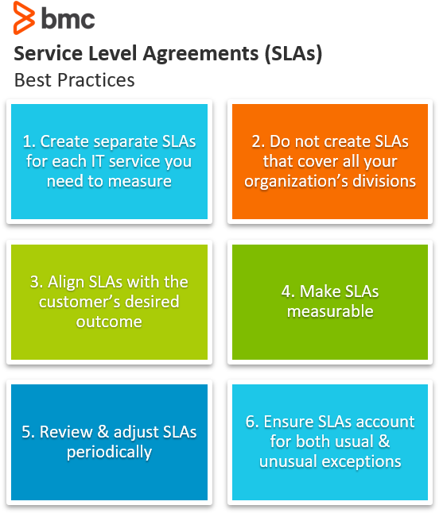
Figure 20: SLAs Best Practices [48]

CONCLUSION
There have been a variety of approaches and standards developed over the years to help contemporary businesses attain an effective procedure for achieving their goals in terms of IT governance and information security.
Major corporations continue to employ a variety of procedures to guarantee that their IT governance is in sync with their business goals and core business, as well as with local and worldwide IT governance norms and regulations.
Part one of this report examined three security frameworks and models – ISO/IEC 27000, ITIL, and COBIT, critiquing, analysing and comparing each framework, and addressed why it is good practice to have new and updated regulations and standards.
The report found that ISO 27001 standards differ significantly from COBIT and ITIL standards. While ISO 27001 standards address information security in depth but narrowly, COBIT and ITIL standards address many information technologies processes, including information security, broadly, but not as comprehensively as the ISO 27001 standard in terms of information security.
Part two of the report designed an approach to meet the needs of a coffee company named CoffeeBlue. It covered 8 main areas to help design the approach – Compliance with Laws and Ethics, Governance and Strategic Planning for Security, Security Policies, Risk Management, Security Management Models and Practices, Contingencies Planning, Protection Mechanisms, and Service Level Agreement.
With more time, more areas could be covered to help design the security approach.

REFERENCES
[1] “ISO 27000 Series of Standards,” IT Governance UK, 2021. https://www.itgovernance.co.uk/iso27000-family (accessed Nov. 03, 2021).
[2] ISO/IEC JTC 1/SC 27, “ISO - ISO/IEC 27000:2018 - Information technology — Security techniques — Information security management systems — Overview and vocabulary,” Feb. 2018. Accessed: Oct. 20, 2021. [Online]. Available: https://www.iso.org/standard/73906.html
[3] W. Zarządzania, K. Informatyki, and Stosowanej, “Information Security Management with accordance to ISO 27000 Standards : Characteristics , implementations , benefits in global Supply Chains 1,” 2015.
[4] “Fines / Penalties - General Data Protection Regulation (GDPR),” Intersoft Consulting. https://gdpr-info.eu/issues/fines-penalties/ (accessed Nov. 03, 2021).
[5] “ISO 27001 Advantages and Disadvantages,” Wiz Management Solutions. https://www.wizms.net/iso-27001-advantages-and-disadvantages (accessed Jan. 01, 2022).
[6] S. K. White and Lynn Greiner, “What is ITIL? Your guide to the IT Infrastructure Library,” CIO, Jan. 18, 2019. https://www.cio.com/article/2439501/infrastructure-it-infrastructure-library-itil-definition-and-solutions.html (accessed Oct. 22, 2021).
[7] IBM Cloud Education, “IT Infrastructure Library (ITIL),” ITIL - IT Infrastructure Library, May 22, 2019. https://www.ibm.com/cloud/learn/it-infrastructure-library (accessed Oct. 25, 2021).
[8] A. Kaiser, “The Spectacular History of ITIL,” Abhinav PMP, Jan. 11, 2021. http://abhinavpmp.com/2021/01/11/the-spectacular-history-of-itil/ (accessed Nov. 01, 2021).
[9] S. Chand, “What are 26 ITIL® Processes and how they work?,” Edureka, Nov. 25, 2020. https://www.edureka.co/blog/itil-processes/ (accessed Nov. 01, 2021).
[10] IT Process Wiki, “ITIL Processes,” IT Process Wiki. https://wiki.en.it-processmaps.com/index.php/ITIL_Processes (accessed Nov. 01, 2021).
[11] Freshservice Thoughts, “ITIL 4: Why are Practices better than Processes?,” Freshservice Thoughts. https://freshservice.com/itil4-practices-and-processes-blog/ (accessed Nov. 01, 2021).
[12] Axelos, “ITIL | IT Service Management,” 2021. https://www.axelos.com/certifications/itil-service-management (accessed Nov. 01, 2021).
[13] S. de Haes and W. van Grembergen, Enterprise Governance of Information Technology. Springer International Publishing, 2015. Accessed: Oct. 22, 2021. [Online]. Available: https://www.google.co.uk/books/edition/Enterprise_Governance_of_Information_Tec/zNgRBwAAQBAJ?hl=en&gbpv=1&pg=PA102&printsec=frontcover
[14] 20000 Academy, “COBIT vs. ITIL vs. ISO 20000: A comparison,” advisera. https://advisera.com/20000academy/blog/2019/09/25/cobit-vs-itil-vs-iso-20000-a-comparison/ (accessed Oct. 22, 2021).
[15] “COBIT vs ITIL: Selecting The Right IT Governance Framework,” Nov. 30, 2017. http://www.icthub.pk/blog/cobit-vs-itil/index.html (accessed Nov. 08, 2021).
[16] A. F. Zuhdi, “COBIT,” Medium, Sep. 28, 2018. https://medium.com/@afawwazz/cobit-bc5b8d88ceae (accessed Oct. 28, 2021).
[17] I. Horvath, “5 Key COBIT 5 Principles: Explained in Detail,” Invensis Learning, Jul. 17, 2021. https://www.invensislearning.com/blog/cobit-5-principles/ (accessed Oct. 22, 2021).
[18] M. Simonsson, P. Johnson, and H. Wijkström, “Model-Based IT Governance Maturity Assessments with Cobit.,” 2007. Accessed: Oct. 20, 2021. [Online]. Available: https://www.researchgate.net/publication/221409373_Model-Based_IT_Governance_Maturity_Assessments_with_Cobit
[19] ITGI, “Global Status Report on the Governance of Enterprise It (GEIt)-2011,” 2011, Accessed: Oct. 20, 2021. [Online]. Available: www.itgi.org
[20] IT Governance, “ISO 27701,” IT Governance. https://www.itgovernance.co.uk/iso-27701 (accessed Jan. 01, 2022).
[21] Husam. Abu Khadra, Majdy. Zuriekat, and Nidal. Alramahi, “An empirical examination of maturity model as measurement of information technology governance implementation,” International Arab Journal of Information Technology, vol. 6, no. 3, pp. 310–319, Jun. 2009, Accessed: Jan. 01, 2022. [Online]. Available: https://www.researchgate.net/publication/220413814_An_empirical_examination_of_maturity_model_as_measurement_of_information_technology_governance_implementation
[22] A. K. Rama, Suharjito, and E. Gunawan, “Evaluation of IT Governance Implementation Using COBIT 5 Framework and ISO 38500 at Telecommunication Industries,” Proceedings of 2020 International Conference on Information Management and Technology, ICIMTech 2020, pp. 453–457, Aug. 2020, doi: 10.1109/ICIMTECH50083.2020.9211275.
[23] S. Allam and S. Flowerday, “A model to measure the maturity of smartphone security at software consultancies,” in SAISMC, Jan. 2010, pp. 272–284. Accessed: Dec. 09, 2021. [Online]. Available: https://www.researchgate.net/publication/290060705_A_model_to_measure_the_maturity_of_smartphone_security_at_software_consultancies
[24] Y. Herdiana and M. Lomate, “A Business Framework for the Governance and Management of Enterprise IT PREVIEW VERSION,” 2012, Accessed: Dec. 09, 2021. [Online]. Available: https://static1.squarespace.com/static/56b3cadb59827ecd82b02b43/t/56d8c0d84d088e673055c308/1457045725120/COBIT-5_res_eng_1012.pdf
[25] Cecil, “Practicing proper governance with Cobit 5,” Medium, May 13, 2017. https://medium.com/@cecildt/practicing-proper-governance-with-cobit-5-19c25bc2ed15 (accessed Dec. 09, 2021).
[26] J. David Patón-Romero, M. T. Baldassarre, M. Piattini, and I. G. R. de Guzmán, “A governance and management framework for Green IT,” Sustainability (Switzerland), vol. 9, no. 10, Sep. 2017, doi: 10.3390/SU9101761.
[27] van Haren Publishing, “ISO/IEC 38500 for IT Governance - in 3 minutes,” May 07, 2013. https://www.vanharen.net/blog/isoiec-38500-for-it-governance-in-3-minutes/ (accessed Dec. 09, 2021).
[28] A. Holt, Benefits of good IT governance. BCS Learning & Development Limited, 2013.
[29] ISO, “ISO - ISO/IEC 38500:2008 - Corporate governance of information technology,” Jun. 2008. https://www.iso.org/standard/51639.html (accessed Dec. 09, 2021).
[30] QMS, “Strategic Planning With ISO 9001:2015,” QMS, Jun. 15, 2019. https://qms-certification.com/blog/strategic-planning-with-iso-90012015/ (accessed Jan. 01, 2022).
[31] “The New ISO 9001:2015 – Strategic Planning is Key to Implementation,” Jul. 06, 2020. https://www.missourienterprise.org/the-new-iso-90012015-strategic-planning-is-key-to-implementation/ (accessed Dec. 30, 2021).
[32] “Information Security Policy: The Ultimate Guide,” High Table. https://hightable.io/iso-27001-information-security-policy/ (accessed Jan. 02, 2022).
[33] ISO, “ISO 31000:2018(en), Risk management — Guidelines,” ISO 31000:2018(en), 2018. https://www.iso.org/obp/ui/#iso:std:iso:31000:ed-2:v1:en (accessed Dec. 04, 2021).
[34] ISO, “ISO 31000 — Risk management,” ISO. https://www.iso.org/iso-31000-risk-management.html (accessed Jan. 01, 2022).
[35] Information Systems Audit and Control Association, COBIT 5 for risk. ISACA, 2013.
[36] S. Vilarinho and M. M. da Silva, “Risk management model in ITIL,” Sociotechnical Enterprise Information Systems Design and Integration, pp. 207–214, Mar. 2013, doi: 10.4018/978-1-4666-3664-4.CH013.
[37] J. Hertvik, “IT Risk Management Process for ITIL® v3 & ITSM Environments,” Service Management Blog, Nov. 04, 2021. https://www.bmc.com/blogs/risk-management-framework-process-itsm-environments/# (accessed Dec. 08, 2021).
[38] J. Hertvik, “IT Risk Management Process for ITIL® v3 & ITSM Environments,” bmc, Nov. 04, 2021. https://www.bmc.com/blogs/risk-management-framework-process-itsm-environments/# (accessed Jan. 01, 2022).
[39] 20000 Academy, “Three key elements of assessment and evaluation of changes according to ITIL,” ISO 20000 & ITIL® Blog, Jun. 30, 2015. https://advisera.com/20000academy/blog/2015/06/30/three-key-elements-of-assessment-and-evaluation-of-changes-according-to-itil/ (accessed Dec. 08, 2021).
[40] V. Thiagarajan and M. Comp, “Information Security Management Audit Check List for SANS”.
[41] “What is a Business Contingency Plan | A Step-by-Step Guide,” Oct. 16, 2020. https://creately.com/blog/business/business-contingency-plan-templates/ (accessed Dec. 10, 2021).
[42] S. Tangen and D. Austin, “BUSINESS CONTINUITY - ISO 22301 WHEN THINGS GO SERIOUSLY WRONG,” ISO, Jun. 18, 2012. https://www.iso.org/news/2012/06/Ref1602.html (accessed Dec. 10, 2021).
[43] “ISO 22301:2019(en), Security and resilience — Business continuity management systems — Requirements,” ISO. https://www.iso.org/obp/ui/#iso:std:iso:22301:ed-2:v1:en (accessed Jan. 02, 2022).
[44] A. Marker, “ISO 22301 Business Continuity Management Made Easy,” Jun. 22, 2020. https://www.smartsheet.com/content/iso-22301-business-continuity-guide (accessed Jan. 02, 2022).
[45] “ISO 22313:2020 - Security and resilience — Business continuity management systems — Guidance on the use of ISO 22301,” ISO, Feb. 2020. https://www.iso.org/standard/75107.html (accessed Jan. 02, 2022).
[46] M. Y. Wu, S. F. Chang, and W. C. Li, “Protection Management of Enterprise Endpoint Based on the ITIL Management Framework,” Lecture Notes in Electrical Engineering, vol. 253 LNEE, pp. 557–565, Jun. 2013, doi: 10.1007/978-94-007-6996-0_59.
[47] van Haren Learning Solutions a O, ITIL® 4 Foundation Courseware - English. Van Haren Publishing, 2019.
[48] bmc, “6 SLA Best Practices for Service Management Success,” Service Management Blog, Aug. 20, 2019. https://www.bmc.com/blogs/sla-best-practices/ (accessed Jan. 02, 2022).

