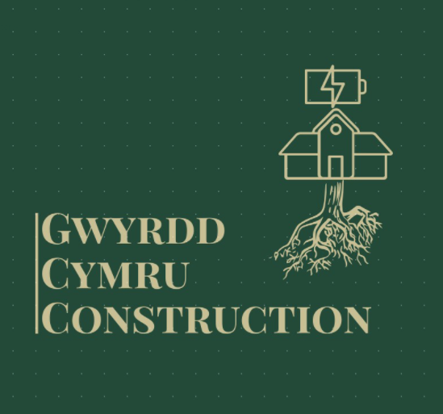

Project Information and Management Plan

Gwyrdd Cymru Construction Ltd
146 High Street,
Swansea,
SA1 2PN.
gwyrddcymruconstuctionltd@gmail.com
May 2022.
Contents
Project Information and Management Plan 1
1. Project Summary 4
1.1. Description 4
1.2. Location 5
1.3. Development Site Plan & Plot Information 5
2. Duty Holders & Key Personnel 7
3. Project Constraints & Considerations 8
3.1. Pedestrian & Vehicle Access 8
3.2. Residential Area & Businesses Nearby 8
3.3. Public Safety 9
3.4. Welsh Government Planning Restrictions 9
3.5. Ground Considerations 10
3.6. Weather and Location 12
3.7. Proximity to Docks (Spillage / Contamination / Water Pollution) 13
4. Method Statement 14
4.1. Project Details 14
4.2. Introduction & Site Rules 15
4.3. Example 1 – Excavation 16
4.3.1. Safe Working Method 16
4.3.2. Reference Documents: 17
4.3.3. Tools & Equipment Required: 17
4.3.4. Personal Protective Equipment (PPE) 19
4.3.5. Environmental Procedures: 19
4.3.6. C.O.S.H.H. Considerations: 20
4.3.7. Personnel Requirement: 20
4.4. Example 2 – Roof Covering 21
4.4.1. Safe Working Method 21
4.4.2. Reference Documents: 21
4.4.3. Tools & Equipment Required: 22
4.4.4. Personal Protective Equipment (PPE) 22
4.4.5. Environmental Procedures: 23
4.4.6. C.O.S.H.H. Considerations: 24
4.4.7. Personnel Requirement: 24
4.5. Method Statement Confirmation Signatures 25
5. Project Risk Assessment 26
5.1. Risk Assessment Matrix 26
5.2. Risk Assessment 26
6. Environmental Arrangements 48
7. Emergency Contacts 49
7.1. A&E Location and Directions 49
8. Bibliography 52

This report outlines the anticipated site construction activities and the relevant controls associated with the development of the scheme. The report will also describe the procedures and mitigations that will be implemented throughout the project to ensure the health, safety and environmental standards maintain the priority.
Any and all sub-contractors used across the project will abide by the procedures and controls agreed and identified within this document. As the project progresses this document will be continuously amended to ensure it always remains current and relevant to the associated activities.

Project Summary

Description
The proposed scheme is to develop an inclusive and multi-functional halls of residence that will be inviting to students from all over the world whilst they carry out their studies with the university.
The first and second floors will be allocated as residential spaces comprising of many student rooms of varying size. These floors will also contain a segregated floor where fully independent two bedroom apartments with integrated kitchens and bathrooms will be situated. These apartments will be reserved for students that travel from overseas with their families to study or private rental accommodation for small families. This build will ensure comfort and quality throughout and each room as a minimum will contain an en-suite shower-room, workspace, plenty of storage and a double bed.
At ground level there will be a multitude of modular spaces that are designed to occupy retail units of varying size. There is a car park to the North of the building that will have spaces for retail users as well as residents. The building will surround a large open space equipped with outdoor exercise equipment, a seating and picnic area, as well as a green / lawn. To the rear and separate to the public vehicle and pedestrian access points, deliveries for the retail unites will traverse the outside of the building via a one way system alongside a wildflower / grassland area that will encourage biodiversity.
Inclusivity is at the forefront of this project and therefor the building will cater for people of all abilities ensuring all users get proper access to all areas.

Location
The building will be located at plot ‘E9’ highlighted in blue on the following plans. It is part of a larger development scheme to advance the area into a sought after and established neighbourhood (see full details in documents submitted by Rhys Bolton – 1902382).
To the North, on the opposite side of the road, there is a large promenade that surrounds the Prince of Wales Dock. On the other side of the dock there is a series of new residential estates comprising of three story town houses with more development areas to the East. To the South of the plot, there is a green area of overgrown plants and grassland before some industrial units. Beyond this is to the South is Swansea’s Kings Dock, which has the capacity to accept vessels of up to 30,000dwt and provides berths and facilities for most types of cargo, ranging from Minerals and Ores, to Passengers and cruises.

Development Site Plan & Plot Information
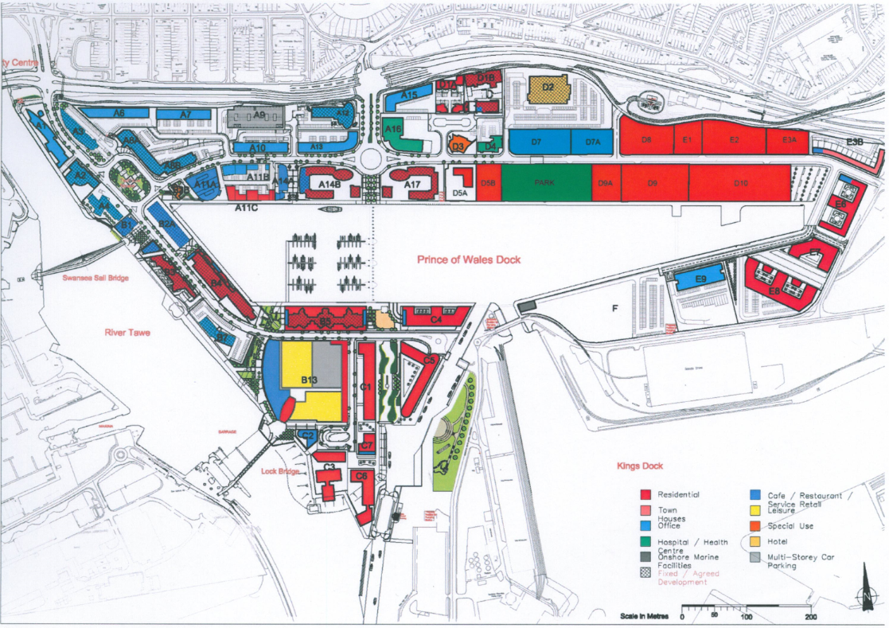
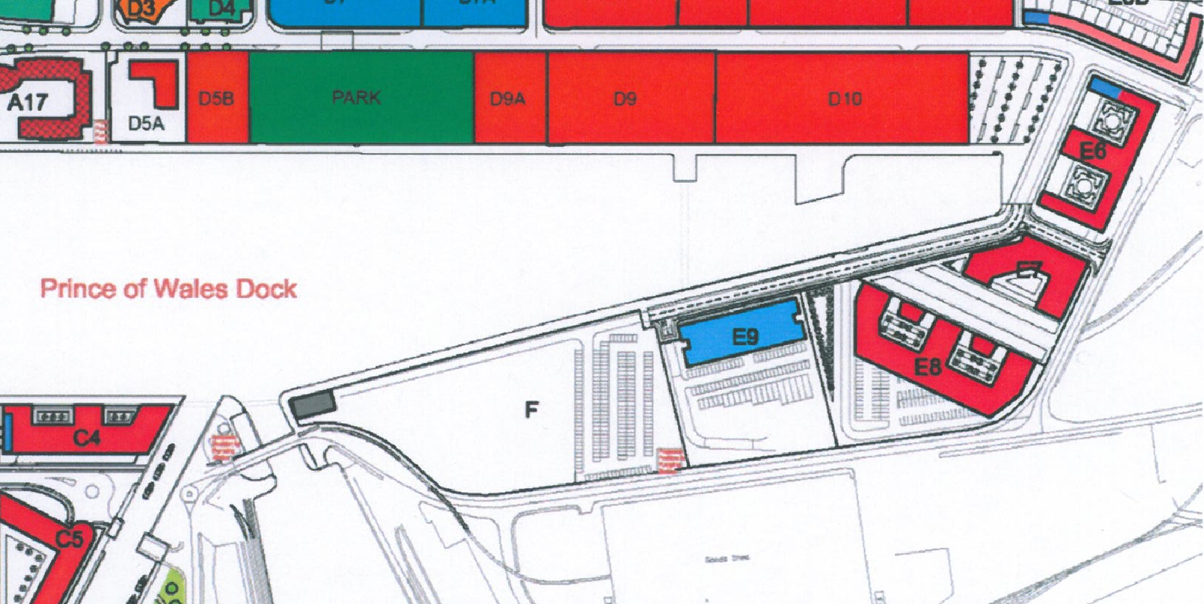
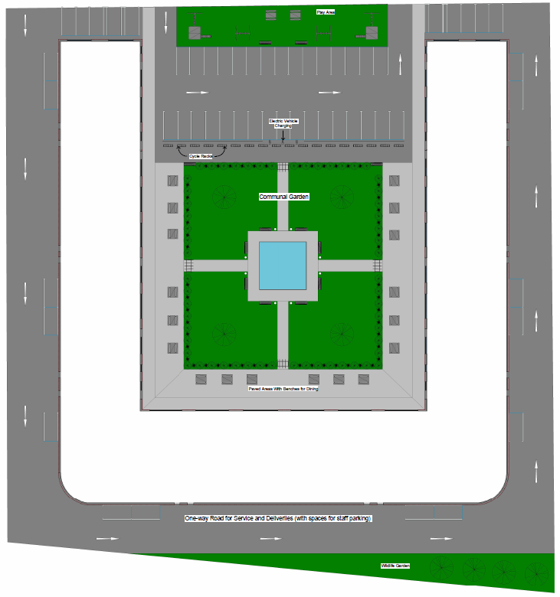
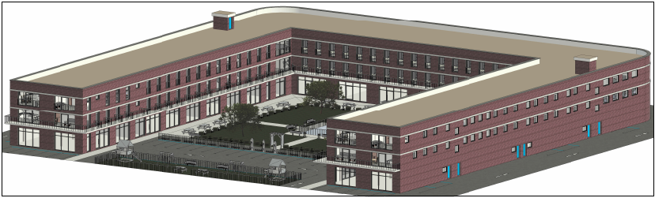
Figure 1 - Designs Illustrated by Owen Brown (1901187)

Duty Holders & Key Personnel
CLIENT | University of Wales Trinity Saint David.  Swansea Waterfront,  IQ Campus,  Swansea,  SA1 8EW.
PRINCIPAL DESIGNER | Gwyrdd Cymru Construction Ltd.  146 High Street,  Swansea,  SA1 2PN.
PRINCIPAL CONTRACTOR | Gwyrdd Cymru Construction Ltd.  146 High Street,  Swansea,  SA1 2PN.
PROJECT MANAGER | Gwyn Davies  E: Gwyn.Davies@gcconstruction.co.uk  M: 07837 763022
SITE MANAGER & TEMPORARY WORKS  CO-ORDINATOR | Aled Owen  E: Aled.Owen@gcconstruction.co.uk  M: 07884 673922
SITE SUPERVISOR & TEMPORARY WORKS SUPERVISOR | Rhys Jones  E: Rhys.Jones@gcconstruction.co.uk  M: 07767 636343
H&S MANAGER | Hannah Rees  E: Hannah.Rees@gcconstruction.co.uk  M: 07855 346721
SITE SAFETY OFFICER | Alex Williams  E: Alex.Williams@gcconstruction.co.uk  M: 07775 433222
COMMUNITY LIAISON OFFICER | Barry Davies  E: Barry.Davies@gcconstruction.co.uk  M: 07012 143621
PROJECT ENVIRONMENTAL MANAGER | Llinos Rees  E: Llinos.Rees@gcconstruction.co.uk  M: 07442 369283

Project Constraints & Considerations

Pedestrian & Vehicle Access
The Association of British Ports (ABP) currently control access to the plot as it is yet to be segregated from the land under their control. They have however allowed access via our requested access point at the East end of the Prince of Wales Dock. As ABP’s site at King’s Dock is a live working area, we will install a secondary gate further along the road and segregate this are so the workers can’t enter any restricted areas.
Typically, the sites working times will be: Monday to Friday - 07:00 to 18:00, Saturday and Sunday - 08:00 to 14:00 (Weekends to be authorised by Gwyrdd Cymru Construction only).
Fabian Way (A483) is a busy primary access road in and out of Swansea city centre and is usually quite busy at rush hour. As this will also be one of the feeder roads for our project, it will be closely monitored throughout the duration of the work to ensure any disruption is controlled. This will be through imposing deliveries on delivery times and encouraging employees to use public transport or car share wherever possible.

Residential Area & Businesses Nearby
As we are registered under the Considerate Constructors Scheme we understand the importance of taking the local people, businesses and public into consideration during a project like this.
Just across the Prince of Wales Dock there is a large cluster of housing estates that would need to be considered. Discussions and consultation meetings will be held with Swansea Council & the local residents regarding what (if any) restrictions may be implemented onto the project or it’s deliveries, because of the proximity between the residential area and the building site. During these discussions the Project Manager will explain the detail of works planned for the upcoming days / weeks / months and the duration required to complete the work.
It is possible that working hours may have to suit their requirements for activities that exceed their accepted noise or vibration level. If this is the case, then this will be taken into consideration with the resource increased where possible with activities scheduled to suit, i.e. any activities that have increased noise level will be prioritised within the allocated most convenient times.
Along with the above, we will implement a number of other controls to manage and mitigate nuisance. Examples of some are;
- Setting of 'Action Levels' for noise and vibration.
- Using receptors at the site boundary to carry out routine monitoring of noise, vibration and dust.
- Provide acoustic screening with the use of hoardings.
- Requirement for engines to be switched off on-site when not in use, use of quieter plant, regular plant maintenance, screening of plant (if appropriate).
- Spraying of areas with water to dampen down dust when conditions dictate.
The Project Manager will be the main point of contact along with the Community Liaison Officer (Barry Davies) for any engagements, questions, complaints or concerns from the local community with an online forum used to store frequently asked question and answers.
Community notice boards will be continuously updated with newsletters issued to neighbouring properties and social media channels but in specific circumstances where any abnormal activates or road closures need to take place neighbours will be informed directly.

Public Safety
Despite the location of the site being away from any popular thoroughfares or venues, as always, public safety will be of utmost priority throughout the project. Gwyrdd Cymru Construction will implement a number of procedures and controls to safeguard the public from any hazards at all times. Although this will include restricting access and segregation by use of fences, where it’s safe, we will still be involving the locals and showcasing work throughout. This will be balanced through signage, scheduled visits and visual panels in fencing.
There is also a Driving Test Centre nearby where learner drivers are frequently accessing. To manage this we will ensure the adjacent roads aren’t blocked or used for parking by any of our site staff or deliveries. We will also engage the scheduler of the test centre of key milestones where large deliveries are likely to disrupt operations and traffic in the area. As mentioned previously, they will be involved in any outgoing communications and meetings with locals.

Welsh Government Planning Restrictions
When liaising with other construction companies and ongoing projects in the area, they informed us that there were specific restrictions and stipulations imposed by the Welsh Government’s Planning department in addition to Swansea Council. They were primarily in relation to the use of nearby roads and the proximity of the building to the carriageway however, early discussions must be held to understand this and mitigate any wrongdoings through the execution phase. Throughout the planning and execution phases, we will be in contact with their designated persons and ensure everything is as streamline as possible. the foreseeable impact will however be minimal as the development is set back from any public access ways.

Ground Considerations
Over its lifetime, the plot has been occupied for a number of different uses but primarily as an industrial site. Over the years it will have most likely been subject to contamination of various different kinds and may hide a multitude of underground obstacles.
NOTE: Please see full ground consideration detail in documents prepared by Timothy Rees (1807470).
    - Tennant Canal
As can be seen in the below map (1903), there was once a Canal running along and through the area that our plot is located. It was re-routed from here in 1909 and instead entered directly into the Kings Dock further east. Whilst there isn’t any information available to document how this was relocated and what became of the original canal, this will have to be something we consider and test for during the Site Clearance and Ground Investigations.
If nothing is discovered, then we will excavate part of this area carefully without loading it excessively until we can confirm it has been demolished and backfilled with stable ground.
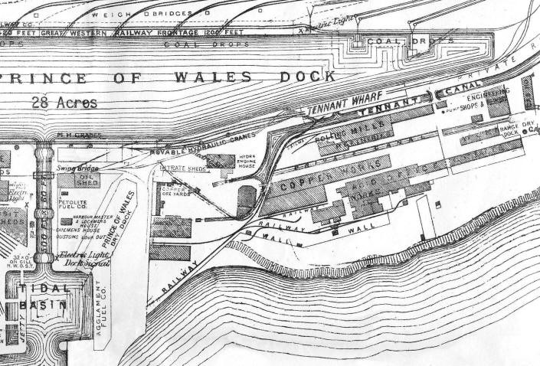
(Swansea & Port Talbot Docks, 2021)

    - Industrial Factories and Operations
From the above map it is also clear what type of infrastructure and businesses occupied this plot such as; Copper Works, Rolling Mills, Movable Unloader Cranes and Railway Lines making it a brownfield site. There are a number of ways in which this type of infrastructure and its subsequent activities can contaminate the surrounding ground, therefore it is an essential consideration during the Ground Investigation, Foundation Design, Excavation and Construction.
All excavated soil will be frequently sampled by an independent certified laboratory in order to understand the contamination level and therefore the related remediation procedures required.
Any areas identified to contain contaminated soil will be segregated and controlled separately to the rest of the site. All personnel likely to interact with any potentially contaminated soul will be wearing the relevant Personal Protective Equipment (PPE). This will be stored on site or disposed of after each shift to ensure no contaminated materials are taken off site. All existing contaminated material will be temporarily stored on site in a designated area whilst being covered and segregated by a bund. It will then be removed from site and treated by a competent and certified sub-contractor.
      - Asbestos
However, this procedure will differ if the suspected contaminant is Asbestos. As part of the ground sampling process Asbestos samples will be taken to identify any possible background information or concentrated areas across site.
In the event that a suspicious material is found, the operative will: Stop work, Keep the soul and excavation damp, wash down the excavation equipment and collect all run off-water as recommended by the HSE. In the meantime the site Manager will contact our designated UKAS-accredited asbestos contractor to take samples. If they are returned positive, they will be engaged to remove the contaminated spoil.
    - War Remnants and Explosives
During the second world war, the dock was subject to air-raids and, along with other docks, became targets that at times took so much damage that they were at risk of being put out of commission. It’s for this reason that this must be ruminated when carrying out the Ground investigations and stringent controls or procedures must be in place during any excavation activities.
Before starting any excavation works, we will ensure an Unexploded Ordnance Survey (UXO) is carried out and a risk assessment developed and communicated on the back of the results. For specific tasks like piling or any required deep excavations, intrusive survey can be carried out to ensure that there is nothing that will be affected in this location.
If there is any suspected unexploded bombs identified during any other excavations or activities, then they will be reported to the Site Manager who will then check the concern. If they also has suspicions, then they must report it to a specialist UXO consultant and the police before cordoning of the area and controlling access.
    - Existing Services
Given the aforementioned history of the plot, it is expected that a number of live and redundant services are present across the site. the identification and protection of any services is very important, especially for any groundworks. To manage this, a survey will be carried out to identify any existing services which will then be added to the Service Master Plan. When any excavations are to be undertaken, the utility drawings and service master will be reviewed alongside the ground clearance certificate before a ‘Permit to Dig’ is issued. Where possible, services will be isolated or disconnected and when working near to services hand excavation to be used in tandem with the excavator.

Weather and Location
The weather in Wales varies significantly throughout the year and at times can be very unpredictable. This plays a massive factor in any deliveries and execution works. Careful planning is required to ensure that any key delivers or critical tasks are scheduled to periods where the weather is more likely to be suitable.
The location of the site, being near the coast, will also be considered during the execution but also in the choice of materials and method of installation. Construction beside the sea means the building will be susceptible to harsh conditions such as driving winds, higher UV exposure and corrosion due to salt spray. These are considerations that will heavily influence the materials and methods of construction used.
This will be considered when siting any Cranes, Erecting Scaffolding, Working at Height Externally or Operating a MEWP. The forecast will be checked regularly with the programme altered where required. the wind speeds will be continually checked throughout the day with the work risk Assessed accordingly and limits identified and followed.

Proximity to Docks (Spillage / Contamination / Water Pollution)
During excavation works to protect nearby watercourses; cut off ditches, swales or silt fences will be positioned around the perimeter of the area to divert any silt or contaminated water to a designated point for de-watering or to a settlement tank.
All Chemicals, Oils or Fuels will be transported via predetermined routes to and across site and stored in the designated safe area (see site plan). These areas will be away from any draining points and will be equipped with a designated COSHH storage area for chemicals. It will also hold bunds and drip trays large enough to hold 100% of the containers capacity to capture spillages. When using any of these types of liquids, including the clearing of any spills, all employees will follow their training and site procedures, and use the correct equipment.
The Environmental Protection Act 1990 describes the importance of controlling any polluting matter from entering into any place which may ultimately affect the water course. Spill kits will be located at various locations across the site in preparation for any potential spillages. These will be clearly marked and signposted with all operatives trained to use them and briefed of their locations within the site induction.
If any contaminant liquids should enter the waterways accidentally then the local water authority will be advised immediately. If there is any land contaminated then the affected land will be excavated and replaced, with the contaminated earth removed from the site as soon as possible to a site which is registered to accept that type of pollutant.

Method Statement

Project Details
 |  |  | Job Reference: |  |  | UWTSD-6003
1. Contractor Company: |  |  |  |  | 2. Client:
Gwyrdd Cymru Construction Ltd |  |  |  |  | University of Wales Trinity Saint David
3. Exact Location of Work: |  |  |  |  |  | 4. Purchase Order Number:
UWTSD - SA1 Development - Plot E9 - South East Corner of the Prince of Wales Dock. |  |  |  |  |  | 221459
5. Job Description:
Construction of a new Halls of Residence for the University of Wales Trinity Saint David at the South East end of the Prince of Wales Dock.
6a. Anticipated start date (dd/mm/yyyy): |  |  |  | 6b. Anticipated end date (dd/mm/yyyy): |  |  | 7. Duration:
04/10/2021 |  |  |  | 31/07/2023 |  |  | 22 Months
8a. Access and Egress: (To and from the location in box 3 above. All other areas are then prohibited.)
Access to and from the site for staff, visitors, plant and deliveries is via Fabian Way/A483 before turning South at the traffic lights toward Langdon Road and then taking the 2nd exit at the roundabout on to Langdon Road. Head West following the road to the left before taking the signposted turning on to the dock road towards the site. Park in the designated car park at the site compound and proceed to the site gates via the designated walkways. Access through the gates using the card supplied during the induction and then proceed to the working are by using further designated routes. Egress is in reverse.

NOTE: Please see site layout drawings prepared by Stuart Jones (1910146) for further detail.
8b. Assembly Point in the event of an emergency: |  | The safest possible route using designated walkways where possible to the nearest Assembly Point. Primary Assembly Point will be positioned in the Car Park at the CDM Project Compound to the West of the Site.  NOTE: Please see site layout drawings prepared by Stuart Jones (1910146) for further detail.
8c. Ambulance Meeting Point in the event of an emergency: |  | The safest route using designated walkways where possible to the nearest Ambulance Meeting Point. Primary Ambulance Meeting Point will be positioned at the at the Site Entrance adjacent to the Security Office.  NOTE: Please see site layout drawings prepared by Stuart Jones (1910146) for further detail.
10. Emergency telephone number (24 hour): |  | Internal contacts: Site Manager (07884 673922), Safety Officer (07775 433222), First Aider (TBC), Fire Warden (TBC).  Emergency Services: 999.  Utility Services: Water (0800 052 0130), Power (0800 052 0400), Gas (0800 111 999).
11. Name of any Sub-contractor companies to be used: |  | To be confirmed on start of Construction Phase.

Introduction & Site Rules
    - This is an example Method Statement & Project Risk Assessment that must be referred to and included within all tasks specific Job Method Statements (JMS) and Risk Assessments (RA) through the course of the project. Each Supervisor or Sub-Contracting manager must ensure their activities have been effectively planned, risk assessed and documented for review before commencing any work.
    - Each working team or sub-contractor must have a named ‘Person in Charge of the Working Party’ (PICWP) that is on site at all times during any ongoing work. This person will be the designated contact for their team / company and will be responsible for their activities ensuring; all safety measures are followed, PPE & RPE is worn and tools & equipment are stored correctly.
    - All individuals must be trained and competent for the task they are employed to carry out with a CSCS qualification as a minimum.
    - All machine operators must have the relevant training and competence to operate their machinery. On registration to the site, proof of this must be shown for recording on the security system.
    - All individuals wishing to enter site must attend an induction and register their details with security, whilst presenting their CSCS card, to gain authorisations to access via the data scope equipment (further info available from Stuart Jones 1910146).
    - All JMS/RA’s mut be submitted to the Site Supervisor or Site Manager 4 working days in advance of start date to ensure they have ample time to review. Only once they are satisfied and give authorisation can the work to go ahead.
    - All members of the working party must sign on the back of their task specific JMS/RA to certify that they have; read, understood and agreed to the stipulations included.
    - Maximum Speed Limit of 5mph is enforced across site and must be adhered to.
    - All Plant, Tooling & Equipment must be checked prior and after use to ensure it is of a good condition. Any signs of excessive ware or damage must be reported to your designated PICWP or Site Manager / Supervisor.
    - Working area must be inspected and cleaned at the start of every shift and made safe at the end of each shift.
    - Welfare Facilities provided must be kept clean and tidy. They will be regularly inspected and any damage recouped from the occupants employer.
    - Where required, temporary task specific lighting can be requested from the Site Manager.
    - This is a ringfenced site and is under the full control of Gwyrdd Cymru Construction.
    - All designated storage and welfare areas, boundaries and access zones are identified on the main site layout drawings prepared by Stuart Jones (1910146).

Task Specific Method Statements will be created and used for all individual building elements. Where sub-contractors are used, they will also be required to submit a method statement and risk assessment. They will be similar to the examples provided below and include any key information provided within this document.

Example 1 – Excavation

Safe Working Method
      - Before commencing excavation, we shall make sure that there are no live underground services passing through the proposed working area.
      - Trained, competent operative to CAT scan pre-designated area of ground prior to starting of work, highlight located services with line marker and consult site clearance certificate.
      - Site shall be cleared of all shrub, trees, bushes and old foundations.
      - Site engineer to confirm setting out and level of the ground as per drawing prior to excavation.
      - Levels and setting out shall be given by the surveyor ,checked by Civil Site engineer / QA Engineer & Consultant.
      - Permit to Dig to be received.
      - Excavator to commence ensuring to remain along the setting out lines.
      - Materials to be removed from the immediate area ensuring for the short term it is not stored adjacent to the trench where it could affect side loadings.
      - Material will be moved and be stored in the designated location in readiness for re-use or collection at the end of each shift.
      - Excavated areas to be barricaded to restrict access.
      - Excavations to be inspected by the PICWP/Supervisor at the start and end of every shift and after any period of heavy rain.
      - Excavation in soft soil areas of excavations of required depth will be protected by shoring. For shallow excavations in soft soil, proper side slope shall be maintained to avoid the soil sliding.
      - The excavated material which can be reused shall be stored separately on site as designated on site plans and in the induction. Unusable excavated material shall be disposed via designated routes according to material type and environmental plans.
      - Faces and bottom of excavation shall be properly trimmed and cleared of all loose materials and foreign matters.
      - Shore the sides of excavations for structures, trenches, and pits to prevent them from slipping or falling as and when required by engineer and drawing.
      - Civil site engineer / QA engineer shall confirm level of the excavation ground as per drawing.

Reference Documents:
- Ground Investigation Report,
- Environmental Impact Assessment,
- Site Clearance Document,
- Drawings pertaining to existing services,
- Permit to Dig,
- Civil Specification,
- Programme,
- Bill of Quantities.

Tools & Equipment Required:
- Excavator (Size and number according to Excavation),
  - Only trained and competent personnel are allowed to drive and operate mini diggers and excavators. Machines are to be greased on regular basis and confirmed by the operator. A pre-use check must be carried out and recorded by the operator before the start of each shift prior to operating the machine. Any damage to be reported immediately. Banksman to be present when in operation. All correct PPE to be worn when operating. Drip trays to be used when filling plant. Cab to be cleaned extensively if changing operators.
- Swivel Dumper (Size and number according to Excavation),
  - Only to be operated by trained and competent personnel. A Pre-use check must be carried out and recorded prior to operating of dumper. Any damage to be reported immediately. Banksman is to be present as required. Seat belts to be worn at all times. Fully working lights to be working. All correct PPE to be worn when operating. Keys not to be left in ignition when left unattended. When being loaded by excavator driver is NOT to remain in its seat. Drip trays to be used when filling plant. Cab to be cleaned extensively if changing operators.
- Shovel,
  - To be used by competent personnel only. Tools to be fit for purpose. All correct PPE to be worn when operating. Daily Pre-use check to be carried out.
- Hand tools,
  - To be used by competent personnel only. Tools to be fit for purpose. All correct PPE to be worn when operating. Daily Pre-use check to be carried out.
- Powered Hand Tools,
  - Only to be used by competent personnel. All correct PPE to be worn as required. Daily Pre-use check to be carried out. Any damage to be reported immediately. PAT Testing to be carried out quarterly. HAV’s data to be displayed in site office and briefed to ops before works and monitored. Mutual tools and equipment to be cleaned thoroughly after every use.
- Levelling instruments,
  - To be used by trained and competent personnel only. To be Calibrated every 12 months and current in date certificates to be held. Mutual tools and equipment to be cleaned thoroughly after every use.
- Suitable Plate Compactors,
  - Only to be used by competent personnel. Pre-use check to be carried out prior to being used. Any damage to be reported immediately. All correct PPE to be worn as required. Drip trays to be used when filling plant. HAV’s data to be displayed in site office and briefed to ops before works and monitored. Mutual tools and equipment to be cleaned thoroughly after every use.
- Trench Boxes / Shoring Equipment,
- Water Pumps,
- Safety Signs,

Personal Protective Equipment (PPE)
Minimum and Mandatory PPE:
- Safety Helmet,
- Ear Defenders (EN 352),
- Overalls / Long Sleeve Clothing,
- High Visibility Waistcoat / Jacket.
- Safety Boots (must have steel toe-cap and be above ankle),
- Safety Glasses / Goggles,
- Safety Gloves (CUT5),
- Dust Mask (FFP1, FFP2, FFP3),
- Minimum of 3-in-1 Gas Monitor,
- CF10 Escape Set where required.
Task Specific PPE e.g.
- Wellington Boots (With Steel Toe-cap),
- Waterproofs,
- Task Specific Eyewear,
- Task Specific Gloves.

Environmental Procedures:
- All works must comply with the Environmental Statement and controls explained during the site induction.
- All Chemicals, Oils or Fuels will be transported via predetermined routes to and across site and stored in the designated safe area.
- These areas will be equipped with a designated COSHH storage area for all required materials.
- All static plant must have drip trays large enough to hold 100% of the containers capacity to capture spillages beneath them.
- Spill kits along with absorbent granules will be located at various locations across the site in preparation for any potential spillages.
- If any spillages occur on site, you must firstly locate the source of the spill to stop it, and then contain it using the nearest available spill kit and equipment. Once complete, the spillage and use of equipment must be reported back to the Site Manager (Aled Owen) or Project Environmental Manager (Llinos Rees).
- Vehicles and machinery will only be fuelled or re-filled in designated areas where spillages are contained.
- Dust suppression systems will be implemented when needed, along with regular road cleaning, to keep the road clear and reduce dust emissions.
- Dust suppression systems will be used on tolling where activities are likely to cause a large amount of dust.

C.O.S.H.H. Considerations:
- Diesel,
- Oil,
- Grease.

Personnel Requirement:
- PICWP/Supervisor/Foreman,
- Civil Engineer,
- Ground Worker,
- Labourer,
- Machine Operator,
- Vehicle Driver,
- Safety Banksmen.

Example 2 – Roof Covering

Safe Working Method
      - Inspect roof deck ensuring there are no sharps or items of debris that could compromise the waterproofing membrane.
      - Clean and prep surface for laying of single-ply waterproofing membrane.
      - Ensure all required materials and equipment are lifted to working area via mobile crane using competent slingers under PICOLO’s control and following the Temporary Works & Lift Plan.
      - Check all tools and equipment for damage.
      - Before starting installation, ensure Manufacturers representative and site manager have scheduled dates for frequent review of installation procedure and working practises throughout the execution. This will ensure warranties and guarantees remain valid.
      - Insert triangular insulation strips into the corners of the roof deck where it meets the parapet walls to ensure there is no thermal bridging at the corners.
      - Lay Single ply membrane ensuring adhesive is evenly spread across the back of the membrane inserting manufacturers joint tape along the lapping sections to create a secure seal.
      - Install geotextile layer to the top of the membrane being cautions not to damage it.
      - Measure and cut insulation panels to correct required size.
      - Install insulation panels and cement faced board to parapet wall.
      - Install water infiltration layer to the exposed faces of the insulation panel.
      - Position and loose-lay insulation panels, weighting them down where final layers cannot be immediately installed.
      - Install water infiltration layer to the top exposed face of the roof insulation panels.
      - Cover roof will gravel and ensure PV Solar Panel locations are covered with paving slabs.
      - Dress Parapet wall with drip flashing and coping stone.

Reference Documents:
- Manufacturers Design & Installation Specification,
- Relevant Construction Drawings,
- Temporary Works Documentation,
- Mobile Crane Lift Plan,
- Programme,
- Bill of Quantities.

Tools & Equipment Required:
- Mobile Crane,
  - All cranes to have valid test certificates and all operators must be competent. All equipment to be in compliance with the LOLER regulations. Person In Charge Of Lifting Operations (PICOLO) to be supplied by the crane company. Competent Slinger/Banksman to be appointed to control lifts. Temporary works procedures e.g. ground bearing pressures and lift plan to be supplied and adhered to.
- Lifting Equipment,
  - All lifting equipment to be in good working order and have a current certificate and colour coded tag. Only to be operated by competent personnel. Visual checks to be made on lifting equipment by competent person before use. Load to be calculated if not stated. Lifting equipment to be used within safe working load capabilities.
- Hand tools,
  - To be used by competent personnel only. Tools to be fit for purpose. All correct PPE to be worn when operating. Daily Pre-use check to be carried out.
- Electric and Battery Tools,
  - Only to be used by competent personnel. All correct PPE to be worn as required. Daily Pre-use check to be carried out. Any damage to be reported immediately. PAT Testing to be carried out quarterly. HAV’s data to be displayed in site office and briefed to ops before works and monitored. Mutual tools and equipment to be cleaned thoroughly after every use. All electric power tools used must be 110V, in good working order.
- 100V Extension Leads,
  - Examine the leads prior to use for obvious signs of damage or wear and tear. All leads must be in good working order and have a current PAT test certificate.
- Safety Signs.

Personal Protective Equipment (PPE)
Minimum and Mandatory PPE:
- Safety Helmet with chin strap,
- Ear Defenders (EN 352),
- Overalls / Long Sleeve Clothing,
- High Visibility Waistcoat / Jacket.
- Safety Boots (must have steel toe-cap and be above ankle),
- Safety Glasses / Goggles,
- Safety Gloves (CUT5),
Task Specific PPE e.g.
- Waterproofs,
- Task Specific Eyewear,
- Dust Mask (FFP1, FFP2, FFP3),

Environmental Procedures:
- All works must comply with the Environmental Statement and controls explained during the site induction.
- All Chemicals, Oils or Fuels will be transported via predetermined routes to and across site and stored in the designated safe area.
- These areas will be equipped with a designated COSHH storage area for all required materials.
- All static plant must have drip trays large enough to hold 100% of the containers capacity to capture spillages beneath them.
- Spill kits along with absorbent granules will be located at various locations across the site in preparation for any potential spillages.
- If any spillages occur on site, you must firstly locate the source of the spill to stop it, and then contain it using the nearest available spill kit and equipment. Once complete, the spillage and use of equipment must be reported back to the Site Manager (Aled Owen) or Project Environmental Manager (Llinos Rees).
- Vehicles and machinery will only be fuelled or re-filled in designated areas where spillages are contained.
- Dust suppression systems will be implemented when needed, along with regular road cleaning, to keep the road clear and reduce dust emissions.
- Dust suppression systems will be used on tolling where activities are likely to cause a large amount of dust.

C.O.S.H.H. Considerations:
- Adhesive,
- Paints,
- Solvents,
- Chemicals,
- Diesel,
- Oil,
- Grease.

Personnel Requirement:
- PICWP/Supervisor/Foreman,
- Roofer,
- Labourer,
- Mobile Crane Operator,
- Slinger / Signaller,
- Appointed Person / PICOLO,
- Temporary Works Coordinator / Supervisor.

Method Statement Confirmation Signatures

Signature of RA JMS Author |  | :
Printed Name |  | :
Job Title |  | :
Date Signed |  | :
Signature of Contractor* |  | :
Printed Name |  | :
Job Title |  | :
Date Signed |  | :
* The above must be a senior member of the Contracting company, who has reviewed the JMS content to ensure it is accurate, sufficient, and reflects the task. This can be a site-based person, of senior responsibility.
I being the nominated Person in Charge of the Working Party (PICWP) understand the requirements of this Job Method Statement and will communicate the information contained within to the working party.
PICWP Signature(s) | Print Name(s) |  |  | Date
Working Party members - I have been fully briefed, read and understood the requirements of this Job Method Statement& Risk Assessment.
Signature(s) | Print Name(s) |  |  | Date
*** More rows to be added as required to suite number of personnel***

Project Risk Assessment

Risk Assessment Matrix
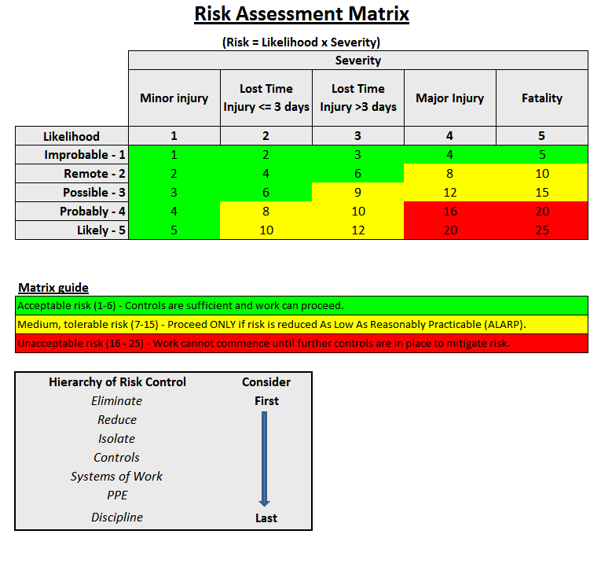

Risk Assessment

Ref. No. | Hazard | Risk to personnel | Who could be harmed? | Initial  Risk Assessment  (without controls) |  |  | L = Likelihood / S = Severity / R = Risk Score | Final  Risk Assessment
 |  |  |  | L | S | R | Controls to be applied | L | S | R
Access & Egress
1 | Access and Egress  Walking To / From  Working Area | Uneven surfaces  Slips / Trips/ Falls  Struck by plant / equipment  Struck / carried by material  Object falling from height | All Employees, Sub-Contractors & Visitors. | 3 | 3 | 9 | Use only the authorised routes for pedestrian access and egress.  High-Viz clothing to be worn at all times.  Remain vigilant and be aware of site traffic and plant movements.  Be aware of other trades and activities in the area and make yourself known when entering someone else’s working area.  Maintain high levels of housekeeping at all times. Do not leave any Tools, Materials or Waste at height.  Store Materials in designated areas and away from any pedestrian walkways or access routes.  Ensure there is suitable exclusion zone and a sufficient signage in place around working areas. | 1 | 3 | 3
2 | Site personnel | Unauthorised access / contact with process / injury | All Employees, Sub-Contractors & Visitors. | 4 | 5 | 20 | Minimum training includes CSCS Training, and Site inductions.  Only trained, competent and authorised persons to undertake work tasks.  Lone working not permitted.  No persons under 16 to undertake tasks under any circumstances. | 1 | 5 | 5
3 | Vehicle Movements | Struck by plant / equipment  Struck by carried material | All Employees, Sub-Contractors & Visitors. | 4 | 5 | 20 | Licensed and authorised drivers only to operate plant / vehicles.  Seat belts to be worn at all times.  Observe on site driving routes and speed limits, Hazard & Warning Lights to be used on all vehicles.  Be aware of other site traffic, plant movements and pedestrians.  Remain vigilant at all times.  Park & Load / Unload vehicles in designated areas only.  No mobile phones to be used while driving, including hands free device. | 1 | 5 | 5
Planning
4 | Temporary Works | Overloading  Structural integrity failure  Crushing / entrapment  Struck by load | All Employees & Sub-Contractors. | 4 | 5 | 20 | Any temporary works e.g. Cranes, Scaffold, Support Steelwork etc. must be installed or erected as per Appointed Person, Temporary Works Coordinator, or as Engineers drawings specify.  Temporary works to be signed off by a Competent Temporary Works Coordinator or Supervisor before any work commences and must then be adhered to.  Temporary works register to be completed and maintained for the project.  If you are unsure ask, don't put yourself or others at risk. | 1 | 5 | 5
5 | CDM | Vehicle movements  Struck by plant / equipment  Fall from height  Interactions with loss of containment / process  Interaction with others | All Employees, Sub-Contractors & Visitors. | 4 | 5 | 20 | Ensure F10 has been completed and displayed on all access points.  Ensure all employees have a CDM induction for the site and adhere to site the site rules.  Ensure all Read and do not deviate from the Job Method Statement & Risk Assessment. | 1 | 5 | 5
Confined Space
6 | Confined Space (Drainage Work / Excavations) | Trapping  Asphyxiation  Gas  Chemicals  Drowning  Fire  Explosion  Equipment left in confined space | All Employees & Sub-Contractors. | 3 | 5 | 15 | Confined space permit to be in place. Atmospheric testing / gas test to be carried out before entry. Emergency evacuation and rescue plan in place.  All personnel to undertake confined space training before entry and rescue plan in place and cascaded and signed by the working party.  Follow safe system of work and wear the appropriate PPE. Safetyman at point of entry at all times with a means of raising the alarm - DO NOT ENTER CONFINED SPACE OR ATTEMPT RESCUE. Sign in/out procedure to be adhered to for personnel and equipment.  All operatives entering the manhole must be wearing a gas monitor in their breathing zone. The Gas monitor must be checked for damage & calibration date before each use.  All operatives involved in the activity will be briefed of the emergency procedure prior to starting work. If gas monitor sounds then the emergency procedure will be followed.  No Hot Work to be carried out - Cold work only. | 1 | 5 | 5
COSHH
7 | Asbestos Containing Materials (ACMs) | Inhalation of asbestos fibres resulting in chronic respiratory injuries (asbestosis)  Contamination of clothing, hair etc. if inadvertently disturbed - spreading of ACMs beyond work area | All Employees & Sub-Contractors. | 5 | 5 | 25 | There is no available Asbestos register for the working site but as a brownfield site it must be considered with the potential for materials to be buried.  Working party carrying out any excavations must have received asbestos awareness training.  If potential ACMs are identified, stop work, vacate and report immediately.  Never knowingly disturb confirmed or potential ACMs.  Follow site emergency procedure in case of inadvertent disturbance of ACMs as per training and induction. | 2 | 5 | 10
8 | Asbestos Containing Materials (ACMs): Non-licensed works | Inhalation of asbestos fibres resulting in chronic respiratory injuries (asbestosis)  Contamination of clothing, hair etc. if inadvertently disturbed - spreading of ACMs beyond work area | Employees  Client personnel  Other contractors  Visitors | 5 | 5 | 25 | Handling of ACMs is only to be undertaken by persons trained in non-licensed works.  Handling, PPE, hygiene, decontamination and disposal controls outlined in detail within job method to be adhered to without fail.  Follow site emergency procedure in case of inadvertent disturbance of ACMs as per training and induction. | 2 | 5 | 10
9 | Gas Cylinders | Asphyxiation / overcome by fumes / death  Explosion / fire / burns | All Employees & Sub-Contractors. | 4 | 5 | 20 | Cylinders to be stored with valve in closed position, upright and to be secured at all times.  Appropriate fire extinguishers to be readily accessible.  Use trolleys to transport cylinders - never roll cylinders flat along the floor. Remove gauges and tubes and close bottle valves prior to moving the bottles.  Use bottle cages for lifting cylinders - do not sling directly to the cylinder.  Store cylinders in a locked, secure and well ventilated cage.  Competent personnel to transport cylinders by vehicle.  Ensure Flash Back arrestors are used along with cable lanyards for all hoses. | 2 | 5 | 10
10 | Solvents, Chemicals, Oils and Paint Products (COSHH) | Personal Injury / Ingestion / Inhalation / Respiration  Occupational Dermatitis / Asthma  Burns / Fire | All Employees & Sub-Contractors. | 4 | 4 | 16 | Use alternative materials where possible (e.g. water based instead of solvent).  Read and make sure you understand and adhere to COSHH risk assessments and Data Sheet for the products in use.  Operatives to use barrier creams, cover skin and wear the appropriate PPE.  Practice good hygiene - wash hands before going to the toilet, smoking, eating or drinking.  Store safely and do not leave tins / containers open when unattended. Store away from ignition sources.  Ensure an eye wash station and first aid kit and burns kit is readily accessible. | 1 | 4 | 4
11 | Working with Cement / Mortar / Concrete (COSHH) | Serious issues through spilling of chemicals and hazardous substances.  Incorrect wearing of PPE or use of substance. | All Employees & Sub-Contractors. | 3 | 4 | 12 | Use relevant COSHH Safety Data Sheet as guide to using substances and PPE requirements.  Ensure skin is fully covered and all required PPE is worn at all times.  Read and make sure you understand and adhere to COSHH Risk Assessments and Data Sheet for the products in use.  Operatives to use barrier creams, cover skin and wear the appropriate PPE (Glasses, Gloves, Wellies).  Practice good hygiene - wash hands before going to the toilet, smoking, eating or drinking.  Store materials safely and do not leave exposed when unattended.  Ensure an eye wash station, first aid kit and burns kit is readily accessible.  Ensure Concrete washout stations are used. | 2 | 3 | 6
Cranes
12 | Mobile Cranes | Overloading  Falling materials  Crushing / entrapment  Struck by load | All Employees & Sub-Contractors. | 5 | 5 | 25 | Ensure ground clearance permit in place and that all relevant drawings for underground services are checked and ground bearing pressure test completed. Temporary works certificate to be in place.  Specific lift plan to be in place, PICOLO to be in charge of crane operations.  Only competent authorised persons to operate crane.  Ensure plant and equipment are stored away from areas where crane loads could come into contact.  Ensure personnel are aware of cranes working in area and do not encroach. Do not work / walk under suspended load and do not place your hands on any load - use push sticks / guide ropes.  Barriers and banksman (distinct Hi-Viz) to be used, only authorised personnel in area.  Maintain radio contact with crane driver and use recognised hand signals. | 2 | 5 | 10
Environment
13 | Outside Working  Adverse Weather:  High winds | Overturning plant / equipment  Struck by plant / equipment  Struck / carried by material  Object falling from height  Hard hat blowing off  Being blown over | All Employees & Sub-Contractors. | 3 | 5 | 15 | Weather check to be carried before commencement of work.  Anemometer to be present and used to carry out wind speed checks pre-work and at regular intervals.  Items to be stored in storage area unless needed for that shift. When in the work area they are to be secured/tied down to prevent being lifted by wind.  Chin strap to be worn on all safety helmets when working at height in exposed and windy conditions. | 2 | 5 | 10
14 | Outside Working  Adverse Weather:  Heavy rain / storm conditions  Wet slippery surfaces  Lightning strike | Slip and fall  Reduced visibility  Reduced grip  Discomfort caused by being wet / hypothermia in extreme cases  Struck by lightning | All Employees & Sub-Contractors. | 3 | 5 | 15 | Weather check to be carried before commencement of work.  Outdoor work to cease in storm conditions i.e. thunder and lightning.  Appropriate wet weather gear to be worn in rainfall.  Wear appropriate footwear with deep treads for grip and move carefully - ensure safe access route to from work e.g. hand rails, safe underfoot conditions.  Use appropriate hand protection to ensure grip where needed.  Use antifogging eye protection and wipe clean if misted. | 1 | 5 | 5
15 | Outside Working  Adverse Weather:  Heavy fog / mist | Reduced visibility  Respiratory problems | All Employees & Sub-Contractors. | 3 | 2 | 6 | Weather check to be carried out before commencement of work.  Work to cease in heavy fog / mist if visibility is sufficiently restricted - report all concerns to Foreman / Site Manager immediately. | 1 | 2 | 2
16 | Outside Working  Adverse Weather:  Sleet / snow / ice / low temperature  Slips and falls  Reduced visibility of ground conditions  Extremes of cold | Slip and fall  Reduced visibility  Reduced grip  Discomfort caused by being cold / hypothermia in extreme cases | All Employees & Sub-Contractors. | 3 | 4 | 12 | Weather check to be carried out before commencement of work.  Work to cease in blizzard conditions.  Appropriate wet weather gear and warm clothing to be worn.  Use grit salt in snow / icy conditions.  Wear appropriate footwear with deep treads for grip and move carefully - ensure safe access route to from work e.g. hand rails, safe underfoot conditions.  Use appropriate hand protection to ensure grip where needed.  Use antifogging eye protection and wipe clean if misted.  Work to cease if visibility is sufficiently restricted - report all concerns to Foreman / Site Manager immediately. | 2 | 4 | 8
17 | Outside Working  Adverse Weather:  High temperature / strong sun | Sunburn  Dehydration  Heat stress- loss of concentration, disorientation | All Employees & Sub-Contractors. | 3 | 4 | 12 | Keep exposed skin covered - Suitable PPE to be worn at all times.  Apply sun block regularly.  Hydrate regularly - drinking water to be readily available to the working party.  Supervisor / Foreman to enforce thermal comfort breaks as required. | 1 | 4 | 4
18 | Dust e.g. Silica (construction dust) or process dust | Inhalation resulting in irritation, potential for chronic respiratory injuries over prolonged periods  Eye injury / irritation | All Employees, Sub-Contractors & Visitors. | 3 | 4 | 12 | Wear appropriate dust masks (FFP1/FFP2/FFP3) - wearers of FFP3 respiratory protection to be clean shaven and have been face fit tested.  Attend to housekeeping regularly and where possible, damp down the work area to reduce airborne dust.  Eye protection is mandatory, use safety glasses with side protectors or goggles at all times. Correct eye protection to be worn depending on task in hand - i.e. Safety glasses to be worn when required by work areas and when using specific tools. Safety goggles to be worn when using disc cutter/grinder.  Eye wash to be readily available at identified areas across site.  Water to be used to suppress large volumes of dust.  Pre-use checks to be carried out. | 1 | 4 | 4
19 | Noise | Potential for disabling condition - hearing damage / noise induced deafness  Reduced awareness of surrounding hazards | All Employees, Sub-Contractors & Visitors. | 4 | 4 | 16 | Remain vigilant at all times.  Suitable hearing protection must be worn by the working party and anyone in the near vicinity during tasks which result in elevated noise levels e.g. during use of power tools generating over 80 decibels.  Operators of power tools to give suitable pre-warning of noise to others in the area and erect 'Noise Exclusion Zone' around working area.  See additional guidance on: https://www.hse.gov.uk/noise/hearingprotection.htm | 1 | 4 | 4
20 | Work Environment / Housekeeping | Slips, Trips & Falls | All Employees, Sub-Contractors & Visitors. | 5 | 3 | 15 | Check the work area regularly and remove waste, unused tools, equipment and materials.  Only those necessary to be in the works area.  Ensure any slip / trip hazards that cannot be rectified are easily identified and brought to the attention of operatives / others.  Maintain good housekeeping at all times.  Leave the work area in a clean and orderly fashion at the end of the job.  Use only authorised routes for access and egress.  Arrange for any spillages or contamination to be cleaned immediately.  Wear appropriate footwear with deep treads for grip and suitable protective gloves for cleaning wastes /other items.  Ensure lighting is adequate - temporary lighting to be supplied where necessary. | 2 | 3 | 6
21 | HAV (Hand Arm Vibration) | Potential for disabling condition - such as carpal tunnel syndrome or vibration white finger | All Employees & Sub-Contractors. | 4 | 4 | 16 | HAV awareness training provided to those using vibration generating tools.  Register of vibration generating equipment and vibration magnitudes on HAVS form - daily usage logs to be completed.  Trigger time to be limited in line with Exposure Action Values (EAV).  Do not exceed Exposure Limit Value (ELV) under any circumstances. If you have been advised of specific controls by occupational health you must adhere to these controls.  Job rotation to be used where necessary to reduce trigger time / exposure.  Try to keep your hands warm. | 2 | 4 | 8
22 | Biological agents:  Legionella / Leptospirosis (Weil's Disease), Hepatitis A,B,C, Tetanus (Lock Jaw), Toxocariasis (Round worm) | Inhalation of large amounts in water droplets  Contamination of open cuts / wounds | All Employees & Sub-Contractors. | 4 | 4 | 16 | All Water Fountains and Cabin Water Supplies to be tested and cleaned regularly.  The bacteria multiply where temperatures are between 20-45°C and nutrients are available. The bacteria are dormant below 20°C and do not survive above 60°C.  Pre-occupation water sampling has been carried out. Report any signs of unusual illness / sickness / skin irritations immediately to your first-aider / Supervisor/Site Manager.  Wear suitable PPE and RPE and cover any open cuts / wounds. Wear barrier cream and ensure skin is covered. | 1 | 4 | 4
23 | Oil / Grease | Slips, trips & falls  Skin irritation  Fire | All Employees, Sub-Contractors & Visitors. | 4 | 3 | 12 | Wear barrier cream and correct PPE, in particular suitable gloves and safety glasses  Correct fire extinguishers in date and tagged to be present  Inspect area before, during and 1 hour after Hot Works in case of any rouge sparks / embers.  Maintain good housekeeping - any oil spillages to be cleared up with absorbent granules and disposed of in the correct oil bins.  Grease to be cleaned up and disposed of immediately. | 1 | 3 | 3
24 | Working on / over / near water | Drowning  Hypothermia | All Employees, Sub-Contractors & Visitors. | 3 | 5 | 15 | Rescue plan to be in place to include specific named, trained and competent rescue personnel.  Life float rings to be readily accessible and rescue personnel to be informed immediately.  Heat wraps (foil jackets) to be available in site compound.  Working Area and activities to have specified controls in place before work starts to prevent water contamination. | 1 | 5 | 5
25 | Third-parties working overhead, below or in same area | Dropped / falling objects  Interactions / risks introduced by processes being carried out or products being used by client / other contractors | All Employees, Sub-Contractors & Visitors. | 3 | 5 | 15 | Ensure personnel are aware of other trades and activities in the area and that they are aware of our planned activities.  Bolt boxes / buckets to be used to contain small items.  Warning signage to be displayed where working overhead.  Undertake a Two minute risk assessment to ensure working conditions haven't changed.  Exclusion zone and communication process to be in place.  Tool lanyards to be in place. | 1 | 5 | 5
26 | Animals: Birds | Exposure to / inhalation of bird droppings  Attack by birds | All Employees, Sub-Contractors & Visitors. | 4 | 2 | 8 | Work area to cleaned prior to commencement of work.  Avoid contact with bird droppings.  Long sleeves & gloves to be worn to avoid skin contact.  Wash hands before eating. Good hygiene rules to apply.  Nesting birds can be very protective of their nests and will attack if they feel threatened. Avoid nesting areas during nesting season. Spatial awareness to be considered in work permit process. | 1 | 2 | 2
27 | Animals  Rats  Rabbits  Bats  Foxes / Other | Weil's disease  Infections | All Employees, Sub-Contractors & Visitors. | 4 | 4 | 16 | Cover any grazes or cuts with waterproof dressings whilst at work.  Wash any new cuts or grazes immediately with soap and running water and cover with waterproof dressings – advise site manager/first aider .  Wear suitable protective gloves and clothing .  Wash hands regularly with soap and water - after handling contaminated clothing, soil, materials or any animal Always wash hands before eating, drinking or smoking.  Dispose of food scraps in a closed bin and clean up after eating.  Report any sightings of rats, water voles, other pests .  Do not touch rats or other pests.  Report to your Supervisor/First Aider/Site Manager if you feel unwell. | 1 | 4 | 4
28 | Contaminated Land | Hydrocarbons  Gas  Fuels  Toxic Substances | All Employees & Sub-Contractors. | 4 | 5 | 20 | Relevant task specific PPE to be worn at all times. E.g. FFP3 Masks, task specific rubber gloves, and sealed boots.  Soil testing to be carried out and communicated before any excavation works.  Soil stabilisation techniques to be used where possible and excavated materials to be treated.  Wash hands regularly but particularly before smoking, eating or drinking.  All trenches and excavations to be suitably supported where required and a gas monitor is to be inserted and remain for a minimum of 15 minutes to establish any potential gasses. Any persons entering trenches or excavations to be fitted with 3in1 Gas monitors. Monitors are to be checked before use and only used if within date. | 2 | 5 | 10
29 | Existing Services |  | All Employees & Sub-Contractors. | 3 | 4 | 12 | Ensure utility drawings and service master plan is reviewed with Ground Clearance, CAT Scan & Permit is in place with known services marked out.  Where possible, services should be isolated or disconnected.  When working near to services express caution and don’t use any heavy machinery. i.e. hand excavation to be used in tandem with the excavator. | 1 | 4 | 4
Fire & Hot Work
30 | Smoking / e-Cigarettes / lighters / matches | Fire / explosion | All Employees, Sub-Contractors & Visitors. | 3 | 5 | 15 | Smoking is only permissible at designated points and times and in line with the site smoking policy.  Ensure used cigarettes are disposed of in the designated bins.  E-cigarettes, lighters and matches are to be stored away from the work area and clear of any flammable substances. | 1 | 5 | 5
31 | Hot Work | Sparks / fire / burns | All Employees, Sub-Contractors & Visitors. | 4 | 5 | 20 | Ensure Hot work permit is in place prior to starting work.  Observe hot work permit control measure (e.g. fire watch for 1 hour after cessation of hot work).  Dedicated trained fire watch required with suitable fire extinguisher to be readily accessible.  Appropriate PPE must be worn during hot work operations. Clear visor with safety glasses beneath / goggles to be worn by any persons within a 5m radius of any hot work i.e. burning, welding and grinding activities.  Always check area for flammable and combustible materials / vulnerable fixed plant. Remove / cover with fire blanket before undertaking any hot work activities.  Ensure any sparks from hot work activities are contained by use of fire resistant blankets.  Damp down the area prior to starting hot work activities.  Only competent persons to operate hot work equipment.  Ensure a first aid kit specifically stocked for the treatment of burns (i.e. burn kit) is readily accessible. | 1 | 5 | 5
32 | Grinding  up to 7" maximum | Sparks, fire  Lacerations / amputation  Struck by debris | All Employees, Sub-Contractors & Visitors. | 4 | 5 | 20 | Competent persons only to operate grinders. Only persons trained in the use of abrasive wheels to change discs / wheels.  Ensure hot work permit is in place and adhered to.  Dedicated fire watch required and suitable fire extinguisher to be readily accessible.  Always check area for flammable and combustible materials and remove / cover before undertaking any grinding activities.  Ensure that where necessary, sparks from grinding operations are contained by use of fire resistant blankets.  Guards and handles to be in place on grinders at all times.  Goggles and appropriate PPE must be worn during grinding operations. Clear visor with safety glasses beneath / goggles to be worn by any persons within a 5m radius of any burning, welding and grinding activities.  Ensure the wheel comes to a complete stop before placing down on floor or work surface. | 1 | 5 | 5
33 | Grinding  9" | Sparks, fire  Lacerations / amputation  Struck by debris | All Employees, Sub-Contractors & Visitors. | 4 | 5 | 20 | Only to be used when agreed by Site Manager & H&S Officer and a risk assessment in place.  Competent persons only to operate grinders. Only persons trained in the use of abrasive wheels to change discs.  Ensure hot work permit is in place and adhered to.  Dedicated fire watch required and suitable fire extinguisher to be readily accessible.  Always check area for flammable and combustible materials and remove / cover before undertaking any grinding activities.  Ensure that where necessary, sparks from grinding operations are contained by use of fire resistant blankets.  Guards and handles to be in place on grinders at all times.  Goggles and appropriate PPE must be worn during grinding operations. Clear visor with safety glasses beneath / goggles to be worn by any persons within a 5m radius of any burning, welding and grinding activities.  Ensure the wheel comes to a complete stop before placing down on floor or work surface. | 1 | 5 | 5
34 | Flame Cutting Operations | Sparks, fire | All Employees, Sub-Contractors & Visitors. | 5 | 5 | 25 | Only competent persons to use flame cutting equipment.  Ensure hot work permit is in place and adhered to.  Always check area for flammable and combustible materials / vulnerable fixed plant. Remove / cover with fire blanket before undertaking any burning activities.  Ensure that where necessary, sparks from burning operations are contained by use of fire resistant blankets.  Dedicated fire watch required and suitable fire extinguisher / charged hose to be readily accessible.  Wear the appropriate PPE for the task. Clear visor with safety glasses beneath / goggles to be worn by any persons within a 5m radius of any burning, welding and grinding activities.  Powered Air Purifying Respirator (PAPR) to be worn at all times during flame cutting activities with anyone in a 3m radius wearing a FFP3 Mask.  Flash back arrestors must be fitted and non-return valves to be in place at lamp end of hoses. | 1 | 5 | 5
35 | Welding Operations | Sparks, fire  Radiation burns  Arc-eye  Struck by spatter  Inhalation of fume | All Employees, Sub-Contractors & Visitors. | 5 | 5 | 25 | Only trained and qualified persons to use welding equipment.  Ensure hot work permit is in place and adhered to.  Always check area for flammable and combustible materials / vulnerable fixed plant.  Remove / cover with fire blanket before undertaking any burning activities.  Ensure that where necessary, sparks from welding operations are contained by use of fire resistant blankets. Dedicated fire watch required and suitable fire extinguisher to be readily accessible.  Powered Air Purifying Respirator (PAPR) to be worn at all times during welding activities. RPE (min. FFP3) to be worn by third-parties in the immediate vicinity.  Wear the appropriate Pro-Ban PPE. with Welding Gauntlets being worn at all times.  Clear visor with safety glasses beneath / goggles to be worn by any persons within a 5m radius of any burning, welding and grinding activities.  Unless outside, LEV's should be used where possible. If the use of LEV has been assessed and is not practical due to the work location - PAPR & RPE are to be used as primary control measure for fume.  Use screens to protect third-parties against U/V flash. | 1 | 5 | 5
36 | Welding Sets | Fire  Electric shock  Spillage | All Employees, Sub-Contractors & Visitors. | 5 | 5 | 25 | Ensure set is earthed close to the job.  Ensure spark arrestor fitted.  Inspect cables and set for condition pre-use.  Fire extinguisher to be readily available.  Drip tray to be placed beneath fuel sets.  Fuel to be stored in metal jerry can, remote from areas of hot works. Spill kit to be readily accessible.  Route weld cables away from walkways. | 1 | 5 | 5
Lifting Activities
37 | Lifting equipment | Overloading  Falling materials  Crushing / entrapment  Struck by load | All Employees, Sub-Contractors & Visitors. | 4 | 5 | 20 | All lifting to be carried out by a competent person.  Exclusion Zones to be used and controlled by competent people.  All lifting equipment to be in good working order, to have current certificate and display the correct coloured inspection tag.  Visual checks of equipment to be carried out by a trained and competent person before use. Remove damaged equipment from use and place in quarantine.  Lifting equipment to be used within safe working load capabilities (include weights of all items being lifted and additional chain/hook/etc. weights)  Store lifting equipment in appropriate storage locations away from the elements or where they might me susceptible to damage. | 2 | 5 | 10
38 | Lifting activities  (inc. Test Lifts) | Overloading  Falling materials  Crushing / entrapment  Struck by load | All Employees, Sub-Contractors & Visitors. | 5 | 5 | 25 | Lifting operations to be carried out by trained, competent personnel.  PICOLO to be appointed to supervise all lifts.  Load to be calculated and recorded on lift plan.  Do not walk/work under suspended loads / control area to avoid access by other.  Do not place your hands on any load - use push sticks / guide ropes and keep out of the line of fire.  Use of a barriered area and warning signs to be employed.  Temporary works certificate to be in place.  Store lifting equipment in appropriate storage lockers. | 2 | 5 | 10
39 | Loading / Unloading of Equipment | Falling or dropped loads -  Crush / strike injury  Equipment damage | All Employees, Sub-Contractors & Visitors. | 3 | 5 | 15 | Exclusion zone to be in place when vehicles are loading and offloading.  All lifting equipment to be within its inspection date and checked for damage.  Delivery vehicle to be parked in designated location with handbrake applied and keys removed.  Adhere to 3-metre exclusion zone and use driver safe haven.  Where practicable use mechanical means of loading / unloading.  If manual handling is required use best practices as taught in the manual handling course.  Check condition of vehicle bed before accessing. If not safe, do not access, turn delivery away and contact haulier.  Access / egress to the vehicle bed is by approved means only. If access to the vehicle bed is required, fall protection measures must be in use including impact protection, safety helmet with chin strap (fitted and worn).  Hi-Viz to be worn.  Banksman to be in place. | 1 | 5 | 5
Manual Handling
40 | Manual Handling | Musculoskeletal injuries  Strains and sprains  Injury resulting from dropped load e.g. broken bones  Cuts / abrasions | All Employees, Sub-Contractors & Visitors. | 5 | 4 | 20 | All personnel to have Manual Handling Training.  Use mechanical handling in preference of manual handling where practical.  Follow TILE guidance: Task, Individuals Capabilities, Load, Environment.  Where manual handling is unavoidable adhere to best practices e.g. lift from the knees keeping your back straight, do not exceed comfortable weights when lifting alone.  Be aware of your personal limitations and take into account any medical conditions which may impact your ability.  Assess the load - What does it weigh? Is it easily handled? Use team lifting where appropriate - do not risk injury.  Ensure that the handling route is clear of slip / trip / fall hazards, work environment to be kept clear at all times.  Wear gloves where appropriate for grip and protection against cuts / abrasions.  Suitable safety footwear to be worn. | 2 | 4 | 8
Plant & Equipment
41 | Hand tools | Struck by tool resulting in hand / finger injury  Struck by debris resulting in eye injury | All Employees & Sub-Contractors. | 4 | 3 | 12 | Ensure all tools are in good condition before using them - quarantine if not.  Ensure the correct tool is used for the application e.g. never use a screwdriver as a chisel, don't cut corners.  Use tool guards, finger savers etc. wherever possible.  Keep hands and fingers clear of potential impact or pinch points.  Maintain full concentration and keep your eyes on the task at all times.  Maintain housekeeping standards and store tools safely when not in use.  Wear suitable gloves and eye protection for the task.  Clean tools after use and ensure that they are maintained in good condition. | 1 | 3 | 3
42 | Electric Power / Battery Tools & Extension Leads | Electric shock  Trip / fall | All Employees, Sub-Contractors & Visitors. | 4 | 5 | 20 | All tools to be 110V.  All electrical power tools, extension leads and chargers must carry a current PAT test label.  Inspect tools for condition before use e.g. look for wear or damage to plug, cord, controls, tool body etc.  Take out of use and report damage to your Supervisor / Foreman.  Only competent and authorised persons to operate electrical equipment.  Power leads to be routed so as not to present a trip hazard. | 2 | 5 | 10
43 | Refuelling / Using Plant and Equipment  Generators  etc. | Fire  Explosion  Spillage | All Employees, Sub-Contractors & Visitors. | 5 | 4 | 20 | Ensure all plant and equipment is in good condition before use - quarantine if not.  Ensure plant and equipment is in a safe location during use.  Ensure equipment is switched off prior to refuelling.  Fire extinguisher to be readily available.  Fuel to be stored in metal jerry can, remote from areas of hot works.  Drip tray to be placed beneath fill up points.  Spill kit to be readily accessible. | 1 | 4 | 4
44 | Material Conveyors  Rotating Machinery  Pinch Points | Entrapment  Entanglement  Crushing | All Employees, Sub-Contractors & Visitors. | 5 | 5 | 25 | Ensure an exclusion zone has been erected around conveyors when in use.  If necessary to work nearby then ensure conveyor guards are in place and adequate to stop any impact / trapping.  Ensure the conveyor has been isolated when not in use. Conveyors can stop and start without warning if not isolated.  Do not ride conveyor belts or bypass safety devices.  Keep loose clothing / hands away from rotating rollers, moving conveyor belts and pinch points. | 1 | 5 | 5
45 | Operating Plant - Lifting Equipment e.g. Telehandler, Fork-Truck etc. | Overloading  Overturning  Crushing / entrapment  Struck by load | All Employees, Sub-Contractors & Visitors. | 5 | 5 | 25 | Only trained, competent and authorised personnel to operate machinery and seat belts to worn. A suitably sized oil spill-kit to be easily accessible.  All lifts to be assessed by driver before commencing. Load to be calculated and lifting equipment to be used within safe working load capabilities.  Lift plan to be completed by the PICOLO and in place for non-palletised loads. Do not sling directly off the forks under any circumstances. 3m exclusion zone and driver safe havens required when loading / unloading vehicles.  Thorough examination records of machinery to be available for inspection and pre-use safety check to be recorded and report damage immediately including checks of ground conditions.  Do not work / walk under suspended load and do not place your hands on any load - use push sticks / guide ropes.  Switch engine off, apply handbrake and remove keys when unattended.  Barriers and banksman (red Hi-Viz) to be used, only authorised personnel in area.  Working amber beacon, reversing alarm and Fixed (secure) seat. Secure engine covers and Fuel tank filler cap. | 1 | 5 | 5
46 | Operating Plant - Other Equipment e.g. Excavator, dumper etc.. | Overloading  Overturning  Crushing / entrapment  Struck by load | All Employees, Sub-Contractors & Visitors. | 5 | 5 | 25 | Only trained, competent and authorised personnel to operate machinery and seat belts to worn.  Thorough examination records of machinery to be available for inspection and pre-use safety check to be recorded and report damage immediately including checks of ground conditions.  Do not work / walk under suspended load and do not place your hands on any load - use push sticks / guide ropes.  Switch engine off, apply handbrake and remove keys when unattended.  Barriers and banksman (red Hi-Viz) to be used, only authorised personnel in area.  Working amber beacon, reversing alarm and Fixed (secure) seat. Secure engine covers and Fuel tank filler cap.  A suitably sized oil spill-kit to be easily accessible.  Cab to be cleaned after every shift.  Do not use on steep incline - Point of Work Risk Assessment to be carried out and recorded. | 1 | 5 | 5
Process Safety
47 | Live electrical equipment | Electric shock | All Employees & Sub-Contractors. | 4 | 5 | 20 | Ensure that all power sources are isolated or disconnected before starting any work.  Supervisor / Foreman to make the working party aware of isolations in place before commencing work. | 1 | 5 | 5
48 | Hazardous Dust /  Fumes / Gases / Vapours from Galvanised coatings on steel work. | Inhalation  Ingestion  Absorption | All Employees & Sub-Contractors | 4 | 4 | 16 | Mandatory wearing of FFP3 masks for all hot work and grit blasting activities. Face fitting to be carried out on all individuals. Welder / Fabricator to wear PAPR at all times.  Practice good levels of personal hygiene. Prior to eating, drinking, smoking or using a mobile phone thoroughly wash your hands, arms and face. When taking meal breaks remove overalls and store in a separate location away from welfare amenities.  All contaminated PPE to be cleaned on a weekly basis by a specialist industrial cleaning firm able to deal with lead contaminated garments. No contaminated PPE or footwear to be taken home for washing or cleaning.  Disposable overall can be used for non-hot work areas. All disposable PPE to be disposed of as hazardous waste. Regularly communicate work instructions, planning and information to all personnel. | 1 | 4 | 4
49 | Compressed Air  Air Tools | Injection of particles  (skin / eyes)  Pulmonary embolism  Excessive noise  Vibration from tools  Slips / Trips / Falls  Struck by flying hose | All Employees & Sub-Contractors | 3 | 5 | 15 | Only competent operatives to use compressed air. Follow safe system of work and wear the appropriate PPE.  Ensure pressure in the line is compatible with equipment to be used.  Ensure that the system is in good working order complete with service records and inspect the condition of the hose and tools before use. Ensure hose whip-end protectors are fitted before use.  Ensure the air supply and equipment is turned off when attaching / removing equipment.  Hang trailing hoses out of the way and secure keep hoses as short as possible and as close to work area as possible.  Do not use Compressed Air to blow self or others down. | 1 | 5 | 5
Working at Height
50 | Work at height: Objects at height | Struck by dropped / falling object | All Employees, Sub-Contractors & Visitors. | 4 | 5 | 20 | Establish exclusion zone beneath working area - segregate and place signs warning of overhead work.  Bolt boxes / buckets to be used to contain small fixings and tools at height. Materials to be stored safely.  Any tools in use in critical areas to be restrained by fall arrest lanyard.  Safety Nets to be installed where required in critical areas.  All items to be cleared from working area at end of shift, housekeeping to be maintained during activity.  Safety man at ground level to monitor exclusion zone. | 2 | 5 | 10
51 | Work at height: Fixed scaffold | Fall from height  Scaffold collapse | All Employees & Sub-Contractors. | 4 | 5 | 20 | Scaffolding to be erected or altered by competent scaffolding contractor only.  Ensure valid Scaff-tag in place before accessing scaffold - do not access without this being in place and in date.  Inspect scaffold at start of shift and report any defects immediately.  Use recognised access points only, maintain three points of contact when ascending or descending.  Do not work outside, climb or stretch out of the scaffold perimeter under any circumstances. If scaffold is not adequate or suitable report to your Supervisor/Foreman.  Gates to be closed when not in use.  Housekeeping to be maintained during activity and keep walkways clear.  Ensure scaffold is re-inspected weekly and again following high winds / storm.  Chin-strap to be worn on all safety helmets at height. | 1 | 5 | 5
52 | Work at height: Mobile scaffold tower (MST) | Fall from height  Scaffold collapse / topple  Unsecured scaffold moving | All Employees & Sub-Contractors. | 5 | 5 | 25 | Scaffolding to be erected, altered and dismantled by PASMA qualified personnel only and recorded on the MST register.  Ensure valid Scaff-tag in place before accessing scaffold - do not access without this being in place and in date.  Inspect scaffold at start of shift including ground conditions and report any defects immediately.  Ensure scaffold is re-inspected weekly and again following high winds / storm and recorded on the MST register.  Outriggers to be extended and fixed in place, casters to be secured.  Trap doors and gates to be fitted and closed when not in use, only recognised access points to be used, maintain three points of contact when ascending or descending.  Do not work outside, climb or stretch out of the scaffold perimeter under any circumstances. If scaffold is not adequate or suitable report to your Supervisor/PICWP  Safety harnesses and lanyards must not be used when working on mobile tower scaffold under any circumstances. | 1 | 5 | 5
53 | Work at height: MEWP / scissors lift  Note: Genie Z135/70 MEWP models are not to be used under any circumstances  https://www.hse.gov.uk/safetybulletins/mewp-genie-z135-70.htm | Fall from height  Impact with personnel  Impact with plant or equipment | All Employees & Sub-Contractors. | 5 | 5 | 25 | MEWP for internal/restricted height access must be suitable and fitted with a secondary guarding system to avoid controls being operated accidentally.  MEWP to be operated in accordance with manufactures instructions and the working area is controlled via bollards, bunting and safety person at all times.  MEWP operator and safety man at ground level to be IPAF trained and familiar with controls of the specific MEWP. Ensure ground controls remain accessible at all times and control key is available.  Thorough examination records of MEWP to be available for inspection. Pre-use safety check to be recorded including check of ground conditions. Work at height to cease if wind speeds exceed 23mph (Force 5)  Do not climb out of the basket or stand on the mid-rail under any circumstances. Maintain full concentration / spatial awareness when operating the equipment e.g. overhead / underground services and protruding objects  Safety harnesses and fall restraint lanyard to be worn at all times and securely fixed to suitable anchorage. Harness / lanyard users to be trained.  Rescue plan to be in place and followed in the event of an emergency. | 1 | 5 | 5
54 | Work at height: Rope access | Fall from height  Damage to anchor line from sharp edge, hot surface, power tool or corrosive substance. | All Employees & Sub-Contractors. | 5 | 5 | 25 | Only IRATA trained personnel to carry out rope access. Rope Access manager & L3 IRATA Supervisors to approve all rope access activities.  All rope access to be carried out in accordance with safe working procedure. All RA technicians to have 2 point rope access at all times.  Job specific rescue plan to be completed by IRATA Level 3 before work commences.  Ensure the Hierarchy for protection of anchor line as detailed in Annex P of the ICOP is followed.  All tools and equipment to be attached to Operative or other anchorage by the use of lanyards.  Construction/deconstruction materials to be securely shackled prior to lowering. Small waste material to be bagged. | 1 | 5 | 5
55 | Work at height: Ladders | Fall from height | All Employees & Sub-Contractors. | 5 | 5 | 25 | Only use ladder suitable for the task and specified in the JMS.  Ladder users to be competent in the use  of ladders and only used for light work and short durations.  Inspect ladder for condition pre-use i.e. stiles, feet, rungs, locking mechanisms.  Ladder to be angled at 75° - use the 1 in 4 rule (1 unit out for every 4 units up).  Tie / foot the ladder to prevent it from slipping either outwards or sideways and rest against a strong point.  Grip the ladder and face the ladder rungs and maintain three points of contact when ascending or descending ladder.  Only carry light materials and tools via belt or backpack and don’t overload the ladder  Ladder : Never work off the top 3 rungs, make sure the ladder extends at least 1m (three rungs) above where you are working. Do not lean / stretch sideways. Don’t try to move or extend ladders while standing on the rungs.  Stepladder : Never work off the top 3 steps or platform unless there is a suitable handhold. Do not lean / stretch sideways. Try to work forward not sideways i.e. facing the task if you need to work side on have someone to support the ladder.  Don’t try to move the stepladder while standing on the rungs. | 2 | 5 | 10
56 | Work at height: Excavations | Fall from Height  Damage to Machinery  Excavation Collapse | All Employees & Sub-Contractors. | 3 | 5 | 15 | Excavations to be carried out in designated areas with correct surveys and permits in place.  Excavation to be in accordance with HSG 47.  Ensure shoring / sloping sides are used as directed.  Inspect Excavations before commencing any work and after any periods of heavy rain.  Do not access any Excavations without safety measures in place and authorisation from the Site Manager.  Ensure fences and signage is installed around any excavations to segregate access.  Vehicles and Machinery to be kept away from edges of Excavations. | 1 | 5 | 5
Miscellaneous
57 | COVID-19  Coronavirus / Infectious or Viral Infections | Respiratory  Infection | All Employees, Sub-Contractors & Visitors | 5 | 5 | 25 | If someone becomes unwell with a new, continuous cough or a high temperature - report the symptoms to your Supervisor.  Persons who develop the symptoms should be sent home and advised to follow the Government guidance on the Coronavirus pandemic.  Wash hands frequently for at least 20 seconds in soap and water.  Use hand sanitizers when soap and water are not available e.g. when out on site.  Avoid touching your face or surfaces with your hands.  Frequently clean and disinfect objects and surfaces that are touched, using standard cleaning products. especially before and after breaks.  Stagger start times and meal breaks to reduce the numbers in the same vicinity at any one time.  Maintain high levels of housekeeping and dispose of rubbish in the bins provided. Clean and empty the bins on a frequent basis.  Catch coughs and sneezes in tissues and bin them.  Where practicable maintain a social distance of at least 2m.  If this is not practicable because of the task ensure the correct PPE (gloves, FFPP3 mask and clear face visor) are being worn.  Have workwear regularly washed or laundered and changed frequently. | 2 | 5 | 10

Environmental Arrangements
This project provides us with a variety of challenges both inside and outside of our site limit. Local authorities (HSE, EHO, NRW) will be notified of our strategy before execution starts, and will be contacted throughout. The Project Manager is responsible for ensuring that any trees and hedgerows are safeguarded in compliance with planning requirements and / or tree preservation orders.
Any protected species discovered on site must be reported to the project Environmental Manager (Llinos Rees), who will ensure that suitable actions are taken and the necessary authorities are alerted.
If any such finds are made, all work in these areas will be suspended until the appropriate authorities / individuals are contacted and a rectification and/or prevention strategy is put in place to address the situation.
For further information and detail please refer to the Environmental Impact Assessment & Environmental Statement prepared by Timothy Rees (1807470).

Emergency Contacts
Emergency & Utility Services
Police | 999 (Swansea Central)
Ambulance | 999
Fire (Emergency) | 999
Hospitals | Morriston Hospital, Heol Maes Eglwys, Cwmrhydyceirw, Morriston, SA6 6NL.
Hospitals | Neath and Port Talbot Hospital, Baglan Way, Port Talbot, SA12 7BX – 01639 862160.
Fire (Swansea Central) | 0370 606 0699
HSE | 0845 345 0055
Environmental Agency | 0800 807 060
Welsh Water | 0800 052 0130
Western Power | 0800 052 0400
Wales and West Utilities | 0800 111 999
Site Contacts
Site Office | To be confirmed and signposted at site set up.
H&S Manager | Hannah Rees – 07855 346721
Site Safety Officer | Alex Williams – 07775 433222
Site Manager | Aled Owen – 07884 673922
First Aiders | To be confirmed and signposted at site set up.
Fire Wardens | To be confirmed and signposted at site set up.

A&E Location and Directions
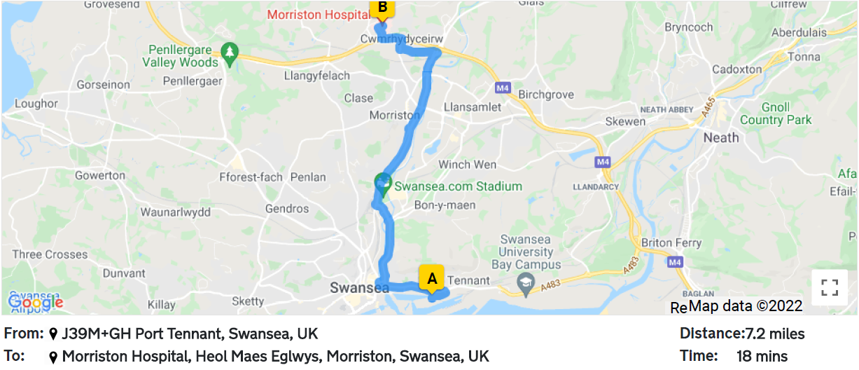


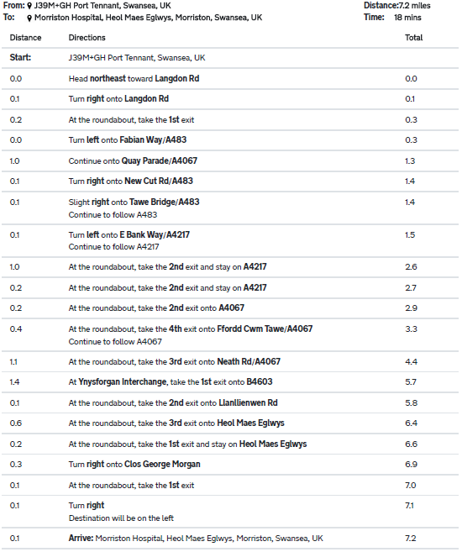
Figure 2 - Emergency Route to Morriston Hospital (Davies, 2022)

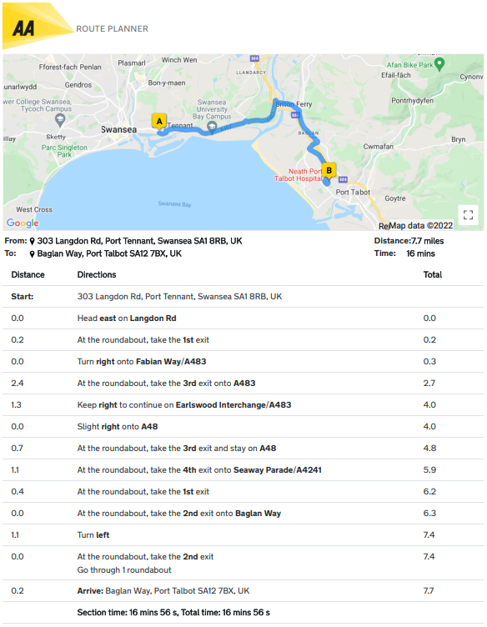
Figure 3 - Emergency Route to NPT Hospital (Davies, 2022)

Bibliography
Baptie, P., 2019. Surveyor's Guide to Unexploded Ordnance. [Online]
Available at: https://ww3.rics.org/uk/en/journals/land-journal/surveyors-guide-to-unexploded-ordnance.html
[Accessed -9 03 2022].
Docks, S. &. P. T., 2021. Swansea & Port Talbot Docks. [Online]
Available at: http://www.swanseadocks.co.uk/docksnewsite/buildingkings.html
[Accessed 03 2022].
Enva, 2022. How Contaminated Soil Affects Construction Projects. [Online]
Available at: https://enva.com/case-studies/contaminated-soil-in-construction-projects#:~:text=Remediating%20Contaminated%20Soil,it%20is%20surplus%20to%20requirements.
[Accessed 09 03 2022].
GOV.UK, 1990. Environmental Protection Act 1990. [Online]
Available at: https://www.legislation.gov.uk/ukpga/1990/43/contents
[Accessed 23 02 2022].
Kingspan, 2022. What is an inverted roof?. [Online]
Available at: https://www.kingspan.com/gb/en-gb/products/insulation-boards/insulation-technical-hub/articles-and-advice/what-is-an-inverted-roof
[Accessed 02 05 2022].
NetRegs, 2018. How to manage surface water drainage. [Online]
Available at: https://www.netregs.org.uk/blog/how-to-manage-surface-water-drainage/
[Accessed 23 02 2022].

