Module Code- ACE - BMSK4001

Prepared By:
Sanzina Rahman
Student Number (ID): 1812578
Group 3

MODULE Name:
Academic and Employability Skills

Prepared for:
Shao Yuen

Assignment Task: Write a report of 2,000 words, in which you provide an analysis of relevant employability skills that you have, or need to develop in the future to gain credibility in search of employment opportunities. You need to consider the perspective of an employer trying to recruit.

Content page:

In this report I am going to explain 3 skills that I learned from this course and applied in my day to day life;
First I am going to explain,
- Mind-set for personal development identifying skill.
- What is employability skill?
- SWOT Analysis of my skills.
- What does an employer look from the employee?
Secondly I will explain,
- Prioritising/ time management skill.
- The Key qualities to improve these skills.
- Eisenhower method
- KOLB CYCLE
Lastly I am going to explain,
- My third skill simultaneously with the above 2 other skills.

Mind-set for personal development identifying your skill

In today’s world academic qualification is a very important tool. But in reality employers are often looking for skills that can go beyond qualification and experience, cause education and experience may make you qualified to apply for the job but to be successful in that job you will need some other inner skills as well. When you are new in a job the employer will usually teach some specific skill that is required for the particular job. But he will expect from you to put some employability skills in the job at the same time.
Now the question is what is employability skill? It is a combination of a couple of skills. Like;

- Communication through the workplace:
This communication can be verbal or non-verbal. For example; As I work in a pharmacy communication throughout the whole day is very important. For example, whenever any customer arrives with a prescription we need to check with the dispenser if the item is available or not. Then the dispenser will transfer the item to the pharmacist. Finally, pharmacist will confirm it, pack it, and handed over to the patient. The whole process is a big chain of flawless communication. Any miscommunication can mess the whole system all together. Like, if the dispenser doesn’t say whether we have the item or not then the pharmacist won’t be able to know that we have got a script to do. The same thing goes for the whole team. Without communication we won’t be able to run an efficient pharmacy.
- Team working:
This skill is to work within a group in the workplace. For example, in my workplace a complete team work is mandatory. The whole system won’t be able to work efficiently and smoothly without a strong team. At first, the dispenser will help the pharmacist to make sure that they are dispensing the right medicine in a right amount. Then the inventory team will help them by doing the checking of inventory and ordering the new item for next day. If the full team does not cooperate with the pharmacist then it will be impossible for her alone to run the business.
- Transferable skills:
Transferable skills are basically portable skills. For example, in time of changing career then these transferable skills can work as a strong positive point for the applicant. It doesn’t matter if the previous experience is relevant or not to the new job but still if you can show that you can transfer your previous experience to the new job and make some good difference in the work place then it will be a very satisfactory point for the employer. Lack of experience for the relevant sector will not be an issue then.
Like for me, I worked for 2 years in the administrative sector. Then I moved to the retail job ladder. From there now I moved to a complete new kind of job, pharmacy job. In every sector I was able to transfer my skills. When I apply for any new job I put my transferable skills on the top. My previous knowledge about record keeping and customer handling gave me an advantage for my pharmacy job. My employer focused on my transferable skills rather that my lack of direct experience in the time of my appointment.
- Academic skills:
Academic skills are very important. For example, if I don’t know what does a certain medication is for or who is allowed to take it and who is not and what will be the consequence of any wrong handling then it can affect not only me but the whole business. Academic knowledge gives us the privilege to do our job confidently and effectively.

SWOT Analysis
It is always helpful for own improvement to know about your own strength, weakness, opportunity and threats all the time. I have done my swot analysis to get a clear picture of my strengths and weaknesses.

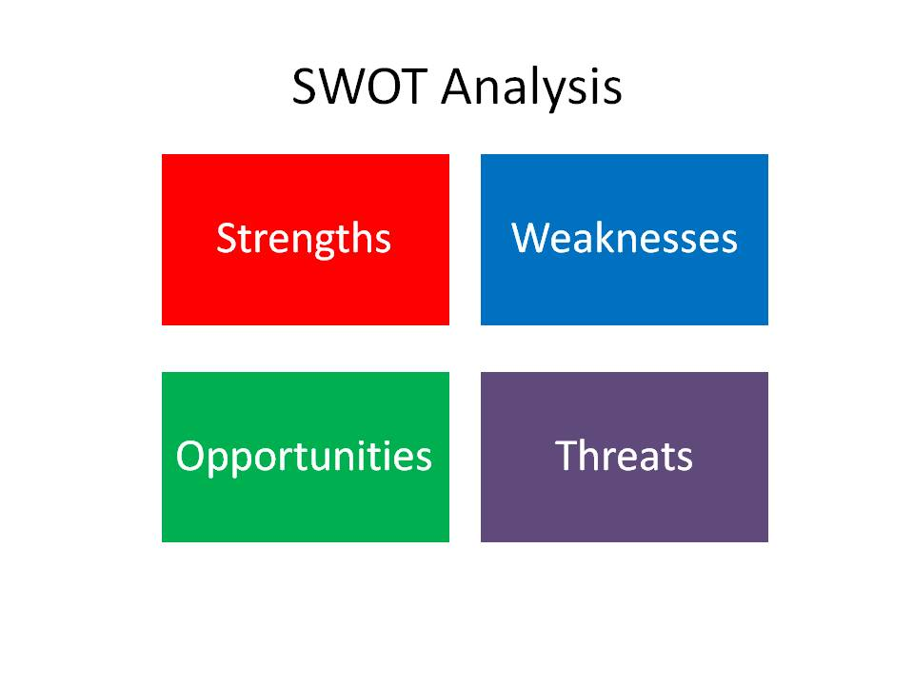
Source: Albert Humphrey (1960s and 1970s)

- My strengths are:
Work experience: My different kinds of work experience which I obtained from my previous jobs. Every place has given me a fresh experience of handling different situation and helped developing coping mechanism.
Educational background: To be a pharmacy worker it’s mandatory to do a certified course. It’s not legal to work without a pharmacy education certificate. It is my biggest strength to have that certificate to do my job.
- My Weaknesses are:
Limited technical knowledge: As I am still very new in my job, I am still learning a lot every day. This lacking sometime makes me lose my confident and I hope to overcome this lacking through academic knowledge and work experience as well.
Negative personal characteristics: I am very introvert. I tend to follow the instruction blindly instead of asking question. This does not portray a confident picture of my character.
- My opportunities:
Enhancing education: By doing some related course I can enhance my technical knowledge and convert my lacking in to an opportunity to improve and prepare myself for the next level up.
Strengthening my network: In today’s world networking skill is a very important skill. I need to have knowledge about what is happening in my work field. What new rules, regulation is coming. Always need to be up to date.
- Threats:
Competition in your field: Every year there are fresh graduates are adding in the work force. In the pharmacy there is usually only one person required for my post that’s why it is very competitive in my field to get a good opportunity.
Training & educational obstacles: There are lacks of training available to do free of cost in my field. And all the paid ones are very expensive to do at a time.

Now the question arises that what does an employer look from the employee?
The answer is dependability, trustworthy, and responsible.

- Being dependable:
1. Reducing the employer’s workload
2. Reducing stress.
This sound simple but it needs a wide range of skills to do that.
- Being organized:
When the employer has assign any responsibility it is important to make a mental map of the work plan that how you are going to do it, what kind of resources will be needed and also what kind of output can be achieved.
- Time management:
This is very important skill to have. When you are assigned a job you need to able to identify what to do first, what is most or less important work and allocate your given time depending on their importance level.
- Trust Worthy:
It is very important to be trustworthy enough so that the employer can give you any responsibility knowing that you will finish it within expected time.
For example if any employer ask you to make a report on future expansion plan, he is expecting that you will look at every single aspect of the project and make a realistic report providing all the necessary information in a single place to help him make a proper decision without spending tons of his valuable time.
- Take responsibility:
One can’t always expect to be right all the time. So everyone should take responsibility by accepting his/her failure, learn from the mistake and move forward with a positive attitude.
I now try to apply this skill in my work place by helping my manager to process the everyday task and doing so it reduce his stress and make me a responsible, trustworthy employee as well.

Reflection:
By this above discussion we learnt that how important it is to have employability skill with academy skill side by side.
Now I have a mental picture of how I am going to use my strength to overcome my weaknesses and use the opportunity that I have in my work place to minimize my threats.
I achieved a positive outlook from this discussion. Now I know to look at the glass half full rather than half empty. I know that failure doesn’t mean that it’s over, it just give us a new opportunity to start everything from the scratch.

- The second skill I am going to talk about is Time management skill in day to day life.

Time management in day to day life
In order to be successful in life we must need to learn about time management. The best way we can manage this skills, the best outcome we can hope for our future. This prioritizing skill gives us positive feeling, energy and self-esteem. By practising this skill in our day to day life, it will become a natural part of our characteristic. For example, whenever we face any scenario, our mind will automatically divide the work depending on their priorities. Practising 3 key qualities can improve these skills as well.
Decision-Discipline-Determination
First, take a decision about expected outcome then follow a planned rout to achieve the goal and be determining to finish the job anyhow.

Eisenhower Method:
I recently learnt about Eisenhower method where we learn about how to priorities our day to day work and setup a goal for our future.
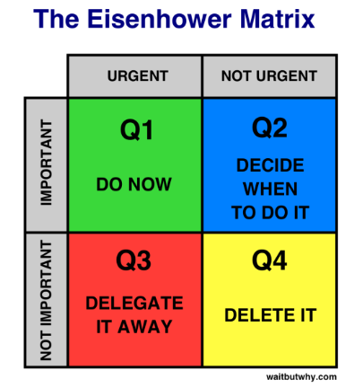
Source: Dwight David Eisenhower

We learnt from here that if we divide our work in an urgent or non-urgent way, prioritize them based on their urgency then we can focus ourselves on the most important thing. And also I learnt how to identify the distractions that make us loose the focus. Now I try to eliminate or minimize the distraction as much as possible. I am trying to be proactive by concentrating on self-development so that it won’t come in the way of my prioritized work. I need to have the will power to follow the priority rule strictly rather than my desires. According to Stephen Covey; “the challenge is, not to manage time but to manage ourselves” (The 7 habits of effective people, 1989). For me, my main target is to know my priority and put them to my schedule. When we focus on prioritising we are actually thinking and planning ahead to prevent crisis from happening. This gives us advantage on our way to achieve success.
In this course I have learnt about Kolb cycle of reflection which I am trying to apply in my day to day life;

KOLB CYCLE:
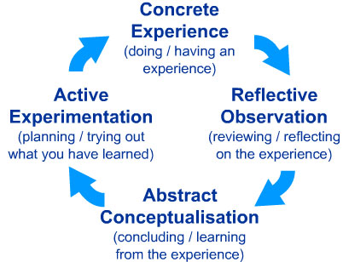
Source: https://www.simplypsychology.org/learning-kolb.html. (David Kolb, 1984)
- Concrete experience:
This stage is mostly feeling the new knowledge or experience. I find myself here, I enjoy the new experience. But I feel the need to improve myself by practising time management to get the best output from this new experience. For example, since I have started this course, it’s consuming a big part of my time but on the other hand I am getting a concrete experience to learn many academic as well as employability skills to be able to implement this in my future job.
- Reflective observation:
Second stage is about reflection. After having an experience reflecting on that observation is very important. It is to watch a matter properly from every aspect to make a reflection on it.
Unfortunately I was not in this part of the cycle. I was used to follow some previously set rules for me rather than trying something new or learning something new. But now I try to put more effort on my observation skill, which will ultimately help me to make informative decision.
- Abstract Conceptualization:
In this part, abstract conceptualisation means thinking before taking any decision. After feeling and observing any matter it is better to think about the expected output from the previous steps before taking any decision. I had a tendency to jump from feeling to thinking skipping the observation part. But I realised now that after having a new experience, it is better to observe the task for some time. By doing so, we can plan a route to achieve the best outcome. In my opinion it is not entirely wrong to directly move from feeling to thinking. Lots of people do that as well. These kinds of people are mostly like instant decision maker. They don’t tend to be spent much time on this process.
- Active Experimentation:
This stage is output stage. In here whatever we have felt, observed, planned till now will put together to do the job. Almost everybody falls under this stage. Everybody’s cycle will be different for example- I used to be like,
Feeling first then –Thinking then -Doing kind of person.
Some other person can be only Watching- Doing kind of person or Feeling- Thinking kind of person.
Every persons thinking process will be different but to have an efficient output any one should follow all these 4 cycle.
Reflection:
Planning is the most important part of prioritising. While planning we should keep in mind about long term reward. For example, coming back to education after long break is my long term reward planning. When I started this course I thought that I had already figured out the way to achieve my goal but after reading this module I got to know that there is always a better way to execute my plan. I realised that I can do my job properly, time efficiently just by doing some advance planning. I realised that if I sharpen my employability skills with my academics I can have a chance to make progress in my career very soon. I have also developed responsibility skills for my employer to trust me with more important tusk. I learned to be in charge of my decision. Not only taking the credit of my win but also taking the responsibility about my failure also. I learn to focus on the things that matters to me most. For example; my goal is achieving this certificate, polishing my knowledge and applying them in my work place to achieve an accepted result. This will help me to build self-awareness by empowering me to shape up my life.

Reference:

- Covey,S.(1989). The 7 Habits of Highly Effective People. USA.

- Tracy,B. (2008). Eat that Frog. 2nd ed.USA.

- Dweck,C.(2006). Mind Set: The New Psychology of Success. New York: Ballantine Books.

- David,K.(1984).Experiential learning: Experience as the source of learning and development. Englewood cliffs, Prentice Hall.USA.

- https://www.simplypsychology.org/learning-kolb.html. (David Kolb, 1984)

- Humphrey, A. (1960s and 1970s). SWOT Analysis.

