University of Wales Trinity St Davids

School of Engineering

Report discussing improving the efficiency in the Slab Yard at a Hot Rolling Mill

Matthew Preece
Student Number 1809102
November 2019

L4 Engineering Applications & Study Skills
M4X02063

Abstract

This report discusses the hot rolling process and in particular the slab yard as being a key part of the hot rolling process. It identifies from recent literature what improvements are being considered to increase the effectiveness of the slab yard to enable greater efficiencies in the hot rolling process. The literature review showed that there are a number of processes that if properly controlled can lead to improved performance in the slab yard and increase productivity in the hot mill. These include controlling stock and developing systems to know where slabs are stored. Scheduling is key and the literature provides some solutions to improving how slabs are scheduled and how cranes are used efficiently. It also looks at what other steel companies and institutions are considering to improve performance in slab yards. Improvement methodologies such as Six Sigma and Lean are suggested as ways to manage defects and eliminate waste. The literature review helps identify solutions such as inventory control and systems to improve stacking, shuffling and moving slabs

Contents
Introduction 4
The Hot Rolling Process 4
Process in the Slab Yard 6
Literature Review 7
Discussion 9
Conclusions 11
References 12

Introduction
This report discusses the hot rolling process and in particular the slab yard as being a key part of the hot rolling process. It identifies from recent literature what improvements are being considered to increase the effectiveness of the slab yard to enable greater efficiencies in the hot rolling process.

The Hot Rolling Process
2.1 Casters
The casters get steel from the BOS plant and turn it into slabs by continuous casting where steel is poured shaped and then cut in into slabs with the desired measurements.
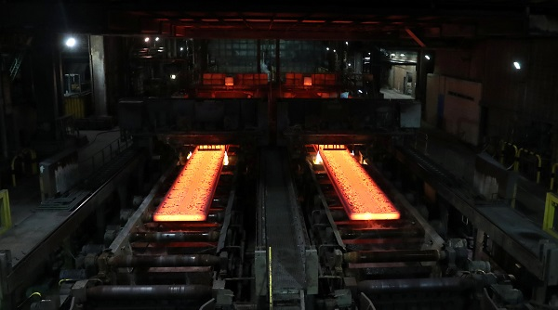
Figure 1 Slabs coming out of the casters.
2.2 Kress
Kresses are big machines that carry slabs. The kresses will pick up the hot slabs from the casters and take them to the slab yard where the hot boxes are located.
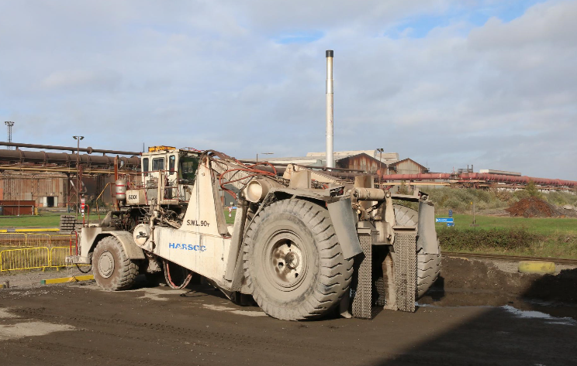
Figure 2 Kresses
2.3 Slab yard
In the slab yard, slabs are received from the casters via the kresses, they are then marked up to make sure they are in the right order ready to send to the reheat furnaces and then the mill to be rolled.
2.4 Reheat Furnace
There are two reheat furnaces in the hot mill which are used to heat up slabs to about 1000 degrees Celsius ready for the mill to roll them.
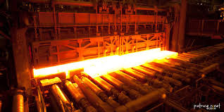
Figure 3 Hot slab leaving the reheat furnaces.
2.6 Hot Mill
As slabs are dropped from the furnaces the mill rolls them using sets of rollers to thin and lengthen the slabs to the customers preference, they also change to metallurgies of the steel to create a range of steels. At the end of the mill are the coilers where the strip is coiled, banded and sent on to the next stage.
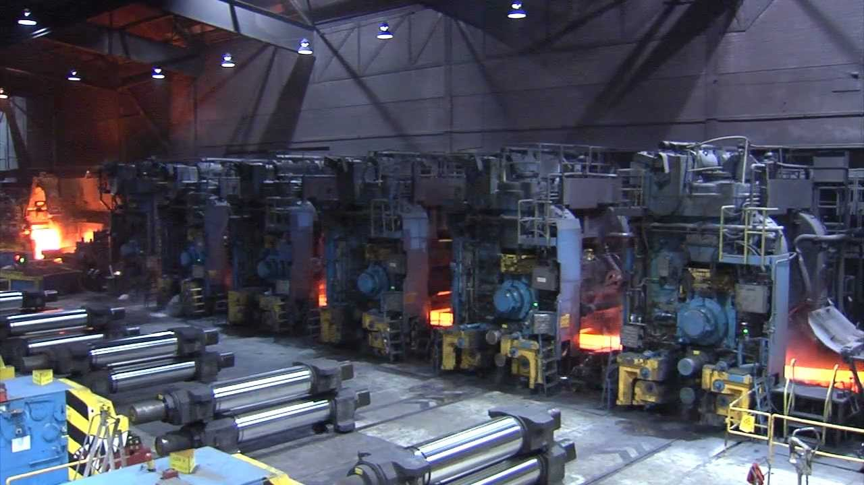
Figure 4 A slab being rolling through the multiple stands.
The main focus of this report is the slab yard.

Process in the Slab Yard
The purpose of the slab yard is to feed slabs in the right order to feed the hot mill to ensure maximum productivity.
When a cold round is scheduled the kresses will then bring the correct slabs to the slab yard. The slab control will let the cranes know in the area that there is a kress coming in to avoid any collisions. When the kress has dropped off the slabs the slab IDs is checked and the correct round and sequence number painted, and the slab is accepted into the yard in Oasis, the computer program in the slab yard. The crane drivers build the slabs looking at the round and sequence numbers, they build in lifts of six high. The booker comes out and measure the widths on each end and the length of the slabs to make sure they are correct and then enter them and any amendments into the system, they also look for any defects on the slab which could cause them to drop them from the round as they are not fit for rolling as the quality will be too poor to sell. When ready the crane drivers will then start to load the beam which then loads the slabs into the reheat furnaces.

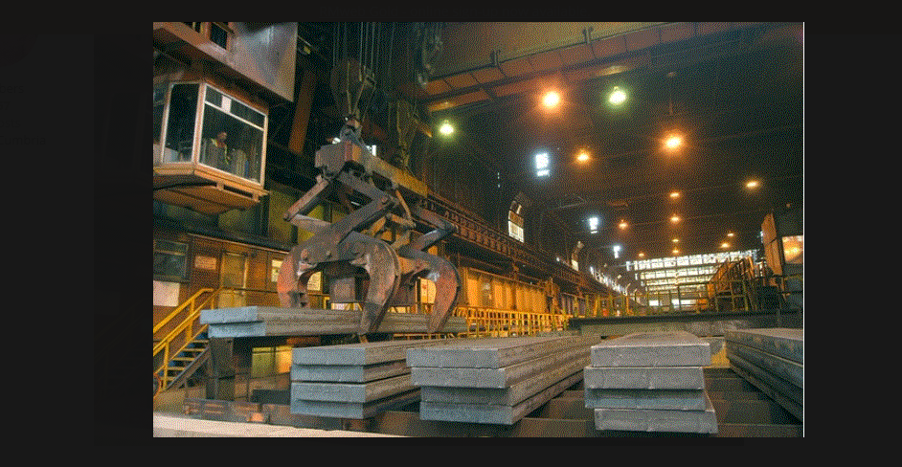
Figure 5 A crane loading the beam ready for the furnaces

Literature Review
There are a number of processes that if properly controlled can lead to improved performance in the slab yard and increase productivity in the hot mill. This literature review looks at what other steel companies and institutions are considering to improve performance in slab yards. [1] were experiencing difficulties in their slab yard including excessive obsolete stock and poor inventory control. They initiated a project to identify the problems and systematically address them to improve their processes.
[2] comment that scientific studies that “specifically target the optimization of storage assignment in steel slab yards are unfortunately sparse”. They also say that slab shuffling creates problems. They developed a model for optimising storage in a steel slab yard.
[3] also recognised that slab yard efficiency was crucial to ensure productivity in the hot rolling process and they set out to develop a computer programme to use to maximise scheduling in the slab yard.
Arcelor Mittal a major steel company in Germany have also introduced a stock yard logistic system to improve its slab stacking and slab movements. Reporting at a conference in Rio de Janeiro [4] in 2015 they identified stock control, reducing manual slab stacking and improved sequencing of slabs to be key to improving efficiency in their slab yard.
The literature review also identified the need to use cranes in the best way to improve scheduling [5]. These researchers developed a programme to schedule multiple cranes on common tracks to make sure that they were as efficient as possible.
Much has been written on the importance of inventory control. Wild [6] states that “Inventory management is simple: keep customers happy, stock low and reduce the operating costs”. This book gives practical methods for reducing stock and setting the right stock levels. ABC analysis [7] is an approach used for managing stock based on consumption analysis. This is based on the Pareto 80/20 rule. It helps managers focus on the most valuable and important products.
Defects can be managed using Six Sigma processes [8], [9], [10]. This is a disciplined, statistical-based, data-driven approach and continuous improvement methodology for eliminating defects in a product, process or service.
Lean processes [11] is another process improvement methodology with a focus on reducing and eliminating waste.

Discussion

  - How the Literature Review can be used to address Problems in the Slab Yard at Port Talbot
There are a number of issues frequently seen in the slab yard and in the processes which are identified in the literature review above. The work done by Evraz Highveld Steel and Vandum looks at all the issues in the slab yard, many of which are similar to the issues in the yard at Tata Steel Port Talbot. The work that they have done is useful in identifying solutions for the issues at Port Talbot.

    - Space, Inventory Control and Scheduling
The slab yard only has a certain amount of slabs it can hold at any one time, so if lots of big rounds get scheduled the yard will not be able to hold all of them, which slows the process down. This links in with scheduling as if rounds need to be moved, usually because of problems with the mill and the mill not being able the roll certain types of slabs, the slab yard is not big enough to be able to hold these slab until the mill can roll them. Slabs then have to be moved which takes time and the operators have to make sure that they know where all the slabs are and what chemistry each slab is to ensure that the correct grade of coil is produced. This takes a lot of time and it is double/triple handing slabs which is not an efficient process. The literature review gives possible solutions to help with space, inventory control and scheduling. The system in Alcolor Mittal is interesting to look at slab stacking and movements.

    - Cranes
Cranes are used to move slabs around the slab yard and if one breaks down it will cause a delay. Delays are a huge cost to the hot mill and need to be sort as fast as possible. The cranes in the slab yard are very old and tend to break down frequently. They can also only lift a limited number of slabs in one go. If the cranes could lift more slabs at once this could increase productivity and decrease the time it takes to move and build rounds. The work done by Zhao et al showed the importance of cranes to improve efficiency although the computer programme that they developed is very complicated.
5.1.3 Quality of Slabs
The quality of slab coming into the slab yard from the casters is poor, this is could make poor quality coils which in turn will need rework, sold at a lower price or scrapped all together. Quite often the only way to spot this is by manual inspection. Slabs with defects that need reworking are marked by the Booker and the crane drivers will send them to be reworked. All this takes time to do, and if they take all this time to rework and still are too poor of a quality to be booked it would be a waste of time. Six Sigma and Lean are two improvement methodologies that could be used by Tata Steel as part of their improvement system. They are effective as separate systems but using them together can get the benefits of them both and may get quicker benefits.

Conclusions

- An efficient slab yard is vital in improving the productivity of the hot mill.
- The literature review identified a range of problems that are being tackled to improve slab yard efficiency
- The literature review also shows other steel companies are having the same problems
- The literature review helps identify solutions such as inventory control and systems to improve stacking, shuffling and moving slabs

References
[1] Evraz Highveld Steel and Vandum
[2] Kofler, Monika & Beham, Andreas & Vonolfen, Stefan & Wagner, Stefan & Affenzeller, Michael. (2012). Modelling and optimizing storage assignment in a steel slab yard. LINDI 2012 – 4th IEEE International Symposium on Logistics and Industrial Informatics, Proceedings. 101 -106.
[3] Kun Li and Huixin Tian, Integrated Scheduling of Reheating Furnace and Hot Rolling Based on Improved Multiobjective Evolution. Complexity, vol 2018, Article 1919438, 19 pages , 2018.
[4] Grabowski, Rene (2015) Technical Contribution to the 19th Industrial IT and Automation, part of the ABM Week, August 17th -21st, 2015, Rio de Janeiro, Brazil.
[5] Zhao, Guodong, Jiyin Liu, Lixin Tang, Ren Zhao and Yun Dong, (2019). Model and Heuristic Solutions for the Multiple Double Load Crane Scheduling Problem in Slab Yards. Accepted for publication in IEEE Transactions on Automation Science and Engineering
[6] Wild, Anthony. Best Practice in Inventory Management. Third ed. 2018. Web.
[7] Rusanescu, M., (2014). ABC Analysis Model for Classifying Inventory. Hidraulica, (2), pp. 17 – 20.
[8] www.6Sigma.us
[9] https://goleansixsigma.com/wp-content/uploads/2012/02/DMAIC-The-5-Phases-of-Lean-Six-Sigma-www.GoLeanSixSigma.com_.pdf
[10] http://leansixsigmadefinition.com/glossary/six-sigma/
[11] Arnheiter Edward D and Maleyeff John The Integration of Lean Management and Six Sigma , The TQM Magazine Vol 17 No. 1 2005
[1] Kasselman, Geani (2011). www.repository.up.ac.za

