PROJECT MANAGEMENT

Project: Development of an integrated information system for Broadgreen Hospital patients

Student name: Anastasiya Petrova
Student number: 1816952
Module title: Project Management (LCBB5005)
Assignment title: Assignment 1
Module Lecture’s name: Dr Molly Jack

Table of Contents:
- Introduction ……………………………………………………………………… p. 3
- Business case …………………………………………………………………… p. 3
- SMART Objectives ……………………………………………………………… p. 4
- Work Breakdown Structure ……………………………………………………… p. 7
- Activity Sequencing ……………………………………………………………… p. 11
- Budget ……………………………………………………………………………… p. 13
- Execution Challenges …………………………………………………………… p. 15
- Conclusion ………………………………………………………………………… p.16
- References ………………………………………………………………………… p. 17

Introduction
Project management is one of the most influential elements that determine the success of any project. Hence, it is vital for the project manager to plan effectively for the manner, in which he/she would run their project to ensure that it achieves its required objectives. In this regard, this report is a project management plan for the Broadgreen Hospital for a project to develop an integrated patient information system. As the project manager, the major elements that I will include in this plan include the stakeholders’ concerns, risks, time, cost and benefits realization, and the project execution challenges. The development of a Project Management Plan is a process in which all components of the plan are defined, prepared, and agreed upon, followed by integration into a general management plan (Meredith, J. et al, 2018, p.2-5).
Business case
The Broadgreen Hospital plans to come up with an integrated patient information system that will be used to store all the necessary data about their patients. The system will be an electronic care record that will be used to store all the information that the hospital needs about their patients. Some of the data that will be stored include the patient’s name, address, contacts, age, medical history, date of birth, and the treatment they receive from the hospital. This system is necessary for the hospital, as it will permanently solve the problem of patient data management which the hospital is currently facing. Through it, all the authorized staff in the hospital will be able to record, share, and access all the necessary information they need about the patients who receive services from the hospital. The system will also improve the quality of services offered to the patients, as their previous medical history are vital for informing their current medical needs (Kapoor and Kleinbart, 2012). To achieve these goals and high-quality requirements, the duration of the project is up to 6 months, with a budget of up to £ 50,000.
The organizational problem. Currently, the Broadgreen Hospital stores its patient information in hard copy files for individual patients. These files are retained within the hospital and the health practitioners can only access them whenever a patient visits the hospital for any medical attention. The aspects that are captured in these documents include the patient’s names, their contacts, date of birth, and their medical conditions and treatments that they receive from the hospital. This kind of storage has been cumbersome for the hospital, as patient data management has become quite overwhelming. This is because whenever patient data is needed, most of it is sought manually among the files. As well, this is costly for the hospital because they require additional staff to supervise the management of these files. Hence, there is a need for the hospital to come up with an integrated patient information system for better patient data management.
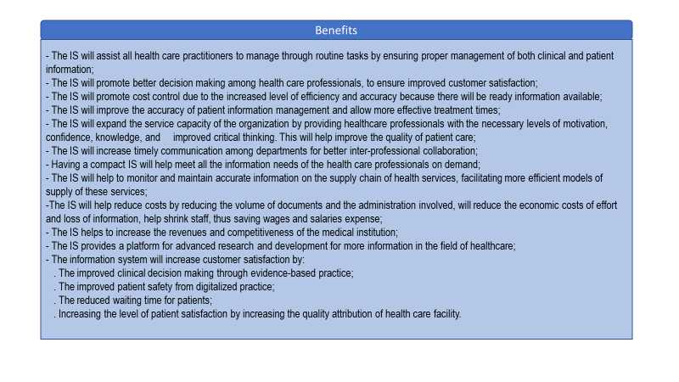Stakeholders
Project organisational structure
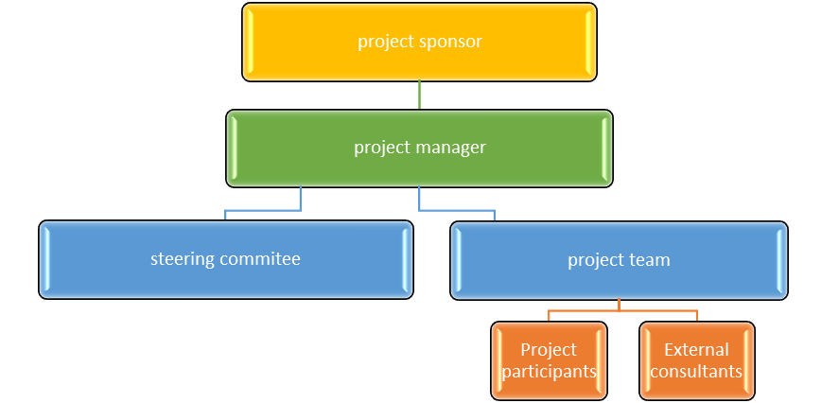
Source: Autor’s work
There are good coordination and communication between the members of the organization who have all the professional skills to provide the final product. This also defines the leadership style as Laissez-Faire, which gives the team complete freedom. Regular meetings are held to discuss possible problems, possible decisions, and make a final decision. Team members gain more autonomy and take more responsibility for their work, which increases their productivity, encourages their creativity. Our team uses a mixed approach to work between Agile and Predictive life cycle. This approach is dynamic, with an emphasis on quality. Each task is performed until a final result is achieved, which saves time. The work is delivered by performing frequent small tasks related to the purpose of the project. The team receives early feedback and provides visibility to the client for project progress and control. This approach allows the team to complete the project earlier, which in turn can provide an earlier return on investment (AGILE practice guide, 2017, p.13-30).
The stakeholder analysis table for this project:
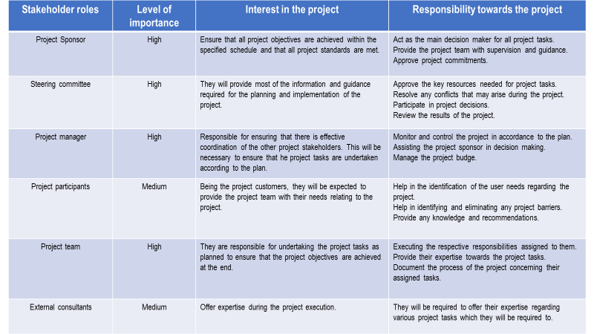
Source: Autor’s work
Various techniques are used to analyse the power of stakeholder interaction, one of which is Power Versus Interest Grid. Based on factors such as financial interests, moral and ethical values, business interest, communication preferences Stakeholders are prioritized into power and interest levels (PMBOK® GUIDE, p.503- 536).
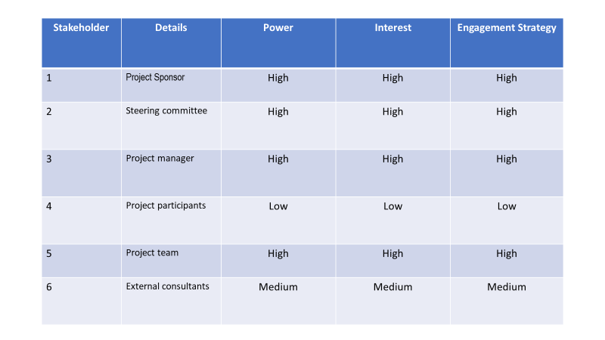

Source: Autor’s work

As Muszynska, K. (2015) note, communication is one of the most significant aspects which determines the success of any project. Hence, it is vital for all the stakeholders involved in the project to practice regular communication among themselves in order to facilitate and coordinate all the project tasks and ensure they are successful. For this to be achieved, there will be different communication channels that will be used among the stakeholders as discussed below.
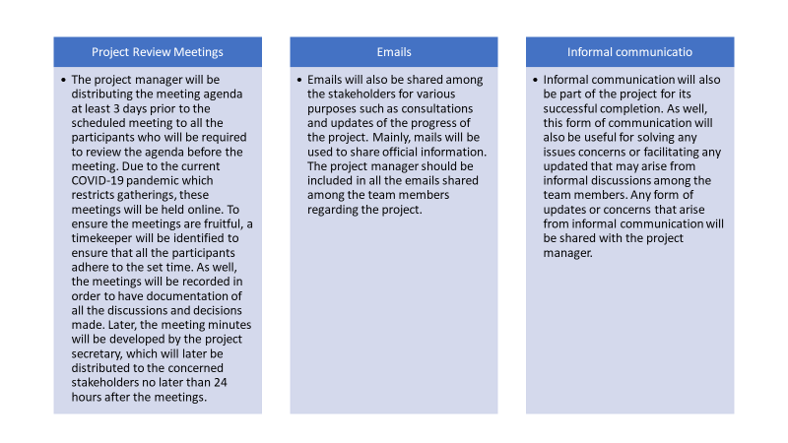
Source: Autor’s work
SMART Objectives
The objectives which ought to be attained by this project are:
Creating a direction that will be followed to develop an integrated patient information system for the hospital.
Defining the main characteristics that should be included in the new system.
Determining the resources needed for the development of the system.
Facilitating the development of the integrated information system for the patients in the hospital.
The scope of the project is documenting the list of specific goals, objectives, as well as deadlines, results, and costs. The documentation defines the responsibilities of each team member, the method of monitoring, control, and validity. All objectives, requirements, and results need to be relevant to the goal of the project (PMBOK® GUIDE, p.129 – 155).
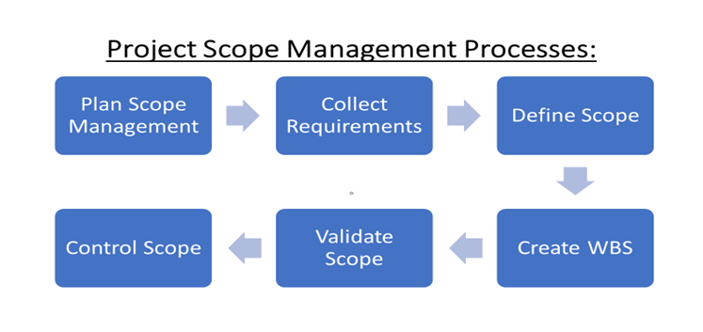
Source: Autor’s work
Scope Management Plan
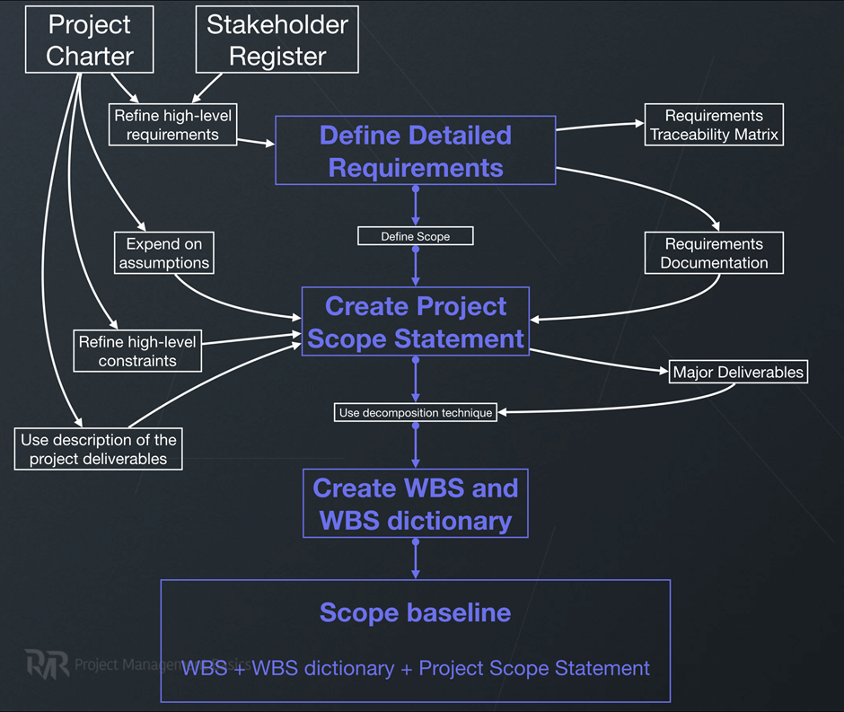
Source: Timoshenko V., Puz N., (2017)
This is a process by which a detailed description of the project is develop and the parameters of the results and the acceptance criteria are defined in detail. The tools and techniques used are as follows expert judgment, data analysis/alternative analysis, meetings.
Work Breakdown Structure
The tools used to define, verify, and control the scope are useful for project management, but they cannot be used to assess project implementation and quality. Work Breakdown Structure is basic element of the Project Management Plan because it contains information on what needs to be done, by whom and within what timeframe. This facilitates the timely acquisition of the necessary resources, monitoring and control during the implementation of the project, and directs the focus on milestones. All of this minimise the risks and saves time. A deliverable-oriented structure has been applied for the purpose of the project (Amjad, S., 2017).
The WBS Dictionary is a supporting WBS and in addition to the information from the WBS, additional information from other processes can be added at a later stage. For example, this could be Schedule milestones, Resources required, Acceptance criteria, Cost estimates, Agreement information as other as well. The techniques and tools used are inspections, including measuring, examining, and validation, which determines the compliance of the work and results with the objectives of the plan, and decision-making when validation between management and stakeholders is required (Graham N, 2015, p.36-50).
Autor’s work
Risk and Constraints
Any uncertain event that would have a negative effect on the achievement of the project objectives, such a cost, scope, schedule, quality is a risk. The risk management steps are combined in a repetitive process as follows - identification, priority, planned resource for overcoming, monitoring, and control (Muriana C., Vizzini G, 2017).
Risk Management Circle
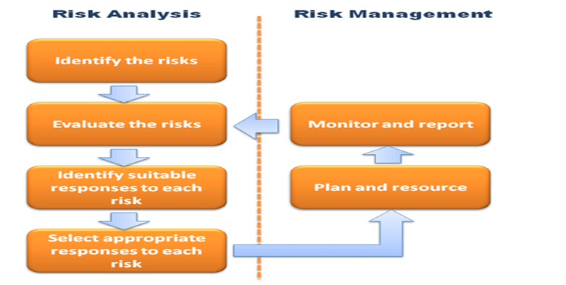
Source: Managing Successful Projects with PRINCE2, CCTA
In order to align the risk management plan, it is necessary to take into an account all approved management plans. In order to identify and prioritize risks, they are documented in a Risk Register document.
The main advantage of this process is that it visualizes the connection between guaranteed risk management, other stakeholders, and the importance of the project for the organization. The risk register provides an opportunity to choose optimal strategies for overcoming the possible risks and their connection with the project objectives, and this framework does not include the interdependence between the risks and the complexity. The development schedule is in line with the potential risks. The main advantage of this process is that it visualizes the connection between guaranteed risk management, other stakeholders, and the importance of the project for the organization.
Source: Autor’s work
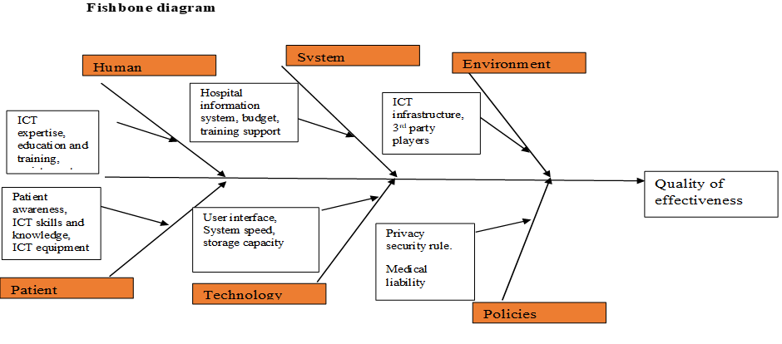
Source: Autor’s work
Activity Sequencing
Sometimes the reason for the failure of a project is in the creation of a structure for work analysis. The activities in the project must be arranged in order of importance and sequence, which allows the project to be implemented within the time frame constraint. The process that identifies and documents the sequence and relationships between the activities in the process is called Sequence Activities and it can be used to assess whether the sequence is correct. To outline this process, the AON method is selected. This is one of the techniques used for the Program Evaluation and Review Technique (PERT), where the grid shows each activity as a node, and the arrows show the immediate activities of the predecessor. This method is particularly suitable for analysing the time to complete each task, as well as the minimum period required to complete the project. CPM is used to determine the minimum process duration and schedule flexibility.

CPM
Source: Autor’s work
Using the Three-point estimation tool helps to analyse the accuracy of the time required to complete the project.
Source: Autor’s work
From the analyses made, it can be concluded that the time provided for the implementation of the tasks is rather optimistic, and the probability of completion is in the range of 95.5%.
Stakeholders focus on the implementation of the main stages of the project, which shows the progress. These stages can be mapped, and with milestones, the change is noted, which helps to communicate during the implementation of the project. The milestones are zero-duration tasks, can be included in the plan of the start or end date of the project stage, in presentations, important meetings, breaks, and dates that can have a significant impact on the implementation time (Clayton, M., 2017). Gantt graphics is one of the most used methods used to provide information about the performance of tasks over time. This information includes the estimated start and end dates, estimated duration, effort required, relative progress. The use of milestones, in the Gantt chart, adds value to the project, making it understandable, flexible, showing planned, and actual progress. This helps the project manager to better allocate resources and tasks. Another advantage of placing milestones in a Gantt chart is that they help identify potential risks. Motivation is another advantage because the team has satisfaction with what has been achieved.
Gantt chart
Source: Autor’s work
Budget
Effective management aims to ensure that staff resources are available throughout the project, when and where they are needed, as well as what physical resources are needed and when they need to be provided during the process. The needs for physical resources must be built into the plan, similar to the needs of the staff, because if people are available for a planned task but the equipment is not, the project can have delays and unforeseen costs. In addition, team members may experience dissatisfaction, which leads to reduced engagement. Therefore, in order, for the plan to be successful, it is necessary to draw up a clear list of physical resources, a timetable for when they are needed, and a budget to cover both physical and staff needs. After preparing and analysing the budget, this information is embedded in the WBS and Gantt chart presented above.
Three-points estimating

Description | Budget (£)
Project supplies  Software and hardware  Stationery  Subtotal | 12,000  140  12,140
Project team human resources  Direct cost- staff salaries  Consultants salaries  Indirect costs – travel cost  Sub-total | 29,760  900  2,000  32,660
Administrative | 5,200
Total budget for the project | £ 50, 000

Source: Autor’s work
The above budget is however adjustable, where some of the aspects which may necessitate these adjustments include the variances which may emerge between the project budgeted items and the actual costs which will be incurred during the project execution. Some of these variances could be material cost and labour costs, which will call for the adjustment of the budget.
Assumptions
The assumption is what is considered true based on our knowledge, experience, and information by team members. According to the PMBOK Management, all expected team problems that may arise during the project are assumptions, and the constraints are what limit the actions of the team, and the project must be implemented within these constraints /costs, time, scheduling/. The constraints that determine the management of the project are in terms of scope, quality, schedule, budget, risk, process. They all interact because each of them influences the others. It is therefore important that assumptions and limitations are defined, carefully analysed, and documented. This helps the manager in the process of project implementation to be able to check the accuracy of assumptions, as well as to learn lessons. This analysis is essential to reduce the risk.
The following assumptions were made in the planning of this project:
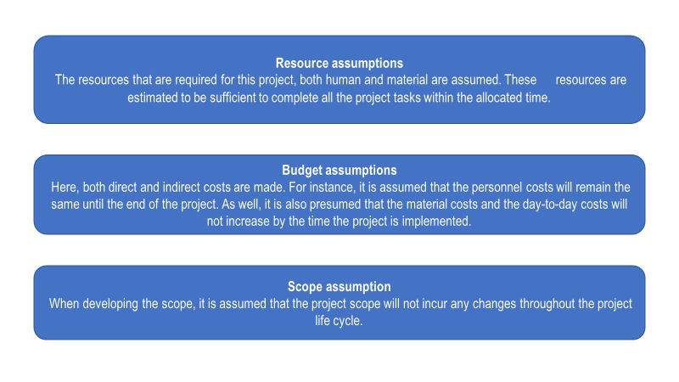
Source: Autor’s work

Execution Challenges
To manage a project, it is important to pay attention to each element such as plan, resources, time frame, budget, good and proper communication, risk foresight and management, quality control. In addition, the manager needs to have the ability to anticipate the challenges that would hinder the successful implementation of the project (Hoda, R., Murugesan, L., 2016).
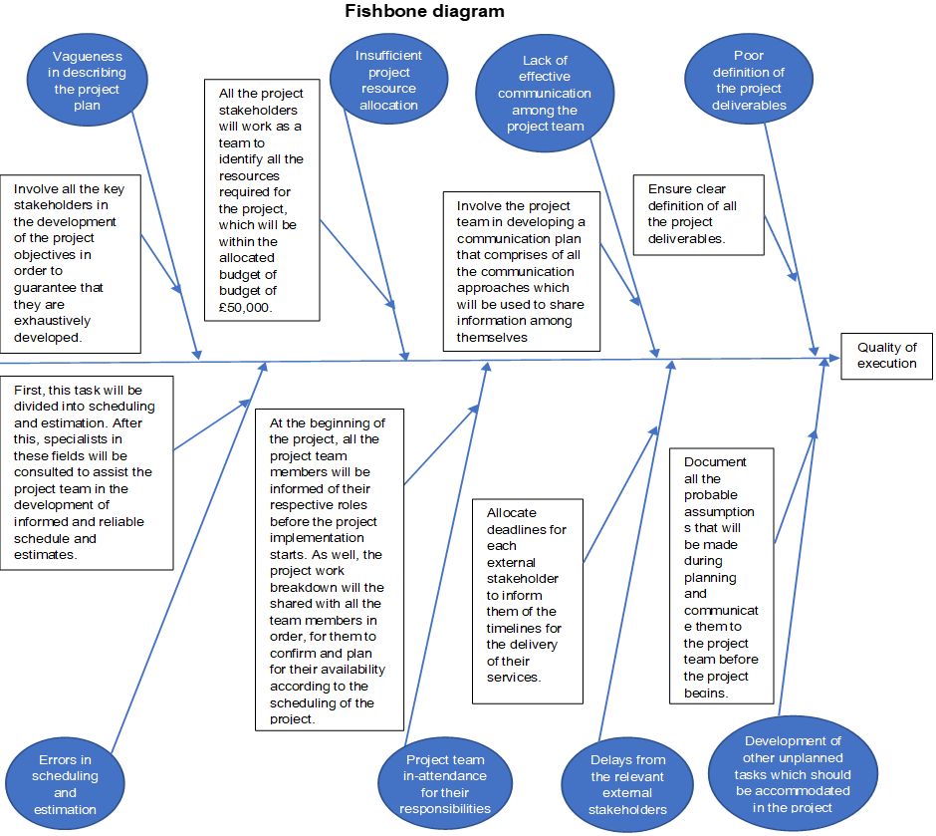
Source: Autor’s work
Conclusion
Project management is a skill that requires patience, time, perseverance, analysing failures so that we can learn from them. Having carefully analysed each of the challenges in order to find a way to deal with them, we can move on to actions to implement a successfully managed project to achieve its goals. With the development of IS that meets the information needs of the hospital, Broadgreen Hospital uses this opportunity to improve the quality of service to its patients. IS will meet all the information needs of the hospital through its integrated platform. The development of IS will cost £ 50,000 and will take six months (130 days).The implementation of the information system will achieve the objectives of the project namely to improve the quality of health care for patients, to improve organizational competitiveness, as well as to increase the revenues of the organization.

References:
- ‘AGILE Practice guide’, (2017), Agile Alliance, p.13-30.
- Amjad, S. et al, (2017), ‘Calculating Completeness of Agile Scope in Scaled Agile Development’, IEEE Access.
Available at: https://ieeexplore.ieee.org/stamp/stamp.jsp?arnumber=8078177
(Accessed: 08.07.2020)
- Benta, D., et al, (2011), ‘On Best Practices for Risk Management in Complex Projects’, Informatica Economică vol. 15, no. 2.
Available at: http://revistaie.ase.ro/content/58/13%20-%20Benta,%20Podean.pdf
(Accessed: 21.07.2020)
- Clayton, M., (2017), ‘What is Milestone Planning? Project Management in Under 5’, YouTube video.
Available at: https://www.youtube.com/watch?v=aJcd1rQ0Z9w
(Accessed: 21.07.2020)
- Hoda, R., Murugesan, L., (2016), ‘Multi-level Agile project management challenges: A self-organizing team perspective’, Journal of Systems and Software.
Available at: https://www.researchgate.net/profile/Rashina_Hoda/publication/298918282_Multi-Level_Agile_Project_Management_Challenges_A_Self-Organizing_Team_Perspective/links/5b14e6bba6fdcc4611e20343/Multi-Level-Agile-Project-Management-Challenges-A-Self-Organizing-Team-Perspective.pdf
(Accessed: 13.08.2020)
- Kapoor, B., Kleinbart, M., (2012), ‘Building an integrated patient information system for a healthcare network’, Journal of Cases on Information Technology (JCIT), 14(2), 27-41.
Available at: https://www.igi-global.com/article/building-integrated-patient-information-system/71811
(Accessed: 25.07.2020)
- Maqsoom, A., et al., (2020), ‘Managerial control mechanisms and their influence on project performance: an investigation of the moderating role of complexity risk’, Engineering Construction & Architectural Management · April 2020 DOI: 10.1108/ECAM-05-2019-0244.
Available at: https://www.researchgate.net/profile/Muhammad_Jamaluddin_Thaheem/publication/340654693_Managerial_control_mechanisms_and_their_influence_on_project_performance_an_investigation_of_the_moderating_role_of_complexity_risk/links/5e981c71299bf130799e57ca/Managerial-control-mechanisms-and-their-influence-on-project-performance-an-investigation-of-the-moderating-role-of-complexity-risk.pdf
(Accessed: 28.07.2020)
- Meredith, J., et al, (2018), ‘Project Management: A Strategic Managerial Approach’, 10th ed, WILEY, p.2-5.
- Muriana, C., Vizzini, G, (2017), ‘Project risk management: A deterministic quantitative technique for assessment and mitigation’, International Journal of Project Management.
Available at: https://www.researchgate.net/profile/Cinzia_Muriana/publication/312875787_Project_risk_management_A_deterministic_quantitative_technique_for_assessment_and_mitigation/links/59d0a45a0f7e9b4fd7f9faf1/Project-risk-management-A-deterministic-quantitative-technique-for-assessment-and-mitigation.pdf
(Accessed:13.07.2020)
- Muszynska, K., (2015), ‘COMMUNICATION MANAGEMENT IN PROJECT TEAMS – PRACTICES AND PATTERNS’, Joint International Conference 2015.
Available at: http://www.toknowpress.net/ISBN/978-961-6914-13-0/papers/ML15-266.pdf
(Accessed: 15.07.2020)
- PMBOK® GUIDE, (2017), ‘A Guide to the Project Management Body of Knowledge’, Global Standard, 6th edition, p.129 – 155.
- PMBOK® GUIDE, (2017), ‘A Guide to the Project Management Body of Knowledge’, Global Standard, 6th edition, p.503-536
- Timoshenko V., Puz N., ‘Scope Baseline, Project Scope Statement’, (2017).
Available at: https://pmbasics101.com/project-scope/
(Accessed: 7.07.2020)
- Vaidyanathan, G., (2017), ‘INTEGRATED CONTROL MECHANISMS TOWARD PROJECT MANAGEMENT SUCCESS’, Issues in Information Systems Volume 18, Issue 2, pp. 31-38, 2017.
Available at: https://iacis.org/iis/2017/2_iis_2017_31-38.pdf
(Accessed: 30.07.2020)

