
Applied Leadership and Management in the Workplace
Module Assignment Submission
Student Name: | Mica Davies
Student Number: | 2313850
Module No: | BMSK4013
Module Title: | Management Communication

Statement of Confirmation of Authenticity
By the act of making this submission, the student declares that this is the work of the student named above. The work has not, in whole or in part, been knowingly presented elsewhere for assessment, or where assessment has been built on a previous assessment, this has been identified. Where materials have been used from other sources it has been properly acknowledged. If this statement is untrue, the student acknowledges that an assessment offence has been committed.
Attention is drawn to the plagiarism and unfair practice policies of both the University and of ILM.

Table of Contents:
1. Introduction
2. What is communication?
3. Communication in the workplace.
4. What is motivation? And the effect it has in the workplace and in personal life.
5. Personal Development plan.
6. Conclusion
7. References
Introduction:
Throughout this report I will discuss communication in the workplace, the different forms, and the effectiveness in management. It will show the positive and negative effects that can arise at work due to poor communication skills, and the strategies that can be put in place to change these habits. The different theories of motivation and how this is applied to people. The reason for looking at the importance of communication is so that we can apply it to our management skills in the future and make it working practice.
What Is communication?
Communication is the way in which we communicate to each other in day-to-day life. The communication cycle is a concept that explains the process of messages and how they are sent and received ensuring effective communication. The cycle involves different stages that deliver a clear message. A communication cycle is very necessary in both personal life and in the workplace. Being able to understand the structure of the cycle, it enables us in a work team to work to the best of our abilities. To know how to find the breakdown and work towards making a conscious effort to improve the ways in which we communicate as it builds a foundation of healthy patterns.
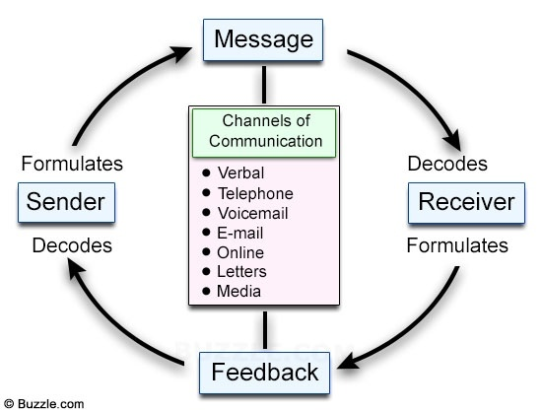
Communication comes in many forms such as Verbal, Non-verbal, Hearing, Visual, Body Language/Signposting, Text message and other services via the internet. Having conversations with family, friends and colleagues through text message and social media has grown massively over the years and has become a more common way in which we communicate to others. Many people feel that it is not efficient or affective to communicate through text message, email, or signposted messages at work as it can sometimes become difficult to decipher the message that is being delivered. As those options are non-verbal it can sometimes come across in a different way than intended, due to the fact you can’t see or hear the other person’s body language, tone, facial expression.
Communication is not always effective due to breakdown and barriers; others do not always understand the message delivered to them. To be effective, we must look at the different factors that make up communication and ask ourselves the relevant questions. Was the message clear? What method of communication did I use? Did the person understand the message and was it delivered successfully?
To communicate healthily and effectively there are barriers of trusting another person and allowing yourself to build a relationship with them, whether that is a professional work-based relationship or personal life. Communication can be a very delicate topic as not every person can communicate efficiently due to their own abilities or their environment in which they are used too. Communication is something that I have personally struggled with over the years which has been in both my personal and professional life. To effectively communicate with others there must be a level of trust within another person. Once that information given to another person it can easily be sent to others whether that’s verbally, text message or via any other means. I had my diagnosis of EUPD and have had to learn to communicate with different members in my life in unique ways as each person has a different understanding. It can be hard for me to balance my emotions and it can become quite overwhelming at times.
Communication has been a large barrier to overcome and must manage as I tend to shut myself away and not speak to those, I’m close to, or explain my thoughts due to feeling unable to. Through displaying these patterns, it led to breakdowns in communication in my relationships and therefore became an issue. Over the years I had to learn the way in which I communicate best and had to place those habits into my personal and professional life. EUPD is a condition that relies heavily on constant reassurance from others, clear messages of approval and instruction. By not being able to communicate effectively with others it has not allowed me to have full confidence in myself and my abilities, and I was unable to maintain healthy relationships with my family, friends, and colleagues.
Communication In the Workplace.
At my workplace the effectiveness of communication is essential as it is a hospitality environment, without clear communication the business would not run correctly. I work within a Café and Bar as a team/senior member in the kitchen as well as some admin tasks. I work with multiple members of staff on a daily basis and have to communicate in different ways as well as communicate with customers. I have face to face interactions with customers as well as take orders/deal with queries and booking via the phone and social media. It’s important for management to identify the way they speak to their employee’s as it can be the drive behind their motivation and attitude, this is detrimental to the overall performance from each member. Lack of or no communication often leads to a low moral at the workplace and therefore staff do not work to the best of their abilities. High change of employment rates is typically down to poor management skills. By holding the correct tone, having a friendly upbeat attitude and allowing colleagues to see that you are approachable but professional, it can ensure success and ensures the environment grows at a healthy standard.
At any workplace there will be conflict and issues could arise due to a number of varied factors. Job status/roles, personality clashes, difference of opinion, bad management, culture, Age etc. To build healthy relationships, in a management position it is advised to organise staff gatherings where people socialise and get to know each other. This can be arranged through meetings, days out, problem solving activities/team building exercises. By creating fun and happier work settings it can higher chances of having more loyal employee’s, higher recommendations, and popularity/custom. I have been taking on the role of opening the café in the mornings. I completed my Level 2 Food hygiene and safety for catering and plan on next completing my level 3 and/or expanding my qualifications, recently I’ve started to organise the rota and lead the shifts so have had to look into my communication skills deeper to ensure that I’m doing what is asked of me and all staff members are happy.
Though we work well as a team and business runs smoothly, communication at times can be our biggest downfall. “For effective communication, first, ask these questions: What is the goal? Who needs to hear this? How should I pass it on?”. Forbes,(2023). For example, there are members in the team that do not communicate effectively which causes a disruption to the routine of the café. Management have discussed the different points of conflict with the members but some struggle to take onboard constructive criticism and therefore has resulted in bad communication. The individual in question that works at the café, struggles with anxiety, their time management and consistency with their standards in the kitchen. If you give this person advise or criticism then they become very overwhelmed, emotional and this results in them crying and arguing with other staff members. This can become difficult for staff as they are unsure on how to handle the situation and do not know how to resolve it. This person struggles to communicate their feelings and thoughts and often overloads their personal problems onto others. This causes a conflict as she becomes very emotional, and it disrupts the work that needs to be completed.
During a meeting to solve the issues, the meeting the lady explained that she suffers with mental health and likes to be in control and struggles with failing tasks. She explained that it eases her anxiety to have more clear direction of instructions throughout her shift as it gives her the reassurance that she is completing the tasks she is supposed to whilst being in control. By other staff prompting her with her responsibilities and checking throughout her shift with her progress, the staff member felt that this approach would help her maintain her job at the café and work to a higher standard. This meeting helped understand that there is a barrier within our communication specifically with herself. Each person is different and not everyone will think, act or be able to comprehend information the same. We then verbally discussed a plan on how to move forward and created a diagram of responsibilities that this person needs to achieve. This visually gave them the ability to break their task down, know how to complete them. To have healthy effective communication as a manager you must be approachable, understanding, fair, confidential, alongside keeping professional boundaries.
Using McClelland’s Three Needs Theory, I was able to use the approach and understand that this person’s need was achievement and affiliation. If one person does not understand the information that has been passed onto them, then the communication between them both cannot be effective. Its easy for there to become barriers to communication, such as not delivering the message with clear instruction or information, some individuals struggle to concentrate and listen to information, and others struggle to remember this information and can become distracted.
What is motivation & The effect In and Out of the workplace.
The definition of Motivation is the reason as to why a person does something. It is the driving force behind a person’s actions and the way they do things. Motivation can be broken down into two main types which are explained as being extrinsic or intrinsic. Tasks that as extrinsic as things you must do such as, eating food and drinking water, going to work to earn money, taking medication. Intrinsic motivators are things you do because you enjoy doing them, they are tasks that make you happy and don’t feel like tasks. Examples of mine would be going for a walk to the beach, drawing, running. My biggest motivator is money as I want to better my financial situation by changing habits and making better choices. By completing this degree I’m giving myself the opportunity to better myself in the future and look into opening my own business in something that I love to do. Harvard Business Review, (2020). Say that recent studies show that prioritizing money over time can have an adverse effect although there have been studies to show that those who have a good financial situation tend to be happier in their lives.
A theory if motivation that I like to use is Maslow’s Hierarchy of needs theory. This theory based around motivation was developed by Abraham H Maslow,(1954) and he states that as humans there is a hierarchy of needs that we all must work towards and to move up the levels of the structure.
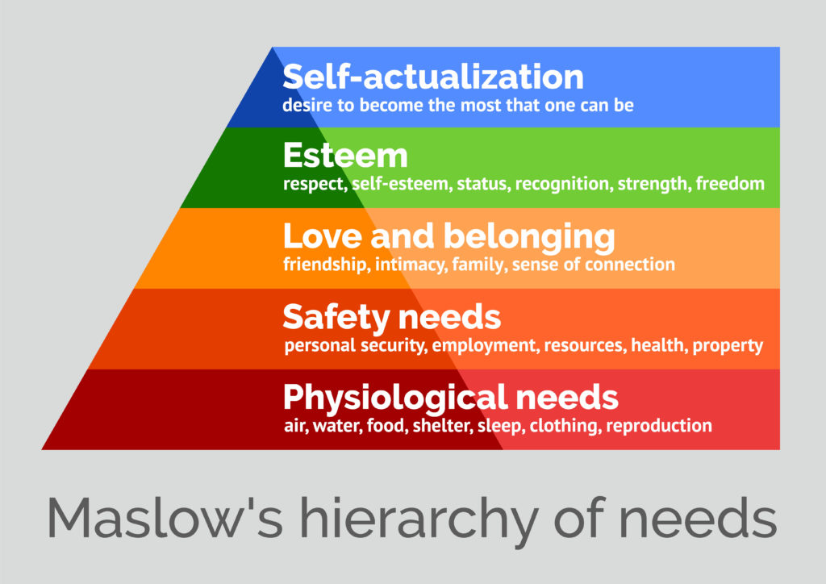
The five-stage approach is divided into deficiency needs which are the first four levels, and growth needs which is the top levels. Maslow says that deficiency needs arise when being deprived of them and are said to motivate people when they are not met. Growth needs are then the opposite where they do not occur from a lack of something, but from a person wanting to grow and better themselves. Maslow also states that one need does not need to be met 100 percent. When it has become satisfied to a certain degree they will feel content to a point. The theory has a perspective that every person is different and that is why we each have diverse needs. One person may long for belonging and love, whereas others may feel the need for Esteem and recognition.
David McClelland’s theory of motivation of management is one that I personally feel fits myself and my workplace the best as it gives a more basic yet true breakdown. McClelland suggests that a person has three basic needs. The need for Power, Achievement, or Affiliation and whichever category that person has the need for has a significant impact on their behaviour. The need for power is a person who is motivated by having authority or control and tend to be strong leaders who are disciplined. The need for achievement is driven by success and achievements. The drive for them is putting themselves in challenging situations whilst setting goals to achieve them at a standard of excellence. The need for affiliation is someone who works well in a team setting, they seek out to socialize and have interactions and feels more relaxed and comfortable in a group. I personally feel that I fit into both the categories of Achievement and Affiliation. Both Maslow and McClelland agree that what drives a person is a “need,” but the differences between each theory is that Maslow looks at the motivation of humans as a species and McClelland looks at the motivation of employee’s specifically in a workplace setting.
By being professional and not allowing personal factors to affect your performance at work, this can improve the morale of employees. My manager at work can often use his own personal stress and worries to project it onto staff. This is due to lacking the ability to emotionally regulate the stress from the business and poor management skills. Other colleagues and I often feel that the appreciation he once had for us has lowered significantly and this has had an effect on the performance and attendance of staff. Attendance records over the last 6 months has shown that there has been a high percentage of sickness, and I personally believe this is because the morale is low in comparison to what it was. I can see that staff members are changing their usual hours to lower amounts recently. The manager used to be very accommodating and would be very understanding with working hours and commitments with childcare, and appointments within the team. With him not appearing approachable, staff members are reluctant to speak to him about personal issues and often call in sick.
Personal Development Plan:
This PDP is created by analysing my own feedback from my person verbal and written communication from colleagues. I was informed that I have honest communication skills, and I am approachable and empathetic. I listen well but due my hearing difficulties it can sometimes be a barrier for me, when in busier environments.
What I want to Improve. | How can I do this. | What will I need to achieve this. | How will I measure my success. | Date Review.
Be Productive in my personal life and in university. | -Create a weekly schedule and dedicate hours to studying. Avoid distractions and be more disciplined with myself.  -Set Goals and Tasks. | -Persevere with being dedicating time to completing Goals.  -Give 100% at university and focus on my deadlines/Set time to Study. | Look at what I achieved within time limits.  -Aim to improve my grades per each assignment.  -Ask for regular feedback. | Every 2-6 months.
Improve my punctuality. | Be more conscious and arrive on time. Plan my journey earlier. | Being more organised.  Focus on what drives me and have more motivation. | I will keep a person record of my time keepings and ask for feedback. | Monthly.
Improve listening skills. | Listen what those are telling me first before responding. | Have more patience with others, and myself. Keep up a positive outlook. | I can ask my family and tutor if they have seen an improvement. | 6 months.
I spoke to my manager about the way in which I communicate and had some particularly good feedback from both him and colleagues. Stephen gave constructive criticism which I took onboard as it is valid. My punctuality is something that holds me back in my professional life as it is something that I struggle with. It is a barrier I am extremely conscious of and daily am trying to improve this as I know its something that I can change with a different mindset and perseverance. Although I have leadership skills and can run a shift and delegate professionally, I do sometimes struggle to be pro-active as I often doubt my own abilities. This is a barrier as I am told I can apply myself at a higher standard than I do at times. Listening is a factor that was mentioned as a factor as I have traits where I can be stubborn and not always take on board other/easier ways of completing tasks. This is a barrier of communication that has caused arguments in the past in my relationships and have made clear conscious efforts to try and change these behaviours over time. My positive communication was that I am someone who works excellent as a team, and very well alone. I am friendly, approachable, and am always willing to help others when needed. I like to learn new skills and always look to broaden my knowledge.
Conclusion.
In conclusion to this report, I have researched and analysed the different ways in which we communicate as people. The different forms, Different theories of motivation and the positive and negative effects it has on people in and out of the workplace. Whilst writing this report I found communication as a topic interesting as its such a broad topic. There are multiple different forms of communication, methods and there are many difficulties and barriers that arise daily. The opinion that I have gained throughout this report is that communication is something that we are always learning about, failing at, and making progress from. There are many methods, forms, and theories that people are studying about communication and as identified throughout, everyone is different and therefore not each person’s needs will be identical. Each person will go through phases of requiring different needs. Effective communication within management is vital to run a healthy working environment, without it the staff team can suffer in the long term. I have found this report the most detailed and interesting to look at as it has given me a wider insight into how I can better myself in my personal life and professional life. It has helped me visually see the breakdown in which I struggle and in how others could struggle. By studying these theories and methods it can ensure personal growth in myself, colleagues for more effective communication in the future.
References:
1-Motivation: Definition, Types, Theories, and How to Find It (verywellmind.com)
2-Maslow, A. H. (1943). A theory of human motivation. Psychological Review, 50(4), 370-96.
3-Maslow, A. H. (1970a). Motivation and personality. Harper & Row.
4-Maslow, A. H. (1970b). Religions, values, and peak experiences. Penguin. (Original work published 1966)
5-McClelland, D.C. (1965) Achievement Motivation Can Be Developed. Harvard Business Review, 43, 6-25
6-Does More Money Really Make Us More Happy? (hbr.org) Havard Business Review, (2020)
7-Shannon and Weaver Model of Communication (communicationtheory.org)
8- McClelland's Theory of Needs - Organizational Behaviour (myorganisationalbehaviour.com)
9- The 7 Habits of Highly Effective People Book Summary by Stephen R. Covey (shortform.com) Stephen. R. Covey.
10- 10 Tips For Effective Communication In The Workplace – Forbes Advisor

