Sarah Ismail (2312694)

Networks and Cyber Security Essentials
ACCA4024

Table of Contents
Introduction 2
Identification of Modern Threats 3
Modern Security Policies 5
Technical Mitigation Measures 7
Proactive Monitoring and Incident Response 9
Continuous Training and Awareness 11

Introduction
Cyber security has become a major concern for many organisations that are operating within the financial services industry. Companies are increasingly relying on cloud services, hybrid working environments and mobile devices. By doing this this has expanded the number of potential vulnerabilities that attackers can exploit. Financial organisations such as VTAM (Vigilant Trust & Asset Management) are particularly attractive targets because they store sensitive customer information and financial data.

In recent times VTAM experienced a sophisticated phishing campaign that bypass normal email filters, as well as an attempted ransomware infection. This shows that the company’s current security controls may not be strong against modern attacks. Cyber criminals are no longer using basic scam emails. They are now using more advanced such as ransomware as a service, AI generated phishing or vishing attacks, supply chain attacks and weaknesses in cloud systems.

As the IT Security Manager for VTAM, this report will look at the main internal and external threats facing the organisation and recommend a modern security framework based on zero trust. The report will also suggest practical policies, technical control, monitoring processes and training methods. These recommendations will be linked to recognised security guidance such as the NIST Cybersecurity frameworks, ISO 27001 and the CISA known to exploited vulnerabilities catalogue. The aim is to help VTAM reduce the chance of future attacks and improve how quickly the organisation can detect, respond to and recover from incidents.

Identification of Modern Threats

VTAM is facing a few cyber security threats from both outside and inside the business. Because it is a financial service company, it is more likely to be targeted by attackers who want to steal customer data, access financial information or disrupt the company’s services. The recent phishing campaign and attempted ransomware infection show that VTAM Is already being targeted, so the company needs to understand the main risks before deciding what controls to put in place.
One of the main external threats is ransomware as a service, also known as RaaS. This is where criminal groups sell or rent ransomware tools to other attackers. This means even attackers with less technical knowledge can still carry out ransomware attacks. If ransomware infected VTAM’S systems, it could lock important files, stop employees from accessing customers records and cause major disruption to daily work. This could lead to financial loss, complaints from customers and damage to the company’s reputation.
Another serious threat is AI powered social engineering, such as phishing emails and vishing phone calls. These attacks are becoming harder to spot because attackers can make emails sound more realistic and can even use fake voices to impersonate managers or trusted people. This is a risk or VTAM because stay may receive urgent messages asking them to click a link, approve a payment or share login details. With hybrid working, it may be also harder for employ yes to quickly check whether a request is real.
VTAM also needs to be aware of supply chain attacks. This is when attackers target a third part supplier, software provider or clous service that the company relies on. Even if VTAM’s own security is strong, a weakness in a truster supplier could still put the business at risk. This is important because financial companies often depend on external platform for payments, cloud storage, customer systems and other business operations.
Cloud adoption and hybrid working create extra risks as well. If cloud setting is not configured properly, sensitive data could be exposed. Weak access permissions, unmanaged device and insecure home Wi-Fi can also make it easier for attackers to gain access, for example, if an employee logs in from a personal device that is not properly protected, this could give attackers a way into VTAM’s systems.
There are also internal threats that need to be considered. Not every incident is caused by an outside hacker. Employees can make mistakes, such as clicking on phishing links, sending information to the wrong information to the wrong person or using weak passwords. There is also the risk of employees having more access than they need. If an account is misused or comprised, this could allow sensitive data to be viewed or changed without permission.
Overall, the main threats facing VTAM include ransomware phishing and vishing, supply chain attacks, cloud misconfiguration, insecure hybrid working and insider mistakes. These risks show why VTA, needs to move a Zero Trust approach, where no user, device or system is automatically trusted without being checked first.

Modern Security Policies

To improve its security, VTAM should introduce a set of clear security policies that support a zero-trust approach. Zero Trust is based on the idea that no user, device or system should be trusted automatically, even if they are already inside the company network. Instead, access should be checked continuously and only given when it is needed. This is important for VTAM because the recent phishing and ransomware incident show that attackers may be already trying to get access through employee accounts and remote working systems.
One of the most important policies VTAM should use is an access to control policy. This should follow the principle of least privilege, meaning employees only get to access to the sensitive finance system unless it is required. Role based access control, also known as RBAC, can help VTAM manage this properly. This link to the NIST cybersecurity framework “protects” function because it focused on limiting access and reducing the chance of data being misused.
VTAM should also have a strong authentication policy. Multi factor authentication should be required for all staff, especially when accessing cloud services, email, VPNs and administrator accounts. This means that even if a password is stolen through phishing, the attacker would still need another form of verification to access the account. Passwords should also be strong, unique and stored using a password manager where possible.
A cloud security policy is also needed because VTAM uses cloud services and SaaS applications. This policy should require cloud systems to be configured securely, with encryption used to protect sensitive data both when it is stored and when it is being transferred. Access permissions should be reviewed regularly so that old accounts or unnecessary permissions are removed. This reduces the risk of exposed data or unauthorised access.
VTAM should also introduce a patch management policy. This would make sure that the systems, software and application are updated regularly. Critical vulnerabilities should be prioritised, especially those listed in the CISA known exploited vulnerabilities catalogue, because these are weaknesses already being used by attackers. This would help VTAM reduce the risk of ransomware and other malware exploiting outdated systems.
An incident response policy should clearly explain what staff, and it must do when a security incident happens. It should include how to report suspicious emails; ransomware incidents should be contained and who is responsible for communicating with management and affected users. Having this written down makes the response quicker and less chaotic during a real incident.
Finally, VTAM should have an acceptable use policy for employees. This should explain how staff are expected to use company devices, email, internet access and cloud systems safely. It should also make it clear that unauthorised software, personal devices and unsafe file sharing can create security risks. This policy supports ISO 27001 because it helps create clear rules for protecting company information.
Overall, these policies would help VTAM move away from trusting users or devices by default. Instead, the company would have a more controlled and secure way of managing access, protecting data and responding to threats.

Technical Mitigation Measures

To reduce the risks facing VTAM, the company should use a mix of technical controls and practically security processes. One security tool by itself will not be enough, especially because the company has already experienced phishing and an attempted ransomware infection. A layered approach would be better, where different controls work together to reduce the chance of an attack being successful.
A key control VTAM should introduce is multi factor authentication, also known MFA. This should be used for email, cloud application, VPN access and any systems that store customer or financial data. MFA means that a password on its own is not enough to log in. for example, if an employee’s password was stolen through a phishing email, the attacker would still need a second form of authentication. VTAM could use an authentication app such as Microsoft authenticator, as this is usually safer only relying on that text message codes.
VTAM should use endpoint detection and response, known as EDR, on company laptops, desktops and servers. This would help monitor devices for suspicious behaviour, such as malware activity, unusual file changes or attempts to disable security settings. This is useful for ransomware because ransomware often starts by encrypting files very quickly. If EDR detects this type of behaviour, it can alert the security team and isolate the affected device before the infection spreads further.
Another important control is a security information and event management system, or SIEM. A SIEM collects security logs from a different arears of the business, such as firewalls, email systems, cloud platforms, servers and user device. This makes it easier to notice unusual activity. For example, if there were lots of failed login attempt followed by a successful login for a strange location, the SIEM could flag this as a suspicious. This would help VTAM detect attacks earlier instead of only finding out after damager has already been done.
VTAM should also consider using SOAR, which stands for security Orchestration, automation and response. This works well alongside SIEM because it can automate some response actions. For example, if a user looks compromised, SOAR could automatically disable the account, blocks a suspicious IP address or create a ticket for the security to investigate. This would be useful because quick action is important during phishing or ransomware incidents. Because VTAM uses cloud services and SaaS applications, it should use Cloud Security Posture Management, also known as CSPM. This type of tool checks whether cloud systems are configured safely. It can help find issues such as public storage, weak permissions, missing encryption or unused accounts that still have access. This is important because cloud mistakes can expose sensitive data even when there has not been a direct hack.
For ransomware, immutable backups are also important. These are backups that attackers cannot change, delete or encrypt. VTAM should keep backups separate from the main network and test them regularly. This matters because backups are only useful if they work when the company needs to recover. Regular testing would give VTAM more confidence that it could restore important systems after an attack.
VTAM should also improve its patch management. Systems, software and applications should be updated regularly so known weaknesses are fixed. The company should prioritise vulnerabilities listed in the CISA Known Exploited Vulnerabilities catalogue, because these are vulnerabilities that attackers are already using in real attacks. This would help VTAM focus on the most urgent risks first, instead of treating every update the same.
Another useful measure is network segmentation. This means separating the network into different areas so that an attacker cannot easily move across the whole organisation. For example, normal employee devices should not have direct access to critical financial systems unless there is a real business reason. This supports Zero Trust because access is limited and checked, rather than being open by default.
Finally, VTAM should strengthen its email security, as phishing has already been a problem for the company. This could include better email filtering, link scanning, attachment scanning and warning banners on emails from outside the organisation. These controls will not stop every phishing attempt, but they can reduce the number of dangerous emails that reach employees.
Overall, these measures would give VTAM a stronger and more realistic defence against modern cyber-attacks. MFA would help protect accounts, EDR would protect devices, SIEM and SOAR would improve detection and response, CSPM would reduce cloud risks, and immutable backups would improve recovery after ransomware. Together, these controls support a Zero Trust approach because users, devices and systems are checked continuously rather than trusted automatically.

Proactive Monitoring and Incident Response
VTAM should not only focus on preventing attacks, but also on detecting and responding to them quickly when they happen. This is important because no security system is perfect, and modern attacks such as ransomware and phishing can move very quickly. If VTAM can identify suspicious activity early, it has a better chance of stopping the attack before it causes serious damage.
A good approach would be to set up 24/7 monitoring, either through an internal security team or by using a managed Security Operations Centre, also known as a SOC. This would mean that alerts are always reviewed, not just during normal working hours. This is useful because cyber-attacks often happen overnight, during weekends or when staff are less likely to notice unusual activity.
VTAM should use a SIEM system as the main monitoring tool. The SIEM would collect logs from different parts of the organisation, such as firewalls, email systems, cloud platforms, employee devices, servers and authentication systems. By bringing all this information together, the SIEM can help identify patterns that may show an attack is happening. For example, it could detect repeated failed login attempts, logins from unusual countries, malware alerts or a sudden increase in file changes.
VTAM should also use SOAR alongside the SIEM to speed up the response. SOAR can automate some actions when a serious alert is triggered. For example, if an account looks compromised, SOAR could temporarily disable the account, block a suspicious IP address or isolate a device from the network. This would give the security team more time to investigate without allowing the attack to spread further.
The incident response process should follow clear steps. First, the security team should identify and confirm the incident. Then they should contain the threat, for example by disconnecting an infected device or locking a compromised account. After this, the team should remove the threat, restore affected systems and check that the attacker no longer has access. Finally, VTAM should complete a post-incident review to understand what happened and what needs to be improved.
For a ransomware incident, the response needs to be especially fast. The infected device should be isolated straight away to stop the ransomware spreading across the network. The security team should check whether any sensitive data has been accessed, restore systems using clean backups and report the incident to relevant management and regulatory bodies if required. Staff should also be told what happened in a controlled way, so that rumours or confusion do not make the situation worse.

A simple monitoring and response flow for VTAM could look like this:

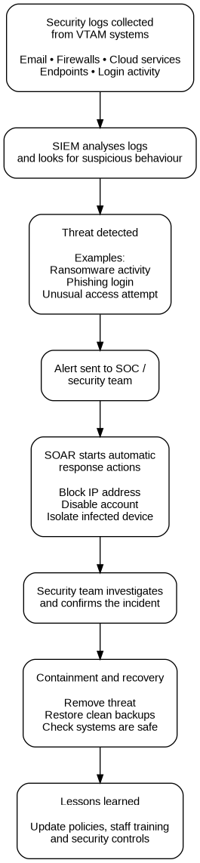
Figure 2 shows how VTAM could detect and respond to incidents using SIEM and SOAR. The SIEM collects and analyses security logs, while SOAR helps automate quick actions such as blocking suspicious activity or isolating infected devices. This would help VTAM respond faster to threats such as phishing and ransomware.

Continuous Training and Awareness
Training needs to be a regular part of VTAM’s security approach, not just something staff complete once a year and forget about. A lot of modern attacks target people rather than just systems, so employees need to know what real attacks can look like. This is especially important for VTAM because the company has already had a phishing campaign that managed to get past normal email filters.
VTAM should run regular phishing simulations where staff are sent safe test emails that look similar to real phishing attempts. These could include fake login pages, suspicious attachments or emails pretending to come from a manager. The point of this should not be to catch people out or embarrass them. It should be used as a way to help staff learn what warning signs to look for. If someone clicks on a test email, they could be given a short follow-up explanation straight away, so the learning happens while it is still fresh.
The training should also cover vishing, because attackers are now using phone calls and even AI-generated voices to make scams sound more believable. Staff should be taught not to rush when they receive urgent requests, especially if the request involves passwords, customer data, payment details or changes to bank information. A simple rule should be introduced where employees must verify unusual requests through an approved internal channel before acting.
It would also make sense for VTAM to make the training role-specific. For example, finance staff should focus more on invoice fraud, fake payment requests and business email compromise. IT staff would need more detailed training on privileged accounts, patching, cloud security and incident response. Managers and senior staff should also be included because attackers may impersonate them or target them directly.
Another important part of the programme is making it easy for employees to report anything suspicious. VTAM could add a phishing report button in Outlook or have a clear security contact for staff to use. Employees should not feel like they will be blamed if they report something or accidentally click a link. If people are scared of getting in trouble, they may stay quiet, which could make an incident worse.
To keep security awareness active throughout the year, VTAM could use short monthly reminders, quick quizzes, posters, team discussions and examples of current scams. This would be more useful than long training sessions that staff are likely to forget. Overall, a continuous training programme would help VTAM build a better security culture and reduce the chance of phishing, vishing and social engineering attacks being successful.

References
[1] CISA, “Known Exploited Vulnerabilities Catalog,” Cybersecurity and Infrastructure Security Agency. [Online]. Available: https://www.cisa.gov/known-exploited-vulnerabilities-catalog.
[2] CISA, “Zero Trust Maturity Model Version 2.0,” Cybersecurity and Infrastructure Security Agency, 2023. [Online]. Available: https://www.cisa.gov/resources-tools/resources/zero-trust-maturity-model.
[3] ENISA, “ENISA Threat Landscape 2024,” European Union Agency for Cybersecurity, 2024. [Online]. Available: https://www.enisa.europa.eu/publications/enisa-threat-landscape-2024.
[4] IBM Security, “Cost of a Data Breach Report 2024,” IBM, 2024. [Online]. Available: https://www.ibm.com/reports/data-breach.
[5] Microsoft, “Microsoft Digital Defense Report 2024,” Microsoft, 2024. [Online]. Available: https://www.microsoft.com/en-us/security/security-insider/microsoft-digital-defense-report-2024.
[6] NIST, “Zero Trust Architecture,” National Institute of Standards and Technology, Special Publication 800-207, 2020. [Online]. Available: https://csrc.nist.gov/pubs/sp/800/207/final.
[7] NIST, “The NIST Cybersecurity Framework (CSF) 2.0,” National Institute of Standards and Technology, 2024. [Online]. Available: https://csrc.nist.gov/pubs/cswp/29/the-nist-cybersecurity-framework-csf-20/final.
[8] ISO, “ISO/IEC 27001:2022 Information security, cybersecurity and privacy protection — Information security management systems — Requirements,” International Organization for Standardization, 2022. [Online]. Available: https://www.iso.org/standard/27001.

Appendix

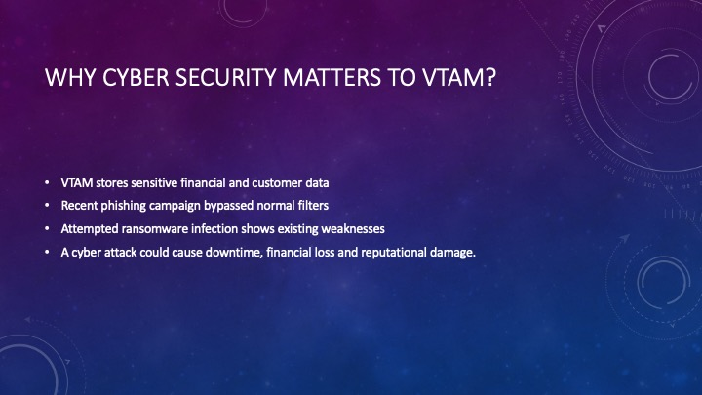
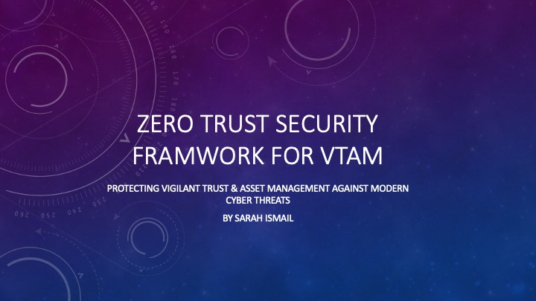

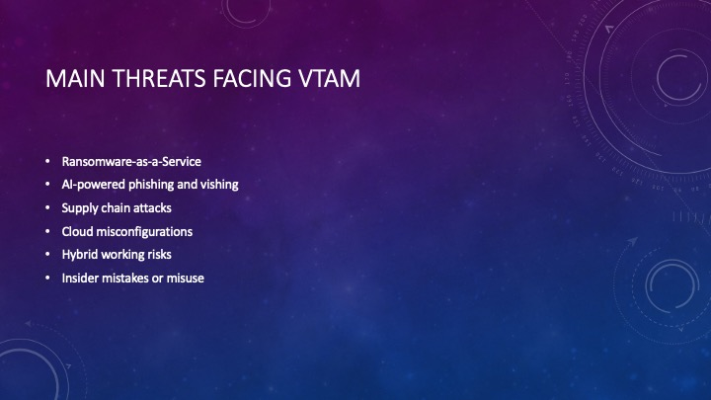
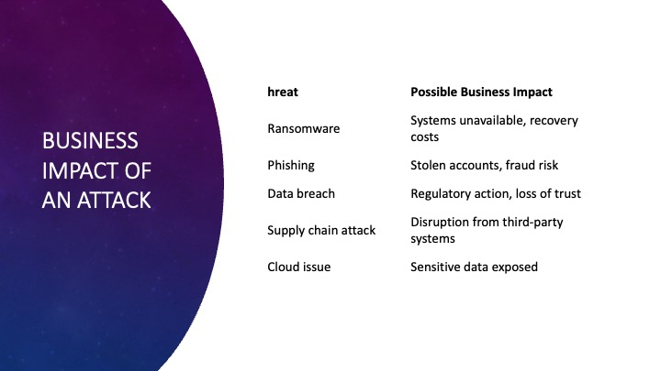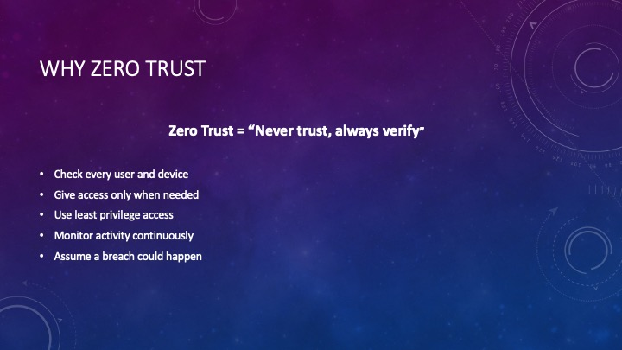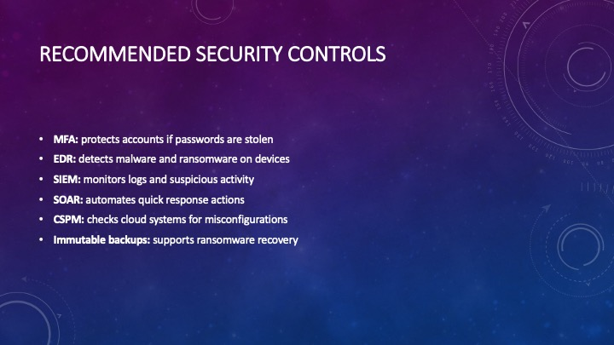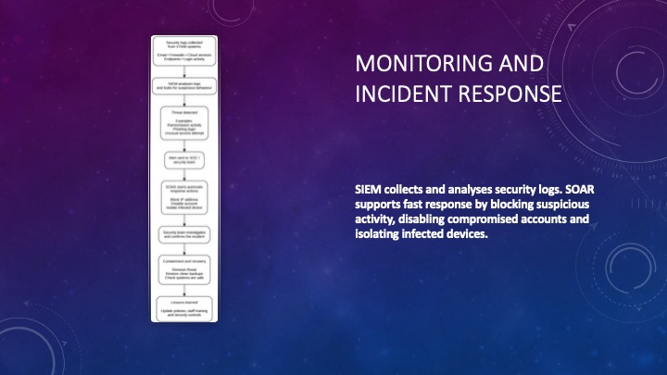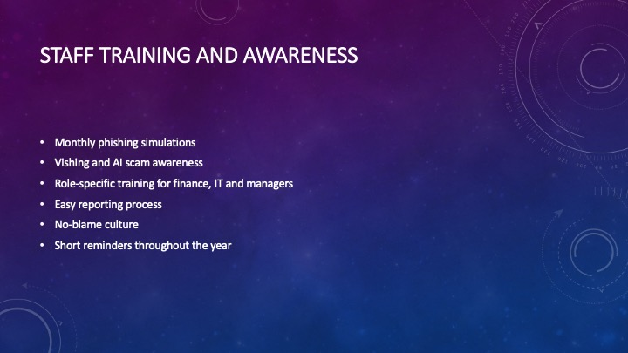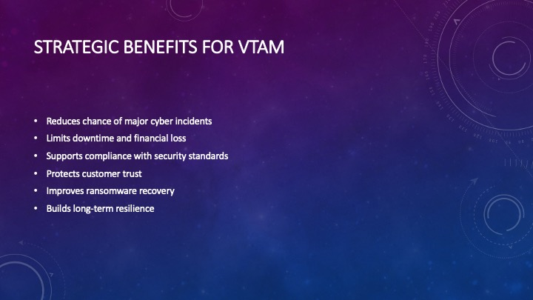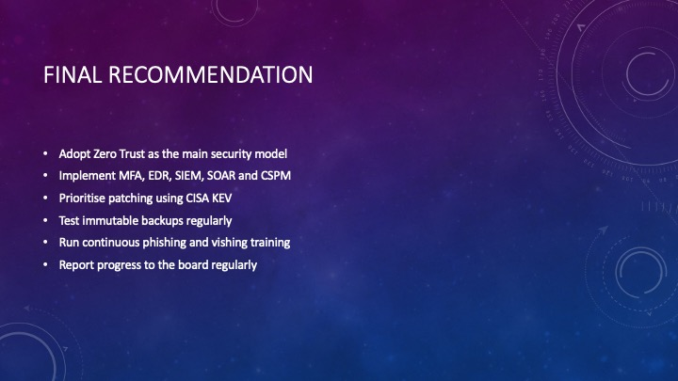

CISCO Certificates

