

Programme: BA Leadership and Management Skills for the Workplace

Module: Developing Innovation and Creativity for Business Advantage
Module Code: BMSW6102 Task 1
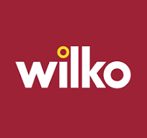

Student Name: Nicusor Ionut Aliu
Student ID: 2131114
Table of Contents
1.0 Introduction 3
2.0 Provisions of the Company: Wilko 4
3.0 Impact of the Innovation on the Company 9
4.0 Application of the SCAMPER Model 12
4.1 Definition 12
4.2 Benefits of using SCAMPER Model 12
4.3 Applying Wilko’s Challenges to SCAMPER Model 12
5.0 Conclusion 15
References 17

1.0 Introduction
As stated by Fletcher and Griffiths (2020), the retail industry of the UK has observed remarkable digital transformation in recent times and many established businesses are facing it hard to continue to exist (Sagar, 2024). One of similar businesses in the UK is Wilko that has got up for meeting considerable challenges. Recognised in the year 1930, Wilko came out as a foundation on British high street, giving a wide-ranging collection of home goods that includes kitchen appliances, rough and ready objects, gardening goods and cosmetics (Wilko, 2024). According to Bennett, Coleman & Co. Ltd (2023), Wilko has been in economic danger most recently (figure 1), consequential to shop closure and key re-organisation efforts in spite of its drawn out history and eminent brand.
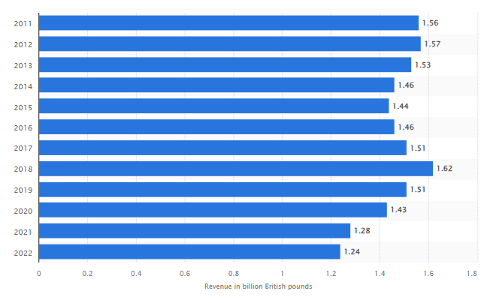
Figure 1: Revenue of Wilko Retail Limited in the UK from Financial Year 2011 to 2022
(Source: Statista Research Department, 2024)
As highlighted by Traynor (2023), Wilko's circumstances are typical of outsized growth in the retail sector, where a hard atmosphere has been brought about by altering consumer behaviour, financial crisis and keen competition from corporeal as well as digital businesses. The business’s conformist corporate approach that is chiefly dependent on sales from physical stores has been influenced by the increase in fame of online platforms. Furthermore, as consumers’ choices alter as per more morally and sustainably produced goods, retailers like Wilko who have had interval following in accepting these patterns are having progressively more demanding retail surroundings. The SCAMPER framework will be applied in the report for resembling inventive thinking projected to endorse innovation; can provide perceptive knowledge on the strategies Wilko might have taken to conquer its challenges. Through alternatives, adaptation, combination, alteration, removal, reversal and placing to other applications, Wilko could have established innovative conduct to renovate its business and maintain its market place in a retail setting that was shifting rapidly.

2.0 Provisions of the Company: Wilko
For more than a century, Wilko has been a prominent brand in the UK retail industry. The business provides an extensive assortment of commodities in a number of regions to satisfy different daily wants. Market ranking of Wilko has been profoundly contingent on this variety of commodities that demand a wide assortment of customers finding simple and convincingly priced buying alternatives.
Home and Living Products
Wilko's major benefit is the extensive choice of commodities it provides for the lifestyle and home. This grouping has supplies for the house like storage appliances, cleaning goods and equipment for decorating and arranging the home. Wilko's cleaning materials, comprising those under its possessed brand, are popular due to their rational costs and effectiveness. With furnishing materials, illumination and decorative tools, the company also retails a multiplicity of home decor items that enable customers finish and tailor their living rooms devoid of going surplus spends (Amazon.com Inc, 2024).
DIY and Gardening
The DIY and gardening segment of Wilko's large products line provide gadgets for saplings, seed and gardening materials are enclosed in this division. Wilko has been recognised as an eminent DIY and gardening terminus by providing premium materials at reasonably priced costs. Throughout the most engaging periods of the year, seasonal gardening materials such as yard furniture and grill illustrate a quantifiable customer base (Wilko, 2024).
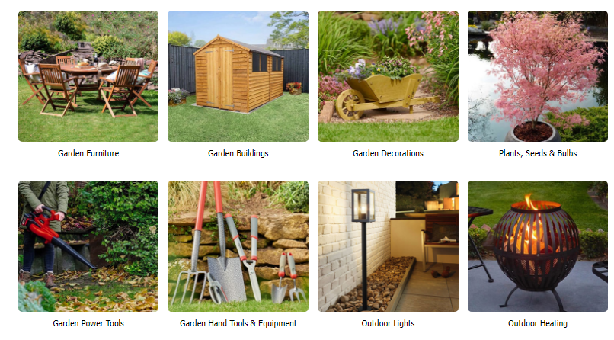
Figure 2: Products of DIY and Gardening in Wilko
(Source: Wilko, 2024)
Health and Beauty
Skincare, cosmetics and hair care items are some of the personal care goods offered at Wilko's beauty and health sector. This segment provides goods under Wilko's both private brand label and branded items, to put up an extensive assortment of customer preferences. Reasonable personal hygiene and cosmetics products are voluntarily offered that has helped Wilko in keeping hold of reliable customers in this competitive industry (Wilko, 2024).
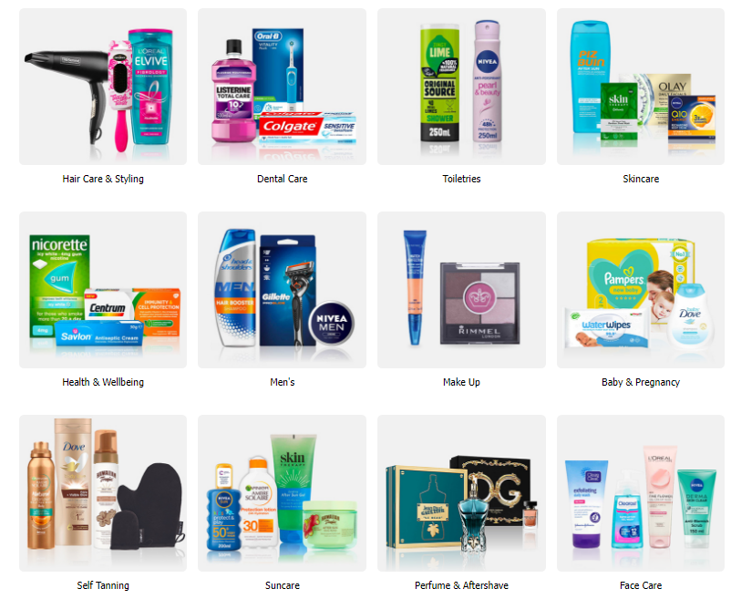
Figure 3: Health and Beauty Products of Wilko
(Source: Wilko, 2024)
Seasonal and Festive Products
Wilko is famous for offering extensive alternatives of festival and occasional products. Wilko satisfies seasonal requirements every year long, providing the whole thing from Halloween outfits and Christmas decoration to school year products and summer needs. All through engaging periods, these items even boost base traffic to physical stores as well as enhance Wilko's digital purchases (Wilko, 2024).
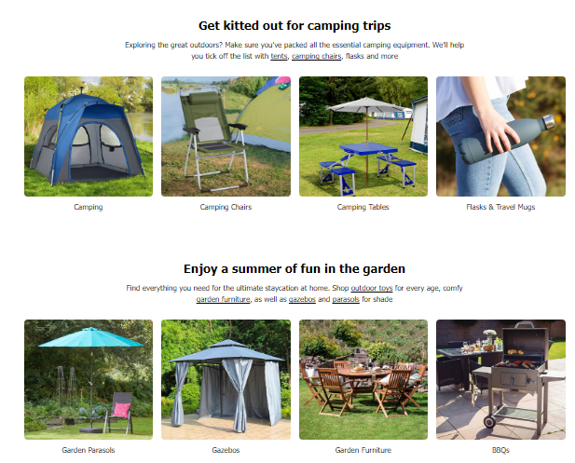
Figure 4: Seasonal and Festive Products Offered by Wilko
(Source: Wilko, 2024)
Stationary and Craft Supplies
A further necessary constituent of Wilko's merchandise line includes the craft supply segment and stationery. Office items, school materials and craft tools are everything integrated in this group. Wilko holds up attention in a broad variety of consumers by offering affordable priced, elegant stationery products for amateurs, professionals and students (Wilko, 2024).
Food and Drink
Wilko also offers a range of food and drink supplies, although they are not its key centre to focus. This entails staple groceries, drinks and snacks. The reason for the inclusion of these goods is to supply consumers more easily by facilitating them to select provisions such as food despite the fact that undertaking their other home purchasing (Wilko, 2024).
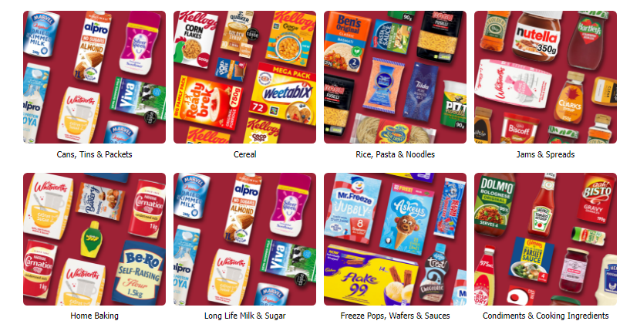
Figure 5: Groceries in Wilko
(Source: Wilko, 2024)
On the basis of Sri-Pathma, Jones and Masud (2023), Wilko has over 400 places in the UK, with a noteworthy existence in urban as well as sub-urban locations. Yet even with its enormous chain of stores and extensive options of items, Wilko has had severe monetary challenges. The company has had obstacles in recent times for declining profits, increasing competition and the development of digital business. It also demonstrates a turn down in sales that encouraged the shutting of various places and a force for administration to remain floating in the severely cut-throat retail industry.

3.0 Impact of the Innovation on the Company
Novelty has had a varied impact all through the years, influencing advantageous and worse effects for Wilko on the company. Being a renowned contributor in the UK retail industry, Wilko's approach for advancement has had a big impact on its ability to stay alive and struggle.
Positive Impacts of Innovation
Product Diversification and Range Expansion
In the past, as cited by Nunis and Edser (2023) and Paxton Media Ltd (2024), Wilko has obtained the programme to boost the range of goods it provides with the intention of a ground-breaking approach that has assisted it to supply a broad scale of consumers. Wilko has drawn the attention of consumers from an assortment of settings by constantly commencing novel product range and seasonal items. This strategy has aided to maintain customer concerns in the brand name and sustained its significance.
Private Label Development
The formation of private label products is an inventive development that has established valuable input (Farrell, 2021). Wilko's home brand items have amplified business margin and enhanced consumer devotion by providing customers less exclusive alternatives for nationwide names. By means of focusing on private brands, Wilko has been proficient to put itself distant from competitors by offering characteristic items.
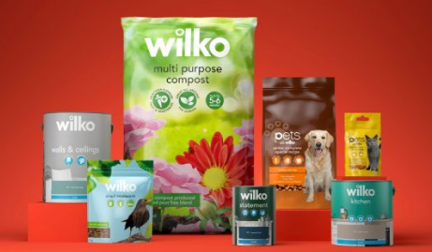
Figure 6: Wilko’s Own Label Range of Packaging
(Source: Zim Packaging, 2021)
In-Store Experience
Wilko has made spending to improve the in-store acquaintances by re-furnishing stores and maximising structures. These programmes have developed the expediency and pleasure of shopping, endorsing recurrent visits. Modernising the appearance and feel of physical store ambience has become necessary to maintain customers in the face of growing competition from digital businesses (Bolton et al., 2022).
Negative Impacts of Innovation
Slow Adaptation of Online Business
As per Skelly (2023), Wilko's slow digital perception has been one of the leading negative aspects. Wilko followed behind its rival’s digital footprint, a swift increasing market of customers who favor digital purchasing. The retarded implementation of an online business platform made it more intricate for Wilko to productively contend with other digital behemoths like Amazon and other geek businesses.
Technology Integration
As per Traynor (2024), Wilko has also faced challenges in the area of using advanced technology into the retail segment. Contemporary business needs an efficient inventory operations system, data analytics for customer impressions and online marketing strategies. Operational efficiency and capability of Wilko to make data-related decisions have undergone as a consequence of its unwillingness or incapability to completely integrate these know-how. Contrasted to geek rivals, this discontinuation has led to product deficiency, overstock issues and a reduced tailored buying experience.
Sustainability and Ethical Practices
The preferences of customers have been stirring progressively towards sustainable and morally produced commodities (Hartmann, Jahnke and Hamm, 2021). The failure of Wilko to take benefit of the increasing market for goods made morally and sustainably as it has been slow to initiate innovation in these points. Wilko has failed to grab ground to competitors that have productively incorporated sustainability in their key business management. These rivals have grown a considerable market share. In a market of valued corporate liability, the status of the brand has been spoiled by this shortage of innovation in terms of sustainability that has also pessimistically influenced customer faithfulness.
Online Marketing and Consumer Involvement
Innovative approaches are required for flourishing marketing and customer communication in the digital era, as the claim of Chapuzet and Bawono (2021). Wilko's incapability to fit youth and geek customers is a consequence of its traditional marketing concepts not keeping pace with the digital uprising. It is complex for Wilko to stay in the vanguard of potential customers’ choices due to its bare practice of influencer relations, social media platforms and interactive digital activities.

4.0 Application of the SCAMPER Model

4.1 Definition
As Anggrianto (2022) defined, SCAMPER acronym for Substitute, Combine, Adapt, Modify, Put to another use, Eliminate and Reverse, is an inventive conflicting thinking procedure that might help companies with the restricted circumstances in approaching up with novel thoughts from present goods and services devoid of pursuing to spend a considerable amount of capital or attempt. It fosters innovation, problem-solving and enhancement to create so many new thoughts. SCAMPER aids customers use different thinking by steering them in making a diversity of ground-breaking elucidations to troubles, re-identifying customers and increasing novel ranking, images, language and marketing strategies that are apt for the situation close by to make a novel brand tactics.

4.2 Benefits of using SCAMPER Model
Budiyanto and Zamil (2021) proclaimed that the SCAMPER tool is often applied to make perceptions and is a technique to enhance project implementation and product development. SCAMPER consists of seven steps for producing perceptions. It is advantageous as it usually smooths the progress of the production of novel approaches that in return creates novel perceptions. As a result, the mentioned method has been integrated to convey together, incorporate and improve diverse concepts to locate novel product perceptions and even the screening process to prohibit novel product notions that are not alluring. Moreover, Nikolić, Mihajlović and Vujičić (2020) outlined the advantages that The appropriate way to apply inventive ideas to support business owners perceive new probabilities involves to know that these techniques go past what other individuals previously know to assist finding chances and this tool can assist to adopt an inventive state of mind productively.

4.3 Applying Wilko’s Challenges to SCAMPER Model
Substitute
Substituting Traditional Practices with Modern Techniques
Wilko might substitute its traditional and outdated in-shop retail approach with a further competent digital company. By focusing on online sales platforms, Wilko might take the lead of the increasing digital client base. Making an instinctive application of mobile and website such as to wealthy competitors that includes Amazon could attract geek consumers (Skelly, 2023). In addition, brand experience and involvement with youth spectators might be enhanced by putting back conventional marketing approaches with digital marketing strategies comprising influencer associations and social media initiatives (Chapuzet and Bawono, 2021).
Combine
Combining Product Line and Service
Wilko holds the capability to incorporate services that perk up the customer understanding with its broad range of goods. For example, coming together of product sales along with DIY workshops and gardening courses can expand a community-oriented purchasing atmosphere and add to consumer constancy (Nunis and Edser, 2023). Adding together a digital platform for suitable application to these educational events would certainly assist Wilko's cut-throat benefit. Besides, Wilko could satisfy the rising urge from consumers for moral and sustainable products by coordinating with sustainability-based businesses and incorporating their products with its present lines (Hartmann, Jahnke and Hamm, 2021).
Adapt
Adapting to Customer Preferences and Market Trends
Wilko requires altering to satisfy the increasing customer requirement for moral and sustainable supplies. This takes into consideration having more ecologically friendly resources by means of bare amounts of plastic and giving more sustainable product alternatives. Consumers that are concerned about the surroundings might also be satisfied by launching an event for conventional products to be given back and by endorsing recycling, as per Hartmann et al. (2021). Moreover, Wilko could provide the needs and choices of its consumers by tailoring its item offers related to customer data analytics that would augment consumer contentment and allegiance, according to Traynor (2024).
Modify
Modifying In-Store and Digital Experience
Wilko might modify the structure of its shop outlets to create the purchasing experience even more customer-friendly. The purchasing procedure may be smoothened by upgrading organisations with automated or also called self-service kiosks and innovative demonstrations (Bolton et al., 2022). In order to improve consumer experience and enhance sales, Wilko might modernise its digital online platform to integrate fidelity events, effortless navigation features and individualised recommendations (Skelly, 2023). Giving one-day delivery or ‘click and collect’ options may help meet the hopes of modern clientele concerning ease.
Put to Another Use
Repurposing Current Resources and Capability
By repurposing its huge network chain of stores, Wilko might proceed as regional hubs with the view of an online product delivery approach, citing consequence in more rapid delivery periods in addition to lesser operational and transportation investments. Besides, deteriorating organisational managements may possibly be replaced to existence and traded by turning them into targets purposely for digital delivery pick-ups or locality events (Paxton Media Ltd, 2024). Developing the service provisions of the brand's may also engage using employee understanding for virtual consultation and digital customer care.
Eliminate
Eliminating Inefficiencies and Traditional Products
In order to make operations management easier and decline expenditures, Wilko may throw out fault product lines and unproductive measures. This involves throwing out goods that do not go with present customer trends consisting of environmentally friendly goods and focusing on popular, sustainable alternatives (Hartmann et al., 2021). In addition, rising automated recurrent jobs and inventory control might enhance operational efficiency and productivity (Traynor, 2024).
Reverse
Reversing Business Models and Strategies
In the transforming era of digitisation, Wilko could uphold its manner of competition by turning over its traditional brick-and-mortar-based model of business and taking on an internet-first concept. Development might be picked up by offering concerns to online revolution initiatives as well as developing the digital purchasing experience and creating data analytics funds (Skelly, 2023). Also, marketing approaches might be upturned to increase contact and efficiency by placing more of a stress on online platforms more willingly than in-store and printed promotions (Chapuzet and Bawono, 2021).

5.0 Conclusion
A swiftly shifting retail setting that is featured by transformations in consumer conduct, economic crises and severe competition from in-store as well as digital stores, has offered Wilko, a significant UK retail establishment, with a number of challenges. A technique of strategic significance for Wilko to introduce and regulate these advancements is offered by the SCAMPER tool. Wilko might perk up its market rank by the integration of product line with service provisions, reinstating out of date techniques with modern ones and tackling customer choices. Operations might advance efficiency by adjusting online interactions and in-store experiences, re-using sources and throwing out ineffectiveness. After all, overturning business tactics to provide online platforms concerns may make certain Wilko's unrelenting significance in the competitive retail market. By placing these creative strategies into exercise, Wilko may be able to maintain its market rank, improve customer pleasure and reinvigorate its brand in the light of incessant industry transformations.
Recommendations
- Wilko may provide top concern to forming a well-built mobile application and online business platform with the purpose to attract in geek consumers and make simpler digital buying, as per Skelly (2023).
- The business may augment the quantity of products that are morally and economically produced to please the increasing stipulate from customers for sustainable items, according to Hartmann, Jahnke and Hamm (2021).
- It can arrange gardening sessions and ready-made workshops to promote a sense of community within purchasers and boost recurrent business (Nunis and Edser, 2023).
- According to Traynor (2024), it should cut expenditures and enhance operational efficiencies, use programmed processes and complicated inventory management.
- It may efficiently involve youth customers and alter the concentration to digital marketing techniques such as influencer coordination and social media events, as highlighted by Chapuzet and Bawono (2021).

References
Amazon.com Inc, (2024). Wilko. [online] Available at: https://www.amazon.co.uk/stores/wilko/Homepage/page/6D4060F3-CF92-40C3-BD0F-7721D9775B15 [Accessed on 17th June 2024]
Anggrianto, C., (2022). Proposing SCAMPER: Approach to reach brand strategy equipoise during the COVID-19 pandemic. In Embracing the Future: Creative Industries for Environment and Advanced Society 5.0 in a Post-Pandemic Era (pp. 256-260). Routledge.
Bennett, Coleman & Co. Ltd, (2023). UK retail chain Wilko at risk of collapse. [online] Available at: https://economictimes.indiatimes.com/news/international/business/chinas-central-bank-leaves-key-policy-rate-unchanged-as-expected/articleshow/111049568.cms [Accessed on 17th June 2024]
Bolton, R.N., Gustafsson, A., Tarasi, C.O. and Witell, L., (2022). Managing a global retail brand in different markets: Meta-analyses of customer responses to service encounters. Journal of Retailing, 98(2), pp.294-314.
Budiyanto, M.M.H. and Zamil, N.A.M., (2021). Developing A Framework to Identify New Market Ventures, Generate and Select New Product Ideas.
Chapuzet, A.C. and Bawono, S., (2021). New Way Modern Marketing: New Perspective Of Marketing In Digital Era For Effective Marketing in Digital Age. BookRix.
Farrell, S., (2021). Wilko gets a brand refresh across own-label ranges. [online] Available at: https://www.thegrocer.co.uk/discounters/wilko-gets-a-brand-refresh-across-own-label-ranges/662038.article [Accessed on 17th June 2024]
Fletcher, G. and Griffiths, M., (2020). Digital transformation during a lockdown. International journal of information management, 55, p.102185.
Hartmann, T., Jahnke, B. and Hamm, U., (2021). Making ugly food beautiful: Consumer barriers to purchase and marketing options for Suboptimal Food at retail level–A systematic review. Food Quality and Preference, 90, p.104179.
Nikolić, M., Mihajlović, L.S. and Vujičić, S., (2020). INNOVATION AND ENTREPRENEURSHIP: CREATIVITY, OPPORTUNITY AND FEASIBILITY. EMPLOYMENT, EDUCATION AND ENTREPRENEURSHIP, p.29.
Nunis, V., and Edser, N., (2023). Wilko: New bid emerges for stricken retail chain. [online] Available at: https://www.bbc.com/news/business-66632468 [Accessed on 17th June 2024]
Paxton Media Ltd, (2024). Featuring Walmart, Wilko, Asia Jewellers, MUJI, and 7-Eleven: last week’s biggest retail technology plays at a glance. [online] Available at: https://retailtechinnovationhub.com/home/2024/5/20/featuring-walmart-wilko-mhuji-and-7-eleven-last-weeks-biggest-retail-technology-plays-at-a-glance [Accessed on 17th June 2024]
Sagar, S., (2024). The Impact Of Digital Transformation On Retail Management And Consumer Behavior.
Skelly, J., (2023). Wilko’s demise shows the importance of digital. [online] Available at: https://www.thegrocer.co.uk/saturday-essay/wilkos-demise-shows-the-importance-of-digital/683112.article [Accessed on 17th June 2024]
Sri-Pathma, V., Jones, L., and Masud, F., (2023). What went wrong at Wilko? [online] Available at: https://www.bbc.com/news/business-66394238 [Accessed on 17th June 2024]
Statista Research Department, (2024). Revenue of Wilko Retail Limited in the United Kingdom (UK) from financial year 2011 to 2022. [online] Available at: https://www.statista.com/statistics/1009407/wilko-retail-limited-turnover-united-kingdom-uk/ [Accessed on 17th June 2024]
Traynor, R., (2023). Wilko: What Went Wrong And What Will Happen? [online] Available at: https://www.redflagalert.com/articles/risk/wilko-what-went-wrong-and-what-will-happen [Accessed on 17th June 2024]
Wilko, (2024). Arts & Crafts. [online] Available at: https://www.wilko.com/en-uk/stationery-office/arts-crafts/c/926 [Accessed on 17th June 2024]
Wilko, (2024). Garden & Outdoor. [online] Available at: https://www.wilko.com/en-uk/garden-outdoor/c/1 [Accessed on 17th June 2024]
Wilko, (2024). Get the holiday essentials sorted. [online] Available at: https://www.wilko.com/en-uk/holiday-essentials/c/5020 [Accessed on 17th June 2024]
Wilko, (2024). Groceries. [online] Available at: https://www.wilko.com/en-uk/groceries/c/1367 [Accessed on 17th June 2024]
Wilko, (2024). Health & Beauty. [online] Available at: https://www.wilko.com/en-uk/health-beauty/c/684 [Accessed on 17th June 2024]
Wilko, (2024). How we got to where we are. [online] Available at: https://www.wilko.com/en-uk/corporate/our-history [Accessed on 17th June 2024]
Wilko, (2024). Wilko.com. [online] Available at: https://www.wilko.com/ [Accessed on 17th June 2024]
Zim Packaging, (2021). Wilko starts revamp of own label range with Free The Birds. [online] Available at: https://zimpackaging.co.zw/2021/11/17/wilko-starts-revamp-of-own-label-range-with-free-the-birds/ [Accessed on 17th June 2024]

