Course Title: PROBLEM SOLVING AND DECISION MAKING BMSW4004
University of Wales and Trinity St David
Course Tutor: Mr Y Kumar
Student: Khudabakhsh Rafique
Student ID No: 1811926

Contents

My Introduction
Background to a problem I was tasked with
Definition of a complex problem in a workplace, its scope and impact
Decision making process for problems
Alternative solutions to the problems
Decision making technique for evaluation of range of problems
Communicating the plan with the stakeholders
Plan for implementing solution
My Conclusion
My References



Introduction
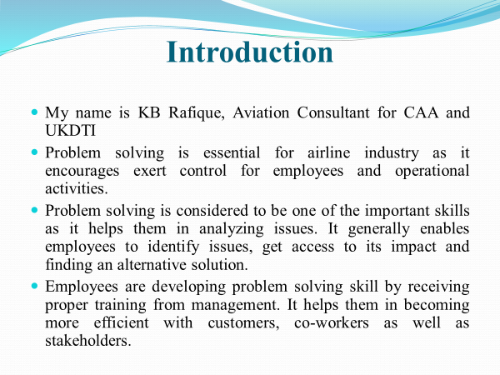
My name is KB Rafique and I am Aviation Consultant to CAA (Civil Aviation Authority) and UKDTI (United Kingdom Department of Trade and Industry) and my role is to manage and implement processes between the Authorities and the Airlines in the UK and abroad. I am writing a report on a problem that me and my team were given to resolve which related to two aircraft crashes within a space of 6 months. Problem solving is essential for the airline industry as it encourages and measure of control, welfare, safety, security for employees, customers, stakeholders and operational activities. Problem solving is one of the important skills for employees as it helps them in analysing issues and ease of solution finding. It generally enables employees to identify problems and obstructions, thoroughly and analyse the impacts of the problems and finding an alternative solution. Employees develop problem solving skill by receiving proper training from their management. It helps them in becoming more efficient while handling customers, co-workers as well as stakeholders both external and internal. They also apply various strategies to improve their communication and application skills. It has been found that complex issues may also impose a negative impact on reputation of a particular airline brand in the airlines industry in market. The following study sheds light on scope, impact, decision making and solutions for complex issues that are arising.
I have very briefly described below the problem that I was tasked to resolve.
Background to a problem I was tasked with.
Two Plane crashes with in 6 months of each other, Lion Air Crash 29/10/2018 and Ethiopian Airline crash on 10/03/2019, both involving two brand new Boeing 737 MAX, one of the most advanced and technological aircrafts of its time.
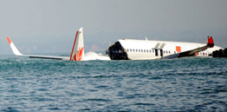

Problem/s:
• Both incidents are they isolated or related to a rooted common problem?
• In UK do we (CAA) ground the B737 MAX until further notice?
• If we ground the total fleet in and out of the UK and who will pay for the losses if proven that the aircrafts were safe, which anticipated to around £300Billion
• If we don’t and a similar accident occurs with the same aircraft over the UK airspace, who will be responsible? Estimated insurance cost of around £750Billion
At team of 14 people was set up and implemented to carry out investigative work and analysis of the crash, crash site, aircraft maintenance, crew, passengers, luggage and aircraft safety systems.
Distribution of work force:
2 people sent to Indonesia
2 people sent to Ethiopia
2 people to collate data from Indonesia
2 people to collate data from Ethiopia
2 people to liase and mediate between UK and Foreign B737 MAX Operators
1 Person to collate possible potential causes of the two crashes (Me)
1 person to feed back all information on daily basis to Department for Transport
2 people on the Crisis Management, Communication and Business Recovery Team
Time Frame:
All work and conclusion to be completed within 8 working days.
My Task
My task was to carry out investigative analysis of top 6 potential possibilities of the two crash, 2 of which must be common to both crashes.
My work involved extensive research of the information available to date of the two crashes:
Investigating Area’s: Avionics, Airframe, Fuselage, Fuel tanks, Engines and Controls surfaces
Sources: for each of the above area’s I had to scour through the following sources, Classified information from Government, official newspapers, Internet, Wikipedia, Boeing 737 MAX journals, manufacturing details, log books, maintenance books etc.
Communications:
I set up a communication process with all of the above 13 people for freeway of valuable information.
Communication Channels: Emails, Microsoft Team, WhatsApp and Conference calling.
Timing of Transfer of information, Mondays, Wednesdays and Fridays between 1pm and 3pm.
Collating of information: I made notes, took pictures and stored incoming information onto a shared drive.
6 Possible Causes of the two crashes inline with the information available.
1. Engine problem
2. Aircraft structure failure
3. Terrorist attack
4. Primary Control surface failure
5. Pilot Error
6. Safety Systems Failure
Following all analysis of all the vital information it was decided that the likeable cause of the crash was either Pilot error, Safety system failure or both.
It was decided by the Government to ground all Boeing 737 MAX aircraft indefinitely and refer the case to Boeing and the aircraft operators. Since March 2019 the Boeing 737 MAX has been grounded worldwide which has so far cost Boeing around $500 Billion in damages, losses and claims.

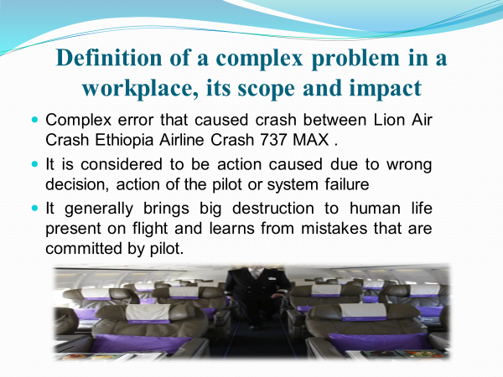

Definition of a complex problem in a workplace, its scope and impact
Complex issues at a workplace in general described as those that give ability to approach a problem through various perspectives which might sometimes even be conflicting amongst each other and which also may give rise to many favorable or unfavorable consequences (Mainert et al,. 2019). Based on an analysis of the probable consequences, the best strategy is chosen to deal with the problem in order to resolve it completely. The most used strategy in workplaces has been found to be the trial and error method. In the airline industry a complex issue can have major consequences not only on the company but also on the customers or the clientele. For example, a complex error caused a crash of two new 737 MAXs of Lion Air and Ethiopian Airlines 2018 and 2019. There are many contributing factors which leads to accidents and harms many lives that are present on the flight (Lester et al., 2017).
A complex error caused by the crew generally causes damage to human life and property on a flight, on the ground and the learning from pilot mistakes. It increases complexity within operational activities of flights. Pilot error also leads to increase in threat of malfunctioning, interruptions or conflict within cabin members and an increased pressure on the flight operations. Some of the impacts of pilot error are airline accidents of which, according to statistics, 80 % are caused due to the pilot’s error and 20 % happen unfortunately because of weather issues and failure of equipment (Yan et al., 2016).

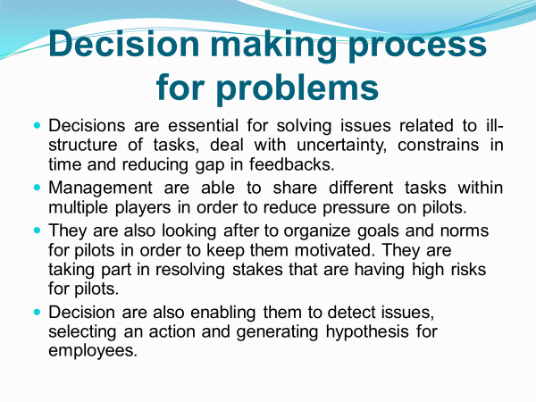

Decision making process for problems
Decision making processes is one of the most effective ways for carrying out the organizational activities. In the global context, decision making in airline industries can help in these ways:
- More number of employees will become motivated if they are engaged in the decision making process. The employees get a clear idea about the guidelines and with motivation they will improve the work productivity level. Based on their work performance the employees are given discretionary pay awards (Chen and Lai, 2019).
- Identifying the best alternative from a given number of options will become easier with the decision making process. From such best alternative, the customers are provided with the options of investment through this organization.

Decision making process that are carried out by management to solve this issue of pilot errors by collecting relevant information, detection of faults, estimating the outcomes and choosing a right alternative solution (Hudson, 2017). Decisions are made to provide proper training to pilot in order to reduce error. It is important to take right decision as poor action might lead to huge consequences and loss of life and property. Investigation is also carried out in different areas such as engines, control systems, fuselage, airframe, and fuel tanks as well as avionic in order to take productive decisions (Dekker et al., 2017). Decisions are essential for solving issues related to ill-structure of tasks, deal with uncertainty, constrains in time and reducing gap in feedbacks (Fairbairn, 2018). Management are able to share different tasks within multiple players in order to reduce pressure on pilots. It is also required to understand the issues that are arising that lead to pilot error within aviation industry. They are taking part in resolving stakes that are having high risks for pilots. Decision are also enabling them to detect issues, selecting an action and resolve the issue.



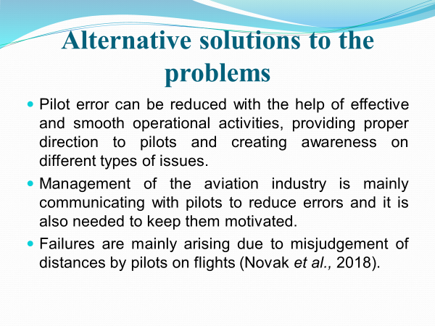

Alternative solutions to the problems
Safety department is mainly looking after workload management in order to develop proper plan and sequencing tasks to helping pilots to avoid overloading of work. They are developing proper checklist that is performed by pilots which is also helpful in standardizing cockpit processes as well as safety (Shmelova, 2018). The airlines must consider troubleshooting electronic system that is present on flight for reduction of pilot error (Albers et al,. 2017). Airlines should recruit pilots with proper experiences, with this pilot error can be reduced with the help of effective and smooth operational activities, providing proper direction to pilots and creating awareness on different types of issues. The aviation industry is mainly communicating with pilots to reduce errors and it is also needed to keep them motivated. Failures are mainly arising due to misjudgement of distances by pilots on flights (Novak et al., 2018). They are providing pre-flight with low workloads to pilots and medium workload while taking off.

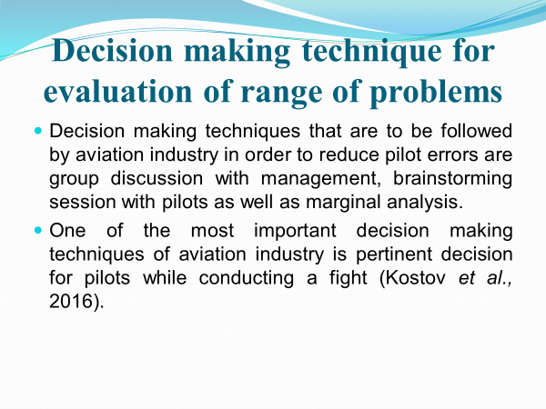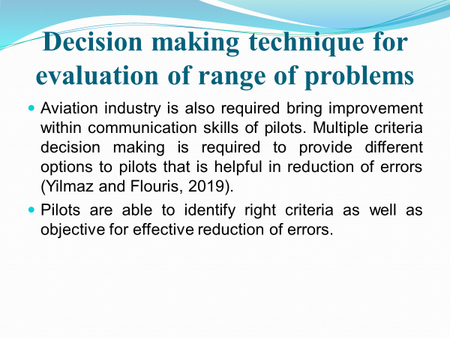

Decision making technique for evaluation of range of problems
Decision making techniques that are to be followed by aviation industry in order to reduce pilot errors are group discussion with management, brainstorming session with pilots as well as marginal analysis. One of the most important decision-making techniques of aviation industry is pertinent decision for pilots while conducting a fight (Kostov et al., 2016). They are following systematic approach which is helpful in selecting best course of action to provide proper responses to all inflight circumstances. It is required to measure performance of pilots which is also needed for reduction of errors. This decision making technique is helpful in allocating resources for pilots in order to accomplishing objectives. Aviation industry is also required to bring improvement within communication skills of pilots. Multiple criteria decision making is required to provide different options to pilots that is helpful in reduction of errors (Yilmaz and Flouris, 2019). Pilots can identify right criteria as well as objective for effective reduction of errors

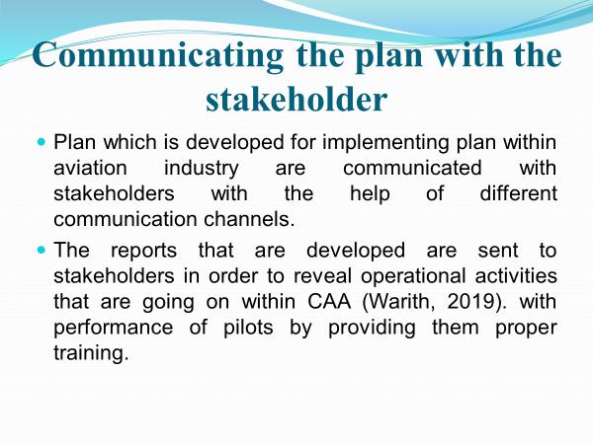
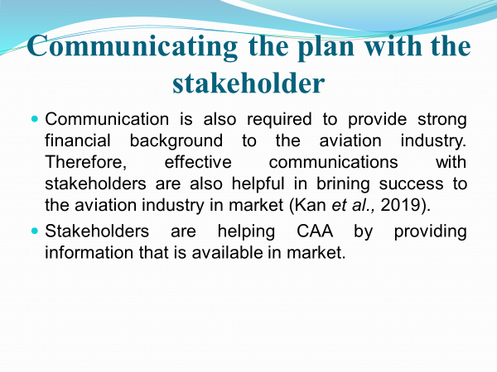

Communicating the plan with the stakeholders
Management held meetings with stake holders to provide them with reports of everyday activities. It is important for the team to set realistic expectations which are beneficial for the aviation industry. Communications with stakeholders are needed to get proper feedbacks for improving plans. Management schedules meeting with stakeholders, sending new letters, on-screen conferences and developing summary report. The strategies and policies developed by implementing a business plan within aviation industry are communicated with stakeholders with the help of different communication channels. The reports that are developed are then sent to stakeholders in order to reveal operational activities and recommendations to follow (Warith, 2019) with performance of pilots during their training period.



Plan for implementing solution

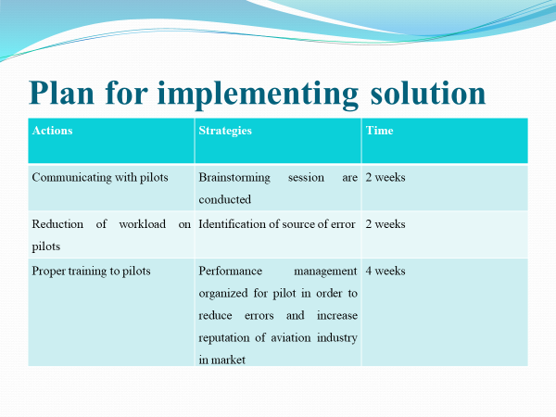

Actions | Strategies | Time
Communicating with pilots | Brainstorming session are conducted | 2 weeks
Reduction of workload on pilots | Identification of source of error | 2 weeks
Proper training to pilots | Performance management organized for pilot in order to reduce errors and increase reputation of aviation industry in market | 4 weeks

Monitoring and review technique to implement the solution successfully

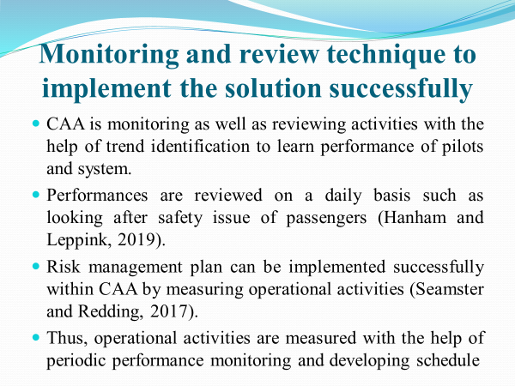
CAA monitors as well as reviews activities with the help of trend identification to learn performance of pilots and system.
Reviewing is also helpful in implementing control and risk measures within the flights. It helps the management in identifying and reducing associated risks in order to help and enhance safety and security. Reviewing and monitoring is needed to detect undesirable states that are leading to accident and is also needed to prevent accidents that are deemed to be inevitable for the aviation industry. It encourages the management to measure the impact of damages caused due to risks. The risk management plan is required to identify hazardous, analyse them, assessing the risks as well as documenting measures that are use used. They are also conducting a stress test for pilots in order to expose control measures that are inappropriate to carry out operational activities (Dožić, 2019).

Conclusion
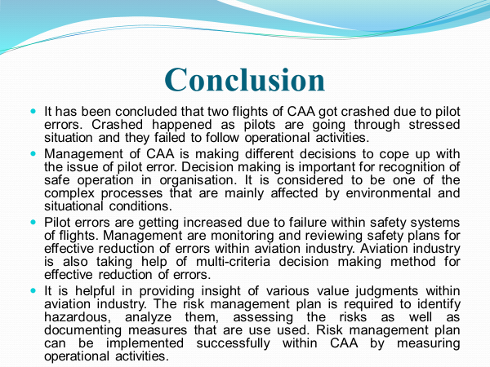

It has been concluded that the accident caused by two flights of was due to multiple of human errors. The crash was evaluated and was found to have occurred because pilots were going through stressful situation and they failed to follow operational activities. The report shows how various decisions were made by the management team to cope up with the issue of pilot error. Decision making is important for recognition of safe operation in this organisation. It is considered to be one of the complex processes that are mainly affected by environmental and situational conditions. Pilot errors are on the increase due to failure within safety management system. Management are monitoring and reviewing safety plans for effective reduction of errors within the aviation industry. Aviation industry is also taking help of multi-criteria decision-making methods for effective reduction in errors. The risk management plan is required to identify hazardous, inflight risks and how to analyse them. Assessing the risks as well as documenting measures that are use used. Risk management plan can be implemented successfully within CAA by measuring operational activities.


References

Albers, S., Baum, H., Auerbach, S. and Delfmann, W., 2017. Strategic management in the aviation industry. Routledge.
Chen, Y. and Lai, J., (2019), May. Information and Personal Networking in Decision-making Process: the Case of HSBC. In 2019 International Conference on Management, Education Technology and Economics (ICMETE 2019). Atlantis Press.
Dekker, S., Dahlström, N., van Winsen, R. and Nyce, J.M., (2016). Crew resilience and simulator training in aviation. In Resilience Engineering Perspectives, Volume 1 (pp. 133-140). CRC Press.
Dožić, S., (2019). Multi-criteria decision making methods: Application in the aviation industry. Journal of Air Transport Management, 79, p.101683.
Fairbairn, G.R., (2018). Development of aviation management coursework. The Collegiate Aviation Review International, 5(1).
Hanham, J. and Leppink, J., (2019). Decision Making in Aviation. In Instructional Design Principles for High-Stakes Problem-Solving Environments (pp. 63-81). Springer, Singapore.
Hudson, P.T., (2017), November. Safety culture and human error in the aviation industry: In search of perfection. In Aviation Resource Management: Proceedings of the Fourth Australian Aviation Psychology Symposium: v. 1 (pp. 19-31). Routledge.
James, S., (2018). The structural-informational power of business: credibility, signalling and the UK banking reform process. Journal of European public policy, 25(11), pp.1629-1647.
Kan, S., Chung, D. and Chung, G., (2019). Customer Experience Transformation in the Aviation Industry: Business Strategy Realization through Design Thinking, Innovation Management, and HPT. Performance Improvement, 58(1), pp.13-30.
Korchagin, A., Deniskina, A. and Fateeva, I., (2019). Lean and energy efficient production based on internet of things (IOT) in aviation industry. In E3S Web of Conferences (Vol. 110, p. 02124). EDP Sciences.
Kostov, B., Ahmad, J. and Křemen, P., (2016), October. Towards ontology-based safety information management in the aviation industry. In OTM Confederated International Conferences" On the Move to Meaningful Internet Systems" (pp. 242-251). Springer, Cham.
Lester, E., Georgiou, A., Hein, M., Littlepage, G., Moffett III, R. and Craig, P., (2017). Improving Aviation Students’ Teamwork, Problem Solving, Coordination, and Communications Skills During a High-Fidelity Simulation. In 19th International Symposium on Aviation Psychology (p. 119).
Middleton, Howard. (2002). Complex problem solving in a workplace setting. International Journal of Educational Research. 37. 10.1016/S0883-0355(02)00022-8.
Mainert, J., Niepel, C., Murphy, K.R. and Greiff, S., 2019. The incremental contribution of complex problem-solving skills to the prediction of job level, job complexity, and salary. Journal of Business and Psychology, 34(6), pp.825-845.
Novak, D., Pavlinović, M. and Trojko, F., (2018), January. An Outline of Sectoral Qualification Framework in Aviation Industry. In International Scientific Conference “Science and Traffic Development”.
Seamster, T.L. and Redding, R.E., (2017). Applied cognitive task analysis in aviation. Routledge.
Shmelova, T., (2018). Stochastic Methods for Estimation and Problem Solving in Engineering: Stochastic Methods of Decision Making in Aviation. In Stochastic Methods for Estimation and Problem Solving in Engineering (pp. 139-160). IGI Global.
Warith, M.F.A., (2019). Assessment of Green IT/IS Within the Aviation Industry Using the Analytic Network Process Approach. International Journal of Hospitality & Tourism Systems, 12(1).
Yan, W.Q., Zhu, Y.M. and Ahmad, N., (2016), December. Theory of Inventive Problem Solving (TRIZ) based contradiction resolution strategies for Shaanxi Aviation Industrial Upgrading. In (2016) IEEE International Conference on Industrial Engineering and Engineering Management (IEEM) (pp. 1111-1115). IEEE.
Yilmaz, A.K. and Flouris, T.G., (2019). Decision-Making in Aviation Management: Multi-criteria Problem-Solving Strategy. In Values, Ergonomics and Risk Management in Aviation Business Strategy (pp. 151-166). Springer, Singapore.

