Analysis of results
This section's goal is to analyse the questionnaire's results. The survey was made to be distributed to the general public and was intended to be finished in no more than five minutes. With an average completion time of 4 minutes, 30 seconds, the target completion time of 5 minutes was met. Due to a single anomaly in the data pool, where one participant took an hour to complete it, the mean was calculated from 49 results.
The survey was made available on a variety of social media platforms. 15 quantitative and qualitative questions were included in the survey. The researcher believed the combined approach to be the most successful. The researcher was able to get a definitive response by using closed questions, which required the participant to choose just one response. The open-ended questions on the questionnaire, however, permitted participants to express their opinions on the subject because the survey intended to gauge public perception. The findings will only focus on a subset of the questionnaire's questions; however, the appendix contains a complete list of all the questions.

Question 2: Age
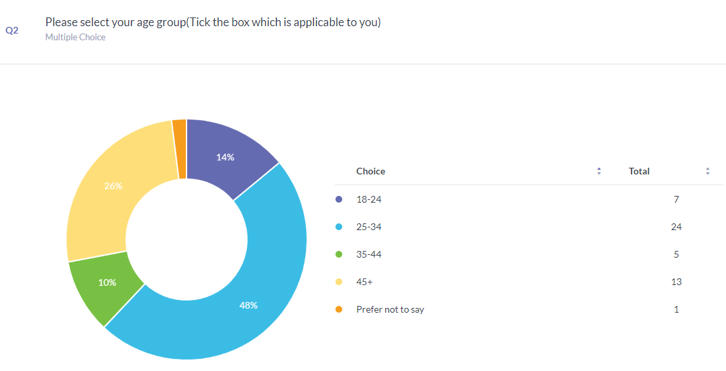
Question 2 was intended to gather more information about the participants as a whole. Those who were aged 25 to 34 years old made up 48% of the total participants, with those 45+ making up 26%. Less participants (14% of the group) were between the ages of 18 and 24, and just 10% were between the ages of 35 and 44. One participant wished to remain anonymous regarding this information.

It was essential that there be at least one response for each age group because the researcher was interested in the views of the general population and didn't want to focus on any particular demographic.

Question 3: Educational level
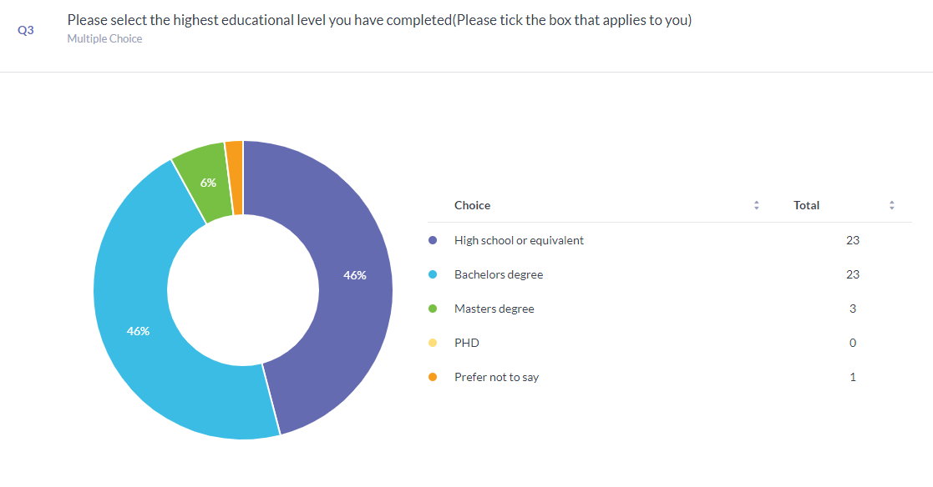
Once more, the goal of Question 3 was to obtain additional general knowledge about the individuals. Additionally, it was discovered in previous research that were part of the literature review that those with higher levels of education were more tolerant of the rule of law. The purpose of the question was to determine whether this corroborated earlier findings and whether people with higher levels of education did not support vigilante behaviour.

It was desired by the researcher that there was at least 1 response for each category however no participant held a PHD. 46% Participants held an educational level of that of a high school or equivalent and 46% held a bachelor’s degree. 6% of participants held a Masters degree and one participant wished to remain anonymous regarding this information.

Question 4: In your own words, what is a vigilante?
Question 4 focused on what the general public believed to be a vigilante was, it was vital for the researcher for the public to give their own answers for this question. The researcher wanted to gain an understanding of what the public thought a vigilante was to see if they understood what a vigilante was. 34 participants used the general wording “Takes the law into their own hands” which amounts 68% of those who took the survey. 2 persons that took the survey believed that a vigilante was someone who wanted to stop crime and enforce the law as they believed that the police were negligent and inadequate 1 participant stated that it was revenge. There were further answers including protecting the public and groups of people working outside of the law to bring others to justice.

question 7: When do you believe vigilant acts are justified?

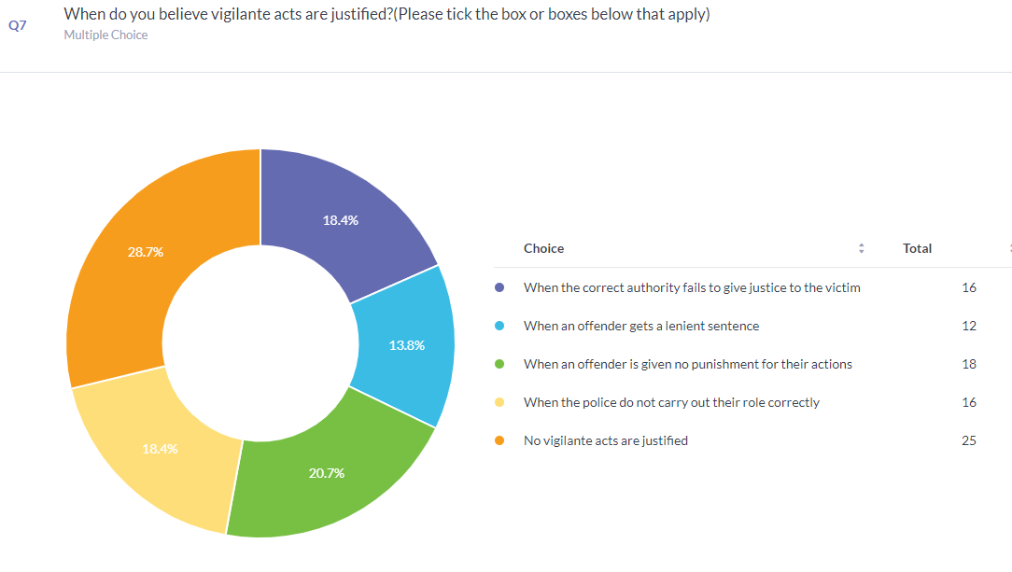

The researcher allowed the participants to choose multiple answers for this question. The most selected answer by participants was that no vigilante acts are justified. This was the largest response with it being 8% higher than every other answer showing that some participants did not believe any vigilante acts to be justified. The second highest response being vigilante acts are committed when an offender is given no punishment for their actions.

The third most selected answers were when the correct authority fails to give justice to the victim and when the police do not carry out their role correctly This does corroborate the above question whereby participants stated that the police being the proper authority were negligent and inadequate.
Question 8: Which incidents in your opinion, is the cause of most vigilante involvement?

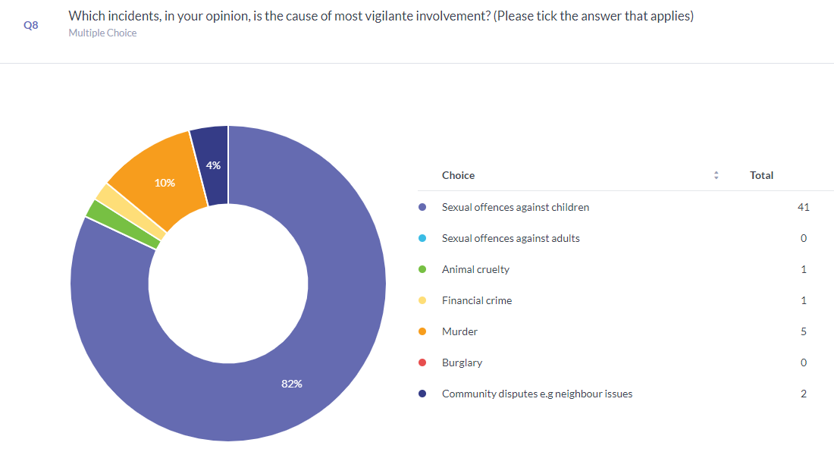

One question that received a more one-sided result was question 8. The question related to which crime received the most vigilante involvement. This resulted in 41 participants choosing sexual offences against children, which equalled a staggering 81%. No other answer came close with only 5 participants choosing murder, 2 selecting community disputes, 1 selecting animal cruelty and 1 selecting financial crime.
This links with the death of 8-year-old Sarah Payne who was murdered and sexually assaulted and the riots that ensued after. It also links in with the rise of paedophile hunters online becoming more prominent as it is clear that the public believe that child sexual offences are one of the most serious crimes to commit.

Question 10: How much do you support vigilantism?
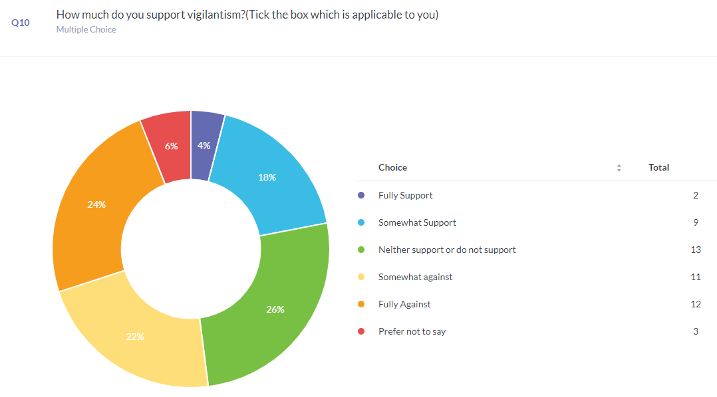
This question was vital for the researcher as one of the aims for the research was to find out the public’s perception of vigilantism and it was imperative that they found out if the public supported vigilantism or not. This question has an array of mixed answers from participants. Most participants, 26%, neither supported nor did not support vigilantism. Out of those 7 participants were at high school or equivalent and 6 held a bachelor’s degree.
Those who fully supported, 4%, held an educational level of high school or equivalent. Out of those who somewhat supported 7 held a high school or equivalent, 1 held a bachelor’s degree and 1 held a master’s degree.
Those who chose somewhat against made up 22% with 2 holding a high school or equivalent education, 7 held a bachelor’s and 2 held a Masters
24% of participants were fully against with 4 holding a high school or equivalent education and 8 holding a Bachelor’s degree. 3 persons preferred not to disclose this information.

Question 14: Do you agree that misinformation inspires people to engage in vigilantism?
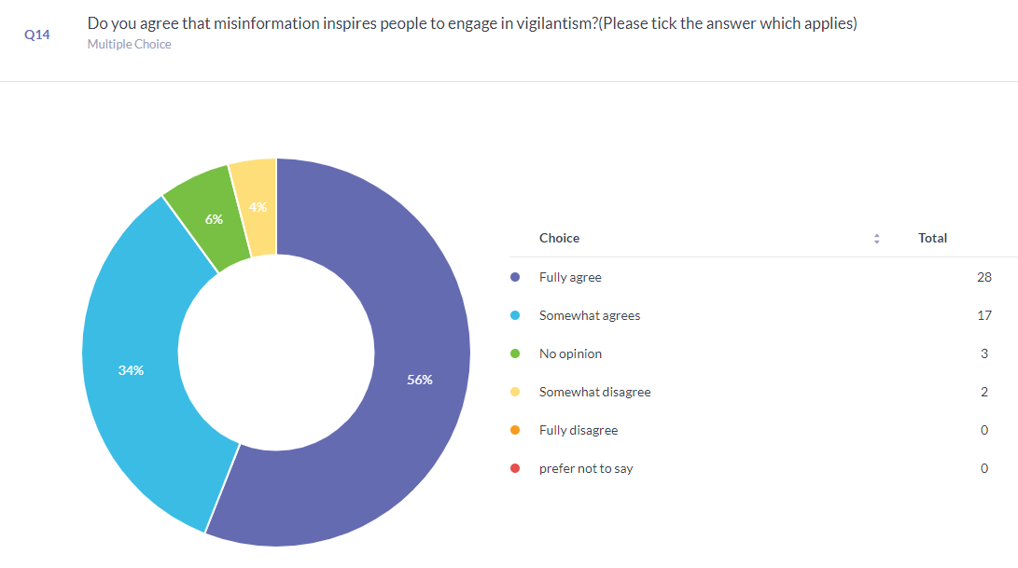
This question was asked by the researcher as part of their research was based around news outlets spreading information that may not always be correct. The outcome was very one sided whereby 56% of participants fully agreed that misinformation inspires people to engage in vigilantism and 34% somewhat agreed. 6% had no opinion on the matter and only 4% somewhat disagreed.
This shows that nearly all participants agreed on some level that misinformation can cause people to engage in vigilante acts.

Question 15: What do you think could be done to end vigilante acts?

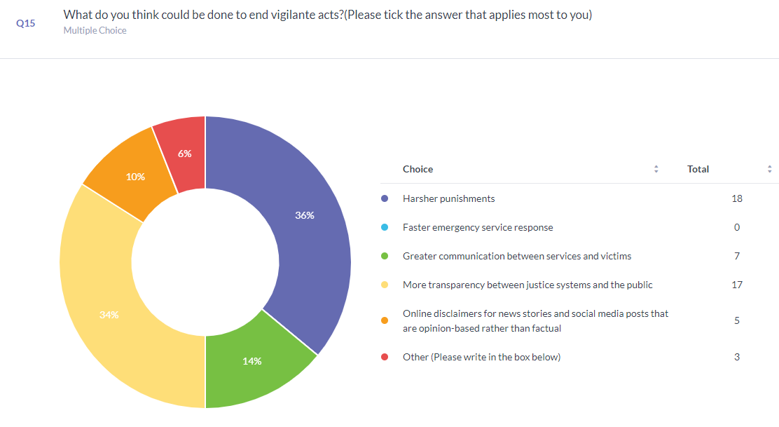
This question was imperative to the researcher as it is vital to show what the public think could be done to stop those taking the law into their own hands. The top answer from participants was that harsher punishments would be effective in stopping vigilantes, 36% of participants believed this. The second most selected answer that 34% of participants chose was more transparency between justice systems and the public. Thirdly 14% of participants thought that greater communication between services and victims would help end vigilante acts. Only 10% believed that online disclaimers for news stories would help.
3 participants stating other. 2 of those had points relating to emergency services with one participant stating that more money should be put into emergency responders so the can carry out their roles effectively and the other stating that state police should be abolished to create stronger social systems to tackle the issues that lead to crime. It is clear to see that although many people have the same opinion on what could be done to end vigilantism, there are still several issues that need to be addressed.

Findings and conclusion
The purpose of this survey was to determine whether the general public views vigilantism positively or negatively. Furthermore, it was predicted, in line with earlier research (Rosenbaum and Sederberg, 1974), that the public does, in fact, embrace vigilantism to a significant extent. Additionally, this study explored the justifications for supporting vigilante actions as well as the ways in which false information can inspire someone to commit an act of vigilantism.
The difficulty of defining vigilantism was previously highlighted by Rosenbaum and Sederberg (1974). However, a sizable portion of survey respondents defined a vigilante as "Someone who takes the law into their own hands"; this is a very broad definition and demonstrates that the general public is unaware of the precise definition of the term vigilante. Participants may have responded to the following questions based on their own assumptions about what a vigilante and vigilantism are using this broad definition. Participants did, however, identify vigilantism as someone who wished to put an end to crime because they believed the police were inadequate and negligent. This in turn supports the study of Tyler et al (2012) that found that support for vigilantism can be a result of low confidence in the police. Additionally, Tankebe (2009) discovered that public confidence in the police can be utilised for predicting the likelihood of vigilantism. While fewer participants supported vigilantism, many of them said that vigilantism was justifiable when there was less trust in the police. When police fail to perform their function properly, public confidence in them falls. This is also consistent with the "Confidence hypothesis" put out by Haas (2010), which claims that when the public has little to no confidence in the CJS, vigilantism is supported.

According to a survey conducted by the Sentencing Council for England and Wales (2019), participants considered that the criminal justice system as a whole, not just the police, was lacking, which contributed to vigilante acts. According to Marsh et al. (2019), nearly half of their participants lacked faith in the authorities' justice or effectiveness, which led them to hypothesise that this may be one of the primary causes for certain members of the general public to support vigilantism. When participants in this survey were asked what could be done to stop vigilante acts, 70% of them said that more severe punishments and greater transparency between the justice system and the public was needed. This information could be used in order to demonstrate that the criminal justice system fails to educate the public of its rationale prior to making decisions.
As demonstrated in this study, those who fully supported vigilantism held a high school diploma or an equivalent educational level, and out of those who fully supported, 8 participants held a bachelor's degree, which is another correlation between this study and other studies, particularly Tankabe (20009) and Marsh et al. (2019) who hypothesise that those with a greater degree of education are more tolerant towards the rule of law.
.

Whatever the motivation for a vigilante act, the public had a very strong opinion about what crimes it thought vigilantes were most likely to commit and were very one sided. According to 81% of survey respondents, vigilante activity was most prevalent in sexual offences against children. This comes as no surprise given how vulnerable people generally perceive children to be and their inability to defend themselves against harm. Finding the perpetrators of these atrocities is definitely a top concern for the people, as evidenced by the online "Stings" being carried out. The News of the World's "Naming and shaming" campaign also put a lot of pressure on local communities. Individuals were then pressured by other members of their community to commit vigilante acts, which survey respondents said was one reason they thought vigilante acts were committed. This also correlates with the personal involvement aspect as local communities discovered there were several registered sex offenders in their towns that they personally knew. This is consistent with Haas' situational hypothesis from 2010, since there were several factors involved and not solely because of confidence in the CJS. A recent child fatality involving a sexual offence, a possible child sex offender in the vicinity, and exceptionally high community emotions all contributed to the situation. Haas (2010) situational hypothesis could predict how a member of the general public could change their mind from being fully against vigilantism to fully supporting it.
Misinformation was another element. Although most participants got their information through social media, the majority participants firmly agreed that this platform and news sources in general play a significant role in the dissemination of disinformation. The Paulswood riots show how that plays out in real life, where innocent individuals are persecuted due to a lack of research by the source. 56% of participants stating that they totally agreed that misinformation drives others to execute vigilante activities, with social media becoming the top news source for the public there is nothing yet in place to show what is real and what is opinion based.

In conclusion, the results of the exploratory study show that public opinion is divided between those who support vigilantism and those who do not; however, there are several underlying factors that can alter the public's perception, and each situation may have an alternative outcome depending on these factors. It’s not just a singular factor but usually a group of factors that the public believe causes vigilantes to commit their acts. Although educational level can have an impact on whether they support vigilantism it is very hard to determine exactly if this is the case with a small pool of participants.

