By John Gallacher
Storage of Hydrogen in Pressure Vessels for Military Vehicles
L6 OME Degree ACDA 6016
University of Wales Trinity Saint David
12/07/2024

Declaration

The work of this report completed under the supervision of Phil Holden. I declare this that this report is the product of my own work and is not being submitted for any other degree etc.

Signature:
J.Gallacher (Signed electronically)

Acknowledgement

I would like to thank Phil Holden the lecturer at the University of Wales Trinity Saint David for the Material Science module. I was provided extensive knowledge and experiences within the materials industry, considerations and an overall understanding of the subject area.

Abstract

In this analysis, I tackled the design and manufacturing considerations for automobile hydrogen storage pressure vessels, focusing on materials, processing methods, and cost estimates. Task 1 involved selecting the most suitable materials, where I discussed the use of composites, metals, and polymers. Composites, particularly carbon fiber reinforced with epoxy resin, were chosen for their excellent strength-to-weight ratio and high-pressure resistance, crucial for hydrogen storage under high-pressure conditions. Additionally, polymers like high-density polyethylene (HDPE) and polyamide (PA) were considered for their hydrogen impermeability and durability, while aramid fibers (Kevlar) were recommended for the outer protective layer due to their superior impact and abrasion resistance, essential for military applications. Task 2 focused on selecting appropriate processing methods, including filament winding for the composite layers, ensuring optimal fiber orientation for high strength and pressure resistance. Autoclave curing was identified as necessary for producing high-quality composites, while surface treatments like non-destructive testing (NDT) were emphasized to detect defects like microcracks. The complexities of the manufacturing process, including longer lead times and the need for precise control over curing, were acknowledged as potential challenges. The health and safety considerations, such as handling carbon fiber and epoxy resin, were also highlighted, with personal protective equipment (PPE) being essential to minimize risks. Task 3 involved estimating costs, where I considered material costs for carbon fiber, epoxy resin, and protective layers like Kevlar, along with manufacturing expenses for filament winding and autoclave curing. Testing costs for ensuring the vessel’s performance under extreme conditions were also included, with an understanding that while the upfront costs may be higher than traditional methods, the performance advantages and safety benefits make this investment justifiable, particularly for military applications. The analysis concluded that the chosen materials and processing methods strike a balance between performance, durability, and cost-effectiveness, making them ideal for the demanding conditions of automobile hydrogen storage vessels.

Contents

1.Introduction 1
2.What is a Hydrogen Pressure Vessel 1
3. Design Choice & Material Selection 2
3.1 Inner Layer 3
3.2 Outer Layer 4
4. Manufacturing 6
5. Conclusion 9
11.References 11

1.Introduction

There has been a continuous increase in the use of Hydrogen Gas in military vehicles. Hydrogen gas can be generated from multiple sources such as renewable electricity, methane oils and biofuels. Storage of this gas can result in extremely high pressures, making it increasingly important to identify the suitable materials to sustain and contain these environments.
In this assignment the suitable materials for creating a Hydrogen Gas vessel will be identified to meet the operational capability of a military standard. To do so it is critical to identify the suitable materials that can sustain such high pressures and cope with the environmental demands.
The materials used are critical for achieving optimum performance and storage of the Hydrogen Gas however achieving these results it is crucial the manufacturing processes are considered and opted appropriately. During the manufacturing process, metals are heated, formed, cooled, and treated to create the desired shape, size, and mechanical properties. The manufacturing process can influence the properties of a material such as the mechanical properties of a metal by changing the grain size, microstructure, and porosity of the material [1]. This could result in an excellent material choice but disrupted using the wrong means of manufacturing, examples such as the Ariane 5 rocket's fuel tank, made of an alloy of Aluminium (Aluminium 2219) a material well-suited for aerospace applications due to its strength-to-weight ratio, corrosion resistance, and overall performance at high stress and pressure.
However, many of the manufacturing processes were deemed inadequate such as the heat treatment used and welding process leading to weak spots in the material and the structural integrity of the Aluminium to be lost. Ultimately resulting in the catastrophic failure of the rocket [2].

Therefore, this assignment will identify suitable materials and manufacturing processes for a Hydrogen Vessel tank suitable for military vehicle operations. Ultimately the cost of such materials and processes are vastly disproportional therefore a sensible judgement will be used for the cost of the system used.

2. What is a Hydrogen Pressure Vessel
A hydrogen pressure vessel is a critical component for safely storing and transporting hydrogen gas under high pressure environments. These containers are designed with highly sophisticated materials to ensure safety and efficiency, making hydrogen a plausible option and alternative to polyatomic hydrocarbon fuels such as gasoline (C8H18) as a clean fuel for various applications, including transportation, energy storage, and industrial use. Hydrogen gas can improve and be the catalyst for the development of lightweight and durable materials, alongside advanced safety features, it continues to improve the performance and reduce the cost of these pressure vessels, helping hydrogen become a more practical alternative to fossil fuels.
Despite the practical and environmental advantages that Hydrogen gas can have in the automobile industry and military application, there is negatives in its structure. Hydrogen (H2), Hydrogen gas is particularly dangerous for pressure vessels due to its high flammability and wide range of explosive concentrations in air, making leaks highly hazardous. Its small molecular size allows it to penetrate materials and escape through microscopic cracks, increasing the risk of leaks. Additionally, hydrogen can cause embrittlement in many metals, weakening the vessel and making it prone to cracking or sudden failure. Its high diffusivity further exacerbates the risk of leakage over time. With a very low ignition energy, hydrogen can ignite from small sparks or static electricity, and its nearly invisible flame makes detection challenging. These properties necessitate special materials, designs, and safety measures for pressure vessels containing hydrogen to ensure safety [3].

3. Design Choice & Material Selection

In the material selection we must consider the practicality of the materials, cost and the environment the vehicles will be operating in. As we consider military operations these are generally in extreme conditions.
Military vehicles operate in diverse and extreme environments, such as deserts, arctic regions, jungles, mountains, urban areas, marshlands, coastal zones, and CBRN (Chemical, Biological, Radiological, and Nuclear) environments. Each setting presents unique challenges like extreme temperatures, high humidity, rough terrain, or exposure to toxic substances. For a hydrogen storage vessel in these conditions, materials must be high-strength steels for durability, composite materials like carbon fibre for lightweight strength, aluminium or polymer liners to prevent hydrogen permeation, and corrosion-resistant alloys for harsh environments like coastal or humid areas. These materials ensure the vessel can withstand pressure, avoid embrittlement, and resist environmental degradation.
In industry there is various pressure vessels used commercially these are classified into four main types (Type I to Type IV) (Figure 1), each with different designs and materials, which affect their weight, strength, and applications.
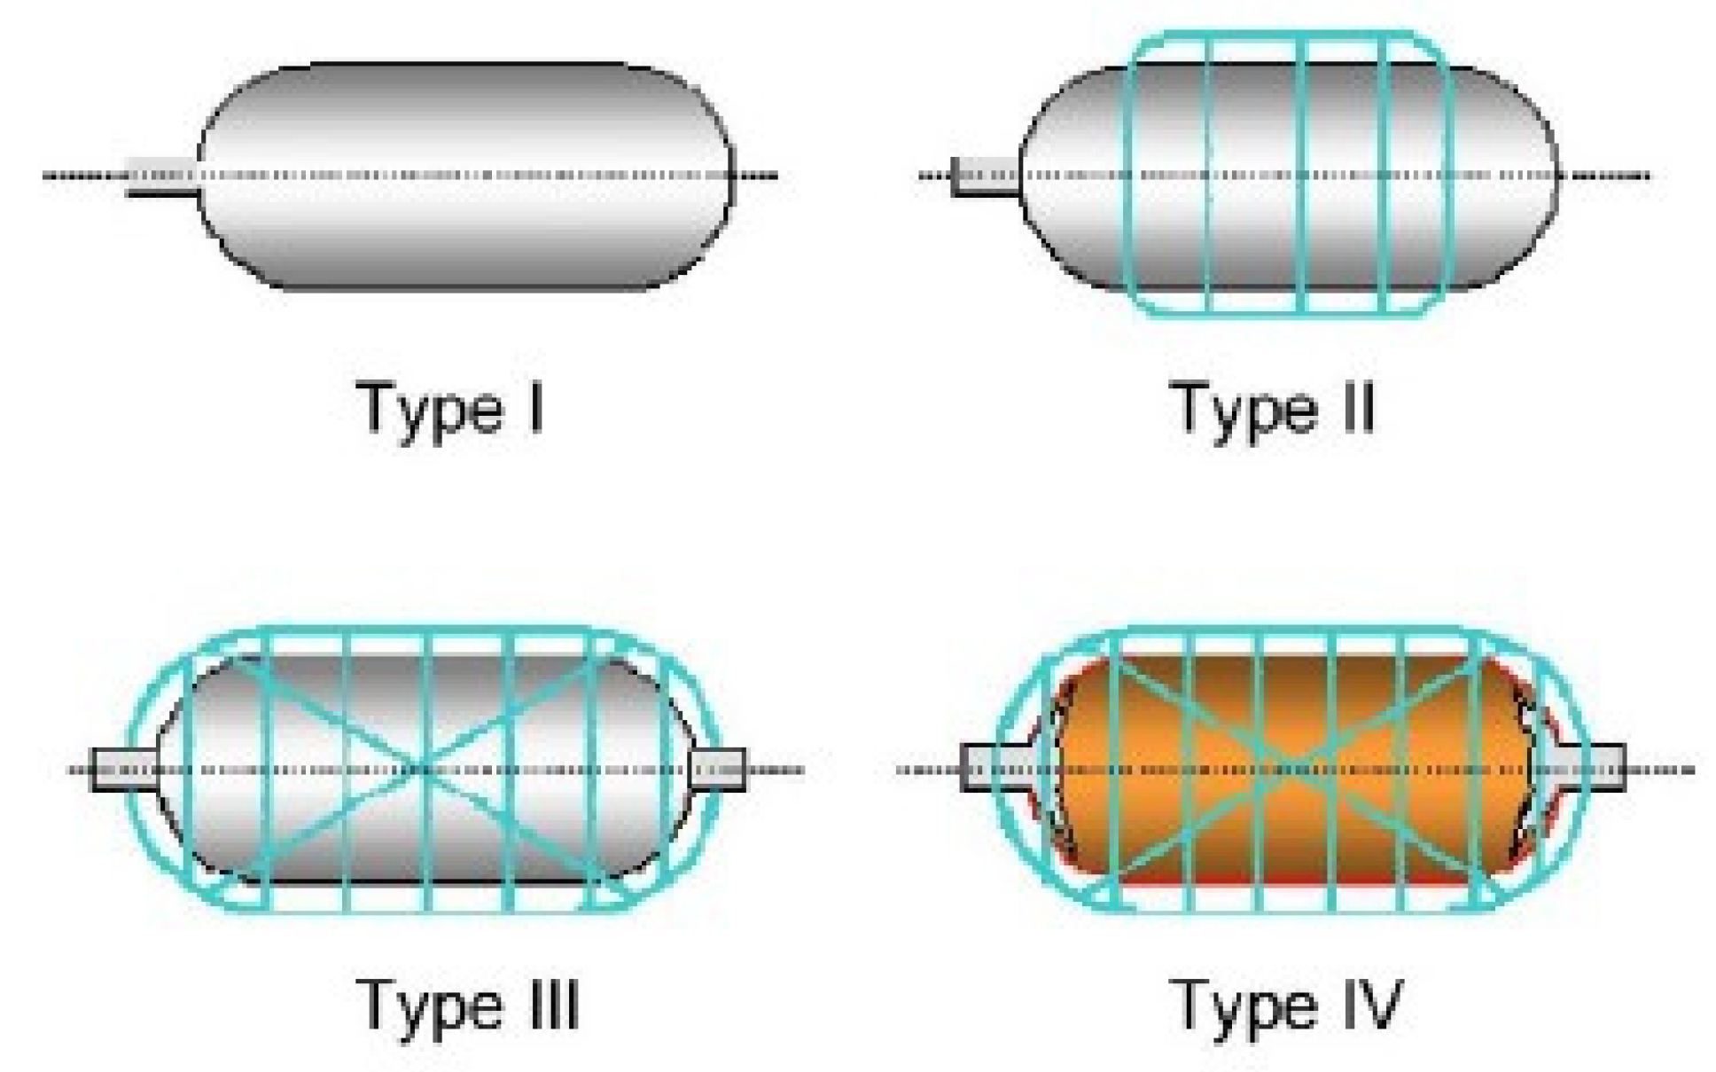
(Figure 1- Types of Pressure Vessels used commercially) [4]

From assessing the various vessels, it has been determined that Type IV would be suitable for this application. With the various other vessels shown, they use far more dense metals that would significantly impact the performance of a vehicle carrying the additional mass. Therefore, the Type IV is suitable due to the lightweight, high strength, and resistance to extreme conditions, they come with a higher initial cost. Their cost-effectiveness depends on the specific use case, the scale of deployment, and long-term benefits like reduced maintenance and fuel efficiency. For specialised operations in which mobility, stealth, and durability are crucial, they are a valuable investment, though for broader, more cost-sensitive applications, a detailed cost-benefit analysis would be needed.
As figure one provides an image of the spherical design of the pressure vessel this would be preferred in this environment, because they distribute internal pressure evenly, reducing stress concentrations and increasing durability.
As a case study of the Type IV pressure vessel will be used for assessment, we can determine the suitable materials used. This writer has completed this using the Ansys Granta EduPack software which Is a unique set of teaching resources to support materials education, also further literature sources were explored to reduce bias and provide validity in the conclusion.
3.1 Inner Layer
The Inner Liner of a hydrogen storage vessel can be made from High-Density Polyethylene (HDPE) (Figure 2) or Polyamide (PA) (Figure 3), each offering distinct advantages depending on the application.

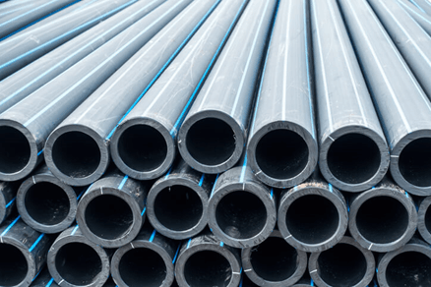
(Figure 2&3- Polyethylene (HDPE tubes left)/Polyamide (PA) fabric right)

HDPE is widely used due to its excellent hydrogen impermeability, low cost, and good chemical resistance, making it suitable for both civilian and military hydrogen storage systems. However, Polyamide (PA), such as Nylon, offers better abrasion resistance and chemical stability under harsher conditions, and its ability to withstand higher temperatures makes it ideal for more demanding environments. While HDPE is cost-effective for mass production, PA provides enhanced durability and is more suitable for high-performance applications, justifying its higher cost in critical military settings. The Composite reinforcement includes Carbon Fiber, which is key for providing high tensile strength while maintaining a low weight. This makes it ideal for hydrogen storage vessels in military vehicles that need to remain manoeuvrable and mobile under high-pressure conditions.
Although carbon fiber is relatively expensive, its strength-to-weight ratio provides a significant performance boost, making it a preferred choice in military applications where weight savings are critical. The Epoxy Resin used to bind the carbon fiber layers offers rigidity and chemical resistance, ensuring structural integrity under high pressures. While epoxy resin is cost-effective, it also contributes to the overall performance of the composite by providing resistance to high pressures and corrosive environments, both of which are essential in military operations.
3.2 Outer Layer

Using the software, we can begin to manipulate the appropriate density, modulus, temperature, abrasion etc to determine a table of the most suitable materials in this application
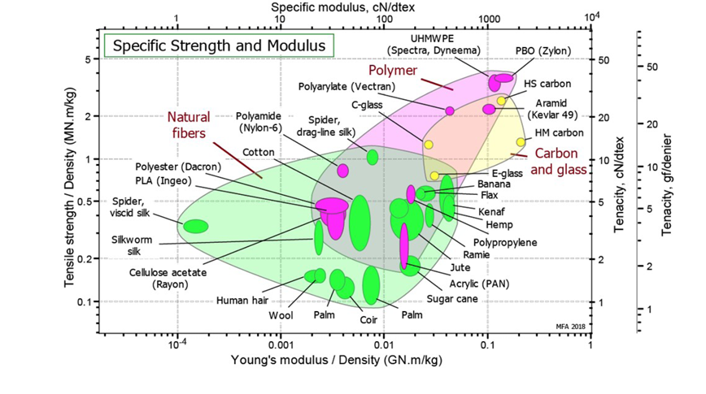
(Figure 4- Ansys Granta EduPack comparisons)

Aramid Fiber (Figure 5) (e.g., Kevlar) is a high-strength material, widely used in body armor and explosive-resistant applications. It provides abrasion resistance, impact resistance, and protection against shrapnel, making it particularly well-suited for military applications where hydrogen storage vessels might face exposure to hostile forces.

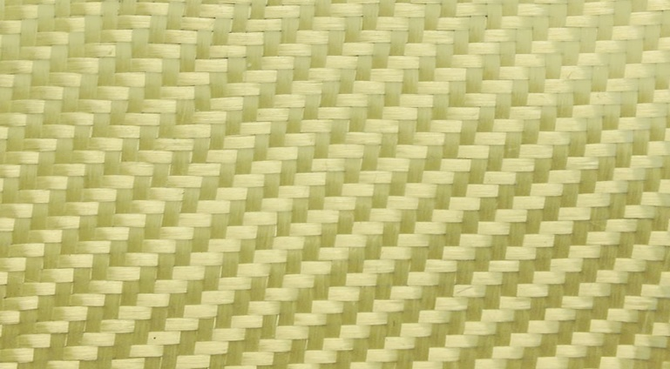
(Figure 5- Aramid fiber eg Kevlar)

Although Kevlar is relatively expensive, its enhanced protective properties make it crucial in military scenarios where the vessel could be subjected to impacts, gunfire, or even explosions. The added safety it provides justifies the cost in such critical applications. Metallic Shielding (Optional), including Aluminium or Titanium, is sometimes added for extra protection. Aluminium offers lightweight corrosion resistance and shields the vessel from environmental damage, making it suitable for less extreme military environments. Titanium, while heavier and more expensive, provides superior strength and impact resistance, making it ideal for high-risk scenarios where the vessel may be exposed to enemy fire. While aluminium is cost-effective, titanium is justifiable for high-durability applications in military combat due to its robust protection.

4. Manufacturing

For military vehicle hydrogen storage vessels, the filament winding method would be a sensible solution, particularly using carbon fiber and epoxy resin being the most suitable choice. This approach is highly effective for producing high-strength, lightweight structures necessary to endure the demands of military operations while maintaining performance and durability under extreme conditions.
Filament winding is a manufacturing process in which continuous strands of fibers (such as carbon, glass, or aramid) are tensioned and wound around a rotating mandrel (mold) in specific patterns. These fibers are impregnated with a resin (such as epoxy, polyester, or vinyl ester) that hardens once the winding is complete and cured in a specialised oven or autoclave. The result is a composite material that is both incredibly strong and lightweight. The process can be broken down as:
Mandrel Preparation (Figure 6): A hollow Mold (mandrel) is prepared to the desired shape of the hydrogen storage vessel, typically made of steel or aluminium, designed to withstand high-pressure conditions once the composite is cured [5].
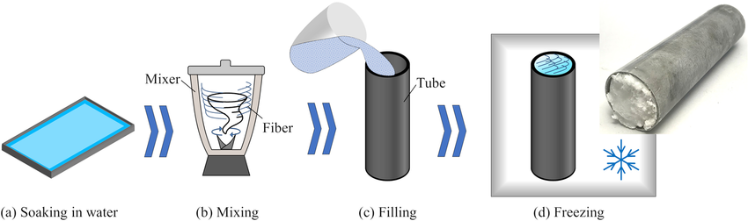
(Figure 6- Mandrel Preparation)

Fiber Winding (Figure 7): Continuous carbon fiber filaments are drawn from a spool and guided through a resin bath, where they are impregnated with epoxy resin (or another suitable resin for high-pressure performance). The fiber is then wound around the mandrel in a specific pattern (e.g., hoop or helical windings), optimizing the structure for tensile strength and impact resistance [6].
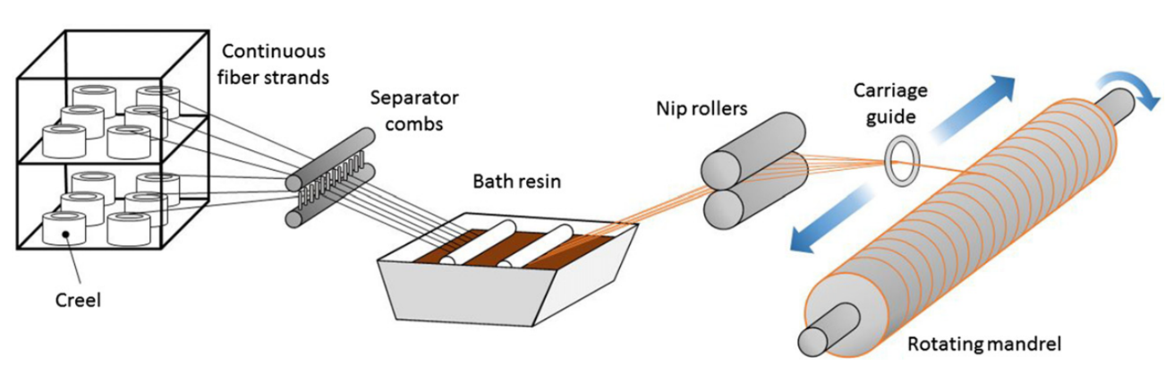
(Figure 7- Fiber Winding)

Layering and Orientation (Figure 8): Layers of carbon fiber are applied in multiple directions (often alternating between longitudinal, helical, and hoop winding patterns) to enhance the vessel's strength-to-weight ratio. The orientation of the fibers is crucial, as it determines the directionality of the vessel’s strength, ensuring it can withstand high internal pressures while maintaining its lightweight properties [7].

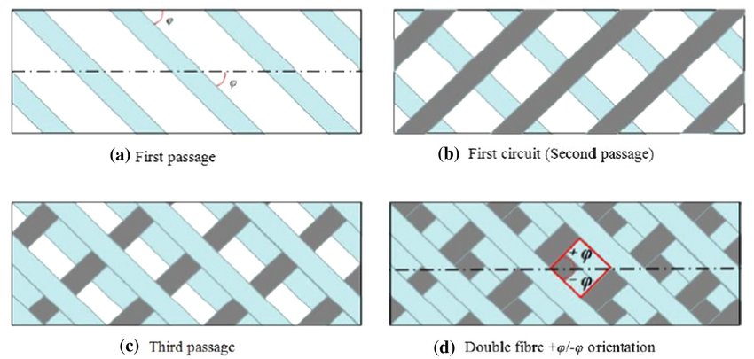
(Figure 8- Example of the layering of the material)

Curing (Figure 9): After the fibers are wound, the epoxy resin is cured using heat and pressure in an autoclave (high-pressure oven) or oven curing system. The curing process ensures that the resin bonds tightly to the carbon fiber, forming a solid, rigid, and durable composite material [8].
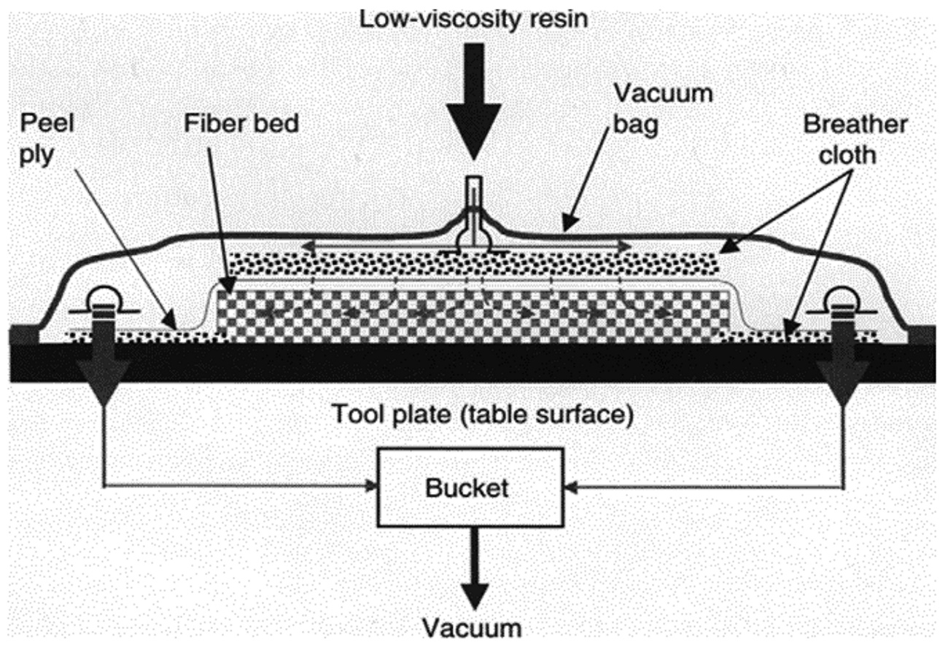
(Figure 9- Curing)

Post-Winding (Figure 10): Once cured, the composite is removed from the mandrel, and any necessary finishing steps are performed, such as trimming edges, adding threads for mounting, or applying protective coatings.

In using this process with Carbon fiber composite and in conjunction with filament winding for a hydrogen storage vessel will generate an exceptional strength-to-weight ratio, crucial for military vehicles where weight impacts speed, manoeuvrability, and fuel efficiency. The filament winding technique ensures high pressure resistance by optimizing fiber orientation, allowing the vessel to withstand the high internal pressures required for hydrogen storage. Additionally, the carbon fiber and epoxy composite offer superior durability and impact resistance, making it resilient against explosions, shrapnel, and high-velocity impacts in combat scenarios. Customizable thickness and shape enable the vessel to fit within a vehicle's spatial constraints, while the continuous filament winding process reduces the risk of leaks, ensuring safety under high-pressure conditions.
Other safety considerations can also be introduced into this process protecting the operators and product. During the filament winding process, safety measures such as the integration of pressure relief valves and burst discs are implemented to prevent over-pressurisation and catastrophic failure. Post-curing, non-destructive testing (NDT) methods like ultrasonic or X-ray inspections ensure the composite material is free from delamination or microcracks, guaranteeing safe operation however this will come at additional costs in the manufacturing processes. Additionally, a Kevlar reinforcement layer can be incorporated around the carbon fiber composite to provide extra impact resistance, making the vessel more resilient against shrapnel, explosions, or enemy fire, particularly in military applications.
The filament winding process is an excellent choice for manufacturing military-grade hydrogen storage vessels due to its ability to create high-strength, lightweight structures that can withstand the high pressures required for hydrogen storage. This method, combined with carbon fiber and epoxy resin, ensures that the vessel can perform reliably in extreme environments while maintaining low weight for military vehicle efficiency. The customizable design, high-pressure resistance, and impact resistance of filament-wound composites make it a superior option for demanding military applications where performance and safety are paramount.
While filament winding offers many advantages for military hydrogen storage vessels, such as high strength, low weight, and impact resistance, it comes with some drawbacks. The use of carbon fiber and autoclave curing increases the overall cost, which may be a concern, though the performance benefits justify the investment for military applications. The manufacturing process is also complex, requiring precise control over fiber orientation and curing conditions, which can lead to longer production times. Despite these challenges, the high-quality, reliable performance of filament-wound composites makes this method an ideal choice for military vessels, ensuring durability and safety in extreme environments.

5. Conclusion

From this assessment is has been determined that the hydrogen pressure vessel can be adopted at an extremely high standard and is being used widely in the commercial environment. Despite its varied cost range based on applications and specific operations- it has concluded that a more cost-effective way could be adopted in specific scenarios. As determined here that a long-term investment of hydrogen vessel military vehicles is a sustainable and suitable option the Initial upfront cost and demand may be scarce for government bodies investing with the pro-active state the world is currently in and its ever advancements in technology. The vessel is a cost effective and sustainable method in a longer-term project.

Despite that there can be some miraculous designs and incredible engineering completed to have a comprehensive and grade A military vehicle standard based on the research. As determined previously the combination of HDPE and Polyamide (PA) ensures a balance of cost-effectiveness and enhanced performance. HDPE offers a cost-effective solution for hydrogen storage with good impermeability and durability for less extreme environments, while PA provides additional durability and temperature resistance for more demanding situations. The carbon fiber composite structure, bound with epoxy resin, is critical for maintaining a lightweight, high-strength vessel capable of withstanding the high pressures required for hydrogen storage, ensuring that military vehicles remain manoeuvrable. The Kevlar layer offers impact resistance, making the vessel highly resistant to shrapnel and gunfire, while the optional aluminium or titanium shielding provides an added layer of protection from environmental and combat-related damage. Together, these materials form a robust and efficient solution for military hydrogen storage vessels.
In comparison to other hydrogen storage vessels, the combination of HDPE, carbon fiber, Kevlar, and metallic shielding offers several key advantages. Traditional hydrogen pressure vessels made of metals, such as steel, are typically heavier and less resistant to impacts or corrosion. The composite materials used in this design, particularly the carbon fiber and Kevlar, provide a superior strength-to-weight ratio, making the vessel much lighter and more manoeuvrable for military vehicles. Additionally, the Kevlar layer ensures better protection against external threats compared to standard metal coatings, which might not offer the same level of abrasion resistance or impact protection.
This combination of materials ensures that the vessel is not only cost-effective but also durable, with an enhanced capability to withstand hostile environments and combat situations. The use of HDPE keeps production costs lower, while carbon fiber and Kevlar make the vessel lightweight and impact-resistant, which is crucial for military vehicles operating in extreme environments. Thus, this hybrid material approach offers improved performance, safety, and cost-efficiency for military applications, not only matching but making it a better solution than traditional pressure vessels.
Regarding manufacturing, this system has multiple methods in achieving the desired results. As highlighted the filament winding process being an excellent choice with military-grade hydrogen storage vessels due to its ability to create high-strength, lightweight structures that can withstand the high pressures required for hydrogen storage. This method, combined with carbon fiber and epoxy resin, ensures that the vessel can perform reliably in extreme environments while maintaining low weight for military vehicle efficiency. The customizable design, high-pressure resistance, and impact resistance of filament-wound composites make it a superior option for demanding military applications where performance and safety are paramount.
It can be concluded that the hydrogen storage vessel can be considered a plausible option in military vehicles. Despite the concerns of the volatile gas being exposed to high pressure and intense environments, there is multiple methods and materials that can be used for the protection of the gas to use it as a resource despite its safety concerns.

6.References

[1] | ProPlate, “How does the manufacturing process influence the characteristics and performance of biomedical metals in metal-plated catheter components?,” ProPlate Engineering Metal Coating Solutions=, [Online]. Available: https://www.proplate.com/how-does-the-manufacturing-process-influence-the-characteristics-and-performance-of-biomedical-metals-in-metal-plated-catheter-components/#:~:text=During%20the%20manufacturing%20process%2C%20metals,and%20porosity%20of%20the%20mate. [Accessed 05 11 2024].
[2] | “First Ariane 5 launch of 2007,” 12 March 2007. [Online]. Available: https://www.esa.int/Enabling_Support/Space_Transportation/First_Ariane_5_launch_of_2007.
[3] | H. L. a, “Safety of hydrogen storage and transportation: An overview on mechanisms, techniques, and challenges,” Energy Reports, vol. 8, pp. 6258-6269, 2022.
[4] | J. A. Gómez, “The Status of On-Board Hydrogen Storage in Fuel Cell Electric Vehicles,” Center of Physics and Engineering of Advanced Materials, 2023.
[5] | T. M. e. a. Ali Talebi Anaraki, “Enhancement of shape accuracy and die quenchability of ultra-high strength steel hollow products in hot stamping of tubes using eco-friendly fiber-reinforced ice mandrel,” The International Journal of Advanced Manufacturing Technology, 2023.
[6] | AddComposites, “What is Filament Winding Process?,” AddComposites, 26 Sep 2024. [Online]. Available: https://www.addcomposites.com/post/filament-winding.
[7] | A. S. e. a. M. A. M. Rizal, “Filament-wound glass-fibre reinforced polymer composites: Potential applications for cross arm structure in transmission towers,” Polymer Bulletin, 2022.
[8] | O. A. Ekuase, “A Review on the Out-of-Autoclave Process for Composite Manufacturing,” High-Performance Materials Institute, College of Engineering, Florida Agricultural and Mechanical University (FAMU)-Florida State University (FSU), Tallahassee, FL 32310, USA.

