BA (Hons) Business Management
Module: Introduction to Leadership and Management
Goleman's Leadership Styles and Essential Leadership Skills in Contemporary Organizations

Component 2: Essay
Student Name: MOHAMMED ELSAYED ELSHARKAWY
Internal Verifier: Dr Anupam Mazumdar
Module Code: LCBB4015
Word Count: 1,500 words (approximately)
Submission Deadline: 26th July 2026

Table of Contents
1. Introduction 2
2. Defining Leadership 2
3. Goleman's Leadership Styles 3
3.1 The Visionary (Authoritative) Style 3
3.2 The Democratic Style 4
3.3 The Coaching Style 5
4. Essential Leadership Skills for Today 6
5. Conclusion 7
6. References 8

1. Introduction
There is a consensus within the literature that leadership is one of the most important factors for the successful operation of an organization. Effective management can occur in any business context through one's ability to lead, motivate and influence others towards a common goal. As the world continues to change rapidly, becoming increasingly complex and diverse, organizations need leaders who have both the knowledge of resources and technologies to perform their roles but also the emotional intelligence to adapt their style of leadership as situations and individuals change.
This paper will examine three of the six different styles of leadership identified by Daniel Goleman (2000) in his widely known model of leadership and will discuss the various characteristics, advantages and disadvantages of each style, as well as the organization-specific scenarios where each style would be most useful. It will also discuss the different skills required of leaders today in order to successfully lead, facilitate growth within an organization and meet the many challenges placed on businesses today.

2. Defining Leadership
Various definitions of leadership exist in the academic literature. One of the most widely used definitions who defines leadership as "a process whereby an individual influences a group of individuals to achieve a common goal” (Northouse, 2018). This definition represents two key elements of a leadership definition. First, there is the relational aspect of leadership in that it involves influencing others, and second there is a purposefulness to the process in that it is goal directed. Mullins (2019) makes the same point as Northouse by highlighting that leadership is about inspiring commitment and guiding the behavior of others towards the achievement of the organization’s goal.
Goleman (2000) associated the effectiveness of leaders to emotional intelligence (EI) by extending the definition of EI as the ability to identify, comprehend, and manage one's own feelings, in addition to the ability to identify and inspire the feelings of others. In a historic article published in Harvard Business Review titled "Leadership That Gets Results," Goleman (2000) presented evidence from a study involving nearly 4,000 executives that found that the best leaders do not just rely on one approach, but rather developed six specific styles of leading and who choose to use a combination of styles depending on the circumstances and the needs of the team. The six styles developed through this process are Visionary, Coaching, Affiliative, Democratic, Pacesetting, and Commanding (Goleman et al., 2002).
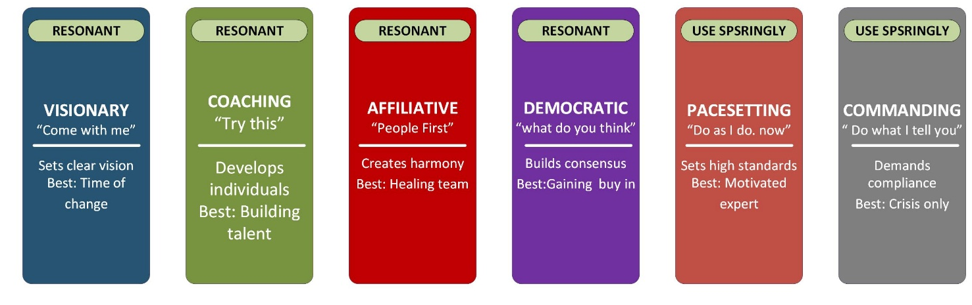
Figure 1: Goleman's Six Leadership Styles

3. Goleman's Leadership Styles

3.1 The Visionary (Authoritative) Style
Visionary (Authoritative) leadership is characterized by a leader who defines a clear long-term vision and inspires others to work toward this vision. Goleman (2000) states the Visionary leader's direction is "come with me," which highlights an invitation instead of a command. This clearly defined goals for employees while allowing them the ability and autonomy to create their plans to achieve these goals.
A Visionary leadership style will create clarity, inspire loyalty, and align people's efforts with the organization’s overall goals (Goleman et al., 2002).
This style is particularly impactful during chaotic times when people are uncertain or anxious about what may happen next or if they do have a clear way forward. A public example of this is Mike Nadella’s leadership of Microsoft after he was named CEO in 2014. Nadella articulated a clear and transformative vision of shifting Microsoft from a culture of “know-it-all” to that of a “learn-it-all” organization. This gave new focus to the overall strategic thinking of Microsoft and led to high levels of effectiveness and involvement among employees (Robbins & Judge, 2022).
However, the Visionary Leadership style has limitations as well. In instances where the leader lacks credibility or expertise, employees are unlikely to support a vision if they do not trust, or believe, in the person providing that vision. Also, in a group of high-experience specialists where the leader has less experience than others, using a directive method to set a vision can be perceived as arrogant or disconnected from reality (Northouse, 2018).

3.2 The Democratic Style
Democratic Legislative Style is an inclusive style characterized by decision-making in cooperation with others. In order to solicit other people’s opinions, the Democratic Leader asks “What do you think?” The Democratic Leadership style aligns with the participative management theory, which holds that people are more committed to the decisions made if they have been involved in the decision-making process (Robbins et al., 2021).
The benefits of the Democratic Leadership Style are especially large, especially given that most of the employees in a knowledge-based environment have high levels of expertise and creativity as well. Involving team members when making a decision helps the leader create more buy-in, increase employee motivation and obtain a wider range of ideas and perspectives. Google’s corporate culture is an example of this, employees had an opportunity to spend part of their work time on self-directed projects, resulting from a democratic leadership philosophy, led to innovations like gmail and maps (Mullins 2019).
The main disadvantage of a democratic leadership style is that it can lead to slow, indecisive leadership in situations that require fast action. This can become cumbersome and counterproductive when it is difficult to reach a consensus or when a team member lacks the expertise necessary to make a meaningful contribution to the decision (Goleman, 2000). Therefore, the democratic leadership style is best used in situations where there is ample time to deliberate before making a decision.

3.3 The Coaching Style
The coaching style is focused on the long-term development of each team member’s professional career with a focus on the words “Try this,” or simply trying to find ways for each team member to learn or grow and develop their competence over time. In contrast to the visionary leader who focuses on the direction of the organization, the coaching leader is focused on the individual by identifying each person’s strengths and weaknesses and providing customized advice and feedback to help them grow or develop (Goleman et al., 2002).
Using Coaching Style leads to higher employee engagement and loyalty, as well as sustained improvement of performance over the long term. By linking the individual goals of employees to that of the organization, leaders who practice Coaching develop a sense of purpose and belonging between employee and organization that strengthens commitment to the organization and reduces employee turnover. Example of Coaching Leadership is the one exhibited by Alan Mulally in his capacity as CEO of Ford Motor Company from 2006 to 2014. During this period, Mulally earned praises because he had nurtured his team of leaders and cultivated behaviors of good communication in his organization, thus creating a culture of continuous learning that helped Ford weather through the 2008 economic crisis without seeking any help from the government (Robbins et al., 2022).
A major limitation of the Coaching Style is that it is time-consuming. It requires considerable effort on the part of leaders to thoroughly understand each individual they supervise and continue to provide them with relevant, customized feedback. The Coaching Style is not appropriate for employees that have low motivation or who are resistant to change, as the success of the Coaching Style depends on the willingness of the individual to engage in reflective growth (Northouse, 2018).

4. Essential Leadership Skills for Today
In addition to using the above-mentioned leadership styles, current leaders must develop several necessary skills so that they can effectively lead their organizations in today's fast-paced and globalized business world. The following are widely identified as being essential skills of a modern leader:
- Emotional Intelligence (EI): Goleman (2000) defines EI as the essential trait of efficient leaders. It captures five skills, i.e. being self-aware, regulating self, being motivated, being empathetic, and having social abilities. Leaders with high EI usually perform well in dealing with conflicts, building up trust, encouraging engagement, and handling inter-personal complexities within a diversified team. The most competent and skilled leaders may not be able to motivate their employees without adequate EI.
- Adaptability and Situational Awareness: Goleman's leadership framework assumes there is no single appropriate leadership style. Leaders must have the capability to read a given situation. Effective leaders will modify their leadership style based on what they see they are adaptable (Goleman et al., 2002).
- Communication Skills: Effective communication skills are essential to effective leadership. Communication is important because it will enable leaders to align their team to organizational goals, create realistic expectations, give appropriate feedback, and engage in tough conversations (Mullins, 2019). With the current trends of a multicultural and digital world, communication skills should go beyond the barriers of language and culture.
- Strategic Thinking: A good leader needs to be able to comprehend the environment in which his/her organization exists through strategic thinking that goes beyond organizational issues to include the broader picture of what affects the industry to which his/her organization belongs. Through strategic thinking, a leader will be able to anticipate changes and position his/her organization for future success (Robbins et al., 2021).

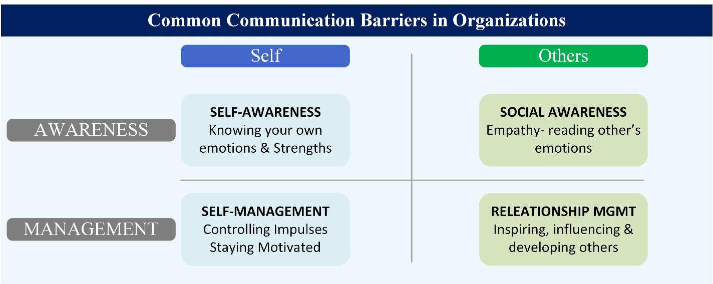
Figure 2: Goleman's Emotional Intelligence Model

5. Conclusion
Three of the six leadership styles outlined in Goleman's model, the Visionary, the Democratic and the Coaching were evaluated in terms of their characteristics, advantages, disadvantages and potential use in a business context. The Visionary style is most effective during times of change and uncertainty, the Democratic style fosters employee engagement and innovation in collaborative and knowledge-intensive environments, and the Coaching style promotes employee retention and long-term development of capabilities.
No one style is most effective in all situations rather, the best leaders develop a repertoire of styles and use each in the appropriate situation as informed by their base of emotional intelligence (Goleman, 2000).
Therefore, the most practical recommendation for organizations wishing to build upon their leadership capacity is to develop leadership development programs that will encompass not only developing technical skills, but also developing emotional intelligence, cross-culturally communicating, and employing multiple styles of leadership in all situations.

6. References
Goleman, D. (2000) 'Leadership that gets results', Harvard Business Review, 78(2), pp. 78–90. Available at: https://www.scirp.org/reference/referencespapers?referenceid=751486 (Accessed: 6 June 2026).

Goleman, D., Boyatzis, R. E. and McKee, A. (2002) Primal Leadership: Realizing the Power of Emotional Intelligence. Boston, MA: Harvard Business School Press. Available at: https://www.researchgate.net/publication/230854764_Primal_Leadership_Realizing_the_Power_of_Emotional_Intelligence (Accessed: 6 June 2026).

Mullins, L.J. (2019) Management and Organizational Behavior. 11th edn. Harlow: Pearson Education.

Northouse, P.G. (2018) Leadership: Theory and Practice. 8th edn. London: SAGE Publications.

Robbins, S.P. and Coulter, M. (2021) Management. 14th edn. Harlow: Pearson Education.

Robbins, S.P. and Judge, T.A. (2022) Organizational Behavior. 18th edn. Harlow: Pearson Education.

