Karen Anne Windsor (1918576)
1918576@student.uwtsd.ac.uk
Abstract
The assignment was to create a responsive website of at least 5 pages, containing information on an interest or hobby. For this assignment I have built a website to highlight my passion which is the overlooked world of Clinical Coding
HTML & CSS Web Development
L4 – Introduction to Web and Database Concepts Module Code : ACCA403 BSc Computing Data and Information Systems

Contents

1. Introduction 3
2. Requirements 3
2.1 Purpose of the website 3
2.2 Target Audience 4
3. Implementation 5
3.1 Screen Shots 5
3.1.1. Landing page 5
3.1.1 Page 1 – History of Clinical Coding 6
3.1.2 Page 2 – Qualifications and Qualities 7
3.1.3 Page 3 – Tools of the Trade 8
3.1.4 Page 4 – Four Step Coding Process 9
3.1.5 Page 5 – Why we code? 10
3.17 Page 6 – What does the future hold? 12
3.2 Validation 13
3.2.1 HTML Validation 13
3.2.2 CSS Validation 14
4. Evaluation 15
4.1 Useability 15
4.1.1 Design Documents 15
4.2 Accessibility 16
4.2.1 Perceivable 16
4.2.2 Operable 17
4.2.3 Understandable 17
4.2.4 Robust 17
4.3 Search Engine Optimisation 17
5. References 19
6 Website References 20
6.2 Landing Page 20
6.2.1 Heading background 20
6.2.2 Detective Image 20
6.3 Page 1 History of Clinical Coding 20
6.3.1 Heading background 20
6.3.2 Bills of Mortality Image 20
6.3.3 John of Gaunt Text And Florence Nightingale Text 20
6.3.4 Florence Nightingale Image 20
6.4 Page 2 Clinical Coding Qualifications and Qualities 21
6.4.1 Heading Background 21
6.4.2 IHRIM 21
6.4.3 NCCQ UK Image 21
6.5 Page 3 Classifications Tools of the Trade 21
6.5.1 Heading Background, Image of OPCS Book and Used ICD-10 Books 21
6.5.2 ICD-10 Classification Books Image 21
6.5.3 ICD-10 Classification and OPCS Classification Text 21
6.6 Page 4 Four Step Coding Process What is it? 22
6.6.1 Heading Background 22
6.6.2 Page Text 22
6.6.3 Four Step Coding Process Image 22
6.6.4 ICD-10 Tabular and Index Images 22
6.7 Page 5 What Happens to all these Codes ? 22
6.7.1 Heading Background 22
6.7.2 Covid Virus Image 22
6.7.3 The Importance of Coding Text 23
6.7.4 Heading Background 23
6.8.2. ICD-11 Image 23
6.7.5 ICD-11 Text 23
6.9 Banner at bottom of all pages 23
6. Appendices 24
6.1 HTML Coding 24
6.1.1 Landing page- HTML Index 24
6.1.2 Page 1 History of Clinical Coding HTML 28
6.1.3 Page 2 Qualifications and qualities HTML 33
6.1.4 Page 3 Tools of the Trade HMTL 37
6.1.5 Page 4 Four Step Coding Process HTML 42
6.1.6 Page 5 Why we code? 46
6.1.7 Page 6 ICD-11 50
6.2 CSS Coding 54
6.2.1 Landing Page CSS 54
6.2.2 Children Pages CSSS 59
6.3 Glossary of Terms 65
6.4 Documents 66
6.4.1 Site Design Document 66
6.4.3 Wire Frame Landing Page Document 68

Introduction

For the assignment we were tasked with creating a website with at least 5 pages, the instructions stated that although the landing page of the website should contain text that was specific to the website to clarify how search engine optimisation works, the rest of the website could be filled with lorem ipsum generated text. Just for experience of looking for relevant text and as it is a subject, I am very interested in, I have taken text from different websites that have mention Clinical Coding to fill in the Children pages of my website. All the copied text has been placed in quotation marks and has been referenced both on the website page and in section 6 of this document Website References, where I have also referenced any images, I have used in the building of this website. I do however realise that the copying of text would not be acceptable if this was a live published website.
This report documents what the website has been designed to portray and how the functionality of the website was designed and coded.
The report also goes on to describe what subject matter the website has been designed to promote, who are the potential users and how they have been influenced into viewing the website.
It goes on to further demonstrate how the website has been validated which includes both the coding of the website and the accessibility of the website.

Requirements

The one subject that I am passionately interested in is “Clinical Coding”, which is fortunate as I am the Lead Clinical Coding Auditor for Wales. However, though I find this subject enthralling, I am aware that it is a subject that most people have never heard of. I am member of several groups on Facebook:
- Clinical Coding Banter
- Clinical Coders UK
- Clinical Coding Training/Audit UK
- Clinical Coding
- Clinical Coding Forum
And there is one question that is posted on all of them “What is clinical coding and where can I find out more about it?”. So, I thought I would build my website to answer that question and to give a background in what uses clinical coded data is put to.

2.1 Purpose of the website

The purpose of the website is to:
- Explain what Clinical Coding is
- Give a brief history of Clinical Coding
- What are the qualities and qualifications that make a clinical coder?
- A brief outline of the 4-step coding process
- What is the coded data used for?
- What will ICD-11 mean for Clinical Coders

2.2 Target Audience

The target audience of this website would be those individuals who wanted to start a career in clinical coding.
There are Clinical Coders based in all acute/major hospitals throughout the United Kingdom (UK), but the department is usually very isolated from the staff in the main hospital. So, although their a 100’s of clinical coders in the UK, absolutely hardly anyone knows what they do or why they do it. Therefore, this website has been designed to help those who have seen an advert or have an interview for the role of clinical coder. It will give them basic information and pinpoint other websites that could assist them with their research into the role.

Implementation

Screen Shots

This section contains all the screen shots for the website, starting with the main landing page and then progressing through the children page.

3.1.1. Landing page

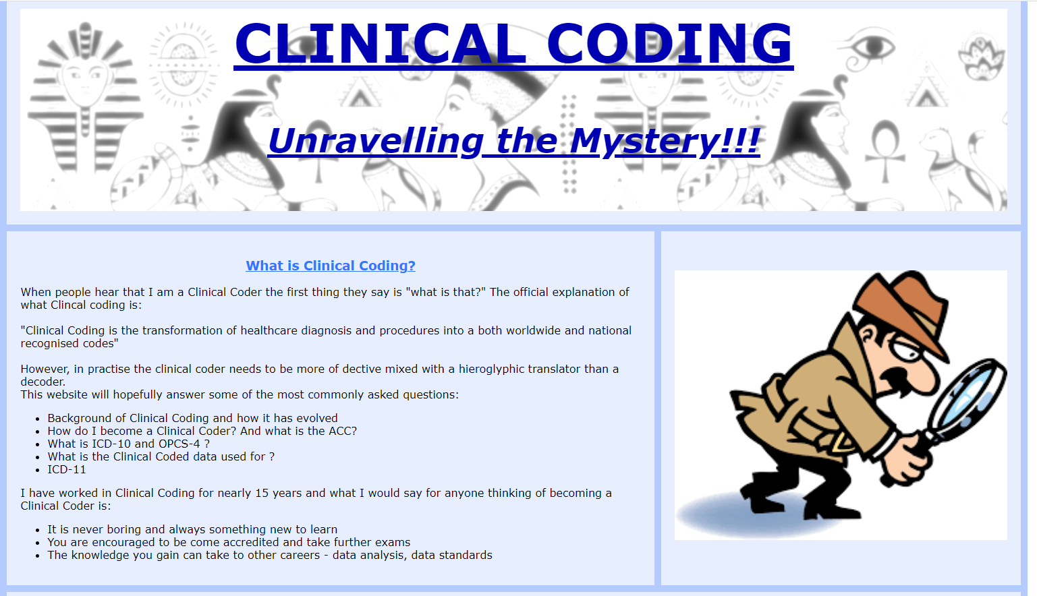
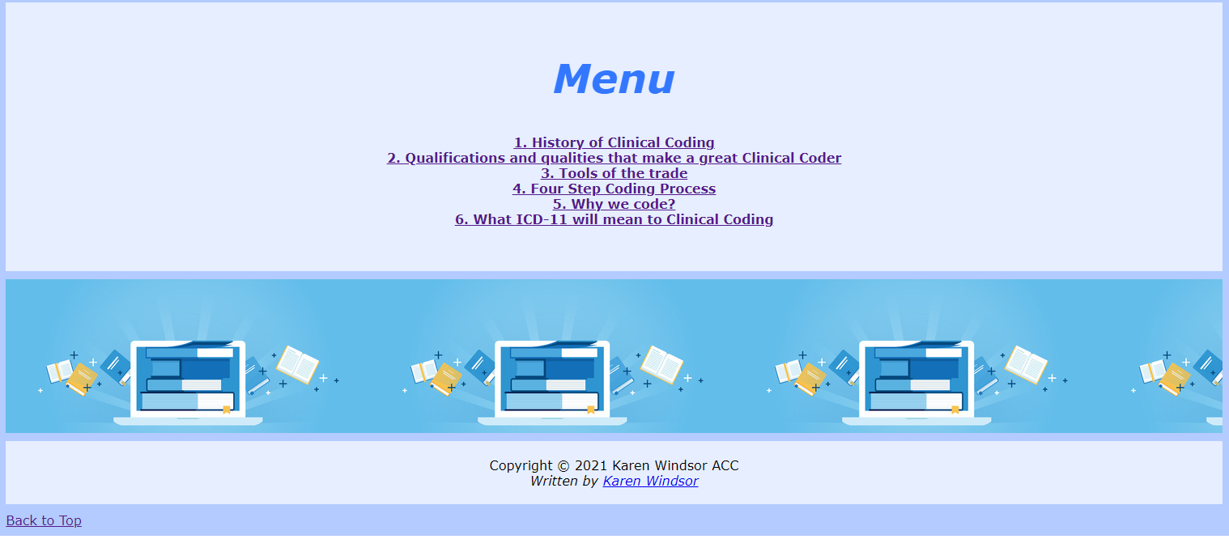

Page 1 – History of Clinical Coding
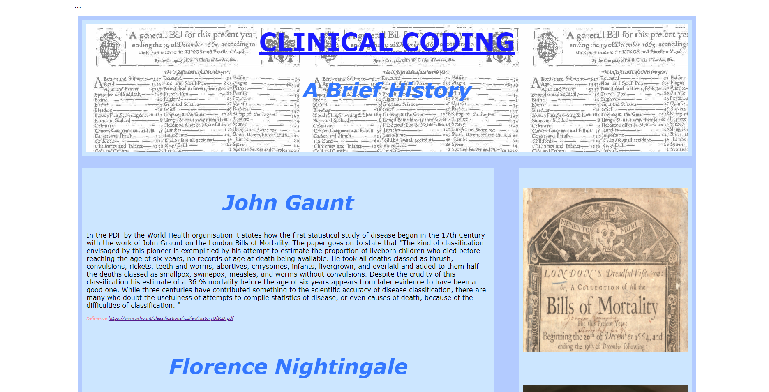

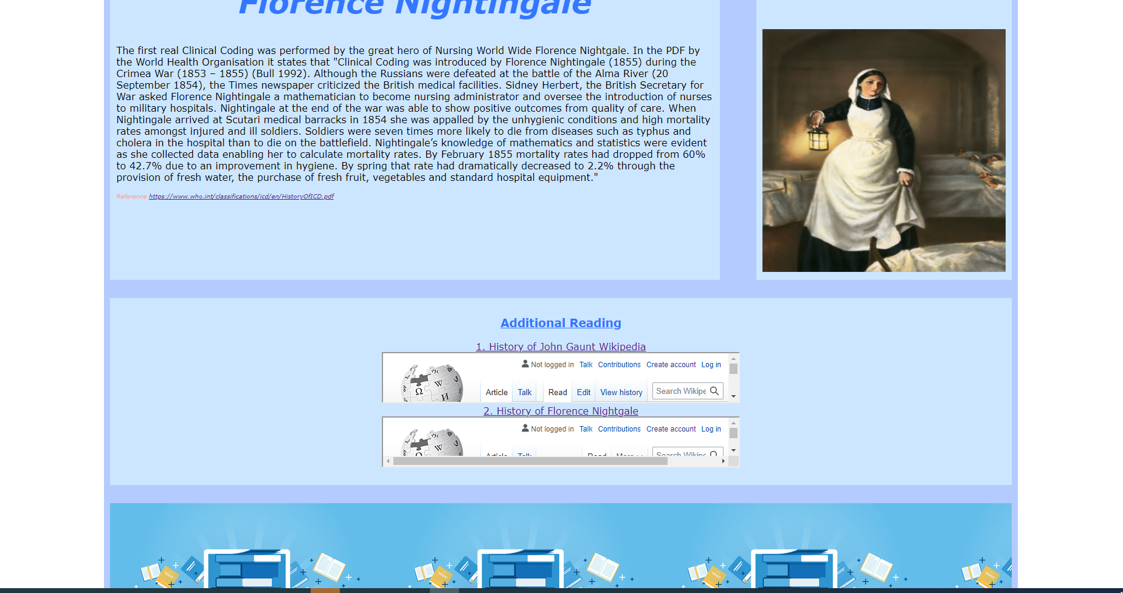

Page 2 – Qualifications and Qualities

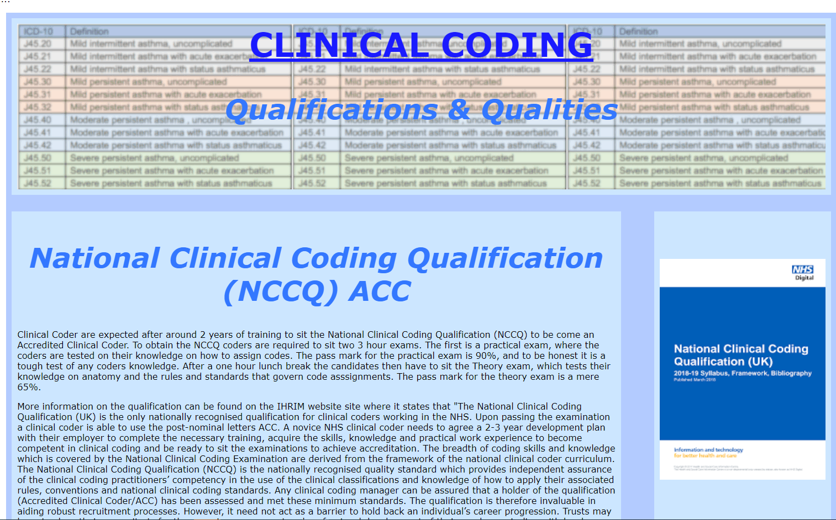
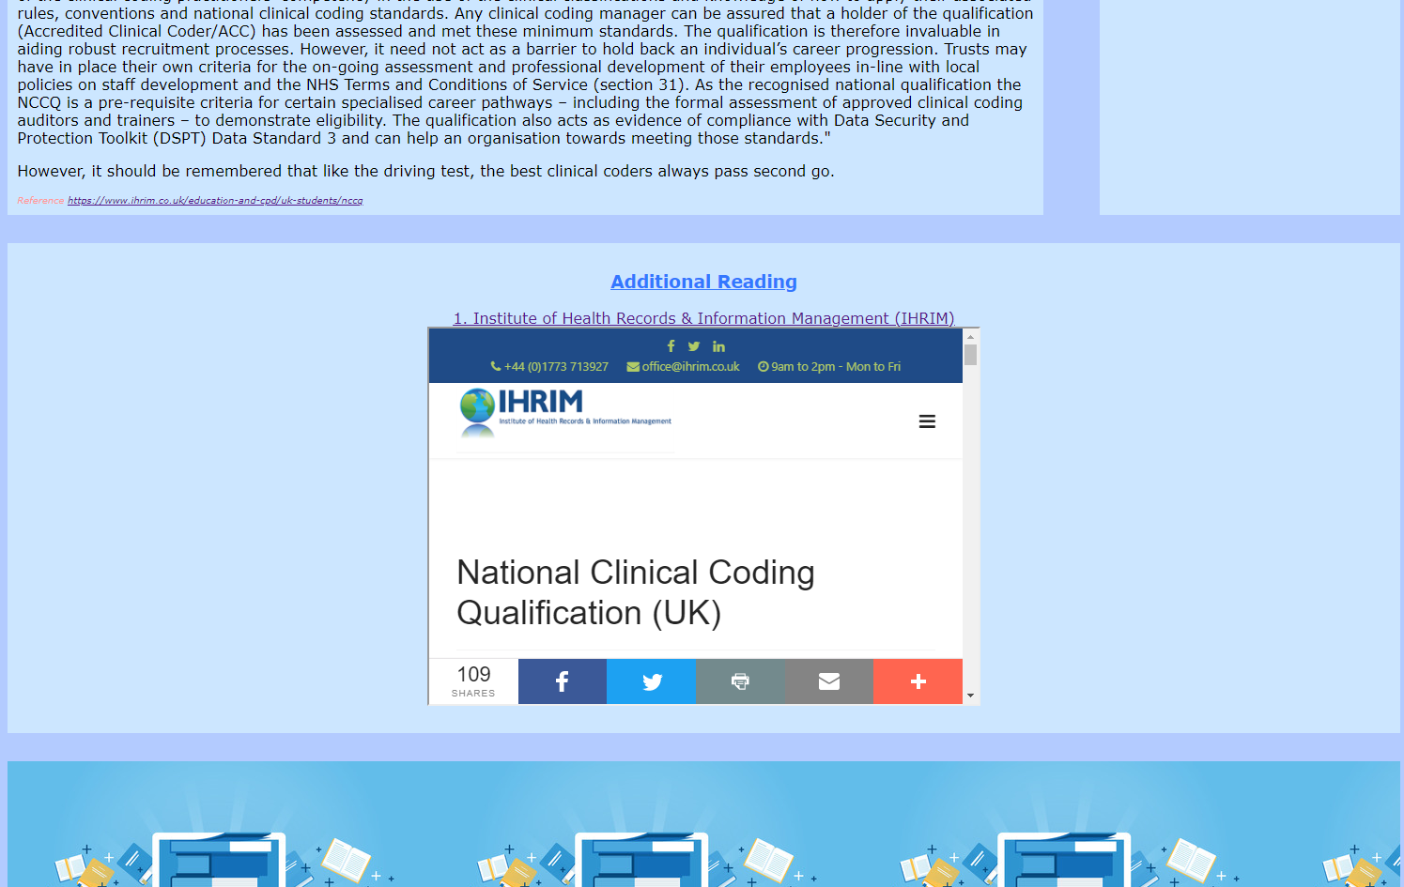

Page 3 – Tools of the Trade
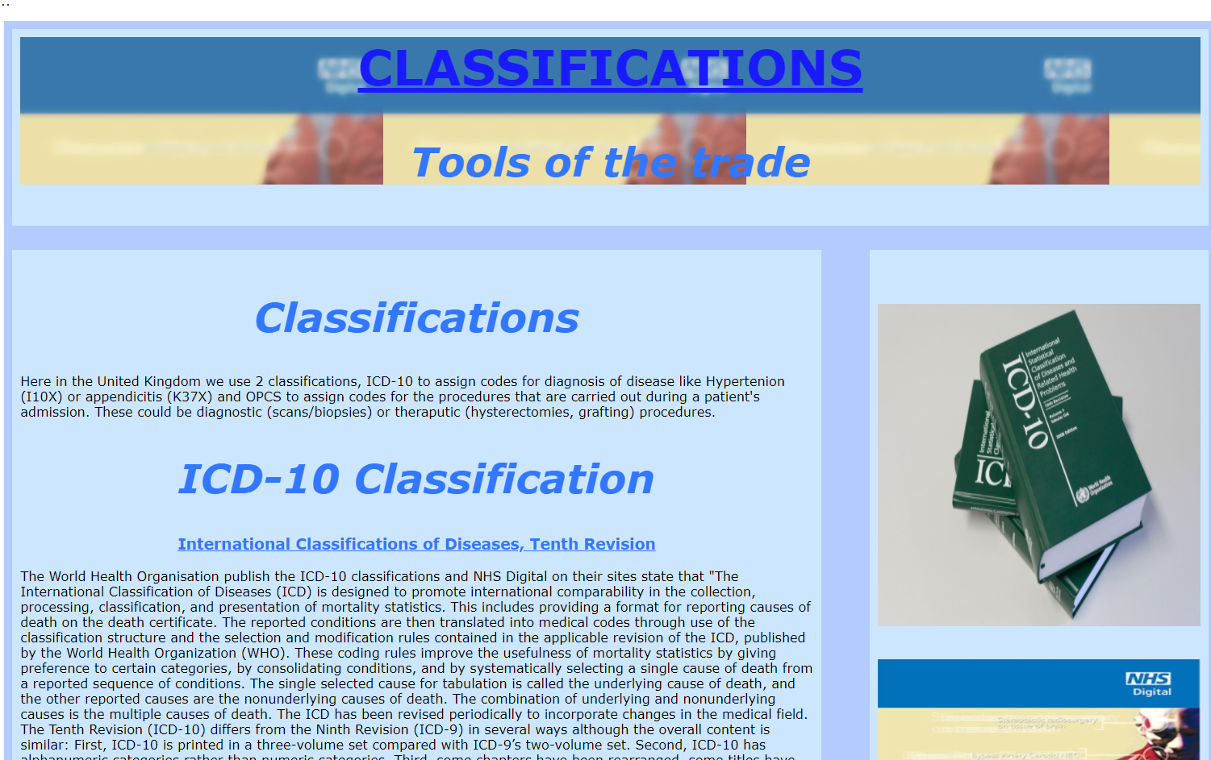
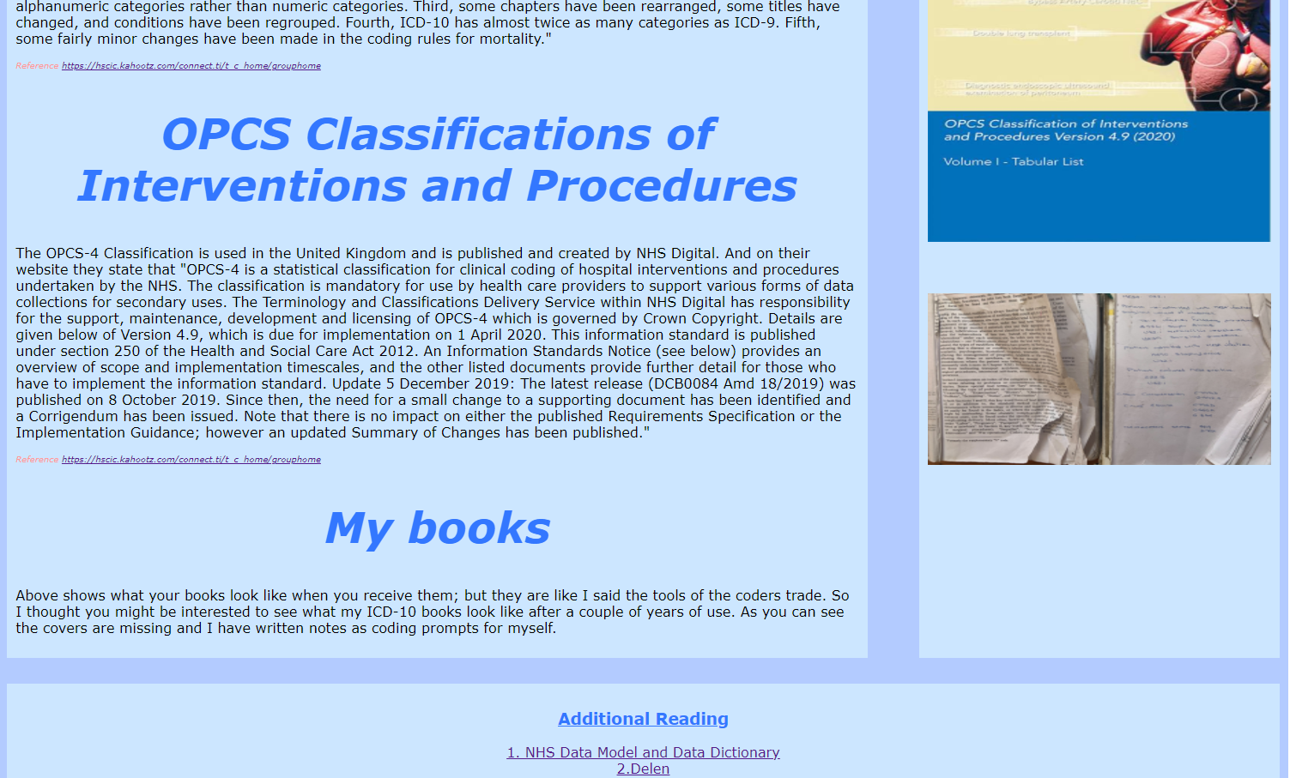

Page 4 – Four Step Coding Process

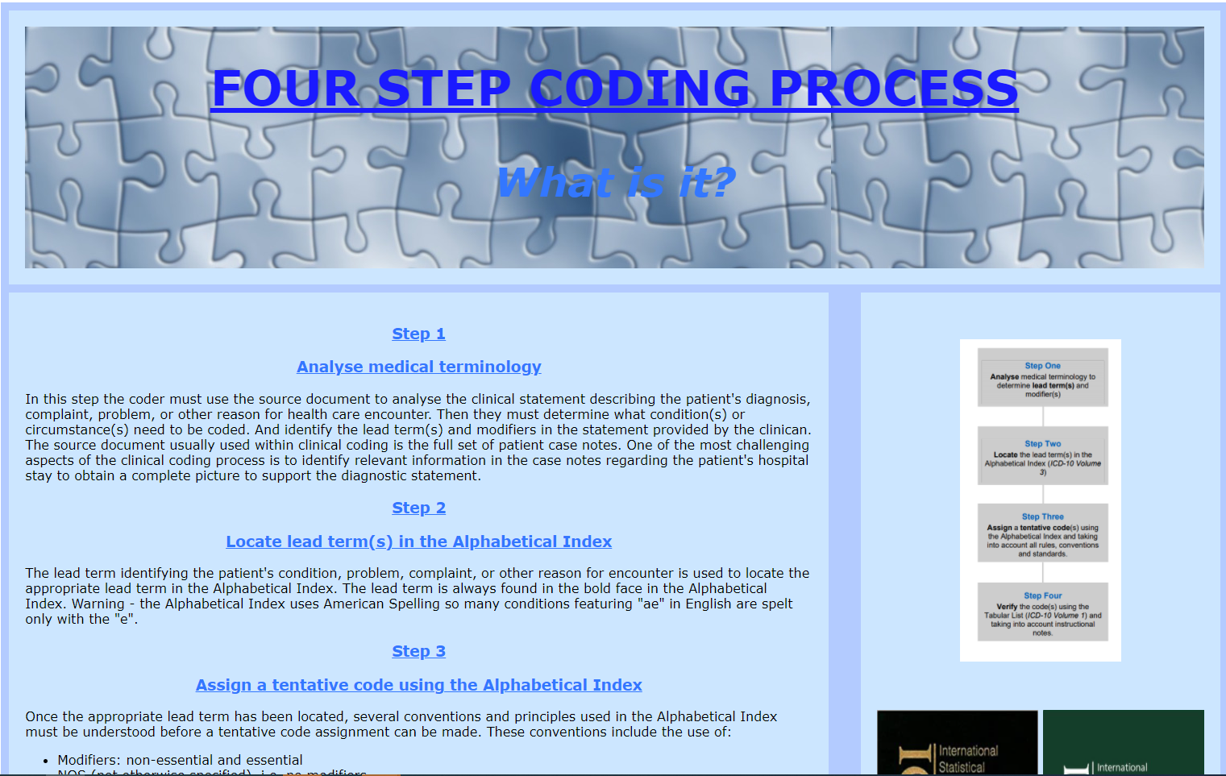
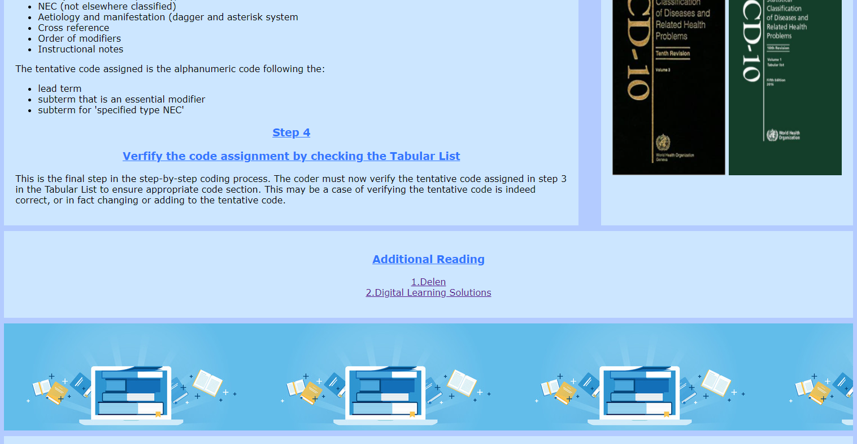

Page 5 – Why we code?

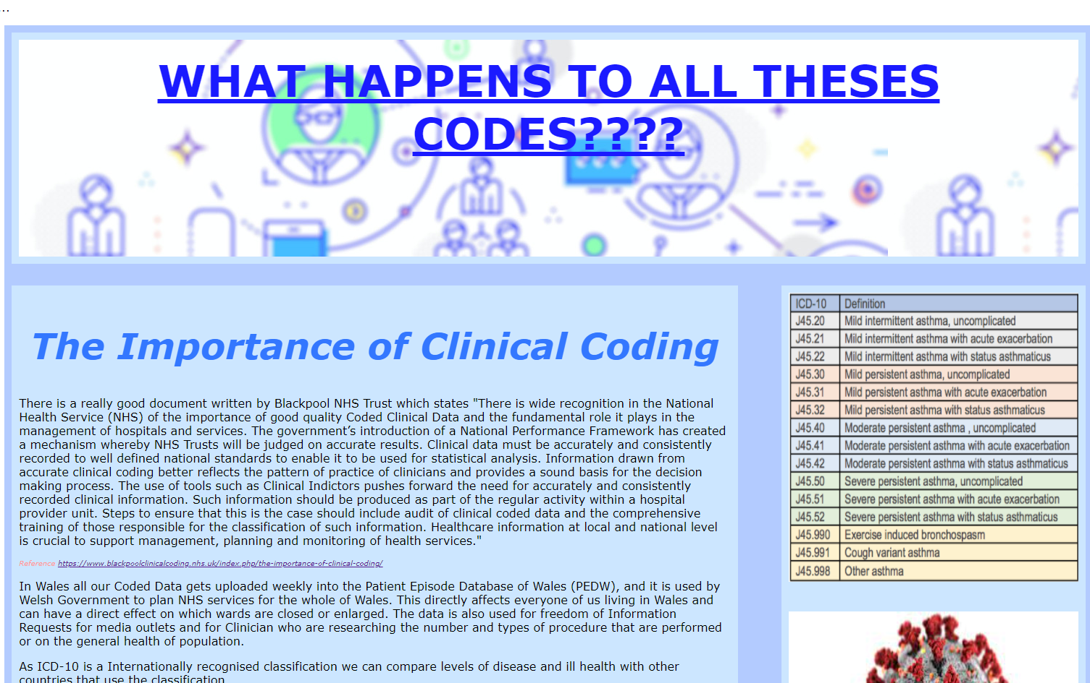
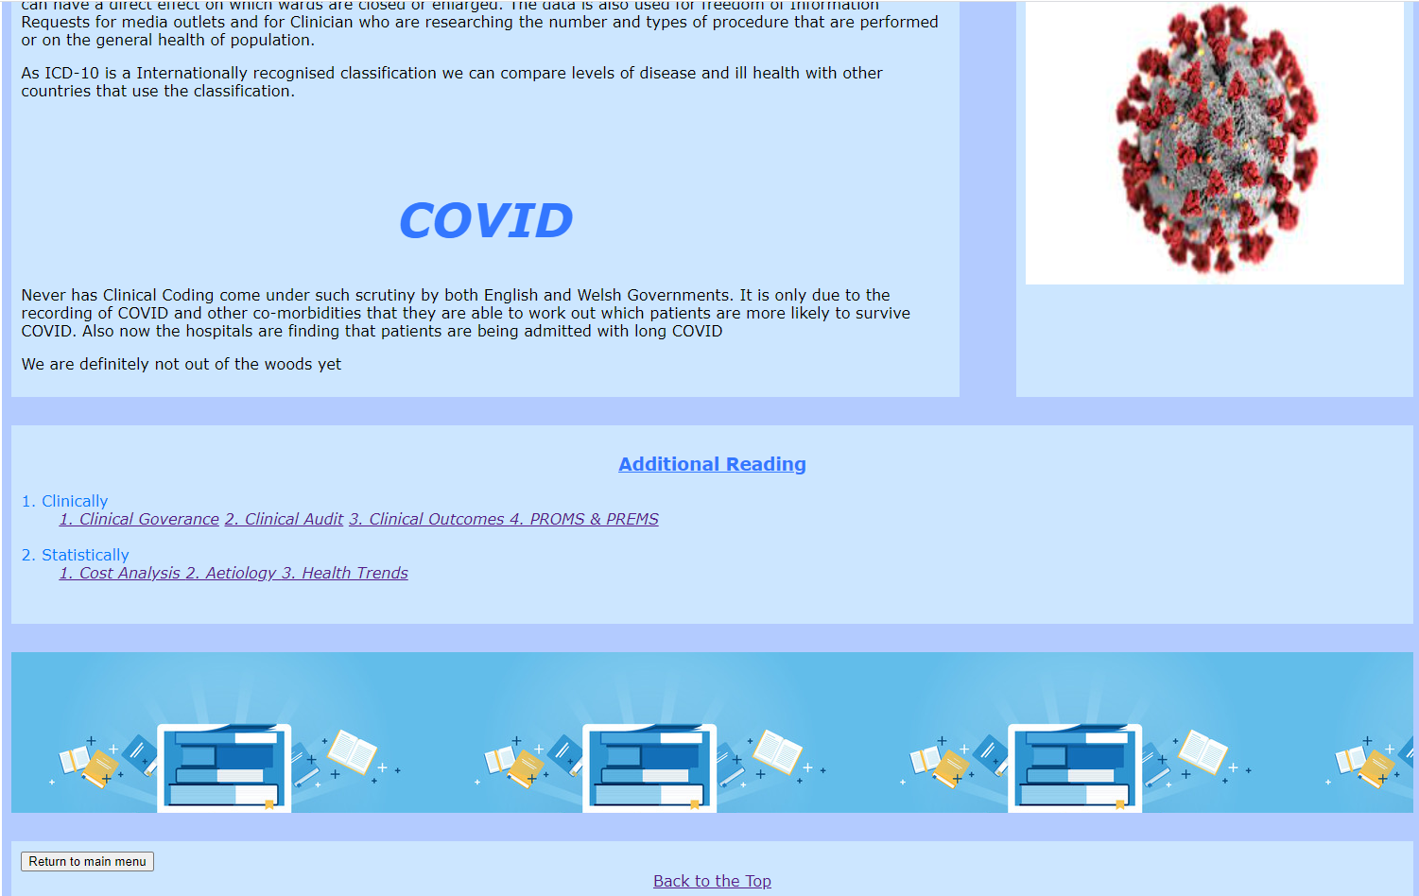

3.17 Page 6 – What does the future hold?

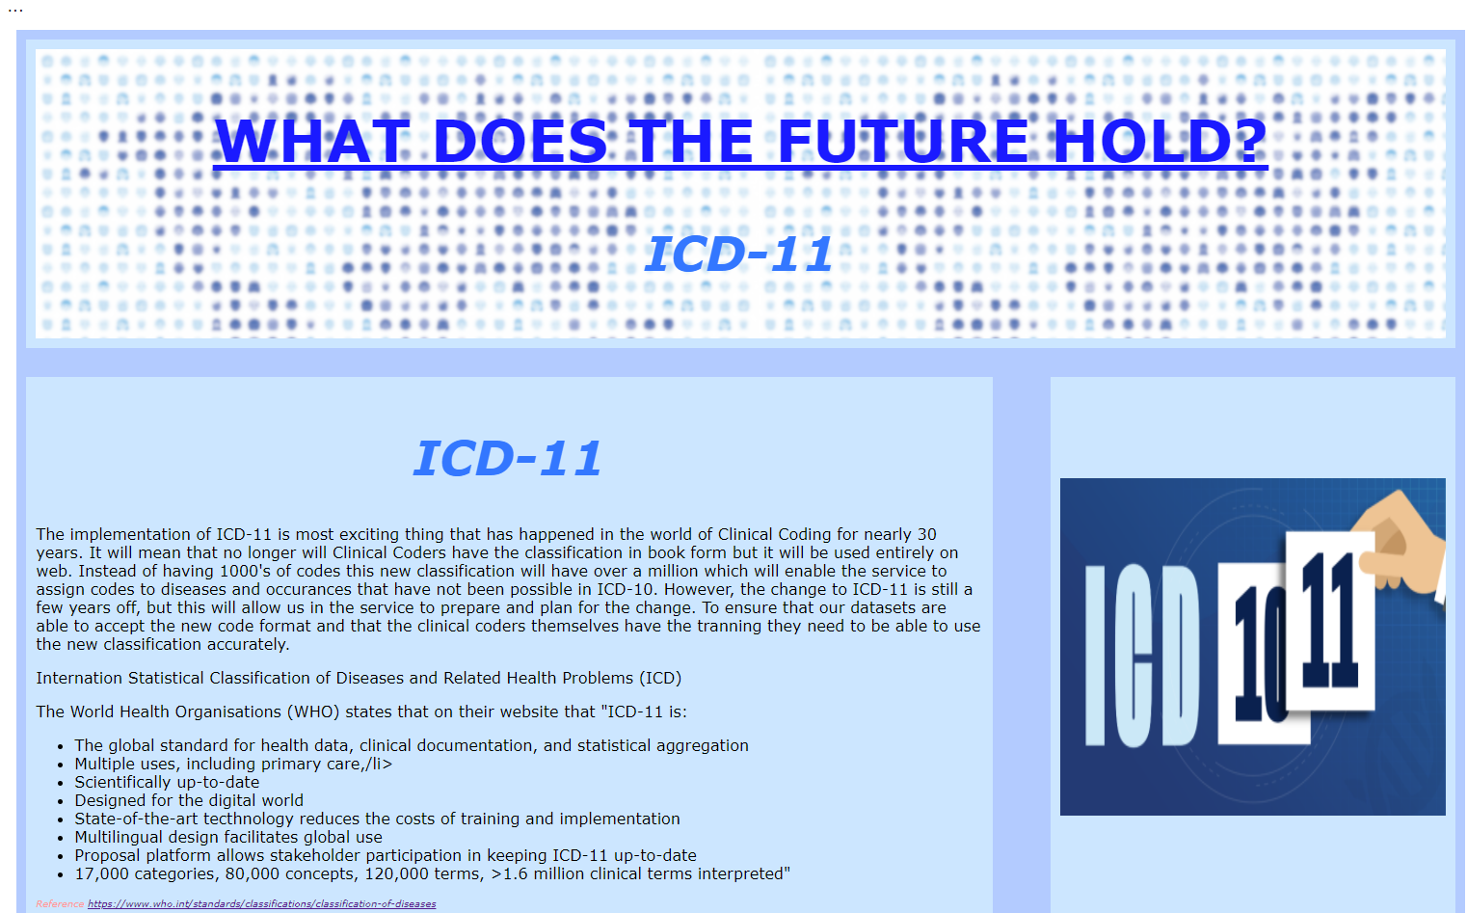


Validation

HTML Validation

The errors that have been displayed due to </br> have come about due to me miss hearing what a colleague told me was best practice when using the “br” tag. Stack.com [1] confirmed that the preferred tag structure is <br/>, which I have amend these tags to in all the HTML scripts for this website.
The errors shown below I have not been able to resolve. If I had more time, I would like to research these errors and warning in-depth and find a resolution for them.

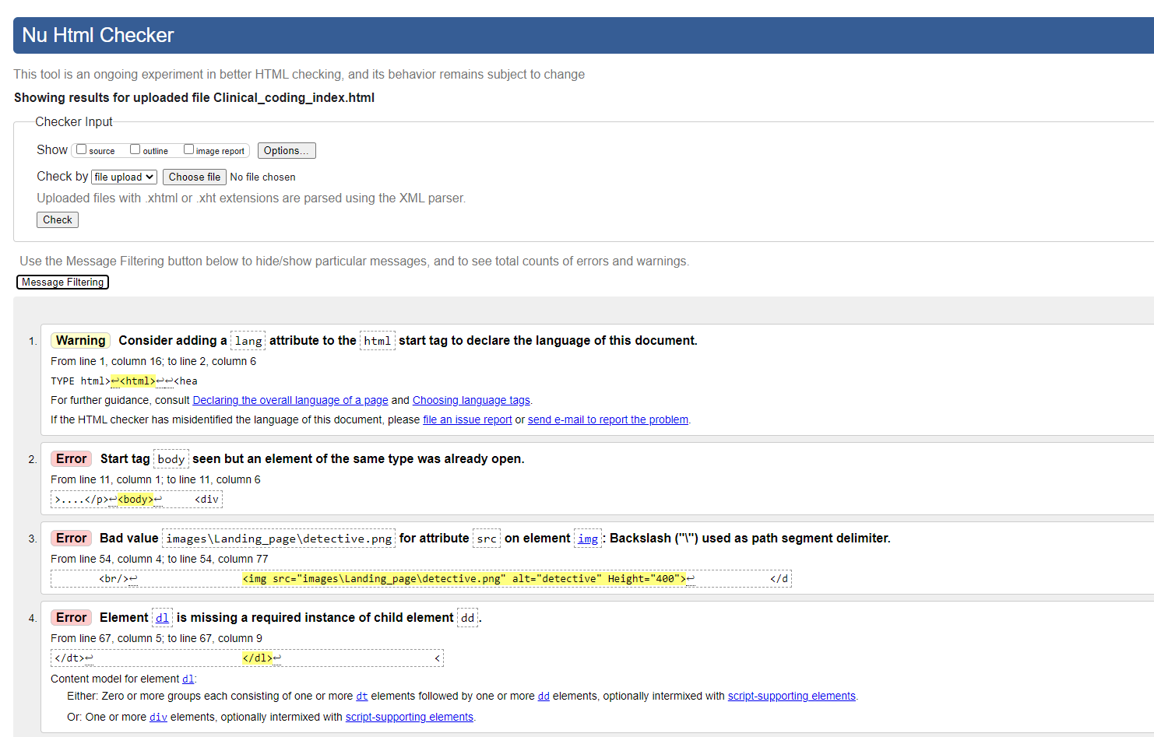

CSS Validation

After running the CSS validation check it showed 3 errors (see below)
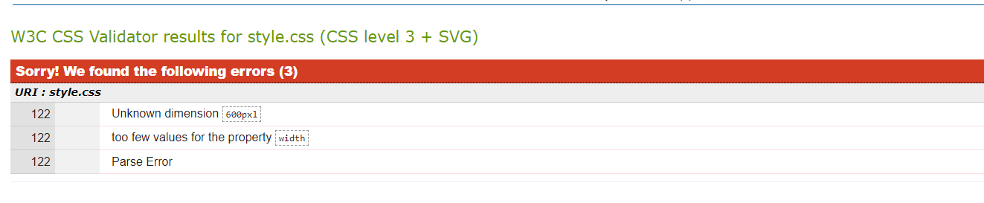
I had a “l” for some reason at the end of “px”, I managed to sort that quickly but not entirely sure what the “Parse Error” is and have been unable at this time to resolve the error.

Evaluation

Useability

Design Documents

As I am very new to the world of website design, as before starting this module I had never heard of HTML or CSS, the first thing I felt that I needed to do, was a bit of research about what are the basic foundations of a good website. Marianne [2] states in her blog that there are 9 fundamentals of website design that you need to incorporate into your website to ensure that it can communicate your message to your target audience:
- Purpose – what is your message and is it clearly accessible to your target audience
- Simplicity – how easy is it to use
- Navigation – how do you drill down from landing page to “child” pages and how do you return to the landing page
- F shape – how is the web page read – left to right – top to bottom
- Visual hierarchy – how is your paged structured and can you establish the main focal point of your page
- Content – is it interesting – does it match the “purpose”
- Grids – how is your website laid out – is it orderly
- Load time – if this were a live website – the designer would be looking into loading speeds of less than 3 seconds.
- Viable media – is the website able to be viewed on laptops, tablets, and mobile phones
The purpose of the website has already been discussed in the Requirements Section of this report, so I will not repeat that and move on to document the other 8 principals.
I wanted this website to be as simple as possible to use so I used a basic grid designed for both the landing and child pages as depicted in:
- The site design document (appendix 6.4.1)
- Wire frame landing page document (appendix 6.4.2)
- Wire frame pages document (appendix 6.4.3)
The navigation to allow the user to return to the landing page from a child page did cause me some concerns. If this were going to be a permanent website and I did not have to submit it as a zipped file I would just have used the HTML code to direct the user back the HTTP address for the landing page of the website. As I worked out this would change when the location of the HTML page address would alter due where it was physical situated, I had to go to W3 Schools to research another method of navigating back to the landing page.
The solution that I came to was to use the “history back” command and embed it in a button, this would allow the user always to return to the website landing page. I also used “href” command as demonstrated during our lectures to take the user back to the top of the current page.

Accessibility

According to Robbins [3] there are 4 types of disabilities that can influence how people will be able to utilize your website:
- Vison – when designing the website, I ensure that all images also come with the “alt” tag so that they also have a description for those with vision impairments.
- Mobility – thought this is a very simple website I did keep in mind that those with a mobility impairment, might have to use modified mice or keyboards. I have tried to make navigating around the website easy with buttons to return to the main landing page. I did have a few issues with the navigating back to the main menu. First, I tried to “\” go back but could not get my script to work. Using the actual “http” address of the landing page, but soon realized this would not work when the scripts were stored in a zip file and sent to be tested. The only fixed I could get to work was to create a “button” and a “history back” command. Not entirely happy with this resolution and if I had more time, I would like to explore HTML codes to find a better method of navigating back to the landing page.
- Auditory – although I do not have any audio aspects to my website, it is important to consider this and provide alternatives such as transcripts or captions for videos when these are incorporated into your website
- Cognitive – those with cognitive impairments cope better with websites that designed simply and clearly. I have tried to ensure that my website is easy to navigate, and the design is repetitive so the user can familiarize themselves with the site easily.
To help address the needs that everyone must be able to use the web the World Wide Web Consortium (W3C) set up the Web Content Accessibility Guidelines (WCAG). W3.org [4] states that the WCAG has 4 principals.
- Perceivable
- Operable
- Understandable
- Robust

Perceivable

To ensure that my website adheres to the perceivable principal I have made sure that there is:
- a text equivalent for all non-text elements (i.e., pictures and photographs)
- that colour is not used as the only visual means of conveying information
- that text can be resized within the website to assist those with visual disabilities
I have used different blues as my base colour for the website as according to Morris [5] the colour blue is trustworthy, knowledgeable, and cool. This is backed up by Rentz in her blog [6] in which she describes the colour evoking feelings of trust, honesty, loyalty, and confidence. She goes on to say that dark blue evokes a sense of knowledge, integrity, power seriousness.
I have tried to veer away from reds, oranges, yellows, browns, and greens as the NHS in their website [7] documents that these are the colours that people with a vision impairment of colour blindness have the most difficulty distinguishing.
To pick the colour for the website I use the w3schools [8] and I also used Contrast Checker [9] to analyse how my chosen colour would appear before I hard coded them into my script
I took time to choose the font for my website as Irfan [10] states that choosing the correct font has a huge impact on the overall appearance of your website and how easy it is for the end user to navigate around it. And vice versa how choosing an inappropriate font can be off-putting to any prospective end-user.

Operable

This is the functionality of the website and how people with mobility impairments can navigate around the website. When designing your website, you should ensure:
- That functions are available via the mouse and keyboard
- The browsers and other tools can provide keyboard support
- That users have sufficient time to review the material
- Content does not include media that could cause harm
- The user can navigate easily through the website
According to Kurpiel [11] C.R.A.A.P evaluation is also a method of testing operability:
- C – Currency, is the content up to date and when was the contents published, is it still relevant
This website has links to the most up to date information that is available about clinical coding.
- R - Relevance, does the information answer the questions that it says it will, and who is the intended audience. I have set my target audience as people who are curious about clinical coding and would just like to find out what it is and how it relates to data Quality in the NHS.
- A – Authority, can you trust the author and publishers. As I am lead for Welsh Government on the subject matter, I would hope that my qualifications and credentials were up to date and appropriate.
- A – Accuracy, if this were a real website, I would ask my colleague and peers within the Clinical Coding world to review the contents. I would use the sites available to check your colours and contrast to review my design, I would ask the web designers in my organization to review the design of the website.
- P – Purpose, why has the website been created. I have tried to create the website with links that those interested in Clinical Coding will find interesting but also, I have tried to add a pinch of my own love of the subject.

Understandable

I have endeavored to make my website as readable as possible and have identified and explained any use of abbreviations.
There are no overly complicated or unusual wording that would require a more advanced reading ability. The website also operates in a predictable manner as the pages are all designed in the same format and the menus and navigation buttons are all in the same physical location on the pages.

Robust

This is to ensure that the content of the website is up to date and valid. Also, that both the contents and technical aspect of the website are future proof. I have also tested the website to ensure that it will open in the main web browsers:
- Google Chrome
- Edge
- Internet Explorer

Search Engine Optimisation

According to Robbins [12] search engine optimisation is just a case of fine tuning the website in such a manner that it increases the chances that it will show on the first page of any internet search. This is important for a live website as in reality how many of us bother to advance passed the first page of a search. WIX [13] states in their blog that there are 6 ways to get your site to rank higher within a specified search parameter:
- Submit your site to Google – if you want your website to show in the top ten – you can bid on the chance to show an advert of your website next to searches.
- Lay a link trail
- Choose prominent key words
- Mega tags
- Multimedia
- Local service

For this website I have tried to use all the keywords that I think would be important for someone googling a clinical coding website:
- Clinical Coding
- ACC
- NCCQ
- OPCS
- ICD-10
- ICD-11
And I have tried to make it as media assured and accessible as I can though to be honest, I am still not entirely happy with how some aspects of the pages look when they are minimized. If I had more time and resources, I would like to resolve these concerns.
If I had more time to research how to make the website totally multimedia accessible – I would like to change how the web pages open when minimized, mainly how the size of the images that I have used I would like them to change as I do not like the way they are appear when the browser is minimised.
For the below image I would like it to resize as the browser size changes but even though I have experimented with resizing image in the software package Gimp [14] and trying to use resizing commands in CSS, unfortunately I have not managed it to create this design aspect for this assignment.
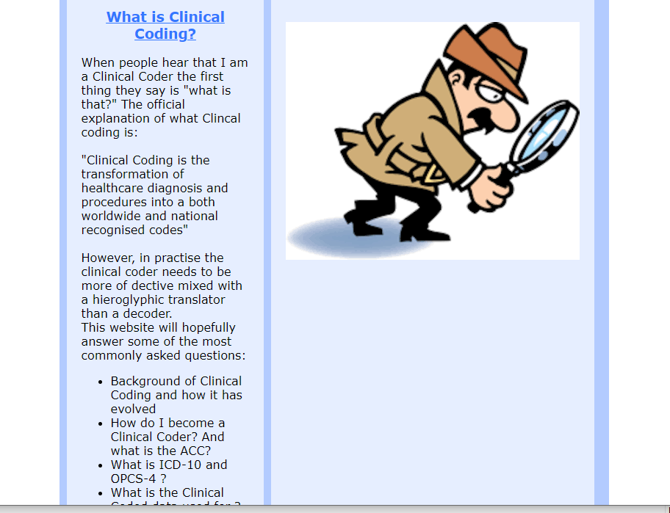

References

[1] Stackoverflow, “HTML 5:is it <br>, <br/>, or <br/>?,” Stack overflow, 19th July 2019. [Online]. Available: https://stackoverflow.com/questions/1946426/html-5-is-it-br-br-or-br. [Accessed 12th April 2021].
[2] Marianne, “9 Principals of good web design”, FeelingPeaky.com Blog, 2021. [online] Available: https://www.feelingpeaky.com/9-principles-of-good-web-design/#:~:text=Several%20factors%20such%20as%20consistency,guide%20visitors%20to%20take%20action. [Accessed Apr. 5, 2021].
[3] J.N. Robbins, Learning Web Design, 5th Edition, Farnham: O’Reilly Media Inc, 2018, pp.42-43
[4] W3.org, “How to Meet WCAG(Quick Reference),” W3.org, 4 October 2019. [Online]. Available: https://www.w3.org/WAI/WCAG21/quickref/. [Accessed 5th April 2021].
[5] B. Morris, “10 Colours That Increase Sales, and Why,” Business 2 Community, 2nd Jan 2013. [Online]. Available: https://www.business2community.com/marketing/10-colors-that-increase-sales-and-why-0366997. [Accessed 12th April 2021].
[6] J. Rentz, “This is Why You Love The Color Blue,” BLDG/25, 9th July 2015. [Online]. Available: https://blog.freepeople.com/2015/07/love-color-blue/. [Accessed 12th April 2021].
[7] NHS, “Colour vision deficiency (colour blindness),” NHS.uk, 1st April 2019. [Online]. Available: https://www.nhs.uk/conditions/colour-vision-deficiency/. [Accessed 12th April 2021].
[8] w3schools.com, “HTML Color Picker,” w3schools.com, 2021. [Online]. Available: https://www.w3schools.com/colors/colors_picker.asp?colorhex=000000. [Accessed 12th April 2021].
[9] Acart Communications, “Contrast Checker”, contrastcheck.com, 2017. [Online]. Available: https://contrastchecker.com/. [Accessed 12th April 2021].
[10] F. Irfan, “The 20 Best HTML Web Fonts To Use In 2021,” Hostinger Tutorials, 2nd March 2021. [Online]. Available: https://www.hostinger.co.uk/tutorials/best-html-web-fonts. [Accessed 12th April 2021].
[11] S. Kurpiel, “Evaluating Sources: The CRRAP Test”, Bendictine University, 19th January 2021. [Online]. Available: https://researchguides.ben.edu/source-evaluation. [Accessed 18th April 2021].
[12] J. N. Robbins, Learning Web Design, 5th ed., Farnham: O'Reilly Media, Inc, 2018, pp. 13
[13] WIX, "How to get your website on Google in 6 simple steps," WIX.com, 10 December.2020. [Online]. Available: https://www.wix.com/blog/2018/10/how-to-get-your-business-found-on-google?utm_source=google&utm_medium=cpc&utm_campaign=9852964004^115258512927&experiment_id=^b^473625301901^^_DSA&cq_src=google_ads&cq_cmp=9852964004&cq_con=115258512927&cq_term=&cq_med=&cq. [Accessed 12th April 2021].
[14] Gimp, “Gimp GNU Image Manipulation Program”, Gimp.org, 21st October 2020. [Online]. Available: https://www.gimp.org/. [Accessed 19th April 2021].

Website References

6.2 Landing Page

Heading background

Imgbin, “Egyptian Pyramids Ancient Egypt Egyptian Hieroglyphs Symbols PNG”, IMGBIN.com, 2nd January 2019,[Online]. Available: https://imgbin.com/png/ypsrjNwb/egyptian-pyramids-ancient-egypt-egyptian-hieroglyphs-symbol-png. [Accessed 12th April 2021].
This image has been modified with Gimp [14]

Detective Image

Kindpng,”Magnifying Glass Detective With Clipart Transparent – Clip Art Detective Magnifying Glass, HD Png”, Kindpng.com, 2019, [Online]. Available: https://www.kindpng.com/imgv/JhmxbJ_magnifying-glass-detective-with-clipart-transparent-clip-art/. [Accessed 12th April 2021].

Page 1 History of Clinical Coding

Heading background

Wikisource, “Bills of Mortality”,Wikisource.org, 3rd January 2021. [Online]. Available: https://en.wikisource.org/wiki/Bills_of_Mortality. [Accessed 12th April 2021].
This image has been modified with Gimp [14]

Bills of Mortality Image

The Public Domain Review, “London’s Dreadful Visitation: A year of Weekly Death Statistics during the Great Plague(1665)”, PublicDomanReview.org,[Online]. Available: https://publicdomainreview.org/collection/londons-dreadful-visitation-bills-of-mortality. [Accessed 12th April 2021].

John of Gaunt Text And Florence Nightingale Text

Who, “History of the development of the ICD”, who.int, [Online]. Available: ttps://www.who.int/classifications/icd/en/HistoryOfICD.pdf". [Accessed 12th April 2021].

Florence Nightingale Image

St Wilfrids CE Primary School, “ Illustration of Florence Nightingale holding lamp”, stwilfridsceprimaryschool.co.uk , 2021, [Online]. Available: https://stwilfridsceprimary.co.uk/curriculum/curriculum/illustration-of-florence-nightingale-holding-lamp/. [Accessed 12th April 2021].

Page 2 Clinical Coding Qualifications and Qualities

Heading Background

NYC Reach, “Using ICD-10 Asthma Severity Codes”, NYCReach.org, 2020 , [Online]. Available: https://nycreach.org/2019/01/23/using-icd-10-asthma-severity-codes/. [Accessed 12th April 2021].
This image has been modified with Gimp [14]
Note: An unmodified version of this image was also used on page 5 What Happens to all these codes ?

IHRIM

IHRIM., “National Clinical Coding Qualification (Uk)”, IHRIM. co.uk, 2021, [Online]. Available: https://www.ihrim.co.uk/education-and-cpd/uk-students/nccq. [Accessed 12th April 2021].

NCCQ UK Image

NHS Digital, “ National Clinical Coding Qualification (UK)”,Hscic.Kahootz.com, March 2018, [Online]. Available: file:///C:/Users/Dell/Downloads/NCCQExamFramework_201819_002%20(2).pdf. [Accessed 12th April 2021].

Page 3 Classifications Tools of the Trade

Heading Background, Image of OPCS Book and Used ICD-10 Books

These images were images that I took of my own OPCS-4.9 and ICD-10 Books
This image has been modified with Gimp [14]

ICD-10 Classification Books Image

Dimdi de, “ ICD-10-WHO”, dimdi.de, [Online]. Available: https://www.dimdi.de/dynamic/en/classifications/icd/. [Accessed 12th April 2021].

ICD-10 Classification and OPCS Classification Text

Kahootz, “Delen: Home”, Hscic.kahootz.com [Online]. Available: https://hscic.kahootz.com/connect.ti/t_c_home/grouphome. [Accessed 12th April 2021].

Page 4 Four Step Coding Process What is it?

Heading Background

Canstockphoto, “abstract blue puzzle background”, CanStockPhoto.com, [Online]. Available: https://www.canstockphoto.com/blue-puzzle-pieces-9258969.html. [Accessed 12th April 2021].
This image has been modified with Gimp [14]

Page Text

The text describing the four step coding process was taken from my own notebooks from when I was studying for my NCCQ

Four Step Coding Process Image

Kahootz , “Delen: Home”, Hscic.kahootz.com [Online]. Available: https://hscic.kahootz.com/connect.ti/t_c_home/grouphome. [Accessed 12th April 2021].

ICD-10 Tabular and Index Images

Amazon.UK, “ICD-10 International Statistical Classification of Diseases and Related Health Problems”, Amazon.co.uk , 2021. [Online]. Available: https://www.amazon.co.uk/International-Statistical-Classification-Diseases-Problems/dp/9241544198. [Accessed 12th April 2021].

Page 5 What Happens to all these Codes ?

Heading Background

Digital Marketing Institute , “8 Ways to Extract Value from Customer Data”, Digitalmarketinginstitute.com 8th March 2019, [Online]. Available: https://digitalmarketinginstitute.com/blog/8-ways-to-extract-value-from-customer-data. [Accessed 12th April 2021].
This image has been modified with Gimp [14]

Covid Virus Image

Wikipedia, “ Virus”, Wikipedia.org, 4th April 2021, [Online]. Available: https://en.wikipedia.org/wiki/Virus. [Accessed 12th April 2021].

The Importance of Coding Text

Blackpool Teaching Hospital, “The Importance of Clinical Coding”, blackpoolclinicalcoding.nhs.uk, 2017, [Online]. Available: https://www.blackpoolclinicalcoding.nhs.uk/index.php/the-importance-of-clinical-coding/. [Accessed 12th April 2021].ge 6 What does the future hold?

Heading Background

Vecteezy, “dotted world map”, Vecteezy.com, 2021, [Online]. Available: https://www.vecteezy.com/vector-art/533675-dotted-world-map-on-a-blue-background. [Accessed 12th April 2021].
This image has been modified with Gimp [14]

6.8.2. ICD-11 Image

Innovaccer , “The ABC of ICD-11: How does it change your practice”, Innovaccer.com, 2021, [Online]. Available: https://innovaccer.com/blogs/the-abc-of-icd-11-how-does-it-change-your-practice/. [Accessed 12th April 2021].

ICD-11 Text

World Health Organization, “International Statistical Classification of Diseases and Related Health Problems ICD”, Who.int, 2021, [Online]. Available: https://www.who.int/standards/classifications/classification-of-diseases. [Accessed 12th April 2021].

6.9 Banner at bottom of all pages

Depostiphotos,”Flat line design website banner of e-learning, e-book, online education – Stock Vector Image”, Depositphotos.com, 14th March 2016, [Online]. Available: https://depositphotos.com/102750706/stock-illustration-flat-line-design-website-banner.html. [Accessed 12th April 2021].

Appendices

HTML Coding

Landing page- HTML Index

<!DOCTYPE html>
<html>

<head>
<meta charset="utf-8">
<title>Clinical_Coding</title>
<link rel="stylesheet" type="text/css"
href="style.css">
</head>
<p id="topPara">....</p>
<body>
<div class="grid-container">
<div class="item1">
<section id="h-header">

<h1> Clinical Coding </h1>
<h2>Unravelling the Mystery!!!</h2>
</section>

</div>
<div class="item2">
<div class="text">
<h3>What is Clinical Coding?</h3>
<p> When people hear that I am a Clinical Coder the
first thing they say is "what is that?"
The official explanation of what Clincal coding is:
<br/>
<br/>
"Clinical Coding is the transformation of healthcare
diagnosis and procedures into a both worldwide and national recognised codes"
<br/>
<br/>
However, in practise the clinical coder needs to be
more of dective mixed with a hieroglyphic translator than a decoder.
<br/>
This website will hopefully answer some of the most
commonly asked questions:
</p>
</div>
<ul>
<li>Background of Clinical Coding and how it has evolved</li>
<li>How do I become a Clinical Coder? And what is the ACC?</li>
<li>What is ICD-10 and OPCS-4 ?</li>
<li>What is the Clinical Coded data used for ?</li>
<li>ICD-11</li>
</ul>
<p>I have worked in Clinical Coding for nearly 15 years
and what I would say for anyone thinking of becoming a Clinical Coder is:
<br/>
<ul>
<li> It is never boring and always something new to learn</li>
<li> You are encouraged to be come accredited and take further exams</li>
<li> The knowledge you gain can take to other careers - data analysis, data standards </li>
</ul>
</div>

<div class="item3">
<br/>
<br/>

<!-- <img src="images\Landing_page\detective.png" alt="detective" height="400px" max-height="auto" min-height="200px"> -->
<img src="images\Landing_page\detective1.png" alt="detective" >
</div>
<div class="item4">
<h2>Menu</h2>

<dl>
<dt><a href="pages/history.html">1. History of Clinical Coding</a></dt>
<dt><a href="pages/qual.html">2. Qualifications and qualities that make a great Clinical Coder</a></dt>
<dt><a href="pages/tools.html">3. Tools of the trade</a></dt>
<dt><a href="pages/four.html">4. Four Step Coding Process</a></dt>
<dt><a href="pages/uses.html">5. Why we code?</a></dt>
<dt><a href="pages/ICD11.html">6. What ICD-11 will mean to Clinical Coding</a></dt>
</dl>
<br/>

</div>
<div class="item5">
</div>
<div class="item6">
Copyright &copy; 2021 Karen Windsor ACC
<br/>
<address>
Written by <a href="mailto:1918576@student.uwtsd.ac.uk">Karen Windsor</a>
</address>

<footer id="main-footer">
<a href="#topPara">Back to Top</a>
</footer>
</div>

</div>
<!-- <a href="#topPara">Back to Top</a> -->

<br/>

</body>
</html>

Page 1 History of Clinical Coding HTML

NOTE: The codes to create the go back button for the all the children pages of this website was taken from w3schools

W3schools, “History back () method”, w3schools.com, 2021, [Online]. Available: https://www.w3schools.com/jsref/met_his_back.asp. [Accessed 12th April 2021]

<!DOCTYPE html>
<html>
<head>
<meta charset="utf-8" />
<title>CC_History</title>
<link rel="stylesheet" type="text/css"
href="pages.css">
</head>
<p id="topPara">...</p>
<body>
<div class="grid-container">
<div class="item1">
<section id="h-header">

<h1> Clinical Coding </h1>
<h2>A Brief History</h2>
</section>

</div>
<div class="item2">
<h2> John Gaunt</h2>
<p>
In the PDF by the World Health organisation it states how the first statistical study of
disease began in the 17th Century with the work of John
Graunt on the London Bills of Mortality. The paper goes on to state that "The kind of
classification envisaged by this pioneer is exemplified by his
attempt to estimate the proportion of liveborn children
who died before reaching the age of six years, no records of
age at death being available. He took all deaths classed
as thrush, convulsions, rickets, teeth and worms, abortives,
chrysomes, infants, livergrown, and overlaid and added to
them half the deaths classed as smallpox, swinepox,
measles, and worms without convulsions.
Despite the crudity of this classification his estimate of
a 36 % mortality before the age of six years appears from
later evidence to have been a good one. While three centuries
have contributed something to the scientific accuracy
of disease classification, there are many who doubt
the usefulness of attempts to compile statistics of disease, or
even causes of death, because of the difficulties of
classification. "
</p>

<section id="reference">
Reference <a href="https://www.who.int/classifications/icd/en/HistoryOfICD.pdf">
https://www.who.int/classifications/icd/en/HistoryOfICD.pdf</a>

</section>
<br/>
<br/>
<h2> Florence Nightingale</h2>
<p>
The first real Clinical Coding was performed by the great hero of Nursing World Wide Florence Nightgale.
In the PDF by the World Health Organisation it states that
"Clinical Coding was introduced by Florence Nightingale (1855) during the Crimea War
(1853 – 1855) (Bull 1992). Although the Russians were defeated at the battle of the
Alma River (20 September 1854), the Times newspaper criticized the British medical
facilities. Sidney Herbert, the British Secretary for War asked Florence Nightingale a
mathematician to become nursing administrator and oversee the introduction of
nurses to military hospitals.
Nightingale at the end of the war was able to show positive outcomes from quality of care.

When Nightingale arrived at Scutari medical barracks in 1854 she was appalled by
the unhygienic conditions and high mortality rates amongst injured and ill soldiers.
Soldiers were seven times more likely to die from diseases such as typhus and
cholera in the hospital than to die on the battlefield.
Nightingale’s knowledge of mathematics and statistics were evident as she collected
data enabling her to calculate mortality rates. By February 1855 mortality rates had
dropped from 60% to 42.7% due to an improvement in hygiene. By spring that rate
had dramatically decreased to 2.2% through the provision of fresh water, the
purchase of fresh fruit, vegetables and standard hospital equipment."
</p>
<section id="reference">
Reference
<a href="https://www.who.int/classifications/icd/en/HistoryOfICD.pdf">https://www.who.int/classifications/icd/en/HistoryOfICD.pdf</a>

</section>
</div>

<div class="item3">
<br/>
<br/>
<img src="images_pages\plague.jpg" alt="London Bills of Mortality" width="400" height="400">
<br/>
<br/>
<br/>
<br/>
<br/>
<img src="images_pages\lamp.jpg" alt="London Bills of Mortality" width="400" height="400">
</div>

<div class="item4">
<h3>Additional Reading</h3>
<dl>

<dt><a href="https://en.wikipedia.org/wiki/John_Graunt#:~:text=Graunt%20was%20one%20of%20the,following%20his%20conversion%20to%20Catholicism."
target="iframe2"> 1. History of John Gaunt Wikipedia</a></dt>
<iframe src="https://en.wikipedia.org/wiki/John_Graunt#:~:text=Graunt%20was%20one%20of%20the,following%20his%20conversion%20to%20Catholicism.
"name="iframe2"width="40%" height="80">
</iframe>
<dt><a href="https://en.wikipedia.org/wiki/Florence_Nightingale" target="iframe1">2. History of Florence Nightgale</a></dt>
<iframe src="https://en.wikipedia.org/wiki/Florence_Nightingale"name="iframe1"width="40%" height="80">
</iframe>
</dl>
</div>

<div class="item5">
</div>

<div class="item6">

<footer id="main-footer">
<!-- <a href="file:///C:/Users/Dell/OneDrive%20-%20University%20of%20Wales%20Trinity%20Saint%20David/weba/Clinical_coding_index.html">Back to main page</a> -->
<form>
<input type="button" value ="Return to main menu" onclick="history.back(-1)">
</form>

</footer>

<a href="#topPara">Back to Top</a>
</div>

</div>

</body>

</html>

Page 2 Qualifications and qualities HTML

<!DOCTYPE html>
<html>
<head>
<meta charset="utf-8" />
<title>CC_Qualifications</title>
<link rel="stylesheet" type="text/css"
href="pages.css">
</head>
<p id="topPara">...</p>
<body>
<div class="grid-container">
<div class="item1">
<section id="q-header">

<h1> Clinical Coding </h1>
<h2>Qualifications & Qualities</h2>
</section>
</div>
<div class="item2">
<h2>National Clinical Coding Qualification (NCCQ) ACC </h2>
<p>
Clinical Coder are expected after around 2 years of training to sit
the National Clinical Coding Qualification (NCCQ)
to be come an Accredited Clinical Coder. To obtain the NCCQ coders are
required to sit two 3 hour exams. The first
is a practical exam, where the coders are tested on their knowledge on
how to assign codes. The pass mark for the
practical exam is 90%, and to be honest it is a tough test of any coders knowledge.
After a one hour lunch break the
candidates then have to sit the Theory exam, which tests their knowledge on anatomy
and the rules and standards that
govern code asssignments. The pass mark for the theory exam is a mere 65%.
</p>
<p>
More information on the qualification can be found on the IHRIM website site where it states that
"The National Clinical Coding Qualification (UK) is the only nationally recognised qualification
for clinical coders working in the NHS. Upon passing the examination a clinical coder is able
to use the post-nominal letters ACC.

A novice NHS clinical coder needs to agree a 2-3 year development plan with their
employer to complete the necessary training, acquire the skills,
knowledge and practical work experience to become competent in
clinical coding and be ready to sit the examinations to achieve accreditation.
The breadth of coding skills and knowledge which is covered by the National
Clinical Coding Examination are derived from the framework of the national clinical coder curriculum.

The National Clinical Coding Qualification (NCCQ) is the nationally
recognised quality standard which provides independent assurance of
the clinical coding practitioners’ competency in the use of the clinical
classifications and knowledge of how to apply their associated rules,
conventions and national clinical coding standards.
Any clinical coding manager can be assured that a holder
of the qualification (Accredited Clinical Coder/ACC) has been assessed and met these minimum standards.

The qualification is therefore invaluable in aiding robust recruitment processes.
However, it need not act as a barrier to hold back an individual’s career progression.
Trusts may have in place their own criteria for the on-going assessment and professional
development of their employees in-line with local policies on staff development
and the NHS Terms and Conditions of Service (section 31). As the recognised national
qualification the NCCQ is a pre-requisite criteria for certain specialised career pathways
– including the formal assessment of approved clinical coding auditors and trainers –
to demonstrate eligibility. The qualification also acts as evidence of compliance
with Data Security and Protection Toolkit (DSPT) Data Standard 3 and
can help an organisation towards meeting those standards."
</p>
<p>
However, it should be remembered that like the driving test, the best clinical coders
always pass second go.
</p>
<section id="reference">
Reference
<a href="https://www.ihrim.co.uk/education-and-cpd/uk-students/nccq">
https://www.ihrim.co.uk/education-and-cpd/uk-students/nccq</a>

</section>
</div>
<div class="item3">
<br/>
<br/>
<br/>
<br/>
<img src="images_pages\ACC.png" alt="ACC" width="300" height="400">
</div>
<div class="item4">
<h3>Additional Reading</h3>
<dl>
<dt><a href="https://www.ihrim.co.uk/education-and-cpd/uk-students/nccq#:~:text=The%20National%20Clinical%20Coding%20Qualification%20(NCCQ)%20is%20the%20nationally%20recognised,conventions%20and%20national%20clinical%20coding"
target="iframe1">1. Institute of Health Records & Information Management (IHRIM)</a></dt>
<iframe src="https://www.ihrim.co.uk/education-and-cpd/uk-students/nccq#:~:text=The%20National%20Clinical%20Coding%20Qualification%20(NCCQ)%20is%20the%20nationally%20recognised,conventions%20and%20national%20clinical%20coding"
name="iframe1" width="40%" height="400">
</iframe>
</dl>
</div>
<div class="item5">
</div>
<div class="item6">
<footer id="main-footer"
<form>
<input type="button" value="Return to main menu" onclick="history.back(-1)">

</form>
</footer>
<a href="#topPara">Back to Top</a>
</div>
</div>
</body>

</html>

Page 3 Tools of the Trade HMTL

<!DOCTYPE html>
<html>
<head>
<meta charset="utf-8" />
<title>CC Tools</title>
<link rel="stylesheet" type="text/css" href="pages.css"/>
</head>
<p id="topPara">...</p>
<body>
<div class="grid-container">
<div class="item1">
<section id="c-header">
<h1>Classifications</h1>
<h2>Tools of the trade</h2>
</section>
</div>
<div class="item2">
<h2> Classifications </h2>
<p> Here in the United Kingdom we use 2 classifications, ICD-10 to assign
codes for diagnosis of disease like Hypertenion (I10X) or appendicitis (K37X) and OPCS to assign
codes for the procedures that are carried out during a patient's admission.
These could be diagnostic (scans/biopsies) or theraputic (hysterectomies, grafting) procedures.
<h2>ICD-10 Classification</h2>
<h3>International Classifications of Diseases, Tenth Revision</h3>
<p> The World Health Organisation publish the ICD-10 classifications and NHS Digital on
their sites state that
"The International Classification of Diseases (ICD) is designed
to promote international comparability in the collection, processing,
classification, and presentation of mortality statistics.
This includes providing a format for reporting causes of death
on the death certificate. The reported conditions are then translated
into medical codes through use of the classification structure and
the selection and modification rules contained in the applicable
revision of the ICD, published by the World Health Organization (WHO).
These coding rules improve the usefulness of mortality statistics by
giving preference to certain categories, by consolidating conditions,
and by systematically selecting a single cause of death from a reported
sequence of conditions. The single selected cause for tabulation is called
the underlying cause of death, and the other reported causes are the
nonunderlying causes of death. The combination of underlying and
nonunderlying causes is the multiple causes of death.

The ICD has been revised periodically to incorporate changes in
the medical field. The Tenth Revision (ICD-10) differs from the
Ninth Revision (ICD-9) in several ways although the overall
content is similar: First, ICD-10 is printed in a three-volume
set compared with ICD-9’s two-volume set. Second, ICD-10 has
alphanumeric categories rather than numeric categories. Third,
some chapters have been rearranged, some titles have changed,
and conditions have been regrouped. Fourth, ICD-10 has almost
twice as many categories as ICD-9. Fifth, some fairly minor
changes have been made in the coding rules for mortality."
</p>
<section id="reference">
Reference
<a href="https://hscic.kahootz.com/connect.ti/t_c_home/grouphome">
https://hscic.kahootz.com/connect.ti/t_c_home/grouphome</a>

</section>
<h2>OPCS Classifications of Interventions and Procedures</h2>
<p> The OPCS-4 Classification is used in the United Kingdom and is published and
created by NHS Digital. And on their website they state that
"OPCS-4 is a statistical classification for clinical coding of
hospital interventions and procedures undertaken by the NHS.
The classification is mandatory for use by health care providers
to support various forms of data collections for secondary uses.

The Terminology and Classifications Delivery Service within NHS
Digital has responsibility for the support, maintenance,
development and licensing of OPCS-4 which is governed by Crown Copyright.

Details are given below of Version 4.9, which is due for
implementation on 1 April 2020.

This information standard is published under section 250 of
the Health and Social Care Act 2012. An Information Standards Notice
(see below) provides an overview of scope and implementation timescales,
and the other listed documents provide further detail for those who have
to implement the information standard.

Update 5 December 2019: The latest release (DCB0084 Amd 18/2019)
was published on 8 October 2019. Since then, the need for a small
change to a supporting document has been identified and a Corrigendum
has been issued. Note that there is no impact on either the published
Requirements Specification or the Implementation Guidance; however an updated Summary of Changes has been published."
</p>
<section id="reference">
Reference
<a href="https://hscic.kahootz.com/connect.ti/t_c_home/grouphome">
https://hscic.kahootz.com/connect.ti/t_c_home/grouphome</a>

</section>
<h2> My books </h2>
<p>
Above shows what your books look like when you receive them;
but they are like I said the tools of the coders trade. So I
thought you might be interested to see what my ICD-10 books look like after a couple of
years of use. As you can see the covers are missing and I have written notes as coding prompts for myself.
</p>
</div>
<div class="item3">
<br/>
<br/>
<br/>
<img src="images_pages\ICD10.jpg" alt="ICD-10" width="400" height="400">
<br/>
<br/>
<br/>
<img src="images_pages\OPCS49.jpg" alt="OPCS-4.9" width="400" height="400">
<br/>
<br/>
<br/>
<br/>
<img src="images_pages\book.jpg" alt="My books" width="400" height="200">

</div>
<div class="item4">
<h3>Additional Reading</h3>
<dl>
<dt><a href="https://datadictionary.nhs.uk/" >1. NHS Data Model and Data Dictionary</a></dt>
<dt><a href="https://hscic.kahootz.com/connect.ti/t_c_home/grouphome" >2.Delen</a></dt>

</dl>
</div>
<div class="item5">
</div>
<div class="item6">
<footer id="main-footer">
<form>
<input type="button" value ="Return to main menu" onclick="history.back(-1)">
</form>

</footer>
<a href="#topPara">Back to Top</a>
</div>
</div>
</body>
</html>

6.1.5 Page 4 Four Step Coding Process HTML

<!DOCTYPE html>

<html>
<head>
<meta charset="utf-8"/>
<title>CC_4_Step</title>
<link rel="stylesheet" type="text/css" href="pages.css">
</head>
<p id="topPara">...</p>
<body>
<div class="grid-container">

<div class="item1">
<section id="four-header">
<br/>
<br/>
<h1>Four Step Coding Process</h1>
<h2>What is it?</h2>
</section>
</div>
<div class="item2">
<h3>Step 1</h3>
<h3>Analyse medical terminology</h3>
<p>
In this step the coder must use the source document to analyse the clinical
statement describing the patient's diagnosis, complaint, problem, or other
reason for health care encounter. Then they must determine
what condition(s) or circumstance(s) need to be coded. And identify the lead
term(s) and modifiers in the statement provided by the clinican.
<br/>
The source document usually used within clinical coding is the full set
of patient case notes. One of the most challenging aspects of the clinical
coding process is to identify relevant information in the case notes regarding the patient's hospital
stay to obtain a complete picture to support the diagnostic statement.
</p>
<h3>Step 2</h3>
<h3>Locate lead term(s) in the Alphabetical Index</h3>
<p>
The lead term identifying the patient's condition, problem, complaint,
or other reason for encounter is used to locate the appropriate lead term in the Alphabetical Index.
The lead term is always found in the bold face in the Alphabetical Index.
Warning - the Alphabetical Index uses American Spelling so many conditions
featuring "ae" in English are spelt only with the "e".
</p>
<h3>Step 3</h3>
<h3>Assign a tentative code using the Alphabetical Index</h3>
<p>
Once the appropriate lead term has been located, several conventions
and principles used in the Alphabetical Index must be understood before
a tentative code assignment can be made. These conventions include the use of:
</p>
<ul>
<li>Modifiers: non-essential and essential</li>
<li>NOS (not otherwise specified), i.e. no modifiers</li>
<li>NEC (not elsewhere classified)</li>
<li>Aetiology and manifestation (dagger and asterisk system</li>
<li>Cross reference</li>
<li>Order of modifiers</li>
<li>Instructional notes</li>
</ul>
<p>
The tentative code assigned is the alphanumeric code following the:
<ul>
<li>lead term</li>
<li>subterm that is an essential modifier</li>
<li>subterm for 'specified type NEC'</li>
</ul>
</p>
<h3>Step 4</h3>
<h3>Verfify the code assignment by checking the Tabular List</h3>
<p>
This is the final step in the step-by-step coding process. The coder
must now verify the tentative code assigned in step 3 in the Tabular
List to ensure appropriate code section. This may be a case of verifying the tentative
code is indeed correct, or in fact changing or adding to the tentative code.

</div>
<div class="item3">
<br/>
<br/>
<img src="images_pages\steps.png" alt="Four step coding process" width="200" height="400">
<br/>
<br/>
<br/>
<br/>
<img src="images_pages\index_.jpg" alt="Index" width="200" height="400">
<img src="images_pages\tab.jpg" alt="Tab" width="200" height="400">
</div>
<div class="item4">
<h3>Additional Reading</h3>
<dl>

<dt><a href="https://hscic.kahootz.com/connect.ti/t_c_home/grouphome" >1.Delen</a></dt>
<dt><a href="https://www.dls.nhs.uk/Learning?brand=TerminologyandClassificationsDeliveryService" >
2.Digital Learning Solutions</a>
</dl>
</div>
<div class="item5">

</div>
<div class="item6">
<footer id="main-footer">
<form>
<input type="button" value="Return to main menu" onclick="history.back(-1)">
</form>
</footer>
<a href="#topPara">Back to Top</a>
</div>

</div>

</body>

</html>

6.1.6 Page 5 Why we code?

<!DOCTYPE html>
<html>
<head>
<meta charset="utf-8" />
<title> CC Uses</title>
<link rel="stylesheet" type="text/css" href="pages.css">
</head>
<p id="topPara">...</p>
<body>
<div class="grid-container">
<div class="item1">
<section id="u-header">
</br>
<h1>what happens to all theses codes????</h1>
</section>
</div>
<div class="item2">
<h2>The Importance of Clinical Coding</h2>
<p>
There is a really good document written by Blackpool NHS Trust which states
"There is wide recognition in the National Health Service (NHS) of
the importance of good quality Coded Clinical Data and the fundamental
role it plays in the management of hospitals and services.
The government’s introduction of a National Performance Framework
has created a mechanism whereby NHS Trusts will be judged on accurate results.
Clinical data must be accurately and consistently recorded to well defined
national standards to enable it to be used for statistical analysis.
Information drawn from accurate clinical coding better reflects the
pattern of practice of clinicians and provides a sound basis for the
decision making process. The use of tools such as Clinical Indictors
pushes forward the need for accurately and consistently recorded clinical
information. Such information should be produced as part of the regular
activity within a hospital provider unit. Steps to ensure that this is
the case should include audit of clinical coded data and the comprehensive
training of those responsible for the classification of such information.
Healthcare information at local and national level is crucial to support
management, planning and monitoring of health services."

</p>

<section id="reference">
Reference
<a href="https://www.blackpoolclinicalcoding.nhs.uk/index.php/the-importance-of-clinical-coding/">
https://www.blackpoolclinicalcoding.nhs.uk/index.php/the-importance-of-clinical-coding/</a>

</section>
<p> In Wales all our Coded Data gets uploaded weekly into the Patient Episode Database of Wales (PEDW), and
it is used by Welsh Government to plan NHS services for the whole of Wales. This directly affects everyone of
us living in Wales and can have a direct effect on which wards are closed or enlarged. The data is also used
for freedom of Information Requests for media outlets and for Clinician who are researching the number and types
of procedure that are performed or on the general health of population.
</p>
<p> As ICD-10 is a Internationally recognised classification we can compare levels of disease and ill health with
other countries that use the classification.
</p>
<br/>
<br/>
<h2> COVID</h2>
<p> Never has Clinical Coding come under such scrutiny by both English and
Welsh Governments. It is only due to the recording of COVID and other co-morbidities
that they are able to work out which patients are more
likely to survive COVID. Also now the hospitals are finding that patients
are being admitted with long COVID
</p>
<p> We are definitely not out of the woods yet </p>
</div>
<div class="item3">
<img src="images_pages\ICD7.png" alt="codes" width="400" height="400">
<br/>
<br/>
<br/>
<img src="images_pages\covid.jpg" alt="codes" width="400" height="300">
</div>
<div class="item4">
<h3> Additional Reading</h3>
<section id="midPara">
<dl>
<dt>1. Clinically</dt>
<dd><i><a href="https://www.gov.uk/government/publications/newborn-hearing-screening-programme-nhsp-operational-guidance/4-clinical-governance">
1. Clinical Goverance</a>
<a href ="https://www.england.nhs.uk/clinaudit/"> 2. Clinical Audit</a>
<a href="https://www.bmj.com/content/346/bmj.f620"> 3. Clinical Outcomes </a>
<a href="http://www.wales.nhs.uk/promspremsandefficiencyprogramme"> 4. PROMS & PREMS </a>
</br>
</br>
</i></dd>

<dt>2. Statistically</dt>
<dd><i><a href="https://www.england.nhs.uk/national-cost-collection/"> 1. Cost Analysis </a>
<a href="https://www.medicinenet.com/aetiology/definition.htm#:~:text=Aetiology%3A%20The%20study%20of%20the,a%20certain%20disease%20or%20disorder."> 2. Aetiology </a>
<a href="https://digital.nhs.uk/data-and-information/data-insights-and-statistics"> 3. Health Trends </a>
</i></dd>
</dt>
</dl>

<br/>

</section>

</div>
<div class="item5">
</div>
<div class="item6">
<footer id="main-footer">
<form>
<input type="button" value="Return to main menu" onclick="history.back(-1)">
</form>
</footer>
<a href="#topPara">Back to the Top</a>
</div>

</div>

</body>

</html>

6.1.7 Page 6 ICD-11

<!DOCTYPE html>
<html>
<head>
<meta charset="utf-8" />
<title>CC_ICD11</title>
<link rel="stylesheet" type="text/css" href="pages.css"/>
</head>
<p id="topPara">...</p>
<body>

<div class="grid-container">

<div class="item1">
<section id="f-header">
<br/>
<br/>
<br/>
<h1>What does the future hold?</h1>
<h2>ICD-11</h2>
</section>
</div>
<div class="item2">
<h2>ICD-11</h2>
<p> The implementation of ICD-11 is most exciting thing that has happened in the world of Clinical Coding
for nearly 30 years. It will mean that no longer will Clinical Coders have the classification in book form
but it will be used entirely on web. Instead of having 1000's of codes this new classification will have over a million
which will enable the service to assign codes to diseases and occurances that have not been possible in ICD-10. However,
the change to ICD-11 is still a few years off, but this will allow us in the service to prepare and plan for the change.
To ensure that our datasets are able to accept the new code format and that the clinical coders themselves have the tranning they need
to be able to use the new classification accurately.
</p>
<p>
Internation Statistical Classification of Diseases and Related Health Problems (ICD)
</p>
<p>The World Health Organisations (WHO) states that on their website that "ICD-11 is:</p>
<ul>
<li>The global standard for health data, clinical documentation, and statistical aggregation</li>
<li>Multiple uses, including primary care,/li>
<li>Scientifically up-to-date</li>
<li>Designed for the digital world</li>
<li>State-of-the-art tecthnology reduces the costs of training and implementation</li>
<li>Multilingual design facilitates global use</li>
<li>Proposal platform allows stakeholder participation in keeping ICD-11 up-to-date</li>
<li>17,000 categories, 80,000 concepts, 120,000 terms, >1.6 million clinical terms interpreted"</li>
</ul>
<section id="reference">
Reference <a href="https://www.who.int/standards/classifications/classification-of-diseases">
https://www.who.int/standards/classifications/classification-of-diseases</a>
</section>
</div>
<div class="item3">
</br>
</br>
</br>
</br>
</br>
<img src="images_pages\ICD-11_1.png" alt="doctor" width="400" height="350">
</div>
<div class="item4">

<h3>Additional Reading</h3>

<dl>
<dt>Why dont you have a go yourself using the <a href="https://icd.who.int/browse11/l-m/en" >ICD-11 Browser</a></dt>
</dl>
</div>
<div class="item5">
</div>
<div class="item6">
<footer id="main-footer">
<form>
<input type="button" value="Return to main menu" onclick="history.back(-1)">

</form>
<!-- </footer> -->

</footer>
<a href="#topPara">Back to the Top</a>

</div>

</div>

</body>
</html>

CSS Coding

Landing Page CSS

body {

background-color:white;
margin: 0 10%;
font-family:verdana, Helvetica, san-serif, Arial;

}

.item1 {
grid-area:header;
grid-template-columns:repeat(autofit);

}

#h-header {
background-image:url(images/hiero.png);

padding:5px;
margin:0;
/* Height:300px; */
grid-template-columns:repeat(autofit);

}

h1 {
text-align:center;
font-size:80px;
font-family:verdana;
font-weight:normal;
text-transform:uppercase;
color:#0000b3;
margin-top:30px;
text-decoration:underline;
font-weight:bold;
grid-template-columns:repeat(autofit);
}

#h-header h2{
color:#0000b3;
text-decoration:underline;
grid-template-columns:repeat(autofit);

}
.item2 {
grid-area:main;
text-align:left;
/* display:grid; */
grid-template-columns:repeat(autofit);

}
}
.item3 {
grid-area:right;

grid-template-columns:repeat(autofit);
}

.item4 {
grid-area:menu;
text-align:center;

}

.item5 {
grid-area:banner;
background-image:url(images/Landing_page/banner.jpg);
background-repeat:repeat-x;
height:150px;
padding:0;
margin:0;

}

.item6 {
grid-area:footer;
text-align:center;

}

h2 {
color:#3377ff;
font-size:1em;
text-align:center;
font-size:50px;
font-style:italic;

}

h3 {
color:#3377ff;
text-decoration:underline;
}

p {
Text-align:left;
}
ul {
Text-align:left;
}

dt {
text-align:center;
color:#037bfc;
}

.grid-container {
display:grid;
grid-template-areas:
'header header header header header header'
'main main main main right right'
' menu menu menu menu menu menu'
'banner banner banner banner banner banner'
'footer footer footer footer footer footer';
grid-gap:10px;
background-color: #b3cbff;
padding:10px;

grid-template-columns:repeat(autofit);

}
.grid-container > div {
background-color:#e6eeff ;
text-align:center;
padding:20px;
/* font-size:30px; */
}

a:hover {
color:orange;
}
#main-footer {
text-align:left;
color:red;
}

@media(max-width:auto)

Children Pages CSSS
body {
background-color:white;
margin: 0 10%;
font-family:verdana, Helvetica,san-serif,Arial;
}
h1 {
text-align:center;
font-size:1em;
font-size:60px;
font-family:verdana;
font-weight:normal;
text-transform:uppercase;
color:#1a1aff;
padding:0;
margin-top:0;
text-decoration:underline;
font-weight:bold;
}
.item1 {
grid-area:header;
padding:0;
margin:5px;

}

}
.item2 {
grid-area:main;
text-align:left;

}
.item3 {
grid-area:right;
grid-template-columns:repeat(autofit);
}
.item4 {
grid-area:menu;

}

.item5 {
grid-area:banner;
background-image:url(images_pages/banner.jpg);
background-repeat:repeat-x;
height:150px;
padding:0;
margin:0;

}

.item6 {
grid-area:footer;
text-align:centre;

}

#main-footer {
text-align:left;
color:red;
}

h2 {
color:#3377ff;
font-size:1em;
text-align:center;
font-size:50px;
font-style:italic;

}

h3 {
color:#3377ff;
text-decoration:underline;
}

p {
Text-align:left;
}

dt {
text-align:center;
color:#037bfc;
}

#q-header {
background-color:white;
background-image:url(images_pages/ICD8.png);
padding:0;
margin:0;
Height:300px;

}

#h-header {
background-image:url(images_pages/bill.jpg);
background-color:rgba(152,66,211,0.63);
padding:5px;
margin:0;
Height:300px;

}
#c-header {
background-image:url(images_pages/OPCS.jpg);
background-color:rgba(152,66,211,0.63);
/* padding:5; */
/* margin:0; */
/* Height:300px; */
grid-template-columns:repeat(autofit);
}
#u-header {
background-image:url(images_pages/data.jpg);
background-color:rgba(152,66,211,0.63);
padding:0;
margin:0;
Height:300px;
}

#f-header {
background-image:url(images_pages/future2.png);
background-color:rgba(152,66,211,0.63);
padding:0;
margin:0;
Height:300px;
}

#four-header {
background-image:url(images_pages/puzzle.jpg);
background-color:rgba(152,66,211,0.63);
padding:0;
margin:0;
Height:300px;
}
#midPara {
text-align:left;

}
#midPara dt {
text-align:left;
}

#reference {

font-style:italic;
font-size:10px;
text-align:left;
color:#ff9999;
}

.grid-container {
display:grid;
grid-template-areas:
'header header header header header header'
'main main main main right right'
'menu menu menu menu menu menu'
'banner banner banner banner banner banner'
'footer footer footer footer footer footer';
grid-gap:10px;
background-color: #b3cbff;
margin:10px;
padding;10px;

grid-template-columns:repeat(autofit);
}
.grid-container > div {
background-color:#cce6ff ;
text-align:center;
padding:10px;
margin:10px;

/* font-size:30px; */
}

a:hover {
color:orange;
}

li {
text-align:left;
}

@media {max-width:600pxl}

6.3 Glossary of Terms

TERM | DESCRIPTION
HTML | Hyper Text Markup Language – it is the standard markup language used for creating web pages
CSS | Cascading Style Sheets – is used to describe how the HTML elements are to be displayed on the screen, paper, or other media
HTTP | Hyper Text Transfer Protocol – used to load web pages using hypertext links
Landing Page | The page your visitor arrives at on your website
href | HTML code which you set to URL of the page you want to link to
URL | Uniform Resource Locator -the domain name of the website

6.4 Documents

6.4.1 Site Design Document

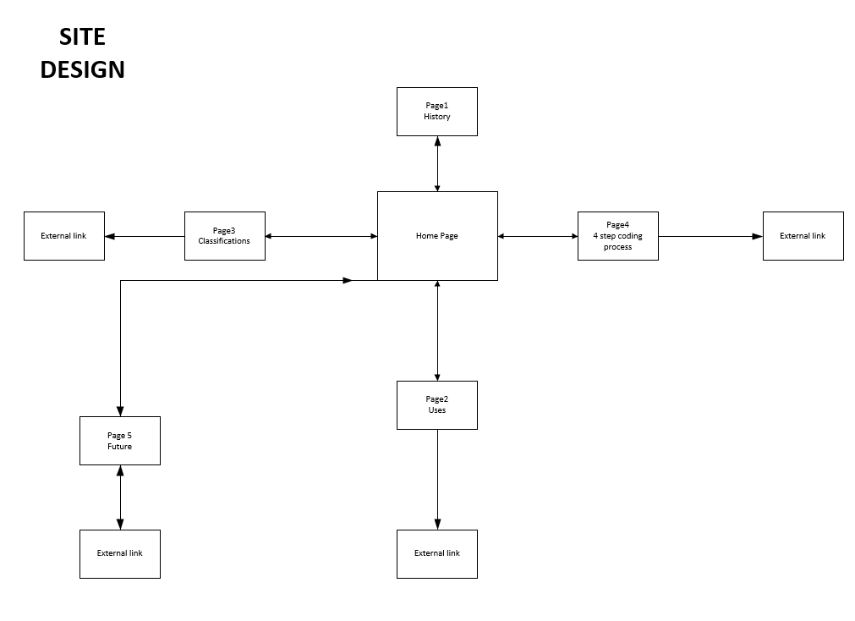

6.4.2 Wire Frame Landing Page Document
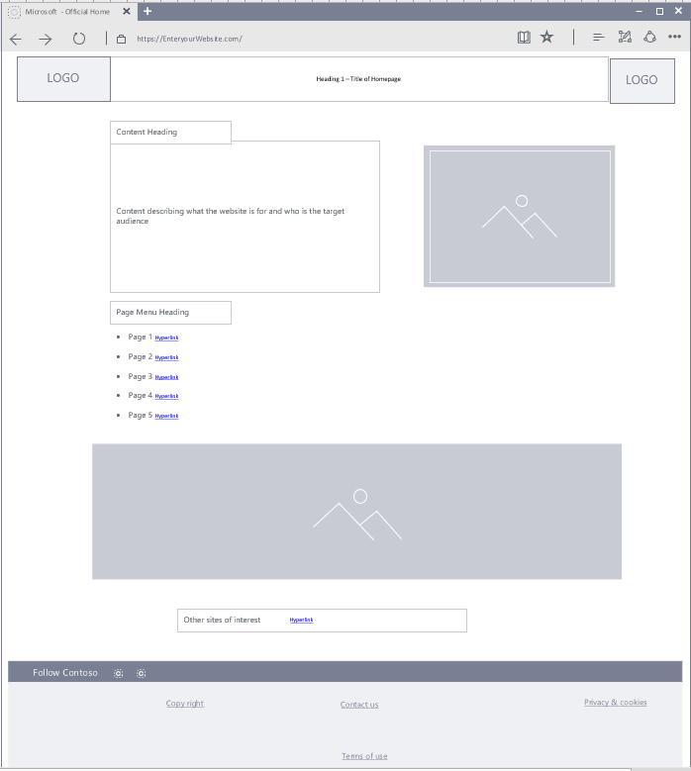

6.4.3 Wire Frame Landing Page Document


