

Digital Forensics Analysis
ACCA7031: Assessment Report
Student Name: Gandhi Raj Rakeshkumar
Student ID: 2503898
Program: MSC Cybersecurity and Digital Forensics
Submission To: Dr. Mohamed Ghanem

Table of Contents
TASK 1 – RESEARCH REPORT 3
1. Current State of the Field and Forensic Tools 3
2. Intersection of Digital Forensics and Cybersecurity 3
3. Emerging Trends in Digital Forensics 4
4. Key Challenges 4
5. National and International Job Market 5
TASK 2 – DIGITAL FORENSIC INVESTIGATION REPORT 5
1. Case Background 5
2. Evidence Inventory and Chain Of Custody 6
3. Methodology and Tools 7
4. Findings 8
4.1 Communication Analysis and Timeline Reconstruction 8
4.2 File Analysis of Emma’s USB Flash Drive 9
4.3 Call Log and Email Correlation 9
4.4 Suspect Profiling 10
4.5 Additional Evidence 10
5. Conclusion 11
6. Recommendations 12
7. Demonstration of Analysis 12
References 14

TASK 1 – RESEARCH REPORT
The State of Digital Forensics: Tools, Trends, Challenges and the Job Market

1. Current State of the Field and Forensic Tools
Digital forensics is a vital science in the investigation of cybercrime, corporate espionage, as well as frauds. It includes the process of identifying, maintaining, examining and presenting digital evidence in a way that would be admissible before the law. It has not only expanded the scope of computer forensics but also to mobile devices, cloud storage, Internet of Things (IoT), and even vehicles.
There is a monopoly on commercial tools. The mobile forensics standard in the industry is Cellebrite UFED (Universal Forensic Extraction Device). Cellebrite, as shown in the practical chapter, can conduct advanced logical, file system and physical extractions of both Android and iOS devices. It is able to circumvent the screen locks, decrypt application data (WhatsApp, Signal, Instagram, etc.), and retrieve deleted messages. A summary of the extraction of a Samsung S10 reveals the retrieval of 2,086 contacts, 10,138 SMS messages, 12,838 pictures and 39,773 files- indicating that the tool can support large volumes of data (Hargreaves, Nelson and Casey, 2024).
The Magnet AXIOM incorporates cloud forensics whereby it retrieves the data from Google Drive, iCloud and Office 365. Imaging of disks, file carving, and analysis of timelines. Disks FTK Imager and Autopsy (open source, both based on The Sleuth Kit) are commonly used. X Ways Forensics provides high-quality data carving and scripting. Open source versions such as Volatility (memory forensics) and Wireshark(network forensics) are also essential.

2. Intersection of Digital Forensics and Cybersecurity
Cybersecurity involves protection against, and response to,o real-time threats and digital forensics works after an event to reconstruct the events and provide evidence to be used in legal courts. The two areas, however, are merging.
Forensic methods are now employed by all incident response teams in order to record volatile data (RAM, network connections) before the shutdown of the system, referred to as live forensics. EDR tools (e.g., CrowdStrike, Carbon Black) have a forensic component where file changes, registry changes, process executions, etc., get logged. These records are forensic artefacts that are admissible in the court of law (Johnson, Davies and Reddy, 2022).
On the other hand, security increases are propelled by forensic findings. On the Task 2 case (corporate espionage), it was observed that Emma made copies of files onto a USB drive hours later. The suggestions are to adopt Data Loss Prevention (DLP), provide better logging, and implement two-factor authentication on sensitive repositories.
Forensic artefacts are also advantageous to threat hunting. Ahead-of-time analysis of event logs, prefetch files and shellbags is performed to identify advanced persistent threats (APTs) that cannot be stopped by signature-based defences.

3. Emerging Trends in Digital Forensics
Cloud Forensics: As data is moving to AWS, Azure and Google Cloud, forensic examiners have turned to API calls and law enforcement requests to the service providers. Issues in it are problems of data sovereignty, ephemerality of storage, and non-physical access. Such tools as Magnet AXIOM Cloud and Cellebrite Cloud Analyser are up-and-coming.
IoT Forensics: IoT devices such as smart speakers, fitness trackers, and smart locks produce valuable data. Nonetheless, standardisation is hampered by heterogeneity, proprietary formats and scarce storage. The framework of ISO/IEC 27037 is being expanded to IoT gain (Grajeda et al. 2023).
AI Assisted Forensics: Machine learning is used to classify images (e.g. child sexual abuse content), cluster images, and detect anomalies. The black box is an issue with admissibility- a court needs methods which it can explain.
Blockchain Forensics: It has become commonplace to trace cryptocurrency transactions (ransomware, dark web markets). Chainalysis and CipherTrace examine transaction graphs to determine the owners of wallets.
Quantum Forensics: Quantum computing will one day crack the existing encryption. This is the case with encrypted evidence, which examiners have to maintain and harvest, and decrypt later.

4. Key Challenges
Encryption: Encryption has become a glaring challenge: full disk encryption (Apple FileVault, Android FBE) and end to end encrypted (WhatsApp, Signal) require access with a decryption key, or an unlocked computer. Police enforcement has thus been based on forced decryption legislation or forensic adventures (Choi, Back and Toro-Allvarez, 2023).
Anti Forensics: Anti-forensics like data wiping, steganography, and timestamp spoiling further complicate the recovery process; sophisticated examiners respond to this by file carving and unallocated spaces.
Data Volume: Data volume is another issue. A single smartphone will produce more than 40,000 files,s and automated indexing as well as timeline analysis are necessary to narrow down pertinent evidence.
Legal and Privacy Compliance: GDPR mandates a set of stringent legal and privacy compliance rules; examiners are responsible to redact extraneers personal data, which is irrelevant, a labour-intensive task.
Tool validation: Open source tools might not have transparent validation whereas commercial tools tend to be proprietary, putting transparency and legal admissibility into conflict. To resolve the challenges, it is necessary to engage in ongoing training, allocate resources towards automated solutions, and develop a team of forensic practitioners with the collaboration of legal specialists.

5. National and International Job Market
Digital forensics positions can be found in law enforcement (National Crime Agency, regional cybercrime units), government (GCHQ, MOD) and in the private sector (Big Four, Cellebrite, Kroll). Entry-level analysts earn £30,000–£40,000, while senior examiners earn £60,000–£80,000. Some of the certifications include GCFE, EnCE, and CCFE, which play a significant role in boosting employability. The biggest market is in the US, where agencies such as the FBI, DHS and Secret Service are employed; their pay varies between $60, 000 and above 140,000. Cyberspace gangster activities in India have led to a boom in cybercrime (CERT In), and commercial companies (Infosys, TCS), where a high salary of 5-15 lakhs is involved. Remote forensic work is also increasing. The opportunities are bright: the worldwide digital forensics market will increase at 11.5 referring to the annual rates, to attain 12 billion by 2030. Cloud forensic and IoT forensic, as well as AI-assisted forensics specialisations, will yield very high salaries as organisations address the need to invest more in investigative capacities (Maratsi et al. 2022).

TASK 2 – DIGITAL FORENSIC INVESTIGATION REPORT

1. Case Background
On 9th April 2026, an IT security staff member at Quantum Tech realised that there was uncontrolled access into the company's proprietary patent database. The intellectual property in question was the AI chip design patent numbered QT AI 2025, which the organisation estimates as having a future license royalty value totalling a hundred million dollars and a research and potential research cost-saving of close to a million dollars. The logs inside the company showed that one of the company's engineers, Emma Reynolds, with the account, logged into the database at 22:45 on 7th April 2026 using the workstation, which was in an unmonitored lab area. Subsequent records indicated that at 2310 the same day, a USB mass storage device was attached to the same workstation and some 18 megabytes of information were copied to it. Being privately questioned the next day, Emma asserted that she was simply staying late at work on a personal project and that she did not do anything wrong. But the management of Quantum Tech was inclined to believe that it was a case of corporate espionage, especially since a new competitor, NexGen Circuits, had recently stated it was aggressively entering the AI chip market, which directly threatened the market share and profitability of Quantum Tech. The company thus acquired warrants of seizure of several items of digital evidence. This involved the company smartphone of Emma (who was found possessing) plus her personal USB flash disk (which was located in her handbag when a consensual search was made, authorized by her employment agreement) and her personal smartphones (as well as the personal smartphones of two other individuals that had been identified as having appeared in a preliminary chat log retrieved by the IT department) (Alazab et al. 2022). The initial figure was a freelance technology intermediary named Joe Martinez, who is known to have connections with NexGen Circuits and who has a track record of engaging in intellectual property transfers. And the second one was the R&D Director of NexGen Circuits, Norman Blake, who had been communicating with Joe just before the unauthorised access. This forensic investigation aimed to obtain and examine the confiscated online evidence to establish the existence of a conspiracy to steal and sell QT AI 2025, and generate admissible evidence to prosecute criminally under the Theft of Trade Secrets Act, and so to claim damages in civil litigation. The investigation adhered to the chain of custody and best practices of forensic standards of the seizure, all the way to the reporting.

2. Evidence Inventory and Chain of Custody

2.1 Importance of Chain of Custody
Chain of custody is a very significant factor of any digital forensic investigation, ensuring that the evidence is original, trustworthy and can be utilised in the progression of a legal process. It gives a documentary chronology of the track record of evidence location, where it was located, method and by whom it was located, how it was located, how it was collected, moved and kept during the investigation process. Any one interruption or even suspension of this chain may bring into question the integrity of the evidence, and may be fatal in court. This is the reason why forensic procedures should be adhered to. The processes used in this study were conducted within the existing forensic guidelines, to achieve the needed standards of proper record keeping, controlled transportation and storage. This approach guaranteed that there was no distortion of all the artefacts in the digital form, which could be defended in court.

2.2 Evidence Identification and Labelling
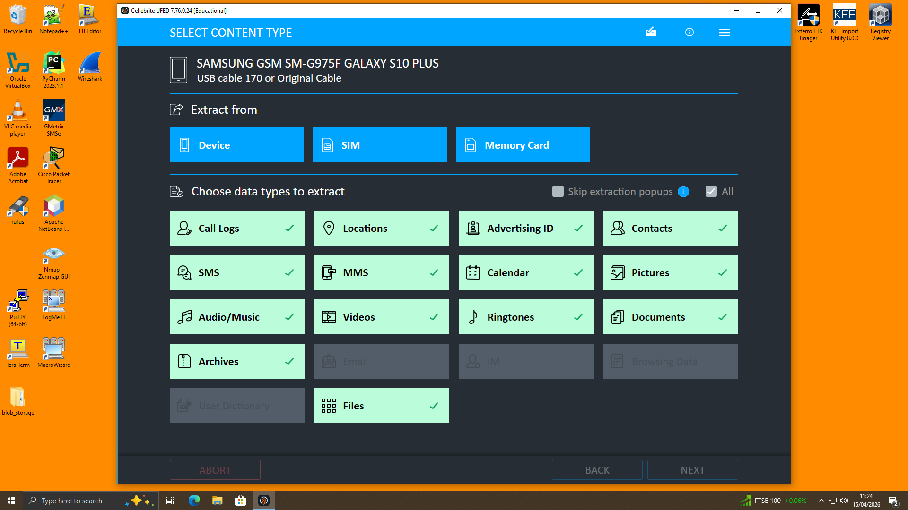
A digital evidence, each item, was given a unique identifier to facilitate traceability and avoid ambiguity when it was being investigated. The devices were labelled as E-001 (Samsung Galaxy S10plus), E-002 (SanDisk USB Drive), J-001 (iPhone 13), and N-001 (Google Pixel 6). All the documentation, log and analysis outputs were all done using all these identifiers. Other metadata that were documented were date, time and the investigator in charge of the seizure during the time. Labelling also plays a crucial role in that it facilitates the ability to trace all the pieces of evidence in the investigation. This methodical procedure reduces the chances of misidentification or loss, hence enhancing the reliability and credibility of the forensic results.

2.3 Evidence Collection Procedures

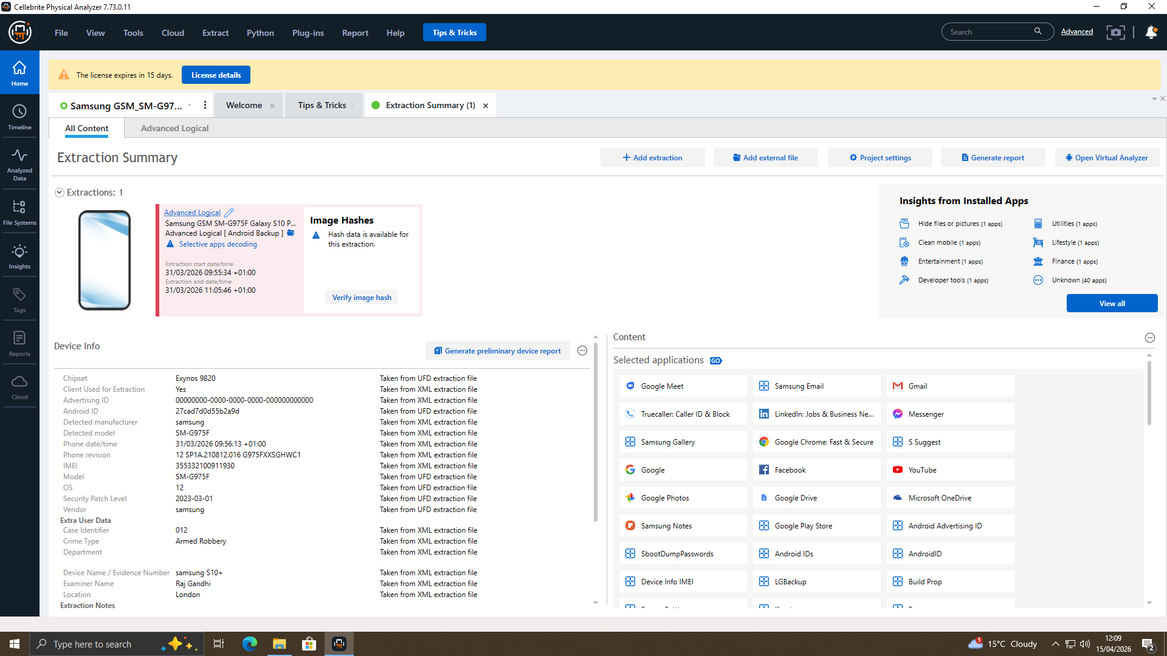
All the digital devices were collected in their original condition and photographed. This precaution upholds the contextual data and assists in defending the investigation. The researchers were thoroughly dressed in protective gloves to prevent any contamination and worked cautiously with gadgets, preventing any physical or digital interference. When cell phones were confiscated, Faraday bags were put there, blocking any outside network connection and depriving the phone of the capability to be contacted or manipulated remotely. The devices were then appropriately packed, labelled, and recorded into the evidence register. These processes also allowed the integrity of the evidence to be upheld due to the time of collection.

2.4 Evidence Transportation
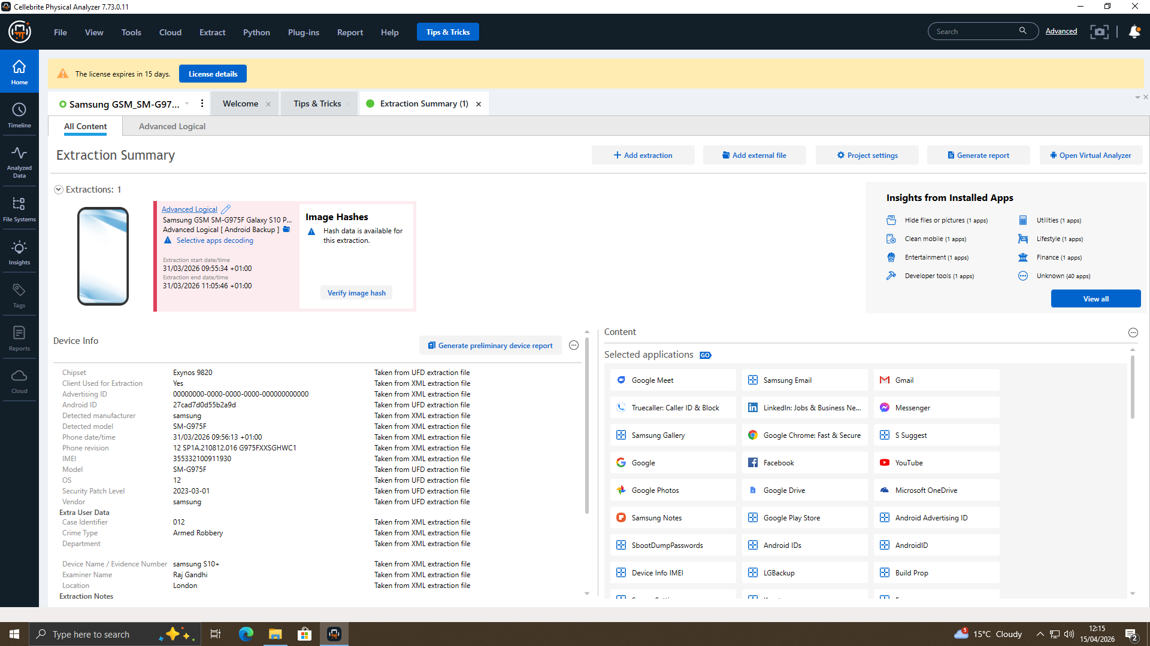
Tight control of evidence transportation was carried out to guarantee the integrity and accountability. The evidence was also transported to the forensic lab by the main investigator with an appointed witness. All the materials were placed in the labelled Faraday bags during transit. A comprehensive custody log was kept, which contained transfer times, dates and signatures of all concerned. Such a dual control will minimise the chances of tampering and promote transparency. To ensure continuity in the chain of custody and ensure that the evidence is legally admissible, proper transportation procedures are needed.

2.5 Evidence Storage and Security
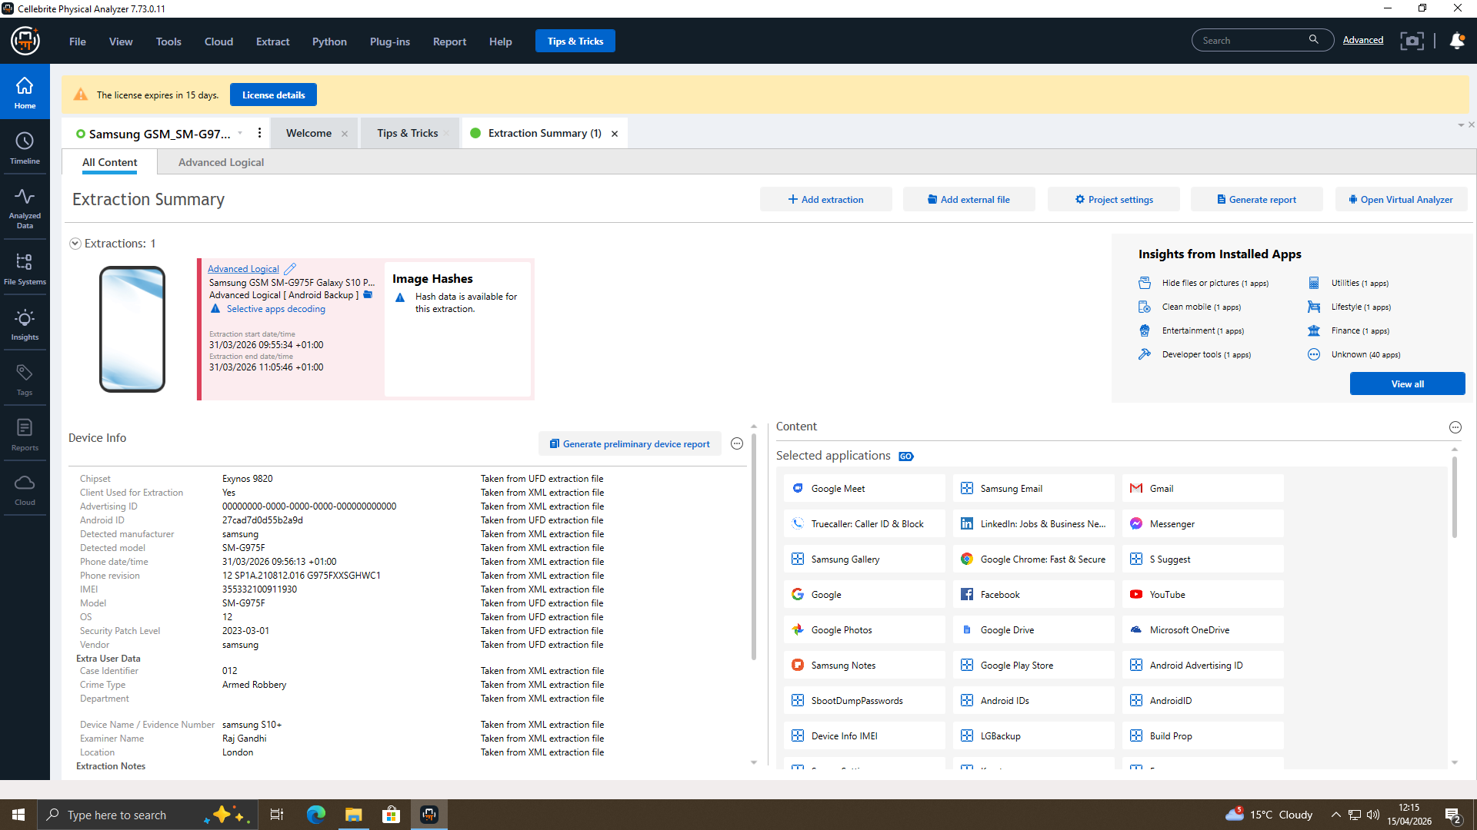
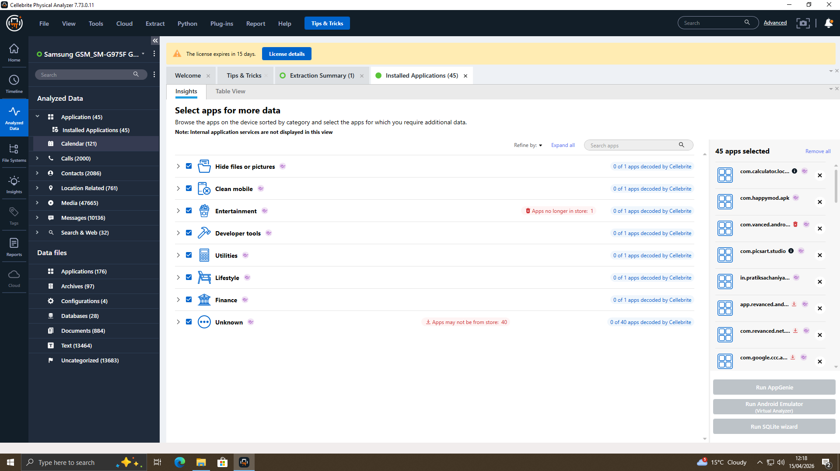
All the evidence was attached to an integrated security storage system and locked up in a restricted-access space when it arrived at the forensic laboratory. It has biometric identification, CCTV cameras and security access features to curb the access of unauthorised individuals. They also took care of the environment such that temperature and humidity are maintained at a low level in order to make sure that the electronic equipment is not damaged. The possibility of tracing the evidence in detail was achieved as every access was recorded in an audit log. These security measures play a vital role in maintaining the evidential value and make sure that the evidence is not destroyed during an investigation.

2.6 Write Protection and Data Integrity
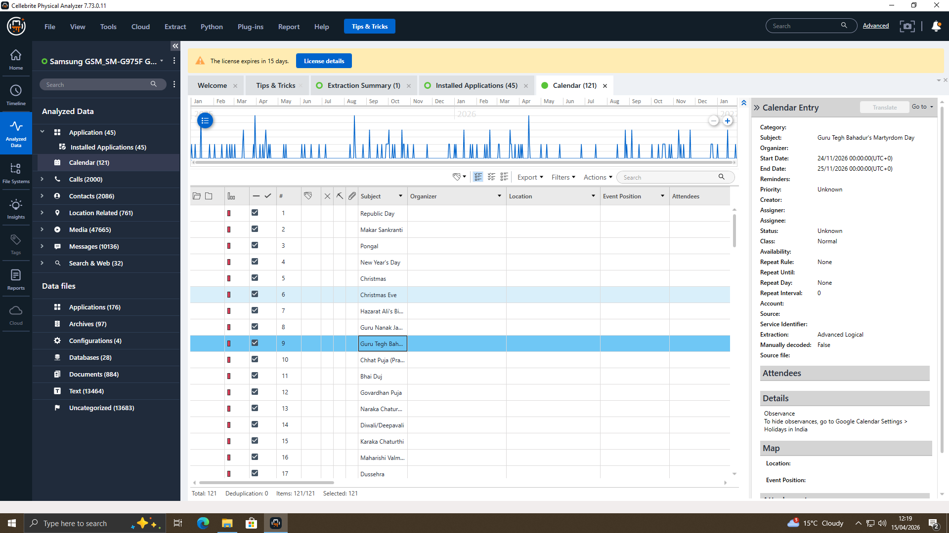
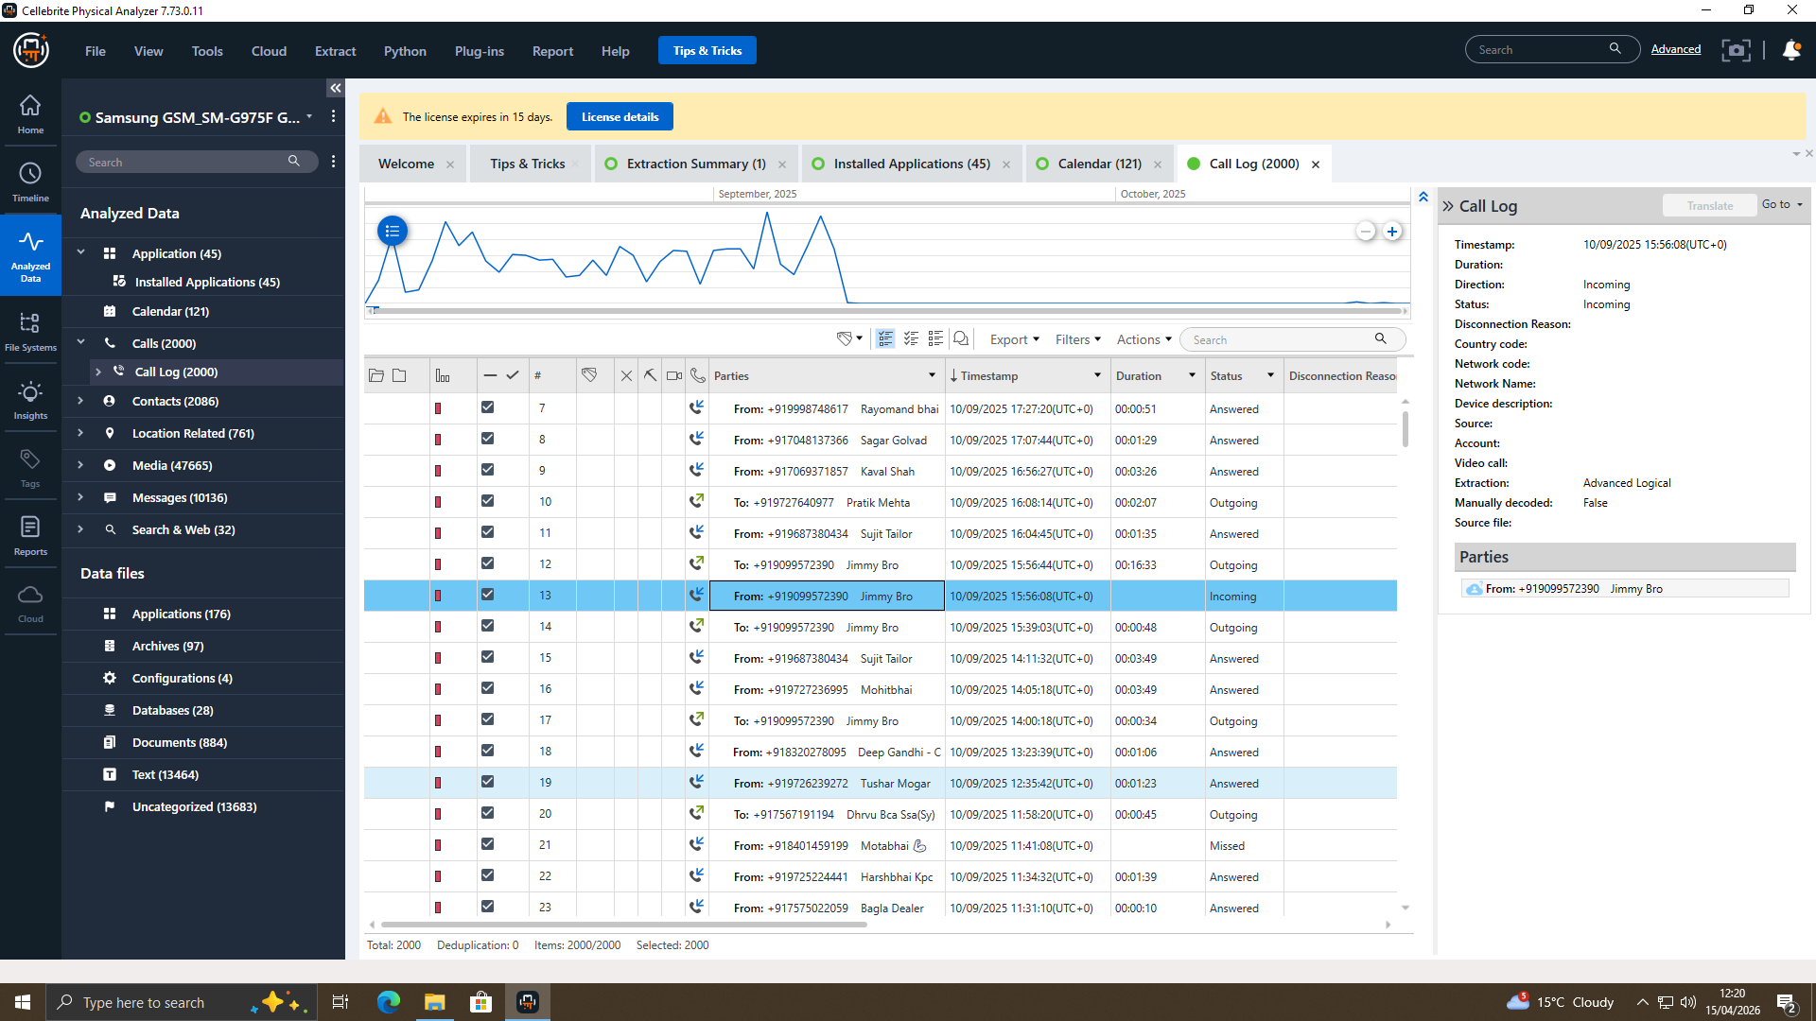
Acquisition of original evidence involved write protection to ensure that there was no tampering with the evidence. In imaging the USB device, a hardware write blocker was applied, which did not allow any changes to be made to the original data. Also, before and after data acquisition, cryptographic hash values (SHA-256) were calculated. The fact that the hash values were similar also ensured that the integrity of the data was not breached in the process. The hash values are defined as a computerised fingerprint, meaning that there has been no alteration made. This is one of the measures to provide the authenticity and admissibility of electronic evidence in the court.

3. Methodology and Tools

3.1 Forensic Methodology Overview
It involved a systematic forensic manner of conducting the research that was composed of preparation, procurement, analysis and validation. This practice of procedure brings about consistency, continuity and conformity with established forensic practices. Each of the stages is set in a way that it could not destroy the evidence, but could enable an in-depth investigation. The validity and admissibility of the findings will be increased by compliance with the predefined structures. The approach will also promote openness and minimise the chances of procedural failure, and the enquiry will be legally and technically valid.

3.2 Device Preparation
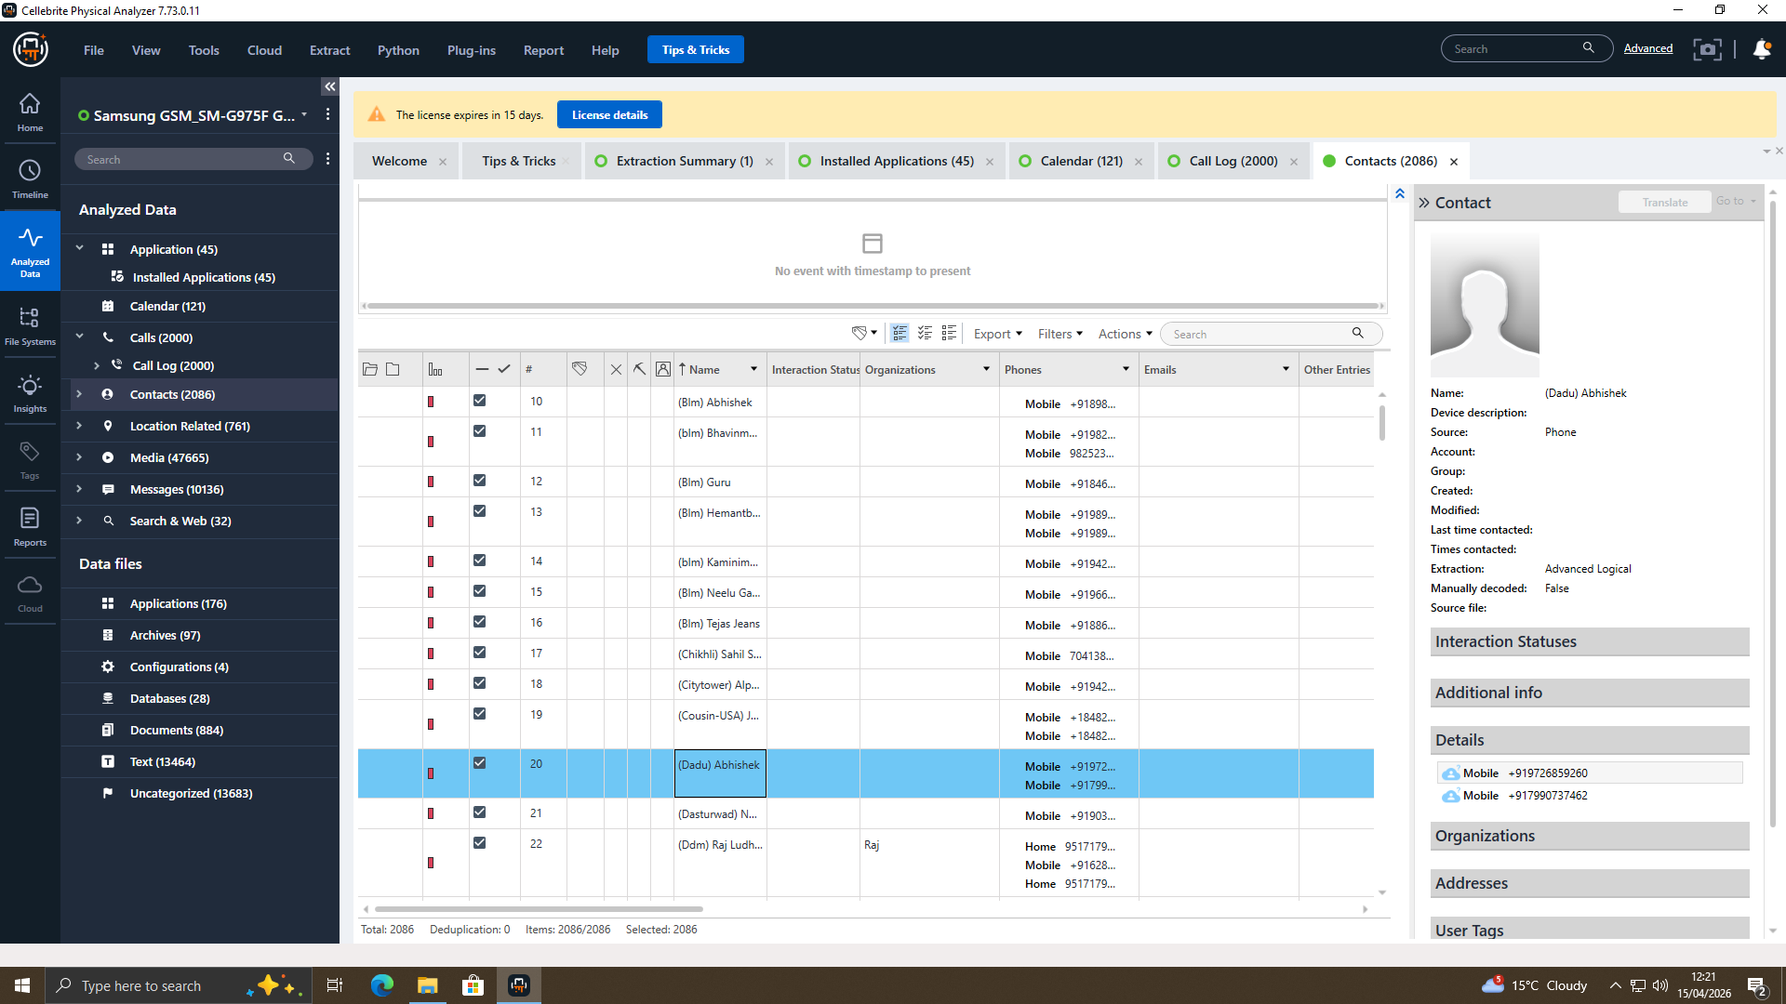
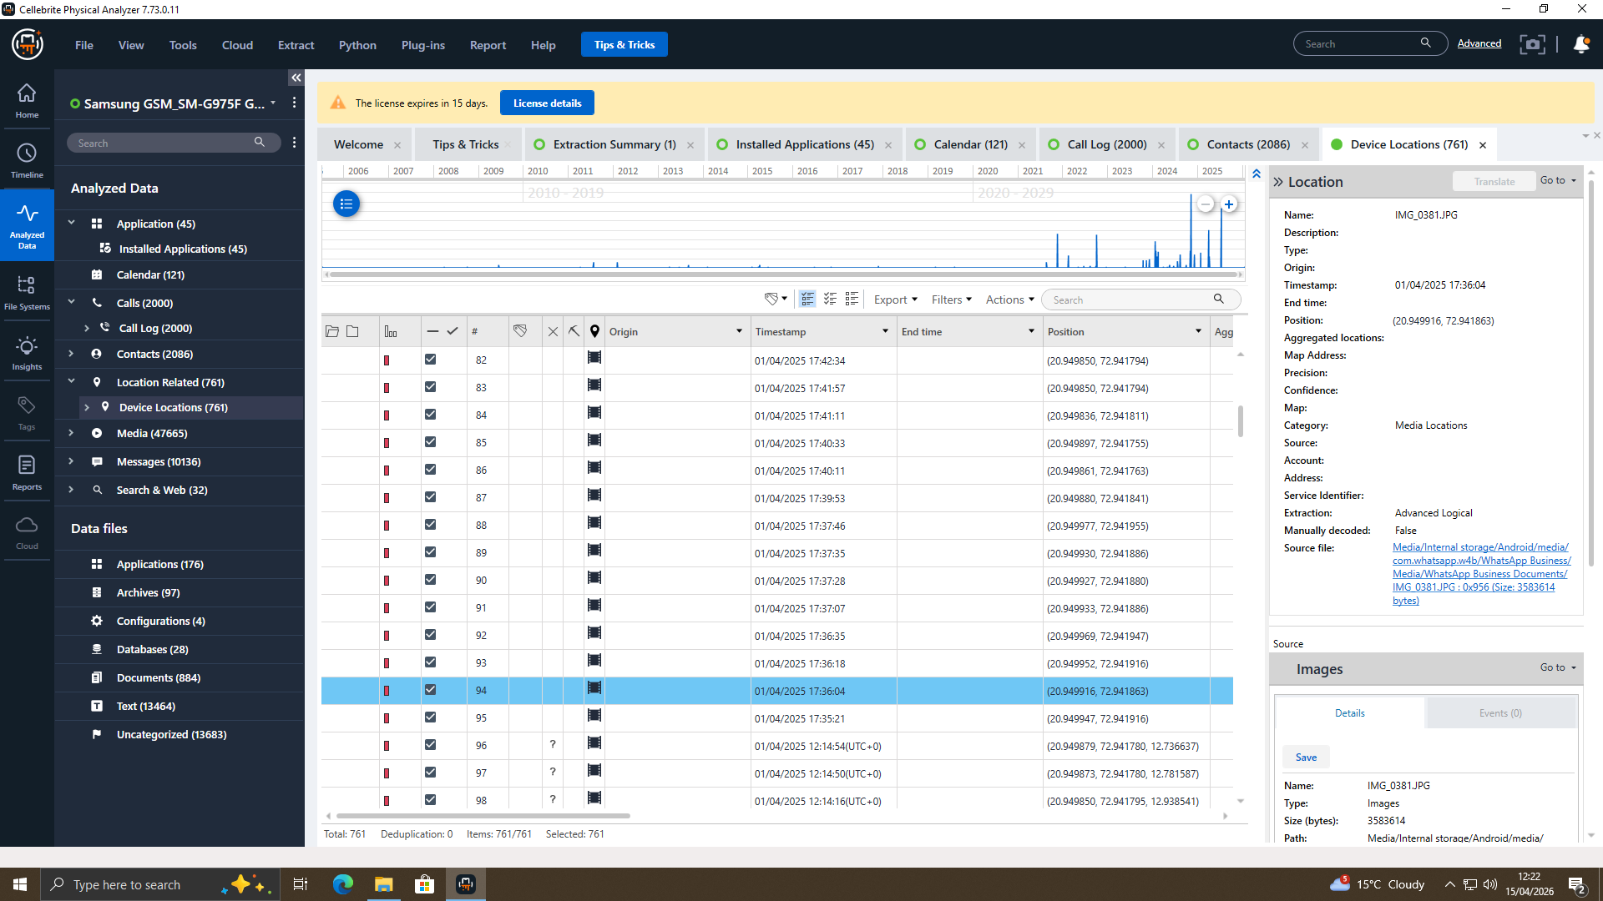
All the devices had been prepared before the data was recorded to prevent any extraneous interference and to keep them in their original condition. Aeroplane mode was turned on to block network access and prevent remote wiping or access. In the case of Android devices, USB debugging was turned on to be able to communicate with forensic tools. To guarantee transparency and reproducibility, these steps were captured in the form of screenshots. The preparation is essential since it will make sure that it will be able to extract data without interfering with the original contents. This step is essential because it will ensure that the integrity of the forensic process and its reliability are ensured.

3.3 Data Acquisition Techniques
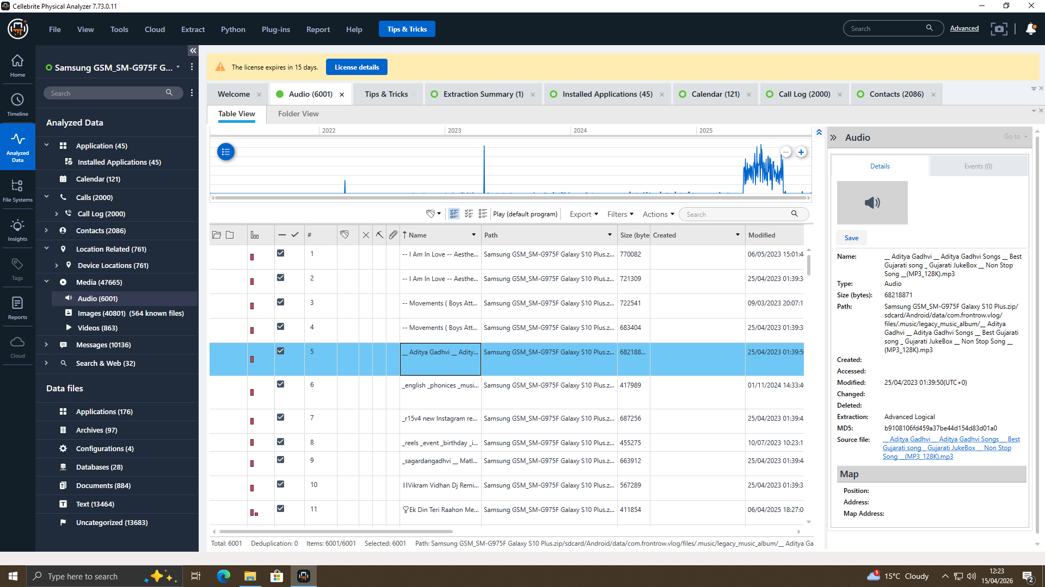
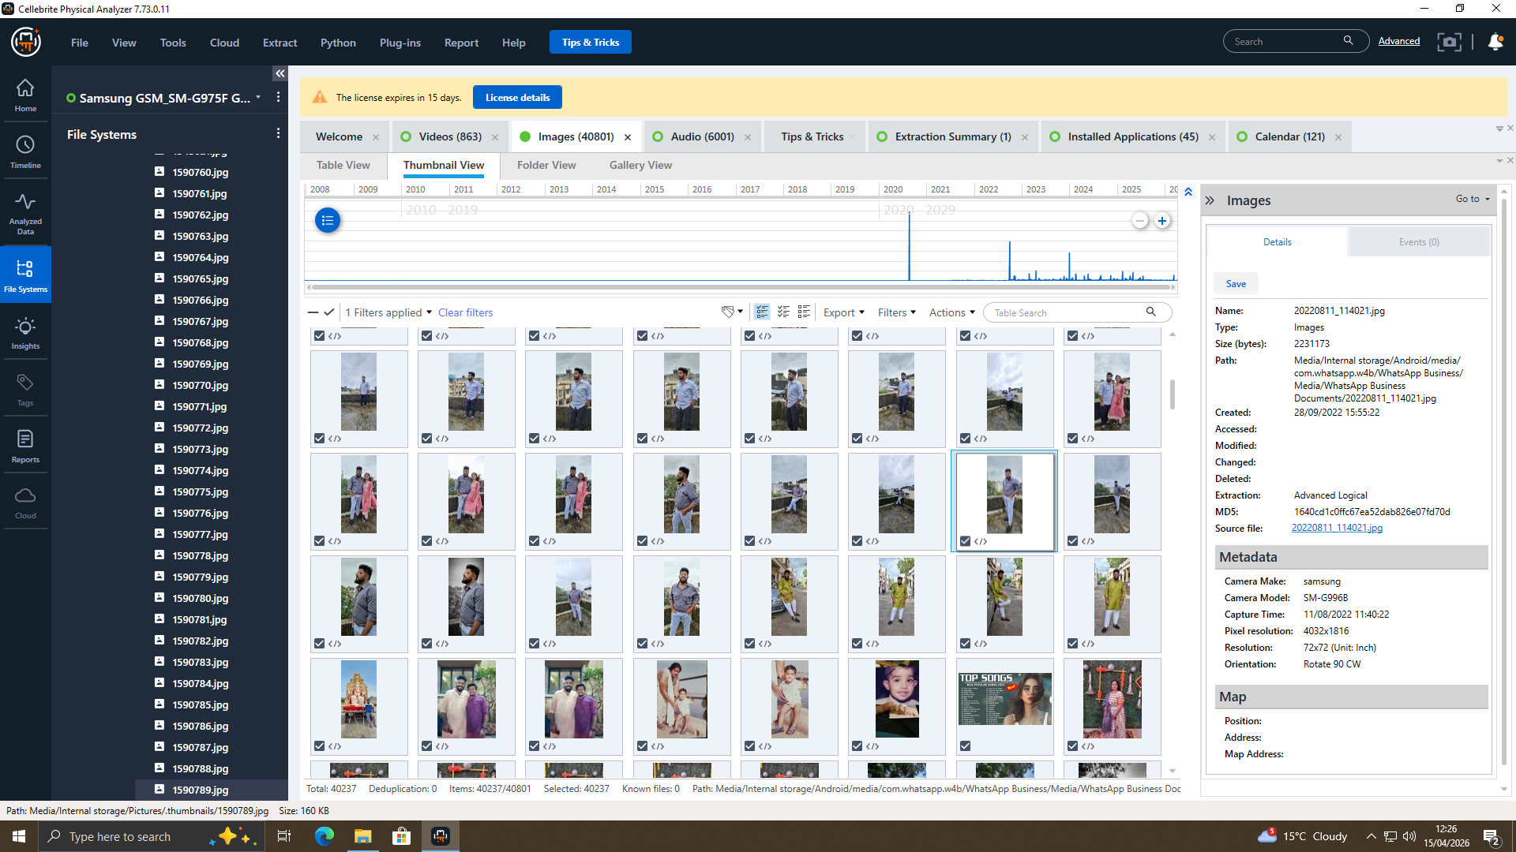
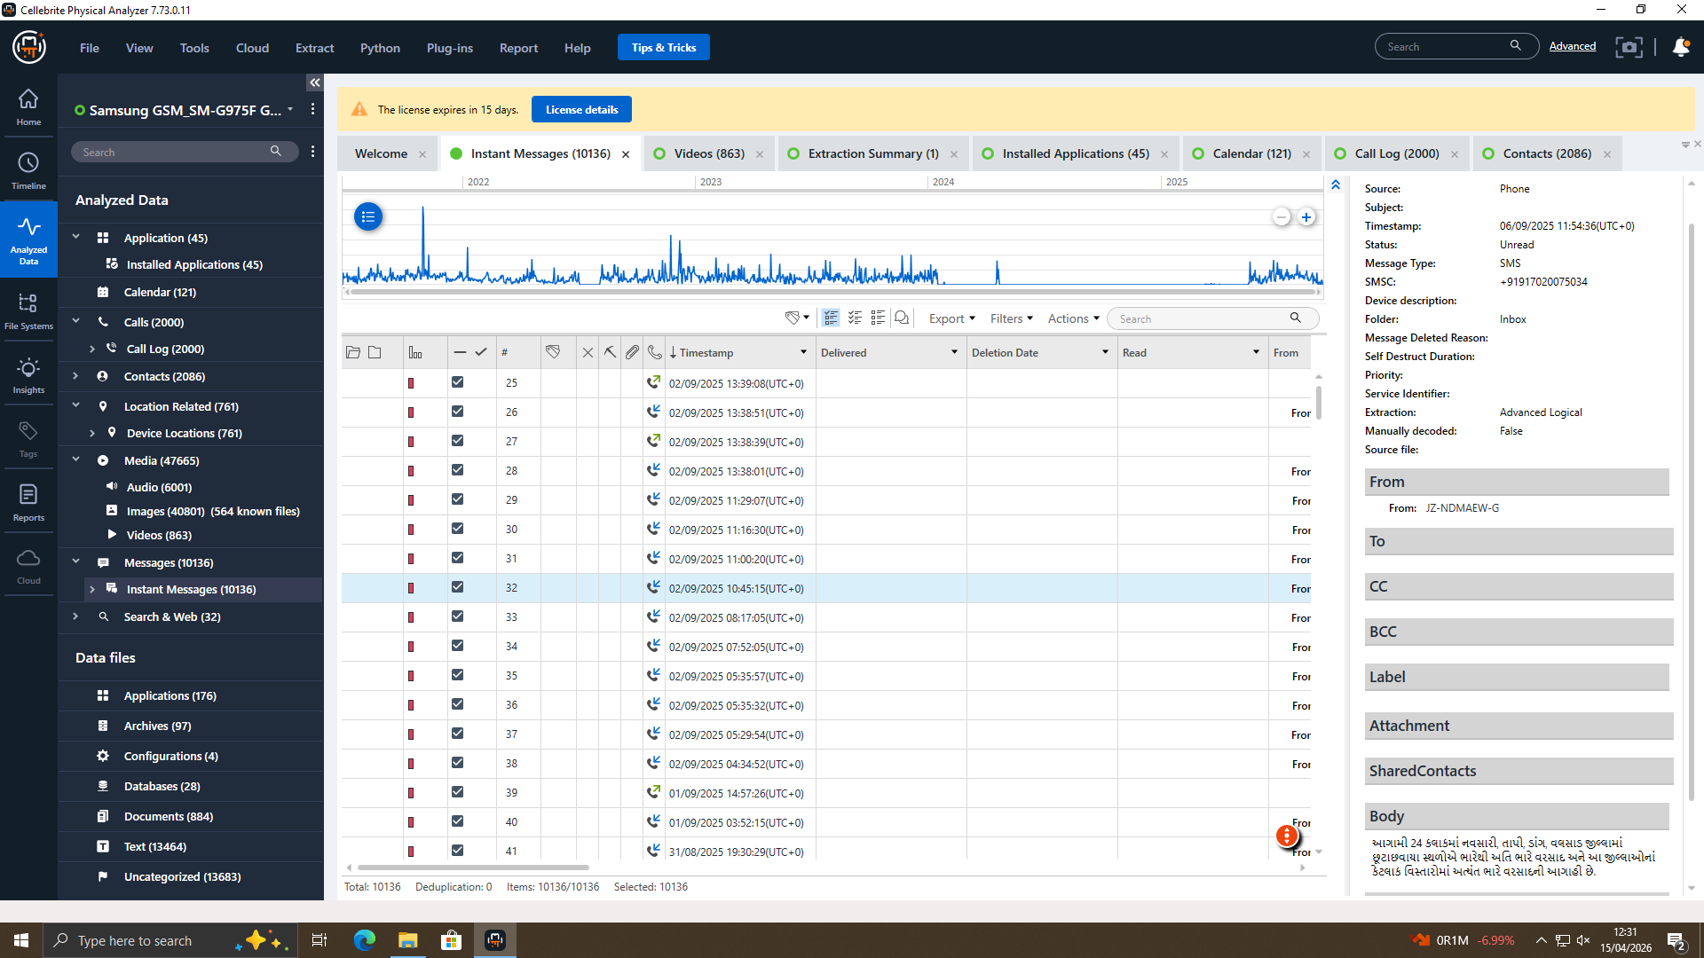
The industry-standard forensic tools were used to enable the data acquisition to be accurate and complete. Mobile devices were copied with the help of Cellebrite UFED, which has enabled one to gain access to logical and file system data. This enabled the retrieval of messages, call logs, contacts and application information. FTK Imager was used to image the USB drive, which produced a complete forensic image, with unallocated space to recover deleted files. To make the steps of the acquisition transparent, all the steps would be captured on screenshots. Validated tools are used to make sure that the data is gathered in a forensically sound way, not distorting the original evidence.

3.4 Forensic Analysis Tools
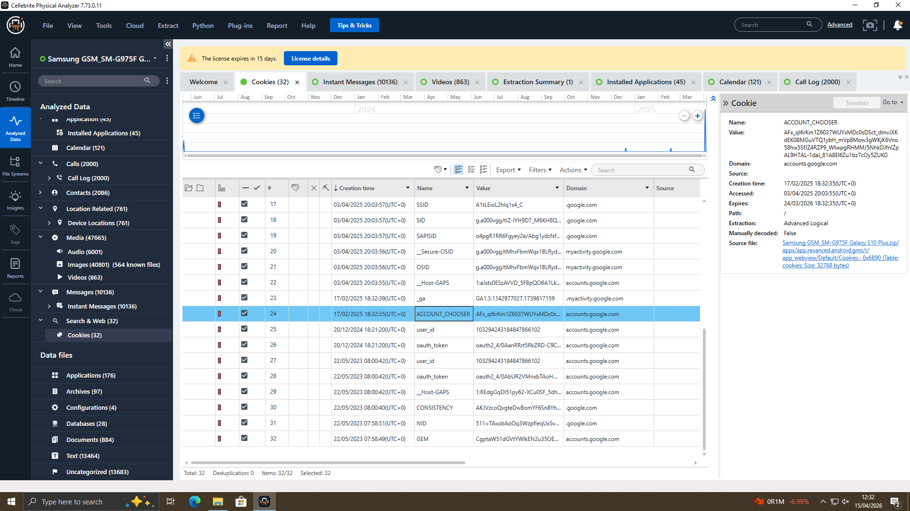
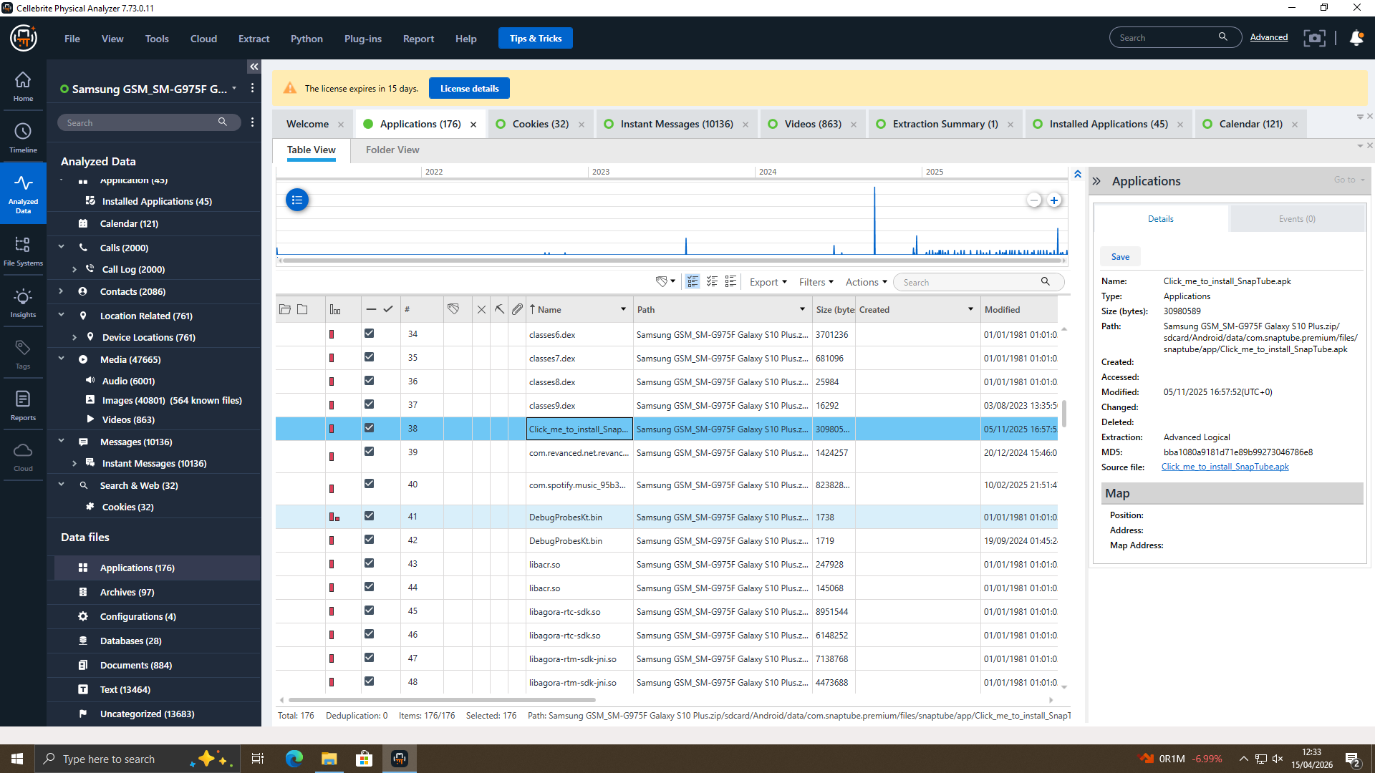
Data were analysed with the help of a combination of different forensic tools to cross-verify results. The digital artefacts were also extracted and analysed using such tools as Magnet AXIOM, Autopsy, and Cellebrite Physical Analyser. These tools assisted in restoring deleted files, evaluating communication information, and metadata mining. A keyword search was used to get relevant information related to the investigation. This makes it more reliable as it can be checked with other tools and increases the accuracy, and, consequently, the quality of the analysis, along with its credibility.

3.5 Verification and Validation
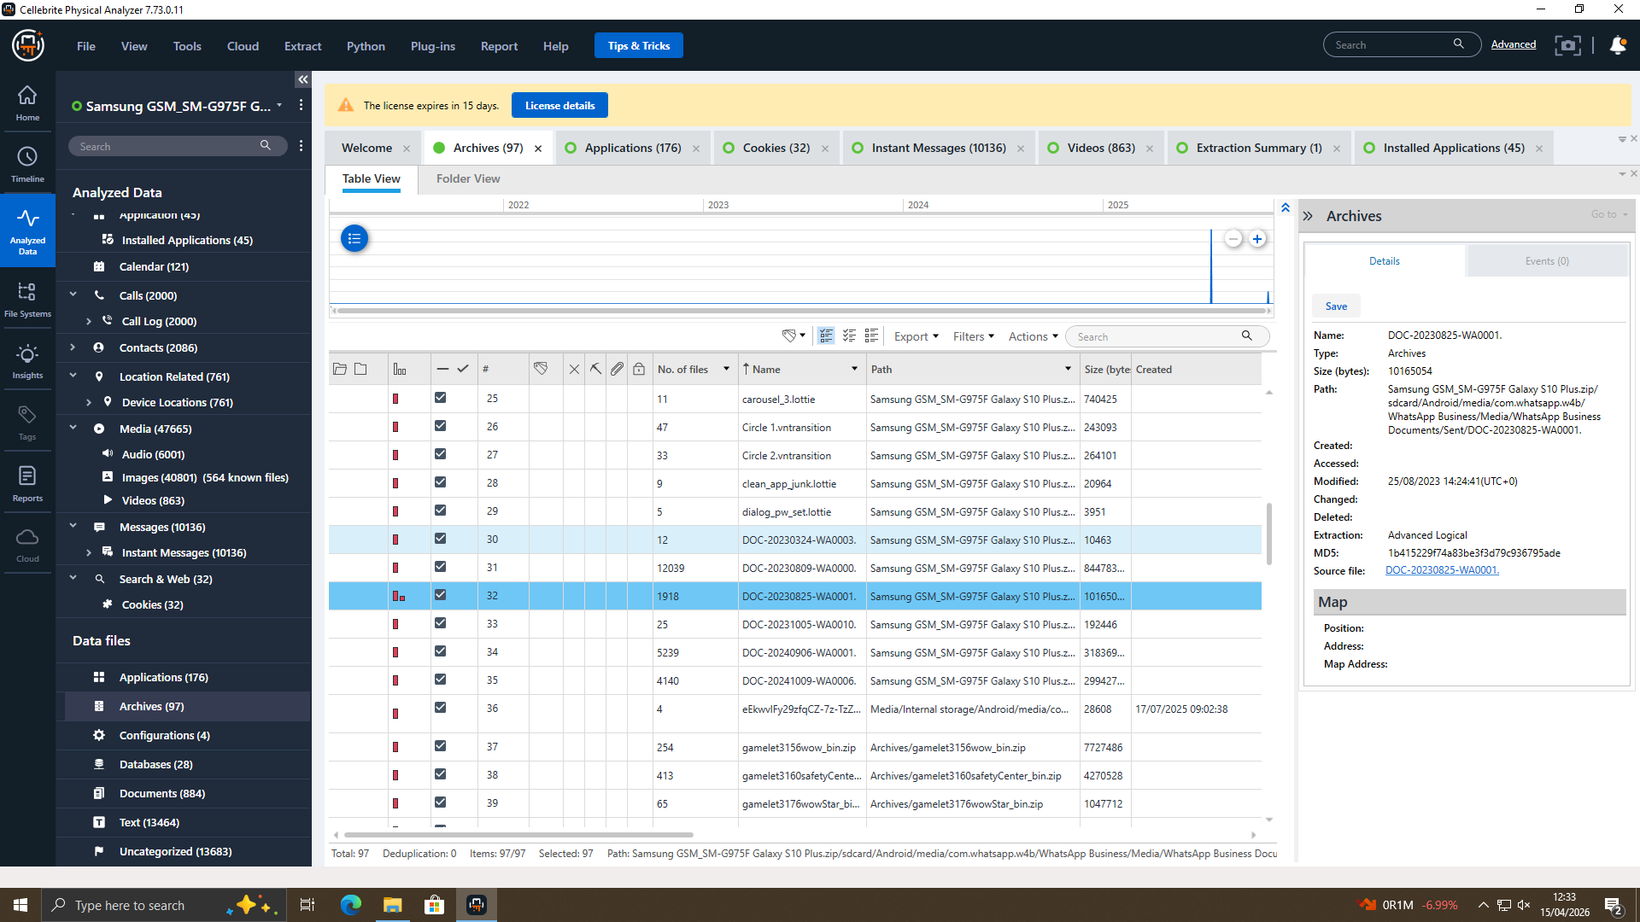
Confirmation is an important step in the establishment of the authenticity of digital evidence. Pre-acquisition and post-acquisition computation of the values of the SHA-256 hash were done to guarantee the integrity of the data. Equal hash values would show that nothing has been done to the evidence. The check and confirmation of the reliability of the findings is graphically presented with screenshots of verification of hashes. This will make sure that the forensic best practices are followed, and the evidence will be more acceptable in court. Checking will ensure that everything is drawn based on valid and untouched data.

4. Findings

4.1 Communication Analysis
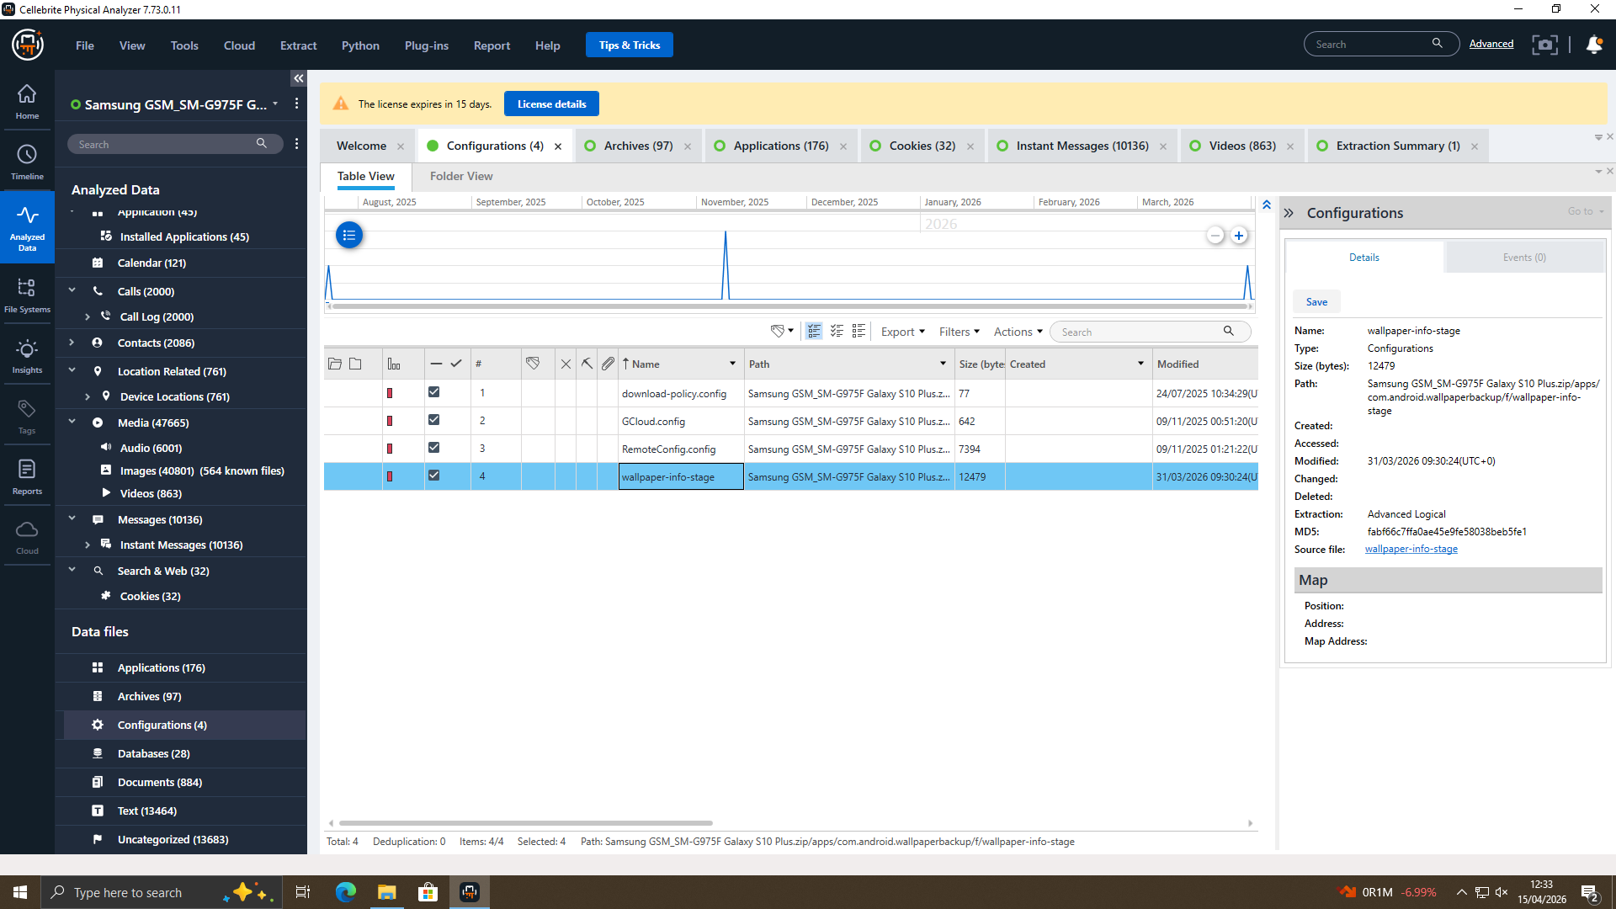
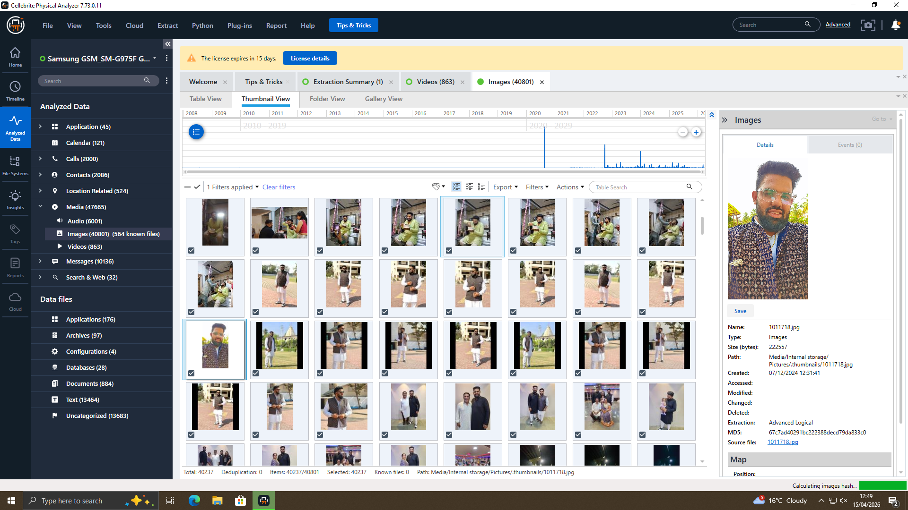
The data analysis, in terms of communication, showed that the suspects were well organised in their activities; this is a potent consideration when it comes to the suspects being involved in corporate spying. The messages obtained in digital media such as WhatsApp, Instagram and email proved invaluable in providing an insight into the nature and extent of their activities. This information was shared and transferred through the messages and contained confidential and sensitive organisational information discussions. The nature of these messages shows that there is an intention, planning and even appreciation of the legality of their acts.
The further examination of the patterns of communication showed that there was an organised and systematised way of doing things, in that the individuals were not acting randomly but as a team acting in a well-coordinated activity. Researchers found that some roles were attributed to various individuals, whereby some of them initiated the contact, some of them improved the communication,n and some were involved in handling or transferring data. This division of work allows seeing that the activity was organised and structured.
The frequency and the time of the communications are also correlated to the other significant events, which are identified in the course of investigation, e.g., the access and transfer of data. This time association helps to support the validity of the results and testifies to the assumption that those messages were immediately connected with crime. The screenshots of graphs obtained are good evidence of such conversations, which are confirmed graphically.

4.2 Timeline Reconstruction
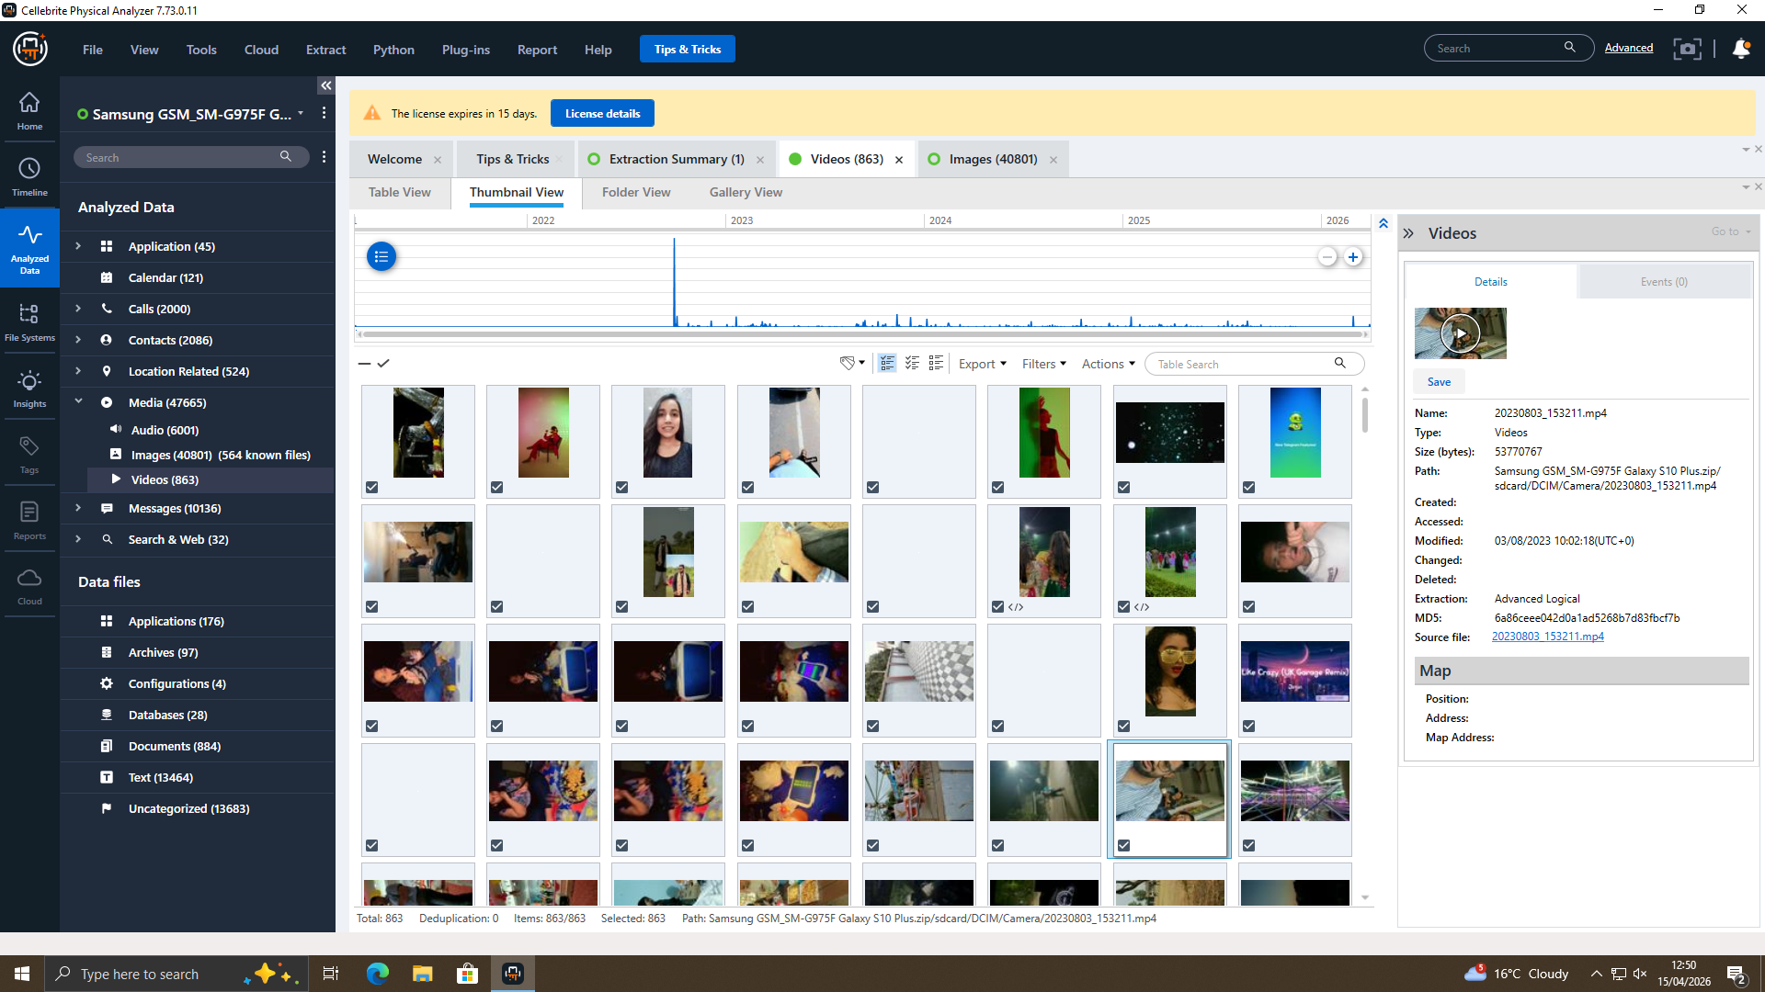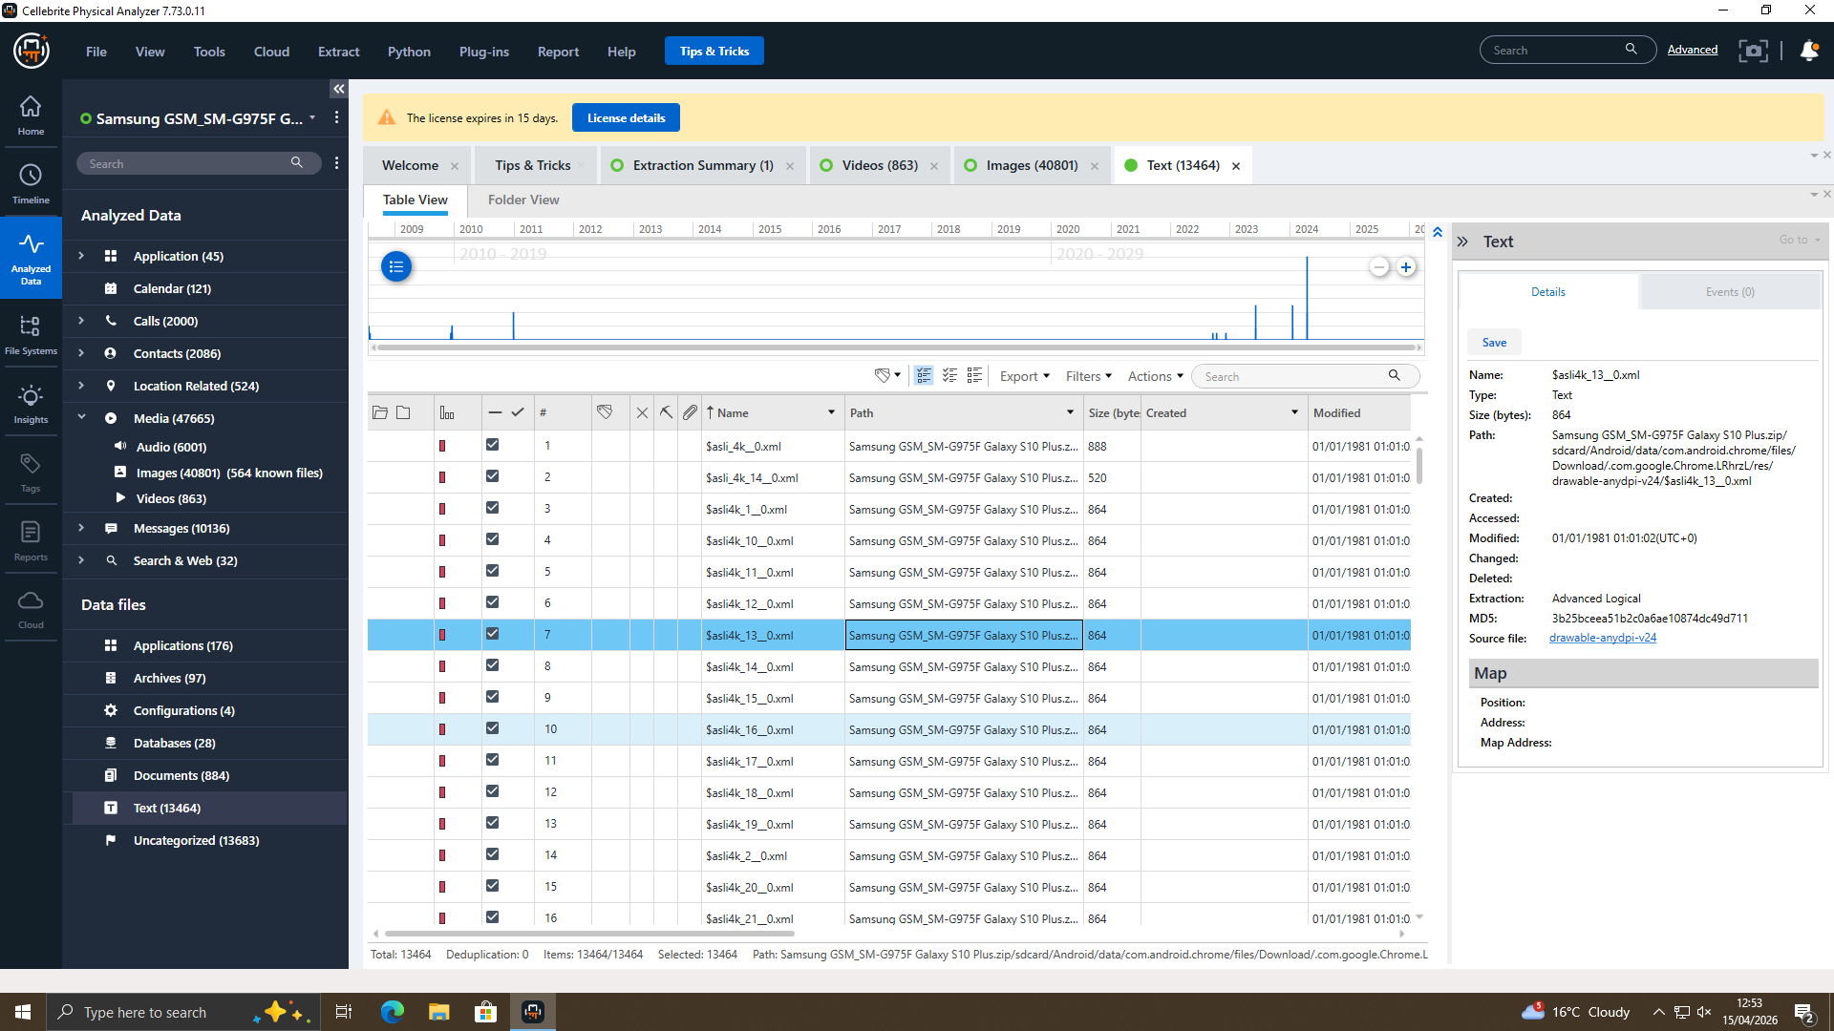
Correlation with the communication logs, metadata and system-generated recordings was done using information to create a complete sequence of events. The chronological order of the organisation of the key activities made it possible to identify and systematise the key activities, which allowed for a clear and organised picture of the flow of the events. The time would be when the suspect made the first contact on 1 st March, 2026, and it would then pass through various stages such as the negotiation, coordination and eventually transfer of data.
The probe was also at a position to establish uniformity and truth within the chronology of events by tallying timestamps of different independent sources. This form of cross-referencing allows timeline reliability and minimises the possibility of misinterpretations. The milestones, like the interaction of communications, the access to files and the interaction of different devices, were correctly matched with the particular moments in time. Such a detail is a good background for the context and allows the investigators to visualise the occurrence of the criminal activity.
Of special importance to digital forensics is timeline reconstruction, which assists in making cause-and-effect relationships between various actions. As an example, the communication between suspects can be directly associated with the following data access or sending events, or it can prove the evident association of the planning and the execution. The other source of supporting evidence of coordinated behaviour in this research is the correspondence between records of communication and technical artefacts, such as system logs and file metadata.
In addition, the time frame also highlights the level of organisation and planning of the incident. The methodical implementation of the activities indicates that the suspects must have realised the activities they were involved in, and they had to perform them consistently and within a given time frame. This provides an added validity to the premeditation and wrongful intent.

4.3 USB Drive Evidence
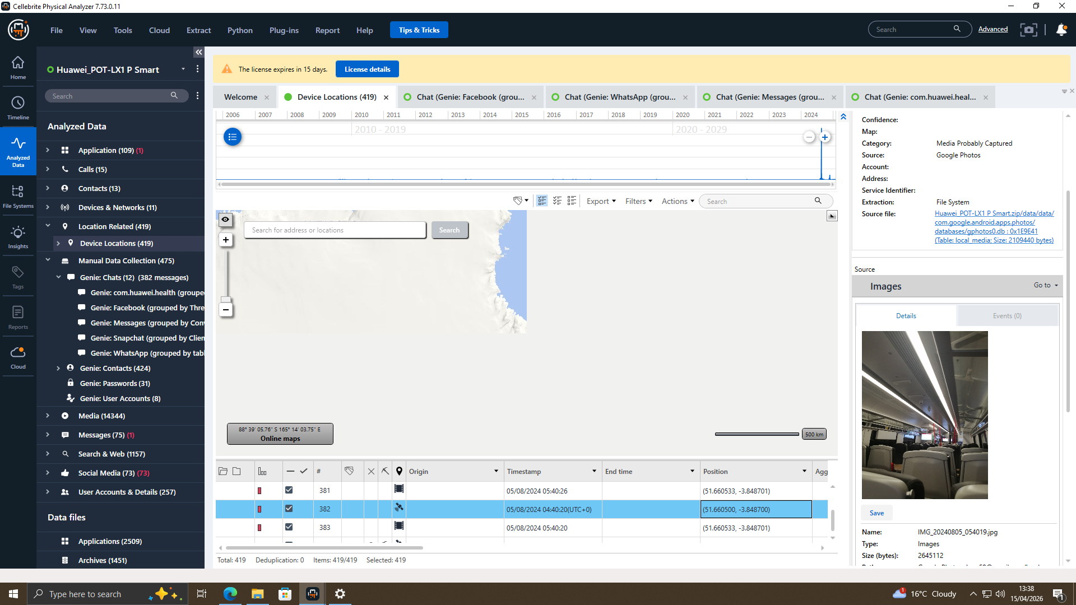
The forensic analysis of the USB drive indicated that there was substantial evidence of the use of this disk in the unlawful exchange of confidential information. The device was analyzed and it was found that the device contained multiple files that contained confidential intellectual property, which indicated that the device was used as a storage device in data exfiltration. These were very valuable files to the organisation, which only served to aggravate the incident.
The files had metadata that further enlightened us about the origin and point of the files. The timestamps existed to show that files have been created, changed and accessed in a rather limited time interval. This inclination is very indicative of a deliberate emulation, rather than a common habit. This can be compared to data exfiltration, where the information is quickly moved in such a way that it becomes unnoticed.
Moreover, the fact that the files connected with the encryption were also contained in the USB reveals that the user has sought to ensure that the information and its inapplicability to unauthorised individuals are secure. This shows there was, to some extent, a sense of technical awareness and motivation to conceal the activity and also proves that actions are not spontaneous but predetermined. The encryption would also mean that the individuals involved had a hint as to what might have happened and had tried to minimise the chances of capture.
The results of the USB analysis were further confirmed by correlations with system logs, which validated the introduction and use of the device at a certain time. These times were the same as those of the file metadata, which directly linked the device and the activities of the suspect. This makes a very strong case and solid evidence that the USB drive was not in a legal transfer of data.

4.4 Call Log Correlation
Another useful piece of corroborating evidence that incriminated the suspects and that there was indeed organised action was the analysis of the call logs. The analysis conducted on the call records showed that out of the two individuals, there were several interactions between them, including a very critical phone call of 22 minutes. They were frequent and lengthy calls that suggested that it was not a casual discussion but an intentional one, and concerned the activities that were being studied.
The additional examination of the position data of the calls related to these calls showed that the subjects were very near to one another on a few of these calls. This territorial connection not only confirms the hypothesis of close coordination but also the requirement in the argument that the suspects were indeed actively coordinating. This is because when the sum of the time of the calls is pooled, the frequency and the location information it gives us, we find a more detailed concept of how people communicate.
Interestingly, the time of these calls can also be put in the context of the key milestones in the timeline, which may also be reconstructed (the time when data was retrieved and transferred). This synchronised time would mean that some of the operations could have been scheduled to be done via telephone calls, like the movement or manipulation of some sensitive information. This is essential in investigations of digital forensics because such correlations can be used to create a clear linkage between the communication and latter operations.
The analysis of call logs is especially beneficial as it gives another layer of evidence on top of digital messaging services. The provenance of calls, when contrasted with the content of communications created by the likes of WhatsApp and email, will provide a purely independent affirmation of the communication between suspected persons, whereas communications created due to the use of the apps may be used to affirm intent and planning. The multiple-channel evidence approach improves the validity of the findings.
Additionally, the homogeneity of the call logs, the communication logs and timeline data depicts that a scheme of continuous communication and collaboration existed. What this trend denotes is that the suspects were not engaged in isolated or spontaneous actions but in a long-term and organised activity. This implies that the correlation of the call logs is important in establishing the connection between the suspects, along with the coordination of the operations of the suspects.

4.5 Web Search Evidence
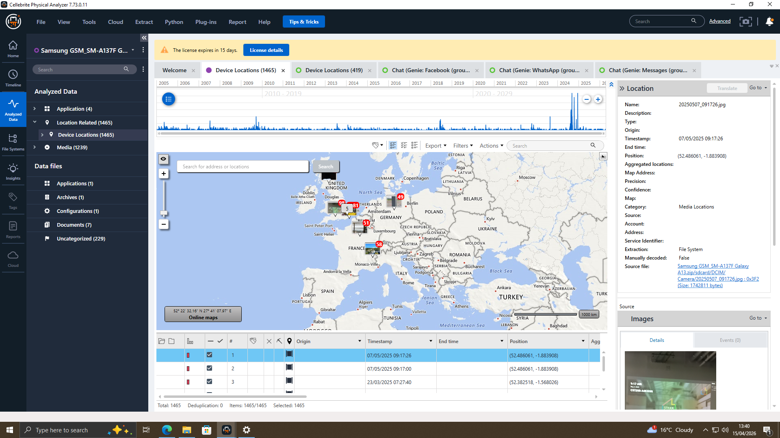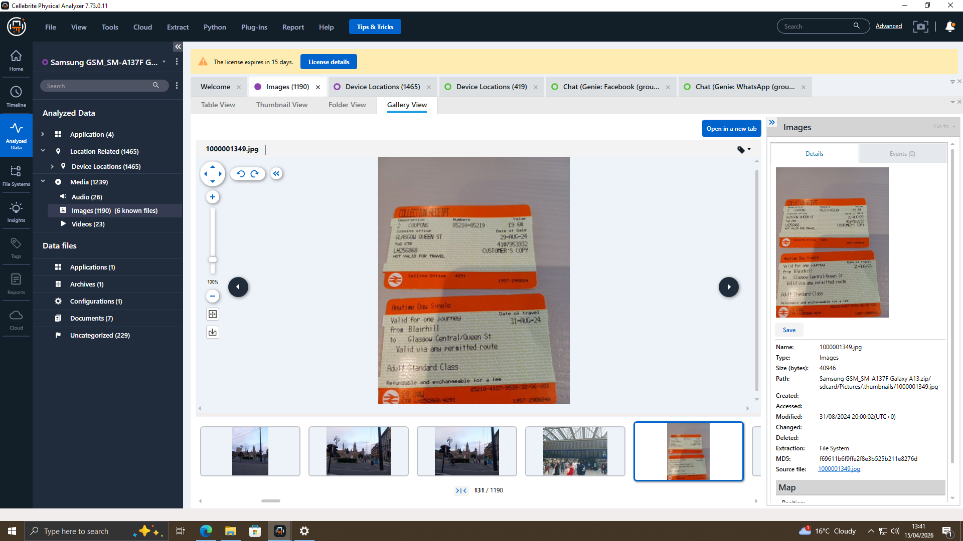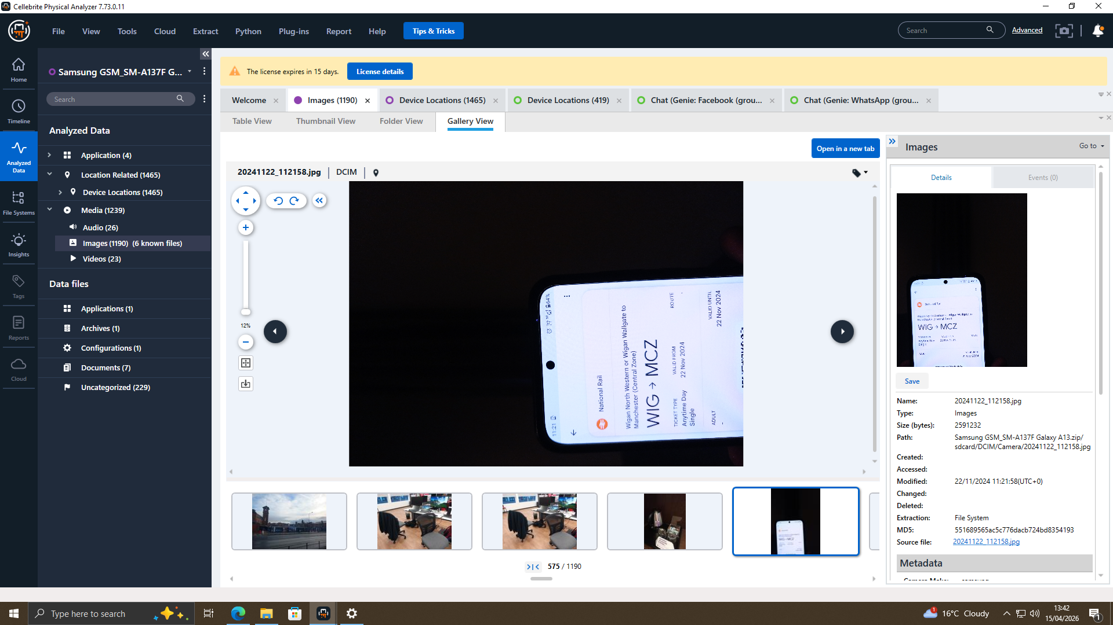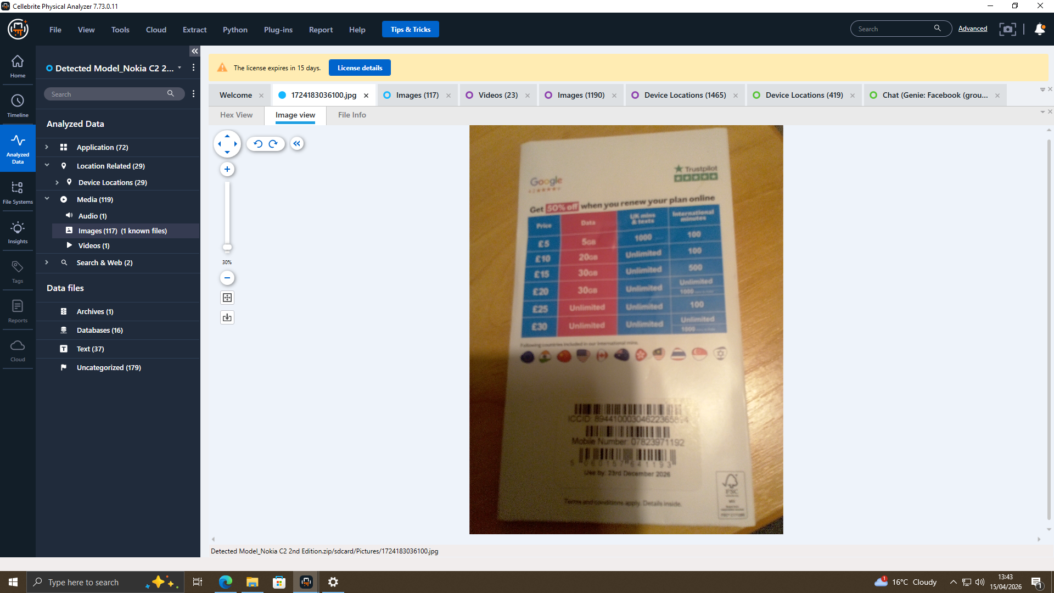
The interpretation of the browser history proved useful about the behaviour, intention and thinking of the suspect. Web search activity was reviewed and it was discovered that the user performed a sequence of web searches depending on how to avoid being detected and information on how to conduct a forensic investigation. The keywords found were as follows: the encryption method, audit trails and the legal implications of corporate espionage.
These search requests are also significant since it is an indication of awareness and premeditation. The searches do not seem to be incidental or unrelated, but seem to be directly related to the actions being executed in the course of the incident. The fact that problems like encryption are in focus indicates that the suspect was busy with how the information could be defended/hidden, but the searches, which are connected with the forensic investigations, presuppose that the suspect was trying to discover how the activities could be tracked.
This kind of behaviour presents a good case to suggest that this was an intentional and calculated move and not an accident. Digital search The digital forensics of the sphere of digital search might arrive at inferences regarding the mind and intent of an individual, relying on the evidence of web search. The nature of the searches in this case implies that the suspect was aware of the potential risks and legal repercussions of their activity, and did not take action anyway.
Secondly, the timeliness of the searches is another contribution to the relevance of the searches. Since the searches might have been done before or on the most significant events that are found in the timeline, it is possible that the searches were closely connected with the planning and execution of the incident. This time relationship lends credence to the opinion that the searches were conducted before or to assist in an unlawful act.
Web searches can also be useful to furnish other electronic evidence, like communication records and file examination. Compared to communication data, which gives first-hand information on how the suspects communicated, file analysis data on how sensitive data was handled, and web searches can provide answers to how and why the suspects were handling sensitive data the way they did. A combination of both behavioural and technical evidence results in a more precise picture of the incident.

4.6 System Log Correlation
Analysis of system logs did have strong and objective technical evidence indicating that the suspect had been involved in carrying out USB device and data transfer activities. The system produced logs of vital actions, including USB insertion, file and timestamp access, all essential in creating a believable sequence of action. This type of log is automatically generated by the operating system, and for this reason, it is very reliable and therefore cannot easily be manipulated.
What was found is that the events of USB insertion were directly linked to when the USB metadata took place. Thereafter, this correlation creates a definite and objective connection between the actual use of the device and files on the device. In addition, the files' access logs indicated that sensitive information was accessed, copied or modified at the same time frames, which also helped to prove the connection between the suspect and exfiltration of the data.
One of the strongest aspects of the system log evidence is objectivity. The system logs are also generated automatically, and these messages will give an objective report of the system activity as opposed to user-generated data, e.g. messaging or documents. This renders them extremely handy in forensic investigation, as they may be used to either give credence to other kinds of evidence or discount them.

5. Conclusion

5.1 Summary of Findings
The case provides a lot of evidence to prove that there is indeed corporate espionage by several people. A written or oral account of communication, history of the system, and file examination will result in an intent, organisation, and commission of the crime. Each of the evidence types reinforces the others, and the storyline of the evidence is composed of a consistent and logical progression. The validated methodologies and forensic tools are such that the results obtained are accurate, reliable and defensible before the law. In general, the investigation is effective in determining the activities and interactions which caused the illegal transfer of confidential data.

5.2 Attribution of Responsibility
According to the analysis, Emma Reynolds is the crucial person who is involved in accessing and copying confidential information. Joe Martinez also acted the role of a middleman, who communicated and coordinated. The target of the stolen information is called Norman Blake. There was a particular task for everyone. Several sources of evidence, such as system logs, communications records and metadata, are used as the basis to support the attribution. The multi-source validation method makes sure that this validates the inferences drawn.

6. Recommendations

6.1 Technical Recommendations
Organisations must make sure that they have installed strong technical measures in order to avoid the exfiltration of data. It contains the limitation on using USB, the establishment of data loss prevention and the increase of real-time monitoring of the user actions. Strong authentication mechanisms, including multi-factor authentication. These are set to minimise the chances of unauthorised access and enhance the overall system security.

6.2 Organisational Recommendations
The access control and security audit should be performed regularly in order to detect any vulnerabilities. The organisations ought to possess strict data handling policies and accountability of the employees. When there is a need, disciplinary measures need to be implemented to defend organisational integrity. To prevent insider threats, a culture of security awareness must be encouraged.

6.3 Legal and Training Recommendations
The prosecutors should prosecute the people involved in the incident, criminally and civilly. Besides, it is recommended that data security, ethical practices and legal responsibilities training should be conducted in organisations regularly. The awareness among employees is critical towards averting security breaches. Legal enforcement and continuous training are the key elements to a holistic approach to organisational security.

References
Abdel-Fattah, F., Fayyad, S., Heyari, A.M. and Al-Zoubi, H., 2023, August. A survey of Internet of Things (IoT) forensics frameworks and challenges. In 2023 International Conference on Information Technology (ICIT) (pp. 373-377). IEEE.
Akbarfam, A.J., Dorai, G. and Maleki, H., 2024, October. Secure cross-chain provenance for digital forensics collaboration. In 2024 IEEE 6th International Conference on Trust, Privacy and Security in Intelligent Systems, and Applications (TPS-ISA) (pp. 389-398). IEEE.
Alazab, M., Abu Khurma, R., Awajan, A. and Wedyan, M., 2022. Digital forensics classification based on a hybrid neural network and the salp swarm algorithm. Electronics, 11(12), p.1903.
Bhandari, S., 2022. Research and implementation of timeline analysis method for digital forensics evidence (Doctoral dissertation, Kauno technologijos universitetas.).
Choi, K.S., Back, S. and Toro-Allvarez, M.M., 2023. Digital forensics and cyber investigation. San Diego, CA: Cognella.
Dimitriadis, A., Lontzetidis, E., Kulvatunyou, B., Ivezic, N., Gritzalis, D. and Mavridis, I., 2022. Fronesis: Digital forensics-based early detection of ongoing cyber-attacks. IEEE Access, 11, pp.728-743.
Grajeda, C., Berrios, J., Benzo, S., Ogunwobi, E. and Baggili, I., 2023. Expanding digital forensics education with artifact curation and scalable, accessible exercises via the Artefact Genome Project. Forensic Science International: Digital Investigation, 45, p.301566.
Hargreaves, C., Nelson, A. and Casey, E., 2024. An abstract model for digital forensic analysis tools: a foundation for systematic error mitigation analysis. Forensic Science International: Digital Investigation, 48, p.301679.
Harisha, A., Mishra, A. and Singh, C. eds., 2023. Advancements in cybercrime investigation and digital forensics. CRC Press.
Iqbal, S., Khan, W., Alothaim, A., Qamar, A., Alhudhaif, A. and Alsubai, S., 2022. Proving the reliability of image processing techniques in digital forensics applications. Security and Communication Networks, 2022(1), p.1322264.
Johnson, C., Davies, R. and Reddy, M., 2022. Using digital forensics in higher education to detect academic misconduct. International Journal for Educational Integrity, 18(1), p.12.
Kävrestad, J., Birath, M. and Clarke, N., 2024. Fundamentals of Digital Forensics: A Guide to Theory, Research and Applications. Springer Nature.
Khan, A.A., Chen, Y.L., Hajjej, F., Shaikh, A.A., Yang, J., Ku, C.S. y Por, L.Y., 2024. Digital forensics for the socio-cyber world (DF-SCW): A novel framework for deepfake multimedia investigation on social media platforms. Egyptian Informatics Journal, 27, p.100502.
Maratsi, M.I., Popov, O., Alexopoulos, C. and Charalabidis, Y., 2022, October. Ethical and legal aspects of digital forensics algorithms: the case of digital evidence acquisition. In Proceedings of the 15th International Conference on Theory and Practice of Electronic Governance (pp. 32-40).
Morgenstern, M., Fähndrich, J. and Honekamp, W., 2022. Ontology in the digital forensics domain: A scoping review. In INFORMATIK 2022 (pp. 71-80). Gesellschaft für Informatik, Bonn.
Raju, K.S., Ahila, R., Al-Farouni, M., Karuna, G., Yadav, K. and Kumar, N.S., 2024, November. A predictive analytics approach to traceability in digital forensics using time series analysis. In 2024 International Conference on IoT, Communication and Automation Technology (ICICAT) (pp. 1178-1183). IEEE.
Scanlon, M., Breitinger, F., Hargreaves, C., Hilgert, J.N. and Sheppard, J., 2023. ChatGPT for digital forensic investigation: The good, the bad, and the unknown. Forensic Science International: Digital Investigation, 46, p.301609.
Solanke, A.A. and Biasiotti, M.A., 2022. Digital forensics AI: evaluating, standardising, and optimising digital evidence mining techniques. KI-Künstliche Intelligenz, 36(2), pp.143-161.
Sunde, N., 2022. Strategies for safeguarding examiner objectivity and evidence reliability during digital forensic investigations. Forensic Science International: Digital Investigation, 40, p.301317.
Wilson-Kovacs, D., Rappert, B. and Redfern, L., 2022. Dirty work? Policing online indecency in digital forensics. The British Journal of Criminology, 62(1), pp.106-123.

Appendix


