BA BUSINESS MANAGEMENT

Assignment 1

Module: Global Business Environment
Code: LCBB4005
Lecturer: Dr Rexon Nting
Name: Amrita
Student ID: 2214339

SUBMITTED ON THE 2022

Assignment Title- The Global Business Environment
Assessment 1

Table of content:

Introduction……………………………………………………... 3
Why choosing India as a selected country for Adidas…………………….3
Theories of Business Environment…………………………………….3-4
PESTEL Analysis…………………………………………………4-6
Porter’s Five Forces Model……………………………………….6-7
The opportunities and challenges face by Mark and Spencer company……………….7-8
Recommendations……………………….9
Conclusion…………………………….9
References…………………………….10
Introduction
The import and export of the commodities, services, technology, information across national borders and on a global scale referred to international business. For instance, the drinks you consume could be made in India with the assistance of a US business. You prepare the tea you drink with Sri Lankan tea powder. You can be watching television made with Japanese technology. Most of you have used the internet to browse, visit various websites, and purchase goods and services without travelling to the nations where they were produced. Due to the operations and activities of international business, all these activities are now a reality. International commerce is the process of bringing together people from different parts of the world. All businesses nowadays anticipate expanding their operations. When they experience success and growth in one nation, they attempt to profit from other markets by moving into that nation with a sound investment. This article will be highlight on Adidas company which will be conduct in India. Adidas company is one of the most recognised company in the worldwide that manufacture footwear products,clothes and begs etc. This business plans to broaden its operations abroad after finding success in the UK market. During this expansion, they will have to evaluate a number of variables that must be taken into account before entering. Hence in this report will examine how outside forces on the market are affecting the company. In order to achieve a success in market and gain best opportunitie.

Why choosing india is selected country for Adidas
India is the largets democracy in the world and a desirable location for investments. With about 45% of the population between the agaes 20 and 40, it is the second most populates country in the world and has a sizable labour force.
India is taking imortant moves to draw in foreign investment. To make their criteria comparable to those of other nations, they have amended their business legislation and listing regulations. Important programmes from the Indian government include “made in India”, “start-up India,” the development of skills, the easing of regulations, and tax beneifts from companies operating in specific industries. These adjustments have received widespread acclaim and considerably aided business expansion. An elected democratic parliamentary sysetem is used to run the nation. Starting a business there gives a lot of opetipn due to the country,s richness of resources.
Theory of Business Environmental Analysis:
Evey organisation operates in a specific environment, and in order to suceed, it is critical to comprehend that environment. Unfortunately, companies occassionally tend to disregard this significance,which can result in unsuccesssful strategic planning. BUisnesses may, make the
Best decidions to stay ahead of the competiton by being familiar with the bisiness environment and performing routine envionmnental analyses. Analysis of business external factor known as business environmental anyalsis. The political environment, the economic climate, technolgy environment, and include in this. By having a good understanding of these aspects, the organisation may develop ways to enhance its performance in this environment.This article will discuss environmental analysis, why its important, and how you can use it to setup business in India.
The Indian business environment will be assesed using a variety of models and framewoeks in the sections below.
PESTLE Analysis
PESTLE analysis of Adidas examines the company’s commercial strategies. Adidas’ Pestel analysis looks at the numerous external factor-political, economic, social, and technology-as well as the legal and environmental ones, that have an great impact on company operations. The Pestel analysis emphasises the various extrinsic circumstamces that are below have an impact in the business that will be conduct in India.
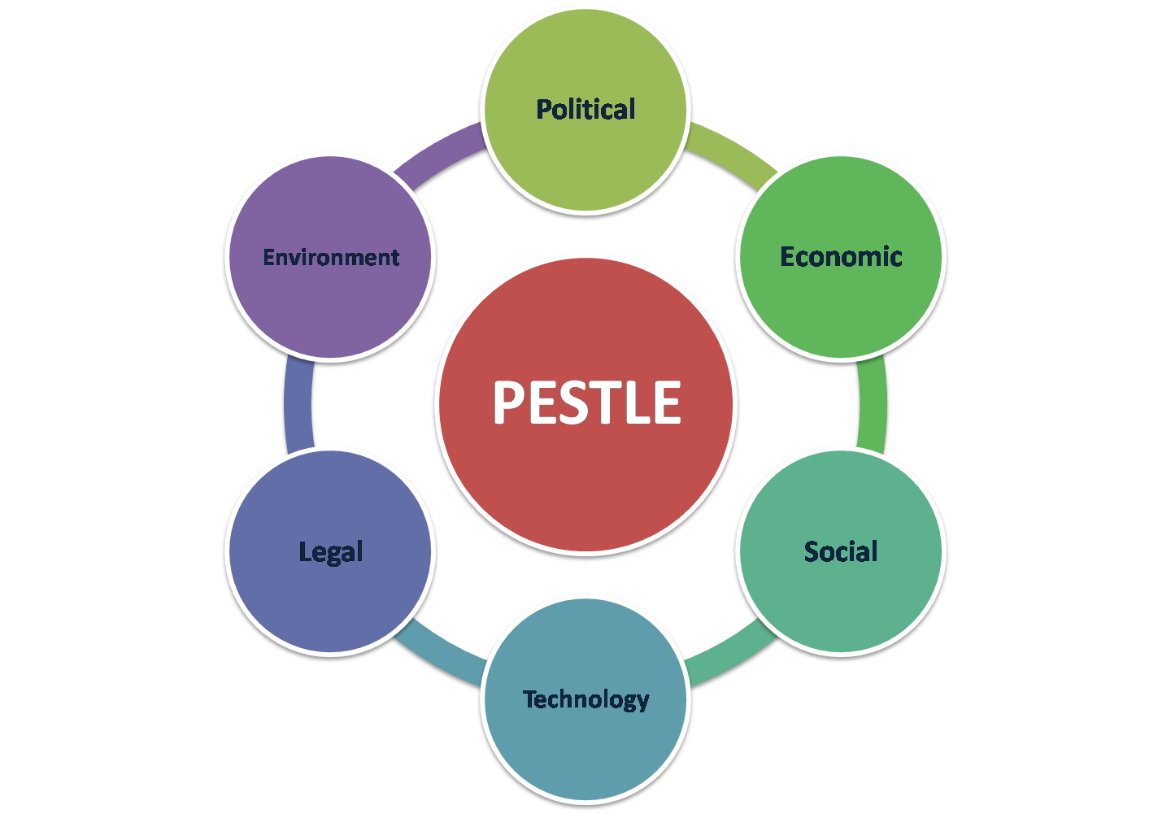
Political Factors:
Adidas's main political worries are the changing nature of trade policy and the political unrest that is taking place in numerous countries. To sustain its financial health and overall success, Adidas must address these issues. Adidas' products are exported all over the world, thus it should be important for it to adhere to a range of legislative and taxation systems in India. The brand's global presence necessitates that it solve challenging supply chain management issues while also managing a number of rules and regulations in order to achieve a number of goals and objectives. The firm may suffer significant time, effort, and financial losses as a result of other problems including war, terrorism, expropriation, and nationalisation if they become unstable.
Economic Factors:
The profitability quotient of the organisation is impacted by economic difficulties such as unemployment, wage rates, taxation, inflation, and interest rates. Other elements that impact Adidas include the unstable stock market that results from interest rate fluctuations, which will also have an impact on growth. Essays from 2003 to 2015 After COVID-19, the growth rate will, nevertheless, face a healthy GDP. As a result, the economy's enterprises stand to gain from its expansion. However, when conducting business there, the corporation can be required to pay a sizable amount in taxes.
Social Factors:
The effectiveness, reputation, and consumer loyalty of Adidas are influenced by social elements like as culture, religion, way of life, and tastes. Adidas should include various communities and beliefs when formulating choices and putting initiatives into action. Due to people's unhealthy lifestyles, health consciousness is growing among the population in India today. It shows that they want to have an active lifestyle and take care of their health. For this, people will require athletic attire, footwear, and other related exercise equipment. The demand for the garment and shoe sectors could benefit from it. Users currently have the ability to share and respond to any issue that may arise thanks to social media. Social networking sites, however, might make you stand out from the crowd.
Technology Factors:
Adopting cutting-edge technologies gives brands competitive advantage over rivals. Technology can be employed in the administration, accounting, and general commercial operations of the organisation in addition to the product itself. Additionally, the availability of a 5G network and cutting-edge technology would enable adidas to improve their products and create a wealth of business development potential in India. They support online sales on their website and via social media. Consumers are currently investigating the smart sportswear sector. A well-liked piece of technology in the health communities is the Fitbit. These technical advancements may allow Adidas to expand into new markets and outperform competitors.
Legal Factors:
It is the factor that affects foreign enterprises' decisions the most. Copyright, property protection, the legal system, data protection, discrimination law, and other legal considerations are among them Adidas will take into account the fact that most young people in India want to wear stylish shoes while older people have distinct fashion tastes as they continue to develop new items. Additionally, Adidas must adhere to a number of laws and regulations in India, much like other sports businesses.
Environmental Factors: Sustainability and environmental concerns have grown in importance for businesses over the past ten years. Organizations are being urged to follow environmental standards by the government and pressure groups. Limiting carbon footprints, insurance policies, climate change, regulations controlling pollution, safe water treatment, safe waste disposal, safe disposal of hazardous materials, increased attention on sustainability, etc. are some of the environmental factors. Due to the need to spend in expanding the supply chain's flexibility, extreme weather is also driving up Adidas' operational costs. Waste management has becoming more crucial for companies like Adidas, especially for locations close to big cities. The Indian government has put strict rules in place for managing rubbish in urban areas. The business should develop a plan that aims to create goods and clothing, followed by a "low waste programe." This approach will aid Adidas in pushing their business forward while taking into account all environmental issues.
Porter Five Forces Model:
Five competing forces are analysed in this framework to explain the industry's flaws and strengths (Tracy, 2019). The analysis of the Indian footwear market will aid in developing the company's corporate strategy.
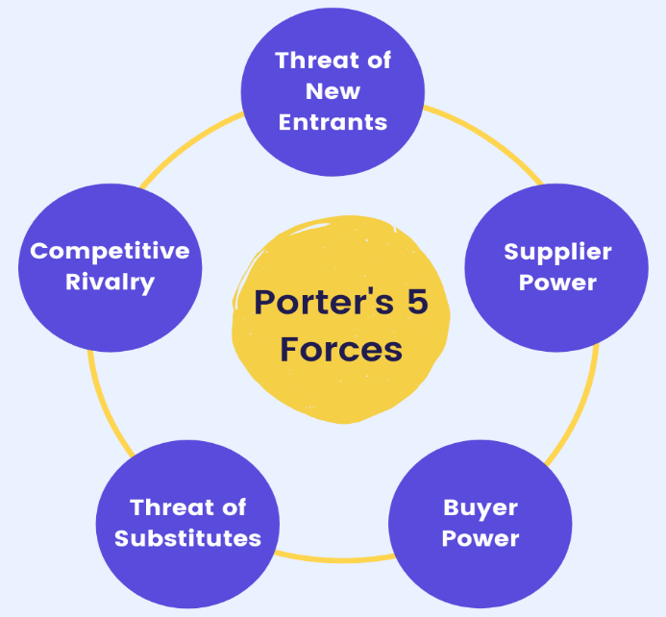
(Figure NO:-.2)

1. Rivalry among existing companies: Consider how many rivals you have, who they are, and how the quality of their product compares with yours.Threats from new competitors show how Adidas market participants are threatened by new competitors. The threat of new footwear entrants will be significant if the business is profitable and the entry barriers are low, which will draw in more participants.
2. Buyer's bargaining power: Buyers with significant bargaining power typically tend to force prices lower, restricting Adidas ability to generate long-term profitability. However, possibility to maintain a price at a steady level is given by the buyers' diminished ability to bargain, which increases profitability. The profitability of the industry may be higher because Indian consumers have less negotiating power.
3. Supplier's bargaining power: Suppliers gain power if they can easily increase their prices or degrade the quality of their products. Despite the fact that if they are the only ones capable of offering a particular service, suppliers will have considerable supplier power. Even if you have the choice, you should consider the expense of switching providers. The more suppliers you have to choose from, the easier it will be to switch to a less expensive one. They will, however, be in a better position and be able to charge you more if there are fewer suppliers and you depend more on them. Your profitability could be impacted, for example, if you are forced to sign expensive contracts.
4. Threat of new entrants: Adidas has had a presence in the apparel and footwear markets since 1949. As a result, Adidas' supply chain and distribution channels would be incredibly broad if the company were to expand into India. For a new participant in the market, setting up a production facility and starting a firm will be no trouble. But it would be challenging to surpass a firmly established company like Adidas. The proportion of marketing and research expenditures made by the company won't be comparable by the new businesses, and they won't be able to replicate the economies of scale that the company can obtain. The convenience of access and the brand's long-standing reputation for excellence
5. Threat of substitute products: Adidas should concentrate on offering products of higher quality. Therefore, consumers would pick its products over alternatives that offer higher quality but more expensively because they offer greater quality at a lower price.Adidas should concentrate on differentiating its goods. This will guarantee that customers view its products as distinctive and do not quickly switch to substitute products that do not offer these distinctive benefits. By conducting market research to better understand their needs and deliver what the customer wants, it can offer such distinctive benefits to their customer and also increase company profitibility.

The Challenges and Opportunities face by Adidas:
When doing business in India, Adidas may encounter a variety of opportunities and difficulties. Here is an explanation of the chalalnges face by Adidas:
Legal issues:
One of the main obstacles for foreign businesses is the complicated legal system and overflowing courts in this nation since they must go through numerous formal hoops to obtain the licences and approvals required for conducting business here. They occasionally must wait months or even years to gather the required clearances. Unfortunately, the obstacles posed by bureaucracy frequently outweigh the positive business consequences envisioned by these firms for India. Naturally, coping with the same issues may not be enjoyable for overseas companies.

Registration of Property:
In India, the registration of property can be a lengthy procedure, thus it may be necessary to seek professional assistance to make sure that foreign businesses are aware of local law. This process takes so much time and it create difficulty for Adidas.
Export and Import:
Investors and exporters must also deal with a regulatory tax and tariff system that is opaque and frequently unpredictable. Even though government law has been designed to enhance foreign trade, businesses wishing to conduct business in India still encounter difficulties in the export and import sectors.

Opportunities experienced by foreign business in India:
Indian Work Ethics:
It is unnecessary to introduce the work ethics in India. Indians are the perfect workforce for excellent performance because of their combination of hard effort, loyalty, and an unwavering desire to learn. They also have a "never say no" mindset. The business index takes advantage of these possibilities to increase productivity and create jobs in the nation.
Extensive Trade Network:
India has a vast network of multiple technical and managerial organisations that are backed by regional and bilateral free trade agreements and uphold the highest international standards. In addition, a variety of business partners are involved in the operation. Outstanding human resources are produced by these institutions which will be helping to grow business.
Initiatives by the Indian Government:
The Indian government occasionally introduces effective programmes and measures to facilitate the flow of foreign investment. The Foreign Direct Investment (FDI) reforms that were introduced in 2015, which relaxed investment by a foreign entity/foreigner in various sectors without obtaining prior approval from the government, are evidence of the noticeable efforts made by the ministries of various industries in India to simplify the rules and regulations regarding foreign investment in the country. With this significant improvement by the government, it is now easier to start a business in India and invest in a variety of areas without first gaining prior approval, which was a lengthy procedure.

Appropriate strategies for setup business in India:
- For a variety of reasons, India is a country where things don't always happen swiftly. Realize how crucial it is to establish strong, enduring human bonds with prospective business partners, team members, or clients. Indians want to spend time getting to know you before doing business with you; in fact, I'd be leery of anyone who wants to start dating right away. It takes time, persistence, and money to create relationships. This is a process that you must willingly and sincerely participate in because there is really no way to avoid it. When the time is right, you will benefit.
- A huge platform exists in social media. Reaching a large audience can benefit your business. To stay in touch with the target market, you should maintain an active social media presence. You may create a page for your products on Instagram, for instance. You can also use other social media platforms, such as Facebook, LinkedIn, etc., to effectively reach your target audience.
- Customer happiness plays a key role in a brand's success. In order to collect client input, a systematic feedback channel must be created. By modifying the products in response to the feedback, the suggestions should be put into practise. By applying this strategy business get high profitability and customer trust.
- For a product to stand out in the marketplace, a strong branding approach is necessary. For your product to make a lasting impression on the customer, emphasise its distinctiveness. A strong branding plan will increase your business's market share. It is necessary to consider the corporate logo, packaging, etc.
- Hiring a diverse and talented team. Without a question, India has one of the world's largest labour marketplaces. Therefore, the company will be able to have a qualified workforce that will be able to significantly improve the performance of the organisation if effective recruitment and selection processes can be employed.
Conclusion
Products are now readily available on international scale. Nowadays business is expanding at fast pace as a result of high technology and creativity. Moreover, in this technology era companies wants to expand their business globally. However, in order to expand business in other nation, it is necessary to analyse external factors like PETEL and PORTER’s FIVE FORCES, which were utilised in the report to assess the aspects of exit in the Indian footwear sector. After the investigation, it’s clear that Adidas will profit form the business potential in India. However, if the business employ focus on the proper strategies and planning, then it may easily overcome any difficulties in the market.

References:
Aishwarya Sandeep. (2022). Challenges faced by foreign companies in India. [Online] Available at: https://aishwaryasandeep.com/2022/02/05/challenges -faced-by-foreign companies-in-India.
Britannica (2020). Marks and Spencer PLC [British Company] Britannica. In: Encyclopaedia Britannica. [Online] Available at: https://www.britannica.com/topic/marks-and-Spencer-PLC.
(Accessed-14 November 2022).
Calkins, P.B. and Allchin, F.R. (2018).India [Facts,Culture,History,Economy,and Geography.In:Encyclopaedia Britannica.[Online] Available at: https://www.britannica.com/place/India.( Accessed- 14 November 2022).
https://tse1.mm.bing.net/th?id=OIP.4Xx3QIKzCosO1XhO4RXWbAHaEK&pid=Api&rs=1&c=1&qlt=95&w=187&h=105
International Relations EDU (2008). What is International Business. [Online] Internationalrelationsedu.org. Available at: https://www.internationalrelationsedu.org./what-is-international-business/. (Accessed-14 November 2022).
Kaul, A. (2022). The opportunities and challenges for India’s stock market. [Online] https://www.livemint.com. Available at: https://www.livemint.com/money/personal-finance/the-oppurtunities-and-challenges-for-india-stock-markets/amp-11661708439065.html (accessed 15 November 2022).
Shaw, A.A. (2021). PESTLE Analysis of India. [Online]SWOT and PESTLE Analysis. Available at: https://swotandpestleanalysis.com/pestle-analysis-of-india/.(Accessed 15 November 2022).
www.linkedin.com.(n.d.).Five Forces Analysis of the Indian IT industry. [Online] Available at: https://www.linkedin.com/pulse/20141201094613-28041706-five-forces-analysis-of-the-indian-it-industry.(Accessed 15 November 2022).
https://tse1.mm.bing.net/th?id=OIP.LVhmWcQeCm_jjfvvJMuhrQHaHZ&pid=Api&rs=1&c=1&qlt=95&w=104&h=104

