Energy In A Flywheel

A Technical Report

By Jason Evans

Student I.D: 1706645

Contents
- Introduction

- Experimental Procedure

- Results

- Analysis

- Conclusion

- Evaluation

- Further Work

- Introduction
The aim of this report is to demonstrate, through experimentation, the transference of energy from potential energy to kinetic energy. It will also show energy loss in this process and offer up a possible explanation to why there is a loss. There will be a results table to show measurements taken and a description of the apparatus that was used as well as the methods used to get the results to assist anyone who may want to replicate these findings.
Through the results from the experiment it would be possible to calculate the moment of inertia of the flywheel. This can be done through the collection of the data available and appropriate equations to get figures that would be needed for later equations.

2.Experimental Procedure
Before the experiment began the apparatus needed to be set up which meant opening the box containing the apparatus that would be needed for the main part of the experiment. There was a support and fixing for the flywheel to be attached to, a 0.29m length of string, a mass hanger, a ruler, and some mass disks with a mass of 0.01kg each.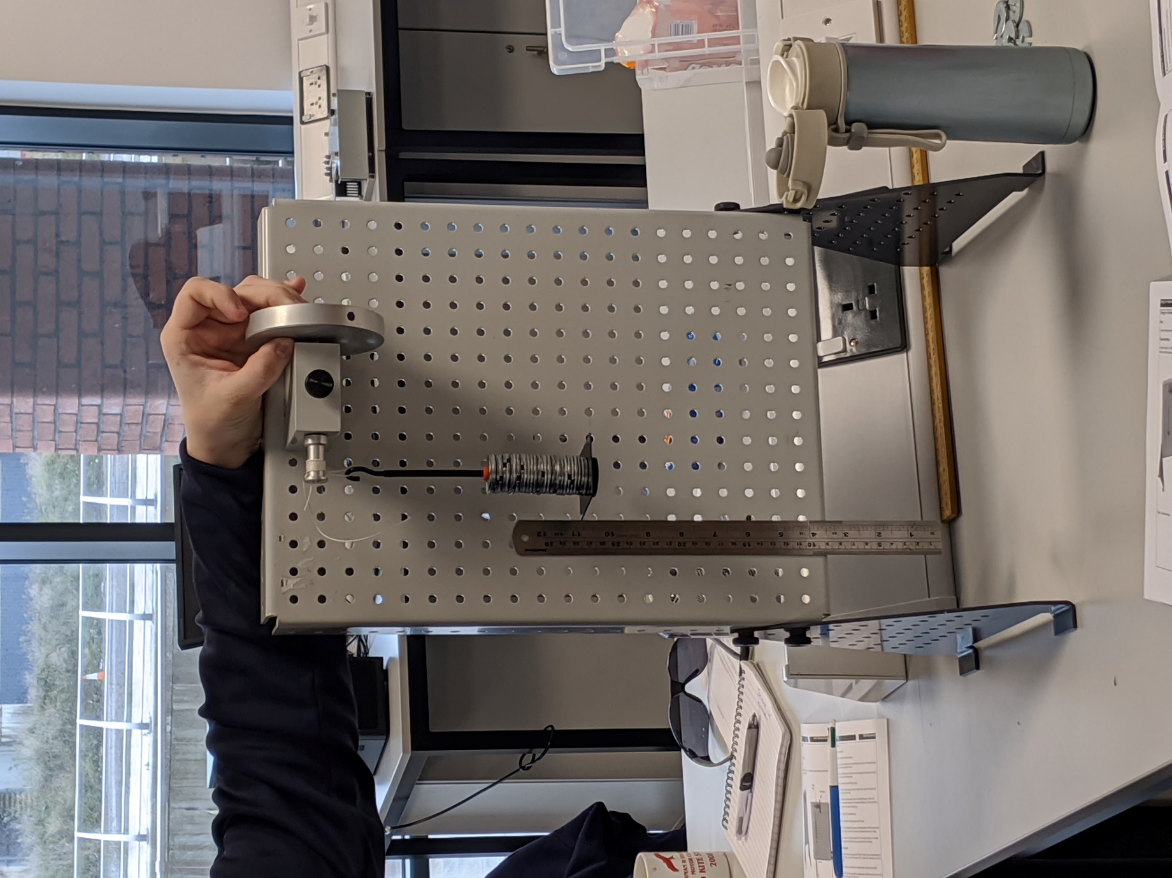
The device was then set up with the flywheel being set up at the top of the work panel in a location which allowed for the mass hanger to move freely with little chance of obstruction. The string was then attached to the pulley the mass hanger was then attached to the other end. The mass hanger has a mass of 0.01kg therefore an additional nine disks which increased the overall mass hanging down, (excluding the string) to 0.1kg.
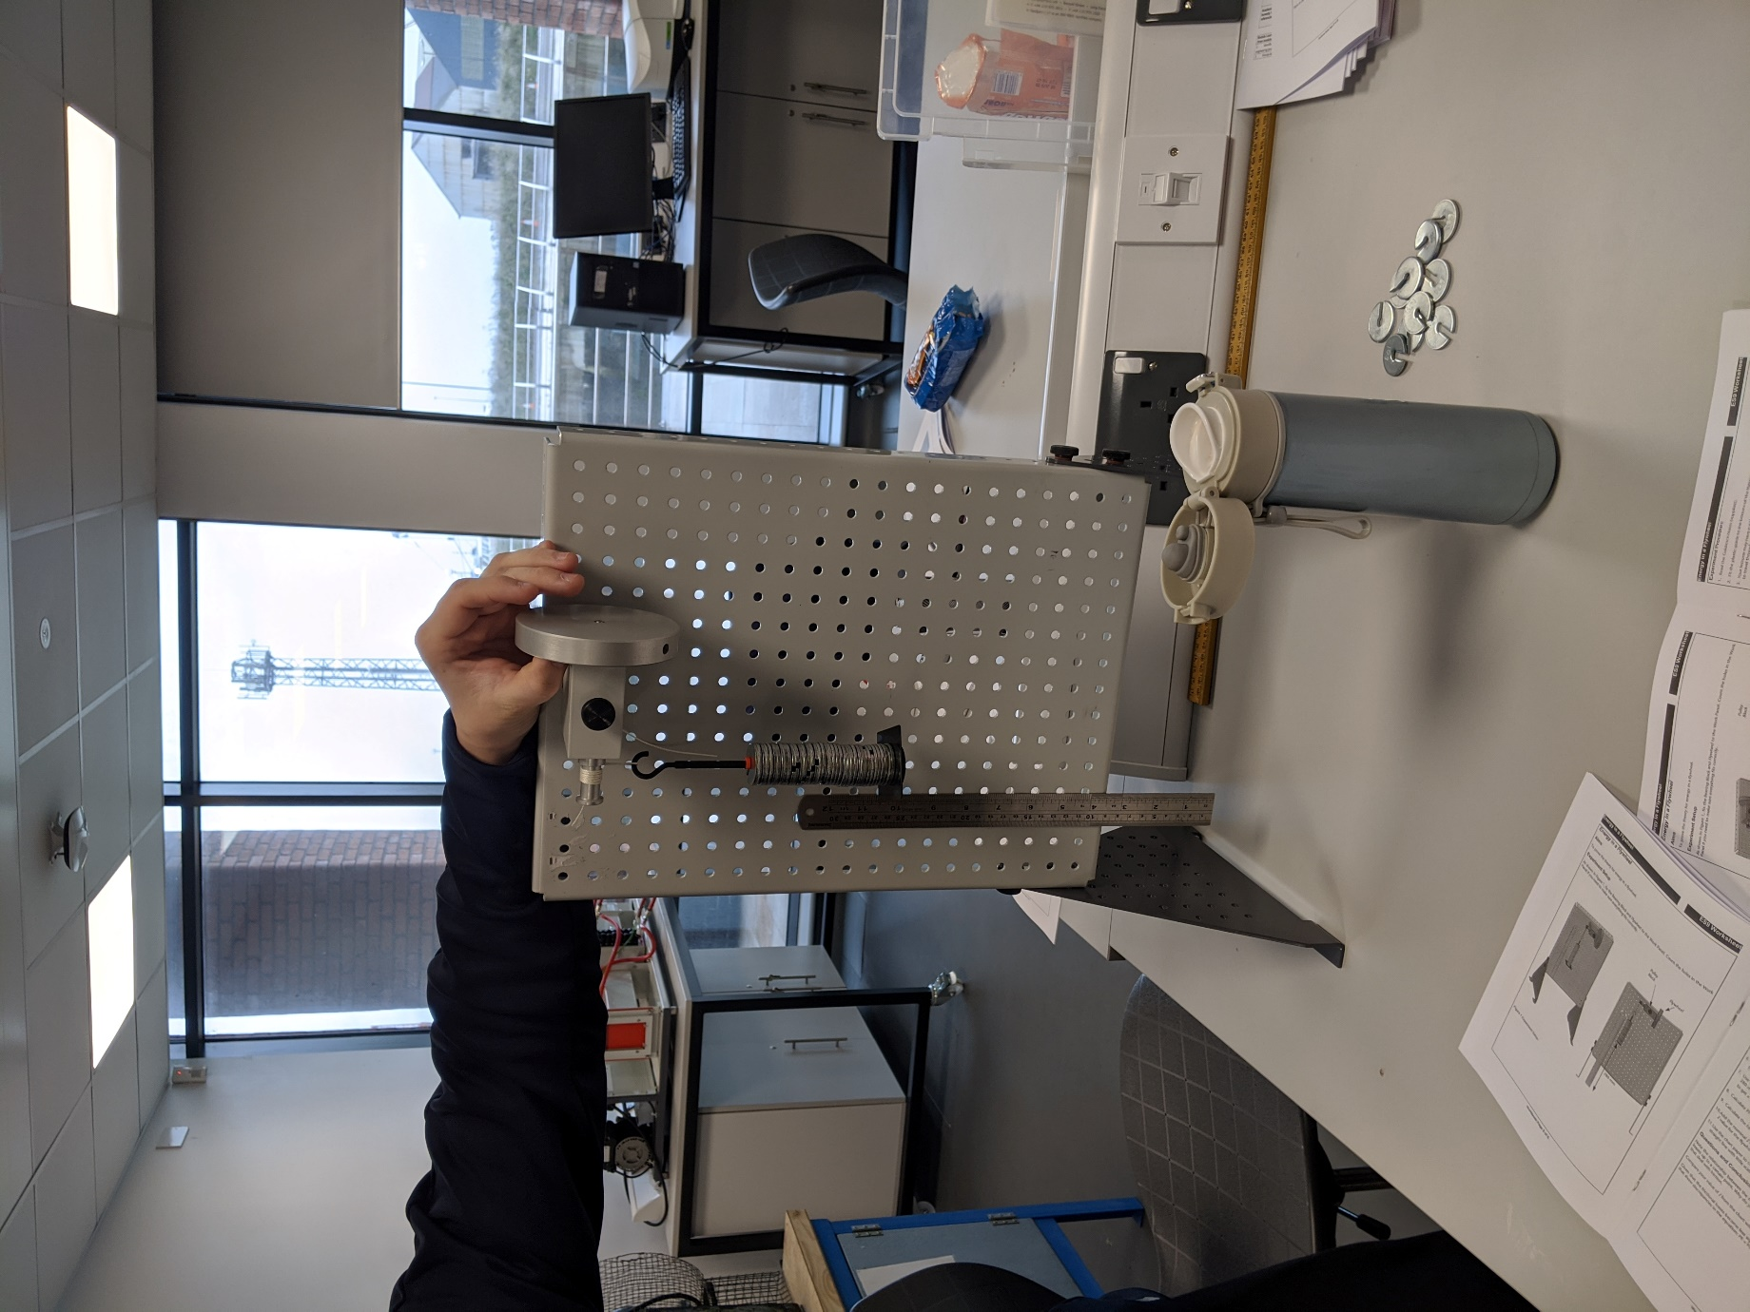 There was one person to turn the flywheel until the mass hanger was at the desired height of 0.28m. This height was measured by an observer who was ensuring that the mass was released at the same height for each subsequent test. The observer also seen what the maximum height was when the mass returned after it hit zero or the bottom of the scale. There were two observers with a stopwatch each, they were taking measurements of how long the mass would take to reach its maximum height after the initial release and a median average (in seconds), was taken from the two times to determine the length of time it took.

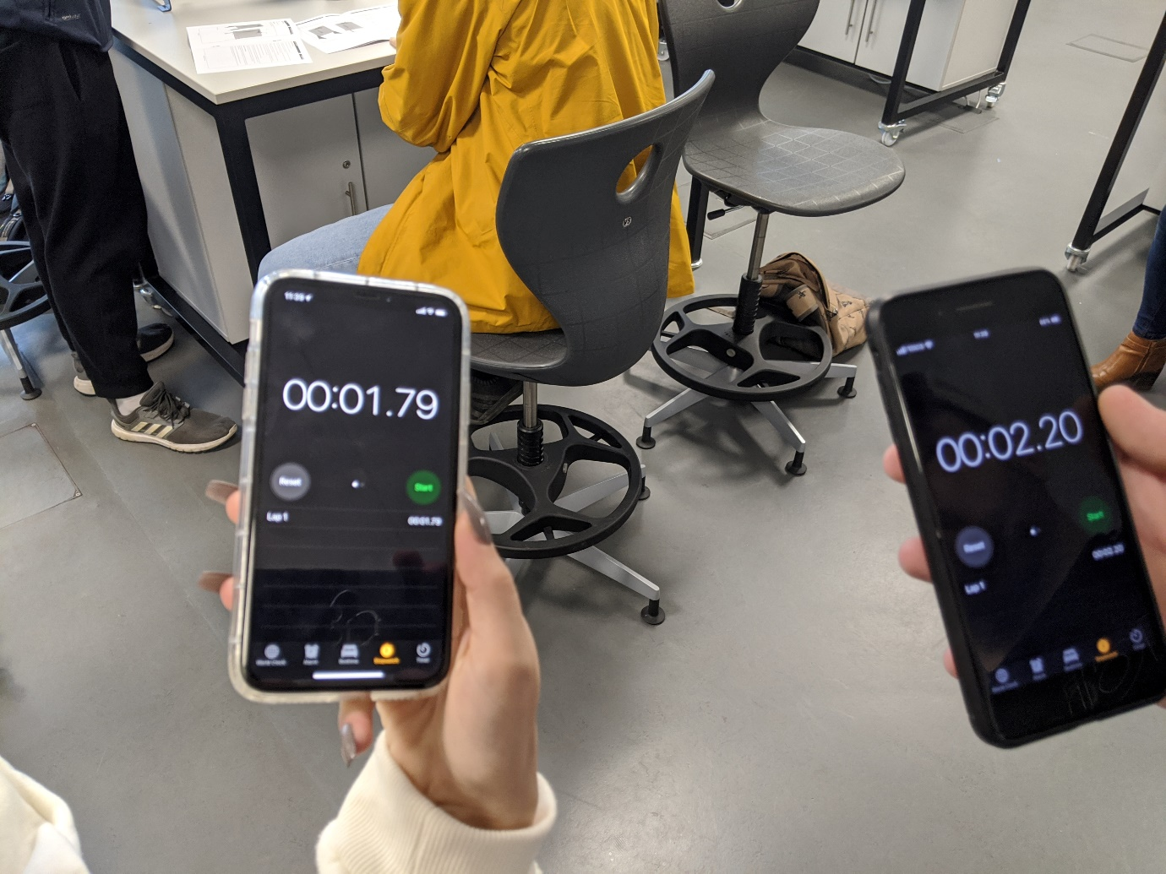 After each test, an additional ten 0.01kg mass disks were added to increase the mass of the hanger by 0.1kg.
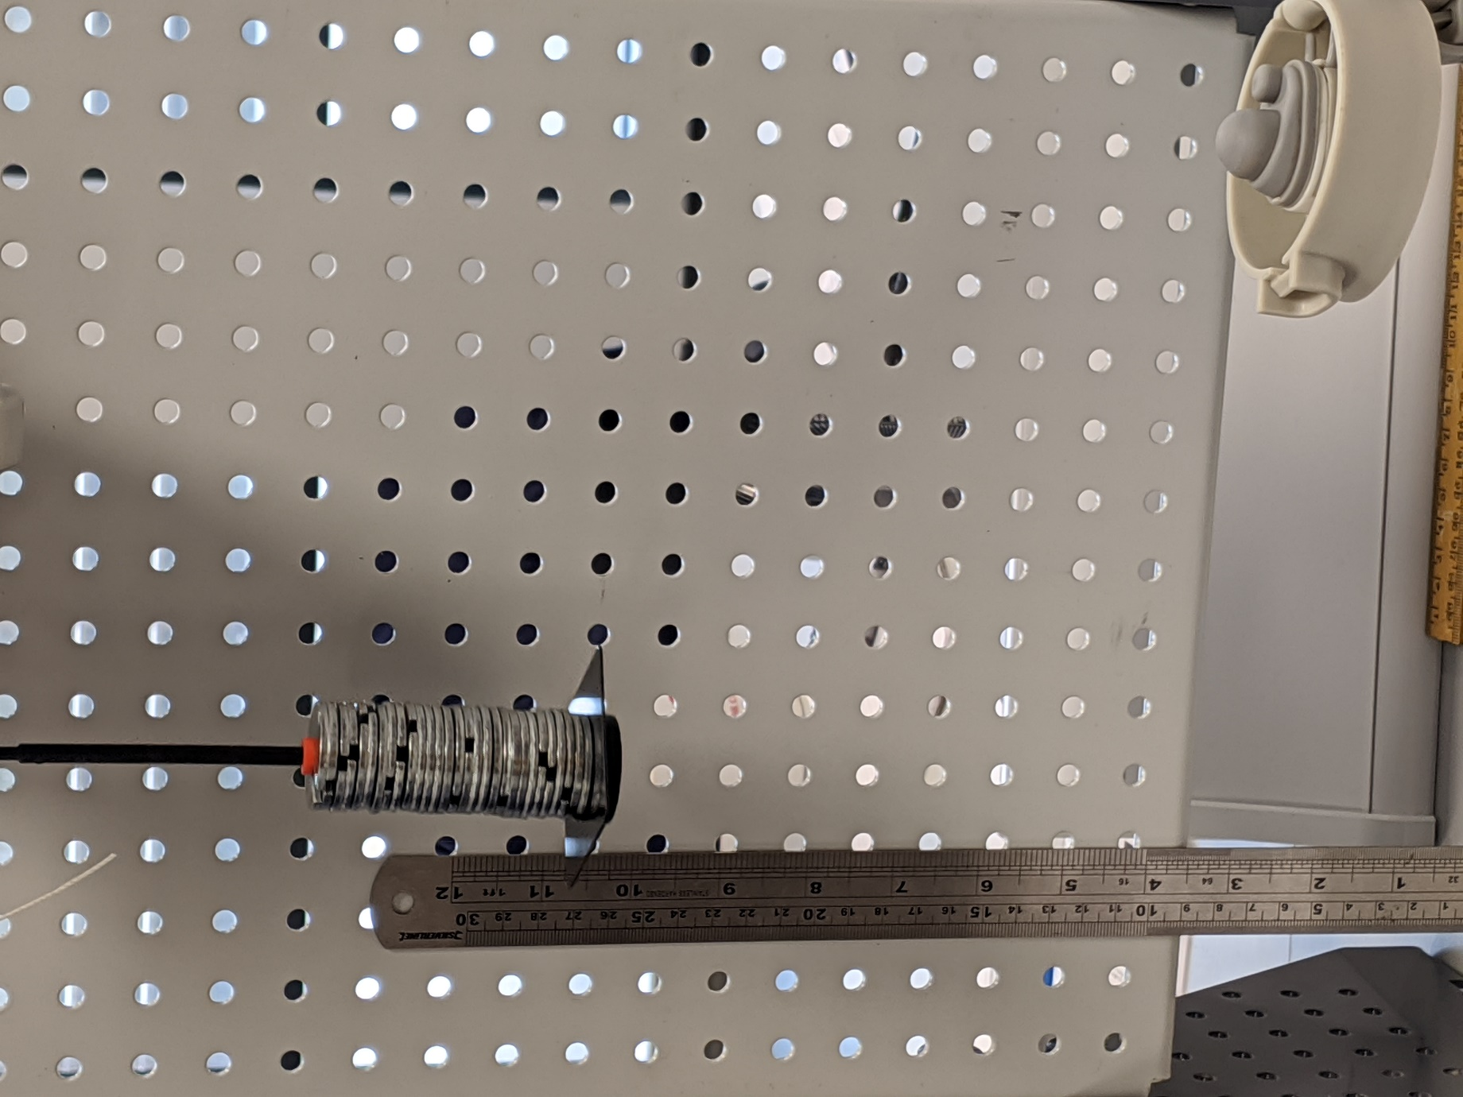

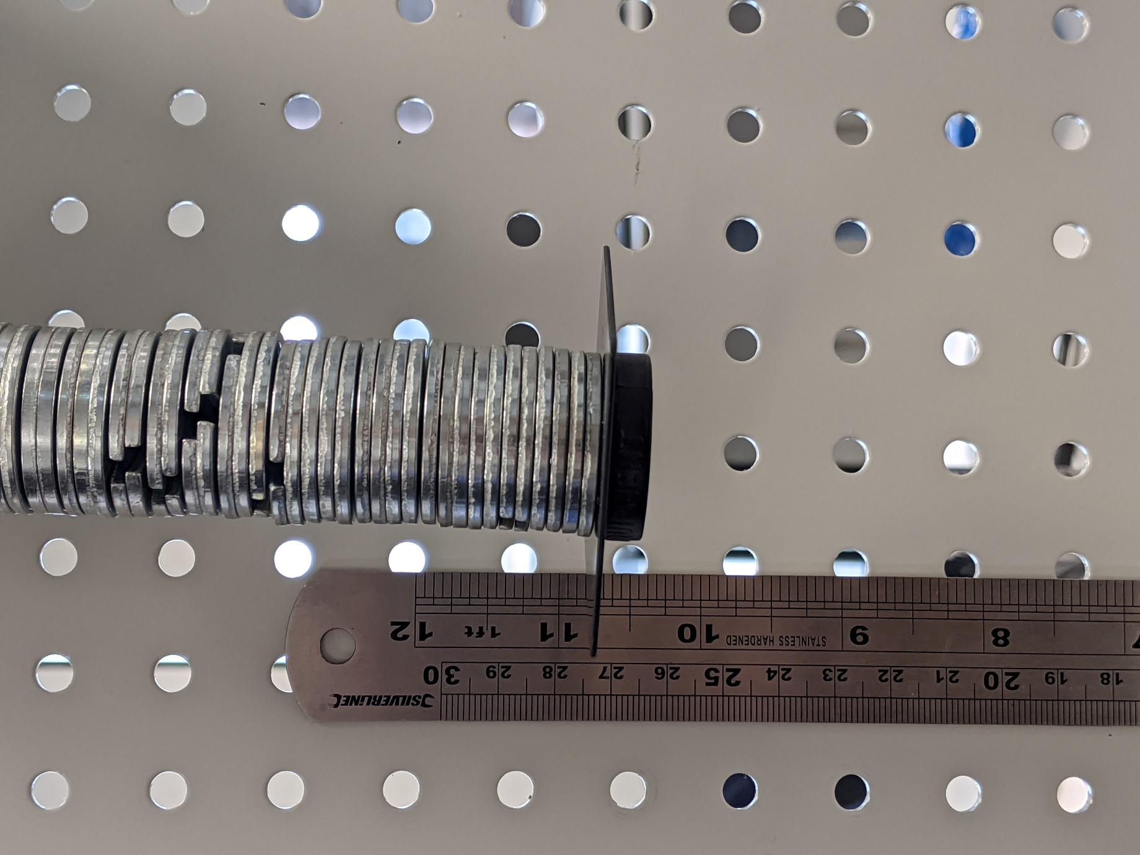After several practice runs to ensure all roles were understood, the test was repeated five times in total and all the results were recorded in a table with calculated values, like the angular velocity and PE loss adjusted, included in the table also.

3.Results
The results of the experiment are shown in the table below:

4.Analysis
In the results it is plain to see that the potential energy increases. The equation for Potential energy is: P.E=mgh, where m= the mass of the object, g=gravity which is constant at 9.81m/s squared and h = height of the object from the floor. The experiment shows that of these variables, the only one to change is the mass as each mass is released from the same height and gravity is constant. This shows that with each increase of mass potential energy increases.
What is also evident from these findings is that the time it takes the mass hanger to reach its maximum distance before it bounces back increases also. There are some discrepancies in the measurements however, this can be attributed to human error and inaccuracies in measuring apparatus. The acceleration and velocity for both linear and angular aspects of the experiment increase with the mass as well.
The force on the string can be calculated using the equation F=mg-ma. If you take the figures for this from the last test then the force would be:
F= (1.37 x 9.81) - (1.37 x 0.0097)
F=13.43N
Using the force on the string and the radius of the pulley we can calculate the Torque due to the simple moment theory, this says that the torque in the cord is equal to the product of the force in the cord and the radius of the pulley
T=Fr
=13.43 x 0.0065
T=0.087Nm
The calculations show a direct correlation between the increase of force and the increase of Torque which is shown in the following graph:

5. Conclusion
In conclusion the experiment demonstrated everything that it set out to. It shows how you can use linear velocity and equations to help work out the angular velocity on anything that is connected from these figures and vice versa.

6.Evaluation
The experiment was conducted in a quiet room with no disturbances or interferences that could have skewed the results of the experiment. Each person who took place in the experiment knew their role in advance of the proper experiment with the practice runs. There were many things that could have been differently however, with the equipment available this was the best that could have been achieved. During the measuring process, there could have been more than one person taking the measurements as this was the case with the time keeping and a median time was taken. The same method could have been used for the height measurements as they do seem relatively inconsistent on the table.
Attention to details on certain measurements may have helped with more accurate results also as some of the results appeared to be general area of the figures on the ruler. A more accurate measuring device measured in microns instead of millimetres may have helped allow for more accuracy.
This experiment directly demonstrates newtons second law which is F=ma (The force to move an object is equal to the objects mass multiplied by the acceleration of that object)and also the second law for rotational motion T=Ia (The Torque to rotate an object is equal to the moment of inertia multiplied by the angular acceleration). It demonstrate the transition between the two of them.

7.Further Work
If this experiment were to be repeated, there are several things that could be done differently. More accuracy in the measuring of the different variables is a must. Getting an average of different times for example is not a very efficient way to determine an “accurate” time for the mass hanger to complete its cycle, this time could have been off by a relatively large margin.
Using a human eye to determine the height at which the mass hanger had returned to is also an in-efficient way of determining the returned height of the mass hanger as is the fact that this was used as the method to determine the starting point also. Measuring with the un-aided human eye is a grievous mistake, in respect of accuracy, for any experiment because it is entirely based on the observer and therefore subject to the flaws of the individual. The person who is measuring could have sneezed, yawned, had a speck of dust in their eye or coughed not to mention any other issues that could have arisen. The person doing the measuring would need to be sat perfectly still to ensure that they are in the same position to take the same measurement at the same location each time. This is just not possible to do as the human eye moves quite a lot even when trying to keep still, this goes for the human head and body too trying to keep perfectly still to get the accuracy that is needed is incredibly in-efficient.
A camera set up with perhaps some laser switches set up may be the best solution. One to begin the timer as the mass hanger is descending and one to stop it as it is at the maximum return, this can also be used for the time measurements.
A disciplined team that strive for accuracy may be an excellent choice as well because, unfortunately not every team who are working on experiments like this strive for the same level of accuracy and professionalism and may be a bit relax on the measurements and rely on “close enough” measurements rather than the actual ones.
The string used is something that can be addressed also as the string that was used could have been prone to stretching. This could have caused a variation in the results and a more sturdy or non-stretchable string could have been used.

