Benzol loading bay PLC entry and exit gate system

Proposal

The project being proposed is to allow for safe entry for tankers in the Benzol loading bay. The Benzol loading bay is a dangerous area within Tata steel Port Talbot, where tankers will drive into for Benzol to be extracted from the tankers and into pipelines which lead to tanks within the plant to store the Benzol. Benzol is a very dangerous and explosive material therefore safety is critical with its use of it and the area surrounding it. The area is an ATEX explosive atmosphere due to the gas being transported, meaning the area needs to be kept secluded from anyone being able to just walk into the area. Due to this the area of the loading bay is to be fenced off. The area will then need an automated Gate to allow the Benzol tankers access to the area when they are to come in and unload Benzol. The project is to be to design a gating system for the area, that runs off a PLC, wherewith the use of sensors and existing CCTV, the operators within the control room will be notified of the Benzol tanker’s arrival. They will be allowed to manually open the entry gate from the control room and close the gate behind the tanker. They will also be able to open and close the exit gate from the control room. A manual override will also be installed near the gates so that the gates can be controlled locally if there were to be any problems. The manual override will consist of an HMI (human-machine interface) to control the gates. The project will also need a PLC program built with commands to control the process of the project.

The goal is to ensure the maximum safety of the area and restrict access to ensure that only the correct people can enter the area. The project intends to run smoothly, and the equipment chosen is the best equipment for value to be used for the project and its goal. Within the project, the correct standards must be met, and the project shall be ethically right. A Gantt chart would be created to allow for proper project management and deadlines set to allow the project to stay on track and a clear indication that the project is falling behind its scheduled dates if it were to by following the plan. The project’s initial plan is to take 8 weeks to complete, from ordering the long lead equipment early after researching what’s needed, to starting to install some equipment on site ready for the long lead items. Alongside these tasks will be the creation of the PLC ladder diagram which will be commissioned and tested once the installation is complete. The work will be tested ad commissioned prior to being completed. The project Gantt chart is shown below.

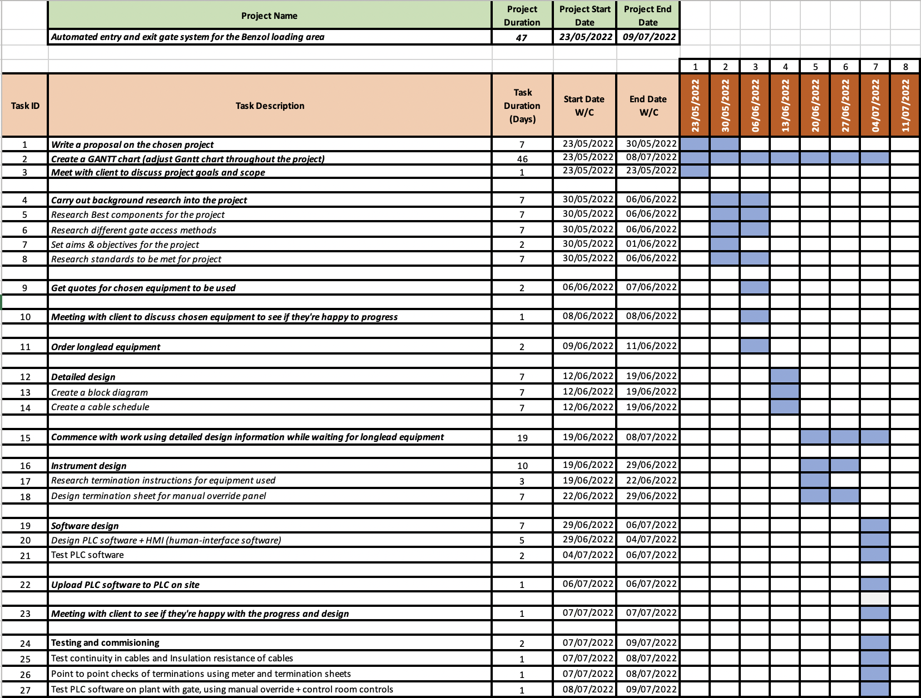

Figure 1 - Gantt Chart of Benzol loading bay access gate project
Above in figure 1 is the detailed Gantt chart of the steps and stages of the project. Using a Gantt chart like this allows the project to be mapped out with deadlines, and dates and to keep the project on track. This Gantt chart can be adjusted throughout the project if the project were to go off track, and then adjusted accordingly to either extend the project finishing deadline or have less time to complete other sections of the project if they can be done.

