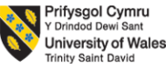

Programme: BA (Hons) International Hotel Management
Module Code: BMIH6001
Module Title: Contemporary Themes in the Hotel and Hospitality
Lecturers: Jessica Newport

Student Name: Flavia Nanu
Student ID: 2239004
Abstract
The research is evidenced to explore on a grappling issue of mental health crisis deepened for the workers in the UK Hospitality industry, and focusing on. As reviewed, mental health crises have emerged due to several issues, where persistent issues have been the long hours, the work stress, the emotional demands and the silence that contributed to workers facing depression or even resulted in leaving the job. It is thought that when looked at from the Job Demands-Resources (JD-R) model or Conservation of Resources (COR) theory, the issue has been pointing towards the lack of balance between the workers' efforts and the way the resources are being utilised, prioritising the well-being of the people. Through the secondary qualitative data and the PESTLE analysis tool as the framework, the thematic evaluation has been done. The findings suggest that the tourism industry does face high pressures due to the huge demands of the travellers, and this in return do impact the mental and physical performances of the people. Cooper and Hall (2023) presented that contemporary tourism has created many advantages for the organisations and the travellers, but employees have been pressurised with mental health issues. The reviewed study by Dawson et al. (2012) also agreed on the same issue in the study, where it projected how mental health conditions are worsening for the employees, and it has been leading to negative impacts on the employees. Along with issues, there are always strategies or measures which can be taken to overcome problems as identified throughout the research. With the aid and promotion of a supportive work environment, it is found that a better impression and sense of love can be created among the employees, which reflects on the performances (Floris, 2024). In line with the argument developed by Kalargyrou et al. (2023), this study stressed the role of managerial support and attitude, which can promote better policies being designed in the workplace culture to be reshaped.
Contents
Introduction: 3
Literature Review 3
The issue of work stress, long hours and emotional demands is causing deepening mental stress to employees 4
The impact of pressing issues on the mental health condition of workers and on the performance of the industry 5
The strategies that could be deployed to overcome issue 6
Literature Gap 6
Method 7
Theme Impact Analysis 7
PESTLE analysis 7
Conclusion 9
Recommendations 9
References 11

Introduction:
Across the hospitality industry in the UK, mental health crises have turned out to be a deepening issue which has been affecting multiple fields like work culture, employee performances, productivity, turnover rates and others. From the survey conducted by UK charity Hospitality Action, it has been found that in 2024, the issue has risen to affect around 76%, which was around 64% in 2020 (Hospitality Action, 2024). Among the concerns that have been directed towards the cause of the issue have been post pandemic recovery, the cost-of-living crisis, and majorly balancing work and personal life, which accounted for almost 60%, causing mental health issues apart from the financial crisis. According to Wong et al. (2025), work stress has already counted as a disturbing issue that has been haunting the workers in the hospitality industry, which has sped up due to rising pressures from customers for services and even due to the market trends.
The research aims to explore the deepening mental health crisis in the hospitality sector of the UK, focusing on the case study of Crown Bawtry si Rossington Hall.
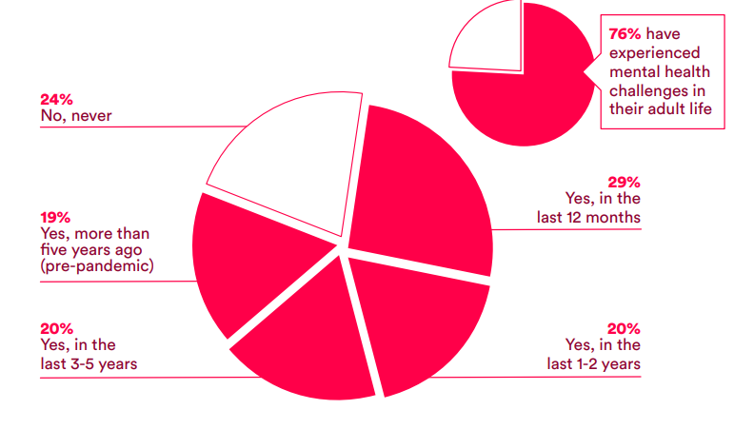
Figure 1: Mental health problems have been rising in the hospitality industry
(Source: Hospitality Action, 2024)

Literature Review
Conservation of Resources (COR) theory
It is one of the theories that fosters wider attention on the psychological factors that lead to the stress which arises from threats or loss. In the hospitality industry, understanding the core needs of the employees, like flexibility in working hours (love and belonging) or listening to them do helps in eliminating work stress and mental health crisis where they are not threatened.
Job Demands-Resources (JD-R) model
The theory does refer to the connection between the job demand and the job resources, which can be negative from the work-related stress, like emotional demands, detachment from the job and the feeling of being less valued within an organisation (Robson, 2016). Brotherton (2015) opined that the industry is witnessing huge changes where both employers and employees both do needs to be paid attention. Kotera et al. (2021) in the study did point on self-criticism or self-harm have been some of the impacts of the mental health crisis of the employees.

The issue of work stress, long hours and emotional demands is causing deepening mental stress to employees.
The tourism industry, or rather the Hospitality industry is continuously being shaped by the market trends, the demands of the tourists and the interference of the digital ecosystem. According to Cooper and Hall (2023), contemporary tourism has brought with it many advantages directed towards economic growth, but at the cost of the employees' mental health. Due to the rapid demands of the customers, employees are instructed to continuously adapt to the situation and perform as needed. However, the question lies in how the employees feel or develop while being engaged with such rapid tasks or work pressures. As argued by Batabyal and Das (2019), the global market and the trends have internally caused massive changes to be undertaken by the employers, where sometimes employees are being subject to face issues. Undoubtedly, the fast-changing world has been asking for quick services, high quality, flexibility and accessibility to the points, but all these do come at the cost of the employee’s health being sacrificed. In "Crown Bawtry and Rossington Hall, one of the issues that led to conflict among staff was regarding the passing out of the tips as laid under the Employment (Allocation of Tips) Act 2023 (TripAdvisor, n.d.), which added dismay to the workers as the tips went straight to the management rather than the workers receiving them for their efforts. Thus, it added to the discomfort of the staff too faced in the hotel, leading to stress.
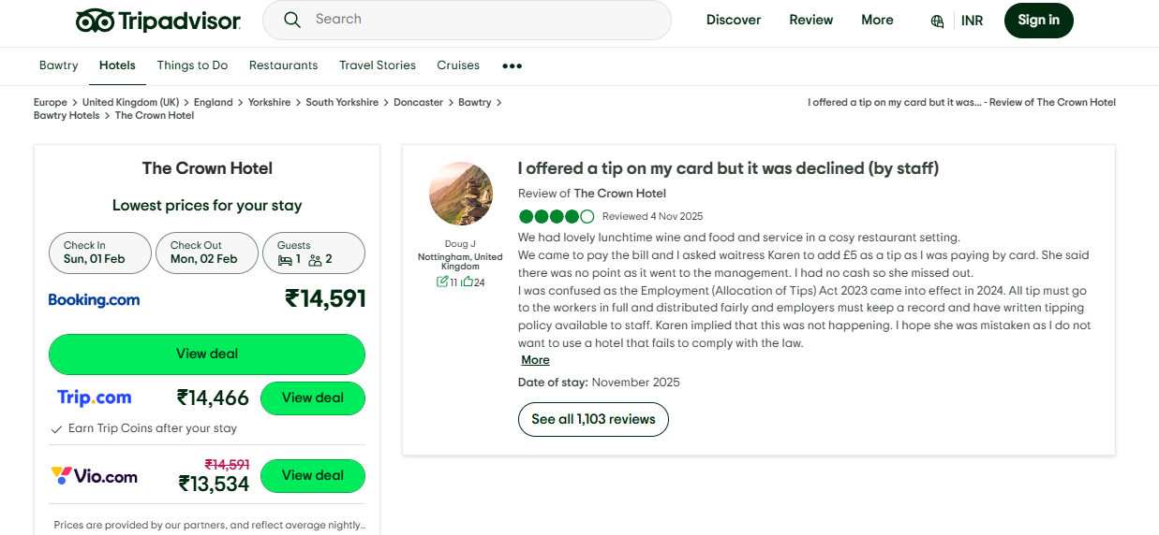
Figure 2: Staff disappointed over tips
(Source: Tripadvisor, n.d.)
During the peak hours or seasonal visits with high visits of national and international tourists, employees do have to perform for long hours to satisfy the guests and provide them with necessary services (Khairunnisa et al., 2025).

The impact of pressing issues on the mental health condition of workers and on the performance of the industry
Certainly, the employees being exposed to the issues which the contemporary tourism trends have exposed them to; the impacts are likely to be negative. Dawson et al. (2012) did affirm it by stating that the tourism industry is adapting to changes to drive in opportunities. However, the advantages are gained at the cost of the sacrifices that employees make with their services; also, many times, not able to express themselves. According to the study of Prentice et al. (2025), structural issues like long and irregular working hours and low wages have been one of the serious issues which have heavily impacted the mental conditions of the employees. Further, it has created a deepening impact due to employees not able to express themselves, and this silence does contribute to the burnout and turnover issues in most situations (Baquero, 2023). Khairunnisa et al. (2025), with the use of quantitative data, revealed that 50% of the people experience high stress, while 65% do face emotional exhaustion. As a result of the pressing issues, many employees have even demanded to quit the job or switch to a better work culture, which has led to an increase in the turnover rate.

The strategies that could be deployed to overcome the issue
To combat the growing mental health crisis, employers have reached a point where they need to take strategic actions that do make sense and work out for the employees. Applying the Job Demands-Resources (JD-R) model could be applied to the organisation’s bottom line that could divert attention to motivate the employees and eliminate the psychological distress. Through the boosting of a supportive work environment, employees can be given the impression of where they can openly express their issues or even state the difficulties that they are facing (Floris, 2024). However, managers do have a bigger hand in developing the environment where they can decide on hosting workshops or even appoint mental health professionals to deal with the well-being problem of the employees. According to Kalargyrou et al. (2023), the manager's attitude towards the employees being depressed or suffering from work stress can shape in developing better policies and break the stigma of the pressing issues. Managers, therefore, can promote positive workplace culture and allow people to express their concerns or engage in feedback, which can enhance the mental health of employees.

Literature Gap
Many studies have researched the mental health stress and other issues like financial crisis or environmental changes, affecting the hospitality industry. However, it is found that those studies have not expressed the silence that employees do face in the hospitality industry, which leads to burnout, turnover and mental health crisis at the same time. This research has aimed to point out the structural issues that the hospitality industry persists in, which led to the deepening of the mental health crisis.

Method
Research conducted with the knowledge of how it will be collected does help in adding efficiency to the data gained and knowledge incurred (Chkoniya, 2021). Here, in this research to explore the issue of the deepening mental health crisis, a secondary qualitative data collection method will be followed. Through the secondary qualitative source, credible information can be gained by following only online sources available. For the analytical technique, the PESTLE analysis tool will be used, which will help to assess the external environment which do causes impacts to the workplace environment and industrial performances. Through the PESTLE analysis, wider reflection can be done on the various external forces, such as social, economic, and environmental factors, that influence the industry or even the decision-making process.

Theme Impact Analysis

PESTLE analysis
Political | The political conditions or policies designed have an impact on the ongoing operations of the organisations. In the UK, the hospitality industry has faced high impacts of the cost pressures in the last few decades, from the time of the post-Brexit period to the cost inflation. The laying down of the employers’ National Insurance Contributions (‘NICs’) or the National Minimum Wage (‘NMW’) has caused a threat to the increment in the employment costs (Ogunware and Thomas, 2025). Hence, workers have been suffering from the wage crisis too, which is limiting their financial strength or even their ability to live a good standard of living.
Economic | Censuswide and hospitality marketing firm Flipdish conducted a survey, which found that mental health crises have widened even more than the pandemic impacts. In 2020, almost 200 of the respondents commented that they had been suffering from a mental health crisis (Gardner, 2022). The key reason identified has been the high volume of vacancies in the industry, where 45% of them have asked the staff to work longer hours. Again, from the 2021 survey, it was evidenced that one in five of the workers have been opting to leave their jobs, where 80% did commented on performance pressure and antisocial hours as the major cause (Gardner, 2022).
Social | In the opinion of Chung et al. (2021), behind the rise of job stress, the customers' behaviours are also counted as one factor, though not openly discussed. The irrational behaviours of customers or being abused lead to silence among the workers, which often they are not able to express due to a poor work culture. Further, for a healthy living condition, there is a requirement for a good wage; however, in the UK, workers have been experiencing low disposable income, which has caused stringent living conditions.
Technological | Digital ecosystem has undoubtedly contributed much to the workplace performances being improved, including the customer service being met with adequate resources (Sevic et al., 2025). However, at the same time, the digital ecosystem has created an inferiority among the workers where they are not able to perform and do feel low self-esteem. The application of Maslow’s Hierarchy of Needs could boost the confidence of the people, where digital literacy could enhance self-esteem and provide better learning opportunities.
Legal | In the UK regime, some laws cater to the needs and rights of employees, where they can raise disputes with the working conditions. According to the law, employers do carry a 'duty of care' where they must do all that is needed to show support for showing support to the health, safety and well-being of the employees (Acas, n.d.). Legally, employees are protected by the Government, which acts as the strength for dealing with the mental health chaos, like the Employment (Allocation of Tips) Act 2023. Through the laying down of the Act, it clearly shows that employees are given an advantage through policies of getting incentivised, but how far organisations are performing on it or are adhering to it has been the main question.
Environment | Working with sustainability has been one of the significant contexts for both employers and employees, which includes the workplace culture (Darcy et al., 2012). The workplace culture does denote that employers take care of the needs of the employees and managers to frame policies for the well-being of the people considered at priority. With every visit, workers do attend to the guests with smiles, but behind that lie serious issues like burnout, the job insecurity crisis or even stigma relating to mental health stress.
Table 1: PESTLE analysis
From the application of the PESTLE analysis, it is evident that social considerations like employers ‘duty of care, the growing demand of sustainable workplace environment and intervening digital literacy among the workers do turn out as strengths. However, the grappling issue of economic crisis, the political landscape, where National Insurance Contributions (‘NICs’) or the National Minimum Wage (‘NMW’) are causing a threat to the workplace regulations. As found from the study by Brotherton (2015), it is highly projected that employees are treated as resources while demands contribute to the benefits to be gained by the organisation. In the same way, when organisations fail to ensure employees are strategic assets, it causes discrepancy and chaos in the performance of the employees. Due to economic pressures or poor policies for the employees, it is evident that high employee burnout does occur therefore. In line with the opinion of Cooper and Hall (2023), employees are emotional and with exhaustion, they do feel irritated, and this leads to employee turnover. Though policies are designed in like the Employment (Allocation of Tips) Act 2023, yet management does play a cruel role in incentivising the employees or designing better work policies. At this point in time, employees do feel deprived, depressed and highly emotional. In the study of Khairunnisa et al. (2025), similarly, it emphasises the emotional turmoil employees face due to loopholes in organisational decisions. Therefore, long hours, stress and lack of attention to employees' needs do raise insecurity and emotional disturbance among people.

Conclusion
Mental stress among workers in the hospitality industry is widening and has taken the shape of a deepening crisis. The persistent issues like long working hours, job stress, emotional demands and silence have been leading to various impacts where job burnout and turnover are serious. The industry has been aware of the growing issue; however, policies and frameworks are found to be failing in dealing with work stress, as external factors are also responsible for the occurrence of mental stress. The grappling impact of inflation or poor living standards is demotivating the employees. It is thus evidenced that with motivating workers with a supportive environment; possible solutions can be drawn.

Recommendations
Develop skills connected to dealing with the emotional demands: The emotional demands do require skills like communication, collaboration and problem-solving skills that could help relieve the work stress and emotional exhaustion (Elshaer et al., 2025). Workers when trained with such skills, they can relate and express their problems with the seniors or leaders, which would help in determining certain ways to cope with the problem of mental health crisis. Certainly, with the knowledge of how they can deal with the issue and even an understanding of the seriousness of the situation, managers can even help in the development of a stable workplace environment. Emotional well-being is highly recommended for managers to take care of the employees, which can build resilience and long-term relations with the organisation. In contemporary tourism practices, understanding each other and building on relations do help to ease the complexities involved in the organisational activities. This can also prompt in teamwork being developed for reducing the workload or introducing flexibility (Mill, 2012). Therefore, the managerial frameworks do play a critical role in shaping the well-being of the employees and relieving work stress.
Integrate open table discussion with management and employers: Tourism industry has been experiencing various changes, among which the demand of sustainable workplace has been a crucial one. In the context of managing the performance of the people, knowing the needs of the people or how their attitudes towards the performance can be developed positively. Thus, reflecting on the integration of open table discussion, where each one can express their needs and issues clearly pave way for mental health stigma to be handled.
Foster Maslow’s Hierarchy of Needs: It is one of the most popular models that can be applied for dealing with psychological distress. Listening to the workers or asking them to share their problems could create a sense of love and belonging, while offering digital training could boost their self-esteem. On the threats faced from customer behaviour, it can be directly reported to the management, where actions can be taken, or strict policies can be mentioned in the booking platform that could avoid such conditions from arising. Employees are the core pillars of any organisation, where they can induce strategic performances through well-being promotion.

References
Acas. (n.d.) Mental health and the law – Supporting mental health at work. Available at: https://www.acas.org.uk/supporting-mental-health-workplace (Accessed: 19 January 2026).
Baquero, A. (2023) ‘Hotel employees’ burnout and intention to quit: the role of psychological distress and financial well-being in a moderation mediation model’. Behavioural Sciences, 13(2), p. 84.
Batabyal, D. and Das, D.K. (eds) (2019) Global trends, practices, and challenges in contemporary tourism and hospitality management. Hershey, Pennsylvania: Business Science Reference, an imprint of IGI Global.
Brotherton. B (2015) Researching Hospitality & Tourism 2nd Edn. London: Sage.
Chkoniya, V. (ed.) (2021) Handbook of research on applied data science and artificial intelligence in business and industry. Hershey, Pennsylvania: IGI Global.
Cooper, C. and Hall, C.M. (2023). Contemporary tourism: an international approach. 5th ed. Oxford: Oxford University Press.
Darcy, S. Ambrose, J. Bulhalis, D. (2012) Best Practice in Accessible Tourism: Inclusion, Disability, Ageing Population and Tourism. London: Channel View.
Dawson, J. Lemelin, H. Stewart, E. (2012) Last Chance Tourism: Adapting Tourism Opportunities in a Changing World. London: Routledge.
Dixit, S.K. (2020) ‘Managing hospitality organizations: achieving excellence in the guest experience (second edition): by Robert C. Ford and Michael C. Sturman, Sage Publications Inc., 2019, 544
Elshaer, I.A., Azazz, A.M., Alyahya, M., Mohammad, A.A., Fayyad, S. and Elsawy, O. (2025) ‘Emotional contagion in the hospitality industry: Unraveling its impacts and mitigation strategies through a moderated mediated PLS-SEM approach’. Tourism and Hospitality, 6(1), p. 46.
Floris, S. (2024) ‘How hoteliers and organisations can support employees’ mental health’. Available at: https://www.hotelowner.co.uk/182862-how-hoteliers-and-organisations-can-support-employees-mental-health/ (Accessed: 19 January 2026).
Gardner, J. (2022) Hospitality: London’s recruitment crisis causing mental health issues. Available at: https://www.bbc.com/news/uk-england-london-61149218 (Accessed: 19 January 2026).
Chung, H., Quan, W., Koo, B., Ariza-Montes, A., Vega-Muñoz, A., Giorgi, G. and Han, H., (2021) ‘A threat of customer incivility and job stress to hotel employee retention: do supervisor and co-worker supports reduce turnover rates?’. International Journal of Environmental Research and Public Health, 18(12), p. 6616.
Hospitality Action. (2024) Taking the temperature 2024. Available at: https://www.instituteofhospitality.org/wp-content/uploads/2024/08/1003_HA_TakingTheTemp_StatsDoc_V9.pdf (Accessed: 19 January 2026).
Kalargyrou, V., Sundar, V. and Jahani, S. (2023) ‘Managers’ attitudes toward employees with depression and organizational citizenship behaviors in the hospitality industry: Assessing the mediating role of personality’. International Journal of Contemporary Hospitality Management, 35(2), pp. 602-629.
Khairunnisa, N.H., Ariani, N.K.R.W., Mardita, I.K.D., Laksmana, I.K.M.S., Raditya, I.K.B.D., Bima, I.K. and Subagiartha, N.D.M.S.D. (2025) THE IMPACT OF EMOTION ON EMPLOYEE PERFORMANCE AT HOSPITALITY INDUSTRY: A CASE STUDY IN AAA HOTEL. Geo Tourism International Conference eoparks for Future Generation: Economy, education and Preservation.
Kotera, Y., Adhikari, P. and Sheffield, D. (2021) ‘Mental health of UK hospitality workers: Shame, self-criticism and self-reassurance’. The Service Industries Journal, 41(15-16), pp. 1076-1096.
Mill, R. (2012) Resorts management and Operations (3rd Ed). London: Wiley.
Ogunware, J., and Thomas, G. (2025) UK Hospitality Industry Faces Severe Pain In Light Of Recent Employment Regulatory Changes. Available at: https://ankura.com/insights/uk-hospitality-industry-faces-severe-pain-in-light-of-recent-employment-regulatory-changes (Accessed: 19 January 2026).
Prentice, C., Dominique-Ferreira, S., Wang, X., Tuominen, J., Duarte, M. and Rocha, H. (2025) ‘Work-life imbalance, burning out, feeling down, I will quit, but quietly–the case of hospitality employees. Journal of hospitality marketing & management, 34(1), pp. 24-45.
Robson, C. (2016) Real World Research. Chichester: Wiley.
Santos, J.D. and Silva, Ó.L. (2019) Digital Marketing Strategies for Tourism, Hospitality, and Airline Industries. 1st edn. Hershey: IGI Global.
Sevic, A., Lungu, D.A. and Brønnick, K.K. (2025) ‘In the shadows of digitalisation: digital stressors as predictors of emotional exhaustion in Norwegian academia’. Behaviour & Information Technology, pp. 1-14.
TripAdvisor. (n.d.). The Crown Hotel. Available at: https://www.tripadvisor.in/ShowUserReviews-g652383-d192689-r1037759886-The_Crown_Hotel-Bawtry_Doncaster_South_Yorkshire_England.html (Accessed: 19 January 2026).
Wahab S. and Cooper C. (2005) Tourism in the Age of Globalisation. Abingdon: Routledge
Wong, A.K.F., Kim, S.S. and Xu, Y. (2025) ‘Does hotel employees’ mental health matter? Assessment of its antecedents and coping behavior’. International Journal of Hospitality Management, 126, p. 104084.

