Silviu Ciobotaru Portofolio
Student id: 2421416

Table of Contents
Task 1 2
1. Introduction 2
2. Questionnaire Design and Data Collection 3
3. Analysis of Key Findings 4
3.1 Age Group of Respondents 4
3.2 Factors influencing the choice of care services 5
3.3 How people search for health and social care services 6
3.4 Willingness to pay for care services 7
4. Audience Segmentation 8
5. Website Design and Development 9
Homepage 9
Services Page 10
Pricing Section 11
Contact Section 11
References 14
Task 2 15
The Importance of Excel in the Digital Era and Its Role in Business Management 15
References 18

Task 1

Introduction
Before developing a new business idea, it is important to understand customers’ needs and behaviour. This is why market research is an important step for businesses. It helps organisations collect information about their target audience and understand what people actually need or expect from a service (Kotler and Keller, 2016). In health and social care this is even more important because services need to respond to the needs of patients and their families, not only the organisation (Saunders, Lewis and Thornhill, 2019).
In recent years there has been more demand for homecare services because many people prefer to receive care at home instead of hospitals or residential care facilities (World Health Organization, 2021). Because of this, the aim of this research was to explore people’s experiences with health and social care services and understand how they search for care providers. A questionnaire was created using Google Forms to collect responses. The results were then used to support the development of the Ecoharmony Homecare idea and to guide decisions for the website and marketing materials.

Questionnaire Design and Data Collection
To gather primary research data, a Google Forms questionnaire was created. Using this method was useful because it made it easier to collect responses from different people and the results were automatically shown in charts with percentages. According to Saunders, Lewis and Thornhill (2019), questionnaires are widely used in business research because they allow a simpler and more organised collection of data from more than one respondent. Online questionnaires are also often used in market research because they allow researchers to collect information more easily and analyse responses more efficiently (Bryman and Bell, 2015).
The questionnaire included 16 questions in total. The questions collected information about demographics, previous experiences with health and social care services, and the factors that influence people when choosing care providers. Understanding users’ experiences and expectations is important when developing services in the health and social care sector. Some questions also explored how people search for care services online and what information they expect to see on a care service website. Most questions were multiple-choice or checkbox questions, which made them easier to answer and analyse. Collecting this type of data can help businesses better understand their customers and improve their service design (Kotler and Keller, 2016).

Analysis of Key Findings

Age Group of Respondents
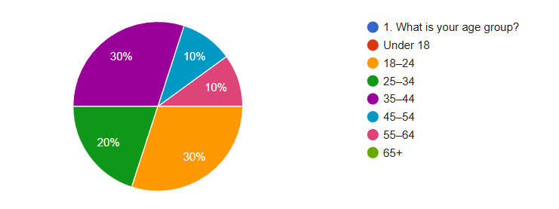

Figure 1: Age distribution of respondents
Results show the biggest age groups are 18–24 and 35–44, both at 30%. The 25–34 group represents 20%, and 45–54 and 55–64 both have 10% as well. There weren’t any respondents under eighteen or over sixty-five. In other words, most of the people who answered the questionnaire were adults. It is often people in these age groups who help arrange care for parents or other relatives.
This is relevant for the Ecoharmony Homecare idea because these are the people who are likely to look for care services and make decisions in their families.
It can also be useful to know the age of potential customers when thinking about marketing or the website. Because many adults search for services online, making the website simple and easy to use could help them find information more easily.

Factors influencing the choice of care services
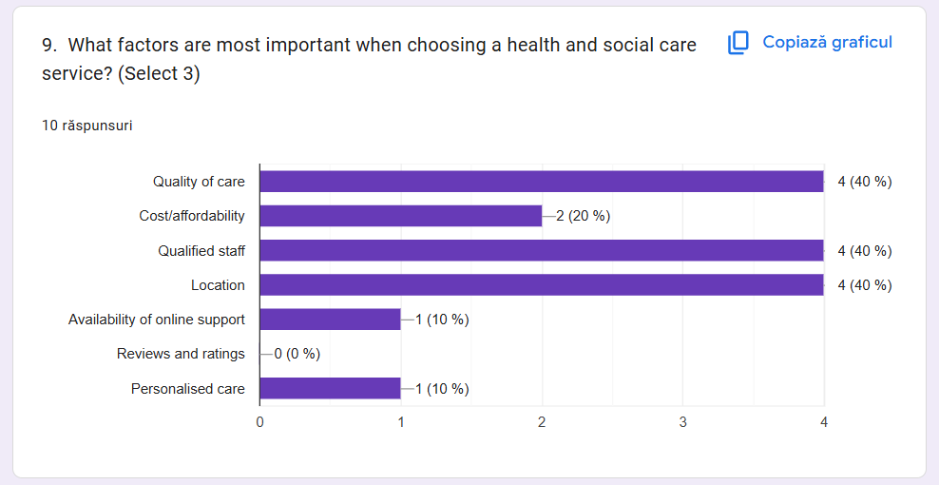
Figure 2: Factors influencing the choice of care services
According to the results, quality of care is the most important factor when selecting a care service, followed closely by qualified staff and location. 20% chose cost, while online support and personalised care were selected by 10%. No respondents selected reviews and ratings. This suggests that users are more concerned about the quality and reliability of care, rather than only the price of the service.
This is important for the Ecoharmony Homecare concept because it shows that potential users want professional and trustworthy care. When people see that staff are qualified and the service offers high-quality support, they may feel more confident choosing that provider. The website should also clearly show staff qualifications, quality of care and the services offered, as these factors appear to influence people’s decisions the most.

How people search for health and social care services
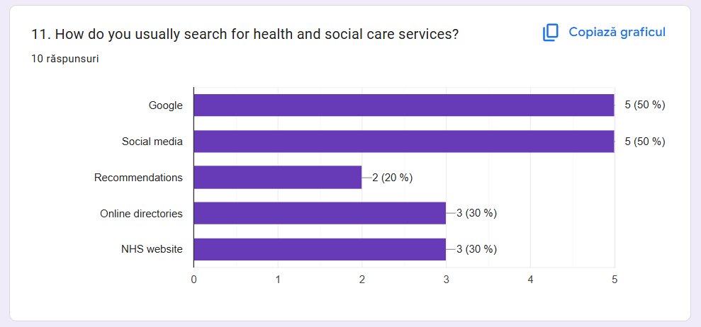
Figure 3: How people search for care services
According to the findings, 50% of individuals use Google or social media as their main way of searching for health and social care services. Around 30% of respondents said they use the NHS website or online directories, while about 20% rely on recommendations. This suggests that many people search online when looking for information about care services.
Because of this, having an online presence is important for the Ecoharmony Homecare concept. A well-designed website and some social media promotion could help make the service easier to find and allow people to access information about the care provided.

Willingness to pay for care services
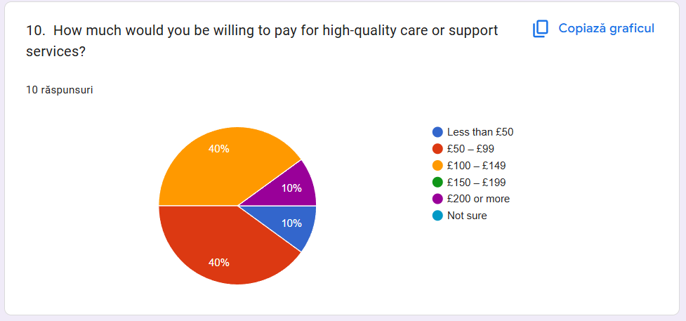
Figure 4: Willingness to pay
As shown by the results, 40% of respondents said they would be willing to pay between £50–£99, and another 40% chose £100–£149. Only 10% selected less than £50, while 10% said £200 or more. No respondents selected £150–£199 or not sure. The findings suggest that most people expect care services to be within a moderate price range.
This result is useful for the Ecoharmony Homecare idea because it gives an indication of what potential customers may be willing to pay for care services. Pricing within this range may therefore be more acceptable for users. Understanding these expectations can help when making decisions about pricing and how the service should be positioned in the market.

Audience Segmentation
The results of the questionnaire show that the target audience of Ecoharmony Homecare service is adults aged between 25 and 44. Individuals in these age groups frequently take responsibility for coordinating care for their parents or other family members. Because of this, they are usually more inclined to search for care services and compare providers before choosing one.
Knowing the audience is an important factor for this business idea because it helps decide how the services will be presented online. People in these age groups mostly search for services on Google or social media, so the website should be simple, clear and easy to navigate. This helps potential clients find information and contact the service.

Website Design and Development
To introduce the service of Ecoharmony Homecare online, a basic website was created using HTML and CSS. The objective of the site is to communicate clearly what services we offer to potential clients.
The website’s design has a clean structure and easy navigation. As the target audience mainly looks for services through the internet, the website needs to be user-friendly, with the information accessible to users without hassle.

Homepage
The Ecoharmony Homecare service business and its overall purpose are presented through the homepage. This page contains a brief description of the services offered and outlines the key benefits such as qualified staff, quality care and at-home support.
Furthermore, the homepage also has call-to-action buttons that direct users to the services page or the contact section. Users and potential customers should be able to easily navigate the site to find the information they are looking for.
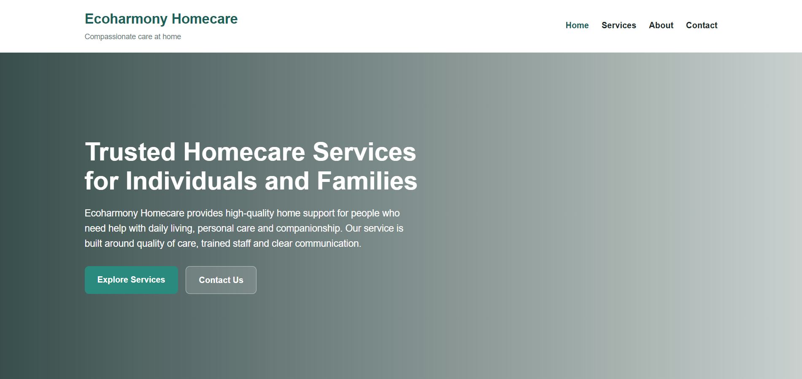
Figure 5: Homepage of Ecoharmony Homecare website

Services Page
The services page of Ecoharmony Homecare provides more details about the help we offer. The services include personal care, companionship and daily living support. Each service is explained in a clear and understandable way so that potential clients and families can understand what type of support is available to them.
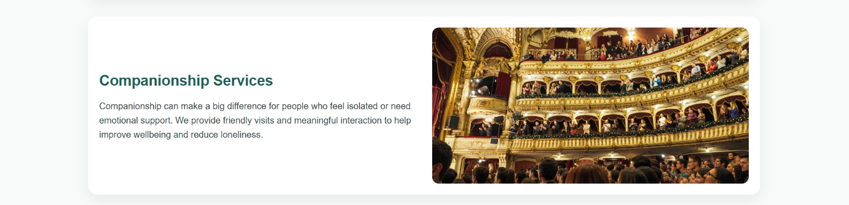
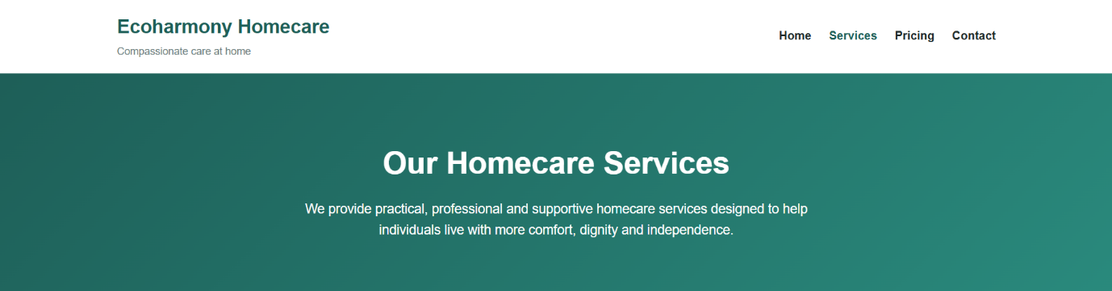
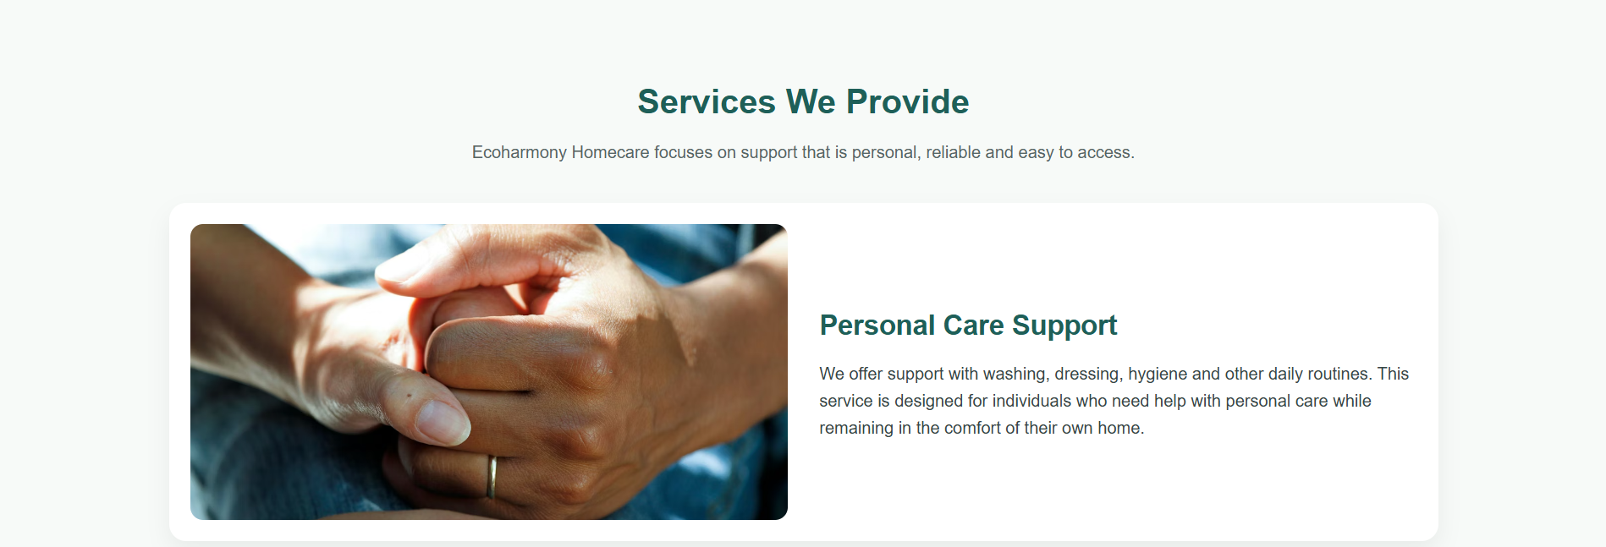

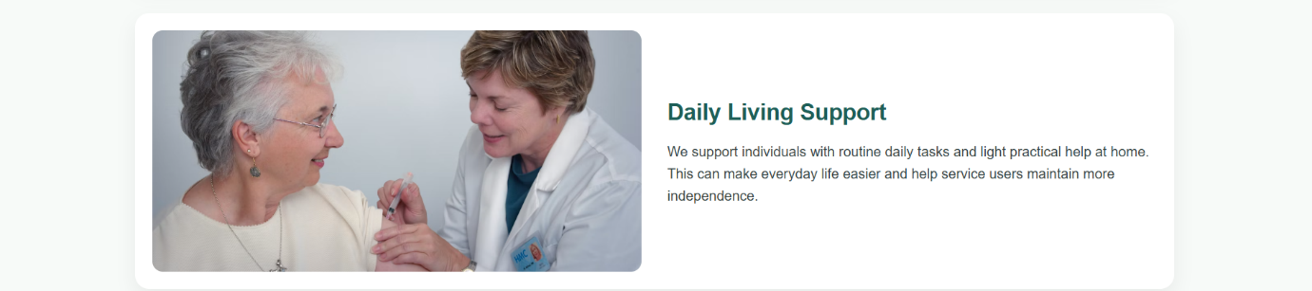

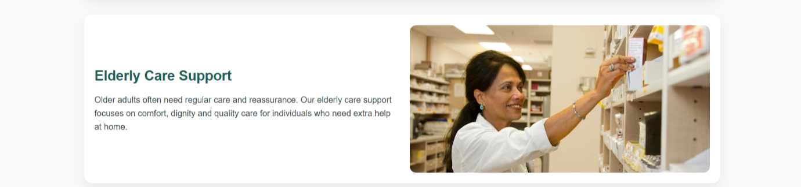
Figure 6: Services page of the website

Pricing Section
The website also includes a pricing section that provides an example of different support packages. This helps visitors understand the possible cost of services and compare different levels of support.
Providing pricing information increases transparency and helps build trust with potential clients.
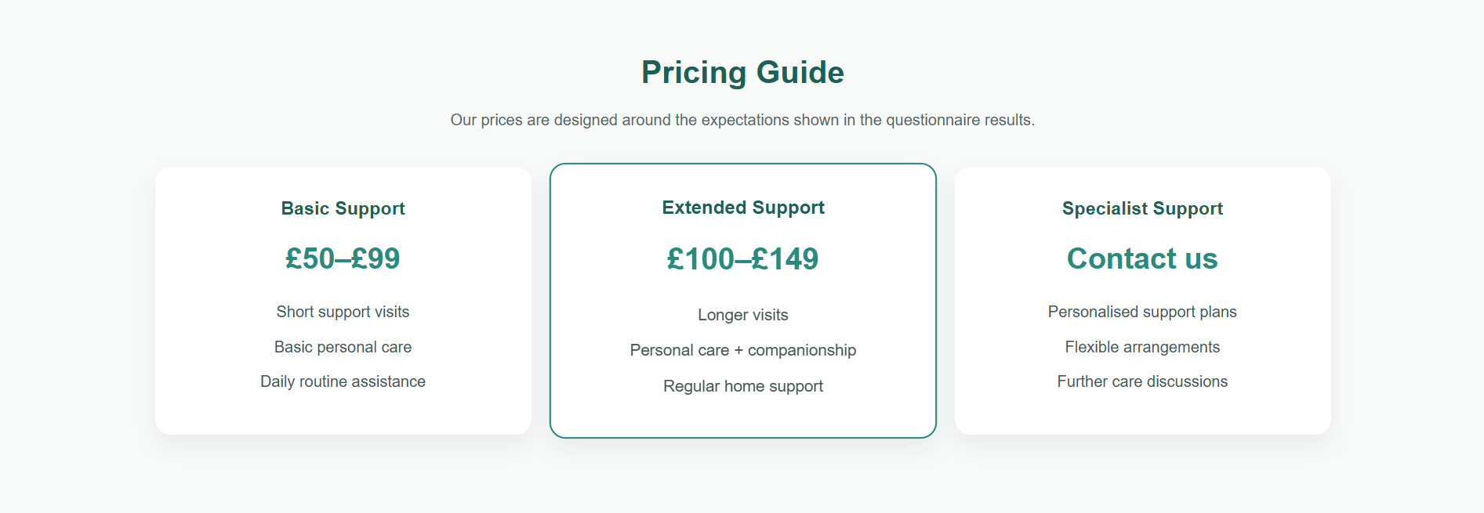
Figure 7: Pricing section of the website

Contact Section
The contact section allows users to easily reach the company by providing an email address, phone number and location. This makes it easier for potential clients or family members to request further information about the services.
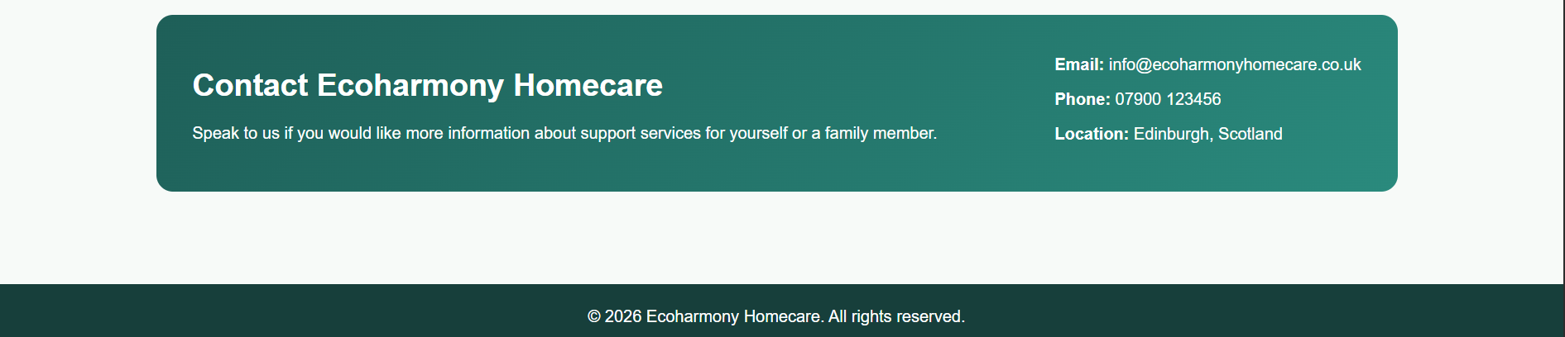
Figure 8: Contact section of the website

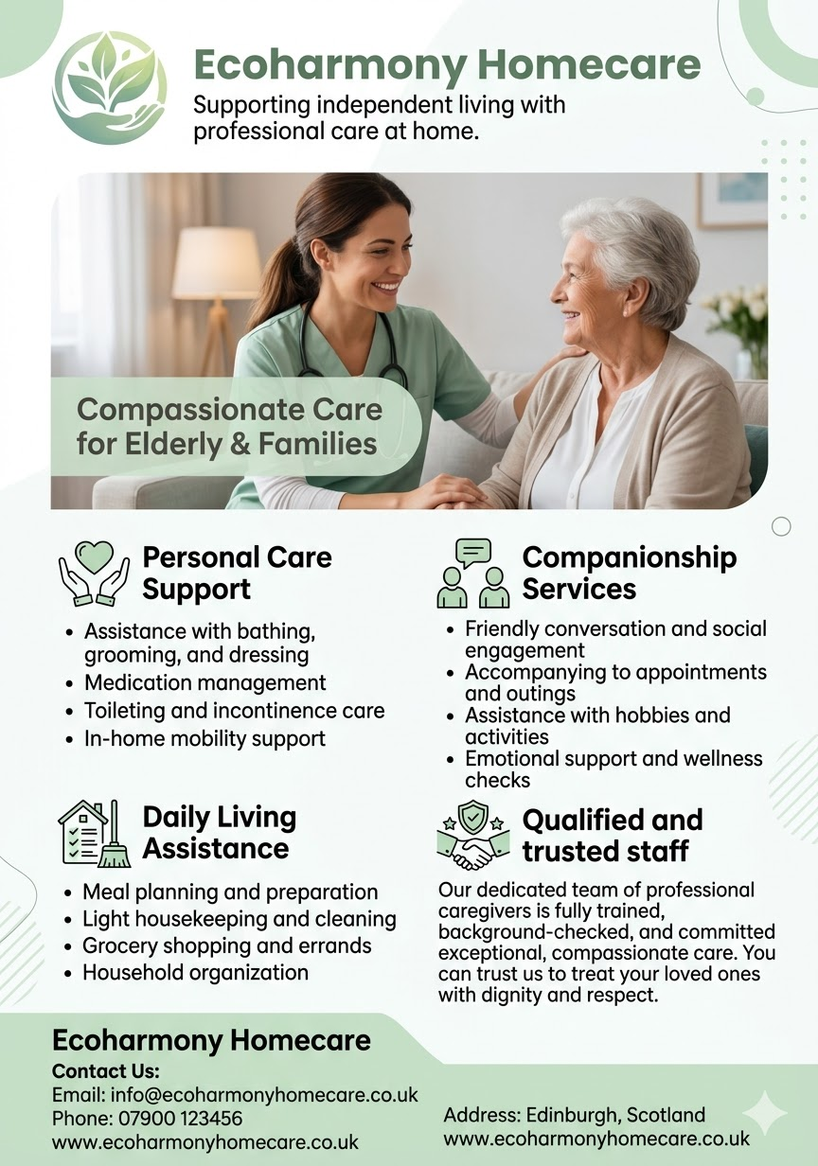
Figure 9: Promotional flyer for Ecoharmony Homecare homecare services

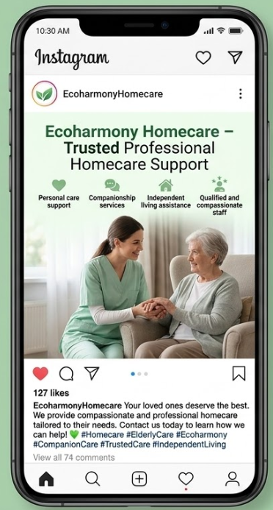
Figure 10: Instagram promotional post for Ecoharmony Homecare

References
Bryman, A. and Bell, E. (2015) Business Research Methods. 4th edn. Oxford: Oxford University Press.
Chaffey, D. and Ellis-Chadwick, F. (2019) Digital Marketing: Strategy, Implementation and Practice. 7th edn. Harlow: Pearson.
Kotler, P. and Keller, K.L. (2016) Marketing Management. 15th edn. Harlow: Pearson.
Krug, S. (2014) Don’t Make Me Think: A Common Sense Approach to Web Usability. 3rd edn. Berkeley: New Riders.
Mintel (2023) UK Home Care Market Report. London: Mintel.
NHS England (2022) Homecare Services Guidance. Available at: https://www.england.nhs.uk (Accessed: 15 March 2026).
Nielsen, J. (2012) Usability 101: Introduction to Usability. Available at: https://www.nngroup.com/articles/usability-101-introduction-to-usability/ (Accessed: 15 March 2026).
Office for National Statistics (2023) Health and Social Care Statistics in the UK. Available at: https://www.ons.gov.uk (Accessed: 15 March 2026).
Saunders, M., Lewis, P. and Thornhill, A. (2019) Research Methods for Business Students. 8th edn. Harlow: Pearson.
World Health Organization (2021) Integrated Care for Older People: Guidelines on Community-Level Interventions. Geneva: WHO.

Task 2

The Importance of Excel in the Digital Era and Its Role in Business Management
Businesses are relying more on digital technologies to manage information, analyse data and support business decisions. Microsoft Excel is one of the most widely used tools in the business industry. Excel is a spreadsheet application that helps users arrange data in a systematic way, perform calculations and analyse financial information. It is used by large, medium and small organisations to support day-to-day business operations because it is accessible and flexible. As explained by Laudon and Laudon (2020), spreadsheets and other digital tools allow organisations to manage information more effectively and improve decision-making.
Businesses are relying more on digital technologies to manage information, analyse data and support business decisions. Business organisations use Microsoft Excel for many day-to-day activities. Excel is a user-friendly spreadsheet application that lets users create, organise, calculate and analyse important financial information. Because of its accessibility and flexibility, it is used by large, medium and small organisations to carry out day-to-day business functions. According to Laudon and Laudon (2020), the increased use of digital information such as spreadsheets helps organisations manage information better and support the decision-making process.
Excel software has the advantage of automatically performing calculations with the help of formulas. Instead of calculating financial information by hand, businesses can use formulas to instantly calculate totals, expenses or profits. This helps save time when analysing business performance and reduces the chance of errors. For example, functions such as SUM allow companies to calculate total income or expenses, while subtraction formulas can be used to calculate profit or loss. Because of these simple but powerful functions, Excel is very useful for financial management.
One more major benefit of Excel is the ability to display data visually in charts and graphs. When financial information is visualised, it becomes easier for managers to understand trends and changes in business performance. Charts give a clearer idea of income, expenses and profitability than just looking at numbers. Boddy (2017) explains that the visualisation of business data helps managers interpret information better and supports decision-making.
Within the Ecoharmony Homecare business idea, Excel can help with financial planning and performance monitoring of the service. As a small homecare provider, the business needs to track how much income it generates from personal care support and companionship services. For the same reason, the company must also monitor operational expenses such as staff salaries, marketing costs, transport costs and administrative expenses. Using Excel, all of this financial information can be organised in a spreadsheet that projects income and expenses over twelve months.
Using Excel software helps Ecoharmony Homecare estimate the income the business could generate from homecare services and how the business may be affected by the expenses it incurs while operating the service. For instance, the monthly income from different services can be entered in the spreadsheet, and Excel formulas can calculate the total automatically. Likewise, adding expenses such as salaries and marketing costs gives the total operating expenses. Excel can then calculate profit or loss using a formula that deducts expenses from income. This helps business owners observe the financial performance of the business more clearly throughout the year.

Excel is also useful for financial projections. Forecasting helps businesses predict future financial performance by estimating revenue and expenses. Using Excel to create financial forecasts can show whether a company’s operations are likely to be profitable in the long run. The spreadsheet can also help identify problems if expenses increase or demand for services decreases. This gives business owners the opportunity to adjust their strategy, change prices and control expenses in order to maintain financial stability.
A key advantage of Excel is that it supports business decision-making. When managers are given organised financial data in spreadsheets, they are better able to see which areas are doing well and which areas need improvement. If the spreadsheet shows that staff salaries constitute the largest expense, the business may need to manage staffing costs more carefully. In a similar way, the business may decide to increase its promotional activities to stimulate demand. According to Kotler and Keller (2016), organisations can improve their strategic decisions by analysing market and financial information.
In addition, digital tools like Excel support research and assist in data analysis for business planning. The collection and interpretation of data often require the use of spreadsheets, which support many business decisions. According to Saunders, Lewis and Thornhill (2019), data analysis tools are useful for research and business planning. To that end, businesses can use Excel to collect data and assess business opportunities.
In conclusion, Microsoft Excel is an important computer program that is widely used in business environments. Organisations can organise data, perform calculations and analyse financial performance through charts and graphs in Excel. Small companies like Ecoharmony Homecare can find Excel a useful tool for financial forecasting, keeping records of expenses and analysing profitability. As organisations become more digital and data-driven, tools like Excel will continue to be an essential part of managing and planning a business.

References
Boddy, D. (2017) Management: An Introduction. 7th edn. Harlow: Pearson Education.
Bryman, A. and Bell, E. (2015) Business Research Methods. 4th edn. Oxford: Oxford University Press.
Kotler, P. and Keller, K.L. (2016) Marketing Management. 15th edn. Harlow: Pearson Education Limited.
Laudon, K.C. and Laudon, J.P. (2020) Management Information Systems: Managing the Digital Firm. 16th edn. Harlow: Pearson.
Saunders, M., Lewis, P. and Thornhill, A. (2019) Research Methods for Business Students. 8th edn. Harlow: Pearson Education.
Turban, E., Pollard, C. and Wood, G. (2018) Information Technology for Management: Driving Digital Transformation to Increase Local and Global Performance. 11th edn. Hoboken: Wiley.
World Health Organization (2021) Global strategy on people-centred and integrated health services. Available at: https://www.who.int (Accessed: 15 March 2026).

