

Programme: MBA International Hotel Management
Module: Intercultural Leadership in the Age of Globalisation
Module code: BMMB7031
Assignment Title: Personal Reflections on Intercultural Leadership- An In-Depth Analysis Based on Personal Experiences and Observations
Lecturer: Robyn Griffiths
Student name: Mohammad Arifur Rahman Khan
Student ID: 2022401

This Essay focuses on the nature of intercultural relations and intercultural leadership in today’s globalized world. This report categorises the challenges and nature of intercultural leadership by exemplifying the topic from the writer’s perspective, and theory. The findings of such situations of brokering ideas across cultures and an explicit self-analysis of applying different models, including Hofstede’s Cultural Dimension and Belbin’s Team Roles also convey an understanding of the nature of cultural intelligence and its possibilities and transformations in leadership.

To Identify and discuss relevant personal experiences Inter-cultural leadership is therefore a complex and therefore a sphere that dynamically develops through a person’s cultural interactions (Ashta and Stokes, 2023). Thus, it is worthy to say that my working experience, academic achievements, and social relationships helped me to develop an understanding of Intercultural Leadership. When reconsidering those scenarios, one realises the fact of how challenging can be to work and lead culturally diverse teams and organisations and how crucial it is to introduce and apply the appropriate leadership approaches depending on the cultural environment (Fey, Miska, and Ighani, 2023).
In my professional experiences, there are so many that involve intercultural leadership as a crucial factor. While pursuing my job with a multinational company, I was required to work with workers from diverse cultures. This environment required a leadership approach that would be culturally appropriate and would encourage the team members to provide cooperation. A specific memorable situation relates to a work assignment in which I had to effectively manage a group of professionals from diverse nations such as Japan, Germany, and Brazil. Every single worker possessed their culture and way of working and it created problems when they clashed at first. For instance, I expected that my Japanese counterpart would agree with me because they seemed to value harmony more than disagreement; while my expectation from my German counterparts was that they would be blunter than the Japanese and that they would appreciate more structured communication and decision making. Dealing with such differences involved cultural contingency and the recognition of the kind of leadership to apply in order to ensure that the differences did not lead to conflicts (Haddad, 2024).
In particular, the application of Hofstede’s Cultural Dimensions Theory proved to be rather effective in this regard. With the help of Hofstede’s model, I was able to grasp the deep-seated cultural factors affecting my team members’ actions and behaviours. For instance, since I acknowledged that power distance in Japanese society is considerably large, I tried to explicitly engage my counterparts from Japan in decision-making procedures so that they would feel appreciated. On the other hand, since the cultural dimensions of Germany are characterized by low power distance and collectivism (Hofstede, 2024), I did not avoid direct communication with my German counterparts. Besides managing the conflicts, this theory also helped the team’s cohesiveness and productivity improve.
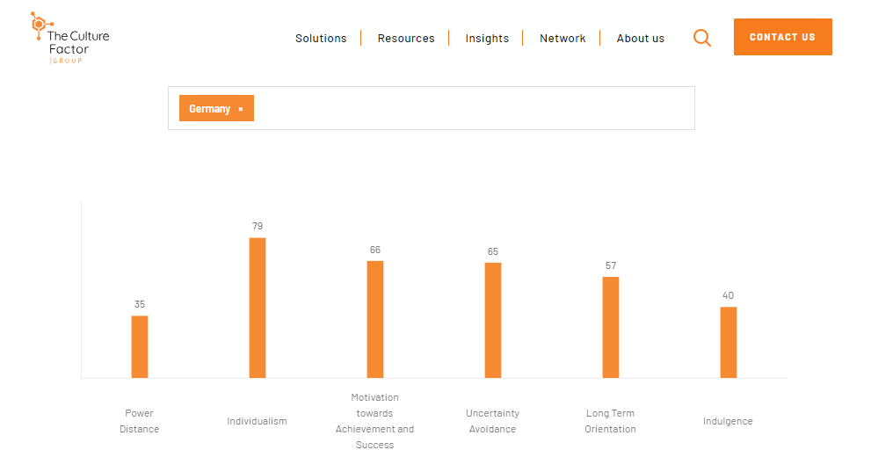
Figure 1: German index (Hofstede, 2024).
My academic studies have also greatly assisted me in the achievement of the intended objectives relating to intercultural leadership. While I was in university I socialize with different people from different countries in different group assignments. A specific assignment entailed creating a business plan for a start-up company and the group was comprised of students from India, China, Nigeria, and the United States. However, it also created issues for communication and teamwork that stemmed from people having different backgrounds and therefore, different ways of thinking. From this, I gathered knowledge on cultural sensitivity and the accomplishment of the need to exercise proper procedures in managing culture shock (Jin and Cortazzi, 2022).
This was supported by the Belbin Team Roles model in this academic environment. Nine specific roles have been distinguished by Belbin and each of them can be effective in certain conditions and inefficient in others. Of course, for this, one has to comprehend the roles that are preferred by each member of a team so that one can assign the tasks that are most likely to cause conflicts in the process (Majlergaard, 2023). For example, one of my teammates from China performed significant analysis during the activity, and I think it was the most suitable as a monitor-evaluator, while another from the United States was extremely creative. Through these roles, we were able to more efficiently and effectively create a well-executed business plan for our group as a whole.
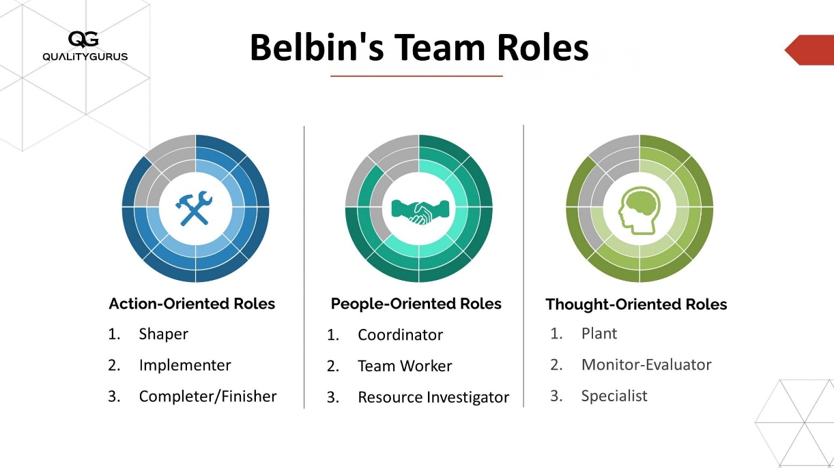
Figure 2: Belbin Team Roles (Drake, 2023).
Moreover, the social activities I have been involved in as part of my professional practice and my academic pursuits have provided insights into intercultural leadership. If I may recall my past, I remember growing up in a multicultural neighbourhood, and this enabled me to appreciate the cultural practices and beliefs of other people. This exposure opened and privileged the African cultural perspective while positing a value in understanding other cultures (Osland, 2023). For example, I one time volunteered to work at a community centre that had a client base of mostly immigrants. Successfully and unsuccessfully, in dealing with co-workers and business partners, I realized the complex opportunities and obstacles discerned in a multicultural environment.
Community welfare is a very significant aspect during my time in the community centre I realized that leadership means respect for the culture of every individual and acceptance of their dignity (Rosado-May, 2023). Moreover, according to Rosado-May, Cuevas-Albarrán, and Pat (2020) supporting the key leadership concept, empathy and listening skills are essential while dealing with intercultural communication experiences. Since it was my proactive approach to listen and analyse the issues that affected the clients in the community and respond appropriately, I was able to gain their trust and ensure that we achieved better reactions. This approach has roots in the theory of transformational leadership, which proposes to engage people by taking into consideration their self-interests and passions.
In light of such experiences, it will be equitable to affirm that intercultural leadership is more of a learning process that embraces knowledge, understanding, and interaction with cultural intensity and variation, coupled with the capacity to transform leadership approaches to comprehend and intertwine with the existing cultural contexts. The Hofstede and Belbin theories help analyse different cultures, yet to evaluate them, the perceived experience and ideas may be as useful (Smith, 2023). Every cross-cultural exchange presents a learning and development experience for the leaders and it helps build up the skills needed to manage people in multicultural environments.

Cross-cultural and cross-institutional environments play an influential role in leadership and management and they also place contingencies for the leaders and managers to follow according to specific circumstances (Yang, 2024). Analysing my practical work in different professional spheres, educational establishments, and social contexts, I have noticed how the described differences affected leadership and management techniques and how my reactions and changes occurred.
Hence, in my career experience, the multicultural and organizational environment of the multinational organization where I worked characterized leadership practices. The corporation was located in America and competed internationally, which means that leadership addressed American management’s requirements while working with local culture. The culture existing in the U. S., with a particular focus on the individualism and direct communication that prevailed there concerning the company and its subordinates, was intuitively evident and was significantly different from other countries with collectivism and hierarchical structures, where the company functioned (Adelakun and Oseni, 2023). The observed contrast could be better illustrated in relations with the contemporaries from Japan and Germany. Japanese leadership styles have intact organizational cultures that value cooperation and group conformity whereas the German leadership styles were characterized by system orientations with a large emphasis on orderliness and rationality when making decisions (Isife, 2023). While dealing with such distinctions of culture, the Change Agent Seven Stages; C-R-E-A-T-E-R seemed to be very much effective. In this regard, the most useful approaches were the stages of CARE and RELATE. CARE required the demonstration of teammate concern and appreciation of their cultures and this formed the basis of most of the trust in the teams. RELATE discusses the ways of communication and the cultural background of the work colleagues (Saxena, Hassan, and Salazar, 2023). Gaining team members’ trust as well as spending time to understand them culturally helped me in uniting the team. For instance, in Japan, I tried to grasp that family unity was of supreme value, so I changed the way I led and provided a platform for all the employees to make their inputs known.
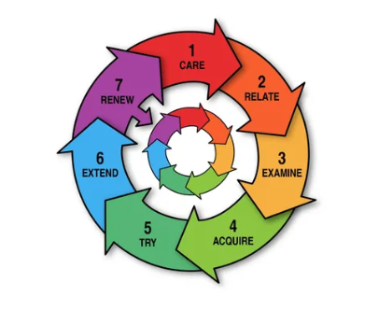
Figure 3: Change Agent Seven Stages (Yang, 2024).
Another factor relevant to this case was the issues of scaling and adaptation. Scaling meant introducing modifications of the scale of leadership impositions depending on the level of collectivism or individualism of the culture (Amin Mekheimer and Fageeh, 2024). For instance, when I was in Germany, I had to be more authoritative and formal since the culture of that nation integrates protocols and clear-cut hierarchies. However, in Japan, I had to mute assertiveness and adjust to work more on creating cooperation among people and winning their support. This was vital to facilitate the vision of leadership practices that were appropriate and efficient in the culture of the organization.
As for leadership behaviour, it also requires cultural sensitivity to adapt to different cultural environments. Individualism prevailed in America, so assertiveness and direct communication were appreciated as opposed to the collectivism of Japanese people who preferred to find a compromise in most cases (Dhiman and Marques, 2023). Knowledge of these cultural differences enabled me to align my leadership behaviour with those of my team members’ expectations. For example, in a project organized in Japan, I had to work more hierarchically and offer more guidance, than when encouraging other team members and involving them in the decision-making process. It was not only culturally sensitive but also effective in increasing staff motivation and the effectiveness of teams.
Recalling my academic experiences, I faced similar issues and saw the same potential in forming groups with my classmates of different cultural backgrounds. In this case, the stages of EXAMINE and ACQUIRE from the C-R-E-A-T-E-R managerial model would be of interest. EXAMINE required the critical evaluation of the cultural interactions that led to an assessment of group influence on the performance of tasks in a project (Wiersma-Mosley, 2023). For example, I realized that people from high-context cultures like China are more inclined toward indirect communication and less say much through gestures as compared to those students from low-context cultures like the USA who are more precise and less apprehensive regarding body language. Understanding these differences allowed me to inform my approach, thus fostering good interdependent relations.
ACQUIRE specifically concerned themselves with learning new information and abilities that will help them address issues that arise due to cultural diversities (Haddon, 2020). This concerned awareness of the cultural backgrounds of fellow students and cultural Sharpness. For instance, I made efforts to find out more about the Indian and Nigerian fellow’s cultural practices and how they relate within a team to better deal with their communication style. This learning process was always going on and it needed a person to open up and evolve into a better leader (Haddon, 2020). Regarding TRY and EXTEND, the latter was more relevant within social contexts which I have experienced during my volunteer work at a community centre. TRY meant that it was possible to use one leadership style but always adjust it depending on the results that were achieved as well as the response that was given by the people involved (Poort, Jansen, and Hofman, 2022). For example, I attempted multiple strategies for interacting with members of diverse cultures to find out what created confidence to share and work together. This experimentation helped me to evolve the specific leadership approach and come up with better techniques for the multicultural environment. The main areas that they encompass are outlined below: EXTEND aimed at enriching the leadership style to cover cultural diversity (Hieker and Pringle, 2021). This entailed going out of one’s way to come across people from other cultures and bothering to listen to their stories. For instance, I coordinated cultural display activities in the facility where people in the community could showcase their culture and way of life. It was also beneficial as it not only allowed me to gain exposure to other cultures but also cultivated the supporting and acceptance aspects of the community.
From these experiences, I have realized that culture and institution play a force role in leadership and management. Societal cultural values as such call for recognition, openness, capacity to learn and adapt when leading in other cultures. With the help of the C-R-E-A-T-E-R model, as well as scaling and adaptation processes, and leaders’ behaviour at different levels of analysis, it is possible to analyse these factors and give the guidance needed for the successful functioning of leaders in cross-cultural settings. However, the feature of cultural adaptiveness present in the C-R-E-A-T-E-R managerial model, especially through such stages as EXAMINE and ACQUIRE highlighted by Wiersma-Mosley (2023) or Haddon (2020), is not the only one to help in leadership contingencies As an alternative approach to studying leadership flexibility there is another model. For example, Belbin’s Team Roles deals with the identification of the strengths and roles of the individual members within a team. Unlike the C-R-E-A-T-E-R model focusing on incorporating cultural intelligence into learning, the Belbin model goes further by defining how many roles in a team interact to ensure an outstanding achievement of the objective (Drake, 2023). By combining the insights from both models, leadership practices may improve the degrees of cultural intelligence and the evaluation of the team specifics and members’ contributions in order to make a team work more effectively. This comparison approach highlights the fact that in leadership, one should embrace many-faceted methods that include cultural sensibility and team-role placement.
In my case, the implantation of cultural intelligence or CQ has been influenced by some specific experiences at work, during learning, and in everyday life. Cultural adaptability or cultural sensitivity, which is usually described as the ability to achieve satisfactory performance in a different cultural setting, is crucial in the contemporary global village where cross-cultural communication is the order of the day (Arghode, Yalcin, and Lawton, 2023). In my cocultivation account, I have learned that CQ is essential for successful interactions across cultures and efficient leadership and teamwork. My cultural intelligence was developed during my professional career particularly when I joined a multinational company where cultural difference was the order of the day. To begin with, Hofstede’s Cultural Dimensions Theory was used to make sense of these cultural differences. For example, Hofstede’s individualism/collectivism and uncertainty avoidance indices have helped me understand why certain colleagues behave or communicate in certain ways (Hofstede, 2024). In the context of Google, which pioneered itself as an innovative and open company to a large extent, these dimensions are vital for understanding the processes of team interactions and decision-making (Dawson and Andriopoulos, 2021). Google’s corporate culture tends to free rein and innovation and falls in the arrangement of individualism and low uncertainty avoidance.
Another theoretical foundation that enhanced my understanding includes Edgar Schein’s contribution in the area of organizational culture and norms that encompassed Subcategories as well as Espoused and Actual/Inferred beliefs. Analysing Google’s values, for example, can be only at first glance which value is the company promoting – openness or continuous innovation, but having this into consideration, the openness at the enterprise allows for such policies like “20% time”, where an employee is free to work on a project which creates interested in (De Mooij, 2019). Still, as was mentioned, risk-taking and failure tolerance assumptions which are not visible or measured are the key factors that determine innovation and distinguish Google’s culture as a strategic advantage rather than a risk. This is in line with Schein who postulated that organizational culture is multileveled, where the first level entails observable objects while the second level is a basic set of unwritten assumptions that guide behaviours (Ramakrishnan, 2013).
In applying cultural intelligence, I have learned to adapt my approach based on Handy's 4 classes of culture: Some of the organizational cultures that can be identified are; power culture, role culture, task culture and person culture (Azila-Gbettor, 2024). For instance, in a power culture that is sometimes witnessed in certain organizations, especially bureaucratic ones, knowledge of the power relations is very essential. On the other hand, at Google which tends towards being close to the task culture based on project teams and innovations, priority is accorded to cooperation and proficiency rather than status. Based on these realizations, cultural intelligence has been applied in different areas to improve teamwork and leadership (Battistella, 2024). For example, when working on a project which required collaboration with many people from different countries, I used my knowledge of cultural dimensions in or- gain to create an equal culture to which everyone could feel what is wanted. This particular solution also made the flow of information more effective while embracing the differences to encourage team cooperation.
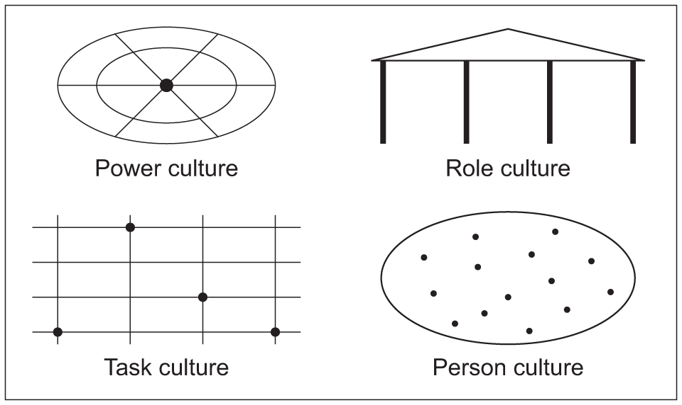
Figure 4: Handy's 4 classes of culture (Mulder, 2023)
After assessing my cultural intelligence, four out of the eight competencies were identified as my areas of strength: adaptability and empathy as applied to meeting and relating. However, I believe there is room for improvement in fields such as certain cultural wisdom and different approaches to intercultural communication tools. Looking at the future, I plan to exercise (Cultural Intelligence) CI even more deliberately and focus on CI issues in leadership roles where diverse cultural considerations are becoming more and more pivotal for organizational performance. This is why my process of building and practising cultural intelligence has involved such theoretical models as Hofstede’s Cultural Dimension Theory, Google’s organizational culture, Schein’s approach to organizational culture, and Handy’s classification. These approaches have enriched me in analysing cultural factors and have provided me with practical tools for success in multicultural settings. Culturally, I am willing to expand my knowledge of cultural intelligence to improve and apply the lessons to various organizations.
Whereas Hofstede’s Cultural Dimensions Theory gives a cursory insight into cultural differences from the aspect of individualism and uncertainty avoidance (Hofstede, 2024), Edgar Schein has taken his model down to the organizational culture dimensions and postulates that values and assumptions constitute layers of organizational culture (Ramakrishnan, 2013). Hofstede’s original work and his six dimensions are suitable for understanding large cultural patterns and their impact on communication and collaboration, as evidenced by the Google case of an innovative culture (Dawson & Andriopoulos, 2021). On the other hand, Schein’s framework reveals the assumption that explains the social practices of an organization, for instance, Google strategies that encourage risk-taking and innovation but operate under the premise of safety (De Mooij, 2019). They complement each other in the enhancement of the use of cultural intelligence in that while CI helps in the analysis of behaviours stereo specifically, cultural mapping assists in going an extra step deeper to look at the cultural underpinnings of behaviour within an organisation, which in the long run assists in leadership effectiveness. It also emphasizes the practicality of the comparative approach as the best way of integrating all the cultural aspects that are required in meeting the growing complexity of the cultural environment in organisation management and leadership.
The concept of intercultural leadership reveals significant complexities, which are however accompanied by equally promising potential for development and creativity. In my working and studying years, I came across and solved many situations that brought me to understand leadership and cross-cultural management.
Another interesting issue of intercultural leadership is that often people experience differences and fail to communicate properly if they are culturally diverse. It was in countering these issues that Belbin’s Team Roles theory turned out to be particularly useful since it focuses on the nature and utilization of teams and talents (Chatterjee, Chaudhuri, and Vrontis, 2024). For instance, in a cross-cultural team project, I experienced a lot of barriers to communication due to cultural differences in how people communicate and differ. Using the theory developed by Belbin which presents, for instance, “Shaper” and “Team worker” roles, I was able to determine each of the team members’ potential and harness it to promote a smooth teamwork procedure and minimize potential conflicts (Hallinger, 2023). Thus, Brokering and Re-Casting, as learnt in intercultural leadership, provide effective ways of dealing with cultural differences. Inter-cultural brokering can be defined as the process of acting between two or more cultural frameworks while trying to promote appreciation and collaboration. For instance, during my contribution to a project in which I was managing fellow team members from China and France, I presumed the role of a broker undertaking several important roles of translating expectations between the two cultures to meet the set objectives of the project. This process had to be done with care; the chair had to be culturally sensitive, always avoiding conflict of interest while at the same time ensuring that the input of all stakeholders was valued. In contrast, the strategy of the Re-Casting aims at redefining a conflict situation or a difficult task into a learning experience (Mitter, 2024). This approach came to light during a crisis management situation where the cultural differences made the situation worse which was already disturbing to the team. Through challenging the narrative and reframing the scenario as a challenge that would allow the team to work on enhancing its’ resilience and ‘learning agility’, I was able to initiate discussion and encourage collaboration. These events emphasised that client issues should be viewed as opportunities/solutions and cultural differences as a factor to drive change (Pincus, 2024).
Hence, intercultural leadership also offers many possibilities of opportunities to develop oneself personally and within one’s occupation (Potosky and Azan, 2023). I have had a cross-cultural experience and this has enabled me to learn different cultures and leadership theories that would have been uncommon to me back at home. For instance, I was once assigned a mentor from India who helped me notice how interpersonal skills are crucial in leadership by changing the perspective I had of leadership mainly focusing on the accomplishment of tasks. According to Belbin’s theory of Team Roles, this evidence also revealed ways of enhancing diversity as a way of positively enhancing the performance of the team (Rosenkranz, 2023). This way, I noticed cooperation enhanced and realized that proactivity and responsibility have increased simply because activity patterns of individuals in teams were consciously coordinated in a manner that shifted the tasks of participants toward what they would participate in most willingly. For example, splitting a conventional work role into a “Completer-Finisher” that focuses on details and a “Resource Investigator” that locates sources of information and ideas helped in attaining the project deliverables (Suhartono, 2023). Inter-cultural leadership encounters constitute one of the leading ways of getting to appreciate personal perceptions about synergy and leadership success. Thus, I have realized the importance of Cultural Intelligence in creating effective and efficient teams. Therefore, according to Earley and Ang’s CQ framework, cultural intelligence comprises cognitive, affective and social requirements that are vital in global contexts (IvyPanda, 2023). As I have pondered over the years, I was able to discern the need for learning and implementation in versatile areas of leadership.
The cultural transformation has been caused by my past experiences which have made me change to a new leadership style that accepts culture as a strength (IvyPanda, 2023). In this context, there is something real and tangible in Edgar Schein’s notions of organizational culture as a liability as opposed to an asset. Google companies can be used as an illustration of how strengthening and coming up with a culture of inclusion and creativity can help sharpen competitive advantage. In other words, the acknowledgement of cultural differences and usage of the revealed aspect as the strength are the major opportunities that may lead to a progressive organizational culture.
Overall, it is crucial to understand the specificity of cultural interaction and manage the conflicts and opportunities in the sphere of intercultural leadership. Hence, by applying such theories as Belbin’s Team Roles, Brokering and Re-Casting strategies together with empirical experiences, leaders can overcome cultural differences and utilize diversity towards the achievement of organizational objectives (Arghode, 2022). Moving forward in my leadership journey, I will actively enhance my cultural intelligence and use it effectively so that I can create multicultural and effective teams regardless of the environment.
When thinking of specific cases of brokering of ideas across cultural boundaries therefore one is equipped with insights of intercultural leadership complexity as well as its efficiency. In the social setting, I have been able to observe or participate in different aspects of multicultural communication and find it positive or negative. In my practice roster, one of the most memorable instances where I had to mediate the exchange of ideas across cultures was with a team comprised of people from India, Germany, and Brazil. As each team member contributed a gender and culture lens, they approached the problem and communicated differently at the start (Agent, 2023). One of the challenges with the project was that I had to come up with a marketing strategy for a global market, and this meant that I had to get all the aspects in sync.
Based on Hofstede’s Cultural Dimensions Theory, I realized that there are deviations in the interactions and choices of the members. For instance, my Indian colleagues favour policies of indirect communication and group decision-making since they are highly sensitive to uncertainty and have a collectivistic cultural background. On the other hand, the German participants provided direct and systematically affixed adorned results due to their low uncertainty avoidance and individualistic behaviour. These cultural differences were not helpful in the manner in which decisions were made or how ideas were implemented in practice. In an attempt to build common ground between these divides I used brokering approaches by engaging myself in the conversation and by engaging between the two seemingly opposing sides. One of the most successful strategies practised by the team was to establish skeleton brainstorming meetings that would enable every team member to voice ideas within particular domains of comfort while introducing other team members from other cultures to the conversation (Anazia, 2021). By accepting the variation in people’s perceived culture and focusing on the common end objectives, I was showing respect for people’s customs and incorporating them into combining our ideas into the final plan.
The feasibility of these brokering attempts could be deduced from the team’s capacity to embrace a convergent marketing perspective as proposed by the diverse participants involved. As a result of using knowledge of cultural dimensions and applying measures for working with multicultural teams, we achieved a balanced decision that would be effective for the global audience (Holtbrugge, 2022). The outcomes of the project demonstrated the significance of cultural sensitivity and leadership flexibility when managing cultural differences with a focus on the utilization of diversity as the most valuable asset. Furthermore, the Application of Belbin Team Roles theory enabled the fitting of roles according to one’s strengths and also preferences which improved the execution of tasks and the cohesiveness of the teams. For instance, it was possible to have a ‘Plant’ of a creative employee from Brazil and a ‘Coordinator’ of a German detail-oriented employee that guarantees both the flexibility of creative thinking and strict following of plans in the strategy formation (Adelakun and Oseni, 2023).
When looking at these experiences, one can identify several key areas of adjustment that are needed when brokering ideas between people of different cultures. Firstly, in that structured brainstorming sessions proved helpful in promoting conversation, it would appear that further attempts could have been made at integrating questions addressing cultural norms into the brainstorming activities. Organisational culture was assessed on three layers: artefacts, espoused values and underlying assumptions using Edgar Schein’s model with deeper penetration into the layers may have helped the team members to understand each other better and improve trust (Haddad, 2024). Moreover, incorporating the deeper sessions in culturally competent training or seminars could have supplemented other perspectives acknowledging cultural diversity among the staff. With suitable working theoretical models of intercultural communication and conflict-solving, the teams can be prepared to form the necessary coping strategies when working with intercultural clashes at the international level.
Additionally, if the method of brokering were expanded to focus on culturally based activities such as tours, cultural sensitivity training, and case study deliberation then team employees could have devised more effective common understanding and mutual respect. These approaches align with the re-framing of challenges into learning d challenges as viewed in the C-R-E-A-T-E-R model of development. Therefore, analysing the episodes of facilitating the exchange of ideas across cultures helps identify the threats and benefits that intercultural leadership entails. Hofstede’s Cultural Dimensions, Belbin’s Team Roles, and organizational cultures by Schein and other brilliant scholars’ theories help leaders and members tackle cultural issues and build collaboration (Jin and Cortazzi, 2022). In my future professional practice, I will continue the enhancement of CI (Cultural Intelligence) competencies and also the improvement of the searched skills for brokering ideas by the chosen stakeholders while paying more attention to the formation of efficient and diverse teams in the global environment.
In conclusion, the focus throughout this report has highlighted the necessity for culturally intelligent leadership in an intercultural context. First, using the principles of theoretical models, and the personal experience of practicing the bridging of ideas across cultural divides, one can appreciate the fact that diversity as a strength in organizations is the best way to ensure that such organizations are equipped with the ability to recover from any form of shock. Therefore, the future will call for further advancements and training in cultural intelligence, and fostering of good leadership traits and skills to enhance multicultural working environment as the world becomes a global village.

References
Abramson, N.R. and Moran, R. (2017) Managing Cultural Differences: Global Leadership for the 21st Century. Routledge.
Adelakun, E.A. and Oseni, T. (2023). Intercultural Competence and Youth Leadership Development in Lagos State. LEAD CITY JOURNAL OF THE SOCIAL, [online] Available at: http://lcu.edu.ng [Accessed 28 June 2024].
Agent, C. (2023) How do we learn?, CHANGE AGENT’S GUIDE. Available at: https://changeagentsguide.com/the-7-stages-of-change (Accessed: 29 June 2024).
Amin Mekheimer, M. and Fageeh, A. (2024). EFL College Programmes In Egypt And Saudi Arabia: Advantages And Difficulties In Intercultural Instruction. Journal of Intercultural Communication, 24(2), pp. 128-143. Available at: http://immi.se/jicc/index.php/jicc/article/view/646 [Accessed 26 June 2024].
Anazia, A. (2021) Organisational culture. S.l.: LAP LAMBERT ACADEMIC PUBL.
Arghode, V., Lathan, A., Alagaraja, M., Rajaram, K. and McLean, G.N. (2022). Empathic organizational culture and leadership: conceptualizing the framework. European Journal of Training and Development, 46(1/2), pp. 239-256. Available at: https://www.emerald.com/insight/content/doi/10.1108/EJTD-09-2020-0139/full/html [Accessed 22 June 2024].
Arghode, V., Yalcin, S., and Lawton, M. (2023). Emotional intelligence, intercultural competence and online instruction: Review and reflection. Journal of Educational Technology and Society, 26(1), pp. 137-148. Available at: https://www.emerald.com/insight/content/doi/10.1108/JET-09-2022-0165/full/html [Accessed 30 June 2024].
Ashta, A. and Stokes, P. (2023) ‘A consideration of the dimensions of servant leadership in intercultural contexts: A focal case study of a UK executive in Japan’, Asian Journal of Business Ethics, 12(2), pp. 347–368. doi:10.1007/s13520-023-00177-2.
Azila-Gbettor, E.M. (2024) ‘Reviewing the influence of positive leadership on worker well-being: A comprehensive analysis’, Heliyon, 10(2). doi:10.1016/j.heliyon.2024.e24134.
Battistella, C. (2024) ‘The impact of cultural dimensions on Project Management Performance’, International Journal of Organizational Analysis, 32(1), pp. 108–130. doi:10.1108/ijoa-11-2022-3498.
Booher, M., Rodriguez, M. and DiMatteo, T. (2023) Culture impact strategies to create world-changing workplaces. La Vergne: Influence Network Media, LLC.
Chatterjee, S., Chaudhuri, R. and Vrontis, D. (2024) ‘Does data-driven culture impact innovation and performance of a firm? an empirical examination’, Annals of Operations Research, 333(2–3), pp. 601–626. doi:10.1007/s10479-020-03887-z.
Chaurasia, S. and Singh, P.K. (2020) Leadership behaviour Sharad Chaurasia, Praveen Kumar Singh. Saarbrücken: LAP LAMBERT Academic Publishing.
Dawson. P, Andriopoulus. C, (2021). Managing change, Creativity and Innovation. 4th ed. Sage. London.
De Mooij. Marieke (2019) Consumer Behaviour and Culture. (3rd ed). Sage, London.
Dhiman, S. and Marques, J. (2023). Handbook of Global Leadership and Followership: Integrating the Best Leadership Theory and Practice. Cham, Switzerland: Springer International Publishing. Available at: https://link.springer.com/book/10.1007/978-3-030-90726-2 [Accessed 27 June 2024].
Drake, T. (2023) Belbin’s Team roles. Available at: https://www.ifm.eng.cam.ac.uk/research/dmg/tools-and-techniques/belbins-team-roles/ (Accessed: 29 June 2024).
Fey, N., Miska, C. and Ighani, J. (2023) ‘Rethinking the role of Cultural Intelligence: A relational view on intercultural leadership coaching’, Academy of Management Proceedings, 2023(1). doi:10.5465/amproc.2023.10933abstract.
Gulikers, J., Brinkman, D., and Runhaar, P. (2022). Using a rubric to grasp intercultural competence development in vocational education. Journal of Vocational Education and Training, 73, pp. 47-70. Available at: https://doi.org/10.1080/13636820.2019.1688854 [Accessed 24 June 2024].
Haddad, E. (2024) ‘Leveraging social media, Big Data, and Smart Technologies for Intercultural Communication and Effective Leadership: Empirical Study at the Ministry of Digital Economy and Entrepreneurship’, International Journal of Data and Network Science, 8(2), pp. 857–870. doi:10.5267/j.ijdns.2023.12.019.
Haddon, H. (2020). Starbucks ties executive pay to 2025 diversity targets. The Wall Street Journal. Available at: https://www.wsj.com/articles/starbucks-ties-executive-pay-to-2025-diversity-targets-11602680401 [Accessed 23 June 2024].
Hallinger, P. (2023) ‘A conceptual framework for systematic reviews of research in Educational Leadership and Management’, Journal of Educational Administration, 51(2), pp. 126–149. doi:10.1108/09578231311304670.
Hieker, C. and Pringle, J. (2021). The future of leadership development: Disruption and the impact of megatrends. Cham, Switzerland: Springer Nature.
Hofstede (2024) Country comparison tool, Hofstede Insights. Available at: https://www.hofstede-insights.com/country-comparison-tool (Accessed: 20 June 2024).
Holtbrugge. D, (2022) Intercultural Management, Concepts, Practice, Critical Reflection. Sage, London.
Indeed (2023) 10 key leadership behaviors for effective leaders | indeed.com. Available at: https://www.indeed.com/career-advice/career-development/leadership-behaviors (Accessed: 24 June 2024).
Isife, E.E. (2023). Intercultural Philosophy and the Question of Leadership in Africa. AMAMIHE Journal of Applied Philosophy, [online] Available at: http://acjol.org [Accessed 25 June 2024].
IvyPanda. (2023). Handy and Schein Models in Organizational Culture. IvyPanda. Available at: https://ivypanda.com/essays/handy-and-schein-models-in-organizational-culture/ [Accessed 29 June 2024].
Jin, L. and Cortazzi, M. (2022) ‘Intercultural Communication Competence for Responsible Leadership’, Responsible Leadership, pp. 139–153. doi:10.4324/9781003129189-14.
Majlergaard, F. (2023) Intercultural leadership – challenges and opportunities, Gugin. Available at: https://gugin.com/intercultural-leadership-challenges-and-opportunities/ (Accessed: 28 June 2024).
Malik, P. (2024) The role of a change agent: Characteristics, types, skills (2024), The Whatfix Blog | Drive Digital Adoption. Available at: https://whatfix.com/blog/change-agent/ (Accessed: 27 June 2024).
Meadenall, M., Osland, J. (eds) and Bird, A. (2017) Global Leadership: Research, Practice and Development. Routledge
Mitter, C. (2024) ‘Does National Culture Impact Management Control Systems? A systematic literature review’, Review of Managerial Science, 18(1), pp. 209–257. doi:10.1007/s11846-023-00661-w.
Mulder, P. (2023) Handy model of Organisational Culture (handy and Harrison), Toolshero. Available at: https://www.toolshero.com/management/handy-model/ (Accessed: 25 June 2024).
Nickerson, C. (2023) Hofstede’s Cultural Dimensions Theory and Examples, Simply Psychology. Available at: https://www.simplypsychology.org/hofstedes-cultural-dimensions-theory.html (Accessed: 22 June 2024).
Oc, B. (2023) ‘The study of followers in leadership research: A systematic and Critical Review’, The Leadership Quarterly, 34(1), p. 101674. doi:10.1016/j.leaqua.2022.101674.
Osland, J.S. (2023) ‘A model of trigger events and sensemaking in the intercultural context: A cognitive approach to Global Leadership Effectiveness’, Advances in Global Leadership, pp. 111–138. doi:10.1108/s1535-120320230000015004.
Pincus, J.D. (2024) ‘Leadership as a determinant of need fulfilment: Implications for meta-theory, methods, and Practice’, Frontiers in Psychology, 15. doi:10.3389/fpsyg.2024.1427072.
Poort, I., Jansen, E., and Hofman, A. (2022). Does the group matter? Effects of trust, cultural diversity, and group formation on engagement in group work in higher education. Higher Education Research and Development, 41, pp. 511-526. Available at: https://doi.org/10.1080/07294360.2020.1839024 [Accessed 18 June 2024].
Potosky, D. and Azan, W. (2023) ‘Leadership behaviours and human agency in the Valley of Despair: A meta-framework for organizational change implementation’, Human Resource Management Review, 33(1), p. 100927. doi:10.1016/j.hrmr.2022.100927.
Ramakrishnan, K. (2013) Managerial Leadership in Multicultural Organisations. Prentice -Hall.
Rosado-May, F.J. (2023) ‘Servant leadership: A critical component in the conservation of Natural Resources – an intercultural approach’, The Palgrave Handbook of Servant Leadership, pp. 895–915. doi:10.1007/978-3-031-01323-2_52.
Rosado-May, F.J., Cuevas-Albarr&aacute;n, V.B. and Pat, N.F.J. (2020) Intercultural leadership: An Indigenous perspective in a multicultural world, SpringerLink. Available at: https://link.springer.com/chapter/10.1007/978-3-030-38129-5_16 (Accessed: 25 June 2024).
Rosenkranz, R.R. (2023) ‘Physical activity capability, opportunity, motivation and behaviour in youth settings: Theoretical framework to guide Physical Activity Leader Interventions’, International Review of Sport and Exercise Psychology, 16(1), pp. 529–553. doi:10.1080/1750984x.2021.1904434.
Saxena, A.K., Hassan, M. and Salazar, J.M.R. (2023). Cultural intelligence and linguistic diversity in artificial intelligent systems: A framework. Artificial Intelligence, [online] Available at: http://neuralslate.com [Accessed 26 June 2024].
Smith, S. (2023) How to become an intercultural leader, Hult EF Corporate Education. Available at: https://www.hultef.com/en/insights/research-thought-leadership/how-to-become-an-intercultural-leader/ (Accessed: 25 June 2024).
Song, H., Varma, A. and Zhang Zhang, Y. (2021) ‘Motivational Cultural Intelligence and Expatriate Talent Adjustment: An exploratory study of the moderation effects of cultural distance’, The International Journal of Human Resource Management, 34(2), pp. 344–368. doi:10.1080/09585192.2021.1966491.
Suhartono, S. (2023) ‘The relationship of leadership, discipline, satisfaction, and performance: A case study of steel manufacture in Indonesia’, International Journal of Professional Business Review, 8(2). doi:10.26668/businessreview/2023.v8i2.1146.
Wiersma-Mosley, J.D., Banton, C., Klein, T., and Hart, S. (2023). Intercultural Competence and Anti-Racism among College Students. Currents: Journal of Diversity Scholarship for Social Change, 3(1). Available at: https://journals.publishing.umich.edu/currents/article/id/2348/ [Accessed 20 June 2024].
Yang, Y. (2024) Intercultural Perspectives on Managing organizational change in response to government policy reform: A case study on the leadership of New Oriental Education [Preprint]. doi:10.22371/05.2024.004.

