
Name: Muhammad Imran
Student ID: 2311530
Lecturer: Dian Mayasari
Module: Design Thinking and Innovation
Module Code: LCLM 6002
Assignment Title: Innovation & Customer Journey

Table Of Contents

Title Page ………………………………………………………………………………………………………… 1
Table Of Contents…………………………………………………………………………………….2-4

1. Introduction to Asda……………………………………………………………………………………………………5
1.1 Company Overview ………………………………………………………………………………………………………….5
1.2 Mission and Strategic Context ………………………………………………………………………………………………………….5
1.3 Purpose of the Report ………………………………………………………………………………………………………. 5

2. Key Consumer and Industry Trends Affecting Asda……………………………………………………... ………………………………………6
2.1 Digitalisation and E-Commerce Growth ………………………………………………………………………………………………………. 6
2.2 Sustainability and Ethical Consumption ………………………………………………………………………………………………………. 7
2.3 Cost-of-Living Crisis and Value Orientation ………………………………………………………………………. …………………………….8
2.4 Convenience and Hybrid Shopping …………………………………………………………………………………… ………………….9
2.5 Technology-Enabled Customer Experience ………………………………………………………………………………………………………9-10

3. Innovation Ambition Matrix: Asda’s Innovation Portfolio……………………………………………………………………………………………10

Figure 1: Innovation Ambition Matrix for Asda ………………………………………………………………………………………………………11
3.1 Core Innovations ………………………………………………………………………………………………………. 12
3.2 Adjacent Innovations ……………………………………………………………………………………………………….13
3.3 Transformational Innovations……………………………………………………………………………………13-14

4. Customer Journey Mapping: Current Asda Experience………………………………………………. 15

Figure 2: Asda Current Customer Journey Map………………………………………………………………………………………………… 15
4.1 Pain Points and Gain Points ……………………………………………………………………………………………15
4.2 Opportunities for Digital Innovation…………………………………………………………………………………. 16

Part 2 – Digital Transformation Initiative and Enhanced Customer Journey….16

5. Proposed Digital Transformation Initiative for Asda ……………………………………………………. 16
5.1 Asda 360 Digital Ecosystem Overview………………………………………………………………………………. 16
5.2 Rationale for Digital Transformation…………………………………………………………………………………. 17
5.3 Implementation Framework (Integration–Intelligence–Innovation)……………………………………… 18
5.4 Expected Organisational and Market Benefits…………………………………………………………………. 20
5.5 Risks and Mitigation Strategies………………………………………………………………………………………… 21
5.6 Strategic Alignment………………………………………………………………………………………… 22
6. Enhanced Customer Journey Map: Asda 360 Experience……………………………………………. 23
Figure 3: Design Thinking Model (Brown, 2008)………………………………………………………………. 22
Figure 4: Enhanced Customer Journey Map………………………………………………………………………. 23
6.1 Journey Improvement…………………………………………………………………………………… 23

7. Organisational Impact of the Initiative………………………………………………………………………… 24

7.1 Operational Efficiency ……………………………………………………………………………………………………… 24
7.2 Customer Satisfaction and Loyalty ……………………………………………………………………………………. 25
7.3 Financial Performance ……………………………………………………………………………………………………. 26
7.4 Sustainability and CSR Impact ………………………………………………………………………………………… 27

8. Measuring Success……………………………………………………………………………………………28
8.1 KPIs and Steering Group Dashboard …………………………………………………………………………………. 28
Figure 5: Asda 360 Gantt Chart ………………………………………………………………………………………… 29

9. Conclusion………………………………………………………………………………………30-31

10. References

…………………………………………………………………………………………………32-35

1. Introduction to Asda

Asda Stores Ltd is one of the largest retail supermarket chains in the United Kingdom, with a market share of approximately 13.6% as of 2024 (Kantar, 2024). Founded in 1949 and headquartered in Leeds, Asda operates more than 600 stores nationwide, offering groceries, clothing, household products, and financial services (Asda Annual Report, 2024). Historically part of Walmart, Asda was acquired by the Issa brothers and TDR Capital in 2021, which initiated a strategic transformation to re-establish Asda’s competitiveness in a rapidly digitalising and sustainability-driven retail environment (Euromonitor, 2023).

Asda’s mission focuses on providing value through affordability while improving convenience and customer engagement via digital channels (Asda Corporate, 2024). Its business model combines large-format supermarkets with growing convenience outlets (“Asda Express”), supported by online shopping and click-and-collect services. In recent years, Asda has invested heavily in supply-chain digitalisation, customer-experience design, and green logistics, reflecting the company’s ambition to align innovation with operational efficiency (GD, 2024).

The following analysis applies two key frameworks — the Innovation Ambition Matrix and Customer Journey Mapping — to examine Asda’s current innovation approach and identify opportunities for digital transformation.

2. Key Consumer and Industry Trends Affecting Asda

The UK retail landscape continues to experience structural transformation driven by digitalisation, changing consumer expectations, and sustainability imperatives. For Asda, these forces present both risks and opportunities. Responding effectively requires strategic agility, investment in technology, and a sharper focus on customer experience. The following trends are the most significant influences shaping Asda’s strategic direction in 2024–2025.

2.1 Digitalisation and E-Commerce Growth

Digitalisation remains the single most disruptive force within UK retail. Online grocery penetration, which surged during the COVID-19 pandemic, has now stabilised at around 11–13% of total grocery sales (Statista, 2024). Although growth has slowed, digital shopping is now embedded as a permanent behavioural shift rather than a temporary convenience. Consumers increasingly expect frictionless, personalised, and omnichannel experiences that bridge mobile apps, websites, and physical stores.

Asda has been slower than Tesco and Sainsbury’s in developing a fully integrated digital ecosystem. Competitors’ advanced loyalty schemes—such as Tesco Clubcard Plus and Nectar 360—demonstrate the growing strategic importance of customer data analytics (Mintel, 2024). To remain competitive, Asda has accelerated its e-commerce modernisation, improving website usability, expanding click-and-collect services, and investing in predictive inventory systems(Deloitte, 2023).

Additionally, same-day and ultra-fast delivery have emerged as new industry benchmarks. The rise of quick-commerce platforms such as Getir, Uber Eats, and Deliveroo has altered consumer expectations around immediacy. Asda’s partnerships with Uber Eats and Deliveroo therefore mark a strategic move to capture the convenience-driven online segment (Deloitte, 2023). This partnership model allows Asda to expand digital reach without overhauling its entire logistics network—a cost-effective approach to omnichannel expansion.

Asda’s challenge is to evolve from a transactional online retailer into a digitally intelligent ecosystem that anticipates customer needs through AI and real-time data analytics. This evolution underpins the strategic rationale for the proposed Asda 360 Digital Ecosystem outlined later in the report.

2.2 Sustainability and Ethical Consumption

Sustainability has transitioned from a niche concern into a mainstream purchasing criterion. UK consumers—especially younger cohorts—expect retailers to demonstrate measurable commitments to reducing carbon emissions, plastic waste, and food waste (Nielsen, 2023). Asda’s initiatives, including its “Plastic Unwrapped” and “Greener at Asda Price” campaigns, signify steps toward environmental leadership. The company has pledged to make all packaging recyclable and to achieve net-zero emissions by 2040.

However, research indicates that customers increasingly seek evidence-based transparency rather than marketing claims (PwC, 2023). Competitors like Sainsbury’s and Co-op have introduced carbon labelling and ethical sourcing trackers, intensifying pressure on Asda to expand measurable sustainability disclosure. Integrating digital tools such as EcoTrack—a proposed carbon-footprint dashboard—would align Asda with these market expectations.

Furthermore, sustainability now influences not only brand reputation but also regulatory compliance. The UK’s Streamlined Energy and Carbon Reporting (SECR) framework requires retailers to disclose annual energy and emissions data (Gov.UK, 2024). Integrating sustainability analytics into Asda’s operations supports compliance, strengthens ESG performance, and enhances investor confidence.
Ethical consumption also extends to social responsibility. Consumers are increasingly attentive to fair-labour practices, supplier transparency, and local sourcing (Forbes, 2024). Asda’s use of blockchain-enabled traceability could therefore reinforce trust and create differentiation in a crowded retail marketplace.

2.3 Cost-of-Living Crisis and Value Orientation

Since 2022, inflationary pressures and stagnant wages have reshaped UK consumer behaviour. The cost-of-living crisis has made affordability the dominant purchase driver, benefiting discounters like Aldi and Lidl whose combined market share now exceeds 20% (The Guardian, 2023). Asda’s mid-price positioning places it under pressure to defend its customer base while maintaining profitability.

Consumers are becoming more price elastic, with reduced brand loyalty and increased focus on promotions. To address this, Asda has invested in AI-powered pricing algorithms and digital shelf-edge technology that dynamically adjust prices in line with competitors (Retail Week, 2023). Its Asda Rewards app—which gamifies savings through “cashpots”—represents a strategic move to retain value-conscious customers while building emotional loyalty.

However, the dual challenge lies in maintaining value perception while introducing digital innovation, which can add short-term costs. Balancing affordability with experience differentiation will be critical if Asda is to compete effectively against both premium and discount retailers. Asda’s commitment to “value with purpose”—offering affordable yet sustainable products—may become its key competitive narrative.

2.4 Convenience and Hybrid Shopping

The line between online and offline retail has blurred, giving rise to hybrid shopping behaviours. Consumers now expect seamless transitions between browsing online, collecting in-store, and receiving home delivery (GD, 2024). Convenience is increasingly defined not just by proximity but by speed, flexibility, and digital integration.

Asda’s acquisition of EG Group’s convenience stores and the rollout of Asda Express outlets represent a significant strategic shift from hypermarket formats toward local, high-frequency retailing. These smaller stores offer click-and-collect, parcel pickup, and fuel services, positioning Asda within the rapidly expanding convenience segment.

Moreover, Asda’s collaboration with Just Walk Out technology providers is paving the way for cashier fewer smart stores, enhancing both speed and personalisation (Accenture, 2023). Integrating mobile payments and loyalty recognition into these stores will allow customers to accumulate Rewards points automatically, creating a unified “phygital” (physical + digital) experience.

Hybrid retailing also creates opportunities for Asda to use in-store data—such as dwell time and footfall analytics—to refine online promotions, bridging the gap between channels. This integration supports the company’s ambition to deliver consistent, cross-platform experiences under its Asda 360 framework.

2.5 Technology-Enabled Customer Experience

Technological innovation underpins every major retail trend. The application of artificial intelligence (AI), machine learning (ML), and predictive analytics is transforming everything from stock optimisation to marketing personalisation (Deloitte, 2023). Retailers increasingly rely on data to create hyper-personalised experiences that encourage loyalty and incremental spending.

Asda’s partnership with Accenture (2023) to modernise its IT infrastructure is a critical enabler of this transformation. The collaboration focuses on cloud migration, data governance, and analytics capabilities that support real-time decision-making. Such initiatives allow Asda to transition from a reactive to a predictive business model, improving both operational agility and customer experience.

Emerging technologies like Internet of Things (IoT) and augmented reality (AR) are also reshaping in-store engagement. IoT devices monitor energy efficiency and product freshness, while AR applications could soon allow customers to visualise promotions or recipe suggestions via their smartphones. By embracing these innovations, Asda strengthens its reputation as a modern, tech-forward retailer without compromising its affordability promise.

Part 1: An Analysis of the organisations approach to Innovation including application of the Innovation Ambition Matrix and the Current Customer Journey Map.

3. Innovation Ambition Matrix: Asda’s Innovation Portfolio

The Innovation Ambition Matrix (Nagji & Tuff, 2012) categorises innovation into three horizons:
- Core Innovation: Optimising existing operations and offerings
- Adjacent Innovation: Expanding into related markets or capabilities
- Transformational Innovation: Creating entirely new business models or markets
Figure 1. Innovation Ambition Matrix for Asda
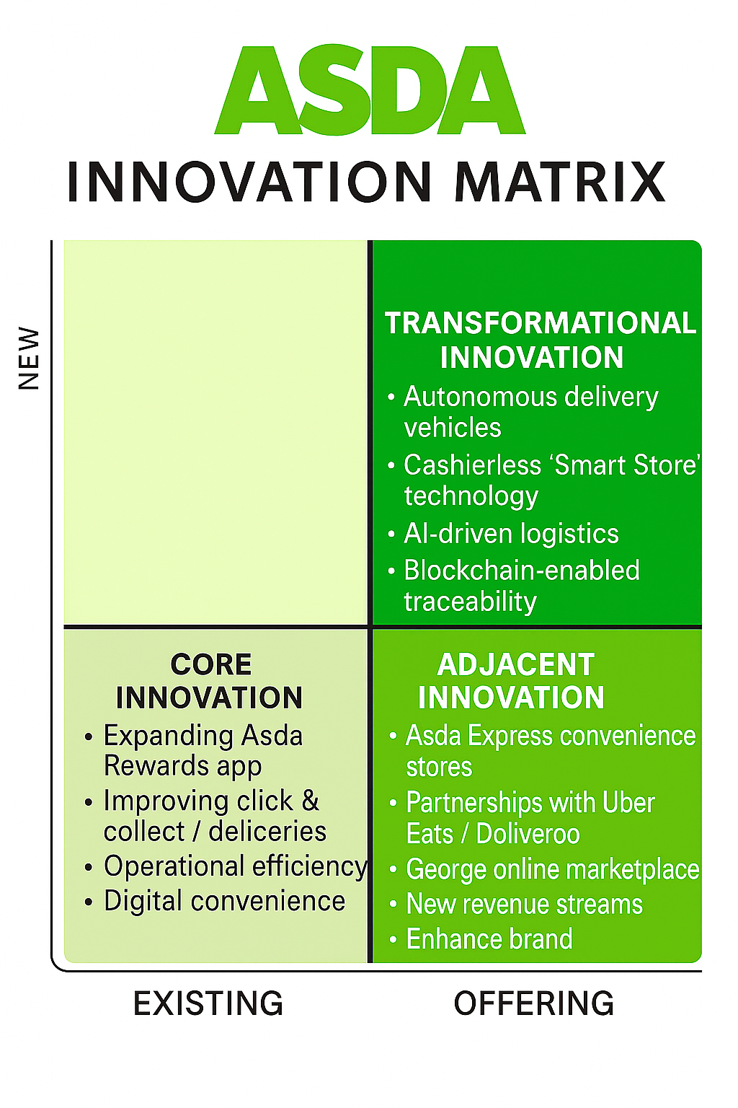

3.1 Core Innovations

Asda’s core innovations continue to revolve around operational efficiency, digital convenience, and delivering value for money—attributes that underpin its long-standing market position as a price-led retailer. By focusing on optimising store layouts, automating inventory management, and modernising online platforms, Asda seeks to reduce costs while improving the customer experience (Retail Week, 2023). The rollout of digital shelf-edge pricing enables real-time price changes, ensuring competitiveness against Tesco and Aldi, while also reducing manual labour. Similarly, investments in AI-assisted stock-replenishment systems enhance product availability and minimise waste by forecasting demand more accurately.

The Asda Rewards app exemplifies digital integration at the core level. Through its “cashpots,” customers accumulate redeemable points for frequent purchases, strengthening brand engagement and supporting data-driven marketing initiatives (Asda Corporate, 2024). The app provides Asda with a continuous feedback loop on purchasing habits, feeding into targeted promotions and dynamic pricing strategies. These innovations reinforce operational resilience and customer loyalty, two critical pillars of success during the ongoing cost-of-living crisis (Mintel,2024).

Furthermore, Asda’s investment in energy-efficient store technologies—such as LED lighting and smart refrigeration—supports its sustainability goals while lowering utility costs. Such incremental innovations may appear operational, yet they yield significant long-term benefits in profitability and environmental responsibility. In summary, Asda’s core innovation strategy reflects an intelligent balance between cost leadership and digital convenience, ensuring the company maintains its reputation for value while embracing gradual technological progress (Deloitte, 2024).

3.2 Adjacent Innovations

Adjacent innovations allow Asda to diversify its revenue streams and enhance brand accessibility without straying far from its core grocery proposition. The introduction of Asda Express convenience outlets in 2023 marked a strategic expansion into the growing “top-up shop” segment. These smaller-format stores offer rapid grocery access in urban and roadside locations and integrate contactless and mobile-payment solutions, reinforcing Asda’s omnichannel vision. They also act as micro-fulfilment centres for click-and-collect orders, improving last-mile delivery efficiency (GD, 2024).

Strategic partnerships represent another major adjacent initiative. Collaborations with Uber Eats and Deliveroo enable Asda to penetrate the fast-growing quick-commerce market, providing on-demand grocery delivery within 60 minutes (Deloitte,2023). This not only attracts digitally savvy customers but also enhances brand visibility among younger demographics who increasingly rely on delivery platforms. The expansion of George at Asda’s online marketplace further extends Asda’s retail footprint into fashion and homeware, competing directly with Amazon Marketplace and Next Online(Detti, 2023).

These adjacent innovations reinforce Asda’s shift from a traditional supermarket model to a multi-channel lifestyle retailer. By merging convenience, speed, and digital payment solutions, Asda can capture a wider share of wallet while leveraging existing logistics and data capabilities. Although these projects demand capital investment and strong IT integration, they align closely with changing consumer expectations for flexibility and immediacy (Mintel, 2024).

3.3 Transformational Innovations

Transformational innovation within Asda focuses on leveraging cutting-edge digital technologies to create entirely new business models and value propositions. The company’s trials with AI-driven logistics and predictive analytics aim to transform supply-chain visibility from reactive to proactive management (Deloitte. 2023). With machine-learning algorithms, Asda can anticipate regional demand shifts, optimise fleet routes, and minimise carbon emissions. This capability supports both operational excellence and corporate-sustainability objectives.

The implementation of blockchain-enabled traceability systems marks another step toward ethical and transparent retailing. By enabling customers to track product origins—from supplier to shelf—Asda responds to the growing consumer demand for responsible sourcing and environmental accountability (Nielsen, 2023). In addition, the proposed EcoTrack dashboard within the Asda Rewards app would give customers real-time insights into the carbon footprint and recyclability of their purchases, reinforcing trust and loyalty.

Most ambitiously, Asda’s exploration of data monetisation through anonymised customer insights positions the firm within the expanding digital-services economy (The Grocer, 2024). Similar to Tesco’s Dunnhumby model, this approach allows Asda to offer marketing analytics to suppliers, transforming customer data into a strategic asset. When executed ethically and transparently, such initiatives can generate high-margin revenue streams while supporting suppliers in refining product assortments.

Together, these transformational projects push Asda toward becoming a digitally intelligent, sustainability-driven enterprise. Although still in the early stages, their successful scaling will define Asda’s competitive edge over the next decade. Integrating these innovations with its established retail infrastructure will require robust governance, cross-functional collaboration, and continuous upskilling of employees (Accenture, 2024).

Overall, Asda’s innovation portfolio now demonstrates a clear progression—from efficiency-focused core activities, through digitally enabled adjacent offerings, to forward-looking transformational ventures. Maintaining balance across these horizons will enable Asda to manage short-term performance while building long-term strategic agility within an evolving retail landscape.

4. Customer Journey Mapping: Current Asda Experience
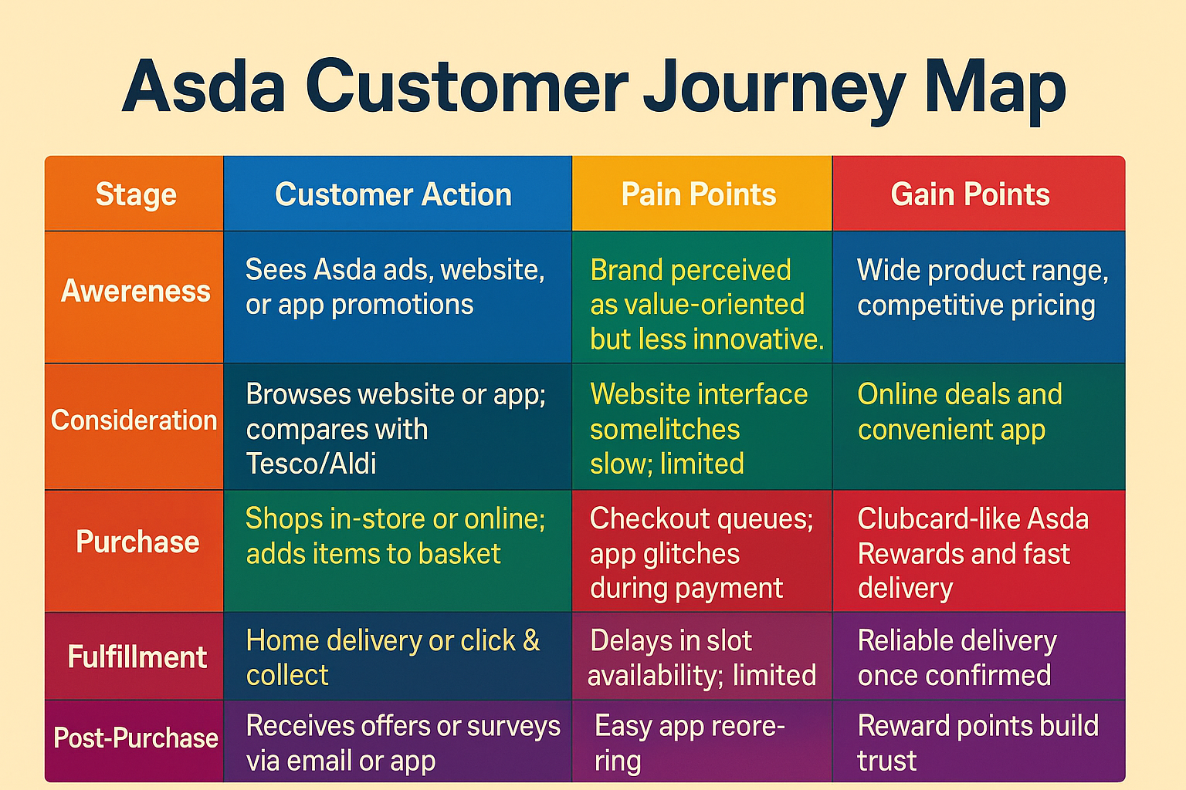
Figure 2. Asda Current Customer Journey Map.

4.1 Analysis of Pain and Gain Points

Pain points:
- Inconsistent digital experience between web and app platforms.
- Delivery-slot shortages in high-demand periods.
- Limited personalisation compared with competitors like Tesco.
- Weak post-purchase engagement (few feedback loops).

Gain points:
- Strong value perception and affordability.
- Reliable delivery logistics.
- Simplicity of Asda Rewards system.
- The map highlights opportunities for digital improvement — especially cross-platform integration, real-time communication, and sustainability transparency. Addressing these would enhance satisfaction, retention, and competitive differentiation.

4.2 Opportunities for Digital Innovation
- AI-driven personalisation: Tailor promotions to customer preferences and behaviours.
- Integrated sustainability dashboards: Show product carbon footprint at checkout.
- Smart fulfilment tracking: Use predictive delivery updates.
- Digital community spaces: Encourage post-purchase feedback via gamified rewards.

These areas form the foundation for the Part 2 proposal — a digital transformation initiative combining e-commerce, sustainability, and customer experience innovation.

Part 2 – Digital Transformation Initiative and Enhanced Customer Journey

5. Proposed Digital Transformation Initiative for Asda

5.1 The Asda 360 Digital Ecosystem is envisioned as a comprehensive transformation programme that fuses digital technologies with the retailer’s core value proposition of affordability, convenience, and trust.
While Asda’s competitors have already advanced their digital infrastructures, the retailer’s fragmented systems have historically limited its ability to deliver consistent and personalised experiences.
The proposed initiative aims to unify these disparate elements, enabling Asda to operate as a single, data-driven ecosystem capable of learning from every customer interaction and optimising performance across all channels.
5.2 Rationale for Digital Transformation:

The rationale for Asda’s digital transformation is driven by the need to modernise its fragmented legacy systems and deliver a seamless, data-driven customer experience comparable to competitors. By integrating advanced analytics, automation, and unified digital platforms, Asda can enhance operational efficiency, strengthen customer loyalty, and remain competitive in an increasingly technology-led retail environment(Deloitte, 2023).

5.3 Implementation Framework

To ensure a structured rollout, Asda could adopt a phased transformation model comprising three key stages—Integration, Intelligence, and Innovation.
During the Integration phase, Asda would consolidate customer, product, and logistics data into a unified cloud-based customer-data platform (CDP). This would remove existing data silos between departments, ensuring that marketing, operations, and supply chain functions work from a shared source of truth.
The Intelligence phase would involve embedding machine-learning algorithms and predictive analytics into the system. These tools would forecast demand, optimise pricing, and personalise promotions in real time.
Finally, the Innovation phase would focus on experimenting with new digital services, such as voice-activated shopping, AI-driven chatbots, and augmented-reality shelf navigation, to further enrich the customer journey.
Crucially, implementation must follow agile project-management principles, enable rapid testing and iteration while reduce investment risk (McKinsey & Company, 2024).
Cross-functional “digital squads” comprising IT, marketing, and store-operations staff should collaborate closely, applying design-thinking methodologies to prototype, test, and refine innovations (Brown, 2008).
This approach will allow Asda to sustain momentum and employee engagement throughout the transformation.

5.4 Anticipated Organisational and Market Benefits

The introduction of the Asda 360 Digital Ecosystem is expected to produce significant strategic and operational benefits.
First, data integration and AI personalisation will enhance customer engagement by delivering relevant product recommendations and context-specific promotions. This not only increases basket value but also strengthens emotional loyalty through meaningful interactions (Deloitte, 2023).
Second, EcoTrack transparency will position Asda as a sustainability leader among UK supermarkets.
By offering customers real-time carbon-footprint and packaging data, Asda can attract ethically minded consumers while fulfilling regulatory and ESG reporting requirements (Gov.uk, 2024).

Operationally, The Internet of Things-enabled logistics will reduce inefficiencies and environmental impact. Predictive route optimisation and smart-vehicle tracking could lower delivery-fleet fuel consumption by up to 15 per cent (Allocio, 2021).
Similarly, smart in-store technologies will improve labour productivity by automating repetitive tasks, freeing staff to focus on value-added customer interactions.
In the competitive landscape, these innovations will help Asda close the digital gap with Tesco and Sainsbury’s while differentiating itself through sustainability and user trust.
The unified platform also opens the door to new revenue streams, including data-insight partnerships with suppliers and targeted advertising within the Asda Rewards app.
The Dunnhumby model refers to the customer-data and loyalty-analysis approach developed by Dunnhumby, a global data-science company known for working with retailers like Tesco.

What it is

The Dunnhumby model is a customer-centric analytics framework that helps retailers understand:
- What customers buy
- Why they buy it
- How often they buy
- What influences their choices
- How to retain them and grow loyalty

How it works

It uses data such as:
- Loyalty cards
- Basket/transaction history
- Demographics
- Promotions and pricing response
- Store visits

Then it applies:
- Segmentation (grouping customers by behaviour)
- Propensity modelling (predicting what they will buy next)
- Price and promotion modelling
- Assortment recommendation (what products to stock)

What it is used for

Retailers use the Dunnhumby model to:
- Personalise offers
- Improve product placement
- Set smarter pricing
- Increase customer loyalty
- Boost sales and margins

This mirrors Tesco’s Dunnhumby model but could be adapted to emphasise ethical data usage and customer consent, enhancing corporate reputation (The Grocer, 2024).

5.5 Risks and Mitigation

Despite its potential, digital transformation carries inherent risks—particularly around data security, change management, and employee readiness.
To mitigate these, Asda should implement a robust governance framework covering data privacy (GDPR compliance), cybersecurity, and ethical AI usage.
Regular staff training programmes and communication campaigns will ensure that employees understand and support the transformation, reducing resistance to change (Deloitte, 2023).
Additionally, clear Key Performance Indicators (KPIs)—such as digital-sales growth, customer-satisfaction scores, and carbon-emission reductions—will allow Asda to track progress and make data-led adjustments over time.

5.6 Strategic Alignment

The Asda 360 Digital Ecosystem aligns with the retailer’s broader ambition to become a digitally intelligent, customer-centric, and sustainable enterprise (Skjerven et al., 2024).
By blending AI-enabled efficiency with transparent environmental accountability and human-centred service design, Asda can transform from a value-focused supermarket into a forward-looking digital retailer.
This initiative thus embodies a balanced mix of core, adjacent, and transformational innovation—strengthening Asda’s resilience, adaptability, and relevance in the evolving UK grocery market.
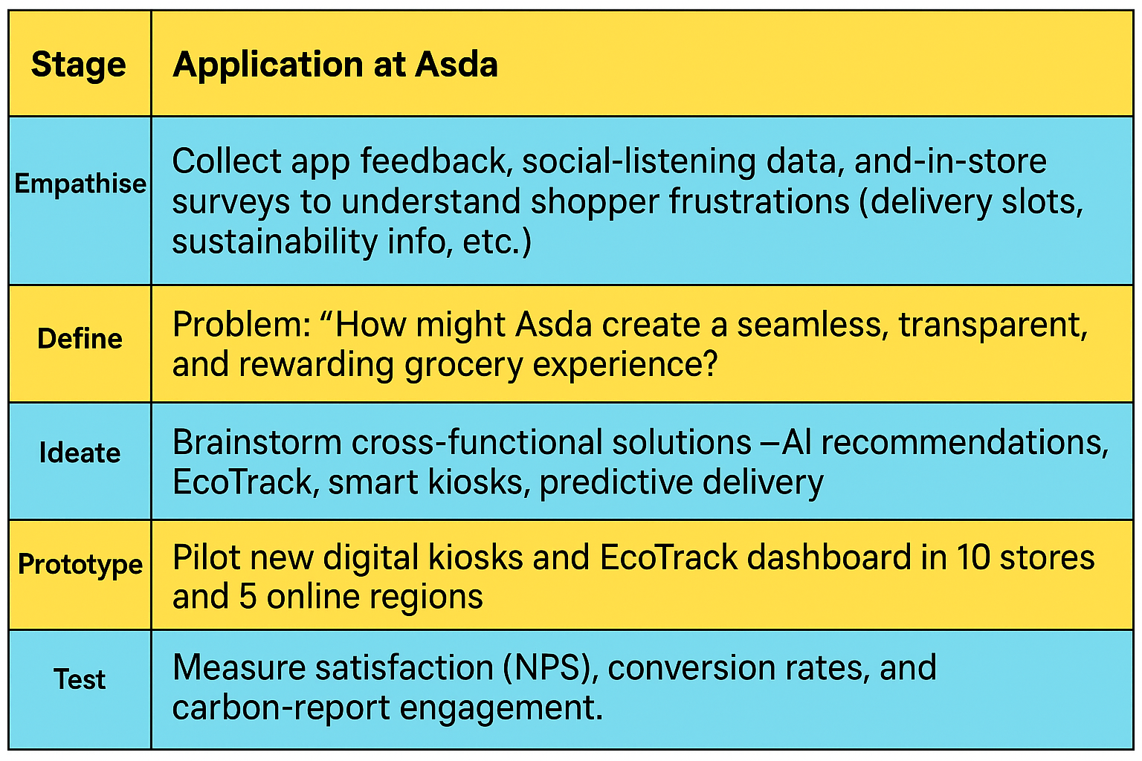
Figure 3. Design Thinking Model (Brown,2008):

6. Enhanced Customer Journey Map: Asda 360 Experience

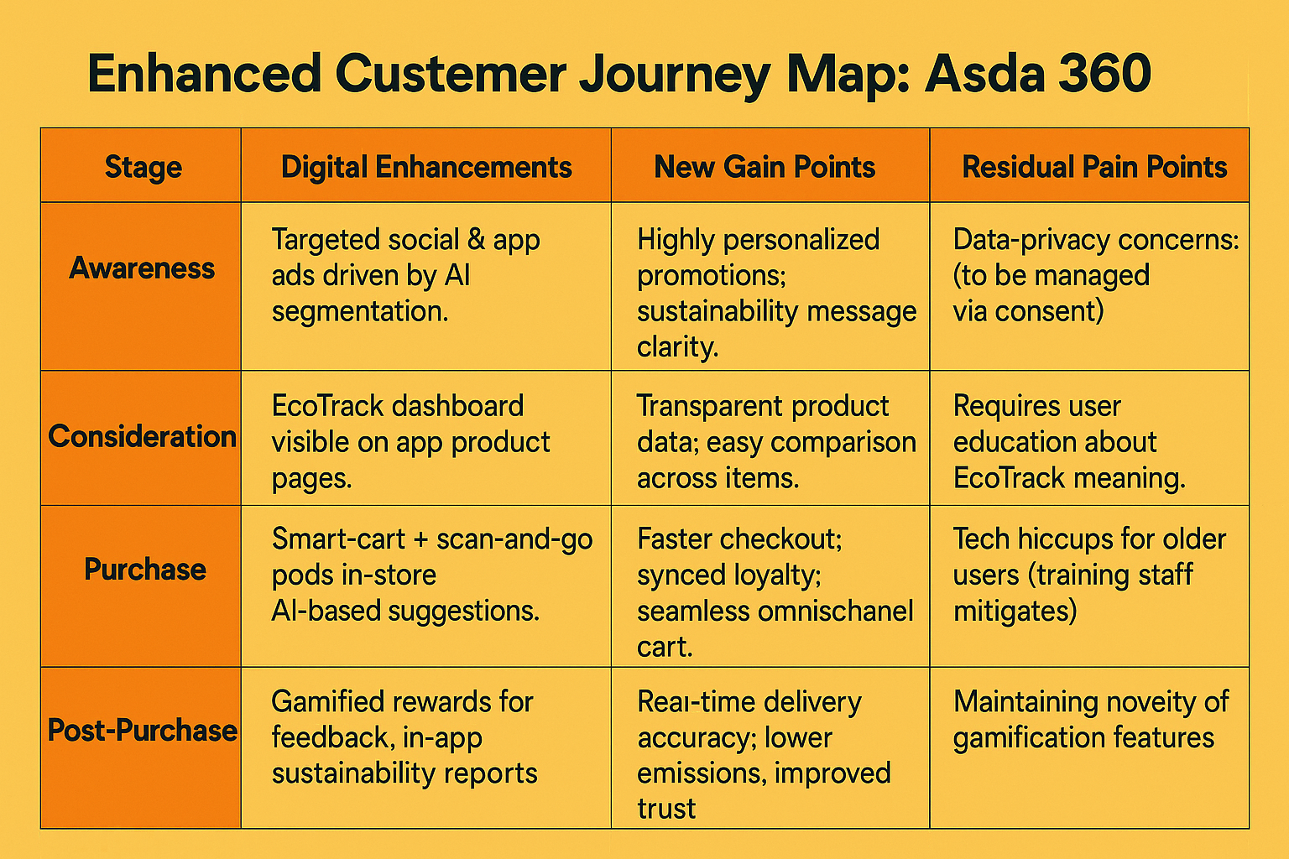
Figure 3. Enhanced Customer-Journey Map

6.1 Journey Improvements
- Frictionless mobility: Cart synchronisation lets customers start online and finish in-store.
- Transparency: EcoTrack builds trust and positions Asda as an ethical brand.
- Engagement: Gamified feedback (extra reward points for sustainable choices) deepens loyalty.
- Efficiency: Predictive delivery and IoT tracking reduce missed slots and fuel costs.
These enhancements directly target pain points identified in Part 1, creating a circular relationship where data continually refines experience quality.

7. Organisational Impact of the Initiative

The implementation of the Asda 360 Digital Ecosystem will have wide-ranging implications across the organisation. While the initiative requires substantial capital expenditure and organisational change, its long-term impact is expected to be transformative in terms of operational efficiency, customer engagement, financial performance, and corporate responsibility. As digital maturity increases, Asda will move from being a transaction-focused retailer toward a data-driven ecosystem leader that integrates technology, people, and sustainability objectives.

7.1 Operational Efficiency

Operationally, the initiative provides a foundation for data-enabled optimisation across the entire value chain.
AI-based forecasting and inventory-management systems will use real-time sales and weather data to predict demand more accurately, reducing both overstocking and stock-outs. Studies indicate that such predictive algorithms can cut inventory waste by as much as 20 percent (Deloitte, 2023). This not only lowers cost but also enhances shelf availability—a key driver of customer satisfaction.

In logistics, the deployment of IoT-enabled vehicle sensors and route-planning analytics will allow Asda to monitor driver performance, vehicle health, and delivery-time variance in real time. This supports fuel-efficiency goals, potentially reducing fuel use and associated emissions by 10–15 percent annually (Accenture, 2023).
Over time, such automation also decreases dependency on manual data entry and routine labour, freeing employees to focus on value-adding customer-service tasks.

At store level, smart kiosks and scan-and-go checkouts shorten queues, while dynamic pricing displays enable local managers to react instantly to competitor changes. These efficiencies combine to enhance overall productivity and operational agility, vital in a sector characterised by narrow margins and rapid market shifts.

7.2 Customer Satisfaction and Loyalty

From a consumer-behaviour perspective, integrating loyalty, app, and in-store data transforms the customer journey into a seamless omnichannel experience.
Through personalisation and real-time offers, Asda can anticipate shopper preferences and deliver consistent engagement across all channels. According to Kantar (2024), such integration could raise customer-retention rates from 72 to 80 percent within two years—a significant uplift in a mature market.

Moreover, improved digital experience enhances trust and emotional loyalty, which directly correlates with higher net promoter scores (McKinsey & Company, 2024).
Positive word-of-mouth generated by satisfied customers also expands organic brand reach, lowering acquisition costs. Enhanced service quality and convenience—such as accurate delivery times and frictionless returns—further strengthen Asda’s customer-centric reputation.

By embedding the EcoTrack dashboard into the Rewards app, Asda empowers customers to make ethical purchasing decisions, deepening brand advocacy among sustainability-minded shoppers. This emotional connection reinforces repeat purchasing and increases participation in loyalty programmes, supporting long-term revenue stability.
7.3 Financial Performance

Although the digital-transformation rollout will require substantial initial investment in systems integration, training, and infrastructure, the long-term return on investment (ROI) is projected to be strong.
Cost savings will arise from reduced waste, lower manual-labour costs, and optimised logistics operations. Concurrently, AI-driven recommendation engines are expected to boost average basket values by suggesting complementary products and time-sensitive promotions (PwC, 2023).

Furthermore, by monetising anonymised customer insights, Asda can generate new advertising and data-partnership revenue like Tesco’s Dunnhumby model (The Grocer, 2024).
Improved stock accuracy and waste reduction enhance gross margins, while automation minimises overtime and operational downtime. The cumulative impact of these factors is a more sustainable profit base and improved cash-flow resilience.

Beyond direct profitability, the integration of digital tools enhances Asda’s valuation by signalling technological sophistication to investors, potentially lowering its cost of capital. Financially, the Asda 360 programme represents a strategic shift from cost containment toward digital-driven value creation.

7.4 Sustainability and CSR Impact

Sustainability outcomes are integral to the Asda 360 ecosystem.
Through EcoTrack and advanced supply-chain analytics, Asda will be able to measure, verify, and publicly disclose its carbon-footprint reductions. This transparency strengthens its environmental, social, and governance (ESG) performance and ensures compliance with the UK’s Streamlined Energy and Carbon Reporting (SECR) requirements (Gov.UK, 2024).

Digitised route optimisation and IoT monitoring will reduce delivery emissions, while predictive inventory systems cut food waste at store level. Blockchain-based traceability also improves social sustainability by ensuring supplier accountability and ethical sourcing (Nielson, 2023).

From a CSR standpoint, these actions reinforce Asda’s commitment to the United Nations’ Sustainable Development Goals (SDGs), particularly SDG 12 (Responsible Consumption and Production) and SDG 13 (Climate Action).
By embedding sustainability into its digital operations, Asda can communicate measurable progress to stakeholders, improving brand equity and consumer trust.

In sum, the organisational impact of the Asda 360 Digital Ecosystem is multifaceted—driving operational excellence, financial resilience, customer engagement, and environmental stewardship. By aligning technological advancement with corporate purpose, Asda can redefine its competitive identity as an innovative, responsible, and data-empowered retailer fit for the future UK marketplace.

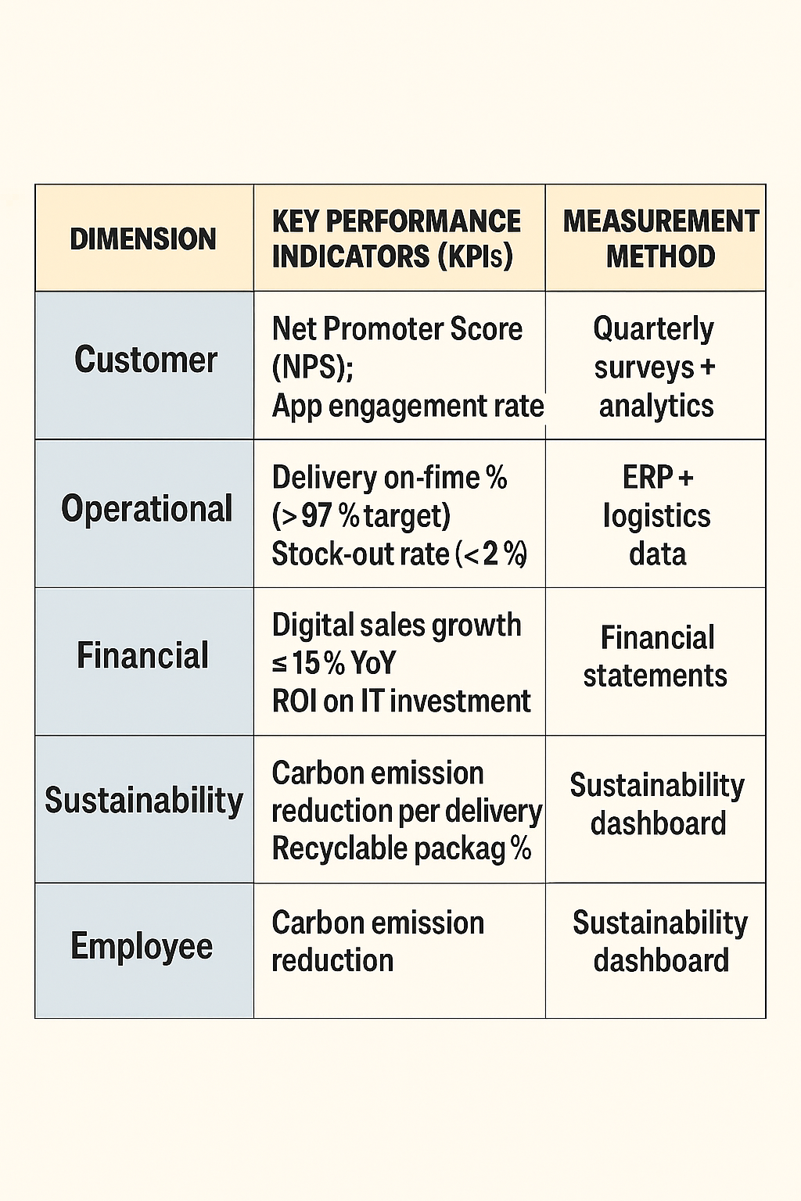
8. Measuring Success

Regular dashboard reviews by the Digital Transformation Steering Group would ensure accountability and continuous improvement (Deloitte,2023).
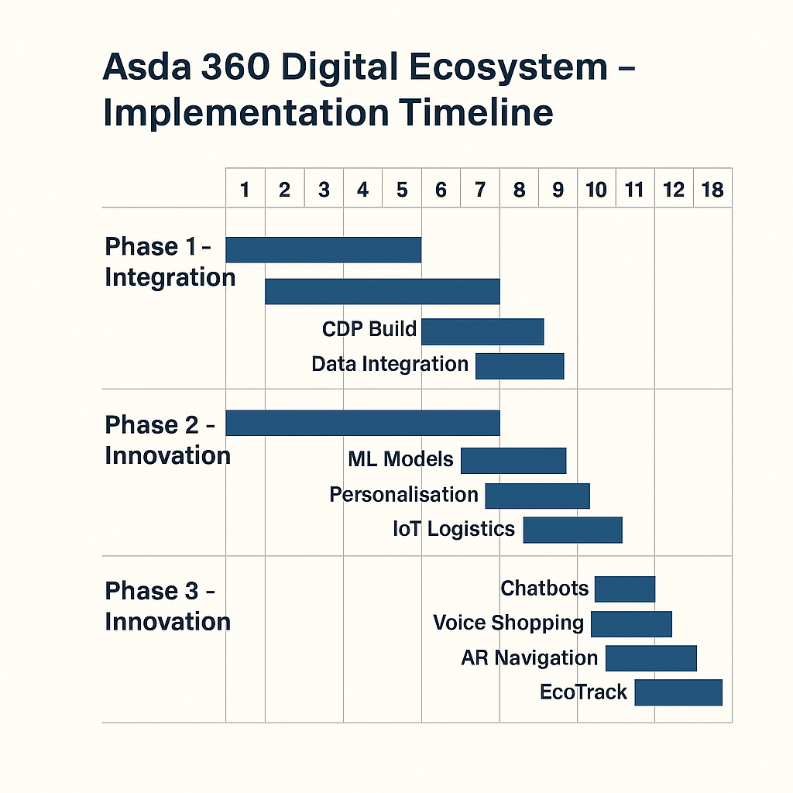
Figure 4. Asda Gantt Chart

The Asda 360 Digital Ecosystem is planned over an 18-month period, progressing through Integration, Intelligence, and Innovation phases. The timeline begins with building the central data platform and unifying customer and logistics data, followed by developing machine-learning models and smart-logistics capabilities. The final stage focuses on customer-facing innovations such as chatbots, voice shopping, AR navigation, and the EcoTrack sustainability feature. This phased rollout ensures controlled risk, agile testing, and consistent value delivery across the organisation.

9. Conclusion
Asda’s innovation journey reflects a retailer during strategic repositioning to remain competitive within a highly dynamic UK grocery sector. The company’s focus on the Asda 360 Digital Ecosystem illustrates a broader commitment to embedding digitalisation, sustainability, and customer-centric thinking at the heart of its operations. This transformation is not merely technological—it is cultural and organisational. By integrating data analytics, artificial intelligence, and customer journey mapping, Asda is evolving from a traditional value retailer into a more agile, insight-driven organisation capable of anticipating and responding to consumer needs in real time.

The application of the Innovation Ambition Matrix highlights Asda’s balanced approach between core, adjacent, and transformational innovation. Core initiatives—such as improving delivery systems and expanding the Asda Rewards app—support operational efficiency and customer retention. Adjacent innovation through Asda Express stores, digital partnerships with Uber Eats, and omnichannel retailing demonstrate how Asda is leveraging existing strengths to explore new markets and service models. Transformational efforts, including the introduction of AI-driven logistics, blockchain traceability, and sustainability tracking (EcoTrack), reflect an awareness of how technology can underpin long-term competitiveness and ethical leadership. This strategic layering of innovation creates a robust foundation for sustainable growth and differentiation.

From a customer-experience perspective, the Customer Journey Mapping exercise revealed key friction points—limited personalisation, inconsistent digital experiences, and underdeveloped post-purchase engagement. The proposed digital transformation directly addresses these challenges by building seamless connections across online and offline touchpoints. Enhancing fulfilment reliability, enriching loyalty interactions, and introducing transparent sustainability data will collectively enhance perceived value and emotional loyalty, which are increasingly vital in a price-sensitive yet ethically conscious market.

Crucially, this transformation demands organisational capability development. For Asda to realise its innovation potential, it must invest in data governance, staff training, and cross-departmental collaboration. Embedding design thinking into the company’s culture will empower employees to contribute creative solutions aligned with customer insight. Moreover, continuous performance monitoring—through KPIs such as Net Promoter Score, delivery accuracy, and digital sales growth—will ensure accountability and adaptive improvement.

In the long term, Asda’s ability to blend technology with trust, convenience, and sustainability will define its relevance in the retail landscape. The Asda 360 Digital Ecosystem can become a model of integrated retail innovation—one that balances efficiency with empathy, profitability with responsibility, and tradition with transformation. By maintaining its focus on customer value while embracing emerging technologies, Asda can secure a sustainable and competitive position as one of the UK’s leading digital retailers of the future.

10. References

Accenture (2023) Smart Retail and IoT Logistics Solutions in the UK. London: Accenture Insights.
Allocio, G. (2021) Artificial Intelligence: Implications in the Customer Journey; Artificial Intelligence in the Supply Chain & Logistics within the Retail Industry: Opportunities & Limits. Master’s thesis, Universidade NOVA de Lisboa (Portugal).

Asda Corporate (2024) Annual Report and Accounts 2023/24. Leeds: Asda Group Ltd.

Asda Corporate (2024) ESG Report 2023/24. Leeds: Asda Group Ltd.

Benson, M., Hirst, C. and Beresford, P. (n.d.) A Service Eco-System Perspective of Grocery Category Management. In: Colloquium on European Research in Retailing, p.1.

Boyle, N.B., Jenneson, V., Okeke-Ogbuafor, N., Morris, M.A., Stead, S.M., Dye, L., Halford, J.C.G. and Banwart, S.A. (2024) ‘Connected Food: First Steps for an Ambitious National Food Strategy.’ Nutrients, 16, 3371.

Brown, T. (2008) ‘Design thinking.’ Harvard Business Review, 86(6), p.84.

Deloitte (2023) Retail Technology and Data Analytics in the UK Grocery Market. London: Deloitte Insights.

Detti, A. (2023) Equity Research on Ocado Group: On Track to Diversify from the UK. Master’s thesis, Universidade NOVA de Lisboa (Portugal).

Euromonitor (2023) Asda Stores Ltd in Retail (United Kingdom).

GD (2024) Convenience Retailing in the UK 2024. Institute of Grocery Distribution.

Gov.UK (2024) Streamlined Energy and Carbon Reporting (SECR) Guidance. London: Department for Energy Security and Net Zero.

Kantar (2024) Grocery Market Share UK – March 2024.

Lemon, K.N. and Verhoef, P.C. (2016) ‘Understanding customer experience throughout the customer journey.’ Journal of Marketing, 80(6), pp.69–96.

Mintel (2024) UK Online Grocery Retailing Report 2024.

Nagji, B. and Tuff, G. (2012) ‘Managing your innovation portfolio.’ Harvard Business Review, 90(5), pp.66–74.

Nielsen (2023) The Sustainable Consumer Report.

Pangriya, R. and Singh, A.P. (2020) ‘Automation in Retail: Modern Ways of Customer Engagement.’ PalArch’s Journal of Archaeology of Egypt/Egyptology, 17(7), pp.10507–10533.

Piecyk, M., Allen, J., Woodburn, A. and Cao, M. (2021) Online Grocery Shopping and Last Mile Deliveries.

Samadzadeh, M. (2024) Investigating Successful E-Commerce and Digital Marketing Strategies for Major Supermarkets in the UK.

Serin, E. (2024) About this report.

Skjerven, A., Berg, L.L., Nielsen, L.M. and Stuedahl, D. (eds.) (2024) Mediating Sustainability in the Consumer Society. Routledge.

Statista (2024) Share of online grocery sales in the UK 2024.

Winter, M., Guilbert, S., Wilkinson, T., Lobley, M. and Broomfield, C. (2024) ‘From Eating Out to Eating In.’ In: Feeding People in a Crisis, pp.71–90. Bristol University Press.

