8/8/2026
University of Wales Trinity Saint David
London campus
Assignment 2

Module Name: Network Operating Systems and Services
Module Code: ACCA5023
Student Name: Mohammed Hamid
Student ID: 2440293
Group: 1

Lecturer’s Name: Md Sadeque Imam Shaikh

Table of Contents
Introduction 2
Main Body 3
Task 1 3
1. Routing: 3
2. Domain Server 5
3. Encrypted Connection between Birmingham and London 7
4. Users 8
5. Domain Membership 8
6. DHCP Server 9
7. Test and Troubleshoot 9
8. Disk Drive 9
9. IIS Server 9
10.Remote Desktop Services 9
Conclusion 9

Introduction

This report explains the setup and configuration of a network connecting Birmingham and London using Windows Server and Oracle VirtualBox. The aim is to create a secure and working network where devices from both locations can communicate and share resources. The practical tasks include routing, Active Directory, VPN configuration, user accounts, DHCP, domain membership, file sharing, IIS web services and Remote Desktop. Screenshots are included throughout the report to provide evidence of the configurations and testing carried out.

Main Body

Task 1

1. Routing:
1.1 Routing in Birmingham Network
1.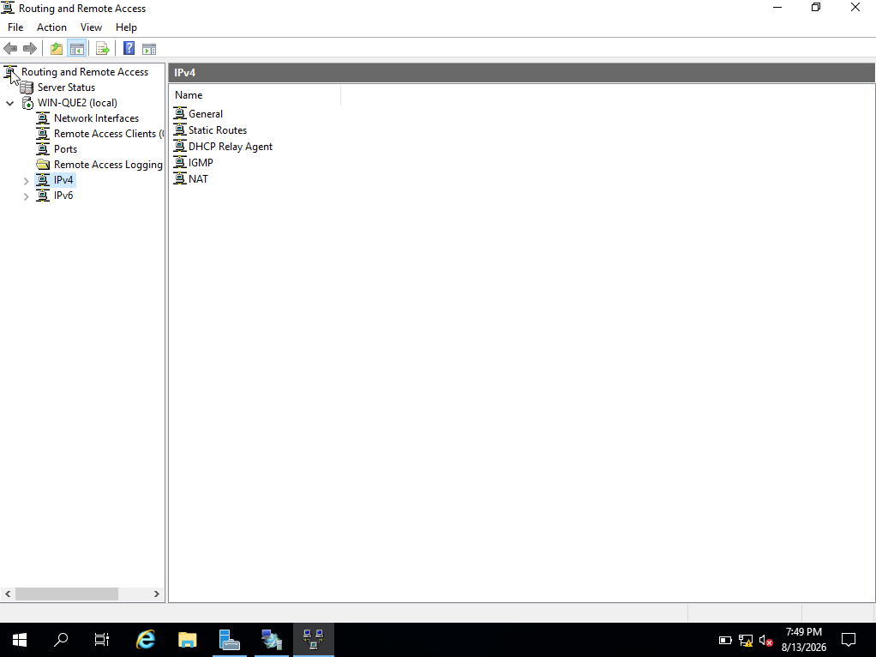
Figure 1: Routing and Remote Access Service configured for routing on the Birmingham Windows Server.
The Birmingham network uses Routing and Remote Access Service (RRAS) on Windows Server to allow communication between different networks. RRAS was installed and configured for routing. The Windows Firewall was also configured to allow ICMP traffic, which allows ping to be used to test that devices can communicate successfully.

1.2 Routing in London Network

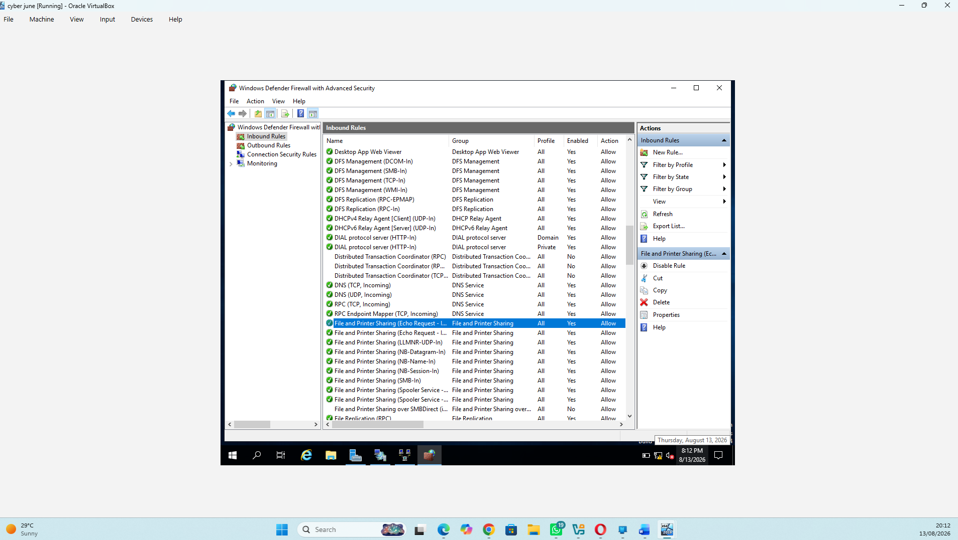
Figure 2: Windows Firewall configured to allow ICMPv4 traffic for network connectivity testing.

The London network was configured with persistent IP forwarding and routing. This allows the Windows Server to receive traffic through one network interface and forward it through another network. The configuration is persistent so that routing continues to work after the server is restarted. Firewall rules were also configured to allow the required network traffic.

Think of Birmingham and London as two separate networks.
A router sits between networks and decides where packets need to go. In VirtualBox, we can simulate physical networks using Internal Network adapters. VirtualBox connects VMs assigned to the same named Internal Network as though they were connected to a virtual Ethernet switch.
For Birmingham, Windows Server's Routing and Remote Access Service (RRAS) will make the Windows Server act as a router. Microsoft specifically supports installing the Remote Access role with the Routing role service for LAN routing.

2. Domain Server
2.1 Active Directory Domain Services
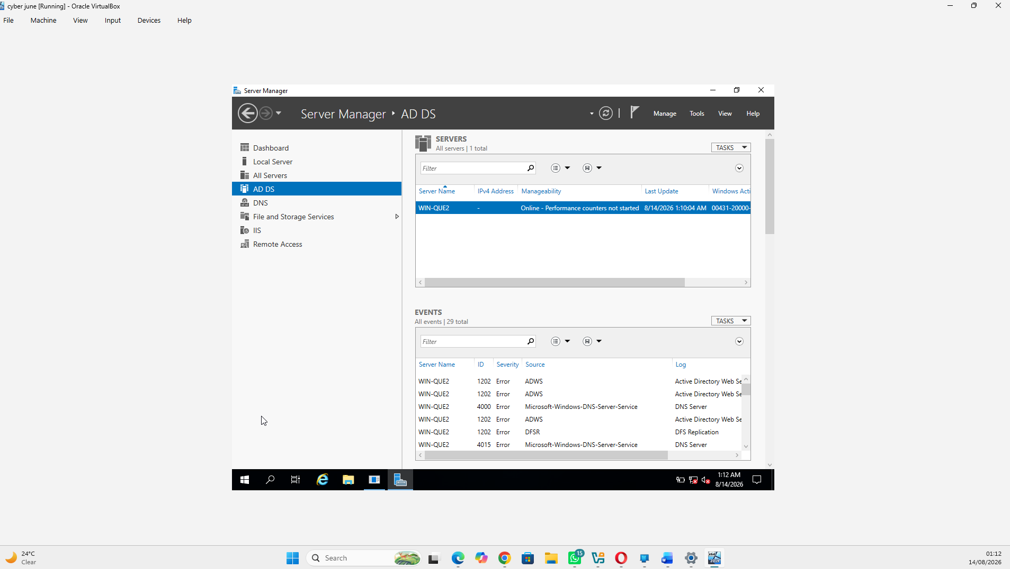
Figure 3 shows Active Directory Domain Services successfully installed on the Windows Server.

2.2

3. Encrypted Connection between Birmingham and London
3.1 Configure Site-to-Site VPN to London Network

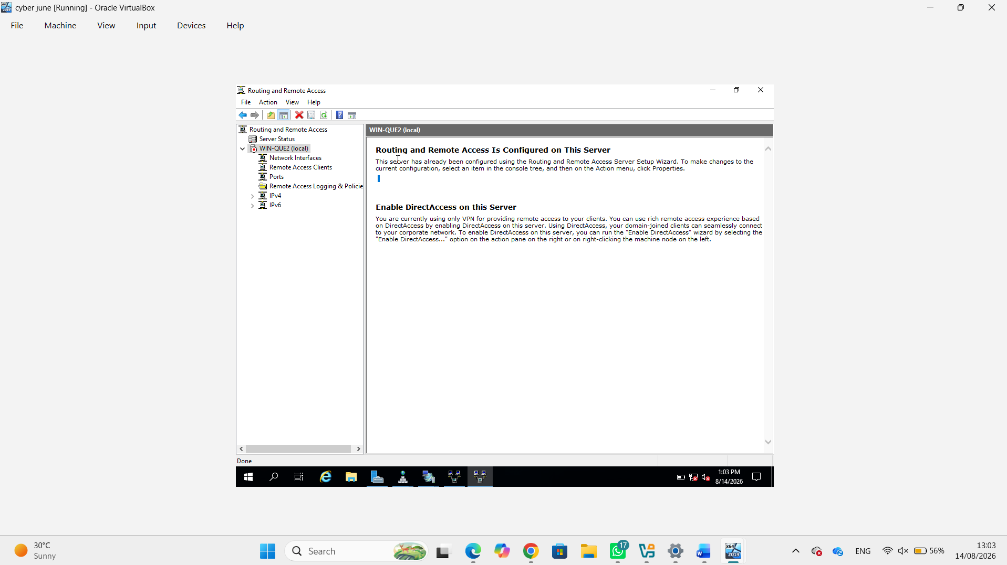
Figure 4 show remote access and vpn site to site

A Site-to-Site VPN was configured to create a secure connection between the Birmingham and London networks. The VPN was configured after installing Routing and Remote Access Service (RRAS) on the server.

A VPN (Virtual Private Network) creates an encrypted connection between two networks, helping protect information while it travels between them. This allows devices in Birmingham and London to communicate securely as though they were part of a connected private network.

4. Users
4.1 — Active Directory User Accounts
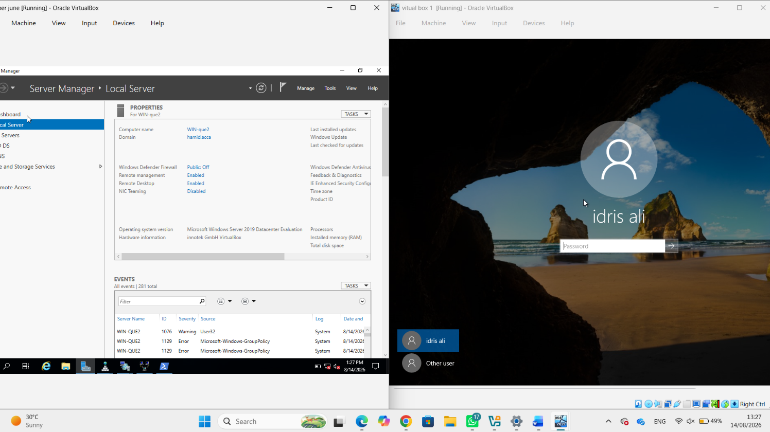

user account was created in the hamid.acca domain using the information provided in the Excel file. The required naming convention was followed, using the first letter of the first name, a dot, and the surname.

5. Domain Membership
5.1 — Domain Membership

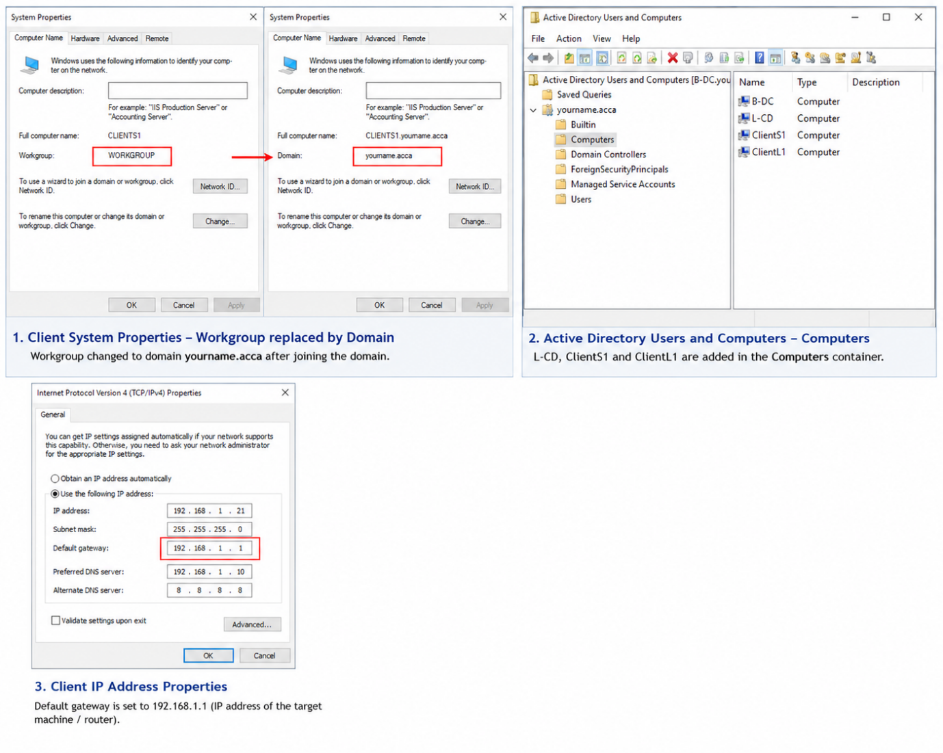

The L-CD, ClientS1 and ClientL1 computers were joined to the yourname.acca domain. After joining, the computers became members of the Active Directory environment rather than simply belonging to a workgroup.
This allows the server to centrally authenticate users and manage computers and accounts across the network.

6. DHCP Server
6.1

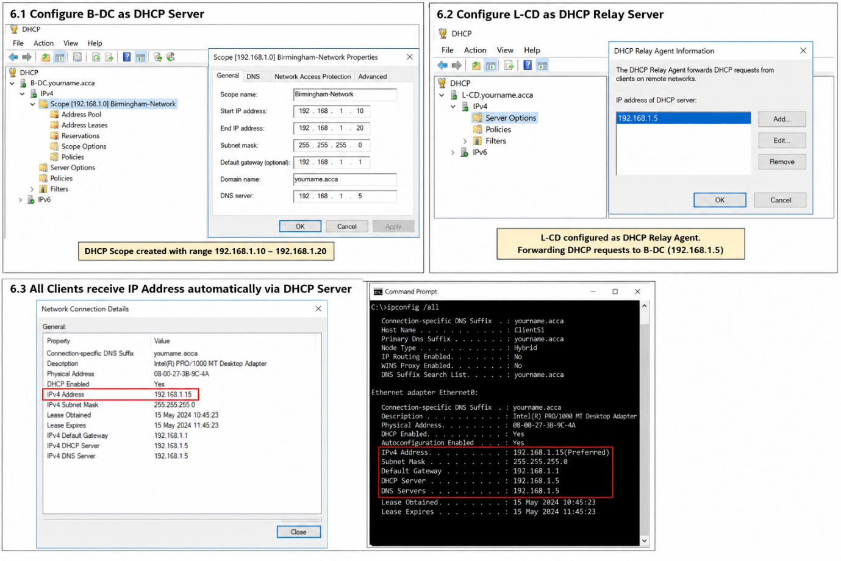

B-DC was configured as the main DHCP server. DHCP automatically provides network settings to clients, including their IP address, subnet mask, default gateway and DNS server.
A DHCP range from X.X.X.10 to X.X.X.20 was configured for each required network. L-CD was configured as a DHCP Relay so that devices on the London network could obtain addresses from the B-DC DHCP server.
The clients were then configured to obtain IP addresses automatically.

7. Test and Troubleshoot
7.1 — Test and Troubleshoot

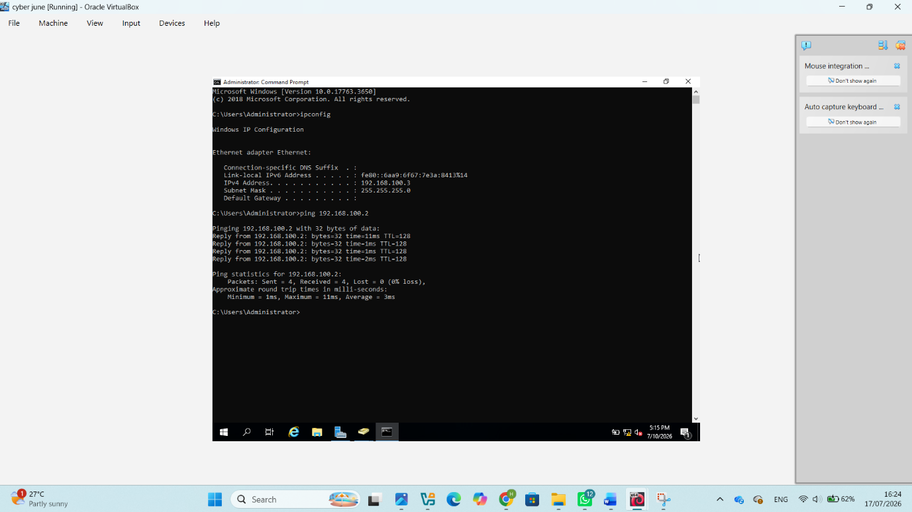

Network connectivity between the Birmingham and London networks was tested.
The ping command was used between clients and servers to confirm that devices could communicate. Connectivity between Windows and Linux machines was also tested where required.
Successful ping replies demonstrate that the IP addressing, routing and network connections are functioning correctly.

8. Disk Drive

8.1 — Disk Drive and File Sharing

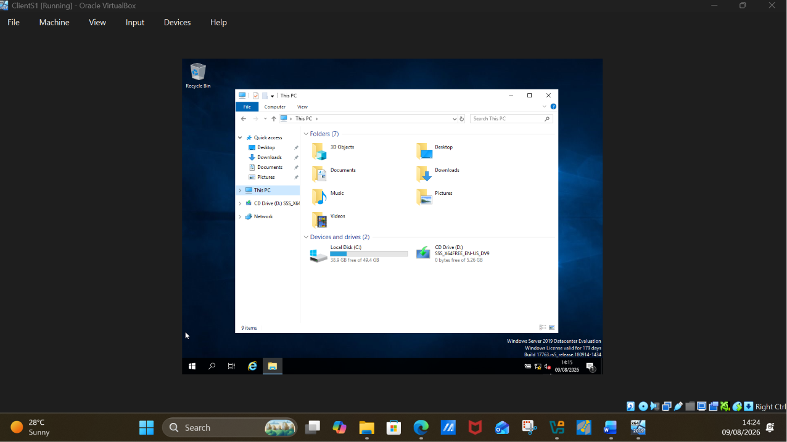

A second disk was mounted on the server as:
E:\BirminghamFiles
The folder/drive was shared across the network and permissions were configured.
Domain Users were provided the required full-control permissions, while other network users were limited to read-only access.
The purpose is to provide centralised file storage that authorised users from both Birmingham and London can access while preventing unauthorised changes.

9. IIS Server

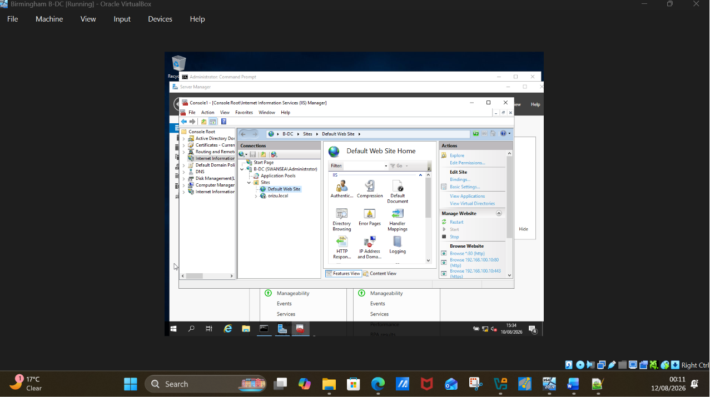

9.1 — IIS Web Server
Internet Information Services (IIS) was configured to host an internal website:
Hamid.acca
IIS is Microsoft's web-server platform and allows Windows Server to host websites and web applications.
For the excellent requirement, the site should use HTTPS, require Windows Authentication, and allow authenticated domain users to access a page displaying:
Welcome to Birmingham Website
This demonstrates that the web server is integrated with the Active Directory domain.

10.Remote Desktop Services

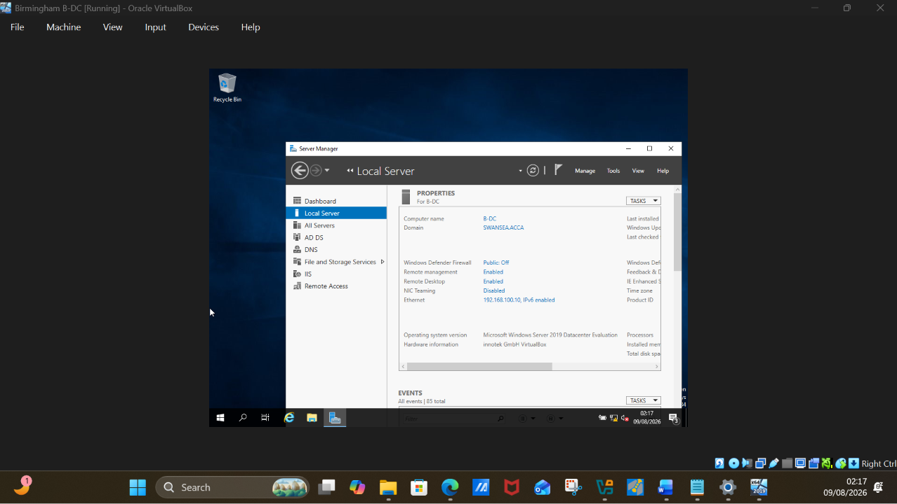

10.1 — Remote Desktop Services
Remote Desktop was configured so B-DC can be remotely accessed from another machine on the network.
From a client computer, Remote Desktop Connection is opened and the B-DC server name/IP address and authorised administrator credentials are used to establish the connection.
Remote Desktop is important because it allows administrators to manage and troubleshoot servers remotely without physically accessing the server.

Conclusion
Conclusion
Overall, this practical project demonstrated how a network can be configured and managed between the Birmingham and London sites using Windows Server and VirtualBox. The main tasks included configuring RRAS routing, Active Directory Domain Services, a Site-to-Site VPN, user accounts, domain membership, DHCP, file sharing, IIS and Remote Desktop Services. Connectivity testing using ping was also carried out to check communication between devices. These tasks demonstrate how different network services can work together to provide a secure, organised and centrally managed network environment.

