Application Development Assignment 1
Application Development
Rhys Lewis 1802146
2019
Table of Contents
Introduction 2
Application Development Concepts 2
Simplification of Fighting Games 2
Frame Data 2
Button Layout and Controls 3
Peer reviewed study 3
Simplification of Mechanics 5
Conclusion 5
Requirements 5
Design and Implementation 6
Moving left and right: 6
Jumping: 6
Transitioning from level to level: 6
Death and Game Over: 7
Collecting Points 7
Scene Images 8
Main Scripts 9
Evaluation 9
Tests 9
Reflection 16
Bibliography 17

Introduction

During this report, the author will address a development concept currently relevant in the gaming world, list the requirements and key features of the implemented game, and finally, test and evaluate the finished project with possible improvements.

Application Development Concepts

As video gaming evolves, more development trends tend to surface. These trends keep gaming diverse and varied while maintaining the core appeal. Below is a list of relevant and modern video game trends [reference(s)]:
- The Battle Royale genre.
- Spectator oriented fighting games.
- Loot-boxes and Micro-transactions.
- Game lifetime increases due to continual support and updates.
- The free-to-play module.
- The simplification of fighting games.
I have chosen to focus on the simplification of fighting games, how different control styles affect the learning process and how the genre offers more tools for new players to improve and become accustomed to the systems.

Simplification of Fighting Games

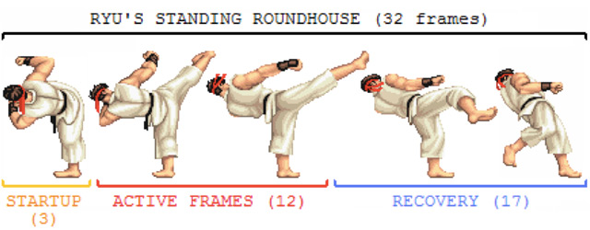
When fighting games first made their major debut, not much information was given about how the games worked, players were often left with their character, the buttons in front of them and their patience and ingenuity. The earliest game that could be found that included an accurate list of moves that could be performed by the respective characters is Street Fighter (SF) EX3 from the year 2000 [reference]. It was around this time that players were given an accurate list of everything they could do without having to look elsewhere for move lists, such as forums dedicated to their game of choice. This inclusion, while not seeming major at a first glance, opened the door to accessibility as now new players could simply look at the move list for their selected character and play.
Figure 1: Ryu's standing roundhouse frame data (https://www.polygon.com/2014/7/7/5876983/how-to-play-street-fighter-fighting-game-primer)

Frame Data
Another major aspect of fighting games that remained unknown was frame data. Put simply, frame data is knowing exactly how long each move takes to perform with each move split into “Start-up frames” (the beginning), “Active frames” (the frames in which the attack deals damage) and “Ending frames” (the attack ending). As most fighting games run at a frame rate of 60 frames per second, one frame can be translated into 1/60th of a second. This information is crucial to high-level play as it informs the player as to which moves are safe to perform at certain times and which are not.
For the longest time, fighting game fans had to analyze each attack frame-by-frame to acquire this data. Super SF 2, one of the bestselling fighting games of all time [1], did not include a move list or frame data, leaving newer players completely in the dark. But in the modern era, some franchises, like Mortal Kombat (MK), have decided to include the frame data for each move on the in-game move list, allowing professional players to gain the information quickly and streamlining the learning process for newer players.

Button Layout and Controls
Another issue with getting engrossed in the world of fighting games are the control and movement systems that vary between games. The MK series contains a basic 4 button layout with each button dedicated to a limb depending on perspective, the button layout is as follows: -
Front Punch
Back Punch
Front Kick
Back Kick
The game also has a dedicated block button while other games, like SF and Skullgirls, made holding back on the directional pad the block function.
Figure 2: Highlighted Scorpion Limbs. Edited version of image owned by netherrealm studios [reference]
Games like SF and Skullgirls, on the other hand, use a 6-button system with each button representing various strengths of punches and kicks. The 6-button layout is as follows: -

Light Punch
Medium Punch
Heavy Punch
Light Kick
Medium Kick
Heavy Kick
Figure 3: Punch strength comparison chart. Ryu owned by capcom, Filia owned by Reverge Labs. [Reference]
These buttons don’t correlate to each limb and are simply representative of which part of the body the attack originates from, with punches coming from the upper body and kicks coming from the lower body. As seen in Figure 3, despite using commands known as punches, Skullgirls’ Filia uses her hair for attacks.

Peer-reviewed study
These varying styles can be quite difficult to grasp. In the peer-reviewed study [reference], Mattiassi attempts to explore the relation between button presses and character actions in fighting games. He begins by discussing the styles of control different games incorporate (Street Fighter’s 6-button, MK’s 4-button, etc.) and how they relate to the movements of the player character [2, p. 11]. He then conducted 2 experiments.
Figure 4: Control Scheme Visualised
In the first test he gives a group of test participants control of a character in a mock fighting game with one of 2 control configurations, one being the limb to limb allocation of Tekken (left and right arm and left and right leg “left/right buttons for left/right limbs actions, upper/lower buttons for upper/lower limbs actions” [2, p. 14]) and the other being the same button commands with the placements randomised. The test participants are given 60 seconds to learn the correspondence between button and command. After the time was over the participants would be asked to verbally define each command with its respective button with the results suggesting that the participants were more likely to correctly identify the commands when using the original layout.

During the second test, participants were shown videos of 2 lesser-known characters from 4 mainline fighting games (SF, Tekken, MK and SoulCalibur), 1 being male and the other being female. During the initial training phase, 24 videos would be presented for each game, each video would include an attack animation. An equal number of videos were shown for each button available.
Figure 5: Visualisation of Test 1 control schemes
During the test phase, 6 videos were shown, each featured two attacks in sequence. The participants were randomly assigned to their respective games and, after having the games control scheme explained to them, proceeded to the training phase; in which the participant attempted to guess which video represented which attacks. After guessing, the participants were given immediate feedback on whether or not their guess was correct and the next video played. The videos that were incorrectly identified could repeat up to five times throughout this phase.
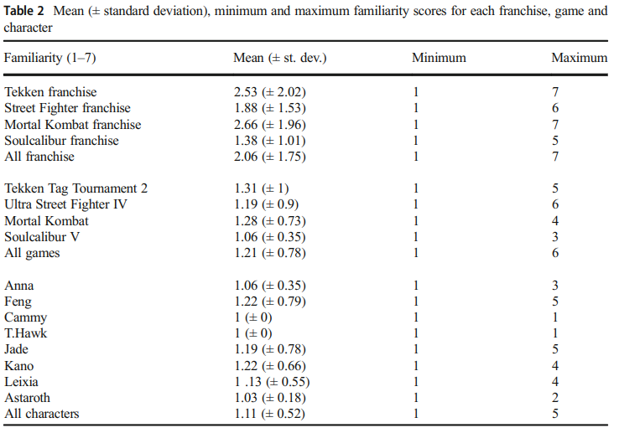
Next, during the test phase, each participant attempted to provide the commands needed to recreate the sequences of attacks shown on the screen. The videos were not repeated during this phase.
The study’s findings show that the participants correctly identified and could recreate Tekken sequences more than any other franchise, with Tekken being the most correctly identified franchise overall, having the most correctly identified game (Tekken Tag Tournament 2) and Anna and Feng, the selected Tekken characters, being the most correctly identified characters. [2, p. 18]. The study concludes by suggesting that the correlation between control layout and the actions of the character on screen may directly influence the player’s ability to learn and play the game. [2, p. 24].
Figure 5: Familiarity Chart, [2 p. 18]

Simplification of Mechanics
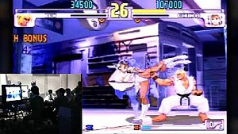
Modern fighting games attempt to familiarise the players with the mechanics and controls as quickly as possible. Upon booting up SF 5, Capcom’s latest entry in the SF series, for the first time, the player is immediately thrown into a tutorial section explaining basic movements, gameplay mechanics and the game’s brand-new mechanics, the V-trigger and the V-skill: a unique mechanic that each character possesses. SF 5 as a whole attempt to make the franchise more accessible to newcomers. [3] A perfect example of this being the game’s version of SF 3rd strike’s parry mechanic. During the Street Fighter 3rd strike Evolution fighting game tournament of 2004, competitive SF player Daigo Umehara successfully parried all 15 hits of his opponent’s super attack, giving him the chance to win the round. 3rd strike’s parry mechanic gives the player a 0.100 to 0.167th of a second window to deflect the opponent's attack, making this a perfect demonstration of timing and skill. [4]
Figure 6: Daigo Umehara Performing The 15 Hit "Daigo Parry". Screenshot from https://www.youtube.com/watch?v=JzS96auqau0
SF 5 brings back the parry as a V-skill for Ryu. It streamlines the parry by mapping it to a single command instead of having it mapped to the control stick and allowing one universal parry to deflect high, medium and low attacks instead of needing to either parry while ducking, standing or in the air depending on the position of the attack.

Conclusion
In conclusion, while the simplicity of fighting games does help the genre gain new players through ease of learning, oversimplification and unnecessary change could potentially reduce the overall skill ceiling and has the danger of pushing away some of the more experienced, skilled franchise veterans. “To be honest, I really don’t like it. By constantly trying to introduce new players…these new changes…it feels too drastic” – Street Fighter pro, “Infiltration” [5]

Requirements

The game developed for this assignment is called “Wizard Quest”. The player takes control of a wizard and has the task of traversing the world freeing fairies and avoiding anti-magic spikes. At the end of every level the player enters a portal gate, taking them to the next level and after 3 levels, the game ends. To play the game, the player must do the following:
- Move left and right using the arrow keys.
- Jump using the space bar.
- Reach the gate at the end of each stage.
- Successfully jump from platform to platform (falling results in death).
- Avoid Spikes (taking too much damage results in death).
- Free Fairies to gain points.
- Clear all 3 levels to win the game.
- Not die more than 3 times, otherwise, the game restarts.

Design and Implementation

This section will detail how each one of the game’s requirements were implemented.

Moving left and right:
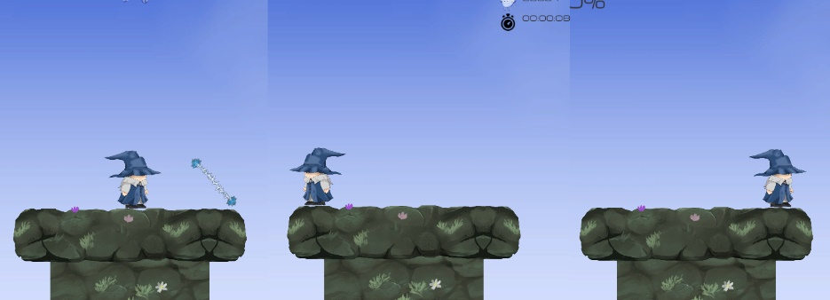
The game requires that the player can move left and right to traverse the levels, this was done by implementing speed mechanics. The “GetAxis.(“Horizontal”)” represents Unity recognising that either the left or the right key is being pressed, upon recognising either of these keys, the engine then assigns the input to the movement variable (1 for right, -1 for left) and multiplies the input with the current time and a speed set by the user in the inspector window. The game also requires that animations change upon moving and the player character changes direction. This was done by setting the walk animation to trigger upon reaching any speed greater than 0.01, the flip was done by inverting the player’s sprites upon reaching negative speed (moving left).
Figure 6: Player at beginning, after holding left and after holding right

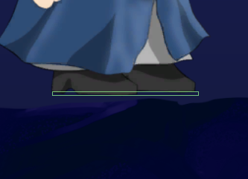
Jumping:
Figure 7: Player's Foot Hitbox
In order to traverse platforms, the player needs to jump. This is accomplished by checking eligibility. The game will check if the player is grounded by comparing the hitbox placed on his feet to the platform below or by checking if the player’s velocity along the Y-axis is 0. If the player is eligible to jump, Unity’s engine applies upwards force to the player equal to a variable set in the inspector window. Unity’s physics engine then takes the player character through the arc of a jump with natural slowdown and gravity.
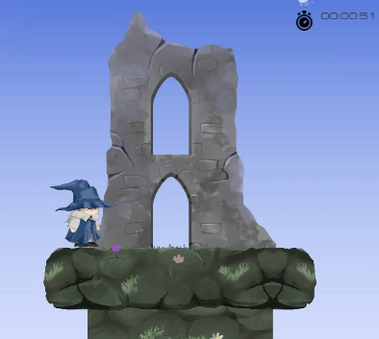

Transitioning from level to level:
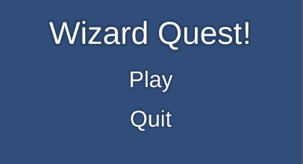
To progress through levels, the player must touch the gate. In order to reach the gate, the author inserted an event to the gate’s hitbox whereupon colliding with another hitbox, the engine would check whether or not the colliding hitbox belonged to the player. If the hitbox belongs to the player, it loads a scene equal to an index put into the inspector window (usually the next level). The menus work in a similar fashion but replacing hitbox interaction with the clicking of a button. The levels all use different background and platform styles to differentiate them.
Figure 8: Wizard Quest Main Menu
Figure 9: Player standing in front of the level 1 end gate

Death and Game Over:
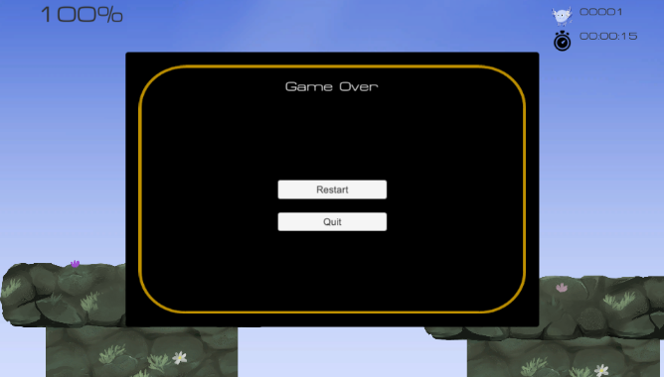
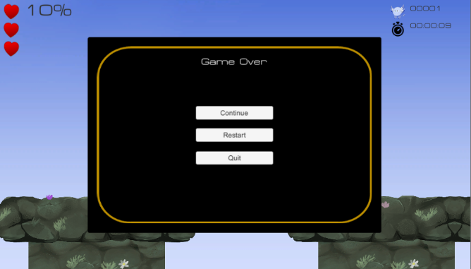
The player is given limited health and lives during play, tracked by a percentage meter and icon set at the top left corner of the screen. Taking damage from enemies results in a loss of health and falling off the world instantly kills the player. Upon dying a menu is displayed and the player can choose to either quit, restart the game or continue from the beginning of the current level. If the player decides to continue, they will lose a life. If the player dies once they’ve lost all their lives, the player will be forced to either quit or restart from the beginning. This was done by having a variable known as “lives” count down upon each continue, to track the player’s death count. Reaching 0 lives the game over process would display the game over menu while keeping the continue button invisible, rendering it unusable.
Figure 10: Game Over screen upon dying with no lives remaining
Figure 11: Game Over menu upon dying for the first time

Collecting Points
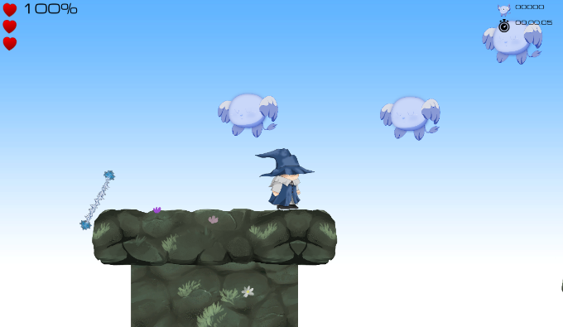
Points are accumulated by freeing fairies and are tracked by a counter at the top right corner of the screen. Fairies are spawned randomly at the beginning of each level. Upon the player colliding with a fairy, the fairy disappears, a sound clip plays and the score increments by one.

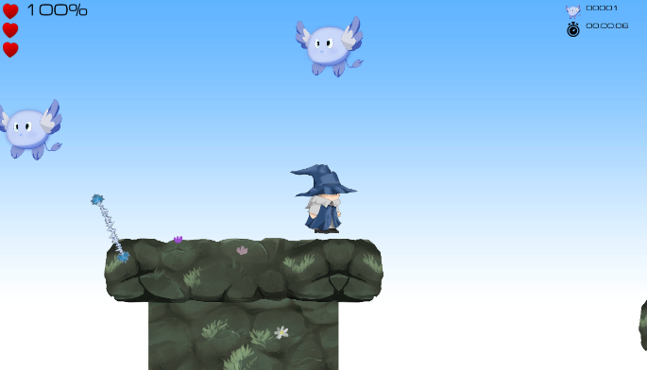
Figure 12: Player After collecting Fairy
Figure 13: Player about to collect Fairy in Level 2


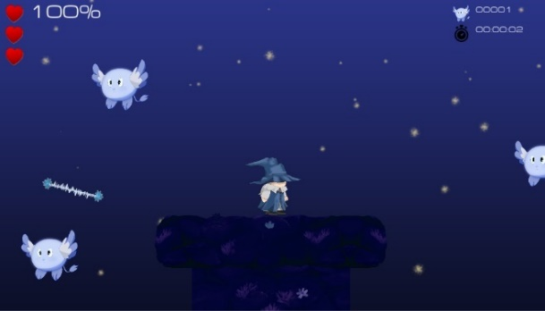
Scene Images
Figure 15: Section of Wizard Quest Level 3
Figure 14: Wizard Quest Win Screen

Main Scripts
The following scripts are essential for the game to function on the most basic level
- Player: Controls all main aspects of the player, including animations, health and movement.
- Game Manager: Controls Hud interactions and health updates.
- Scene Controller: Controls the main aspects of enemy and collectible generation.
- Level Control: Controls the transitions from level to level.
- UI Manager: Updates UI information.

Evaluation

Tests
This section will test the original requirements to see if they are fully implemented. The tests will be formatted as tables.

Test No. | Test Description | Preconditions | Test Steps | Test Data | Expected Results | Actual Result
1 | Player will move left upon pressing left key | N/A | - Press left key | Left key input | The player character will move upon pressing the key. | PASS / Character moves left upon pressing the left key.

Test No. | Test Description | Preconditions | Test Steps | Test Data | Expected Results | Actual Result
2 | Player will move right upon pressing left key | N/A | - Press right key | Right key input | The player character will move upon pressing the key. | PASS / Character moves right upon pressing the right key.

Test No. | Test Description | Preconditions | Test Steps | Test Data | Expected Results | Actual Result
3 | Speed variable will influence how quickly the character moves | Variable “Speed” has been defined. | - Change Speed variable  - Press right key | - Speed variable  - Right key input  - Left key input | The player’s speed will change based on the “Speed” variable. | PASS / Character’s speed changes based on the Speed variable’s value.

Test No. | Test Description | Preconditions | Test Steps | Test Data | Expected Results | Actual Result
4 | The player will jump upon pressing the space | N/A | - Press Space bar | - Space bar input | The player will jump upon pressing the Space bar. | PASS / Upon pressing Space bar the player jumped.

Test No. | Test Description | Preconditions | Test Steps | Test Data | Expected Results | Actual Result
5 | Unity’s physics engine slows the player down during jump and causes them to fall. | Player character is in air, player character contains rigidbody2D component | - Observe Unity’s physics engine | - Space bar input | The player will slow down as gravity takes effect, eventually causing them to fall back down | PASS / Upon jumping, unity’s physics

Test No. | Test Description | Preconditions | Test Steps | Test Data | Expected Results | Actual Result
6 | The player’s jump height will be changed based on the “Jump height” variable. | Variable “Jump Height” has been defined. | - Change Jump Height variable. | - Jump Height variable.  - Space input. | Player’s Jump Height will change based on the “Jump Height” variable. | PASS / Character’s Jump Height changes based on the “Jump Height” variable’s value.

Test No. | Test Description | Preconditions | Test Steps | Test Data | Expected Results | Actual Result
8 | Player Hurt Sound clip plays upon losing health | Player and enemy have collider boxes active  Hurt Sound is active | - Cause player to collide with an enemy | - Player Hurt Clip | Player’s Hurt Clip plays upon taking damage. | PASS / Player’s Hurt sound clip played upon taking damage.
Test No. | Test Description | Preconditions | Test Steps | Test Data | Expected Results | Actual Result
7 | Player health percentage reduces upon colliding with an enemy | Player and enemy have collider boxes active  Health percentage meter is active | - Cause player to collide with an enemy | - Player Health percentage | The player’s health percentage will reduce by 10%. | PASS / Player’s health percentage drops by %10 for each collision with the enemy.

Test No. | Test Description | Preconditions | Test Steps | Test Data | Expected Results | Actual Result
10 | Health dropping to zero causes game over the menu to appear | Player and enemy have collider boxes active | - Cause player to collide with the enemy until health reaches zero. | - Health | Upon causing health to reach zero by colliding with enemies, the game over menu will display and the game will pause. | PASS / Upon causing health to reach zero by colliding with enemies, the game over menu will display and the game will pause.
Test No. | Test Description | Preconditions | Test Steps | Test Data | Expected Results | Actual Result
9 | Spike Spark effect plays upon player taking damage. | Player and enemy have collider boxes active  Spark effect is active | - Cause player to collide with an enemy | - Spark is active | Spark animation plays upon taking damage | PASS / Spark effects plays for a brief moment before disappearing if the player takes damage.

Test No. | Test Description | Preconditions | Test Steps | Test Data | Expected Results | Actual Result
11 | Becoming invisible reduces percentage health to 0 | Health percentage meter is active | - Cause player to fall off-screen | - Health | Upon falling off-screen, the player’s health will reach zero and the game over menu will display. | FAIL / Upon falling off-screen, the player’s health reaches zero and game over menu displays, however, the percentage meter does not visually update as the menu display stops time.

Test No. | Test Description | Preconditions | Test Steps | Test Data | Expected Results | Actual Result
12 | Clicking continue upon dying will cause one heart to disappear from the heads-up display | HUD is active.  The player has at least 1 life remaining. | - Die  - Press continue at the menu | - Heart counter | Clicking continue upon dying will cause one heart to disappear from the heads-up display. | PASS / Clicking continue upon dying will cause one heart to disappear from the heads-up display.

Test No. | Test Description | Preconditions | Test Steps | Test Data | Expected Results | Actual Result
13 | Clicking continue upon dying will cause the player to be reset back to the beginning of the current level. | HUD is active.  Player has at least 1 life remaining | - Die  - Press continue at the menu | - Player position | Clicking continue upon dying will cause the player to be set back to position 0,0,0 of the current level. | PASS / Clicking continue upon dying caused the player to be set back to position 0,0,0 of the current level, time then resumed, allowing the player to play again.

Test No. | Test Description | Preconditions | Test Steps | Test Data | Expected Results | Actual Result
14 | Dying with no lives remaining will cause continue button to be unavailable | HUD is active.  The player has 0 lives remaining. | - Die | - Player lives | Dying with no lives remaining will cause the continue button to be unavailable, forcing the player to either restart or quit. | PASS / Dying with no lives remaining caused the continue button to be unavailable. Forcing the player to restart or quit.

Test No. | Test Description | Preconditions | Test Steps | Test Data | Expected Results | Actual Result
15 | Pressing Restart after dying causes the player to be teleported to the beginning of the first level. | HUD is active. | - Die  - Click restart | - Player position | Pressing Restart after dying causes the player to be teleported to the beginning of the first level. | PASS / Pressing Restart after dying caused the player to be teleported to the beginning of the first level.

Test No. | Test Description | Preconditions | Test Steps | Test Data | Expected Results | Actual Result
16 | Pressing Restart after dying causes the player to regain all lost health. | HUD is active. | - Die  - Click Restart | - Player Health Percentage | Pressing Restart after dying causes the player’s health count to return to 100%. | PASS / Pressing Restart after dying caused the player’s health count returned to 100%

Test No. | Test Description | Preconditions | Test Steps | Test Data | Expected Results | Actual Result
17 | Pressing Restart after dying causes the player to regain all lost lives. | HUD is active. | - Die  - Click Restart | - Player life count | Pressing Restart after dying causes the player’s lives to be reset to 3. | PASS / Pressing Restart after dying caused the player’s lives to be reset to 3.

Test No. | Test Description | Preconditions | Test Steps | Test Data | Expected Results | Actual Result
18 | Pressing Quit upon dying will cause the game to quit. | HUD is active. | - Die  - Click Quit | N/A | Pressing Quit after dying causes the Unity game window to set “playing” to false, returning the player to the editing window. | PASS / Pressing Quit after dying caused the Unity game window to set “playing” to false, returning the player to the editing window.

Reflection
In conclusion, Wizard Quest is a game that, while unoptimized, functions and is simple enough to understand for people of all ages to enjoy. However, more variety could be added with varied platform design, enemies and collectibles. A few bugs are currently present that should be solved in future versions. On occasions, the game will play the death sound effect on jumping after the first death the player takes. Backgrounds may also briefly not spawn after the first death. The player will sometimes not be able to jump briefly after landing. If the player dies to a spike the spike’s spark effect will display above the menu and will not disappear due to stopped time. The game will rarely freeze upon transitioning between levels, this problem can be circumvented by restarting Unity.

Bibliography

[1] | A. Mamiit, “Super Smash Bros. Ultimate earns title of best-selling fighting game in history,” 3rd November 2019. [Online]. Available: https://www.digitaltrends.com/gaming/super-smash-bros-ultimate-best-selling-fighting-game/.
[2] | A. D. A. Mattiassi, “Fighting the game. Command systems and player-avatar interaction in fighting games in a social cognitive neuroscience framework,” Springer Science Business Media, LLC, p. 27, 2019.
[3] | C. Patel, “Street Fighter 5 Designed To Be More Accessible,” Gameskinny, 14th November 2015. [Online]. Available: https://www.gameskinny.com/hxp0r/street-fighter-5-designed-to-be-more-accessible.
[4] | S. Bowling, “The Beauty Of Street Fighter's Parry,” 17th April 2015. [Online]. Available: https://kotaku.com/the-beauty-of-street-fighters-parry-1698221787.
[5] | L. S.-w. "Infiltration", Interviewee, How Infiltration Truly Feels About Capcom and SFV: Season 2. [Interview]. 11 Jan 2017.

marking criteria and Student FEEDBACK

This section details the extent to which the assessment criteria are demonstrated by you, which in turn determines your mark. The marks available for each category of skill are shown. Lecturers will use the space provided to comment on the achievement of the task(s), including those areas in which you have performed well and areas that would benefit from development/improvement.

Common Assessment Criteria Applied (Assignment 1) | Marks available | Marks  awarded
1. Engagement with Literature Skills

An excellent and informative discussion of the chosen application trend. Very good summarisation of the related research study. Please note the comments in your report about how to correctly refer to these sources in your write-up. (Grade mark: 92.00%) | 25 | 23
2. Knowledge and Understanding Skills

3. Cognitive and Intellectual Skills

A detailed set of test cases has been developed. A good, reflective evaluation has also been provided. (Grade mark: 90.00%) | 20 | 18
4. Practical Application Skills

An excellent attempt featuring a well-thought-out game but I would have liked to see a bit more variation from the class tutorial exercise for the core mechanics. The game challenges and exit conditions have been well-defined and implemented. The main area for improvement is using script to dynamically generate game objects when needed, which means the game is not loading unnecessary resources. The platforms really should have been dynamically generated. Also, avoid hard-coding game tags and game object names. Yes a lot of sample scripts you see would do this, but there are better ways to implement this and note that some of the Unity Find functions are resource intensive. For game objects that appear in the hierarchy, use a serialised field to inject the game object or game object's tag. For dynamically generated objects, use dependency injection via an interface or class method/property/constructor. (Grade mark: 76.00%) | 50 | 38
5. Transferable Skills for Life and Professional Practice

The report is well-written and presented. See your report for suggested improvements. (Grade mark: 80.00%) | 5 | 4

Assignment Mark (Assessment marks are subject to ratification at the Exam Board. These comments and marks are to give feedback on module work and are for guidance only until they are confirmed. ) | Late Submission Penalties (tick if appropriate) |  | 83%
 | Up to 1 week late (40% Max) |  | 83%
 | Over 1 week late (0%) |  | 83%

