

MODULE CODE:ECAD5011

STUDENT NAME: Josh James

STUDENT NUMBER: 1900368

AI Acknowledgement
I acknowledge the use of ChatGPT (https://chatgpt.com)] on March 8th to find sources on benefits and challenges of ELSA. I used the prompt(s):

- Can you find me sources on the benefits and limitations on the use of ELSA support in primary school?

I confirm that I have not presented any AI generated text as my own work.

Targets from my previous assignment

Target | How I have addressed it in this work
Continue to synthesise research into your writing to aid the support of your key points. | I have tried to include more research to support my ideas
Continue to develop a critical approach throughout, offering the opposing view whenever possible. | I have tried to find sources for and against what I have said.

Choose an intervention that supports the learning and development of a pupil / group of pupils. Reflect critically on its potential and the possible challenges that may arise.
Idris is a nine year old pupil who is in year 4. Idris encounters difficulties in multiple areas of his development. Idris struggles with reading, writing and maths work. As a result of this, his academic performance falls below what would be expected of his age and is not to the same level of his peers. Idris struggles to keep concentration which makes it difficult for him to remain engaged and complete tasks. Idris enjoys completing activities on a tablet or computer, if this is not allowed Idris tends to sulk and is in a bad mood. Consequently, he then withdraws himself from the classroom for quiet time. Idris is respectful towards other adults and children. However, he enjoys working alone rather than with others, this is noticeable at playtime when he would rather kick a ball on his own rather than playing with someone else or playing as a team. The Welsh government have implemented a number of initiatives to promote the emotional and social development of children. The Welsh Government highlights the need for a holistic approach to child development, this can be seen from the Areas of Learning and Experiences (AOLE) using the Health and Well-being aspect to support emotional and social development resilience (Welsh Government, 2022). The Additional Learning Needs (ALN) Code ensures that children with ALN receive the correct interventions (Welsh Government 2021), this works in line with the UNCRC Article 28, everyone has a right to an education (United Nations, 1989). The National Nurturing Schools Programme (Nurture UK, 2022) and ELSA Network provide structured support to develop social and emotional well-being. These policies and initiatives play an important role in helping pupils like Idris manage their emotions, improve engagement, and develop social confidence in a school setting.

Idris struggles with emotional and social regulation which suggests that he could benefit from support from the ELSA. Emotional Literacy Support Assistance (ELSA) is an intervention designed to support children develop their emotional and social skills. It supports children who struggle with emotional regulation, social interaction, and academic engagement. ELSA focuses on skills like emotional awareness, social interactions, empathy, and relationship building. There are a variety of activities that help develop these skills, these include role playing, discussions, art, and storytelling. During the ELSA period children learn to recognise and manage their emotions while developing coping strategies for frustration and disappointment. I decided to choose ELSA because it directly addresses Idris’s specific need for emotional and social support. The emphasis on emotional regulation works in line with Goleman’s (1995) theory of emotional intelligence. He discusses the importance of self-awareness and self-regulation when managing frustration and improving engagement. Since Idris tends to sulk and withdraw himself when faced with challenges these strategies could help him cope with this. Vygotsky’s (1978) theory on social development discusses the importance of peer interaction. Since Idris prefers working alone, ELSA’s support with social skills could help Idris develop confidence in group settings. By addressing both emotional and social development, ELSA will help Idris in developing his social and emotional skills. The use of ELSA could help Idris regulate his emotions and equip him with tools to build friendships, which could hopefully lead to him being able to stay engaged throughout the tasks leading to an increased academic performance. Maslow’s Hierarchy of Needs is a theory that humans have a series of needs which need to be fulfilled in certain orders, starting with simple basic needs, and progressing to more complex needs (Maslow, 1943). According to Maslow there are five needs physiological needs, safety needs, love and belonging, esteem needs and self-actualisation. ELSA can play an important role in bridging the gap between love and belonging and esteem needs. For someone like Idris who struggles with emotional regulation and social interactions ELSA would provide support to develop these skills. This supports children in progressing towards higher levels of hierarchy, like developing self-esteem and achieving personal growth, therefore promoting holistic development (Goleman, 1995).

Emotional and social development plays a crucial role in a child’s development, influencing how they understand and engage with the world around them. Emotional and social development can influence not only their ability to form relationships and manage emotions, but also their cognitive growth, academic success, and overall well-being. From an early age children form attachments. As children grow their social skills develop through interactions and experiences. While emotional and social development tends to follow patterns, each child with progress at their own pace. There are many factors that contribute to how a child learns to regulate their emotions, such as temperament, home life, culture, and personal experiences. Some children develop social skills early on whereas other children may need more time to build these social skills. Cultural norms can have an impact on how emotions are expressed and how children interact with their peers. As a result, it’s important to recognise that every child’s developmental journey is different, shaped by a combination of individual and environmental influences. Piaget (1952) believed that children develop through four cognitive stages, these include Sensorimotor Stage (Birth – 2 years), Preoperational Stage (2 – 7 years), Concrete Operational Stage (7 – 11 years) and Formal Operational Stage (11+ years). Idris should be at the operational stage considering his age. While Idris does meet some of the criteria for this stage there are a number of points where he would be considered to be in the previous stage. His strengths are logical thinking and problem solving skills. However, he is struggling with the emotional and social aspect. Piaget believes to have successfully completed the Concrete Operational stage and move onto the Formal Operational stage then children should have a high degree of self-regulation, this is one aspect that Idris struggles with as he becomes easily frustrated and withdraws instead of seeking support. In regard to the social aspect Piaget suggests that children Idris’ age should be able to understand other people’s perspectives and be able to work in groups, however Idris prefers to work alone and avoids group activities. It is important to consider that Piaget did not consider the cultural and social influences like home life. Bruner (1966) argued that children’s development is a consequence of social context and cultural experiences.

Implementing ELSA in a school environment relies on a collaborative approach from teachers, the ELSA member of staff and parents. Training is crucial for teachers, school staff, parents and if some cases outside agencies so that they understand how to use the ELSA strategies. Once trained the class teacher can identify children who might benefit from ELSA intervention. Teachers and staff recognise children who might benefit from ELSA support by observing behaviours in class and through interactions with peers. After the child has been identified they will be referred to the ELSA practitioner. The ELSA practitioner would then provide personalised support through regular sessions. The parents play an important role in the ELSA process. The parents are often the first to notice emotional and social developmental issues. Parents can reinforce the skills learnt during the ELSA sessions, successful collaboration from the school and parents could ensure that a consistent approach is followed. Teachers and support staff need to track children’s development, this can be done through regular check ins, sometimes between the ELSA practitioner and the class teacher. Children usually receive ELSA interventions once a week in a 1:1 setting in a room purposely set up for the targeted support. The ELSA interventions usually last 6 to 8 weeks. The ELSA sessions are undertaken by a member of staff who has successfully completed the ELSA training. An ELSA session usually begins with a check-in to see how the child is feeling or if there is something they would like to talk about. As Idris needs emotional support the ELSA could plan activities that might include looking at facial expressions, discussing different emotions and how to deal with them, use flashcards or feeling charts. This will hopefully lead to Idris understanding his emotions and being able to communicate. Another aspect that can be addressed in the ELSA sessions to help Idris is skill building. This can be done through activities that teach coping strategies and social skills such as role playing. This can be utilised for many different situations to practise how to deal with emotions, Idris struggles with frustration so working on this skill would be beneficial to Idris holistically. Creative activities like reading stories and drawing can provide children with a safe space to express themselves, it is also a chance to develop skills such as empathy, problem solving, and conflict resolution. At the end of the ELSA session, children would reflect on what they’ve learnt or practised. The children might talk about what they enjoyed, what worked well, how they felt, and how they could apply these skills in not just a school setting but everyday life.

There are a number of reasons why ELSA is seen to be effective within school settings. Some of these include individual support, promotes emotional regulation, safe and supportive environment, improved social skills, boosts self-esteem and confidence, improved academic performance, helps build resilience, builds peer relationships, self-regulation skills, support available for class teachers and parents, improvement in behaviour and helps children cope with stress. This works in line with the research carried out by Durlak et al. (2011) which found that interventions lead to improvements in not only emotional regulation and social competence but also academic performance. Goleman (1995) found that the skills targeted by ELSA are crucial for success in every aspect of life. Idris faces difficulties with emotional regulation and social interactions which by engaging with the support of ELSA he can learn to manage his emotions in a safe and supported environment. The individual personalised targeted approach means that children get the support tailored to their needs, making the intervention effective. Bowlby’s (1969) theory on attachment stresses the importance of secure relationships in a child’s emotional development. ELSA supports positive, supportive interactions between children and adults, which leads to a secure environment that promotes emotional and social growth. The Welsh Government states the importance of a whole school approach when dealing with emotional and mental well-being. The Together for Young People Programme (T4CYP) looks to improve services for children’s mental health. ELSA can provide children the chance to manage their emotions and improve social interactions. ELSA enhances the overall effectiveness of emotional and social development through the use of effective interventions which fits the framework set out by the Welsh Government (2021). Estyn agrees that ELSA is an effective intervention used to help children develop their emotional and social skills. “The ELSA approach is well established across schools in Wales. These approaches, when implemented fully, can contribute to strengthening pupils’ resilience” (Estyn 2020). The Welsh Governments Additional Learning Needs (ALN) Code says that support for children should be personalised and must consider the different needs of each child. The ALN code promotes a holistic approach to children’s development including academic, emotional, social, and mental health. It also talks about the importance of positive collaboration between school staff, teachers, and parents. The ALN code focuses on children’s well-being, regular reviews form part of the ALN Code (Welsh Government 2021). ELSA support lends itself to the ALN code, by using ELSA Idris can hopefully address his emotional, social, and academic needs.

While it is widely agreed that ELSA is beneficial in schools, it is important to consider the limitations and barriers. Some of these include staffing levels, attitude, training, cost, time, resources, and the ethical impact of removing children. ELSAs receive training from educational psychologists but they are not mental health professionals so therefore may not be able to handle complex issues. ELSAs often work within a tight schedule, this could prove difficult providing long term support. While ELSA is effective on emotional and social development, they might not be able to provide in-depth therapy for serious mental health issues like anxiety and depression. ELSA being effective relies on school funding, leadership support and access to support where needed. Some schools have a large number of pupils, this proves to be an issue for ELSA for two reasons. The first reason is that if the school has one ELSA, then getting to see all the children that need it will be difficult, the other issue is that if the ELSA is unable to work then there would be no one else trained to complete the sessions. ELSA also requires an appropriate place for the sessions to be undertaken, finding a room or space which can be used consistently for ELSA can be difficult in some school settings. The King (2022) talks about the variability in training and implementation across schools could lead to inconsistencies in the quality of support provided. ELSAs have limited scope of practise meaning that they are not trained to handle severe mental health conditions and must refer complex cases (ELSA Support, 2024). McEwen and Maughan (2019) found that the lack of evaluation tools meant it is difficult to assess the long term benefits of ELSA support. Regular supervision from educational psychologists is necessary to maintain high quality interventions, however this support is not always provided (Atherford (2015).

To overcome some of the limitation’s schools should ensure that ELSAs receive ongoing training. Expand the mental health support by using services like Child and Adolescent Mental Health Services (CAMHS), improve resources and funding, encourage children and sometimes to provide feedback. After considering the limitations and the benefits, it would appear to be a good approach to help Idris improve his emotional and social skills. While being on PTE I have seen first-hand the benefits of what ELSA can achieve. Children returned to lessons more motivated and generally happier. While on bridging I had the chance to look at the ELSA room. The room was displayed with lots of positive and self-praise word. There was resources that were suitable for all ages from reception to year 6. While on placement I observed the class teacher using ELSA techniques throughout the day with every member of the class. I found this particularly effective because it meant that the child who was receiving ELSA support felt included in the class and limited the possibility of other children feeling left out.

ELSA is highly effective when there is a holistic approach involving the whole school, with leadership promoting emotional literacy as an important part of the school’s ethos. To further develop Idris’ development, he should continue receiving regular sessions and then start applying the skills and strategies learnt in ELSA sessions to everyday school life including during lessons and playtimes. If Idris is starting to form friendships, then peer support could play an important role, using buddy systems can help build confidence therefore reinforcing the skills learnt in ELSA. Idris can be encouraged to reflect on their emotions and setting small achievable targets for himself which could lead to increased self-worth. If needed, then further support should be sought out from professionals like CAHMS. Staff within the school can further support Idris by participating in regular training. Teachers can integrate ELSA techniques such as emotional check ins, mindfulness activities and social stories. Teachers and ELSA staff should track pupils’ progression through observations, feedback, and assessments. Schools should foster a nurturing supportive school approach ensuring atmosphere where all pupils feel safe, values and encouraged to express emotions. Parents can help reinforce skills learnt during the sessions by creating a safe space at home where Idris can feel safe and comfortable expressing his emotions. By reinforcing ELSA strategies at home Idris can develop his emotional regulation skills outside of school. Since Idris prefers working alone, his parents could encourage social interactions like encouraging play dates with one or two peers or family members of similar age. The Four Purposes of the Curriculum for Wales aim to develop ambitious, capable learners; healthy, confident individuals; enterprising, creative contributors; and ethical, informed citizens. ELSA works well with these purposes by promoting emotional resilience, social confidence and self-regulation which helps children like Idris become more engaged and independent learners. By promoting well-being and positive relationships ELSA supports the development of healthy, confident individuals who can navigate social challenges and contribute meaningfully to their communities. Continued emotional and social support can benefit Idris throughout primary school, helping him develop skills which will continually support him through secondary school and then into adult life.

Reference List

Atherfold, R. (2015). The effectiveness of Emotional Literacy Support Assistants in primary schools: A case study approach. PhD thesis. University of Bristol..
Bowlby, J. (1969). Attachment and Loss.
Bruner, J.S. (1966). Toward a Theory of Instruction. Cambridge: Harvard University Press.
Durlak, J.A., Domitrovich, C.E., Weissberg, R.P., Gullotta, T.P. and Comer, J.P. (2011). Handbook of social and emotional learning : research and practice. New York: Guilford Press, pp.395–405.
ELSA Support (2024). What is ELSA Intervention? [online] Elsa Support. Available at: https://www.elsa-support.co.uk/what-is-elsa-intervention.
Estyn (2020). Learner resilience -building resilience in primary schools, secondary schools and pupil referral units. [online] Available at: https://www.estyn.gov.wales/system/files/2021-08/Learner%20resilience%20en.pdf.
Goleman, D. (1995). Emotional intelligence : Why it can matter more than IQ. New York: Bantam Books.
Goleman, D. (1995). Emotional intelligence: Why it can matter more than IQ. London: Bloomsbury
King, C. (2022). What can be learnt about the Emotional Literacy Support Assistant programme in secondary schools using Goal Based Outcome measures? [online] Available at: https://discovery.ucl.ac.uk/id/eprint/10152871/1/DEdPsy_Thesis_CKING_FINAL.pdf.
Maslow, A. (1943). A Theory of Human Motivation. Psychological Review.
McEwen, F. and Maughan, S. (2019). Evaluating the effectiveness of Emotional Literacy Support Assistants (ELSAs) in primary schools. Educational Psychology in Practice.
Nurture UK (2022). nurtureuk| An inclusive education for all. [online] www.nurtureuk.org. Available at: https://www.nurtureuk.org.
United Nations (1989). Convention on the Rights of the Child. [online] OHCHR. Available at: https://www.ohchr.org/en/instruments-mechanisms/instruments/convention-rights-child.
Vygotsky, L. (1978). Mind in society: The development of higher psychological processes. Cambridge: Harvard University Press.
Welsh Government (2021). Framework on Embedding a whole-school Approach to Emotional and Mental well-being Guidance. [online] Available at: https://www.gov.wales/sites/default/files/publications/2021-03/framework-on-embedding-a-whole-school-approach-to-emotional-and-mental-well-being.pdf.
Welsh Government (2021). The Additional Learning Needs Code for Wales 2021 WG21-23. [online] Available at: https://www.gov.wales/sites/default/files/publications/2024-04/220622-the-additional-learning-needs-code-for-wales-2021%20%282%29.pdf.
Welsh Government (2021). Curriculum for Wales. [online] Available at: https://hwb.gov.wales/api/storage/cbe5e2c9-16cf-4eb7-87a1-c1a64fc598d8/the-journey-to-2022.pdf.

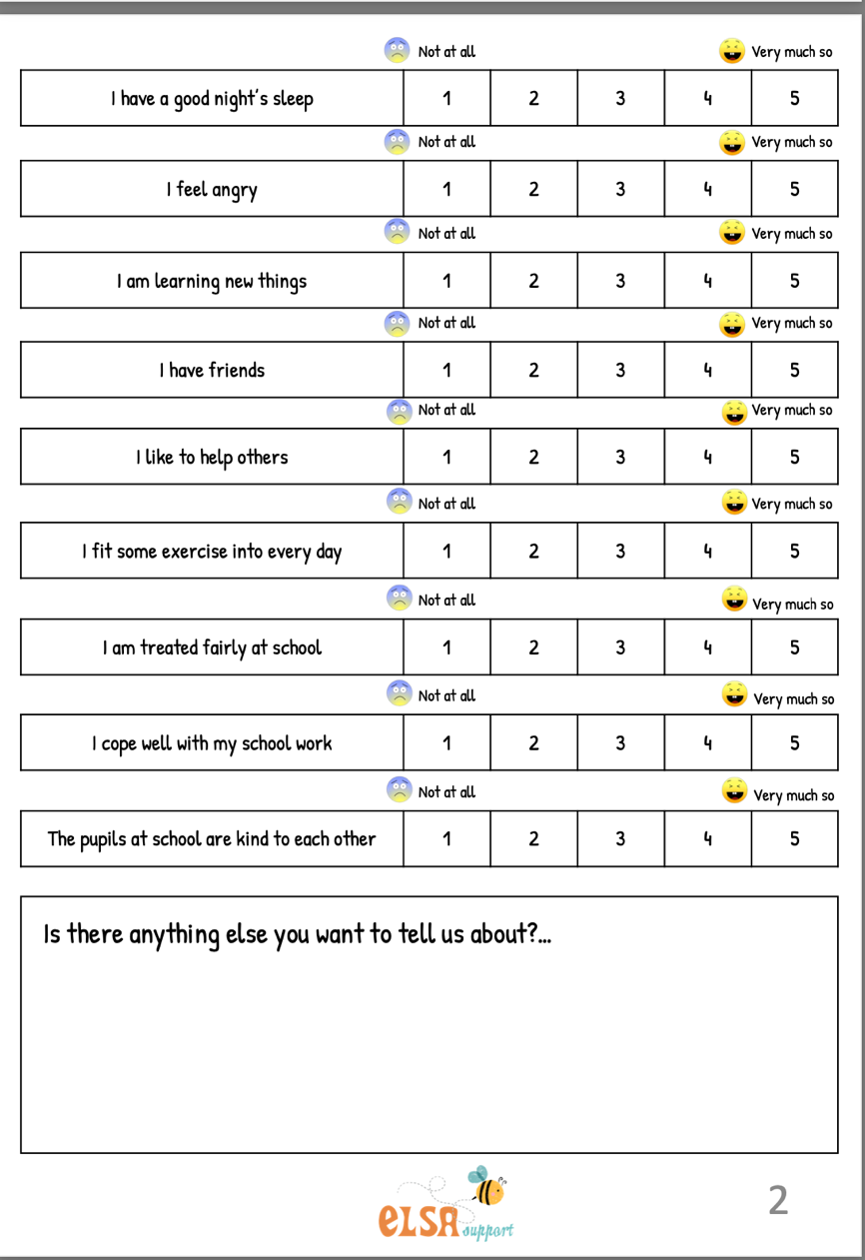
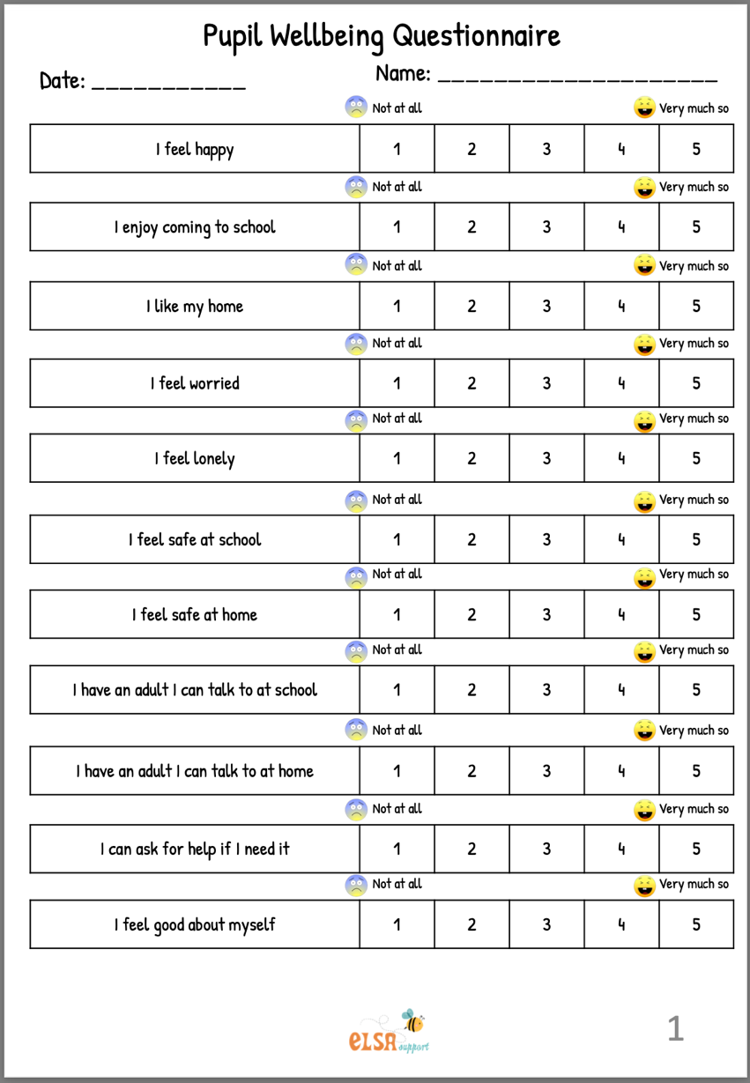
Appendix
Appendix 1-
https://www.elsa-support.co.uk/wp-content/uploads/2020/06/Wellbeing-questionnaire-update.pdf
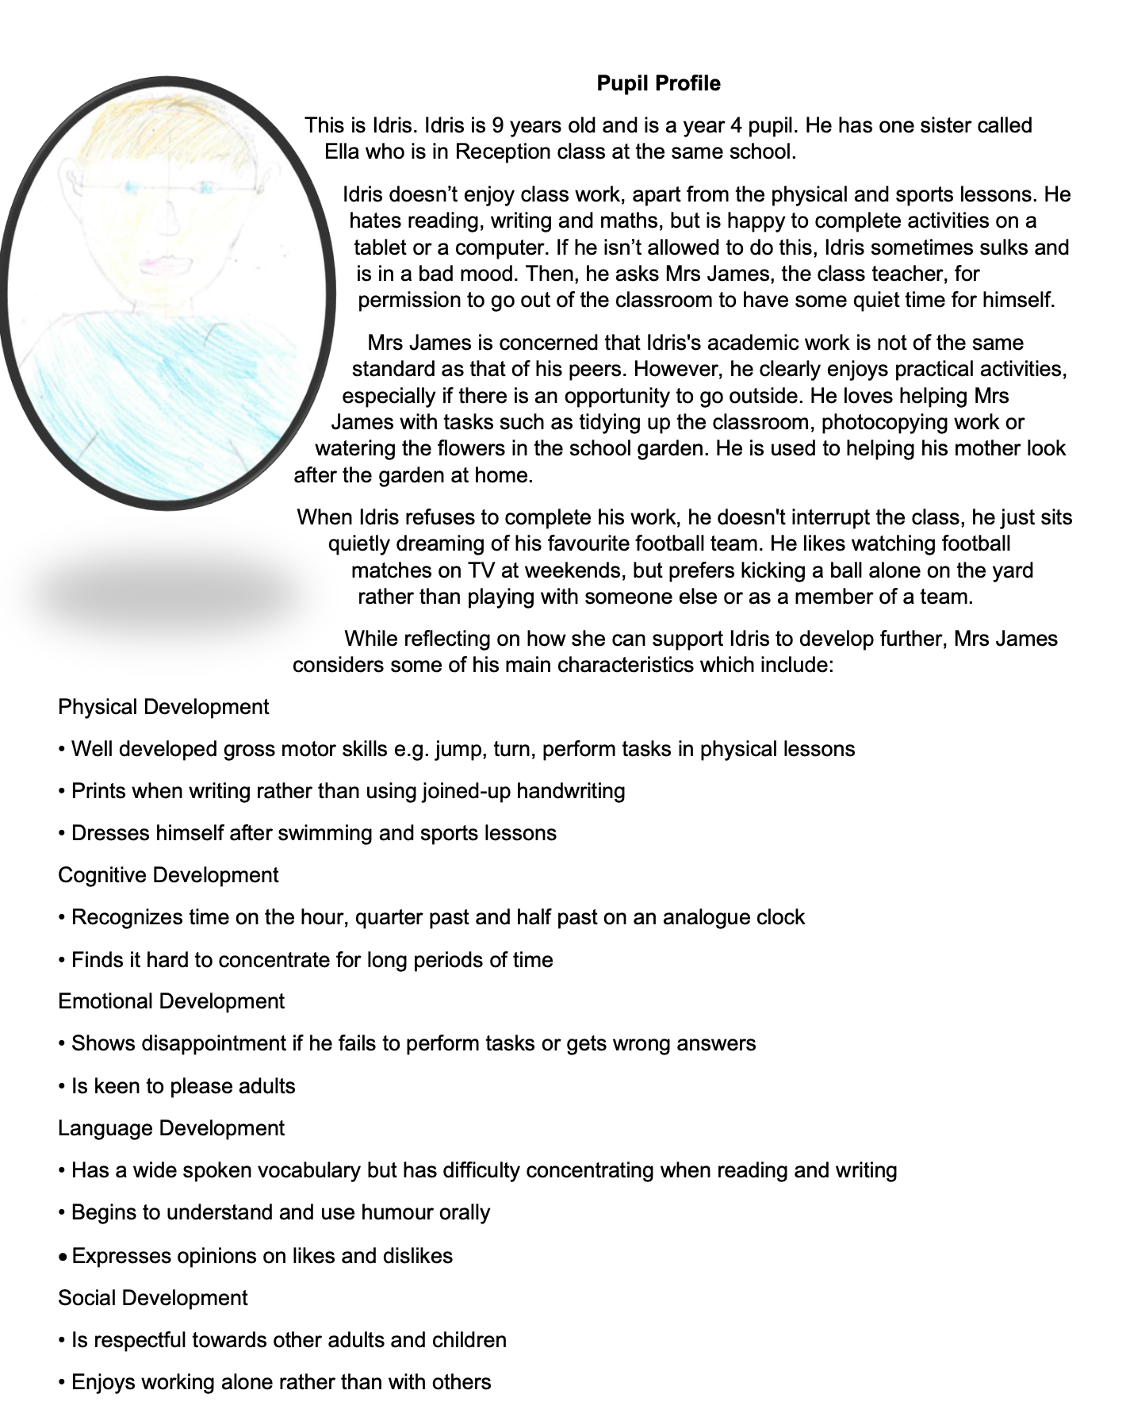
Appendix 2-
Idris pupil profile

