AI Policy in E-Learning: Strategies for Critical Analysis

Introduction: The Transformative Role of AI in Education

Artificial Intelligence (AI) is undeniably revolutionizing e-learning, providing cutting-edge tools for enhanced personalization, automation, and data-driven decision-making. While the benefits are substantial, the integration of AI also presents critical policy challenges, such as ethical considerations, equitable access, and the evolution of teacher-student dynamics. This research decisively investigates how robust AI policies can effectively address these challenges and drive improved learning outcomes.

Research Question
- What are the implications of AI policies for equity and accessibility in e-learning environments?
This key question centers on the principles of fairness, inclusivity, and the necessity for equal opportunities in education.

Policy Context: Key Policies and Frameworks

1. UNESCO's AI in Education Guidelines: Champions a human-centered approach, emphasizing ethical data practices to safeguard learners.
2. GDPR (General Data Protection Regulation): Establishes essential guidelines for managing student data privacy across Europe.
3. National AI Strategies (e.g., UK, US, India):Showcase varied yet effective approaches for integrating AI into educational systems.

Policy Gaps and Issues:
- Equity: Are AI technologies accessible to every educational institution?
- Privacy: What regulations ensure the responsible management and transparency of student data in AI applications?
- Teacher Roles: Are educators equipped with the training necessary to harness AI tools effectively?

Methodology
1. Policy Document Analysis: Conduct a thorough examination of both international and national policies to identify common themes and critical gaps.
2. Case Studies:Analyze and compare countries with mature AI policies (e.g., Finland) to those in earlier stages, drawing connections to impacts on equity and ethical practices.
3. Theoretical Frameworks:
- Critical Theory: Examine the power dynamics inherent in AI adoption and their effects on marginalized groups.
- Transformative Learning Theory: Investigate how AI reshapes teaching and learning processes to foster deeper engagement.

Expected Outcomes
1. Best Practices Identification: Establish policies that successfully balance innovation with ethical and inclusive strategies.
2. Recommendations for Equity: Develop targeted strategies to close the digital divide in AI adoption.
3. Insights on Accessibility: Uncover how effective policies can ensure AI-powered e-learning is universally accessible to all students, irrespective of their socioeconomic status.

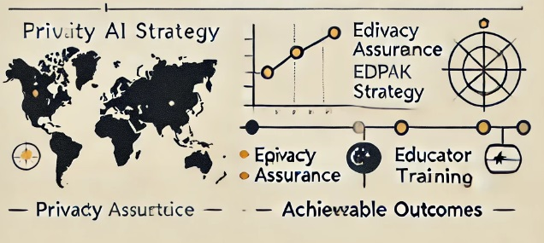

References
1. UNESCO (2019). AI in Education: Guidance for Policy Makers.
2. European Commission (2020). White Paper on AI: A European Approach to Excellence and Trust.
3. Luckin, R. (2018). Machine Learning and Human Intelligence: The Future of Education.
4. OECD (2021). AI and the Future of Skills.
5. Holmes, W., & Porayska-Pomsta, K. (2022). *Ethics in AI for Education.

