Tutorial 1 | Date: 30/01/2023

- Discuss various types of databases with Examples

Points to note:
Your discussion should be at least 1000 words with properly citing in IEEE format.
- Start with a good introduction
- Use intext referencing
- Add reference list at the end of the document
- Make sure you submit it in Turnitin by the end of the day

Introduction

In this tutorial, I will discuss various types of databases including Relational, object-oriented, Distributed, NoSQL (nonrelational), Graph, Open source and Cloud. I will also talk about the differences and what they may be used for whilst providing examples.

Relational databases

A relational database holds data in one or more tables which are referred to as ‘relations’ of columns and rows. This helps in displaying the data in a way which is easy to read and understand. [1]

An example of a relational database would be that of a healthcare database which is used to store data on different offices, doctors and patients. Each would have their own tables of information. In the Doctor table, this may include information such as the Doctors name, ID, address, and office ID. The Patients table may hold information such as their name, patient ID created from the database, their address and other personal details. And the office table would hold information related to the office such as address, name and ID [2]

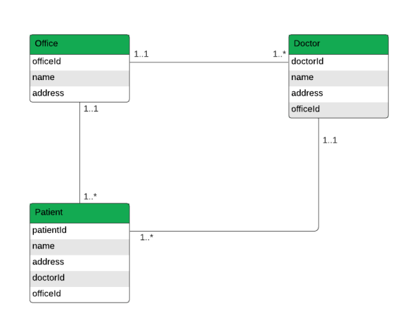

Object-oriented databases (OOD)

An object-oriented database is a system that works with highly complex data objects. These are objects that mirror those that are used in object-oriented programming languages. [3]

Everything is an object in object-oriented programming (OOP). Each have different properties. These management systems work with OOP to make the storage and retrieval of the OOD easier.

Distributed databases

A distributed database is one which uses many computers sometimes across two or more connected servers and a computer network to run and store the data rather than this being completed on a single machine.
The locations of each version of the database which is running is called an ‘instance’ or a ‘node’. [4]

Non-relational databases (NoSQL)

A non-relational database is sometimes referred to as NoSQL which stands for ‘Not Only SQL’. The difference between these and relational ones is how their information is stored. NoSQL databases often perform much faster as they do not have to look through multiple tables of data in order to produce an answer or outcome. The also deal with no unstructured data compared to that of a relational database.

One benefit of using a non-relational database is that it can store massive amounts of information and also query them with ease.

E-commerce companies use NoSQL databases due to their ability to accommodate increased user activity. At Christmas time, there is inevitably a huge increase in the amount of shoppers logging on to mobile apps which creates a spike in the usage. The database can withstand this due to its ability to store and check vast amounts of unstructured data. [5]

Graph database (GDB)

A graph database is one which stores relationships and nodes to store data entities. instead of the traditional tables or documents. It is stored in an unrestricted way much like a sketch of ideas on a whiteboard. This allows flexibility within the thought and use of it. [6]

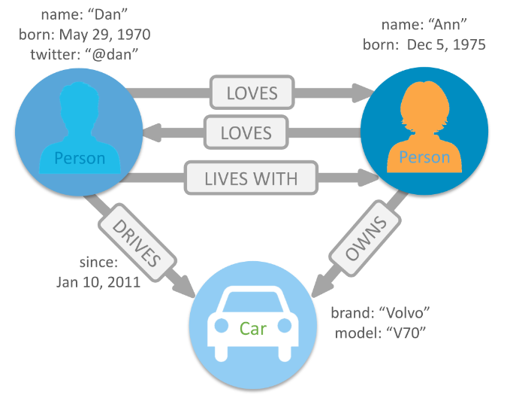
Example of a Graph Database showing the links between 2 people and a vehicle.

Graph databases can also be used in Fraud Detection. These use relationships to process financial transactions almost in real time. An example with fasts graph queries is that it can detect if a purchaser is using the same email address and payment card information known in a fraud case. It can also check for multiple people who are using the same IP address but are living in different physical addresses. [7]

Open-source Database

An open-source database is one which has code that can be downloaded, modified and re-used. This is different from closed databases which are protected to prevent any copying od the code.

Open-Source Database is common in IT departments as they are used to analyse large amounts of data to help establish a business goal. They are also easier to tailor to the needs of a business due to their flexibility.

References

[1] | google, "What is a relational database?," google, [Online]. Available: https://cloud.google.com/learn/what-is-a-relational-database. [Accessed 30 01 2023].
[2] | "MongoDB," [Online]. Available: https://www.mongodb.com/databases/types/examples. [Accessed 30 01 2023].
[3] | "MongoDB," [Online]. Available: https://www.mongodb.com/databases/what-is-an-object-oriented-database. [Accessed 30 01 2023].
[4] | "Cockroachlabs," [Online]. Available: https://www.cockroachlabs.com/blog/what-is-a-distributed-database/. [Accessed 30 01 2023].
[5] | "eweek," [Online]. Available: https://www.eweek.com/database/nosql-database-deployments-10-real-world-examples/9/. [Accessed 30 01 2023].
[6] | "neo4j," [Online]. Available: https://neo4j.com/developer/graph-database/. [Accessed 31 01 2023].
[7] | "aws.amazon," Amazon, [Online]. Available: https://aws.amazon.com/nosql/graph/. [Accessed 31 01 2023].

