Student name : Galeru Izabela-Mihaela
Student Id : 2107607
Module name : Digital Skills and Research Methods
Module Code : BMSW4003
Lecturer name : Abdi Rahman

How I can use the DIKW and CRAAP frameworks to confirm or refute my collected Academic GRIT test result (Primary Data) compared to the UWTSD GRIT Result (secondary Data) based on the work of Angela Duckworth TED Talk lecture

Introduction 2
Overview of Research 2
Factors 3
GRIT Computations 3
Data and Information 3
DIKW model 4
How GRIT should be prioritised? 8
Conclusion 9
References 9

Introduction
Angela Duckworth, a Pennsylvania State University professor, was teaching 7th mathematics in community schools in The City Town whenever she realised that her best students weren't always her smartest. She quit her job as a high school teacher to continue pursuing a professional career expert so that she could fully emphasize the value of fundamental knowledge like self-control and perseverance in attaining greatness. In 2013, Duckworth tried to give a TED Talk about just how grit, or the ability to persevere and be enthusiastic about long-term objectives, is a key factor in performance. It will go over Duckworth's studies in deeper level as well as evaluate the effect of grit in the schoolroom in 2019, 6 years after her TED Chat show (MG, 2015).

Overview of Research
Duckworth's grit concept has received much interest as well as discussion, both positively and negatively, since her 2013 Chat Show. Numerous people seem to believe that grit is important for education, while others genuinely think that relying exclusively on grit ignores other important factors that influence educational objectives. Even those who genuinely think in grit are unsure how to assist their students in developing it. The following paragraphs will discuss how Angela Duckworth arrived at her conclusions about grit, how very much her viewpoints have changed in the six consecutive months even though her TED Talk was posted online, and how one can help children develop grit (Laudon & Laudon, 2016).

Factors
Duckworth studied parents and kids in difficult situations, such as West Point military recruits, national educational decathlon competitors, and educators in distinct public schools. In every study, she as well as her team research made the same comment: "Who is efficient here just because?" Grit turned into a significant predictor of success across a wide range of situations. Grit is a personality trait that enables students to work strong and stay centred for centuries rather than months or even years.

GRIT Computations
Duckworth and her co - workers developed the Grit Severity, a self-reported questionnaire that asks questions like- "How did I conquer setbacks to conquer a difficult obstacle?" On a scale of 1 to 5, respondents were asked to rate themself, with one denoting. "Not really like me" and five implying "Very much like me." After filling the questionnaire, a user's grit points system can be computed and utilised to see how grit corresponds with other success factors. Duckworth as well as her colleagues examined Chicago Metro Region fellow students for seeing if grit, as measured in apprentice year, predicted a master's degree the following year. Educators used the Grit Scale to answer a questionnaire that would include questions about campus safety, effective teaching, interaction with peers, parental support, social awareness, as well as schooling inspiration, which are all known to predict college graduation (Hara & Hew, 2017).

Data and Information
In conformance with cognitive neuroscience, data has indeed been expressed as follows of kinetic hypothesis (physiological) random element, information in form of Colleen (symbol) basic physics, as well as understanding in regarding mental (background) electron density development. As a consequence, information can be assumed of as completely pointless patterns, specifics could be assumed of as data analysis, and understanding could be thought of as "reliable and comprehensive in a landlord's logical investments." Even though some of the above said descriptions would seem to indicate a direct path from data to understanding, it has also been proposed that information and facts both come from understanding. To put it differently, information can be analysed as an unbiased medium for interaction and the stored information can be encrypted from data as well as interpreted into information by a beneficiary. In the context of cryptographic, an encryption method can be used to gather the data needed. Information, but at the other side, is any Boolean representation saved on or attempted to interact via an electronic medium. Information, on the other hand, can be considered a knowledge if it lessens the recipient's threats. Others here have stated that the idea of data is more difficult to define and for its multi-dimensional essence (Jeste et al., 2016).

DIKW model
The DIKW (data–information–knowledge–wisdom) organisation, also known as the 'Knowledge Hierarchical system,' 'Information Hierarchically,' as well as 'Knowledge Sphere,' is one of the most foundational, universally acknowledged, as well as 'taken-for-granted' designs in the knowledge and information works of literature. In school books on data management, data management, as well as organisational learning, it is frequently quoted or even used impliedly in meanings of information, data, as well as knowledge. The pyramid is used to place data, information, knowledge, as well as wisdom in sense with each other, as well as to identify and define the procedures refers to the conversion of a lower-level organisation (e.g. information) into a higher-level entity (e.g. knowledge) (e.g. data). Information could be used to arrange data, data could be used to generate knowledge, as well as understanding could be used to start creating knowledge, according to the unspoken assumption (Leech & Onwuegbuzie, 2017).
The DIKW hierarchy is positioned as a central view of information planning, data management, as well as organisational learning due to its operational definition’s role. Despite the fact that there's been considerable debate from over centuries about issues related like the essence as well as description of data, alike since then, as well as a latest concentrate on the description of knowledge, there was:
• tiny straightforward conversation of the DIKW power structure on its own, its significance and donation; as well as limited conversation of the essence of knowledge, nor much conversation of the organisational aspects that lead to the growing of intellect.
• because of its constant obsession with facts and communication, the DIKW power structure has been dubbed the knowledge hierarchal structure or the expertise management structure, in both (McDermott, 2019).
For two purposes, we relate to the DIKW power structure as the knowledge power structure here:

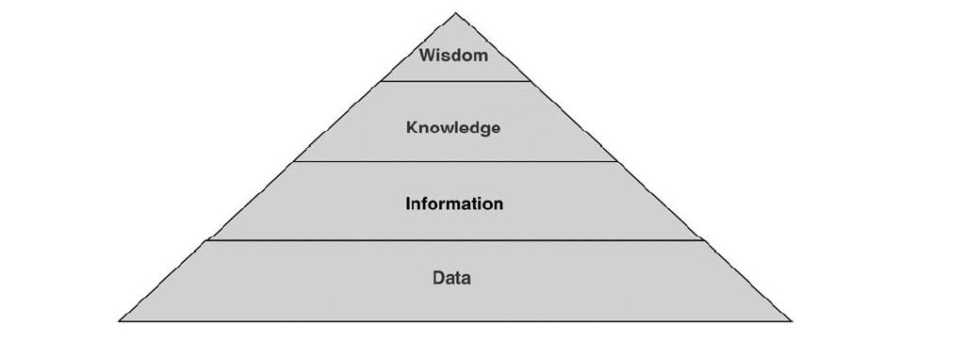
Figure 1. DKIW hierarchy

Many areas of study, which include communication systems concept, information sciences, data management, computer neuroscience, and organisation science, have regarded the vital nature of the information because it is foundational to the presence. This has resulted in a variety of viewpoints on the nature of data. 'Of mundane as well as technological notions, data is presently among the most significant, widespread utilised, as well as least known,' Floridi claims. The interaction theoretical approach, the sampling distribution, the mode shape method, the classification is done, the inference method, as well as the linguistic method are the six methods, he identifies for defining data (Garvin, 2017). Lately, there's been a resurgence of attention in the field as a result of the implementation of the emerging field of knowledge ideology. The crucial inquiry of the abstract nature and core tenets of data, such as its interplay (particularly data processing and flow of information), is the focus of knowledge ideology. Participants in this discussion concur that various writers have provided the word "data" alternate implications, and therefore there is no general agreement on what the word "data" means. Long-running discussions about just the theory of science have gained momentum in the recent, owing to the emergence of the restraint of organizational learning. Plato initially clearly delineated knowledge as "justified true," as well as Aristotle and others have discussed this notion over the centuries (Hardie & Walsh, 2014). Attempting to draw on such debates, we propose that understanding "can be thought up as knowledge on the part to fruitful use." Ideology, system that affect, social science, organizational theory, information systems, predictive modelling, machine intelligence, as well as economics have all impacted organizational learning, as has knowledge philosophy. Suggest five distinct organizational learning perspectives, each with a different view on the essence of knowledge and knowledge management processes: philosophy-based, intellectual, connection, society, as well as quantum. To sum up and set the stage for our deeper dive into the literary works on the DIKW pyramid, both of the knowledge philosophy as well as knowledge management writings have a long history and provide different perspectives on the description of facts and communication (Fayyad et al., 2016).

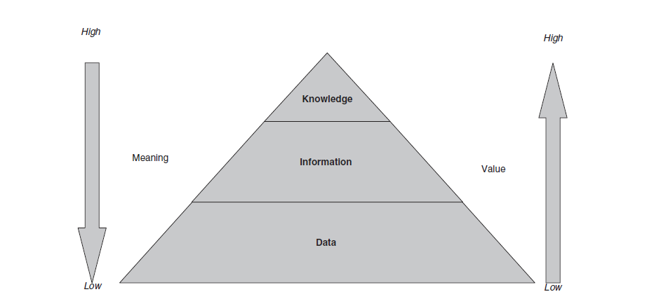
Figure 2. D, I and K
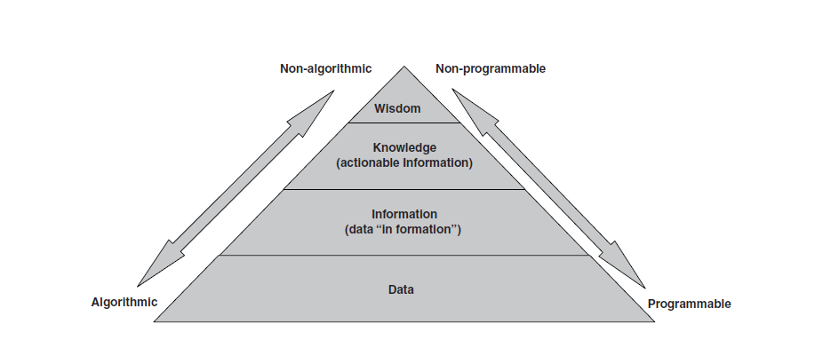
Figure 3. D, I and K
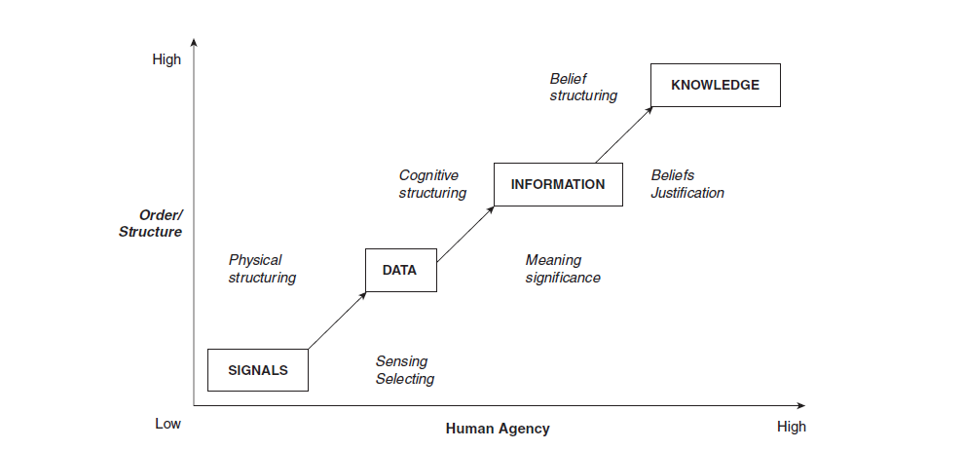
Figure 4. D, I and K
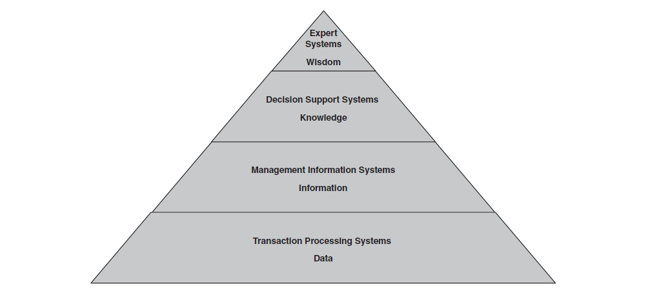
Figure 5. Mapping to kinds of IS

How GRIT should be prioritised?
Regardless of the fact that grit is obviously important for candidate and procedure objectives, little is known on how to assist classmates develop grit. However, an amount of variables impact student starting to learn, as per a report published in accordance with Duckworth's TED Talk as well as Online Promise's own attempting to know scientific research. While encouraging grit is beneficial for measures of student learning such as enabling learners to create adjustments, set the bar pretty high, as well as claim authority over their learning experiences, seemingly insignificant details such as ambient temperature or layout could have an influence on pupils' motivation and perseverance. Since her 2013 Chat Show, Duckworth must have re-assessed the role of grit in academic achievement, confessing in a discussion meeting with Ed-Surge in the year 2018 that "there seem to be a multitude of stuff that kids have to really continue living continues to live that are quite happy, nutrient dense, as well as great for other people." The list includes grit, but it was not the only item." Duckworth co-founded Character Experiment, a non-profit organisation dedicated to demonstrating how a variety of variables affect academic achievement. The site's "game plans" offer teachers with actionable intelligence on a wide range of educational issues. So every playbook focuses on grit, while others focus on personal qualities such as intent, gratitude, and sense of wonder (Crosby, 2014).
GRIT students
It hasn’t ever understood just about everything there is understand about how to help students develop grit, as well as finding a solution would then require close collaboration between scholars and researchers. This will necessitate both motivation and perseverance. "We should choose the recommendations, the largest recommendations, and also check those," Duckworth said throughout her TED Talk. "Throughout determining whether we were successful, we must be willing to fail, make total errors, restart, and learn some lessons." As stated in previous phrases, we should be steadfast in our efforts to instil grit in the children." After the backlash she received within a week of her TED Talk, Duckworth had also made it very clear that a "no reasonings" or shame-based approach to grit is not really the way to go. According to Duckworth, "It's a natural human instinct to avoid responsibility, being perplexed, and also being interrogated (Claver et al., 2015). Ed-Surge, As a result, it is the responsibility of the assistant professor, school environment, or broader society to ensure that kids know so when they do not even must do something tough, but when someone who doesn't want something complicated but can't work collaboratively out, but then when those who don't want to give up items, perhaps most important part is to start by truly understanding that it really is fraught with difficulty. " Educators who want to start cultivating grit in the classroom are urged to do so. She gives an example of a teacher who managed to keep all of her teachers' exams in a bound book that they could easily access to retake the problems they tried to answer in a discussion meeting. Giving students the time, space, and opportunities to be gritty can be a great first step in trying to instil gritty mindsets in the classroom (Burstein & Linger, 2013).

Conclusion
The purpose of this paper was to perform a systematic on the DIKW system of power, its element aspects, and its genuine advancement in detail, and to include a high-level preparation. Furthermore, we geared to floor the regular pattern in an explication framework in order to provide a clearer and coherent understandings. While several researchers have looked into the DIKW power structure as well as its particular criteria, this research goes a step further by explicitly anchoring the hierarchy system in compound called works of literature and looking into the relationship here between structure of power as well as its legitimate advancement. The essay also contributes to the body of proof by demonstrating the lack of consistency with the use of correct terms in normal conversation and by information management experts.

References

Burstein, F. & Linger, H. 2013. Supporting post-Fordist work practices: A knowledge management framework for supporting knowledge work. Information Technology & People, 16, 289-305.
Claver, E., Llopis, J., González, M. R. & Gascó, J. L. 2015. The performance of information systems through organizational culture. Information Technology & People, 14, 247-260.
Crosby, P. 2014. Quality is Free, New York, McGraw-Hill.
Dampney, K., Busch, P. & Richards, D. 2012. The Meaning of Tacit Knowledge. Australasian Journal of Information Systems, 10, 3-13. Available: http://dl.acs.org.au/index.php/ajis/article/view/438 [Accessed Dec 2021].
Falkenberg, E. D., Hesse, W., Lindgreen, P., Nilsson, B. E., Oei, J. L. H., Rolland, C., Stamper, R. K., Assche, F. J. M. V., Verrijn-Stuart, A. A. & Voss, K. 2018. A Framework of Information System Concepts: The FRISCO Report, The Netherlands, Department of Computer Science, University of Leiden.
Fayyad, U. M., Piatetsky-Shapiro, G. & Smyth, P. 2016. From data mining to knowledge discovery: an overview. AI Magazine, 17, 37-54.
Galliers, R. & Newell, S. 2011. Back to the Future: From Knowledge Management to Data Management. Proceedings of ECIS. Bled, Slovenia.
Garvin, D. 2017. Competing on the Eight Dimensions of Quality. Harvard Business Review, 65, 101-109.
Hara, N. & Hew, K. F. 2017. Knowledge-sharing in an online community of health-care professionals. Information Technology & People, 20, 235-261.
Hardie, N. & Walsh, P. 2014. Toward a Better Understanding of Quality. International Journal of Quality & Reliability Management, 11, 53-63.
Jessup, L. M. & Valacich, J. S. 2013. Information Systems Today, Upper Saddle River, NJ, Prentice Hall.
Jeste, D., Ardelt, M., Blazer, D. & Meeks, T. 2016. Expert Consensus on Characteristics of Wisdom: A Delphi Method Study. Gerontologist, 50, 668–680.
Laudon, K. C. & Laudon, J. P. 2016. Management Information Systems: Managing the Digital Firm, Upper Saddle River, NJ, Pearson Prentice Hall.
Lee, Y., Strong, D., Kahn, B. & Wang, R. 2012. AIMQ: A Methodology for Information Quality Assessment. Information Management, 40, 133-146.
Leech, N. & Onwuegbuzie, A. 2017. An array of qualitative data analysis tools: A call for data analysis triangulation. School Psychology Quarterly, 22, 557-584.
McDermott, R. 2019. Why Information Technology Inspired but Cannot Deliver Knowledge Managennent. California Management Journal, 41, 103-117.
Meeks, T. & Jeste, D. 2019. Neurobiology of Wisdom. Arch Gen Psychiatry, 66, 355-365.
MG. 2015. The Gazette's View: On roads and bridges, we need fixes – and information [Online]. Available: http://www.montrealgazette.com/Gazette+View+roads+bridges+need+fixes+information/4960712/story.html [Accessed 10th Dec 2021].
Mider, Z. R. & McCracken, J. 2016. Record Stock Gains for Acquirers Defy Wall Street Selloff Wisdom [Online]. Available: http://www.bloomberg.com/news/2011-06-16/record-stock-gains-for-buyers-defy-wall-street-wisdom-on-takeover-selloffs.html [Accessed 10th Dec 2021].
Morris, C. W. 2018. Foundations of the Theory of Signs, Chicago, Chicago University Press.
Nichol, A. 2016. Knowledge on HST makes all the difference [Online]. Available: http://www.coastreporter.net/article/20110617/SECHELT0302/306179970/-1/sechelt/knowledge-on-hst-makes-all-the-difference [Accessed 10th Dec 2021].
Nozick, R. 1981. Philosophical explanations, Harvard University Press.
O'Donovan, B. & Roode, D. 2012. A Framework for Understanding the Emerging Discipline of Information Systems. Information Technology & People, 15, 26-41.
Østerlie, T., Almklov, P. G. & Hepsø, V. 2012. Dual materiality and knowing in petroleum production. Information and Organization, 22, 85-105. Available: http://www.sciencedirect.com/science/article/pii/S1471772712000024.
Pearlson, K. E. & Saunders, C. S. 2014. Managing and Using Information Systems: a Strategic Approach, New York, Wiley.
Peirce, C. S. 2018. The Essential Peirce, Volume 2: Selected Philosophical Writings, 1893-1913, Indiana University Press.
Piaget, J. 2017. The Development of Thought: Equilibrium of Cognitive Structures, NY, Viking Press.
Pipino, L., Lee, Y. & Wang, R. 2012. Data Quality Assessment. Communications of the ACM, 45, 211-218. Pipino, L., Wang, R., Kopcso, D. & Rybolt, W. 2015. Developing Measurement Scales for Data-Quality Dimensions. In: Wang, R. Y., Pierce, E. M., Madnick, S. E. & Fisher, C. W. (eds.) Information Quality. Armonk, NY: M.E. Sharpe.

