
BMSE4010 / BMSE4010D
Sustainable Enterprise
Student Name: Andrei Liviu Patrasc
Student id:2530288

Table of Contents
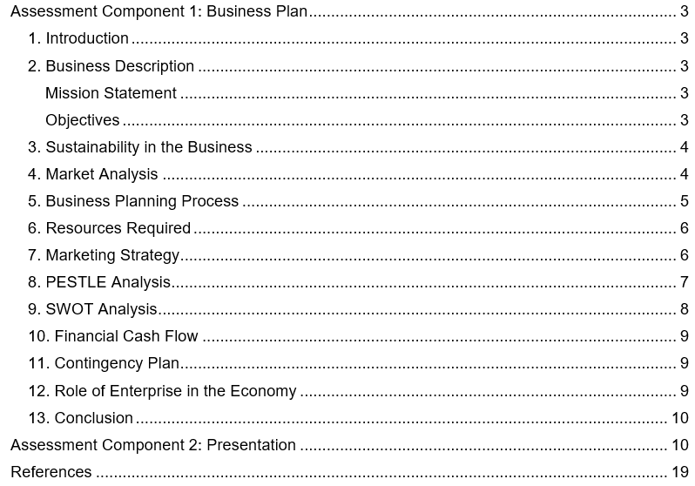

Assessment Component 1: Business Plan

1. Introduction
This is a sustainable enterprise development project of EcoFresh Packaging Ltd as it is proposed in this business plan. To effectively remove plastic in food and retail industries, the company manufactures biodegradable packaging. The business will minimise environmental pollution and make a profit through sustainable business operations. The company includes economic, environmental, and social sustainability in the business in order to promote long-term growth and benefits to the community (Chofreh & Gholamzadeh, 2018). The corporation offers cheap green goods and services, minimises wastes, and generates jobs locally. The plan will entail market analysis, sustainability strategy, marketing, operational requirements, PESTLE and SWOT analysis as well as financial projections.

2. Business Description
EcoFresh Packaging Ltd is a start-up company that manufactures biodegradable packaging made of sustainable natural materials. The company makes packaging products using corn starch, recycled paper, and plant fibres to come up with eco-friendly products. The company aims at substituting plastic packaging in all the fields of the food industry, retail and delivery industries. The business is aimed at the green businesses in markets that want cheaper and sustainable packaging solutions.

Mission Statement
The goal of the company is to offer inexpensive sustainable packaging services which minimise and lessen environmental degradation. The business contributes to the greener future, as it advocates the responsible production and the green consumption exercise.

Objectives
- To launch operations within 6 months
- To achieve break-even within the first year
- To supply at least 50 local businesses within the first year
- To reduce plastic waste in the local community

3. Sustainability in the Business
This business is anchored on the sustainability, which is the determinant of all business decisions. To ensure that it has long term sustainable development goals, the company integrates the environmental, economic and social factors. The business has three pillars of sustainability to balance the organisational performance and the social obligations (Gomes Silva et al., 2022).
Environmental Sustainability: The company also utilises the biodegradable materials so that environmental degradation through the plastic waste is minimised. The company reduces the use of plastic in the production of waste materials by using environmentally friendly package materials and in the production process (Wang and Wang, 2021). The company embraces the use of low carbon production in order to minimise the emission of greenhouse gases. The company encourages the efficient utilisation of resources to save the natural ecosystems and environmental sustainability at all times.
Economic Sustainability: The company aims at achieving long-term sustainable profitability by the use of sustainable production and effective cost management approaches. Cost-effective production processes have enabled the company to achieve competitive prices and financial stability at all times. The venture enjoys the advantage of the rising market demands of eco-friendly products in most sectors worldwide (Anbarasan, 2018). The company reinvests its earnings towards innovation and sustained improvement in sustainable product development.
Social Sustainability: The company also develops local jobs to assist the community growth and development of the economy properly. The company works towards the environmental awareness of the customers by educating them and conducting sustainable business (Rahmana & Bawono, 2020). The business aims to uphold the ethical business practises by treating the employees and other stakeholders fairly. The firm balances the social, economic, and environmental responsibility with sustainability practises (Putri, Naili and Natalis, 2024).

4. Market Analysis
Environmental issues and policies make the market need sustainable packaging. The government has very stringent rules to minimise the use of plastics and encourage ecologically friendly alternatives that are used in the country. Consumers are becoming more conscious about ecological matters and are more willing to use environmentally sustainable packaging products (Boz, Korhonen and Koelsch Sand, 2020). The food distribution industry is growing at an astonishing pace and calls upon the need to demand high quality and sustainable packaging options. Sustainable packaging is embraced in the retail industry so as to address the expectations of customers and the requirements of the regulatory bodies.
Target Market: Restaurants and cafes that have to be provided with high-quality and durable packaging are the target audience of the company on a daily basis. The business targets the supermarkets that desire to get environmentally friendly packaging of products and customer satisfaction (Wechselberger, 2024). The business provides online delivery companies with the need of safe and sustainable packages. The company promotes small retail stores that want to decrease the use of plastic and become more sustainable.
Competitors: The other competitors of the business include the traditional packaging companies that provide more affordable plastic packaging options. The company also competes with the imported suppliers of eco-packaging that offer sustainable products related to packaging globally. The business will be unique in the sense that it provides local packaging at affordable and competitive prices (Suherlan and Widiyanti, 2021). The company establishes good customer relations to achieve the competitive advantage in the sustainable packaging market.

5. Business Planning Process
Business planning process offers a systematic method of creating a sustainable business in an effective way. The company adheres to orderly procedures in order to guarantee efficient planning and the long-term business sustainability results. The process starts with the generation of ideas whereby it is targeted at finding solutions to the market needs that comply with eco-friendly packaging. The company considers new ideas in order to come up with viable and sustainable product development opportunities (Edgeman & Eskildsen, 2014). The company always does extensive market research to be able to see the needs of the customers and industry trends well. The data gathered by the business helps in analysing the demand, competition and potential growth prospects. The business conducts resource planning so that it can determine the necessary amounts of physical, human and financial resources. The company is an efficient way of allocating resources to facilitate production, marketing, and operations of the company. The company develops financial forecasting to determine the anticipated revenue, expenses, and the level of profitability in general (Padmanabhan and Nirmala, 2023). The company discusses financial information in a bid to make sure that the company is economically viable and that sound decision making has been made. The business performs risk assessment to outline the possible business issues and uncertainty in business. The business will come up with strategies to handle risks and reduce adverse effects on performance. The systematic planning methodology makes the business viable and successful in terms of attaining sustainable growth.

6. Resources Required
Production, operations, and long-term sustainable growth require the essential resources to be supported in the business. The resources that the company recognises are physical, human and financial resources to make the business perform efficiently in the long run.
Physical Resources: Production machinery is utilised by the company to produce biodegradable packaging products efficiently and at a constant pace (Ashiwaju et al., 2023). Sustainability of the business demands plant-based raw materials to manufacture environmentally friendly packaging products. The company has warehouse floors to keep raw material and finished products in a secure and efficient location. To handle its day-to-day operations, the company runs office space to take care of administration, finances, and marketing processes.
Human Resources: The company has production employees who oversee the production procedures and ensure that the quality of the products remains the same. The company employs people in marketing as the products need to be promoted and appeal to environmentally aware customers. To manage the daily operations in the enterprise, the business hires an operations manager to facilitate the running of the business. To enhance sustainable production practises, the business trains employees on a regular basis to enhance their skills (Barakat et al., 2023).
Financial Resources: The company will need a minimum of twenty thousand pounds in order to commence operations successfully. Personal savings are efficiently used as the business capital to cover initial establishment cost and initial operating expenses. The business acquires small business loans to enable it to grow and continue operating financially.

7. Marketing Strategy
The marketing strategy directs the business operations in order to appeal to customers and improve the sales of the product. This firm utilises the systematic marketing mix to market sustainable packaging products in the target markets.
Product: The products that the business sells are ecologically safe biodegradable packaging that is meant to be used instead of harmful plastic substances (Rajesh, 2023). The company is consistent in its quality of products across the markets as duly desired by customers and environmental standards.
Price: The company establishes competitive pricing strategies in order to appeal small businesses and cost-saving consumers to the business (Jerab and Mabrouk, 2023). The company is able to keep the prices low to enhance market penetration and customer loyalty in the long run. The business also evaluates the prices on a regular basis to be competitive and to also achieve long-term profitability goals.
Place: The company distributes products locally to the customers in order to optimise on customer relationship and delivery on time. The online sales have enabled the firm to create a wider market and increase the availability of the products to more individuals.
Promotion: Social media marketing is another tool used by the company to market the brand and communication with customers. The company establishes a relationship with environmentally friendly brands to enable the company to succeed in the market expansion (Rajesh, 2023).

8. PESTLE Analysis
The PESTLE analysis is an analysis of the external forces that determine business performance and strategic decision making (Uztürk and Büyüközkan, 2023). The business evaluates the political, economic, social, technological, legal and environmental factors influencing business.
Political Factors: The government implements policies that minimise the use of plastics and also enhance sustainable business in the country (Barrowclough and Birkbeck, 2022). Its business has an advantage of political interest in production and packaging solutions that are environmentally friendly.
Economic Factors: Business is experiencing an increment in the cost of production as prices of raw materials in the world rise (Uztürk and Büyüközkan, 2023). Markets are affected by economic difficulties. The company is enjoying high market demand of eco-friendly products. The company operates efficiently on its costs to ensure that its profitability and competitive pricing practises remain intact.
Social Factors: Consumers are increasingly sensitive to the problem of environmental protection, which has led to the consumption of environmentally friendly products (Alamsyah, Othman and Indriana, 2021). Responsiveness The business responds to the changing consumer tastes and preferences by offering environmental-friendly and ethical packs.
Technological Factors: Technology supports the manufacture of bio-degradable substances and helps in the manufacture of sustainable packaging materials. The company uses contemporary technologies to become more effective and reduce the production costs.
Legal Factors: The government has very strict laws to regulate the use of plastics and promote a sustainable business world (Uztürk and Büyüközkan, 2023). The company adheres to the legal provisions in order to prevent fines and uphold ethical business practises in the business at all times.
Environmental Factors: The climate change poses more demand to the eco-friendly solutions and promotes sustainable business development worldwide. The company minimises environmental effects through sustainable production processes as well as resource management practises (Alamsyah, Othman and Indriana, 2021).

9. SWOT Analysis
The SWOT analysis is used to measure the internal strengths and weaknesses and external opportunities and threats (Uztürk and Büyüközkan, 2023). This analysis is utilised by the company to achieve better strategic planning and overall better business performance.
Strengths: The company has environmentally friendly products which minimise environmental effect and appeal to mindful clients. The company enjoys the advantage of increasing market demand of the sustainability of packaging in various industries worldwide. The company also has a high level of sustainability to facilitate both environmental and economic performance objectives in the long term.
Weaknesses: Investment in sustainable production technologies and material costs the company a lot of initial costs (Alamsyah, Othman and Indriana, 2021). The company has low brand recognition at the initial stages of market penetration and growth. The business also takes time to make customers loyal to it and to effectively gain presence in the market.
Opportunities: To gain market share, the company ventures into new market expansion to get more sales and business expansion opportunities. The government support on sustainable enterprises and environmental protection initiatives in the country is beneficial to the business (Barrowclough and Birkbeck, 2022).
Threats: Large companies that provide similar packaging products at a low price are a threat to the business (Uztürk and Büyüközkan, 2023). The company has to keep customer price sensitivity that can influence the demand of more expensive sustainable products.

10. Financial Cash Flow
The business achieves sales revenue of 5000 pounds in sales of initial products every month. To ensure that the quality of production is up to date, the company incurs 2000 pounds of raw materials. The company salaries are fifteen hundred pounds used to support the staff and operations. It costs the company 800 pounds to rent and keep business facilities running. The enterprise has set a budget of 300 pounds per month on marketing to know people and sell their products. The first stage is where the business makes 400 pounds as net profit monthly. The firm anticipates the growth in finance because the customers will continue to grow in numbers and the brand awareness will gain momentum over time (Kulova and Nikolova-Alexieva, 2023).

11. Contingency Plan
To ensure that there is financial stability, the business has emergency funds that it uses to cater to any unanticipated costs. To minimise risks of disruption in the supply chain and shortage of supplies, it diversifies the suppliers to mitigate the risks of these occurrences (Shekarian and Mellat Parast, 2021). When the cost of production increases, the enterprise changes the pricing strategies to ensure profitability and competitiveness in the market. The company diversifies its products to suit the needs of the customers and address the requirements of the market. The company also formulates risk management strategies to combat any operation, financial and environmental challenges in advance. The business keeps track of risks that may occur in order to provide solutions as fast as possible and reduce the adverse effects on the business. The company educates the personnel on how to act in case of an emergency and ensure that production processes are always smooth. The company also has alternative systems that provide security to the data, inventory, and operating processes. The company cheques the contingency plans on a regular basis to enhance readiness to face unexpected challenges and surprises on a regular basis.

12. Role of Enterprise in the Economy
The business gives back to the local economy through the creation of local employment and the workforce development. The business favours local suppliers by obtaining supplies in the country and facilitating economic growth in the region at all times. The company promotes sustainable business practises in other businesses in an attempt to minimise environmental impact on a collective basis (Odeyemi et al., 2024). The business enhances the economy through generation of income, investment and effective stimulation of regional markets. Responsible operations and programmes of community involvement help the business to enhance social and economic cohesiveness. The company offers skills development and entrepreneurship opportunities in the local economy and achieves this. The business fosters sustainable activities that are in tandem with the social and regulatory requirements in a satisfactory manner. The business encourages innovation and brings sustainable solutions as well as motivates other businesses to implement environmentally friendly ways.

13. Conclusion
This business plan shows that EcoFresh Packaging ltd is a viable sustainable business that is in operation. The company responds to the environmental issues and attains economic growth as well as social benefits at the same time. Sustainability in all business activities will guarantee success in the long run and contribution to the society. Good planning, marketing and financial management guarantee high chances of further growth at any point of time. The business positively impacts the ecological safety, creation of a community and the viability of the regional economy on a routine basis.

Assessment Component 2: Presentation
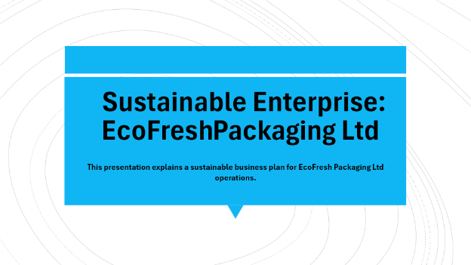
The presentation describes sustainable business plan of operations of EcoFresh Packaging Ltd in a clear manner. The presentation will focus on sustainability plans, market performance and financial performance of the company. The company aims at practising biodegradable packaging so that the environmental pollution and plastic waste can be minimised. The company implements new technologies that promote sustainable growth, and social business conduct across the world. The case of the business has shown that sustainability can be used to generate competitive advantage and long-term profitability effectively. The company has given a clear description of goals, strategies and forecasted expected business results.
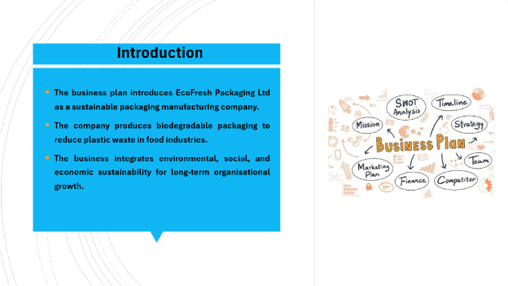
The business plan presents EcoFresh Packaging Ltd as a packaging manufacturing firm with a sustainable nature. To minimise the waste of plastics in food industries, the company manufactures biodegradable packages. The company has successfully incorporated environmental, social and economic sustainability in long term organisational development. The firm is also committed to sustainable development by ensuring that its operations are aligned with the benefits of the environment and the community. The company is concerned with decreasing the environmental impact, as well as keeping the financial stability and the efficiency of the operations at the same level. The company describes how sustainability makes value to the customers, stakeholders and the community at large.
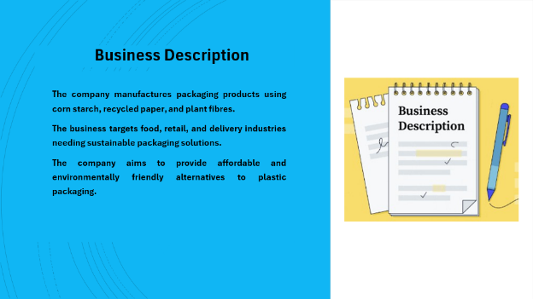
The company produces packaging products with the use of corn starch, recycled paper, and plant fibres. The business will focus on food, retail, and delivery industries that will require sustainable packaging solutions. The company tends to offer an alternative to plastic packaging that is affordable and environmentally friendly. The company is keen on quality production so that it successfully satisfies its customers and environmental requirements. The company comes up with innovative products that enhance durability and sustainability in packaging solutions. The company maintains a high level of product quality in order to establish trust and a relationship with the customers on the long-term basis.
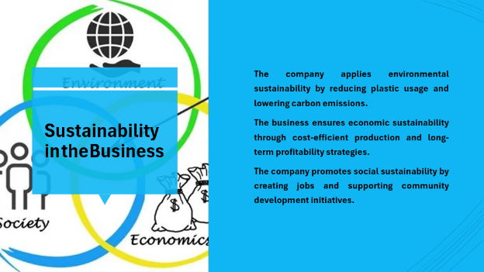
The company is practising environmental sustainability through a reduction of plastic consumption and decreasing the carbon emissions. The company maintains economic sustainability by using economical production and long-term profitability plans at all times. The firm is socially sustainable in that it aims at providing employment and contributes to community development efforts (Boz et al., 2020). The business strikes a balance between the environmental, economic and social objectives to attain the successful organisational performance. The firm incorporates environmentally friendly production methods that reduce wastage and the use of natural resources. The business incorporates sustainability in the process of making decisions to enhance long term business success at all times.
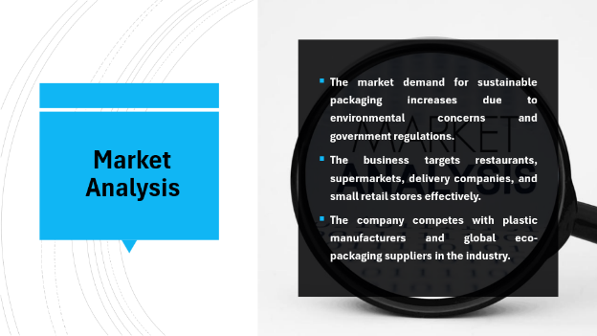
Environmental issue and Government regulations in the world market influence the market demand of the sustainable packaging. The target of the business is restaurants, supermarkets, delivery services and the small retail stores. The company is in competition with the plastic manufacturers and other suppliers of eco-packaging across the world. The business is reactive to these consumer preferences, providing the consumers with eco-friendly and high-quality packaging products. The growth opportunities that the company sees include raising awareness of the environment of sustainability among the customers (Alamsyah, Othman and Indriana, 2021). The market analyses include business, in order to enhance competitive positioning and achieve success in the long term.
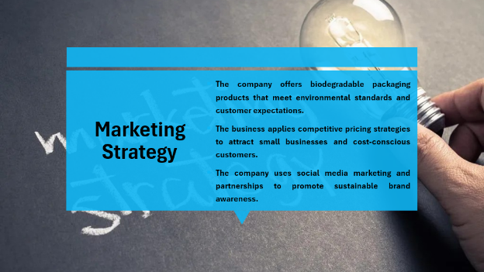
The company comes up with biodegradable packaging products that are always in accordance with the environmental standards and the expectation of the customers (Ashiwaju et al., 2023). The company uses competitive pricing models to ensure that it reaches the small businesses and cost-effective clients. Social media marketing and association help the company to popularise the sustainable brand to many people. The company extends its market coverage using the internet and effective customer relationship management techniques. To ensure the company develops brand reputation, all marketing communications are based on sustainability and quality. Promotion and environmentally friendly branding campaigns enhance the business customer interaction.
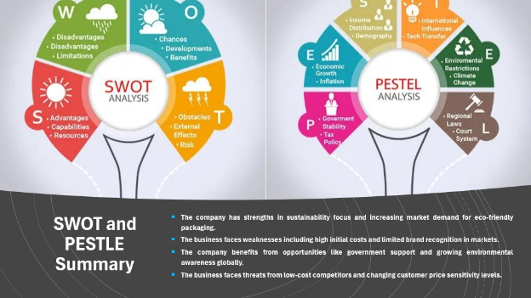
Some of the company strengths include environmental concentration and rising growth in the market of environmentally friendly packaging. The weaknesses of the business are the expensive initial costs and low brand recognition in the market (Chofreh and Gholamzadeh, 2018). The firm has a favourable environment such as governmental support and increased environmental consciousness in the world. Low cost and the fluctuating customer price levels are threats to the business. PESTLE analysis establishes that there are political, economic, social, technological, legal and environmental aspects that influence operations. These analyses enable the company to work on the processes of strategic planning and decision making.
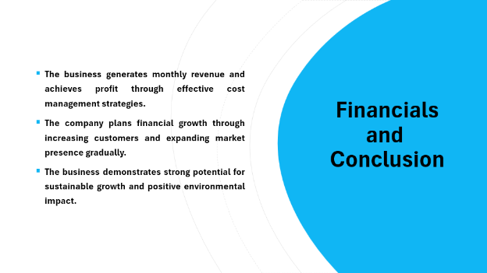
The business has monthly revenue and profitability due to good cost management strategies, which are maintained. The company intends to grow financially by growing the number of customers and penetrating the markets in a progressive manner. The company has high prospects of sustainable development and ecological contribution across the world. The company is helping to grow the economic development through creation of jobs and business sustainability. The business is financially stable due to proper planning and effective resource distribution at all times. The company makes the conclusion that sustainability helps to achieve long-term success and competitive advantage in the contemporary markets.

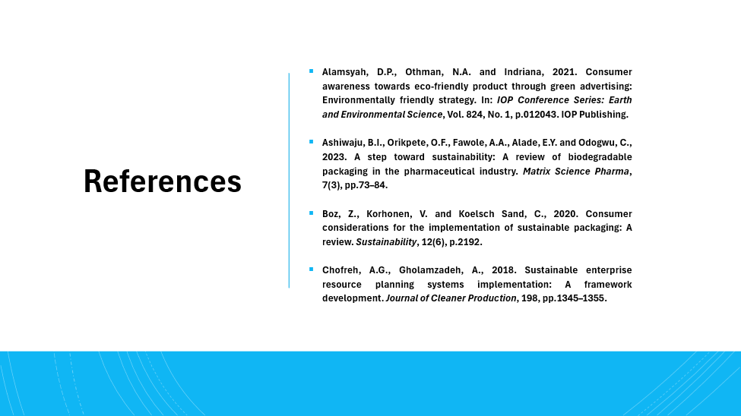

References
Alamsyah, D.P., Othman, N.A. and Indriana, 2021. Consumer awareness towards eco-friendly product through green advertising: Environmentally friendly strategy. In: IOP Conference Series: Earth and Environmental Science, Vol. 824, No. 1, p.012043. IOP Publishing.
Anbarasan, P., 2018. Stakeholder engagement in sustainable enterprise: Evolving a conceptual framework, and a case study of ITC. Business Strategy and the Environment, 27(3), pp.282–300.
Ashiwaju, B.I., Orikpete, O.F., Fawole, A.A., Alade, E.Y. and Odogwu, C., 2023. A step toward sustainability: A review of biodegradable packaging in the pharmaceutical industry. Matrix Science Pharma, 7(3), pp.73–84.
Barakat, B., Milhem, M., Naji, G.M.A., Alzoraiki, M., Muda, H.B., Ateeq, A. and Abro, Z., 2023. Assessing the impact of green training on sustainable business advantage: exploring the mediating role of green supply chain practices. Sustainability, 15(19), p.14144.
Barrowclough, D. and Birkbeck, C.D., 2022. Transforming the global plastics economy: the role of economic policies in the global governance of plastic pollution. Social Sciences, 11(1), p.26.
Boz, Z., Korhonen, V. and Koelsch Sand, C., 2020. Consumer considerations for the implementation of sustainable packaging: A review. Sustainability, 12(6), p.2192.
Chofreh, A.G., Gholamzadeh, A., 2018. Sustainable enterprise resource planning systems implementation: A framework development. Journal of Cleaner Production, 198, pp.1345–1355.
Edgeman, R. & Eskildsen, J., 2014. Modelling and assessing sustainable enterprise excellence. Business Strategy and the Environment, 23(3), pp.173–187.
Gomes Silva, F.J., Kirytopoulos, K., Pinto Ferreira, L., Sá, J.C., Santos, G. and Cancela Nogueira, M.C., 2022. The three pillars of sustainability and agile project management: How do they influence each other. Corporate Social Responsibility and Environmental Management, 29(5), pp.1495–1512.
Jerab, D. and Mabrouk, T., 2023. Achieving competitive advantage through cost leadership strategy: Strategies for sustainable success. Available at: https://ssrn.com/abstract=4574945 (Accessed: 17 March 2026).
Kulova, I. and Nikolova-Alexieva, V., 2023. ESG strategy: Pivotal in cultivating stakeholder trust and ensuring customer loyalty. In: E3S Web of Conferences, Vol. 462, p.03035. EDP Sciences.
Odeyemi, O., Usman, F.O., Mhlongo, N.Z., Elufioye, O.A. and Ike, C.U., 2024. Sustainable entrepreneurship: A review of green business practices and environmental impact. World Journal of Advanced Research and Reviews, 21(2), pp.346–358.
Padmanabhan, V. and Nirmala, D.S., 2023. Predictability of total revenue in global large companies from financial and economic parameters. International Development Planning Review, 22, pp.862–879.
Putri, M.P.D.S., Naili, Y.T. and Natalis, A., 2024. Balancing environmental preservation and economic interests: building corporate social responsibility in the era of sustainable development. Brazilian Journal of International Law, 21, p.263.
Rahmana, F. & Bawono, A., 2020. Sustainable development toward sustainable enterprise. Management Science Letters, 11(2), pp.657–668.
Rajesh, R., 2023. Study of biodegradable materials in consumer products. I-Manager's Journal on Material Science, 11(1).
Shekarian, M. and Mellat Parast, M., 2021. An integrative approach to supply chain disruption risk and resilience management: a literature review. International Journal of Logistics Research and Applications, 24(5), pp.427–455.
Suherlan, Y. and Widiyanti, E., 2021. The model of eco-friendly packaging center to increase the competitiveness of MSMEs’ local products. In: IOP Conference Series: Earth and Environmental Science, Vol. 905, No. 1, p.012072. IOP Publishing.
Uztürk, D. and Büyüközkan, G., 2023. Strategic analysis for advancing smart agriculture with the analytic SWOT/PESTLE framework: A case for Turkey. Agriculture, 13(12), p.2275.
Wang, Y. and Wang, Y., 2021. Research on the application of environmentally friendly packaging materials in the sustainable development of logistics. In: IOP Conference Series: Earth and Environmental Science, Vol. 781, No. 3, p.032025. IOP Publishing.
Wechselberger, J., 2024. Eco-Friendly Choices: Understanding Consumer Responses to Sustainable Packaging in Supermarkets (Master's thesis, Universidade Católica Portuguesa, Portugal).

