Title: Professional and Career Development Task 3
Module Code: BMSW 4005

Student Name: Diana Olimpia Ciolte
Student Number:2122278

Table of Contents
Introduction 3
Self-Audit of Skills and Competencies 4
Skills Required for Effective Management in the IT Industry 6
Understanding Concepts from the Module 8
Conclusion 11
Reference 12

Introduction
In this reflective portfolio, I undertake an in-depth investigation of my professional and career growth, trying to grasp the skills and information required for productive work, demonstrate preparation for employability and define employment goals. The portfolio is split into three primary areas, each meant to fulfil certain learning objectives.
Firstly, the self-audit of skills and competencies comprises employing SWOT Analysis and a Personal Development Plan (PDP) to examine my strengths, weaknesses, opportunities and threats in the context of the IT business. Following this, the abilities essential for effective management in the IT industry are studied, shining light on the competencies crucial for aspiring IT managers. Lastly, the comprehension of topics from the subject goes into insights gained on British employment legislation, career development methodologies, options after graduation and seeking work opportunities. These themes are studied with an emphasis on real-world applicability and the potential impact on my professional progress. Through this portfolio, I intend to plan a strategic and informed path towards reaching my career ambitions.

Self-Audit of Skills and Competencies
To better understand my strengths and opportunities for improvement in the IT field, I want to perform a thorough self-audit of my skills and competences in this department. I will analyse my strengths and weaknesses and plot a course for future development using tools like the SWOT analysis and the PDP as they prove to be valuable across all industries (Neugebauer and Evans-Brain, 2016).
Personal SWOT analysis can provide us with useful insights regarding the way we see ourselves and also pave a way to think clearly in terms of the areas of improvement (Herman, 2017). I have realised that my technical knowledge and skills are among my strongest attributes. I have a deep comprehension of programming languages and software architectures due to my education and work experience in the field of software development. My quick understanding of new technology and developments in my field is further proof of my adaptability. I do, however, see room for development. Improving my leadership abilities is a key area that needs work. While I have experience working in teams, I recognise that strengthening my leadership skills is essential to moving further in my IT profession. In addition, I hope to improve my verbal and writing communication abilities so that I can explain technical concepts effectively and convincingly to a wide range of audiences.
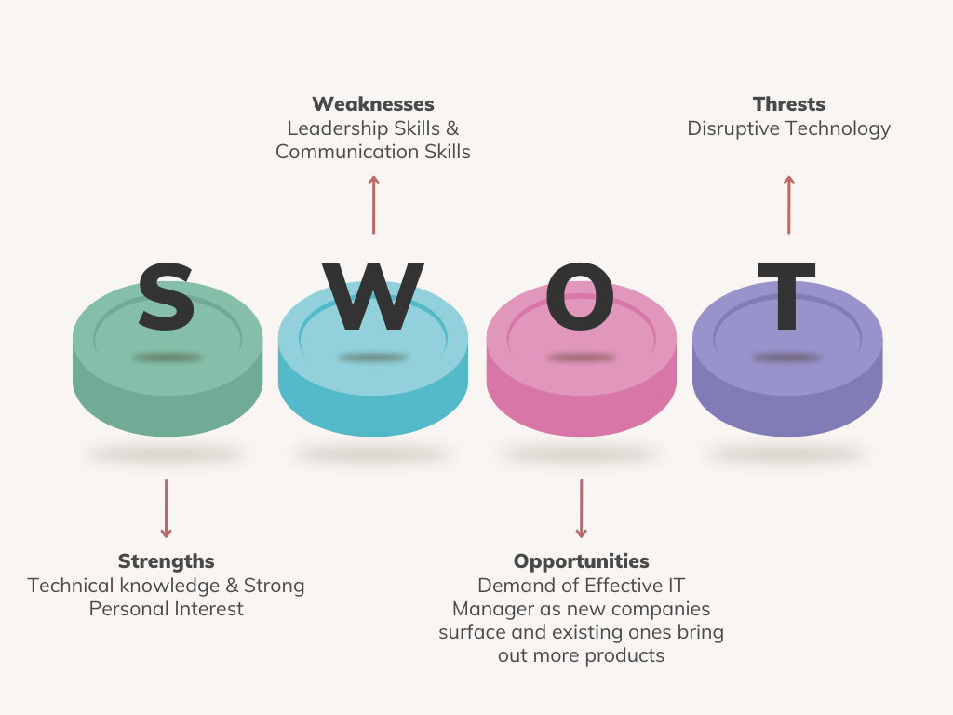
Figure 1: Personal SWOT Analysis (Source: Author)
Based on the results of this self-evaluation, I have recognized the importance of addressing my weaknesses proactively. I have developed a thorough Personal Development Plan (PDP) designed to improve my leadership and communication skills as this plan lets us pin-point areas of improvement and shows us the way forward (Lejeune, Beausaert and Raemdonck, 2021). Recognizing the importance of strong leadership and communication skills for managerial success, I want to embark on a life-altering journey of personal development. My PDP is based on an integrated strategy that incorporates many different tactics. First, I plan to actively participate in training programmes that emphasise leadership growth and constructive communication skills. These courses will help me develop the skills and knowledge I need to lead teams effectively and encourage teamwork in the workplace. I also plan on attending workshops and networking events to meet other professionals and pick the ideas of IT veterans.

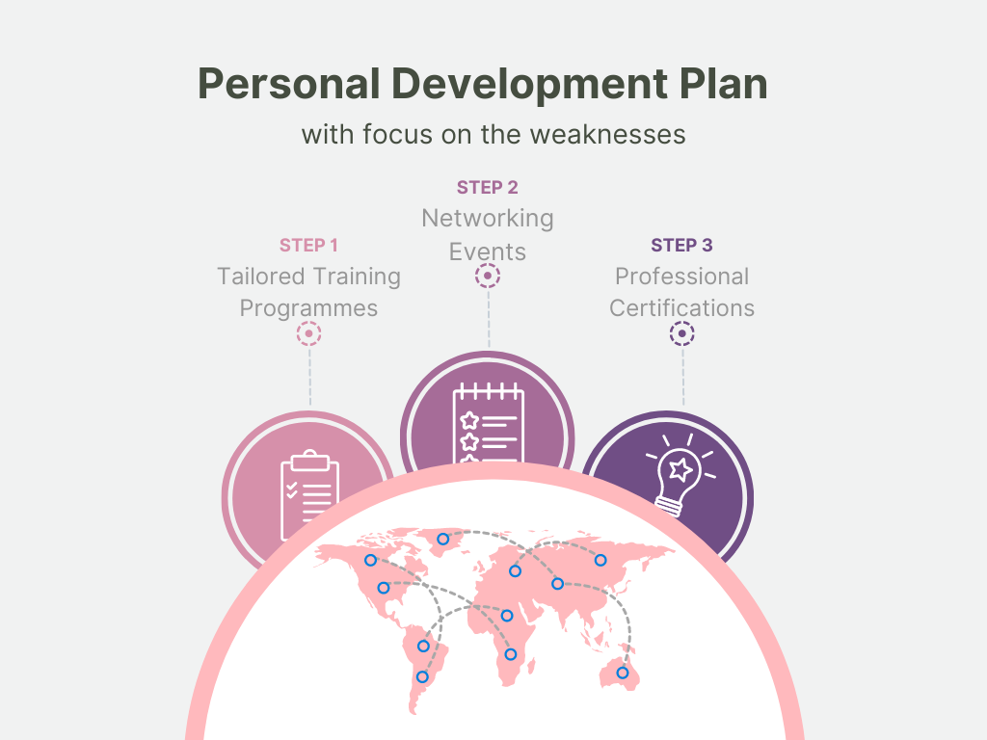
Figure 2: PDP Plan (Source: Author)

Skills Required for Effective Management in the IT Industry
An effective manager in the Information Technology (IT) industry must have a wide range of skills to keep up with the ever-changing nature of the field. As an aspiring IT professional with aspirations of promotion, I know full well the importance of developing the abilities necessary to succeed in a supervisory position. Leadership, technical knowledge, communication, adaptability, problem solving, and strategic thinking are just few of the skills which are essential for successful IT management (Mehmood, 2021).
1. Leadership and Team Management:
An effective manager in the Information Technology (IT) industry must have the ability to adapt to a constantly shifting technical landscape, which places a high premium on a wide range of skills. Developing and nurturing the core competencies or skills necessary to succeed in a managerial capacity is of great importance to me as a young IT worker aiming for promotion. Key competencies for effective management in the IT business are discussed in this section. These include leadership as well as technical expertise. Further emphases were provided on communication and strategic thinking. I should also take into account the concepts of flexibility as well as problem resolution.
2. Technical Expertise and Knowledge:
Technical expertise or technical know-how is very much essential for successful management in the IT sector. As a manager, it is required that I keep up with the latest developments in technology as the landscape is constantly changing. Because of this, I will be able to make technological decisions that are in line with the organization's goals because of my extensive knowledge of programming languages, data analysis, cloud computing, cybersecurity and upcoming technologies.
3. Communication and Interpersonal Skills:
Effective managers in today's team-oriented IT sector need to be excellent communicators as work from home has become a new normal within this sector. Although, tech giants are laying off remote employees and asking more office-oriented workforce, it is required that I have better communication skills. I need to be an expert in breaking down technical jargon for audiences as diverse as clients, coworkers and upper management as the sector demands such activity. I will always be clear and precise in my interactions. If the communication requires written documents, presentations I should be able to do it efficiently but if it requires oral communication then I might be facing a bit of issues. In relation to that, I plan to make an effort to actively listen to my colleagues and customers in order to better understand their needs and problems, encourage candid conversations and cultivate a pleasant environment.
4. Adaptability and Problem-Solving Abilities:
The IT sector is notorious for its dynamic nature, posing a wide range of difficulties and opportunities for managers. In order to succeed as a manager, I will practise flexibility and learn to quickly adjust to new technologies. As a result of my experience and insight, I will be able to steer my team in a proactive direction. With a growth mentality, I will look at setbacks as chances to learn and improve as it is required by almost all professionals (Maund, Schreik and Tinkler, 2017).
In addition, I will excel in the area of problem-solving. I will lead my team in developing efficient solutions to difficult problems by taking a methodical, analytical approach. I will advocate a data-driven approach to decision-making and inspire my team to use critical and innovative thinking to overcome challenges in the sake of fostering a culture of continuous development.
5. Strategic Thinking and Decision-Making:
For long-term success and competitive advantage in the ever-changing IT industry, strategic planning is crucial. As a manager, I plan to look at the big picture when solving problems, taking into account both immediate concerns and the long-term goals of the company. I will make educated choices by considering relevant data, expert opinion, and input from all relevant parties. I will help the company succeed by coordinating IT projects with operational objectives.

Understanding Concepts from the Module

Career Development Approaches:
My understanding of how to design a fulfilling professional life has been much enhanced by learning about different methods of career development. The Cognitive Approach and the Intuitive Approach were introduced in this module. Career planning techniques like the Continuing Professional Development (CPD) cycle and self-evaluation are emphasised in the Cognitive Approach (Filipe et al., 2014). The Intuitive Approach, on the other hand, promotes making decisions on the fly and making the most of unanticipated chances (Morgan, 2017). As I begin my career as an IT manager, I see the merit in taking a balanced approach that draws from both waterfall and agile processes. While I am dedicated to charting my professional course via careful planning and introspection, I also recognise the value of remaining flexible in response to unexpected opportunities. Taking a well-rounded stance will help me succeed in the ever-changing IT profession while still following my heart.

British Employment Legislation:
Gaining a thorough understanding of the legal structure that regulates the British labour market through this study of British employment law has been illuminating. Critical pieces of legislation that underpin the rights and protections of both employees and employers include the Equality Act of 2010, the Employment Rights Act of 1996, the General Data Protection Regulation of 2018, the Working Time Regulations of 1998, the Health and Safety at Work Act of 1974 and the Employment Act of 2008 (Roberts, 2020). As I progressed through the session, I realised how critical it is to comply with these laws in order to maintain a healthy and secure workplace for all employees. As I see my future career as an IT manager, it will be crucial for me to learn about and adhere to these regulations in order to create a welcoming work environment that values diversity and looks out for its employees' best interests. The class's exploration of real-world case studies reinforced my understanding of the IT sector's practical consequences of these laws.

Alternatives After Graduation:
After completing this lesson, I have a much better grasp of the many post-college options accessible to me in the IT field. As we have conducted a survey as part of the module within the class, I discovered the pros and cons of several career paths, such as self-employment. Continuing education as well as starting work now has been also considered. The consideration of these options has been crucial to my decision-making, and it is now clear that my career will change dramatically depending on the direction I take. The classroom exercises also highlighted the significance of considering one's own tastes, one's financial situation and one's ultimate aims. With this information in hand, I feel more prepared to move on in life after college and begin a career that will help me achieve my goal of being an IT manager.

Decision-Making Points:
The module's emphasis on junctures at which choices must be made has given me the tools I need to make smart decisions as I progress through my professional life. Taking a gap year, thinking about graduate programmes, interning, or starting your own business are all examples of decision points that might shed light on the elements that influence one's professional path. We debated the merits of various courses of action and shared our findings with the class. Having done this exercise, I am better able to make decisions that support my long-term objectives. As someone who hopes to one day manage in the information technology field, I know that making well-considered choices is essential for succeeding in the industry's constant flux and seizing opportunities to further my career.

Exploring Employment Opportunities:
The module's greatest strength was teaching me how to systematically research potential careers. To begin, one must have a thorough comprehension of one's own values, interests, strengths and areas for development (Torrington and Hall, 1998). By participating in interesting exercises like the "career motivation test," I was able to get invaluable understanding of my own personal interests and motivations in the workplace. Now that I know more about myself, I can make better choices about my future in the IT field. This module drove home the value of digging deep into the topic of potential careers. I have widened my views and found possibilities that fit my abilities and objectives by exploring a variety of employment roles, industries and corporate cultures. Learning about the many graduation schemes, internships and entry-level opportunities available to prospective IT managers through classroom discussions.

Options Exploration and Preference Ranking:
The IT job market is highly competitive and prospective employees need a methodical way to explore and rate their possibilities (Gati and Kulcsar, 2021). I have a firm grasp on the subtleties of numerous job options because to my considerable research and information collection. Because of this, I am able to prioritise factors in accordance with my long-term professional goals. Due to class discussions and exercises that forced me to weigh the benefits and drawbacks of various options, I now have a solid foundation upon which to base my future choices. Now that I've found a happy medium between following my heart and being realistic, I'm able to give more weight to possibilities that reflect my beliefs and goals. I am now able to make educated career decisions because to this systematic method of ranking preferences.

Graduate Schemes and Internships:
The coursework illuminated the critical role that graduate schemes and internships play in laying the groundwork for a prosperous career in the IT sector. Opportunities for learning new skills, gaining practical experience and making connections with influential people in the field are abundant in these well-designed programmes. By taking part in graduate programmes or internships, I can obtain hands-on experience in a variety of areas within an organisation, broadening my knowledge of the IT field as a whole. Furthermore, my leadership and decision-making skills can benefit greatly from the exposure to numerous parts of IT administration during these seminars. The mentorship opportunities available through these programmes can be essential in directing my professional development. My attitude about internships and graduate programmes has changed for the better and I now welcome the chance to get valuable experience.

The Future of Work and Trends Shaping the Future:
The module's examination of technological developments that will shape the workplace of the future has been informative and thought-provoking. Workplaces are being completely transformed by the rapid development of digital technology, automated processes and artificial intelligence. If you want to make it as an IT manager, knowing and adapting to these trends is essential.

Conclusion
In conclusion, this reflective portfolio has been a transforming examination of professional and career development. The self-audit of skills and competences, utilising SWOT Analysis and a Personal Development Plan (PDP), has provided vital insights into my strengths, weaknesses and growth opportunities within the IT business. Furthermore, the study of abilities required for effective management in the IT business has prepared me with a broad awareness of the competencies important for success in this field. Engaging with themes from the curriculum, including British employment regulations, career development methodologies and investigating work options, has extended my outlook on career choices and potential pathways.

Reference
Filipe, H.P., Silva, E.D., Stulting, A.A. and Golnik, K.C., 2014. Continuing professional development: Best practices. Middle East African journal of ophthalmology, 21(2), p.134.
Gati, I. and Kulcsar, V., 2021. Making better career decisions: From challenges to opportunities. Journal of Vocational Behavior, 126, p.103545.
Herman, M. (2017). Creating a Personal SWOT Analysis. Recuperado de: executivesecretary. com.
Lejeune, C., Beausaert, S. and Raemdonck, I., 2021. The impact on employees’ job performance of exercising self-directed learning within personal development plan practice. The international journal of human resource management, 32(5), pp.1086-1112.
Maund, A., Schreik M. and Tinkler P. K.(2017). Certificate in Higher education: Skills for the work place. London: Sage Publications.
Mehmood, T., 2021. Does information technology competencies and fleet management practices lead to effective service delivery? Empirical evidence from E-commerce industry. International Journal of Technology, Innovation and Management (IJTIM), 1(2), pp.14-41.
Morgan, P. (2017) The Business Student’s Guide To Study And Employability. London: Sage Publications Ltd
Neugebauer, J. and Evans-Brain, J. (2016) Employability: Making the Most of Your Career Development. Croydon: SAGE.
Roberts, K., 2020. Is there an emerging British ‘underclass’?: The evidence from youth research. In Youth, TheUnderclass' and Social Exclusion (pp. 39-54). Routledge.
Torrington, D. and Hall, L. (1998). Human Resource Management. 4th ed. London: Prentice Hall Europe.

