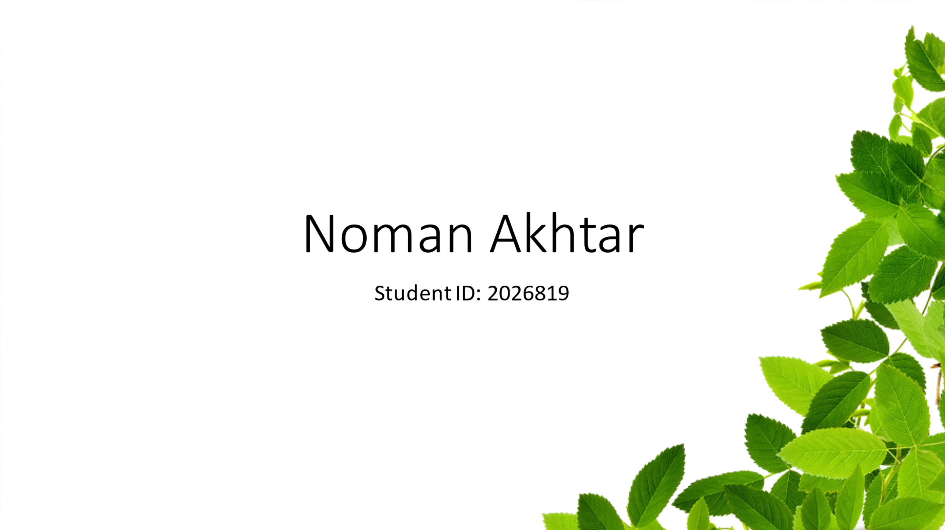

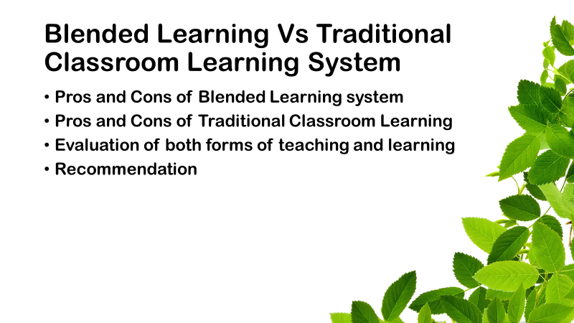
Blended learning is the form of learning or teaching where both settings of teaching are utilised that are; the traditional classroom learning and the modern online learning. the aim of this academic report is to analyse the pros and cons of both learning system, evaluation of these forms of teaching, and finally the recommendation to be made whether the blended learning is suitable for the certificate in higher education or not.

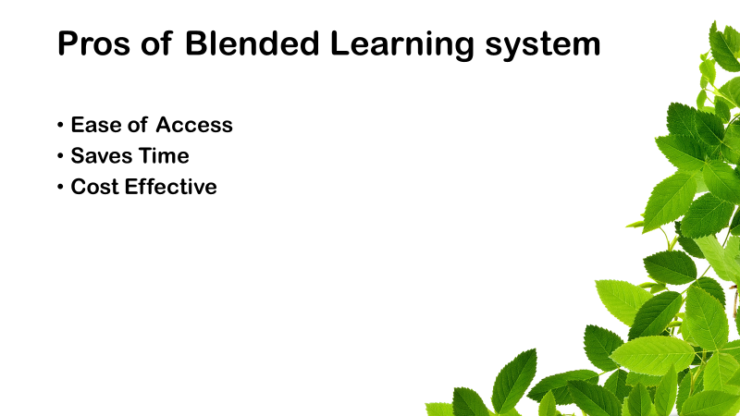
Starting from the pros of blended learning in the university education system, there is a lot to write on this because of its effectiveness and adaptation. blended learning system has made its place within the higher education system rapidly. the recent pandemic outbreak worked as a catalyst in this.

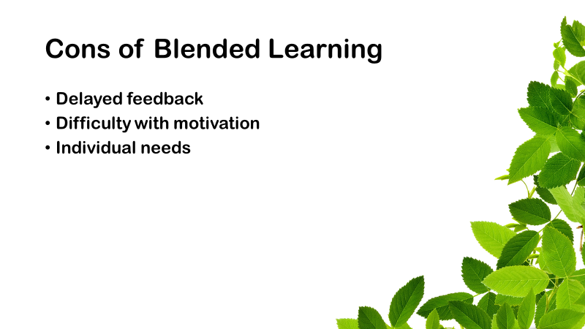
As there as advantages of the blended learning, there are disadvantages as well. every individual is different with respect to learning. students are different on the bases of intention, motivation, learning style, and personality. there is no one fit for every student. an approach that is suitable for one student may not be as effective for another student. for example, a student may be doing very well with online learning because he or she prefers staying at home while the other student may prefer interacting with respectable professors at the university.

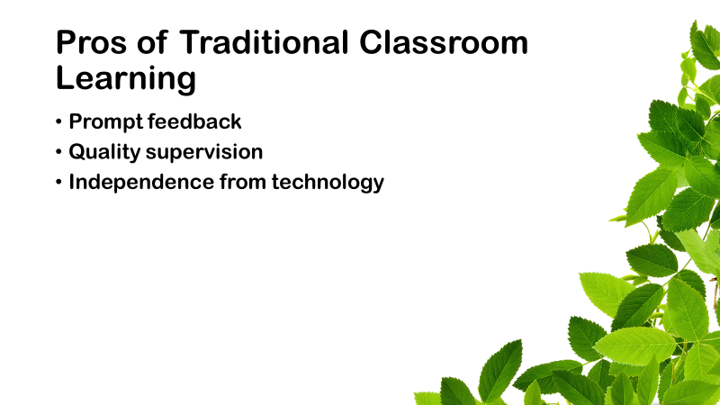
Advantages of traditional classroom learning are enormous such as prompt feedback, quality supervision, and independence from technology. Prompt feedback is one of the advantage of the traditional classroom learning that is loved by the students very much because they do not have to wait for the teacher to access the learning platform and address their query rather teacher can answer their queries promptly, at the spot in the classroom. This increases the learning experience of the student as well as provides the teacher with an insight that how students are doing with the learning process.

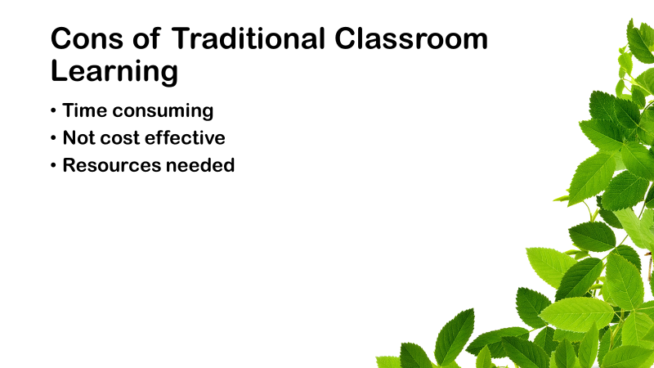
Traditional classroom learning is time consuming. Consider the scenario that a teacher is answering a query to the student while the rest of classroom is waiting for them to finish so that they can continue. Now, sometimes it could be interesting for the rest of the classroom but it is not the case always. Individual have their own pace of learning and they prefer to learn at their pace. Moreover it is not appropriate to make something learn on slower pace when he or she can progress rapidly.

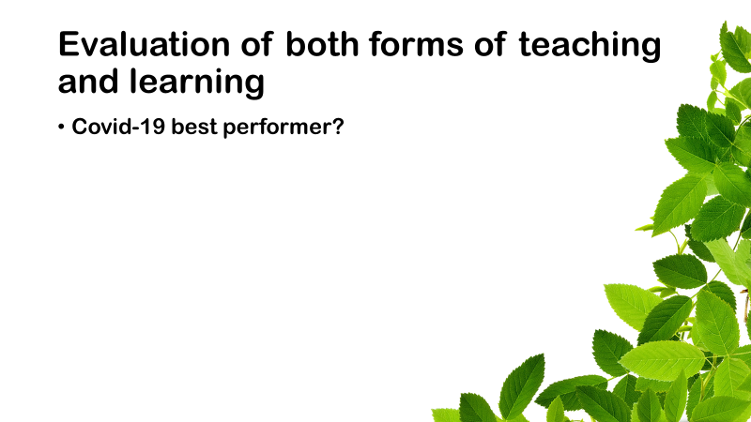
When the traditional classroom learning failed to perform, the blended learning system was there to support the learning process and it provided a beacon of hope to students and teachers to survive the tough time. Form this point of view, blended learning system definitely outweighs the traditional classroom system as it is more advanced and has the capacity to withstand against cruel circumstances. It can fight the traffic jams as well as save resources.

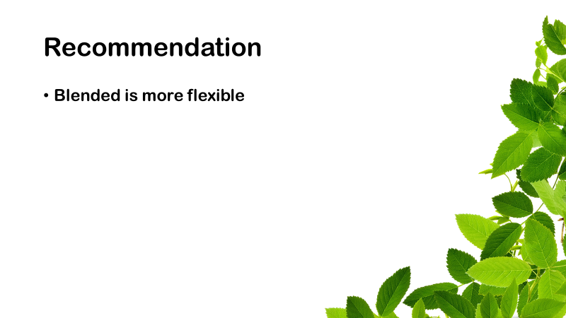
Blended learning has more flexibility and opportunity to shape an inclusive system. using blended learning system for the higher education would be beneficial because it is time saving, money saving, and easy to access.

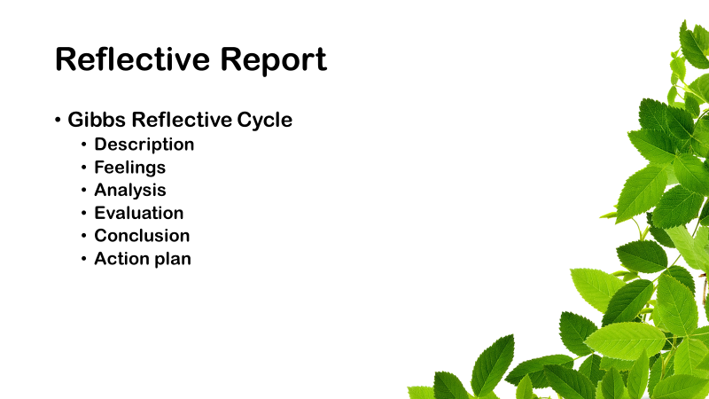
I am using Gibbs Reflective Model (1988) to write this reflection report about my employability skills during this learning setting. Gibbs reflective model is a six-stage model, containing description of the situation, feelings in that particular situation, experience assessment, analysis of the situation, conclusion, and action plan

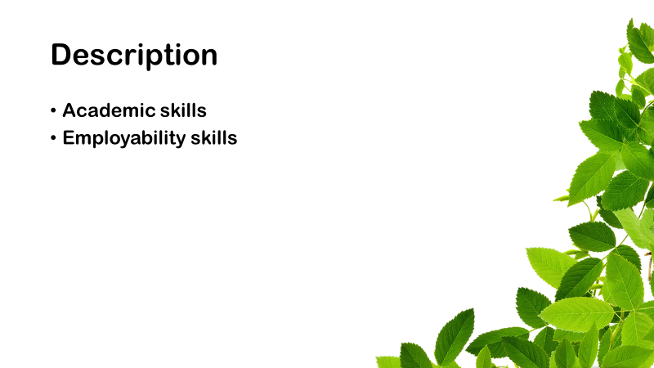
My experience throughout this learning setting was pretty good. during this module of academic and employability skill I have acquired valuable knowledge and skills. in this module the tutor has taught various academic skills and the connection between academic and employability skill. in this module, I came to know that how these academic and employability skills are interlinked and what is the gap between industry and the academia.

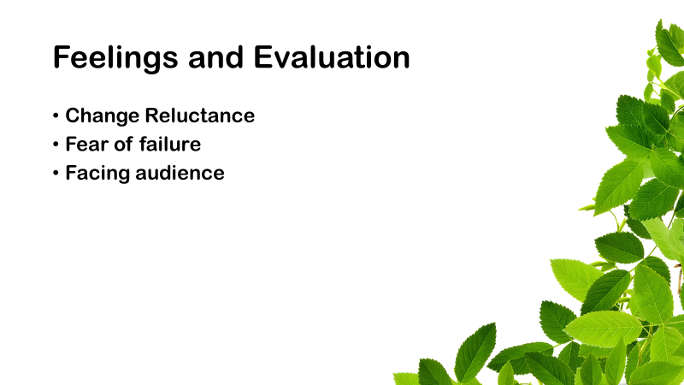
I recognised this and things star to change. I was the person who lack courage to face people while presenting but now I am able to address infinite crowd. In fact, bigger the crowd is, bigger the joy is. I enjoy the presentation.
For me, learning has been easy as compared to teaching or disseminating to others. Yes, presentation has been always the problem for me. Though I am doing pretty great with the presentation, I feel still there are things to improve.

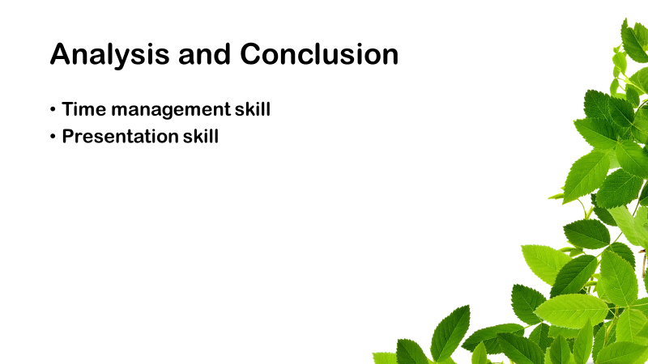
In order to conclude this, I have learnt some valuable skills that have revamped my life in a better way. These skills include time management, presentation, information research, and writing. I am happy with my learning and motivated to learn more and more.

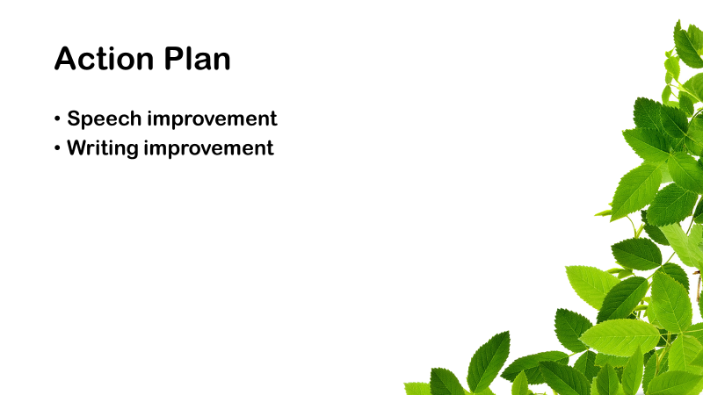
I have planned to improve my writing and speaking skills that will provide me with confidence to present in a better way. In this regard, I have planned to improve my speaking skill by practicing and receiving feedback from an expert of the subject. And the expected start and completion dates are January, 2022 and April, 2022 respectively.

