I confirm that I have not used any AI tools in the research and creation of this assignment.

The Orchard

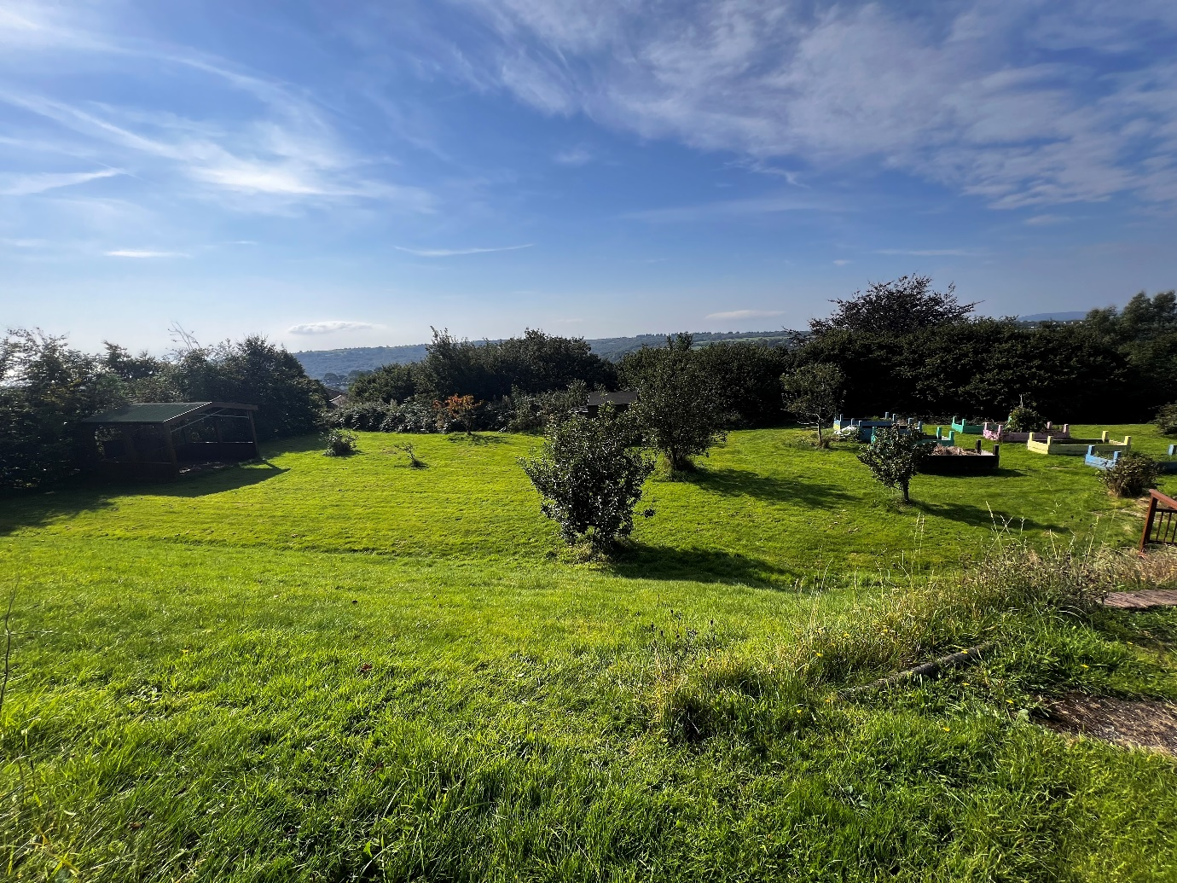
Source: Jones, L (2024a).

Activity one – creating repeating patterns (Mathematics).
The aim of this activity was seeing the children’s understanding of a maths topic that we have recently covered, this being repeating patterns. As a class, we went to the orchard as part of our weekly routine and set the children off to find loose parts within the orchard that can be used to make a repeating pattern using nature. Before setting off to the orchard, the teacher gave the children a reminder of what a repeating pattern is. The children sat and discussed different ways we can make a repeating pattern, for example, one of the children asked, “Can repeating patterns be made with words instead of things?”. The teacher explained that repeating patterns can be made with different objects, seen on an animal’s fur for example a zebra and sometimes in a song, head, shoulders, knees and toes has a repeating pattern throughout also.

The children were set off in their groups and were given 10 minutes to find a variety of objects to use in their own repeating patterns, once the children had collected what they needed they were set off to create their own. The objective of the activity was to create three different repeating patterns, each using a variety of 2, 3 and 4 different objects in each one.
Some of the children returned with, sticks, leaves, pebbles, blackberries, flowers and bark. After they had all collected a variety of loose parts, they were set off to find a space within the orchard to then create their own repeating patterns. The staff regularly checked on the groups to see what kind of patterns that they were coming up with and to see if any of the groups needed any support throughout the activity. The independent activity went well, the children remembered what a repeating pattern was and how they could create their own.
Once the activity was finished the children, took photos of their repeating patterns so they could later be stuck into their books to show that they have understood the topic. Each group walked around to see what one another had created and they all gave positive feedback as to what they had done well.

Activity two – baking with our home-grown fruits (Mathematics).

During our visit to the orchard, the children had been asked to collect items that we could use to create repeating patterns for a maths activity. While the children were outlooking, some of them got very excited and were asking “what are these growing on the bush?”, the children had found that our blackberry bush had lots of berries that were ready to harvest. One of the children responded, “these are blackberries, I use these to make crumble with nanny”. Some of the children were asking “what is a crumble? Can we eat it?”, to which a member of staff responded “a crumble is something that we can bake and eat. Shall we go back to class and find out more and how we can make our own?”. The children continued to discuss what blackberries might taste like and what a crumble might also taste and look like, while picking more blackberries for the crumble.
When we returned to class the children were shown what a crumble looks like and a video on how it can be made. A child suggested that we should make a list of the ingredients that we need to make a crumble, so, as a class, we found out the ingredients that we needed and wrote a list.
The following day, the children arrived extremely excited as they would later that day be making their own crumble. As a class, the children sat and listened to the instructions of how the activity would be carried out and what new skills they may learn. The main skills that were identified were the children learning how to weigh the ingredients correctly while following a recipe, and timing how long the crumble must be cooked for. Later, the children were asked a group at a time to come and make their own crumble. It was decided that the recipe would be divided in half so myself and the teacher could both work with a group.

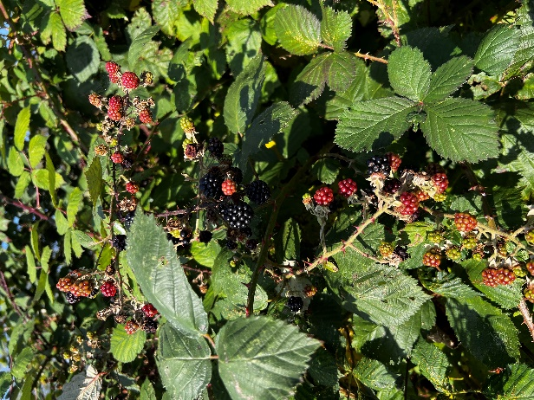
Before the activity started, the children were asked to wash their hands and put on an apron. The children were encouraged to read the instructions and supported with any unfamiliar vocabulary. To weigh the ingredients, we used a weighing scale and made sure that the ingredients were weighed out as accurately as possible, the children found it funny when the ingredients went a over the number needed and they wanted to try scoop the excess back into the packaging to make sure that “the numbers were perfect” as one of the children in my group said. Once all the ingredients were weighed out, ingredients had been heated on the cooker and the crumble had been assembled, it was ready to go in the oven. The children instructed me on the temperature the oven needed to be on, and we set a timer to make sure that it was cooked for the correct amount of time.

At the end of the activity, the children were given the opportunity to try the blackberry crumble. The children enjoyed it and described it as “yummy”, “tasty” and “sweet”. We had a discussion on the carpet of the new skill that they have learnt whilst cooking, the children also decided that that would like to do more cooking and baking when they are in school as they have learnt new skills and had fun.

Source: Jones, L (2024b).

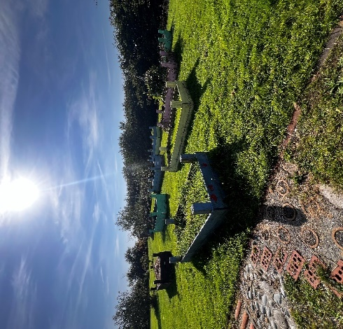
Activity three – life cycles of fruit and vegetables (Science).

As part of our weekly routine, we will visit the orchard, and here classes share a planter to grow their own vegetables, including trees that previous pupils planted that now grow apples and pears yearly. In the spring last year, children planted runner beans, carrots and tomatoes and we would regularly check on them to make sure that they have had enough water to help them grow. The children enjoy checking on the vegetables as it makes them feel proud that they have grown these themselves. Last year, the children looked at life cycles and that is when they planted their own vegetables in the planter, since they the children regularly checked on them to make sure that they are growing.
Source: Jones, L (2024c).

Upon arrival at the orchard, we discovered that our broad beans were growing well, including our carrots, which the children were amazed at to see that something that they had panted had grown. However, the tomatoes, pears and apples has unfortunately had rotten over the summer or had all fallen from the trees, which made the children sad as they did not get to see them ripe. The children looked at what had grown, and we discussed the process of the life cycle again, the children showed that they had a sound understanding of lifecycles. So, this led to the children being provided with pencil and paper and we asked the children to draw their own life cycle for a fruit or vegetable that we had grown. The children were excited, lots of the children chose the broad beans as they were still able to be seen, some of the children worked independently while other in groups.
The teacher and myself supported the children with spellings of tricky words and any questions that they had, one of the children asked, “what would have happened if we planted the seeds at the wrong time of year, would they still have grown?”, I responded to the child that “the vegetables may still have grown, however, they may not have grown as much as ours have. Fruits and vegetables grow with the help of daylight, so if they had been planted in autumn, they will have grown but they would not have had enough sunlight to help them grow”.

Once the children had all drawn their own life cycle, we picked a broad bean to see what it looked like on the inside even though it hadn’t finished growing yet, but the children were curious and asking, “I wonder what colour the beans are on the inside?”, I responded saying “I think they will be green or brown” as I had never seen the inside of one before. We discovered that when we opened them that the beans were pink and brown, the children were shocked, and found it very funny that they were not green or brown.
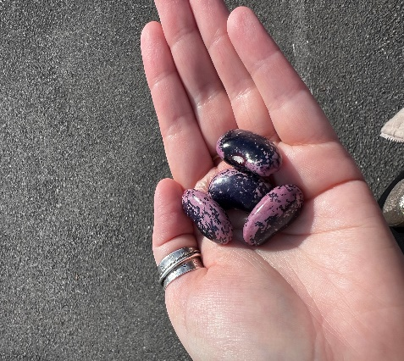
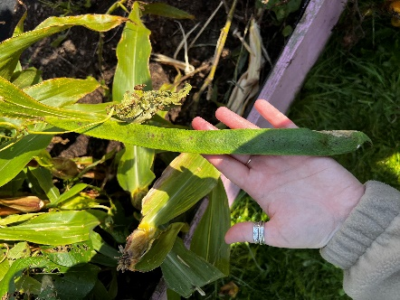

Source: Jones, L (2024e).
Source: Jones, L (2024d).
Activity four – floating and sinking with loose parts from the orchard (Science).

Before the activity took place, the children were taught about floating and sinking and what causes objects to sink. They were taught about density and if an object is less dense than water it will float, but if they are denser than water they will sink. We explained to the children that we would be going to the orchard to do our own experiments in their groups and note our findings on what objects float and sink.

In the orchard, we have a pond that the children regularly check for signs of pond wildlife, however, we are yet to see any signs of pond life. It was decided that as no pond life would be at harm that we would use the pond for a floating and sinking experiment. The children, in their groups were given a task to find two different items they think would float or sink, once these items were collected the children would record their results that they found out.
Once the children had returned with their items and a group of children were curious as to what items would float and sink. They asked, “if we put a feather in the water would it sink because it got wet?”, the member of staff had a conversation with the group, asked the children why they thought the feather would sink and listened to the ideas that they had, they firmly believed that a feather would sink because it would get wet.

After the children had all returned with their items, we began the experiment, and the children were full of ideas. Group A put two of their items in first, a leaf and a thin stick. We got the children to have a discussion and predict which one will float, and which one will skink, most children predicted that the stick would sink as it was heavier than the leaf. However, once the two objects were placed in the water, we found that the stick would also float, the children were shocked and asked, “why does it float, it is heavier than the leaf?”, a member of staff explained that even though the stick is a little heavier than the leaf, it is not dense enough to sink through the water”. We explained that when we return to class we will look further into why lighter objects. All groups too part in the experiment, Group B used a flower and a blackberry, Group C used a wood chipping and a piece of grass and lastly, Group D used a stone and a blackberry.

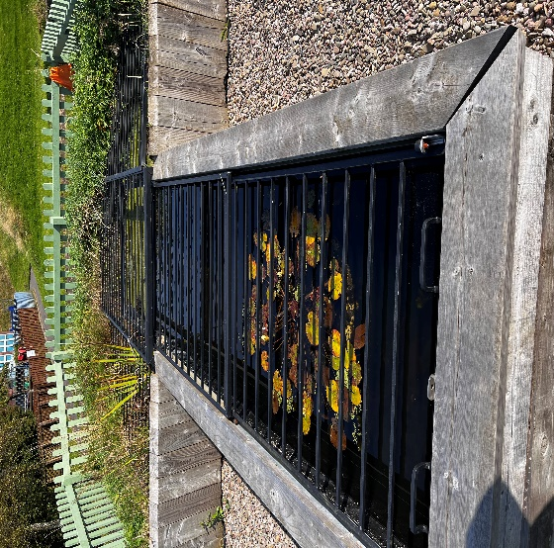
For each one, the children predicted on a piece of paper, each drop the children had a variety of predictions. Some believed that for Group B that the blackberry would sink, however, we found out that the blackberry ended up floating. For Group C, the children predicted that both objects would float, the children were correct. Lastly, for Group D they predicted that the stone would sink, and the blackberry would float, however, both objects sunk. This then caused a lot of confusion as in a previous experiment the blackberry floated. “Why did one blackberry float and the other one sink? They are the same fruit!” the children kept repeating. A member of staff explained that they did not know why that it had happened and maybe we should take the blackberries back to class and weigh them to see if one weighs more than the other. The children discussed that this could be a reason why the blackberries did the opposite things.
Source: Jones, L (2024f).

Name of activity: | Creating nature repeating patterns
Description of activity | The children will be tasked with collecting their own items that they find in the orchard and create their own repeating pattern. We have already looked at repeating patterns and how we can make them in class, now the children are going to try and create their own in the outdoors. The level of difficult is dependent on their learning groups, the children are to make repeating patterns using 2,3 and 4 different objects.
Appropriate for which ages and abilities | Ages 4 and up. The difficulty of the activity can be suited to the ability of the children taking part.
Equipment or resources needed | The children will find their own resources in the orchard to create a nature repeating pattern.
Any special adaptations for different needs | All children in the class are able to take part in this activity, it can be tailored to the needs and ability of the children dependent on their learning groups.
Benefits  e.g. Soft/Hard outcomes, Early learning outcomes, Key stage outcomes | Repeating patterns is an Area of Learning and Experience for the Curriculum. The children are expected to recognise, identify and create their own repeating patterns.
Overall risk (refer to separate risk assessment) | There are minimal risks for this activity, the only one is the rabbit holes that are in the orchard and that the children could fall into one while running around looking for their items. The children will be reminded to take precautions when running around.
Other comments | N/A

Name of activity: | Baking with our home-grown fruits
Description of activity | The children were set to look for objects for their repeating patterns when they found blackberries, the children then decided that they would like to bake with them. The aim of the activity is for the children to gain an understanding on how to weigh ingredients and use time while baking.
Appropriate for which ages and abilities | Age 5 and up. The children will be closely supervised and anything involving the oven and cooker will be completed by the adult with the group of children.
Equipment or resources needed | Oven, cooker or microwave, table, bowls, spoons, baking tray, grease proof paper, ingredients from the recipe, a recipe oven gloves, skink and bowl to wash up.
Any special adaptations for different needs | N/A
Benefits  e.g. Soft/Hard outcomes, Early learning outcomes, Key stage outcomes | The children will learn new skills; measuring and the use of time that fall in line with the Areas of Learning and Experience in the Curriculum for Wales.
Overall risk (refer to separate risk assessment) | There is the risk that the children could get burnt after some of the ingredients have been warmed up in the pan by an adult. This risk will be minimised by wrapping the bowl in a towel and reminding the children that the bowl could be hot and that they must be careful, only the adult is to touch the bowl while it is still hot and wrapped in a towel.
Other comments | There are no children in the class with allergies that can be triggered by any of the ingredients that are being used in this activity.

Name of activity: | Life-cycles of fruit and vegetables
Description of activity | In this activity the children are visiting the orchard where they have previously grown their own fruit and vegetables, and in class they have looked at life cycles of fruit and vegetables. In this the children were also provided with resources to draw their own life cycle of a chosen fruit or vegetable that they have grown and to test their knowledge and understanding after looking at life cycles before the summer.
Appropriate for which ages and abilities | Ages 5 and up.
Equipment or resources needed | Access to the orchard and providing the children with pencil and paper to draw their own life cycle.
Any special adaptations for different needs | Dependent on the need and ability of the group the children were provided support, a sheet that had the cycle on it and they were reminded of spelling.
Benefits  e.g. Soft/Hard outcomes, Early learning outcomes, Key stage outcomes | In the lead up to the activity when the children planted their seed, they used a lot of their fine and gross motor skills to help them plant the seeds when digging and placing the seeds into the holes created.
Overall risk (refer to separate risk assessment) | Children may fall into the planter if they are not being sensible, this leading to them being muddy and may result in an injury to legs or head if they are to bump it on the planter.
Other comments | NA

Name of activity: | Floating and sinking with objects in the orchard.
Description of activity | The children will find objects that they think may float or sink, they will then use the pond to experiment and predict the outcome for each object that they have found.
Appropriate for which ages and abilities | Age 6 and up. This activity is appropriate for all children.
Equipment or resources needed | We will need to use the orchard to find the resources needed, we will also use the pond in the orchard to carry out the experiment.
Any special adaptations for different needs | No adaptations are needed for this activity.
Benefits  e.g. Soft/Hard outcomes, Early learning outcomes, Key stage outcomes | The children will learn about density and making their own predictions.
Overall risk (refer to separate risk assessment) | There is risk that the children could hurt themselves on the wood and railings surrounding the pond, however, this can be prevented if the children are being sensible near the pond.
Other comments | N/A

Activity | Hazard  (Potentially dangerous activity, occurrence or physical item) | Risk  (incident / accident that MAY happen) | Likelihood  +  Severity | Benefit | Action to remove or reduce risk.  (The whole group can learn to take their own precautions guided by the forest school leader) | Who? | When? | Risk  Level (when actions observed)
Repeating patterns in the outdoors | The filled in holes in the orchard dug by the rabbits. | The children could fall and hurt themselves. Possibility of sprained or broken ankle. | Likelihood 3  Severity 4 | The children are learning to create their own repeating patterns and spot them in nature independently. | The children are already aware of the rabbit holes in the orchard. They will learn to take precautions to prevent their own injuries. | The children and staff. | While in the orchard looking for objects. | Medium
Baking with fruits from the orchard | The nettles on the blackberry bush. | A child being stung on the nettles while picking the blackberries. | Likelihood 5  Severity 3 | Learning key skills that can be used throughout life. | The children will be made aware that they can be stung and that they must take precautions and only touch the berry. | The children taking part. | In the orchard picking berries | Medium
Baking with fruits from the orchard | Burning their hands or arms on a hot/warm bowl and ingredients. | Burning themselves while mixing the hot ingredients when in the bowl. | Likelihood 3  Severity 5 | Learning key skills that can be used throughout life. | The children will not be allowed to mix the ingredients while on the cooker. It will be done by an adult and allowed to cool, and the children will be warned that it will be hot and to be careful. | The children that are baking or staff. | During the baking activity. | Medium
Life cycles of fruits and vegetables | Hurting themselves on the planters | Could lean too far into the planter and fall. Can result in leg or head injury. | Likelihood 2  Severity 5 | Learning how to grow their own fruit and vegetables. | The children will be reminded to be safe and not climb into or on the planters. | The children. | Whilst checking the planters. | Medium
Floating and sinking | Climbing on the pond | Hurting themselves on the wood or metal bars surrounding the pond. | Likelihood 2  Severity 3 | Learning about density and how objects can float and sink. | To remind the children that they are not to climb on the pond. | The children. | During the activity. | Low

likelihood | x | severity | risk level and acceptability
likelihood | x | severity | Low - L | medium - m | high - H
1-5 | x | 1-5 | 1-5  acceptable risk level | 5-12  acceptable with precautions | 12+  unacceptable risk level - find ways to reduce risk.

Section 4

The outdoors is an environment that can provide children and practitioners with endless opportunities for learning and development, if it is done in the right way. Outdoor learning is not an approach of taking indoor learning materials to the outdoor, it involves utilising the natural resources that can be found in the outdoors to support the children’s learning and development (Parry, 2022).

The role of the adult in the early years is key as they are the main element to shaping a children’s learning and development throughout the early years. Practitioners are in the environment to support the children and their learning; therefore, it is vital that their attitude and professionalism towards the learning is sound. Practitioners within the setting should be able to adapt the activities so they are nature based but, can also include play-based learning approaches to help involve the children. the environment that children learn in should be rich and allow for continual holistic development, where the children are able to learn and thrive (Wiltshire Council, 2007).

Froebel Trust (No Date) believes that children should be able to learn in the outdoor environment, this is as it allows children to have a rich first-hand experience that help support their overall learning. Not only can it support a child’s learning, but it can support the development of real-world skills and additionally allow the children to gain a sense of the world around them. Additionally, Vygotsky (1978) suggested that giving time for children to explore an outdoor environment will encourage them to learn through interacting with that environment itself. Throughout the early years it is vital that children have opportunities to explore the outdoors, adults within the setting can encourage this by simply creating an activity that encompasses natural resources, for example, sticks, stones and leaves. These resources can be used by children to create their own repeating patterns in the outdoors. Additionally, the outdoor can be enhanced by finding new resources for the children to use (National Numeracy, 2024).

For outdoor learning to be successful, it should link to the provision that is taking place indoors and using the environment as the ‘third teacher’ as Malaguzzi refers to and uses the outdoors as the children see it, being filled with challenges and giving them the opportunity to have control over their own learning. This stimulates children’s curiosity allowing for them to challenge themselves and explore varied concepts that are available to them. This approach is used in settings that follow the Reggio Emilia approach, usually found in Italy (Edwards et al., 1998).

Many children can find the idea of maths difficult, therefore, meaning that it is a subject that the child does not look forward to. It is vital that adults can support the children as best possible, this can be done by taking a maths activity outdoors and using outdoor resources to help while also making it something to look forward to. Learning Through Landscapes (2023) discusses the outdoors and for some children can often be a better suited learning environment where they can also be more hands on, for example, children have access to materials like, sticks, stones, leaves and these objects can be used to make repeating patterns, for counting, measuring and much more. Cutting and Kelly (2014) suggest that the outdoors is a beneficial area for science to take part in. This is as it allows for children to explore the area and see things in context, for example, learning about bugs and their habitats. If the children are learning about this in the classroom, they can research habitats, however, they are unable to see the habitats in person. By taking the children out of the classroom and into the environment allows the children to get up close and personal with their learning and allowing them to explore. Cutting and Kelly (2014) also discuss that when teaching science in the years it should be considered that the lessons are taken outdoors as it also allows the children creativity to run wild even when science is being taught. Additionally, it allows for children to use all their senses and further explore the world around them and enhance their understanding and observational skills which are key for science.

References

Jones, L (2024a) ‘The Orchard’.
Jones, L (2024b) ‘Blackberry Bush’.
Jones, L (2024c) ‘The Planters’.
Jones, L (2024d) ‘A Broad Bean’.
Jones, L (2024e) ‘Broad Beans’.
Jones, L (2024f) ‘The Pond’.
Froebel Trust (No Date) ‘Outdoor Play Pamphlet’. Available at:https://www.froebel.org.uk/uploads/documents/FT-Outdoor-Play-Pamphlet.pdf (Accessed: September 29th 2024).

Vygotsky, L. S. (1978). Mind in society. Cambridge, MA: MIT Press.

National Numeracy (2024) Supporting Parents: Outdoor Maths. Available at: https://www.nationalnumeracy.org.uk/supporting-parents-outdoor-maths (Accessed: September 29th 2024).

Parry, C (2022) ‘Outdoor Maths Activities in the Early Years’. Available at: https://www.cosydirect.com/blog/outdoor-maths-activities/ (Accessed: September 29th 2024).

Wiltshire Council (2007) ‘Effective Practice: Outdoor Learning’. Available at: https://cms.wiltshire.gov.uk/documents/s4092/Item%2013%20-%20Appendix%201b%20-%20annex.pdf (Accessed: September 29th 2024).

Edwards, C,. Gandini, L. and Forman, G (1998) The hundred languages of children – The Reggio Emilia approach to early childhood education. London: Albex Publishing Corporation.

Learning through Landscapes (2023) ‘How to teach numeracy outdoors’. Available at: https://ltl.org.uk/news/numeracy-outdoors-how-to-teach/ (Accessed: September 29th 2024).

Cutting, R and Kello, O (2014) Creative teaching in Primary Science. SAGE Publications Ltd.

