University of Wales Trinity Saint David
INTRODUCING THE MODERN WORKPLACE

STUDENT NAME: Aygyul Shakirova, ID 1818045

T E S C O

Dr. Molly Jack

2019

CONTENT
1. Introduction ...............................................................................3
2. The organizational structure of Tesco ............................................4
3. Strategy of Tesco .......................................................................................7
4. Culture of TESCO.......................................................................................8

5. Build a culture that supports strategy implementation.............9

6. Culture of Tesco supports its strategy.............................................10
7. Tesco dimensions of Culture – Hofstede model...........................11

8. Competitive reward of Tesco................................................................12
9. Conclusion.....................................................................................................13
10.References....................................................................................................13

Introduction
Tesco as a business organisation
“The term business organization describes how businesses are structured and how their structure helps them meet their goals. In general, businesses are designed to focus on either generating profit or improving society.” https://www.encyclopedia.com/finance/encyclopedias-almanacs-transcripts-and-maps/business-organization
Armstrong and Taylor ( 2017:143 ) state that “Organizations can be described as systems that, as affected by their environment, have a structure that has both formal and informal elements. Organizing is the process of making arrangements in the form of defined or understood responsibilities and relationships to enable people to work cooperatively together”
This image shows one of five popular organisations design model, which describes the essential elements of every organisation:
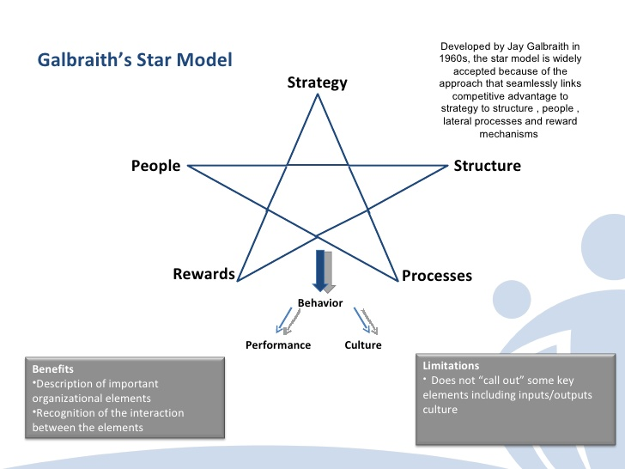
https://images.app.goo.gl/dFgHRK23sL6XNUrYA
For successfully describing and analyzing to process of organizing and functioning to Tesco as a business organization, it is necessary to look the essential elements of each organization which are mentioned above.
The organizational structure of Tesco
Mullins, L ( 2016:394 ), describes that: “ Structure is defining feature of work organisation. However good the goals and objectives, system of management or quality of its members, an organisation will not achieve optimum performance without a sound and appropriate structure.
Structure makes possible the application of the process of management and greatest a framework of order and command through which the activities of the organisation can be planned, organised, directed and controlled. The structure defines tasks and responsibilities, work roles and relationships, and channels of communication.”

“The legal and commercial name of TCTS is Tesco Corporate Treasury Services PLC.
TCTS is a public limited company registered in England and Wales with registered number 8629715 and was incorporated on 30 July, 2013. The Issuer operates under the Companies Act 2006.”
https://www.tescoplc.com/investors/debt-investors/tesco-corporate-treasury-services-plc/
“The difference is that the PLC can quote the shares in a stock exchange whereas the Ltd Company cannot. While a Ltd company thinks more of profit from the business, the Public Limited Company cares less of profit as it is concerned with services and goods for the public. The Public Limited Company has a greater impact on the public as the shares are public. On the other hand, the Ltd companies have no impact on the public as it is just household business. If something goes wrong with a Public Limited Company, it has very adverse impact on the public.” http://www.differencebetween.net/business/difference-between-ltd-and-plc/
Tesco is a customer-orientated business who provide high –quality service and good for the public to generate a profit.
“For-profit organization exists primarily to generate a profit, that is, to take in more money than it spends. The owners can decide to keep all the profit themselves, or they can spend some or all of it on the business itself. Or, they may decide to share some of it with employees through the use of various types of compensation plans, e.g., employee profit sharing.” https://managementhelp.org/organizations/types.htm#anchor1387164
Tesco is large size company with over 450,000 employees across the world. Tesco is a multinational British groceries with different shops of Tesco in 10 countries in Asia and Europe.
Tesco maintains balance and stability in its organization by following a hierarchical functional structure, establishing specific roles for everybody.
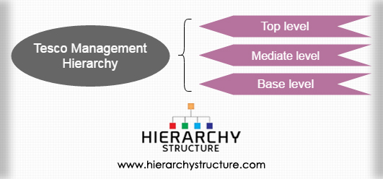
https://www.hierarchystructure.com/tesco-management-hierarchy/
Top level: Board – group chief executive, chief finance officer, non- executive chairman, group company secretary, senior independent director, nine members non – executive directors. 11 members of Tesco Executive Committee are led by Group Chief Executive Dave Lewis. this level perform supervisory functions and take all major decisions as to the functioning of the company.
The structure to the Tesco is composed of 5 committees reporting to Tesco PLC Board

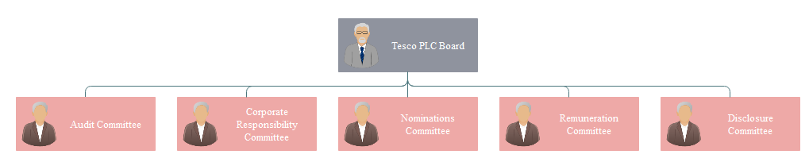
Tesco Corporate Governance Structure chart http://www.orgcharting.com/tesco-company-organisational-structure-chart-example/
Mediate level – “There is also a mediate level functioning between the ground staff and the board of directors. These comprise of various vice presidents and other managers and assistants under them. They coordinate the functioning of other two levels and perform other functions like Funds, Personal Relations, Marketing and Advertising, Human Resource Management, etc.” https://www.hierarchystructure.com/tesco-management-hierarchy/
Base level- Regional managers who manage stores in their regions and report to the executive authority at the mediation level. Under the direction of the regional manager are managers, who are responsible for their store. The people who work at this level are in direct contact with customers and employees. This level is with vertical division of powers.

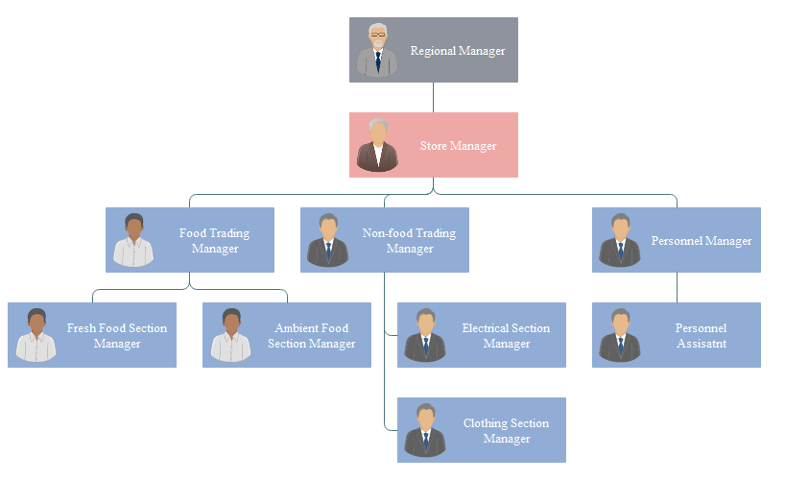
Tesco organizational structure at store level http://www.orgcharting.com/tesco-company-organisational-structure-chart-example/
January,2018 Tesco shared changes to simplify its operational structures to improve efficiency. As part of these changes the role of people manager and compliance manager will be removed from large stores. will be created 900 new role as People Partners, Learning Partners and Colleague Relations Partners. This changes remove complexity and will deliver a simpler, more helpful experience for employees and customers. https://www.tescoplc.com/news/2018/tesco-to-simplify-operational-structures/

Strategy of Tesco
Armstrong and Taylor ( 2017:14 ) describe the meaning of strategy: “ Strategy is the approach selected to achieve specified aims in the future, the determination of the long-term goals and objectives of an enterprise, and the adoption of courses of action and the allocation of resources necessary for carrying out those goals”

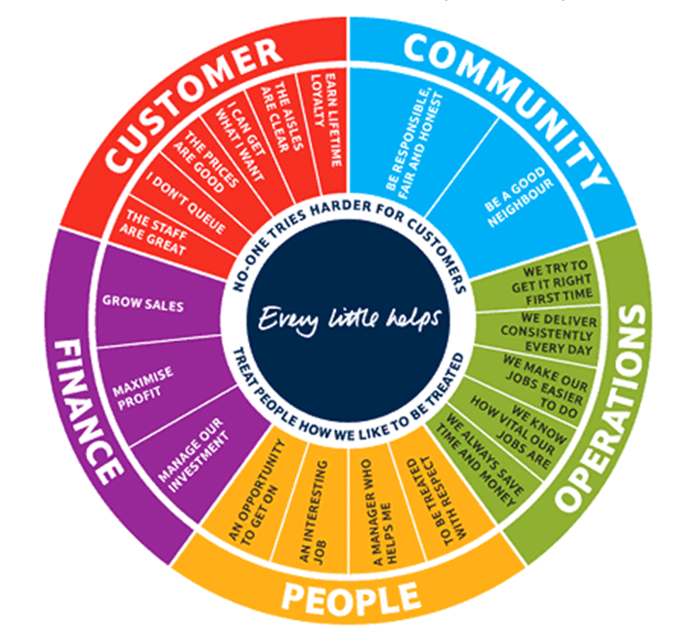
Tesco’s Corporate Steering Wheel (Source: Tesco 2009)
“Today, the Corporate Steering Wheel provides
strategic focus by communicating what matters the
most in a simple and easy to understand
framework. It includes 20 corporate objectives
across five perspectives. The perspectives are
arranged in a circle around the central philosophy of
‘Every Little Helps’ and the two values of ‘No one tries harder for customers’ and ’Treat people how like to be treated”. https://docplayer.net/13498842-Management-case-study-delivering-success-how-tesco-is-managing-measuring-and-maximising-its-performance.html
Culture of Tesco
According Armstrong and Taylor ( 2017:146 ) culture is” pattern of values, norms, beliefs, attitudes and assumptions that may not have been articulated but shape the ways in which people in organizations behave and things get done. Values refer to what is believed to be important about how people and organizations behave. Norms are the unwritten rules of behaviour”.

“Every little help makes a big difference” (https://www.tescoplc.com/sustainability/little-helps-plan-overview/), is a core value at Tesco. It drives what they do every day for their colleagues around the world, in the thousands of communities where their operate, and for the millions of customers their serve.

Build a culture that supports strategy implementation
Torben Rick in online blog says “Business leaders need to be aware that culture is not just something that happens outside of a business. Companies large and small have their own cultures as well. A culture can happen spontaneously within a company, and managers can learn how to harness its power or be overpowered by it. Managers can also take an active part in shaping an organizational culture, to try to ensure that it benefits the company’s goals and its employees.” (https://blog.jostle.me/blog/build-culture-supports-strategy-implementation/) Author explains the importance of culture in implementing a business strategy.
Torben Rick states:” Give employees a reason to care about your customers, their colleagues, and about how to do business right in a world that rewards cutting corners and compromising values.” (https://blog.jostle.me/blog/build-culture-supports-strategy-implementation/
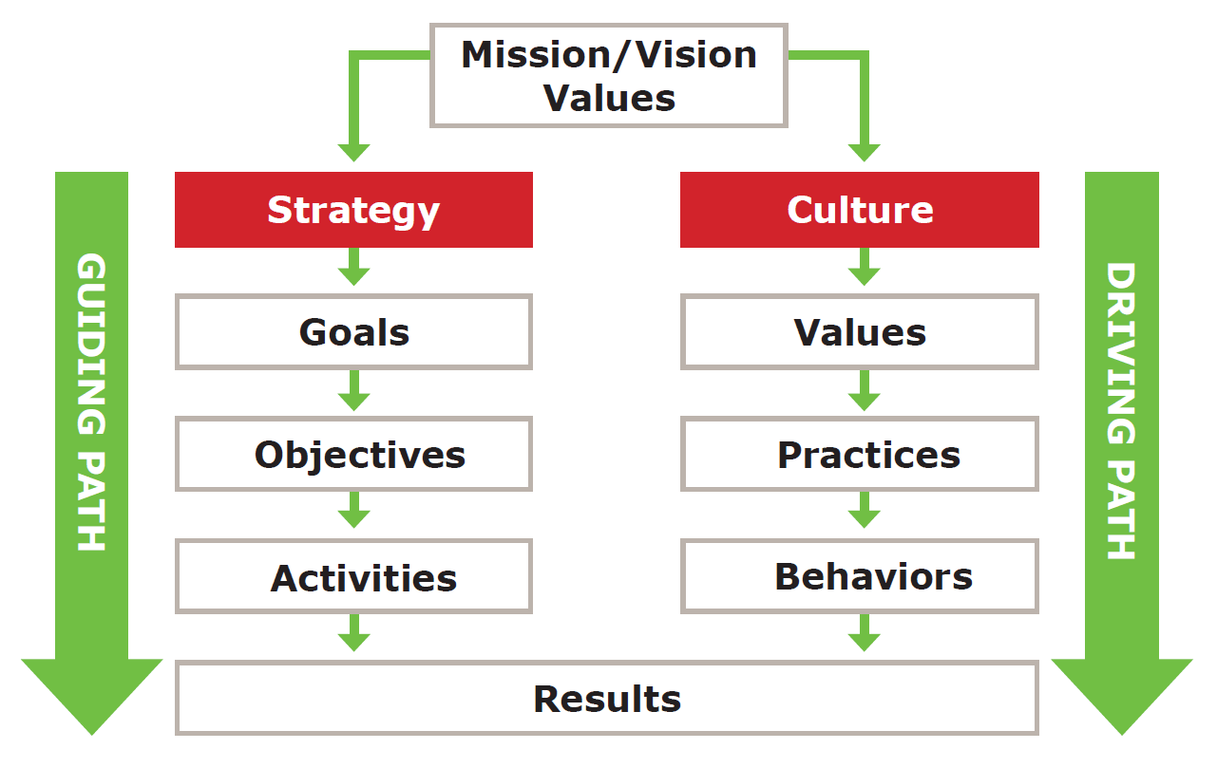
https://blog.jostle.me/blog/build-culture-supports-strategy-implementation/

Culture of Tesco supports its strategy
Core purpose to Tesco is ” Serving shoppers a little better every day. As a business, serving customers is at the heart of everything we do – from colleagues in our stores to those of us in supporting roles” https://www.tescoplc.com/about/how-we-do-business/core-purpose-and-values/ )
Tesco has simple mission ” to be the champion for customers, helping them to enjoy a better quality of life and an easier way of living. This hasn't changed. Customers want great products at great value which they can buy easily and it's our job to deliver this in the right way for them. That’s why 'Serving shoppers a little better every day' is our core purpose. As a business, serving customers is at the heart of everything we do – from colleagues in our stores to those of us in supporting roles”.(https://www.tescoplc.com/about/how-we-do-business/core-purpose-and-values/ )
Describing to Tesco values help to understand how can put this into practice:
“No one tries harder for customers
- Understand customers
- Be first to meet their needs
- Act responsibly for our communities
Understanding people – customers, colleagues, communities – and what matters to them, and then trying to make those things better, is at the heart of Tesco. It's about listening to people and talking to them using all the tools at our disposal – from Club card data to social media – and then acting by changing and innovating to meet their needs.
We treat people how they want to be treated
- Work as a team
- Trust and respect each other
- Listen, support and say thank you
- Share knowledge and experience
We know that looking after our colleagues in a culture of trust and respect is essential to the success of Tesco. Where colleagues feel recognised and rewarded for the work they do together, where they have the opportunity to get on and where they are supported in their development as they move through their careers in the business – they in turn try their hardest for customers.
Every little help makes a big difference
- Helping to reduce food waste globally and ensuring surplus food goes to those in need
- Making it easier to live more healthily
- Sourcing great quality, affordable and sustainable products
- Making a positive contribution to the communities where we operate.
Every little help makes a big difference – it’s the value we live by to ensure we serve our customers, colleagues and their communities a little better every day. It really captures how, when we add up all the small things we do, Tesco can make a big difference to the issues customers, colleagues, communities and wider society care about.
It covers the little things we do every day as well as linking these things together to contribute to the bigger global initiatives in which we are involved. It helps us take the right actions to restore trust and transparency in our business.” (https://www.tescoplc.com/about/how-we-do-business/core-purpose-and-values/

The necessary practices and behaviours for the successful functioning to Tesco as business organization are achieved through implementation Code of Business Conduct.

Dave Lewis, Tesco Group Chief Executive, says: “Our Code of Business Conduct is at the heart of how we run our business, and is designed to help and protect us. It is important that we all understand the rules that we must follow, and the conduct that is expected of us, in order to look after our colleagues, do a great job for customers and protect our reputation. Whether you are new to Tesco or have worked for our business for some time, please take the time to understand our Code and how it applies to you.
Our Code means more than just following the law and our policies. It’s about using our Values and Leadership Behaviours to guide our conduct and decision-making so that we are always doing the right thing for each other and the business.
If you ever have concerns about your own conduct or that of another person, you must speak up straight away and talk to someone you trust, starting with your line manager. Alternatively, speak to your People Partner or the Legal team. If you need to raise your concern anonymously, you can call Protector Line in complete confidence.
We should all be proud of our business and the contribution that we make and by living our Code, we can build an even stronger business for the future.” https://www.tescoplc.com/about/how-we-do-business/

Tesco dimensions of Culture – Hofstede model

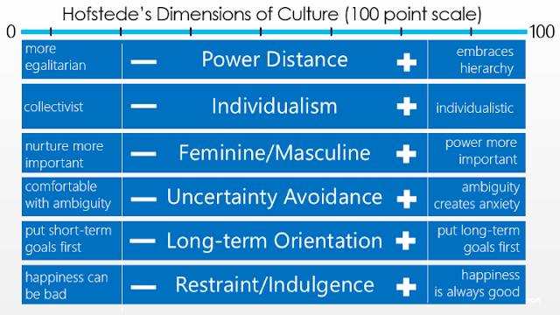
http://exploringleadershipinpublicadmin.blogspot.com/2017/07/hofstedes-dimensions-of-culture.html

-Power distance – Structure of Tesco is hierarchical, each level has a functional role;
-Individualism/Collectivism –Tesco culture is group-oriented, collectivism,
“We treat people how they want to be treated
- Work as a team
- Trust and respect each other
- Listen, support and say thank you
- Share knowledge and experience” (https://www.tescoplc.com/about/how-we-do-business/core-purpose-and-values/)
-Masculinity/femininity – Nurture more important for Tesco.- “Everyone is welcome at Tesco. Whatever their background or personal circumstances, we know it is important to our colleagues to be able to balance work and home life. We have committed to introduce an updated suite of contracts and new technology to give colleagues greater flexibility and control over their work schedules. Our five diversity networks support our colleagues to be themselves at work: Out at Tesco, Women in Tesco, Black Asian Minority Ethnic Network, Tesco Armed Forced Network and Disability Network. We are proud to be members of the 30% Club and are working hard to help women succeed in our business. “ (https://www.tescoplc.com/sustainability/people/our-approach/)
-Uncertainty avoidance- Describe Tesco Code of Business Conduct :“Our Code of Business Conduct is at the heart of how we run our business, and is designed to help and protect us. It is important that we all understand the rules that we must follow, and the conduct that is expected of us, in order to look after our colleagues, do a great job for customers and protect our reputation.” (https://www.tescoplc.com/media/476384/uk_roi_sourcing_cobc-final-181203.pdf)

-Long-term/Short-term orientation- Tesco is long - term orientation- 100 years of great value. “Innovation being open to new ideas • Staying curious and switched on to new thinking. • Looking ahead and welcoming the future. • Taking small steps that make a big difference” https://www.tescoplc.com/media/476384/uk_roi_sourcing_cobc-final-181203.pdf

-Restraint-Indulgence- Tesco has Human rights & ethical trading policy. Tesco creates an inclusive working environment.

Competitive reward of Tesco
“We believe in offering a competitive total reward package. Over the last two years we have made our largest ever investment in UK store colleague pay which has seen hourly rates increase by over 10.5%. We know our colleagues value the wider benefits we offer such as premium payments for Sundays and Bank Holidays, a staff discount, retirement savings plan, share schemes, health support and exclusive deals and discounts.”
(https://www.tescoplc.com/sustainability/people/our-approach/)

Conclusion
Mullins, L, ( 2016:426 ) explain that: “essentially the effectiveness of an organisation depends how accurately human design matches the structure of organised behaviours. An organisation can be separated into two parts one section is a definable structure that will present in every company, the other is the structure caused by human intervention.” Tesco manages to achieve this by following philosophy: ” Since we first introduced our Tesco Values more than a decade ago, they have become a vital part of our culture – and an essential underpinning of our growth and success. They ensure that every person at Tesco understands what is important – about how we work together as a team and how customers are at the centre of what we do. They are universal values, which have helped guide our people as Tesco has grown into new markets and new countries.” (https://www.tescoplc.com/about/how-we-do-business/core-purpose-and-values/)
Tesco is a successful business organization with its unique size, products or services, people, leadership and culture.

References
- Armstrong, M., Taylor, S., (2017), “Armstrong's Handbook of Human Resource Management Practice,”14th Edition, Kogan;
- Mullins, L, (2016) ,”Management and Organisational Behaviour”, 11th Edition, Pearson;
- https://www.encyclopedia.com/finance/encyclopedias-almanacs-transcripts-and-maps/business-organization
- https://images.app.goo.gl/dFgHRK23sL6XNUrYA
- https://www.tescoplc.com/investors/debt-investors/tesco-corporate-treasury-services-plc/
- http://www.differencebetween.net/business/difference-between-ltd-and-plc/
- https://managementhelp.org/organizations/types.htm#anchor1387164
- https://www.hierarchystructure.com/tesco-management-hierarchy/
- http://www.orgcharting.com/tesco-company-organisational-structure-chart-example/
- https://www.tescoplc.com/news/2018/tesco-to-simplify-operational-structures/
- https://docplayer.net/13498842-Management-case-study-delivering-success-how-tesco-is-managing-measuring-and-maximising-its-performance.html
- (https://www.tescoplc.com/sustainability/little-helps-plan-overview/
- (https://blog.jostle.me/blog/build-culture-supports-strategy-implementation/)
- https://www.tescoplc.com/about/how-we-do-business/core-purpose-and-values/ )
- https://www.tescoplc.com/about/how-we-do-business/
- http://exploringleadershipinpublicadmin.blogspot.com/2017/07/hofstedes-dimensions-of-culture.html
- (https://www.tescoplc.com/sustainability/people/our-approach/
- https://www.tescoplc.com/media/476384/uk_roi_sourcing_cobc-final-181203.pdf)
- (https://www.tescoplc.com/sustainability/people/our-approach/)

