Imagined Exhibition

The show I am hosting is about climate change. I feel this is an important topic to be discussing because the climate crisis is one of the biggest problems we are facing today. The artists I am exhibiting are Andy Goldsworthy, Naziha Mestaoui, Tan Zi Xi and Olafur Eliason. These are all artists that mean a lot to me, and who I feel touch on climate change in their work. Andy Goldsworthy is primarily a nature-based sculptor who gathers sticks, leaves and other natural materials to create beautiful 3D pieces of art. Naziha Mestaoui Is a projection artist who shines projected art onto buildings and famous landmarks. The projections usually depict trees with a magical green surrounding them. Tan Zi Xi is a Singaporean artist based in London. She’s an artist and illustrator whose collection, “An Effort Most Futile” uses humour and playfulness to reflect on the realities of climate change. Olafur Eliason is a Danish sculptor and installation artist who uses a mix between technology, shapes and natural elements like water, light and fog to create large immersive environments.

The goal of this exhibition is to highlight the negative effects of climate change and the detrimental impact it will have on our future and day to day living. Climate change is a long term change in the earth's atmosphere whereby the earth is becoming warmer (global warming) due to greenhouse gases being trapped in the earth's atmosphere (Nasa, 2022). It is predicted that over the next century the earth’s temperature will rise by 2.5 to 10 degrees Fahrenheit (Nasa, 2022). Current temperature changes are increasingly affecting the weather causing natural hazards and extreme weather events, affecting large portions of the globe (UN, 2021). Fifty per cent of all disasters can be attributed to natural hazards with 45 per cent of deaths and 74 per cent of economic losses between 1970-2019 (UN, 2021). An ongoing, increasing problem, climate change is a recognised term by many but often not fully understood which is why my exhibition draws together artists who all approach climate change in different ways.
Naziha Mestaoui is a well-known ecological artist whose work has been displayed worldwide. An innovative artist, she creates immersive, sensory experiences through merging technology with imagery and space. “We need to find a way to go back to a more collective approach of dealing with our reality, with land, and with nature” (Mestaoui, no date).
Andy Goldsworthy works with nature becoming attuned with his environment and letting nature direct his art. "We often forget that we are nature. Nature is not something separate from us. So when we say that we have lost our connection to nature, we've lost our connection to ourselves" (Andy Goldsworthy, no date).
Tan Zi Xi likes to experiment with a variety of mediums. She draws her inspiration from different cultures and places and wants her work to be seen all around the world. “I am always intrigued to learn about the less fortunate and why people do things the way they do” (‘Tan Zi Xi’, 2017).

Olafur Eliasson is a large-scale installation artist. Eliason likes to immerse people in the exhibition. “I think the work of art alone won’t make you more empathic, but I do think that art, as it turns out, is like a sequence of spatial and memory-driven activities” (Eliasson, 2021).

I have chosen to only have the exhibition available at night. This is because one of the pieces selected by Naziha Mestaoui is a projection and will not be visible in the daylight.
By holding the exhibition outside in a forest, I am bringing the audience to an environment that some may not normally visit. My point is also made stronger when it’s held outdoors because your senses are heightened and in tune with nature. Hearing the hoot of an owl, the water trickling down a stream and feeling the cold night air all adds to the effect of the experience and the message of the exhibition.
Art can be a tool and we need to focus more clearly on what kind of tool it is and what good it can do for us. What if art had a purpose, which can be defined and discussed in plain terms? Art is a medium that can help guide its viewers, enabling them to become better versions of themselves (De Botton and Armstrong, 2016). This exhibition will use art as a tool to demonstrate the importance of nature and the need to protect it from the effects of climate change.
I think it is important for our mental health to have access to greenspace. With the overwhelming threat of climate change and as the world heats up, the added consequence of flooding and droughts may cause us to lose greenspace.
These artists may not necessarily connect the artworks to climate change themselves, but they can be linked through colours, shapes, and materials.
In Art is Therapy, De Botton and Armstrong talk about how hard it is to see the beauty and power in nature, it’s true essence. It is not immediately apparent how it is essential to our existence, sanity, and spirit, but good art can show us these connections, which is why I have chosen to have this exhibition in a forest, in nature. I think showing these connections with the power of the selected artists’ works is more effective than talking about it (De Botton and Armstrong, 2016).
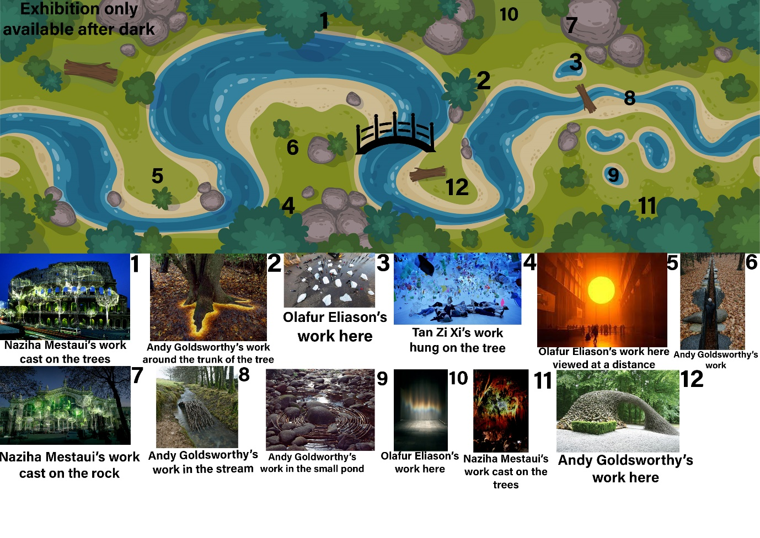
The artworks I selected for this project are all related to climate change. The artworks will be discussed in the order they appear in the exhibition (see figure 1).
Figure 1: Exhibition layout
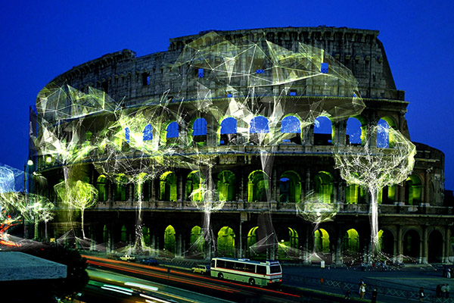
The 1st piece of work is by Naziha Mestaoui. In 2015 she projected a virtual forest on the Roman Colosseum and other famous landmarks around the world. Her work in this exhibition will be projected onto trees, rocks and other natural objects. The project, called One Heart, One Tree, involves an app that allows people to create a virtual tree. On the app you can put your finger on the camera, and it will record your heartbeat allowing the tree to grow to your heartbeat. Your tree is then planted in real life (‘1-heart-1-tree-dossier-partenaires-en.pdf’, no date). The app uses a process called photoplethysmography. It uses your flashlight and camera to read capillaries in your fingers which swell and shrink rhythmically due to blood pressure variation from your heartbeat (Kosecki, 2022).
Figure 2: 1 Heart 1 Tree

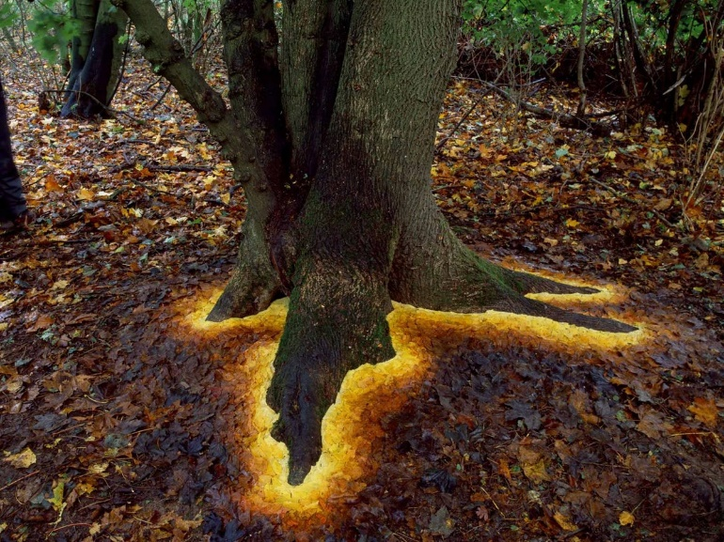
The 2nd piece is called Sycamore leaves edging the roots of a sycamore tree, Hampshire by Andy Goldsworthy. In 2013 he collected golden coloured Sycamore leaves and arranged them to look like the Sycamore tree’s roots are glowing and emerging from liquid gold. This piece is representative of the cohesion between man and nature. The tree is representative of nature and the unnatural way the leaves circle the roots is symbolic of human interaction; the leaves do not however cover the roots showing that humans and nature can work in harmony with each other. Goldsworthy uses natural materials to reflect and provide a social commentary on the fragility of nature.
Figure 3: Sycamore leaves edging the roots of a sycamore tree, Hampshire

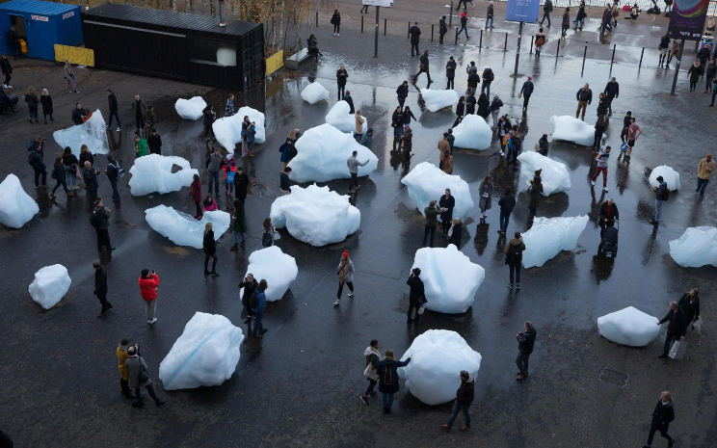
Number 3 is a piece called Ice Watch by Olafur Eliason. In 2014 he extracted 100 tonnes of glacial ice from Greenland to use as an art exhibition highlighting the impact of global warming. Eliason took the exhibition to various locations around the world including London, Paris and Copenhagen. This provided an opportunity for people to directly view and touch the melting glacial ice. A unique experience that would be a once in a lifetime occurrence for most people (Art of Change and Olafur Eliasson’s Ice Watch: “Art has great potential for changing the world”, 2018).
Figure 4: Ice Watch

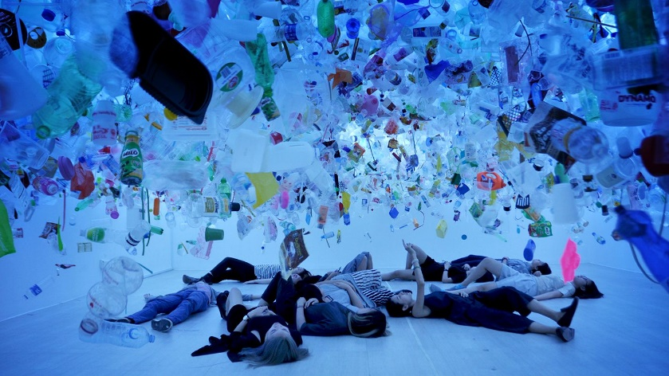
The fourth piece is a work by Tan Zi Xi called Plastic Ocean created in 2016. She is mainly an illustrator but her most recent work has taken on a different form as an installation. She hung over 20,000 pieces of thrown away plastic and let people walk beneath it. This twists your perspective around, so you become an ocean creature. She is trying to portray how mankind affects the natural world (Tan Zi Xi, 2016).
Figure 5: Plastic Ocean

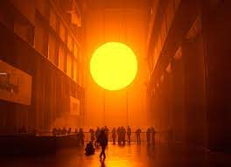
Number 5 is another installation by Olafur Eliason called The Weather Project created in 2003. His goal was to bring the outside world indoors by making a replica of the sun. He used low sodium lamps which emit a light so low that any other colour besides black and yellow are invisible. This creates an environment with only two tones. An illusion was created when he hung a semi-circle from a mirrored ceiling which reflected the whole circle (Olafur Eliasson’s Weather Project - Everything you should know, 2021). The warm colour of the light to me conveys the world is heating up, global warming (Olafur Eliasson’s Weather Project - Everything you should know, 2021).
Figure 6: The Weather Project
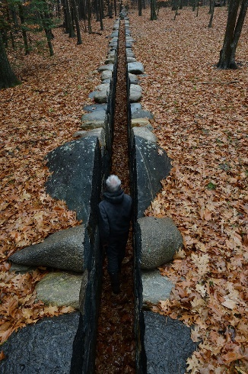
Number 6 is a piece of work by Andy Goldsworthy called Passage created in 2015. Goldsworthy worked with a team of drystone wallers using sledgehammers and wedges to construct a passageway through the rock. It has been compared to the parting of the Red Sea (Drage, no date). The narrow walkway through these large rocks could feel very claustrophobic even though the installation is in an open-air environment.
Figure 7: Passage

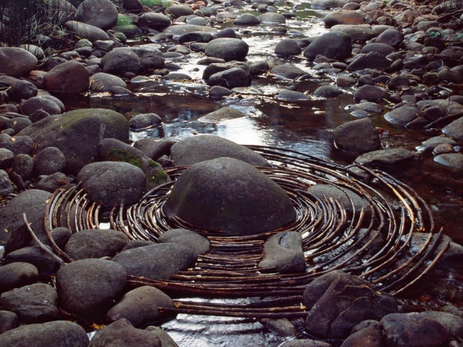
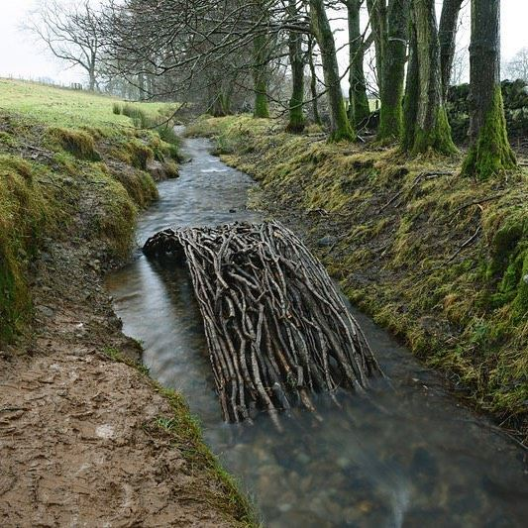
The following pieces, number 7 and 8 are two sculptures by Andy Goldsworthy called Alder branches form a bridge in a Dumfriesshire, Scotland, stream and curved sticks laid around a river boulder, Woody Creek, Colorado. These two pieces are from Goldsworthy’s book called Ephemeral Works. The materials reflect the world we live in. His intention is not to make lasting sculptures but to photograph them when created and let nature take its course. He says that his work isn’t about art but it’s about life and decay and the fact not all things last (Goldsworthy, 2015).
Figure 9: curved sticks laid around a river boulder, Woody Creek, Colorado
Figure 8: Alder branches form a bridge in a Dumfriesshire, Scotland

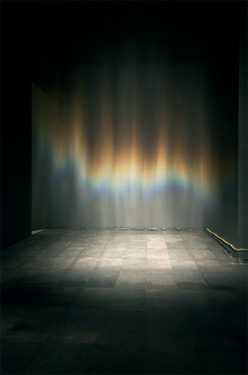
And lastly number 9 is Beauty created in 1993 by Olafur Eliasson. The piece is an indoor rainbow constructed using a recycled water system (Eliasson, 2022). A fine mist of water lit by a spotlight creates the illusion of a rainbow which you can touch and walk through (A Room Full Of Rainbows Has Arrived At The Tate Modern, 2019). Eliason is bringing elements of the natural outdoor world to the suburban closed spaces of London (Walk Into Orange Mists At The Mind-Bending Olafur Eliasson Exhibition, 2019).
Figure 10: Beauty

Bibliography
‘1-heart-1-tree-dossier-partenaires-en.pdf’ (no date). Available at: https://unfccc.int/media/518176/1-heart-1-tree-dossier-partenaires-en.pdf (Accessed: 27 February 2022).
A Room Full Of Rainbows Has Arrived At The Tate Modern (2019) Secret London. Available at: https://secretldn.com/tate-modern-olafur-eliasson/ (Accessed: 7 March 2022).
Andy Goldsworthy (no date) Living Your Wild Creativity. Available at: https://www.livingyourwildcreativity.com/art-gallery-1-mitchell-1 (Accessed: 21 March 2022).
Art of Change and Olafur Eliasson’s Ice Watch: “Art has great potential for changing the world” (2018) Artichoke. Available at: https://www.artichoke.uk.com/art-change-olafur-eliassons-ice-watch-art-great-potential-changing-world/ (Accessed: 6 March 2022).
De Botton, A. and Armstrong, J. (2016) Art as Therapy. London: Phaidon Press Limited.
Drage, D. (no date) The Cleft in the Rock: A Theology of Negative Spaces, Image Journal. Available at: https://imagejournal.org/article/the-cleft-in-the-rock-a-theology-of-negative-spaces/ (Accessed: 7 March 2022).
Eliasson, O. (2021) ‘“The Fastest Way to Make a Populist Into a Humanist Is to Listen”: Artist Olafur Eliasson on How His Latest Work Encourages Empathy’. Available at: https://news.artnet.com/art-world/olafur-eliasson-interview-tanya-bonakdar-1947948 (Accessed: 21 March 2022).
Eliasson, O. (2022) Beauty • Artwork • Studio Olafur Eliasson. Available at: https://olafureliasson.net/archive/artwork/WEK101824/beauty (Accessed: 7 March 2022).
Goldsworthy, A. (2015) ‘Sculptor Turns Rain, Ice And Trees Into “Ephemeral Works”’. Available at: https://www.wbur.org/npr/446731282/sculptor-turns-rain-ice-and-trees-into-ephemeral-works (Accessed: 6 March 2022).
Kosecki, D. (2022) How to track your heart rate with only your smartphone, CNET. Available at: https://www.cnet.com/health/how-to-track-your-heart-rate-with-a-smartphone/ (Accessed: 27 February 2022).
Mestaoui, N. (no date) ‘Interview with ecological artist Naziha Mestaoui’. Available at: https://greendreamer.com/podcast/naziha-mestaoui-ecological-artist (Accessed: 15 March 2022).
Nasa (2022) Overview: Weather, Global Warming and Climate Change, Climate Change: Vital Signs of the Planet. Available at: https://climate.nasa.gov/resources/global-warming-vs-climate-change (Accessed: 8 March 2022).
Olafur Eliasson’s Weather Project - Everything you should know (2021). Available at: https://publicdelivery.org/olafur-eliasson-the-weather-project/ (Accessed: 1 March 2022).
Tan Zi Xi (2016) Oceanic Global. Available at: https://oceanic.global/tan-zi-xi/ (Accessed: 1 March 2022).
‘Tan Zi Xi’ (2017) The Floating Magazine, 9 December. Available at: https://thefloatingmagazine.com/people-tan-zi-xi/ (Accessed: 21 March 2022).
UN (2021) Climate and weather related disasters surge five-fold over 50 years, but early warnings save lives - WMO report, UN News. Available at: https://news.un.org/en/story/2021/09/1098662 (Accessed: 15 March 2022).
Walk Into Orange Mists At The Mind-Bending Olafur Eliasson Exhibition (2019) Londonist. Available at: https://londonist.com/london/art-and-photography/olafur-eliasson-at-tate-modern (Accessed: 7 March 2022).

List of Illustrations
Figure 1: Stewart, O. (2022) Exhibition layout. Private collection.
Figure 2: Mestaoui, N. (2015) 1 Heart 1 Tree [Photo]. Available at: http://dzinetrip.com/artist-naziha-mestaoui-radiates-her-altruistic-vibration/ (Accessed: 5 March 2022).
Figure 3: Goldsworthy, A. (2013) Sycamore leaves edging the roots of a sycamore tree, Hampshire [photo]. Available at: https://www.independent.co.uk/arts-entertainment/art/features/andy-goldsworthy-s-ephemeral-works-artwork-that-is-a-testament-to-passing-time-a6694826.html (Accessed: 7 March 2022).
Figure 4: Eliasson, O. (2014) Ice Watch [photo]. Available at: https://www.telegraph.co.uk/news/2018/12/11/artist-olafur-eliasson-installs-melting-icebergs-heart-london/ (Accessed: 1 March 2022).
Figure 5: Zi Xi, T. (2016) Plastic Ocean [photo]. Available at: https://www.pinterest.co.uk/pin/438186238729659357/ (Accessed: 3 March 2022).
Figure 6: Eliasson, O. (2003) The Weather Project [photo]. Available at: https://publicdelivery.org/olafur-eliasson-the-weather-project/ (Accessed: 10 March 2022).
Figure 7: Goldsworthy, A. (2015) Passage [photo]. Available at: https://imagejournal.org/article/the-cleft-in-the-rock-a-theology-of-negative-spaces/ (Accessed: 7 March 2022).
Figure 8: Goldsworthy, A. (2014) Alder branches form a bridge in a Dumfriesshire, Scotland, stream [photo]. Available at: https://www.northcountrypublicradio.org/news/npr/446731282/sculptor-turns-rain-ice-and-tree-stumps-into-ephemeral-works (Accessed: 13 March 2022).
Figure 9: Goldsworthy, A. (2006) curved sticks laid around a river boulder, Woody Creek, Colorado [photo]. Available at: https://www.northcountrypublicradio.org/news/npr/446731282/sculptor-turns-rain-ice-and-tree-stumps-into-ephemeral-works (Accessed: 13 March 2022).
Figure 10: Eliasson, O. (1993) Beauty [photo]. Available at: https://olafureliasson.net/archive/artwork/WEK101824/beauty (Accessed: 7 March 2022).

