Local 1-Day Event - Feasibility Report

The 12th of July, Northern Ireland

Strategic Festivals and Events Management
Assignment 2

Johnny Thompson – P141643

Structure
The following essay is an event feasibility report focusing on The 12th of July celebrations in Northern Ireland, now re-branded to ‘Orange Fest’. Within the introduction I shall begin by briefly introducing the event destination followed by a clear description of the event and its origins. This will including analysis off the event feasibility as a whole including tasks and timings aswell as capabilities and requirements for the event. After introducing the focus off the report there shall be both a market analysis, so as to determine the demand for the event, aswell as a stake holder analysis so as to be able to see both the supply and demand drawn by and for the event. The report will then discuss the key points from the impact analysis, using both negative and positive impacts from socio-cultural, economic, environmental and economic points of view, with discussion on how these could be used by the region and community for self-betterment. The report will conclude with some forward recommendations on how to mitigate negative impacts and use positive impacts as a tool for growth and development in all areas, socially, economically, environmentally and politically.

Introduction
Northern Ireland, although it borders the Republic of Ireland is part of the United Kingdom (The United Kingdom of Great Britain and Northern Ireland). This also means Northern Ireland lies within the region of Europe, however due to the current political affairs surrounding Brexit, Northern Ireland will also be leaving the European Union with the invocation of Article 50 on 29 March 2017 which is set to be completed this year. (Michael Wilson, 31/3/17)
It is made up of 6 counties; Antrim, Armagh, Down, Fermanagh, Londonderry and Tyrone and is renowned for being a largely open and green landscape full of Norman castles beautiful waterways and Celtic and Christian monastery’s and priory’s.
Northern Ireland is also well known politically and historically as having a very colourful cultural and religious history with Londonderry (the 2013 UK City of Culture) and its history of the Apprentice Boys of Derry that foiled King James during the Battle of the Boyne or The Titanic Quarter of Belfast docks, birth place to the historical White Star Line cruise ship – The Titanic.
The largest of Northern Irelands cultural history celebrations is The 12th July Celebrations, recently re-branded to ‘Orange Fest’ so as to give a more family friendly image and to encourage more overseas tourists for the event.
The 12th July is a Protestant/Unionist event and celebrates King William of Orange’ victory over King James II at The Battle of The Boyne on 12th July 1690 and is for the majority of residents in Northern Ireland, the most important celebration off the year.
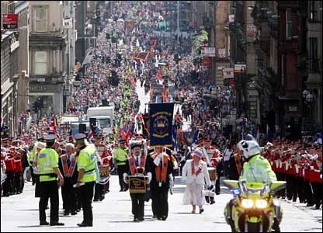
The beginning off the event is marked with the lighting of large multi-storey bonfires in different local housing estates at 12am on 11th night/12th morning with the main event of the large parade not beginning until around 9am, with the event itself being finished around 8pm in the evening however the country celebrates into the night. Shown in the pictures below taken from both google images aswell as a personal collection from the author is a large parade procession aswell as other visual aids so as to help paint a better picture of the event. ‘Band members’ wear colourful uniforms whilst ‘Orangemen’ (people in the Orange Order) wear smart attire and an orange collaret or “Sash”
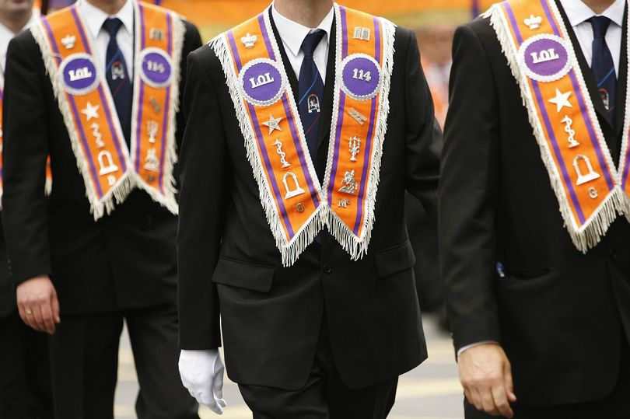

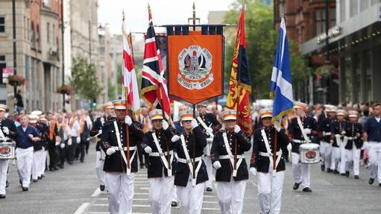

The event is extremely large and is actually held in multiple locations all on the same day with 6 ‘flagship’ locations selected every year aswell as over 15 smaller local parades. These flagship events are held in the biggest and most populated areas as they are more equipped to deal with higher numbers of vehicle and foot traffic aswell as having adequate infrastructure to support the accommodation and hospitality off tourists. The parades follow a strict route pre-planned by the Parades Commission of Northern Ireland to a large meet up point where spectators and participants all gather to socialize, eat and drink from street hospitality vendors and buy souvenirs and other assorted paraphernalia. The event has a designated planning team that work on organising all year round, they take a 1 month break after the event and then begin planning for the following year. Although the core team is small, they have extensive resources available to them. The largest resource required is always man power. Both in planning and running the event there is A LOT of moving parts for the organizers to manage including the people participating in the parade, the spectators, emergency services etc, aswell as the additional infrastructure that needs to be put in place in the days leading up to the festival. This includes stages for awards ceremonies and speeches, partitions along large sections of the route and the erecting of vendor stalls in the event field.
The main aim of the event throughout history and modern history has been to reaffirm Protestantism in a fractured country and to celebrate the acceptance of the protestant religion in Northern Ireland however in recent years, as trends have changed and organizations have strived to become more inclusive and open for a bigger target market, the event has been re-branded with a heavy focus on developing event specific inbound tourists aswell as driving up community engagement and participation. According to Durkheims Theory of Social Solidarity and Social Rules, members of segregated communities experience what is known as social solidarity, this means they are more willing to trust and accept others of their own kind. (Durkheim, 1953). This is very much true for The 12th July festival. In a country where religious identity is quickly being stripped away from communities, the local people hold tighter to this event and surge as a country to promote and host it.

Market and Stakeholder Analysis
Event impact research has been at the core of event studies since its beginnings (Ritchie, 1984; Ritchie & Beliveau, 1974). And it still is (Getz, 2012).
Before highlighting and discussing the impacts off the event we must first determine both who is the target market for the event aswell as identifying the main stakeholders so as to gain a clear perspective on how the event can impact both sides of the celebration.
The main target market for this event is undoubtedly the Loyalist/Protestant/Unionist residents in Northern Ireland and the Republic of Ireland however there is hundreds of Orange Lodges scattered across the world including many in mainland UK, Europe, New Zealand, America and even Africa!
A lot of inbound tourists for the event are often people born in Northern Ireland and moved away or who have family there. In recent years there has been a significant push by the event organisers to actively engage and connect with potential tourists around the world. As an annual event The 12th of July celebrations are the most important religious and cultural festival on the Northern Ireland calendar with not only a steady demand for the ongoing organisation off it, but also strong demand to invest more heavily in the event and market it to further afield in the hope of scaling the event and appealing to more international tourists aswell as adding a heavier family theme so as to further engage the local residents and increase revenues from the day. Gone are the days of 3-4 food vendors and an assortment of bouncy castles. The main event ground, known as ‘the field’ can now be seen packed to the brim with all different styles of food and drinks, a large section takes on what is essentially a large fairground and local business’ travel from miles around to set up shop for the day to sell their items. This event is historical and cultural tourism however it is also part of a small niche market known as ‘Faith Tourism’ which has seen a steady rise across the world, with people travelling specifically to visit or view religions places of worship or events and showings of public worship for the purpose of tourism. It is a form of tourism that is growing in popularity and with work from organizations such as Visit Belfast and The Welsh Government with their Faith Tourism Action Plan, it is hoped that the UK could see an increase in tourists for the purpose of Faith Tourism.
Following the 2017 celebration, Edward Stevenson, The Grand Orange Lodge of Ireland's Grand Master was quoted by BBC Northern Ireland describing it as “The biggest in a century” and said that "unprecedented numbers of people" had attended (BBC, 2017).

GreenEventBook.com defines stakeholders as “any individuals or organisation that have an interest in your activities, have needs or expectations around your activities, or who may be effected positively or negatively by your activities”…” Stakeholders may include individuals and groups both inside and outside the organisation that have some direct interest in the event’s planning, production and implementation, or in participating in it. (GreenEventBook.com, n/a)
Although there are many different stakeholders in this event, in fact to many to record individually, this report shall focus on the stakeholder groups, the people with the highest vested interest, with a short paragraph highlighting the most important elements in these groups and why they are important stakeholders.
Event Organisers – This includes people such as the organising committee, the local partners and sponsors of the event who invest money into bringing the flagship events to their area, aswell as local government who also invest in and fund the event. These stake holders invest both time and money into the organization and running of this event annually for the better off the community and to celebrate and solidify religious beliefs. There is a slight angle for profitability however in this group the main focus is the organization and sustaining of a cultural and historical festival.
Participants and Attendees – This is simply the people involved in the parade, the band members and Orangemen who walk the route for the spectators to watch. Aswell as the spectators themselves, the people from the local community who come out every year to watch the public display of cultural heritage. Although there is many smaller parades organized throughout the year this is the most important date on the marching calendar. This stakeholder group relies on this event for a cultural release, a way to celebrate their religion with their family and friends and in some respects is the last wholesome piece of religious and cultural identity without this festival a significant proportion of the protestant faith would soon disappear. As both of these stakeholders make up the local communities there is little change of opinion for a collective point of view.
Supply Chain – The supply chain is the second largest stakeholder group after the spectators, and is all encompassing, including not only the hospitality and merchandise vendors and their suppliers further down the line but also the suppliers of the band uniforms and instruments, the companies that print all of the booklets and programmes for the event and the companies that provide all of the sound and lighting infrastructure aswell as the local transport links. This stakeholder group, although potentially culturally invested, is highly profit motivated and has a role higher than spectator or participant for the purpose of making money from the event.
Workforce – As the majority off the workforce is made up entirely of both participants and organisers, there is no other stakeholders within the workforce group.

Impact Analysis
Economic – The event has a significantly high Direct Economic Impact, this is described by EventImpacts.com as “a measure of the total amount of additional expenditure within a defined geographical area, which can be directly attributed to staging an event.” (EventImpacts.com, n/a) With an annual tourism income off £164 million, Northern Ireland, in particular the flagship locations, receives a great economic boost from the event, this economic boost is felt by everyone in the communities from contractors and local business’ aswell as the regular workforce in the areas who have more hours available and usually for a higher rate off pay. This is also an example off the multiplier effect, leading to a higher income and local economy. This is just one example of the positive economic impact the event has on the country, communities and the local residents. This allows these areas to invest more in future events, bettering their local area aswell as making it more attractive for tourists therefore leveraging their chances of receiving host status again.
Political – As this is a religious event being held in a country that is as yet still culturally divided, the largest negative impacts from this event are political ones. Issues such as rioting and fighting, violence, a higher need for police and army presence aswell as the ongoing fights in government over various parade routes, timings and policies that are out of the control off the local people and instead relies on the local government to fight for them. However this is rarely seen to be the case, which adds further political issues and social unrest. The political response to the event every year is usually negative as very little of the event is shown to the public and what is shows highlights the few bad spots that are unavoidable due to the circumstances off the event. These political issues are very much fixable if developed over time, however with the current state off the countries cultural divide, it is not an impact they will be able to extinguish any time soon.
Socio-cultural – Probably more important to the local populous than the economic boost is the cultural boost, religious and cultural events are known to bring people together and create a sense of community and The 12th of July is no different. As previously stated, The event is the last strong sense of religious identity remaining throughout communities and being able to come together once a year and celebrate not only the birth off the protestant faith but also the continued faith that has kept the religion alive and strong for so long. This is surely the largest positive impact created by the event even considering the afore mentioned economic boost as it brings people together. Proof of this being more important than the economic impacts is Mazlows hierarchy of needs which is shown below;


As shown in the picture, Physiological needs the things we see, touch and buy that would come from the economic boost, are at the bottom of the hierarchy of needs whilst belongingness and love needs ranks middle.

Conclusion
In conclusion, Northern Ireland as a cultural group and the Orange Order events committee has proven they have the ability and the resources necessary to feasibly host multiple large scale events all at the same time. Through the findings of the report it can be concluded that although Northern Ireland suffers negative political impacts every year in the aftermath off the event, the massive economic boost aswell as the significant socio-cultural boost that comes from this 1-day festival. Recommendations that could be drawn from this report include;
- Networking with local people both in the protestant and catholic communities so as to work towards a resolution to the cultural divide, in time this will lead to less political tension and will mitigate the negative political impacts that can arise from the event.
- Continuing to market and promote the country and the event to people both in the UK mainland aswell as further afield across the globe with the hopes to continue to increase their tourism numbers.
- The organisers and promoters for the festival could also look at specific target marketing for ‘Faith Tourism’, integrating local places of worship into the current tourism infrastructure so as to use pre-existing attractions to their advantage both throughout the year aswell as working as a larger promotion for the 12th of July festivities.
- A final recommendation that the organisers of the festival should consider is possibly moving the event around between maybe slightly smaller host towns. This could not only give regular hosts a break both for their local people aswell as their environment. But this could also help spread a portion of that economic boost throughout further reaches off the country, places that may not be benefitting currently from the event. A simple theory that could support this is the Multiplier effect, as mentioned previously. For local organisers and government to inject a higher in flus of cash into an area to enable them to prepare infrastructure, therefore enabling them to host the events, would lead to a higher spend than the initial injection, minus ‘leakage’ and would allow for a higher GDP and a higher sense of wellbeing within the local communities.

Bibliography
Archive.org – A History of the Siege of Londonderry – [Available at https://archive.org/stream/cihm_12612#page/n145/mode/2up] (Accessed: 17/1/19)

BBC, NI (2015). Twelfth parades 'biggest in generation'. [online] BBC News. Available at: https://www.bbc.co.uk/news/uk-northern-ireland-40493858 [Accessed 16 Jan. 2019].

Durkheim, Émile. [1953] 1965. Sociology and Philosophy. London: Cohen & West. Translation of: Durkheim, Émile. Sociologie et philosophie (1924).

EventImpacts.com (n.d.). Economic | Event Impacts. [online] Eventimpacts.com. Available at: http://www.eventimpacts.com/impact-types/economic [Accessed 17 Jan. 2019].

Getz, D. (2012). Event studies: Theory, research and policy for planned events (2nd ed.). New York: Routledge. (Accessed: 16/1/19)

Getz, D., & Andersson, T. D. (2009). Editorial. Scandinavian Journal of Hospitality and Tourism, 9(2–3), 109–111. doi:10.1080/15022250903216979

Green Event Book (n.d.). 11. Communications & Stakeholders | Sustainable Event Management: A Practical Guide. [online] Greeneventbook.com. Available at: http://www.greeneventbook.com/how-to-guides/10-stakeholderes/ [Accessed 17 Jan. 2019].

Mcleod, S. (2017). Maslow's Hierarchy of Needs. [online] Simply Psychology. Available at: https://www.simplypsychology.org/maslow.html [Accessed 17 Jan. 2019].

Michael Wilson (31/3/17) Telegraph – What is Article 50 – [Available at: http://www.telegraph.co.uk/news/0/what-is-article-50-the-only-explanation-you-need-to-read/] (Accessed: 16/1/19)

Ritchie, J. B. (1984). Assessing the impact of hallmark events: Conceptual and research issues. Journal of Travel
Research, 23(1), 2–11. doi:10.1177/004728758402300101 (Accessed: 16/1/19)

Ritchie, J. B. (1984). Assessing the impact of hallmark events: Conceptual and research issues. Journal of Travel Research, 23(1), 2–11. doi:10.1177/004728758402300101

