The Benefits of Emotional Intelligence within the workplace and its effects on Individual and Organisational Performance.
By Damien Roberts 1904978.
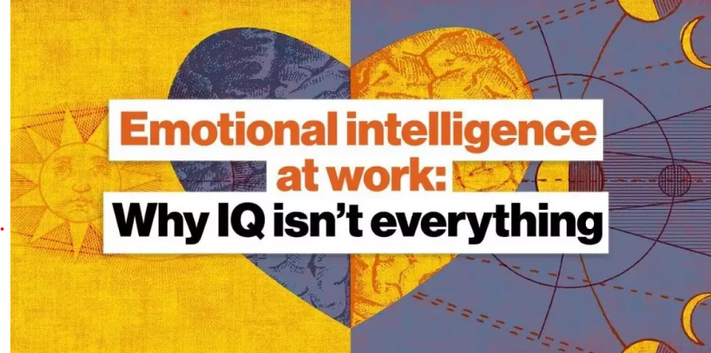

Contents Page.
Page 1 – Contents Page.
Page 2 – Executive Summery & Introduction.
Page 3 – 1.0 - The Link between Wellbeing, Organisational and Individual Performance.
Page 4 – 1.1- Application of Practices, & 1.2- Organisational Examples of effective EI Skills to improve Wellbeing during Covid.
Page 5 – 2.0 Managers Skills needed to support wellbeing through EI and delivering Compassionate Leadership to employees within the workplace.
Page 6 – 2.1 - Theorist Model Examples for supporting EI and wellbeing.
Page 7 – 2.2 Emotional Intelligence through Compassionate Leadership for Sustainability
Page 8 & 9 – 3.0 Emotional Intelligence skills for Mindfulness, Wellbeing and Performance of the workplace.
Page 10 – 4.0 Guidance for Managers on Developing their EI skills in Active Approaches.
Page 11 – 4.1 Reflection of my own Emotional Intelligence.
Page 12 – 4.2 Personal Development Plan & Conclusion.
Page 13 – References.
Page 14 – References.

Executive Summary.
This report was created for the purpose of managers within a sales environment developing better emotional intelligence skills in a post covid climate. The aims of the report are to demonstrate and facilitate understanding of how emotional intelligence through theoretical models and frameworks can enhance the wellbeing of the managers, workforce, and engagements with customers in the external environment. Critical discussion within the report emphasises the importance of EI skills and also what the negative impacts from not applying practical implementation of skills and techniques to the employees can have.

Introduction.

This report has been constructed for the chief executive of an insurance firm in South Wales and to submitted by the 7/06/2023. The purpose of this report is a request by the chief executive to champion the initiative position as a manager, in explaining the link between good people management and emotional intelligence skills. These skills will be examined in the report through understanding of how emotional intelligence can improve employee wellbeing and performance. As the impact of environmental factors such as the pandemic and cost of living has put a strain on employees, the report will discuss the vitalness of how emotional intelligence skills can be adopted in individuals’ attitudes and behaviours in creating a safe and inclusive environment. The report will examine critical analysis of wellbeing and individual and organisational performance, and the EI skills managers need to apply on a practical level and also developing compassionate management. There will be discussion on the benefits of EI skills and mindfulness and critical analysis of how these can promote wellbeing and performance in the workforce. Many sources of information will be utilised during the report such as peer reviewed articles, journals, web sources and the use of important EI theorist models to form evaluation of the evidence used.

1.0
The Link Between Wellbeing, Individual and Organisational Performance.

On average half of all employed working adults spend their waking hours within a work-related environment or engaging in work related activities. This environment, the interactions and the tasks performed there all have an immediate effect on our overall health. There are colleagues within the workplace that we know take full enjoyment and are continuously engaged and thrive within this environment finding much fulfilment in what they do. However, there are also many of us that strive to find that passion and fulfilment and the strong sense of purpose and connection that comes with it. Long hours under stressful conditions make it very difficult to commit time to family and friends with a poor work life balance corresponding to fatigue, burnout, and often lead to poor health. Having this lack of self-management to prioritise ones needs also can lead to overall poor productivity and occupational errors. With this in mind, having the ability to influence an individual’s wellbeing through strategies that employers can adopt can have an overall impact on improving employee’s happiness and wellness (Adams. J. M, 2019).
Occupational stress research has dominated the stressors and strains approach which are mainly characterised by the assumption that stressful situations in the work environment contribute to poor psychological and physical health. With adverse work experiences or stressors such as these in the work environment, this has been seen to cause negative emotional employee responses and the quality of work life balance. Thus, positive work experiences and the emotional responses that have improved from that have been shown to influence overall wellbeing outcomes. More so, research has shown that positive and negative experiences have high contributions to levels of wellbeing and stress not actually necessarily caused by adverse work experience, but rather the perception of the experience of stress being a low level or lack of positive work experiences and emotional states that are positive (Cotton. P, & Hart. P, 2003).
Two distinct perspectives are conceptualised from wellbeing at work, the positive effect being “hedonic” and wellbeing and personal growth being “eudemonic”. This understands wellbeing as being both pleasurable but also meaningful components in an individual. However, research has shown in majority that conceptualization of wellbeing has been from a perspective of judgements and evaluations of satisfaction in areas of like relating to job satisfaction. Research and studies have shown that higher performance indicators are observed with people who are more satisfied with their jobs and in addition the higher positive effect to this predicting quality of performance. More effort has been observed from people who have better wellbeing and achieve then a better level of performance in their tasks. Whilst creating this positive effect within the working environment it has also proved that increase in creativity levels are achieved by workers who are feeling more enthusiastic when starting their mornings. However, some authors such as Greenberger, Strasser, Cummings, and Dunham have studied job satisfaction and job performance but have treated them as separate variables and not being directly related to each other. However, they did not assume to investigate the relationship between the two and the “hedonic” being pleasurable and the satisfaction effect that has in a “eudemonic” dimension of purpose and personal growth (Peiro. M. J, Kozusznick. W. M, Molina. R. I, & Tordera. N, 2019).

1.1
Application of E.I practices.

Direct evidence indicates an association with emotional intelligence and health status and behaviour. It has been shown that self-regulating an emotional state of oneself creates a happier and healthier individual where EI appears to be extremely useful in doing so. Benefits of health and wellbeing are linked to abilities in knowing how to accurately perceive and assess their emotional state, know how to express feelings and when, effectively regulate mood, and thereby creating an effect which reduces negative health outcomes. Recent investigation through meta-analysis describes the relationship between EI and health indicating that overall, there is significant relationship between EI and physical health. Research has shown links to EI and how to practically manage stress, problem solve and promote wellbeing and effective coping strategies (Por. J, Barriball. L, Fitzpatrick. J, & Roberts. J, 2010).
As wellbeing can be measured in outcomes of such as job satisfaction, physical well being and general mental health, certain predictors such as acceptance, emotional intelligence and job control have positive outcomes in these measurements. Being able to compare the relative importance of these characteristics for satisfaction in these areas has to be correlated in practical implementations. For example, higher levels of job control equalling to greater levels of job satisfaction, higher levels of acceptance equalling to better levels of mental health and greater levels of emotional intelligence as being the tangible element between both. Thus, referring to capacity to perceive, assimilate, understand, analyse, and regulate emotion in order to effect wellbeing and performance outcomes (Fielder. E. J, & Bond. F. W, 2004).

Organisational Examples of effective EI Skills to improve Wellbeing during Covid.
In the Wall Street journal in 2018 during the global pandemic, a headline stating 400 healthcare professional a year were committing suicide was alarming. The top 3 reasons for this being burnout, pressure and undeveloped emotional intelligence having an impact on 40% of healthcare professionals and 23 % facing problems with undeveloped EI. A study in this area examined research focusing on investigating the emotional intelligence factors among healthcare workers dealing with the covid-19 pandemic for effective working relationship management and wellbeing. This was created through adopting Daniel Goleman’s management model of being self-aware, self-management, and being aware of situations and people. Data was correlated through circulating questionnaires of 100 healthcare professionals from Mumbai where findings suggested through quantitative evidence determined through implementation of Goleman’s model. These findings were, practical assessment in perspective taking, seeking feedback, caring, trustworthiness, conflict handling, building relationships, learning agility and organisational understanding were important emotional intelligence factors in effectively dealing with covid-19, building emotional resilience, and creating emotional and physical health as important factors contributing to overall wellbeing. Caring through emotional support of team members, building an environment of trust with their team, developing emotional bonds with each other, and being able to create networks of trust and relations were important factors in strengthening their EI skills for wellbeing and performance (Naik. K. R, 2020).
During a time of post covid pandemic effect on social interaction difficulties, emotional regulation has been inseparably intertwined with how social interactions have been an emotional trigger point. Sales teams out working within the external environment and customer service teams based at home can benefit from having reappraisal techniques. These techniques help in reframing an event of social interaction to examine the strengths and weaknesses within that interaction to learn from. Habitual use of this has proved reports in having more closeness and better interaction methods in developing relationships with people as a form of self-reflection and self-regulation methods of EI skills. Conversely, individuals who used suppression techniques reported a lack of social and emotional engagement and less willing to provide response in that interaction. It has also been reported that individuals were more likely also to respond negatively and undermine their social resources at the expense of lack of social awareness. The ability to self-monitor and self-evaluate through reappraisals creates greater mindfulness, connection, and emotional attention (Gross. J. J, & John. O. P, 2003).

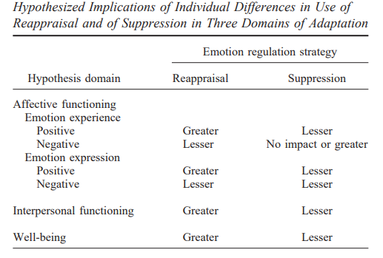

2.0
Managers Skills needed to support wellbeing through EI, and delivering Compassionate Leadership to employees within the workplace.
Work intensification has proved in studies that through production in this manner and acceleration of work pace creates the most common and health impairing consequences and the employees experience and wellbeing in doing this. The connection between both has shown negative outcomes causing strain, disengagement, and psychological distress. Implications on these negative outcomes created performance issues in these areas resulted from burnout and exhaustion. If managers and HR specialists wish to enhance human sustainability in these areas, then appropriate responses in buffering these implications need to be implemented to provide positive motivation, involvement, and engagement. Moderate mediation processes between line manager support and employees are an important recourse focusing the support on responsible people management. Identifying and understanding important stressors is the potential to provide immediate first line support as a strong relation in helping employees cope with demands. Meta- analytical studies have proved manager support as being a strong influencer in employee satisfaction, affective commitment, and productivity when offering support through training, performance evaluations, building group harmony, filling in for absent workers, and helping complete tasks resulting in overall wellbeing (Huo. M.L., Boxall. P, & Cheung, G. W. (2022).

2.1
Theorist Model Examples for supporting EI and wellbeing.
Measuring the importance of a mangers job on organisational performance is of paramount importance to employee’s development as an individual and team potential in assessing performance. Understanding oneself and the individual within the team is necessary in understanding the effect it makes from different independent factors. Among these factors are variables such as motivation, conflict, communication, leadership, EI intelligence and values.
Facilitating these aspects as a manager within the sales environment through EI develops innovation, creativity’ and job performance as an influence for the organisation’s strategic ability. The Bar-On method represents a mixed method approach concentrating on elements of emotional Intelligence with effective dispositions such as a need for achievements, assertiveness, impulse control, happiness, self-esteem, empathy, and emotional awareness. These aspects creating emotional realisation and characteristics resulting in perseverance, commitment, and desirable behaviour (Shahhosseini. M, Silong. A. D, Ismaill. I. A, & Uli. A. J, 2012).

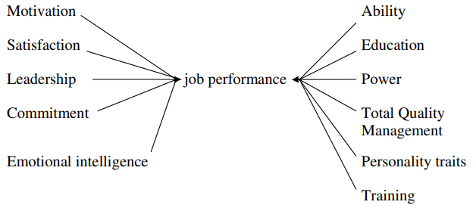

Studies have shown that EI intelligence through questionnaires and tests demonstrate higher EI scores than those of a younger demographic up until the age of 25. Recognising the benefits as a manger in how interpersonal capacity of EI to younger age groups in the sales force can be an advantage to training and experience as the BAR-ON Model studies reveals older people are more socially intelligent. The BAR-ON Model identifies significant relationships between social interaction and EI skills where support and training in emotional management creates the ability to manage one’s emotions and the ability to validate one’s feelings to solve problems of personal and interpersonal behaviour.
Facilitating employees in feeling inclusive and important within the environment creates self-actualisation as a process in striving for individual potential and capacity, ability, and talents. This in turn creates enrichment and meaningfulness within the environment facilitating wellbeing having the ability to better express themselves. Conducting workshops to encourage emotional awareness and empathy towards situations within the workplace develops better EI skills for effective coping strategies in stress and conflict. Change management techniques through adjusting one’s feelings and thinking to new situations by pause and reflect, co-operating more as a team, establishing better relationships, and awareness of other people’s feelings are effective strategies to deploy as a manager within the environment. These are important for better EI skills in social awareness when interacting with customers, colleagues, and appreciation to the effects of the pandemic when relating to the external pressures through empathy and understanding (Psicothema, 2006).

Although the El Farol Bar model is limited to pre-specific learning processes, Daniel Goleman’s model of emotional intelligence is similarly related to the ON-BAR model although Goleman motivates managers and leaders to create an infectious environment to inspire. Forming a strong relationship as a manager with your employees. As a manager within the sales force displaying traits of accountability encourages responsibility but also demonstrating that as a self-awareness technique to learn from. Putting yourselves in other people’s shoes demonstrates perspective of how you actually perceive the other persons circumstances through empathy. Responding to body language creates a better understanding in how to approach customers in the outside environment door to door. Then pausing and reflecting of those understandings develops your emotional responses to those situations (Whitehead. D, 2008).
Through Goleman’s model a manager can make staff aware of strengths and weaknesses in order to improve them through advancing their team in communication strategies to increase EQ intelligence. Practicing team communication with home based workers in isolated environments creates compassionate leadership distracting them by making the employees feel just as inclusive as the field-based operatives. Active listening techniques through creating regular meetings as a means of avoiding overcrowded interruption of people speaking over others, develops consideration in attitude and behaviours. Not implementing such techniques can create conflict and heated arguments by lack of self-awareness and instead adoption of self-regulation (Goleman. D, 2018).

2.2
Emotional Intelligence through Compassionate Leadership for Sustainability
Half of the American population that are employed claim that their managers are mildly or highly toxic resulting in poor employee retention and a significant result as stress at work. Poor leadership has an organisational impact on performance resulting from the level of stress from uncompassionate leadership. Impacts from this have resulted in poor behaviour and pollution of the cultural environment. Even with the covid pandemic highlighting issues of mental health at work humans are rife with emotions which have been carried into the workplace. Managers within the workplace can avoid scenarios of workers feeling these effects by observing their employees and building empathy and support in resistance to emotional sadness, anger, and depression. Recognising these symptoms enables managers to respond to the situational environment by banishing negative thoughts through agility of understanding the workforce conditions in their diversification and difficulties by identification of individual needs. Nurturing a safe environment in this way addresses psychological safety and emotional availability to their needs (Oddie. B. E, & Isabell. K. C, 2022).

3.0
Emotional Intelligence skills for Mindfulness,
Wellbeing and Performance of the workplace.

Consensus around the processes involved in mindfulness is that “being attentive to and being aware of what is taking place in the present”. Momentum gained from research across numerous fields and practices has laid interest in the concept of mindfulness and its origins from Eastern European spiritual traditions. Practitioners from wide range organisations have advertised the effects and benefits of mindfulness techniques to its employees and leaders with empirical evidence of how this continues to support stress and wellbeing outcomes. Evidence in studies has suggests that developments of mindfulness in individuals can be improved through mindful based interventions demonstrating reduced symptoms of stress, anxiety, depression, and fatigue, increasing wellbeing, and associated cognitive enhancements in attention and working memory capacity.
Positive relationships and job satisfaction have been associated with Dispositional mindfulness demonstrating better work life balance, sleep quality, engagement in teams and reduced emotional exhaustion. Proposed areas of mindfulness through organisational management have investigated the role of mindfulness in the psychological wellbeing and resilience within employees. What is already known in relation to application of mindfulness in this area is improved work wellbeing, quality of relationships with other team members, personal regulation, and performance outcomes (Hawkes. A. J, & Neale. C.M, 2020).
Noticeable gaps in research have been perceived from employees actually spend a lot more time interacting with peers than their actual leader demonstrating a latitude of reciprocation in co-worker interactions. Mindful leaders can have an impacting effect of interpersonal functioning with subordinates and the relationship quality resulting from less hostility and reduced verbal defensiveness when undertaking tasks in a stressful environment. Mindfulness through Seers (1989) TMX theory demonstrates that team leader exchange represents the degree of reciprocity, cooperation and collaboration between leaders and their peers. This also represents greater organisational culture in behaviour, job satisfaction and team performance. Conversely, when unequal exchange in relationships is practiced in these areas there is associated increases in tension between leader and peers, interpersonal strain, increased stress social withdrawal and burnout (Organiz. J, 2014).
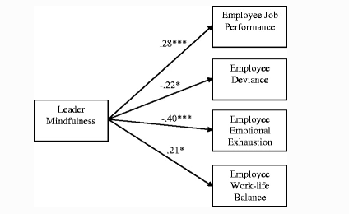

Emotional Intelligence levels and the link to providing improvements through the leadership management exchange, greatly impact psychological activities and team outcomes. Mindfulness has been related to a lot of reaction control abilities in dealing with reactions to hostility, conflict management, aggression, and poor performance. If lack of support by managers through intervention techniques is not presented through useful practices, then negative outcomes can occur. Implications from lack of resolution strategies, dealing with response reactions to hostility and conflict can impact emotional suppression and personal expression within the workplace. However, translating this into actionable plans and practices within the workforce sales environment management has to provide direct support in direction, motivation, and feedback (Reb. J, Narayanan. J, & Chatervadi. S, 2014).
Exercising such leadership practices influencing behaviours and attitudes can be implemented through fostering good work facilitation, self-management through awareness and ability to learn, building relationships at work, understanding individuals needs, and determining the particular capabilities of an individuals needs according to working conditions and the environments they are confined within. Deeper understanding of the workforces operating environments such as working at home, working within the office, hybrid and the employees needs in different aspects of employment such as contracts, are emotionally intelligent traits of leadership awareness and efficiency to support these. Typical individual support from leaders within the workforce can implement efforts to promote self-development behaviours such as active reflection techniques, and internal and external feedback for help in self-assessment, making sense of experiences and better communication through all areas (Urrila. I. L, 2022).

Activities such as paying attention in a particular way, awareness of what is taking place in the present by being attentive, and raising awareness of the internal or external environment such as the covid pandemic builds a psychological capacity in self-awareness and the awareness of others. Empathy and understanding developments from these practices can focus on how the cost-of-living scenario, global conflicts and technology advancements are the attention of harmful implications to behaviour within the environment. Contemplative practice in these ways can involve introspection and reflexive monitoring of not only ones own mental state and actions but that of others creating ethical consciousness of purposeful choices. Leadership qualities in in supporting behaviours in such ways can reflect in experiences and support in a person’s development in becoming better leaders within the environment themselves cultivating interventions through mindfulness and fostering ethical and moral responsibility improving the lives and functioning of other and themselves (Ciulla. B. J, 1995).

4.0
Guidance for Managers on Developing their EI skills in Active Approaches.

As managers understanding oneself and emotions, knowing one's strengths and shortcomings, and striving to be perfectly in sync with one's body and mind are all aspects of self-awareness. Thinking about about how we "carefully" conduct ourselves around other people, how we communicate both vocally, and through our body language has a major impact on understanding our emotions. We need to consider retrospectively how we manage those emotions and sentiments for ourselves, as well as the impact it has on other people. This is a key aspect of self-regulation in our management, which allows us to be flexible in adapting well in various areas while also managing conflict and tense circumstances. These will be important attributes in passing on to our team when dealing socially through our customer services department and field sales operatives (Boyatzis. R. E, Goleman. D, & Rhee. K, 2000).
As managers emotional intelligence creates great capacity of being able to address with ourselves things that we are not so good at, and things we can improve on is the start of an important process. This identifies that being truthful with ourselves is a great reflection of self-awareness, and brutal honesty and having the ability to understand one’s own thoughts and feeling a great self-regulation technique. This will create mindfulness of our own thoughts and feeling and how they impact others.
Since covid has been a stressful environment, understanding how difficult it has been to manage one’s own thoughts and feelings in a very socially closed off environment is challenging. In response to this, encouragement in useful practises of mindfulness by being more present in your thoughts and feelings is imperative. When you're responding and communicating with each other on a daily basis, useful practices useful practices of EI to take into consideration are, taking a moment to pause and be mindful in your thought processes, how you respond to each other in these ways, and in the things, you say, and the way you say them is significant in the impact they may have on the other person. Setting an example of our behaviour in this manner is a duty of care in our own well-being as well as the well-being of others around us. Helpful methods in practicing this would be to breathe, pause and remind oneself of this to respond properly. One of the most significant things in maintaining a healthy aspect in positive connections with others is consideration of our own and others' well-being (Miao. C, Humphrey. R. H & Quian. S, 2018).
“Putting a shoe on the other foot” perspective is a great way of employing compassionate leadership through Goleman’s emotional intelligence model of appreciating the importance of positive and negative impacts of emotions. It makes great sense for leaders to understand that positive emotions are essential for creating internal motivation in optimising performance of individuals and organisational success as much as negative emotions in vitalness for self-improvement. Exercising empathy and understanding through his model and not ignoring pain and need for support emphasises concern for human dignity, and the importance of emotions for workplace functioning alleviating suffering to reintroduce compassion in the workplace. The ability to self-manage distressing situations or conflict creates effective behaviour by empathy in recognising what others are feeling. This s an intrinsic force that drives individuals towards their goals by building good trustworthy social networks with their employees and effectively navigate relationships. Developing practices such as coaching techniques can be implemented by providing a close relationship through appraisals and creating personal growth regressing old behaviours and eliminating negative thoughts to promote wellbeing. This kind of intervention cultivates psychological flexibility and self-compassion as internal experiences (Shultz. J, 2020).

4.1
Reflection on my own emotional intelligence.

Taking part in emotional intelligence quizzes and the results of those quizzes showed that I had a high emotional intelligence score. My scores correlated evidence that I was naturally in tune with others’ emotions at an above average level but with also room for growth in recognition skill with room to practice. More in depth quizzes through mind tools showed that I was emotionally intelligent with relationships and that people approach e for advice. However, when doing this I tend to lose attention to my own needs but have great leadership potential. My advice was to improve my emotional intelligence through Goleman’s model. I believe that often I tend to put important things of my own needs aside where I then create pressure for myself in understanding how to prioritise my time by value of also my own needs, especially if reflecting on work or studies.

My Psychology test revealed 84/100 displaying emotional identification, perception, and expression. My core abilities of identifying, perceiving, and expressing emotions in myself and others is an area I seam to be doing quite well. This aspect of my EI helps me to read others, understand how they feel, and effectively identify my own emotions which I feel to be a good self-awareness aspect of Goleman’s model. However, I seem to doubt my own abilities on occasions which I believe could be a self-regulation technique by Goleman that I can use to better understand why I do this in pause and reflect technique, but also maybe appraisal techniques on where i can identify where improvements in understanding self-doubt arises from. Other quizzes seam to identify the same consistencies in my reports, which has given me a broader understanding of how to improve in areas that will help me exceed my own goals whilst helping others. I believe that mindfulness techniques such as being aware of my internal environment is also just as essential as being mindful of others as it can be impacting in the analogy of not being able to pour from an empty cup. In order to feel happy helping others I must also look after the wellbeing of myself by being healthy through my own activities, as i often feel i can develop anxiety issues in lack of productivity and effecting my wellbeing.

4.2
Personal Development Plan.
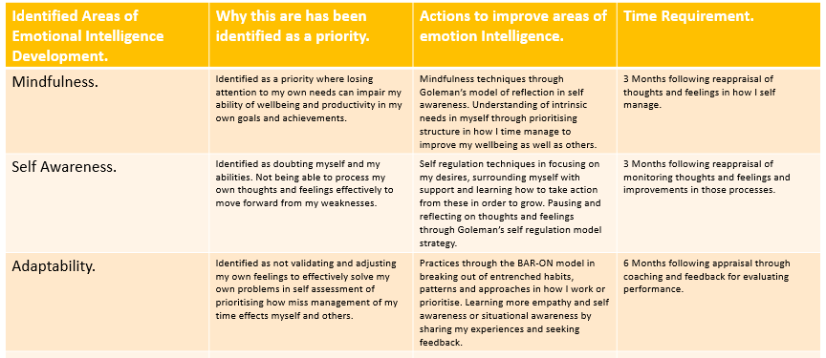

Conclusion.

Discussion and critical analysis of the report creates a deep understanding in how Emotional Intelligence is as of much importance as Intellectual Quotient. The ability to demonstrate good emotional intelligence skills through theoretical frameworks such as Goleman and the BAR-ON model creates a deeper understanding of one’s self-awareness, self-regulation, and adaptability to practically implement those skills. This helps to improve empathy and understanding of a manager and the workforce that he manages to create improved mindfulness in the way we approach situations and the way that we communicate in creating a culture of wellbeing and understanding. Demonstrating skills in EI to improve the environment in social interaction and situational awareness creates stability and trust through relationship management. With process in feedback and also mindfulness in perceiving other people’s thoughts and feelings creates better mental health and wellbeing through consideration to others. Building resilience through the workforce in reflection and appraisal techniques by helping employees understand one’s weaknesses and how to work on developing better attitudes and self-motivation creates personal and organisational performance. Psychological safety and wellbeing have proved resilience intervention in this way is of huge benefit in cognitive behaviour therapy and acceptance and the capacity to manage stressful situations as a result. This prevents absenteeism at work and creates better productivity as a happier healthier workforce for organisational culture, good management and promoting and facilitating early help seeking through the practises and techniques used.

References.
Jerome. M. Adams (2019). The Value of Worker Wellbeing. Available at: The Value of Worker Well-Being - Jerome M. Adams, 2019 (sagepub.com). Accessed: (26/06/2023).
Peter Cotton & Peter. M. Hart (2003). Occupational wellbeing and performance. Available at: Occupational Wellbeing and Performance: A Review of Organisational Health Research - Cotton - 2003 - Australian Psychologist - Wiley Online Library (uwtsd.ac.uk). Accessed: (26/06/2023).
José M. Peiro, Malgorzata W. Kozusznick, Isabel Rodríguez-Molina, and Núria Tordera (2019). The Happy Productive Worker Model and Beyond. Patterns of Wellbeing and Performance at Work. Available at: ijerph-16-00479.pdf. Accessed: 27/06/2023.
Jitna Por, Louise Barriball, Joanne Fitzpatrick & Julia Roberts (2010). Emotional intelligence: Its relationship to stress, coping, well-being and professional performance in nursing students. Available at: Emotional intelligence: Its relationship to stress, coping, well-being and professional performance in nursing students (sciencedirectassets.com). Accessed: 27/06/2023.
Kasturi. R. Naik (2020). An investigation of emotional intelligence factors among health care professionals dealing with COVID 19 pandemic for effective relationship management by means of factor analysis. Available at: 51612__DrKasturiRNaik(NMITD).pdf (fergusson.edu). Accessed: 28/06/2023.
Huo, M.-L., Boxall, P., & Cheung, G. W. (2022). Lean production, work intensification and employee wellbeing: Can line-manager support make a difference? Economic and Industrial Democracy, 43(1), 198–220. Available at: https://doi-org.ezproxy.uwtsd.ac.uk/10.1177/0143831X19890678 . Accessed: 30/06/2023.
Mohmmad Shahhosseini, Abu Daud Silong, Ismi Arif Ismaill, Jegak nak Uli (2012). The role of emotional intelligence on job performance - ResearchGate. Available at: https://www.researchgate.net/profile/Mohammad-Shahhosseini-3/publication/328676144_The_Role_of_Emotional_Intelligence_on_Job_Performance/links/5bdb54f2a6fdcc3a8db696f8/The-Role-of-Emotional-Intelligence-on-Job-Performance.pdf. (Accessed: 30 June 2023).
Psicothema (2006). The Bar-On model of emotional-social intelligence (ESI). Available at: Feijoo,+2006018S00130025.pdf. Accessed: (31/06/2023).
Daniel Goleman (2018). Everyday Emotional Intelligence. Available at: EpubReader (vlereader.com). Accessed: (31/06/2023).
D. Whitehead, (2008). The El Farol Bar Problem Revisited: Reinforcement Learning in a Potential Game. Available at: The_El_Farol_Bar_Problem_Revisited-libre.pdf (d1wqtxts1xzle7.cloudfront.net). Accessed: (02/07/2023).

Bahia El Oddie & Knoop Carin Isabel (2022). Burning up and burning out. Human Sustainability in a Time of Emotional Climate Change. Available at: Burning up and burning out. Human Sustainability in a Time of Emotional Climate Change - ProQuest. Accessed: (01/07/2023).

Amy J. Hawkes & Carla M. Neale (2020). Mindfulness beyond wellbeing: Emotion regulation and team‐member exchange in the workplace. Available at: Mindfulness beyond wellbeing: Emotion regulation and team‐member exchange in the workplace (tandfonline.com). Accessed: (02/07/2023).
Richard E. Boyatzis, Daniel Goleman and Kenneth Rhee (2000). Clustering Competence in Emotional Intelligence. Available at: Clustering competence in emotional intelligence: Insights from the Emotional Competence Inventory (ECI) (eiconsortium.org). Accessed: 04/07/2023.

Jochen Reb, Jayanth Narayanan & Sankalp Chaturvedi (2014). Leading Mindfully: Two Studies on the Influence of Supervisor Trait Mindfulness on Employee Well-Being and Performance. Available at: Leading Mindfully: Two Studies on the Influence of Supervisor Trait Mindfulness on Employee Well-Being and Performance | SpringerLink (uwtsd.ac.uk). Accessed: (02/07/2023).
GEORGE C. BANKS, JOHN H. BATCHELOR, ANSON SEERS, ERNEST H. O’BOYLE JR.4, JEFFREY M. POLLACK5 AND KIM GOWER (2014). Available at: What does team–member exchange bring to the party? A meta-analytic review of team and leader social exchange. Accessed (02/07/2023).
Laura Ilona Urrila (2022). From personal wellbeing to relationships: A systematic review on the impact of mindfulness interventions and practices on leaders. Available at: From personal wellbeing to relationships: A systematic review on the impact of mindfulness interventions and practices on leaders (sciencedirectassets.com). Accessed: (03/07/2023).
Joanne B. Ciulla (1995). Leadership Ethics: Mapping the Territory. Available at: Leadership Ethics: Mapping the Territory on JSTOR. Accessed: (02/07/2023).
James. J. Gross & Oliver. P. John (2003). Individual Differences in Two Emotion Regulation Processes: Implications for Affect, Relationships, and Well-Being. Available at: Individual differences in two emotion regulation processes: Implications fo...: EBSCOhost (uwtsd.ac.uk). Accessed: (03/07/2023).

Chao Miao, Ronald. H. Humphrey & Shanshan Quian, (2018). The relationship between emotional intelligence and trait mindfulness: A meta-analytic review. Available at: The relationship between emotional intelligence and trait mindfulness: A meta-analytic review - ScienceDirect (uwtsd.ac.uk). Accessed: (04/07/2023).

Joshua Shultz, (2020). Becoming the leader, you value: An act of coaching intervention for compassionate leadership. Available at: Becoming the Leader You Value: An Act Coaching Intervention for Compassionate Leadership - ProQuest. Accessed: (04/07/2023).

.

