Student name: Ismot Ara Shammi Chowdhury
Student ID number: 2210487
Programme: Employability Skills
Module: Learning in the Digital Era
Module Code: BMSW4010
Assignment Title: Evidence of Learning (E-Portfolio)

Table of Contents

Table of Contents 1
1. Introduction 2
2. Main Findings 2
Explanation of Academic writing 2
Importance of Critical Thinking/Writing 3
Sense of Place and Identity (Video Presentation Slides) 4
3. Conclusion 6
4. References 7

Introduction
Learning is a method of accumulation of knowledge, and skills, developing attitudes and capabilities of a person (Ozdemir, et al., 2018). From a very old age of the time, people and animals on the planet started to learn on their own against the situations. After and during this process in higher educational institutions, the individuals can have the capabilities to write academic papers and reports as well as can critically analyse the areas of their research and studies, which enhances their personality development and knowledge (Fang, 2021). Also in this report, the analysis of academic writing, the analysis power of research and the understanding of the sense of place and identity are elaborated.

Main Findings
The purpose of the main findings is to critically analyse the academic skills that are required by students to have good academic achievements in their student life (Öz & Balyer, 2018). Also, through the analysis of the academic skills required for the learners, from the perspective of students, it is also very helpful in professional life to write the paper without any plagiarism. Besides, the importance of critical thinking and writing will empower individuals to have logical thoughts and reasoning in their personal and professional lives (Howard, 2012). Also, through this, the understanding of students will increase about the issues in which they will be working.

Explanation of Academic writing
Academic writing is a way of communication, which is one of the significant academic skills required in students, to develop their knowledge and skills. It is the formal style and structure of writing in academic works (Altınmakas & Bayyurt, 2019). In other words, academic writing is the pattern and style of writing academic research reports, case studies, essays and papers, where mainly formal words are used, along with citations as evidence from different sources, such as; textbooks, journal articles, newspaper articles, websites and other sources. Besides, in this academic writing, the authors have to show their clarity of knowledge as well as have to demonstrate the analysis with arguments by logical reasoning. Through these analyses and arguments, academic writers have to show a clear vision and logical concepts with accumulated pieces of evidence from different types of verified sources (Fang, 2021). For that reason, the writers have to synthesize, analyse, paraphrase and quote from the sources to increase credibility. Moreover, academic writing is required to have the fact checking and similarity check, for students, who want to achieve academic success by gaining higher study degrees with good grades. It enables editors, publishers, writers, and readers to cross-reference submitted papers with thousands of other journal articles in a database. Using an automatic text similarity checker, like, Turnitin, Dupli checker, Grammarly, etc. programmes detects plagiarism in the academic writings and research papers. With the similarity check, individuals can check their documents and find out the previous published sources of the data in the writings as well as provides the clarity to the writings. Furthermore, regularly writing academic papers, enhances the vocabularies of the writers and students, along with increasing their intellectual boundaries (Yu & Liu, 2021). Thus, academic writing enriches an individual’s abilities and competencies in a particular area of expertise.

Importance of Critical Thinking/Writing
The critical thinking is the process of the significant and anticipated skills of an individual, which contributes to improving analytical and problem-solving skills. It is the procedure of analysing all the aspects of the relevant areas of the topic, which is intensely scrutinised in rational and logical reasoning (Howard, 2012). In other words, critical thinking is the deep approach in the learning process which is related to the personal knowledge of the individuals. In addition, critical writing is the documentation of critical thinking in the words. Both critical thinking and writing are related to each other. Also, these comprise of logical arguments of comparing and contrasting the relevant contexts to challenge the existing perspectives of the readers based on the theories. As well, these processes permit individuals to have clarity of the information based on several practices and theories along with personal knowledge of the topics (Strobl, et al., 2019). Correspondingly, this process evaluates the writing works of the authors, whether they write in the academic paper or reports in any organisation. In most universities and colleges, for higher education purposes, students have to write many papers and reports, where they have to critically examine the theories and aspects of the topic with pieces of evidence from different sources (Shamboul, 2022). Besides, the students have to provide the proper logical reasoning based on the question of how and why – with the explanation of the personal perceptive, from the appropriate sources of evidence, such as; books, published journals, etc. along with the documentation of the backgrounds of the studies. Through the presentation and documents of the critical thinking and writing by the authors, their readers also can have insights into information and its evaluation, with valid justification for the reliability of the analysis for enhancing the quality of the paper.

Sense of Place and Identity (Video Presentation Slides)

Sense of Place:

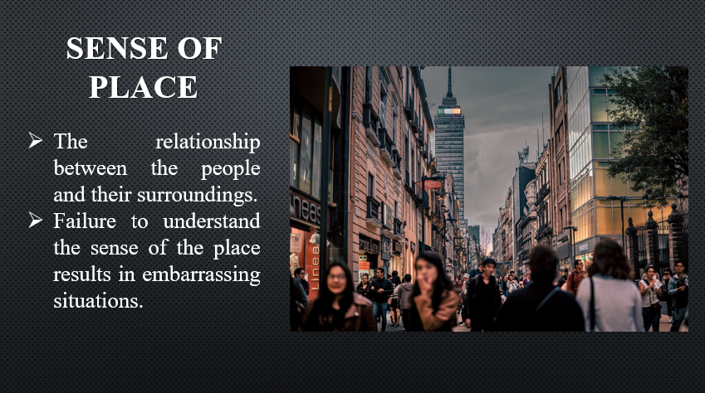

In definition, the sense of place is a multidimensional concept which shows the relationship between people and their surroundings (Öz & Balyer, 2018). It shows the geographical characteristics and the cultures of that environment (Caves, 2005). If a person cannot cope with their new surrounding based on the cultures and other structures, they are more likely to see failure in sensing their environment. For instance, if a person wears woollen shirts and overcoats & jackets in a warm area or region, like in the Sahara desert, it would be absolutely absurd because this person failed to understand the sense of the place. Failure to understand the sense of the place results in such embarrassing situations (Shamboul, 2022). For that reason, all must understand the sense of the place and how to cope up with such events and situations.

Sense of Identity:

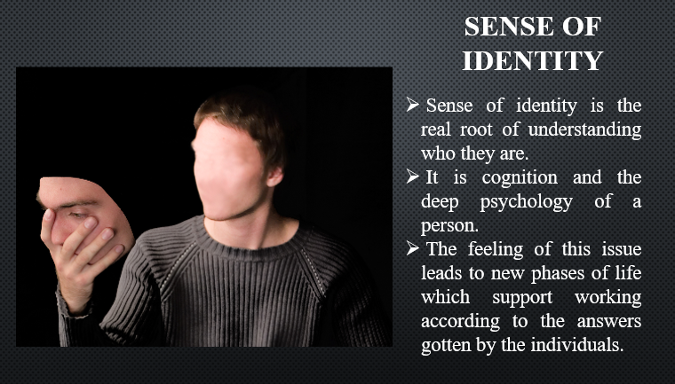

Sense of identity is the real root of understanding who they are. It shows the cognition and the deep psychology of a person and what he or she wants in life (Jagannath, 2018). It is a really significant issue in one’s life about the questions of; who am I and what is my identity (Smith, 2020). The feeling of this issue leads to new phases of life which support working according to the answers gotten by the individuals (Howard, 2012). For instance, after a long period of working in a company as a manager, Mr X found his sense of identity in his creative works of doing the painting.

Conclusion
Learning academic skills and capabilities makes individuals to be succeeded in their kind of achievements (Öz & Balyer, 2018). Through this learning process, a person has the opportunity to progress in their studies and career development. Nowadays, all people need to learn and enhance their skills and capabilities in their areas of interest (Korhonen, et al., 2019). Moreover, sense of identity and place are also significant factors for the people to realise themselves and their surroundings. In this way, the critical learning can help the individuals to realise their personality and the power to analyse environment in their personal and professional life.

References
Altınmakas, D. & Bayyurt, Y., 2019. An exploratory study on factors influencing undergraduate students’ academic writing practices in Turkey. Journal of English for Academic Purposes, Volume 37, pp. 88-103.
Caves, R., 2005. Encyclopedia of the city. 1st ed. London; New York : Routledge.
Fang, Z., 2021. What is Academic Writing? (and Other Burning Questions About It). [Online]
Available at: https://www.routledge.com/blog/article/what-is-academic-writing-and-other-burning-questions-about-it#:~:text=Why%20is%20academic%20writing%20important,and%20critical%20for%20academic%20success.
Howard, H., 2012. Looking to the future: Developing an academic skills strategy to ensure information literacy survives in a changing higher education world. Journal of information literacy,, 6(1), pp. 72-81.
Jagannath, T., 2018. Building a Sense of Place. - Interviews and Articles on Art & Public Spaces. [Online]
Available at: https://medium.com/interviews-and-articles-on-art-public-spaces/building-a-sense-of-place-6df11629e452.
Korhonen, A., Ruhalahti, S. & Veermans, M., 2019. The online learning process and scaffolding in student teachers’ personal learning environments. Education and Information Technologies, 24(1), pp. 755-779.
Öz, C. & Balyer, A., 2018. Examining the Importance of Critical Thinking Skills of School Administrators and Teachers’ Regarding Their Personal and Professional Lives. International Journal on Lifelong Education and Leadership, 4(2), pp. 20-31.
Ozdemir, M., Sahin, C., Arcagok, S. & Demir, M., 2018. The effect of augmented reality applications in the learning process: A meta-analysis study. Eurasian Journal of Educational Research, 18(74), pp. 165-186.
Shamboul, H., 2022. The Importance of Critical Thinking on Teaching Learning Process. Open Journal of Social Sciences, 10(1), pp. 29-35.
Smith, K., 2020. What Happens When You Lose Your Sense Of Identity. - The Good Men Project. [Online]
Available at: https://goodmenproject.com/guy-talk/what-happens-when-you-lose-your-sense-of-identity-bbab
Strobl, C. et al., 2019. Digital support for academic writing: A review of technologies and pedagogies. Computers & education, Volume 131, pp. 33-48.
Yu, S. & Liu, C., 2021. Improving student feedback literacy in academic writing: An evidence-based framework. Assessing Writing, Volume 48, p. 100525.

