John Lewis Customer Relationship Management System
Presentation
Group - Runa, Sultana, Ripara, Kirsty.

Task 1 & 2 - Runa Begum 1710220

What does customer relationship mean? (CRM)
Customer Relationship Management is the principles, practices and guidelines of an organization that follows while interacting with its customers. This relationship covers direct interactions with the customers, such as sales and service-related processes to forecast and analyse the trends and actions of customers, according to Hargrave (2019).
CRM is a technology that helps an organization to manage its relationships and interacts with protentional and existing customers with a simple goal to improve business relationships and to stay connected with customers, modernise processes and improve profit (Rouse 2019).

What does CRM in Retail Mean?
CRM in retail means, to increase satisfaction of customers, reduce the costs and improve organisational performance in the marketplace (Markgraf 2019). CRM in retail means a strategy can be provided to satisfy and optimize the organizations process by having every interaction more customer centric (Hossain 2019). CRM allows organizations to manage relationships with customers, collect data and information that are associated with the business.

There are many benefits as well as drawbacks of using CRM system. Thakral (2017) states, having implemented the correct CRM, will improve the customer relationship, build trust and loyalty. However, if the correct CRM system is not applied then certain challenges will come up during the time of implanting the CRM system. Ipsos (2017), explains the CRM system is important for any business because it helps to share the correct information with the correct person by communicating with customers properly. CRM’s goal is to understand customers’ needs and behaviours therefore, organizations can provide better or improve the quality of service. CRM helps keep the existing customer while provides new opportunities to build relationships between customers and the business, by analysing the data and producing reports when it is needed according to MSG (2019).
Advantages of CRM system are according to Thakral (2017),
- It saves management time by collecting all the data in one database therefore, helps employees to be more productive and efficient in tracking the history of customers and sending reminders on sales and promotions the customers.
- Saves effort. By automatically managing the database while speeding up the growth process.
- It helps value and builds long-lasting relationships with customers by sending birthday wishes to them.
- Improves profits by focusing on profitable customers and identifies customers that are not and deal with them in a cost-effective way.
- CRM improves communication, by providing good level of service, by making customers information available when needed.
- CRM provides clear, easy-to-use dashboard and provides a 360 view of customers in one place.

Protentional drawback of CRM come from lack of commitment of employees of the organisation. This can result in customer dissatisfaction and loss of profit.
The drawbacks of CRM are according to Gaille (2015),
- Cost of CRM implementation, because there are different types of software system available therefore, the business needs to consider the correct CRM system according to the budget of the CRM project.
- Poor communication can prevent in securing and making CRM work.
- Lack of leadership can cause problems in implementing a CRM system.
- Security issues with CRM, such as losing data if the database is not properly maintained.
- Third party can get access to sensitive data, for example, companies like web hosting can track the data and sell it to the highest bidder.

Examples of other organisations that use CRM system
Tesco uses Clubcard to collect data of the customers and uses that information to provide rewards and discounts according to customers needs. For example, customers use the card to collect points through transactions, the theses points can be used online or in store to purchase goods, suggested by Rowley (2005).
Emirates has a loyalty scheme called skywards, where customers collect points by flying with them or with their wide range of partners by becoming a member of skywards (Emirates 2019).
Marks & Spencer has a loyalty scheme that allows customers to earn sparks when they spend or look at products. These sparks provide wide range of offers to the customers. The more sparks customers get, more offers are available to them. Also, customer can exchange old item of clothing for 50 sparks according to Fitzsimons (2019).
Hotel industry like Marriott provides rewards programs, for example they link accounts and transferring points when redeeming free nights, these rewards can be used when staying at hotels, booking flights, to rent cars and other holiday packages. Other benefits are free wi-fi, discounted redemption rates and other offers without having to pay membership fee, according to Tisa (2018).

Examples of some stakeholders that benefit from CRM system
- Owners – get high net profit with high net sales and less operating costs.
They achieve their vision by having successful business.
Can improve the business growth according to customer’s needs.

Sales Managers – helps to train new employees quickly in productive selling.
Has the ability to see opportunities of needing sales coaching.

Sales people – able to provide a positive experience in developing a relationship with protentional customers.
Provides customers with quick feedback that are concerned with support or service-related issues.

IT department – has a system that has opportunities to grow and not be replaced in a few years.
Has reliable database that reduces time for support and troubleshooting.

Also, CRM boost employee satisfaction, increases productivity by having one main system, where they have all the information and use it to provide better customer experience (Success 2019).

There are different types of CRM, they are Operational, Analytical and Collaboration. These come with different advantages and disadvantages. Therefore, organisations need to decide on the correct CRM according to organisational future goals and strategy suggested by (Rasheed 2019).

Slide 1

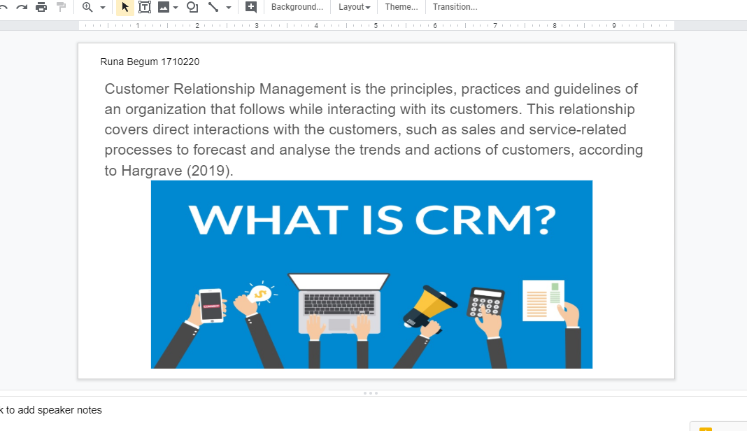
Slide 2
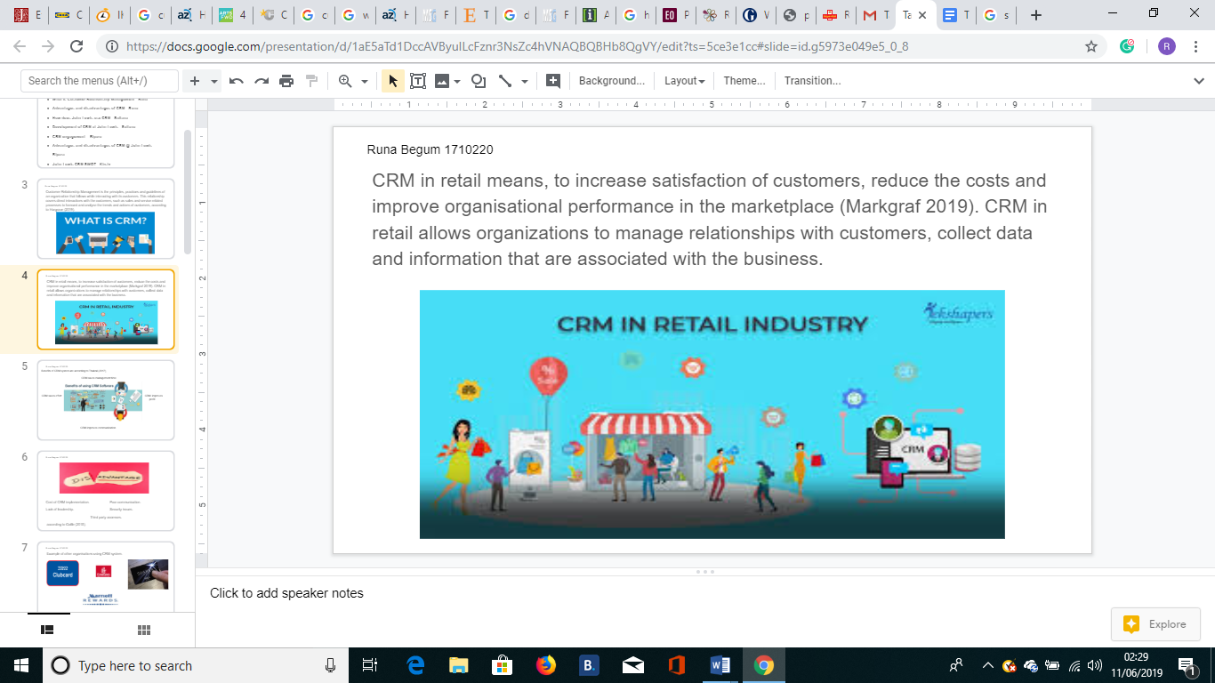

Slide3
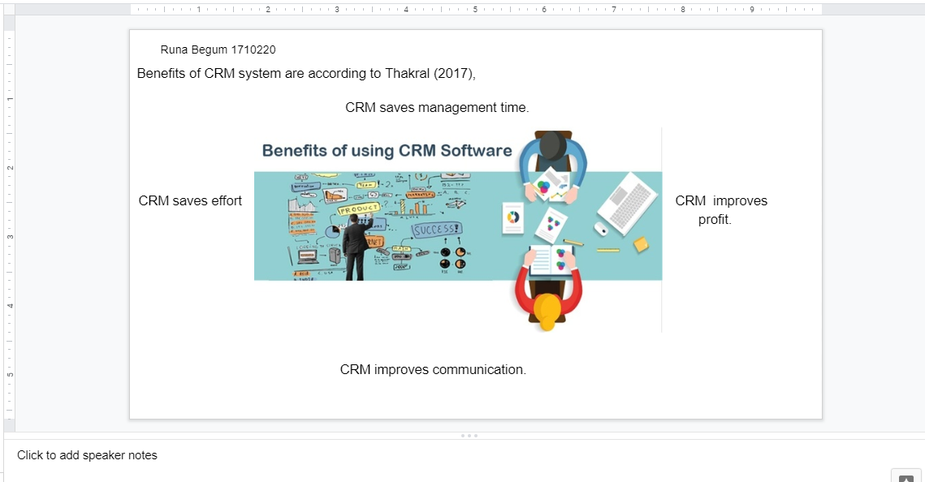

Slide 4
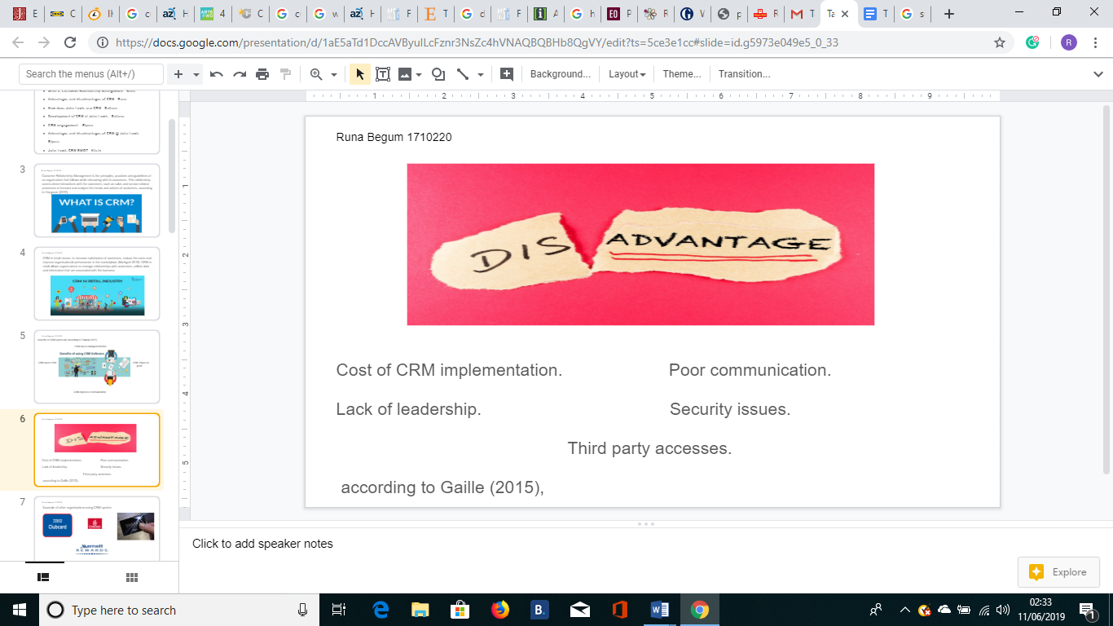

Slide 5

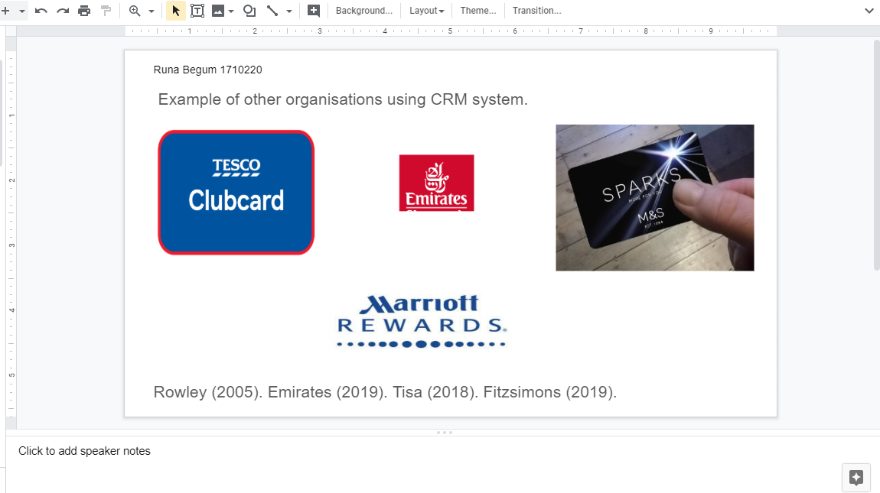
Slide 6
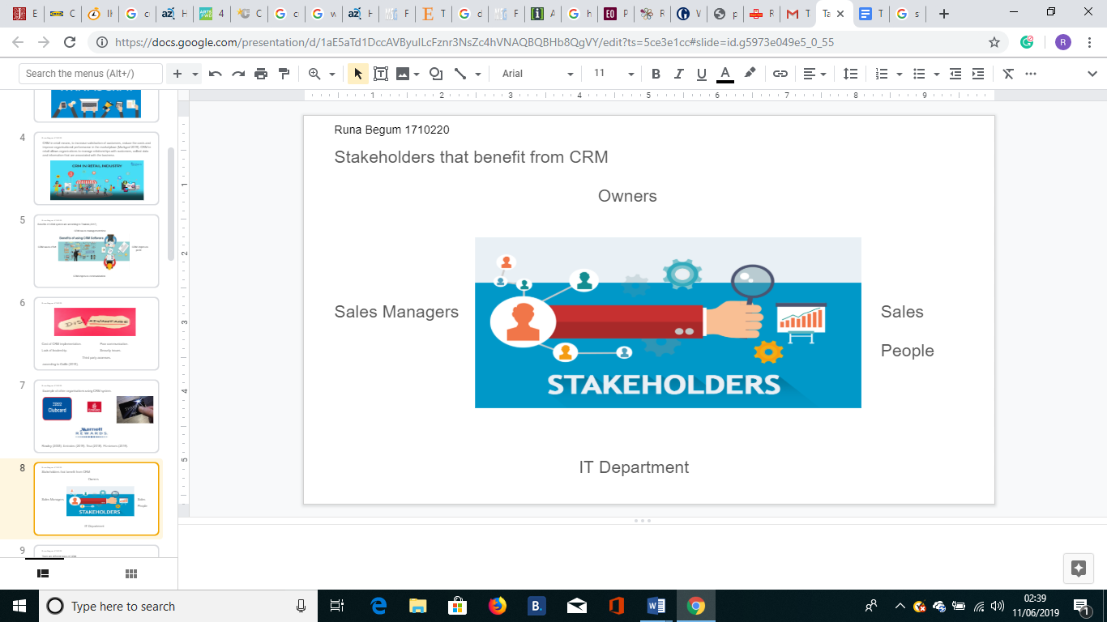
Slide 7
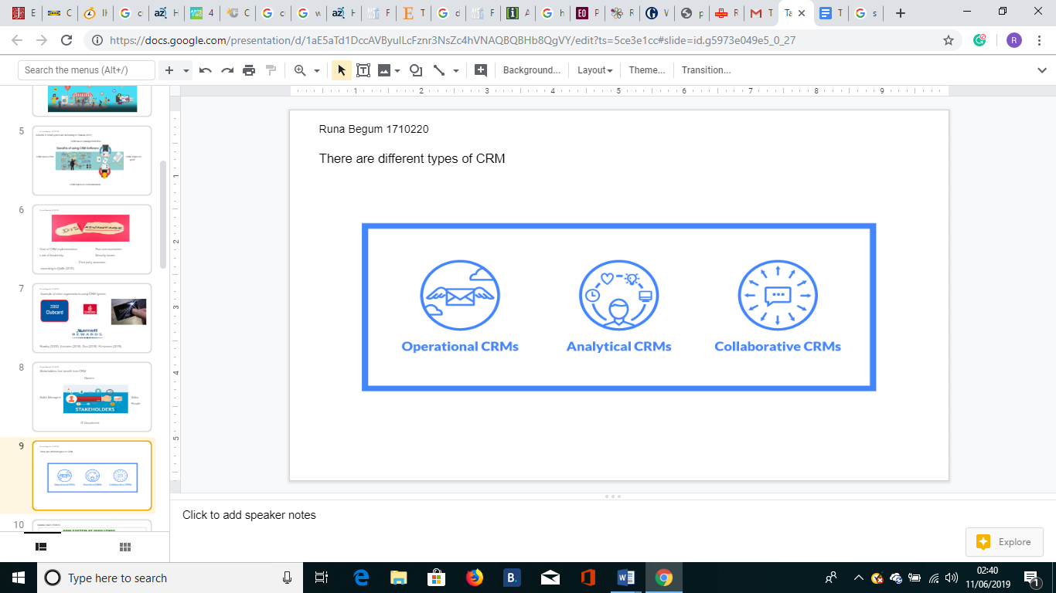

References
Rouse, M. (2019), ‘what is CRM (customer relationship management)? – Definition…,’ [Online] Available: at https://searchcrm.techtarget.com/definition/CRM, [Accessed: 25, May 2019].
Hargrave, M. (2019), ‘Customer Relationship Management – CRM Definition – Investopedia’, [Online] Available: at https://www.investopedia.com, [Accessed: 25, May 2019].
Markgraf, B. (2019), ‘The Effects of CRM in Retail Markets | Chron.com’, [Online] Available: at https://smallbusiness.chorn.com/effects-crm-retail-markets-70890.html, [Accessed: 25, May 2019].
MSG (2019), ‘Importance of Customer Relationship Management (CRM)’, [Online] Available: at https://www.managementstudyguide.com/importance-of-crm.html, [Accessed: 25, May 2019].
Thakral, R. (2017), ‘Advantages and disadvantages of CRM – Target Integration’, [Online] Available: at https://www.targetintegration.com/advantages-and-disadvantages-of-crm/, [Accessed: 25 may 2019].
Gallie, B. (2015), ’12 Pros and Cons of Customer Relationship Management…’, [Online] Available: at https://brandongaille.com>prosandcons, [Accessed: 25, May 2019].
Rowley, J. (2005),’Building Brand web Customer relationship management through the Clubcard loyalty scheme’, International Journal of Retail & Distribution Management, Vol.33, Issue: 3, pp.194-206.
Emirates (2019), ‘Emirates Skywards, Emirates.com’, [Online] Available: at https://www.emirates.com, [Accessed: 25, May 2019].
Success (2019), ‘Stakeholder Value Returned from the Benefits of CRM – Success with…’, [Online] Available: at https://www.sucesswithcrm.com/...stakeholder_value_returned_from_the_the_benefits_o..., [Accessed: 26, May 2019].
Rasheed, N. (2019), ‘Different kinds of CRM System & Software Solutions’, [Online] Available: at https://project-management.com/different-kinds-of-crm-system-software-solutions/, [Accessed: 26, May 2019].
Ipsos (2017), ‘Importance of Customer Relationship Management in Retail…’, [online] Available: at https://www.ipsos-retailperformance.com/.../importance-customer-relationship-manag..., [Accessed: 25, May 2019].
Fitzsimons, J. (2019), ‘Marks & Spencer’s SPARKS Loyalty scheme: how it works, how to…, [Online] Available: at https://www.lovemoney.com/.../sparks-marks-and-spencer-loyalty-scheme-members-clu.., [Accessed: 26, May 2019].
Tisa, C. (2018), ‘How loyalty Programs Benefit Hotels | Internet Marking Inc’, [Online] Available: at https://www.internetmarketinginc.com/blog/loyalty-programs-benefit-hotels, [Accessed: 26, May 2019].

