Name: Shaukat Ali
Lecturer: Walter-Rodney Nagumo
Student number: 2511229

Module code: LCHS4009
Module title: Professional Development within Health and Social Care
Assignment title: Professional Development Portfolio

Professional Development Portfolio

Introduction
Professional development is fundamental to working in health and social care. It involves continuously improving knowledge, skills, values and behaviours to ensure people receive safe, effective, person-centred care. Practitioners work with individuals from diverse backgrounds and must remain adaptable, compassionate and committed to lifelong learning, keeping up to date with legislation, best practice and technological change (Skills for Care, 2023).
The sector is constantly evolving because of changes in legislation, rising public expectations and increasingly complex care needs. Professionals must regularly reflect on their practice, identify areas for improvement and undertake training. Continuous Professional Development (CPD) enhances individual competence and improves outcomes for service users, while employers expect staff to demonstrate professionalism and accountability in line with relevant codes of conduct (Department of Health and Social Care, 2023).
This portfolio evaluates my current knowledge, skills and personal qualities, and identifies areas for further development. It demonstrates my readiness to begin a career as a Support Worker through a professional CV, a personal statement, a SWOT analysis, a personal development plan and a reflective account of my presentation on Communication Skills in Health and Social Care.
My career goal is to become a Support Worker because I enjoy helping others and making a positive difference to their lives. Through my studies I have developed my understanding of communication, safeguarding, confidentiality, equality, diversity and person-centred care, and I am committed to continually developing these skills through education, training, reflection and workplace experience.

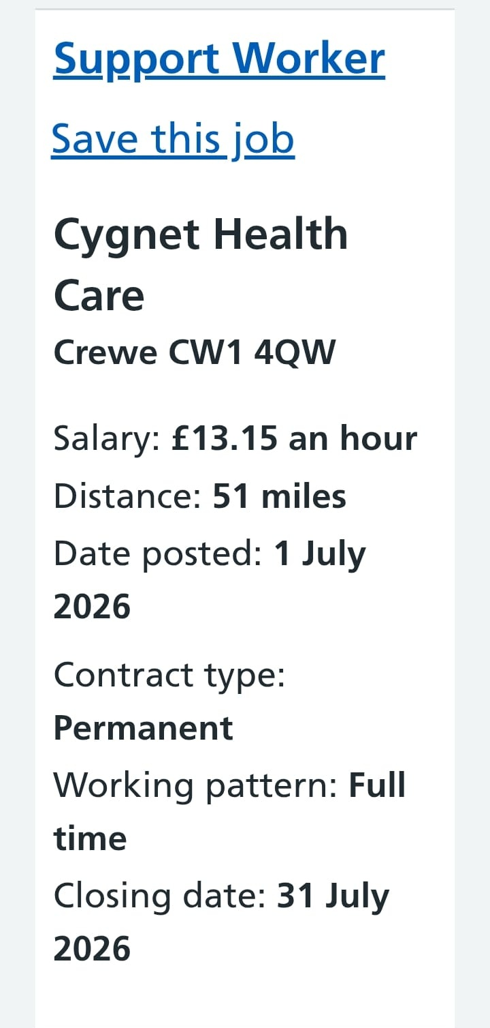

Task 1.1 – Professional Curriculum Vitae

Personal Details
Name: Christine Blakeney
Address: Potters House, Potters Lane, Birmingham, B1 2DY
Email: ChristineB@hotmail.co.uk

Personal Profile
A caring, compassionate and motivated Health and Social Care student committed to a career as a Support Worker, with a solid understanding of person-centred care, communication, safeguarding, equality and diversity, confidentiality, and professional values. Reliable, organised and approachable, with strong listening skills and a genuine desire to improve service users' quality of life while promoting independence, choice and inclusion.

Career Objective
To obtain a Support Worker role applying the knowledge and skills gained through study, providing high-quality, person-centred care, and progressing into more senior roles through further qualifications and experience.

Education
Level 3 Health and Social Care (currently studying), covering communication, safeguarding, equality and diversity, person-centred care, health and safety, confidentiality, professional values, reflective practice and team working. Functional Skills English and Mathematics, Level 2, developing written/verbal communication, report writing, numeracy and problem-solving.

Relevant Experience and Skills
- Effective verbal and written communication; active listening and interpersonal skills
- Understanding of safeguarding responsibilities and person-centred approaches
- Team-working, time management and problem-solving skills
- Confidence delivering presentations and communicating information
- IT skills: Microsoft Word, Excel, PowerPoint, Outlook

Voluntary Experience
Explored the role of a Community Support Volunteer as part of my studies, promoting dignity, independence and wellbeing, and developing an understanding of collaborative working to achieve positive outcomes for service users.

Personal Qualities
Caring, compassionate, honest, reliable, punctual, patient, adaptable, respectful of diversity, professional, and committed to high standards of care.
References available upon request.

Task 1.2 – Personal Statement
I am pursuing a career as a Support Worker because I am passionate about helping people live fulfilling, independent lives. I believe everyone deserves dignity, compassion and respect regardless of age, disability, culture or circumstance, and that health and social care work offers a genuine opportunity to improve wellbeing through practical support and encouragement.
My studies have given me a strong understanding of the principles underpinning practice: person-centred care, safeguarding, equality and diversity, communication, confidentiality and reflective practice. The Care Act 2014 emphasises promoting wellbeing and independence, and I aim to reflect this in everyday practice (Department of Health and Social Care, 2023).
Effective communication is one of my key strengths. Delivering a presentation on Communication Skills in Health and Social Care increased my confidence and taught me the importance of active listening, appropriate body language and adapting communication to individual needs, all of which reduce misunderstandings and improve outcomes (NHS England, 2023).
I understand my responsibility to safeguard children and vulnerable adults from abuse or neglect, remaining alert to concerns, reporting them promptly and following organisational procedures (Care Quality Commission, 2023). I also value equality, diversity and inclusion, recognising that discrimination can harm wellbeing and that I must challenge it while respecting individual beliefs and choices, in line with the Equality Act 2010 (Equality and Human Rights Commission, 2023). Maintaining confidentiality and complying with data protection legislation is equally important for building trust (Information Commissioner's Office, 2023).
While I have a strong theoretical foundation, I recognise I need more practical experience, which I see as an opportunity to learn from experienced professionals and improve through feedback and reflection, since professional development is a lifelong process (Skills for Care, 2023). My personal qualities — caring, patient, reliable, organised and approachable — alongside my ability to work independently and within a team, will support me in delivering trustworthy, person-centred care.
My long-term ambition is to gain practical experience, complete further training, and progress into more senior roles, while maintaining high professional standards and providing compassionate, safe and effective care.

Task 1.3(a) – SWOT Analysis
A SWOT analysis helps evaluate Strengths, Weaknesses, Opportunities and Threats, supporting reflective practice and continuous improvement (Skills for Care, 2023).

Strengths
A caring and compassionate nature, strong communication and interpersonal skills, reliability and organisation, and the ability to work well within a team — all essential for building trust and delivering safe, high-quality care (NHS England, 2023).

Weaknesses
Limited practical experience within a professional care setting, occasional lack of confidence in unfamiliar situations, and leadership skills that are still developing. These will improve through placements, training and reflective practice.

Opportunities
Gaining practical experience through placements, volunteering or employment; undertaking CPD such as safeguarding, first aid, dementia awareness and mental health training; and progressing into roles such as Senior Support Worker, Team Leader, or further study in nursing, social work or occupational therapy, supported by a culture of lifelong learning (Department of Health and Social Care, 2023).

Threats
The emotional demands of supporting individuals through illness, disability or bereavement; competition for roles from candidates with more qualifications and experience; and the need to keep pace with changing legislation and professional standards.

Conclusion
This analysis highlights a strong foundation of caring attitude, communication skills and reliability, alongside clear priorities — gaining experience, developing leadership and continuing CPD — to progress towards becoming an effective, person-centred Support Worker.

Task 1.3(b) – Personal Development Plan
A Personal Development Plan (PDP) helps identify learning needs, set realistic goals and monitor progress, supporting practitioners to maintain high standards and adapt to change (Skills for Care, 2023). My key goals are set out below.
Development Goal | Actions | Timescale | Resources | Success Criteria
Improve communication skills | Practise verbal/non-verbal communication in college activities and presentations; seek tutor/peer feedback. | 6 months | Tutor feedback, workshops | Increased confidence; positive feedback
Gain practical experience | Apply for placements, volunteering or entry-level roles; observe experienced staff. | 12 months | Placement providers, local care organisations | Experience gained; positive supervisor feedback
Develop safeguarding knowledge | Complete safeguarding training; review legislation and procedures. | 6 months | Online courses, employer training | Improved ability to recognise and report concerns
Improve leadership and teamwork | Take an active role in group work; observe leadership styles on placement. | 12 months | Team projects, mentoring | Increased confidence supporting colleagues
Continue professional development | Attend CPD courses; reflect using Gibbs' Reflective Cycle. | Ongoing | CPD courses, online learning | Evidence of continuous reflective practice

Improving communication is a priority because it underpins every aspect of practice; active listening, adapting to individual needs and seeking feedback will build trust and improve care quality (NHS England, 2023). Gaining practical experience will let me apply theoretical knowledge, build confidence and strengthen employability.
Developing safeguarding knowledge will improve my ability to recognise and respond to abuse or neglect in line with policy and legal duties (Care Quality Commission, 2023), while developing leadership skills will prepare me for future senior or supervisory roles. Finally, I am committed to lifelong learning through CPD — training, professional guidance and regular reflection, including Gibbs' Reflective Cycle — to keep my knowledge current and continuously improve the care I provide.

Task 1.4 – Reflection Using Gibbs' Reflective Cycle
Reflective practice enables practitioners to evaluate experience, recognise strengths, identify areas for improvement and apply learning to future practice, supporting CPD and person-centred care (Skills for Care, 2023). This reflection uses Gibbs' Reflective Cycle (1988): Description, Feelings, Evaluation, Analysis, Conclusion and Action Plan.

Description
As part of my course, I delivered an individual presentation on Communication Skills in Health and Social Care, covering verbal, non-verbal and written communication, active listening, empathy, confidentiality and adapting communication to individual needs, plus barriers such as language differences, hearing impairment and cognitive difficulties. I researched the topic, structured my slides and practised my delivery before presenting to my lecturer and classmates.

Feelings
I felt nervous beforehand, worried about forgetting information or becoming anxious. As the presentation progressed I grew more relaxed and confident, helped by my preparation and positive audience reactions. Afterwards I felt proud, and the positive feedback I received reassured me that my preparation had been worthwhile.

Evaluation
The presentation was successful overall. Thorough preparation and research helped me organise ideas logically, and clear language, eye contact and pacing kept the audience engaged. However, I spoke quickly at the start due to nerves and relied on notes more than I would have liked. Feedback was encouraging, noting good subject knowledge, while suggesting I continue building confidence speaking to larger groups.

Analysis
This experience reinforced that communication is central to health and social care — listening, understanding individual needs and building trust — and that poor communication can risk safety while effective communication promotes person-centred care and better outcomes (NHS England, 2023). It also demonstrated the value of reflective practice in identifying strengths and areas for improvement (Health and Care Professions Council, 2024), and showed that confidence develops through preparation and experience. I also recognised the importance of adapting communication to individual differences such as disability, culture and language, in line with the Equality Act 2010 (Equality and Human Rights Commission, 2023).

Conclusion
This experience increased my confidence, strengthened my communication skills and reinforced my understanding of professional responsibilities. While pleased with my preparation and subject knowledge, I recognise that public-speaking confidence can still improve with practice. This confirmed that learning is ongoing and that every experience is an opportunity to develop personally and professionally, increasing my confidence in pursuing a career as a Support Worker.

Action Plan
I will continue practising communication skills through classroom discussion and group activities, actively seek feedback from tutors, supervisors and colleagues, and continue CPD through training courses, professional guidance and up-to-date knowledge of legislation. I will also continue using reflective models, including Gibbs' Reflective Cycle, to evaluate future experiences — supporting my development into a confident, knowledgeable and effective Support Worker.

Appendix A – Example Job Vacancy
As part of researching realistic next steps towards my career goal, I identified the following current Support Worker vacancy, which illustrates the type of role, salary and working pattern I am aiming for.

Source: Support Worker, Cygnet Health Care, Crewe (job advert accessed July 2026).

References (Harvard Style)
Care Quality Commission (2023) Safeguarding people. Available at: https://www.cqc.org.uk (Accessed: 9 July 2026).
Department of Health and Social Care (2023) Care and support statutory guidance: Issued under the Care Act 2014. Available at: https://www.gov.uk/government/publications/care-act-statutory-guidance (Accessed: 9 July 2026).
Department of Health and Social Care (2023) Health and social care workforce: professional development and learning. Available at: https://www.gov.uk/government/organisations/department-of-health-and-social-care (Accessed: 9 July 2026).
Equality and Human Rights Commission (2023) Equality Act 2010: guidance. Available at: https://www.equalityhumanrights.com (Accessed: 9 July 2026).
Gibbs, G. (1988) Learning by Doing: A Guide to Teaching and Learning Methods. Oxford: Oxford Polytechnic.
Health and Care Professions Council (2024) Standards of conduct, performance and ethics. Available at: https://www.hcpc-uk.org (Accessed: 9 July 2026).
Information Commissioner's Office (2023) Guide to the UK General Data Protection Regulation (UK GDPR). Available at: https://ico.org.uk (Accessed: 9 July 2026).
NHS England (2023) Person-centred care and communication. Available at: https://www.england.nhs.uk (Accessed: 9 July 2026).
Skills for Care (2023) The Care Workforce Pathway: supporting career development in adult social care. Available at: https://www.skillsforcare.org.uk (Accessed: 9 July 2026).
The Care Act 2014 (c.23). London: The Stationery Office. Available at: https://www.legislation.gov.uk/ukpga/2014/23/contents (Accessed: 9 July 2026).
The Equality Act 2010 (c.15). London: The Stationery Office. Available at: https://www.legislation.gov.uk/ukpga/2010/15/contents (Accessed: 9 July 2026).
The Health and Social Care Act 2008 (Regulated Activities) Regulations 2014. London: The Stationery Office. Available at: https://www.legislation.gov.uk/uksi/2014/2936/contents (Accessed: 9 July 2026).

