Portfolio

Module: The Professional Practitioner (ECEY4014/C)
Student: Elena-Diana Pintilie (2509353)
Lecturer: Paul Darby

Contents

Part 1. Personal Development Plan 3
Part 2. Importance of Reflective Practice-Poster 6
Part 3. Understanding Professional Practice in Early Years Education 8

Part 1. Personal Development Plan
No | Improvement and Development Goals | Success Criteria  (How I will know when I have made this change) | The actions I will take to achieve the goal | Timelines | What will this help me to achieve? | Achievements  (3 monthly review)
1 | Improve my English communication skills and confidence in a school environment. English is my second language, and I would like to feel more confident when speaking with children and staff in a school environment. I also want to improve my understanding of professional and educational vocabulary. | I will be able to communicate more confidently with colleagues, understand classroom instructions more easily and use appropriate vocabulary when supporting children. I will also feel more comfortable asking questions when I need clarification. | I will continue attending ESOL Level 1 classes, practise speaking English regularly and learn new school-related word or phrases each week, I will also listen carefully to how experienced staff communicate and ask for feedback when appropriate. | 3-6months. | My ESOL tutor, university studies, supportive staff and daily practice in a school environment. | I have already enrolled in ESOL Level 1 and have started attending classes. I have also started gaining practical experience in a primary school through an agency. I will review improvements in my confidence after three months.
2 | Develop my professional knowledge and practical skills needed to become a Teaching Assistant. As I have only recently started working in a primary school, I want to understand classroom routines, safeguarding responsibilities and ways to support children with different learning needs. | I will become more confident classroom routines understanding my responsibilities and supporting children during learning activities. I will also know when to ask for guidance and how to follow the school’s safeguarding procedures. | I will observe experienced teachers and teaching assistants, ask questions, familiarise myself with relevant school policies and attend training when available. After working in school, I will reflect on what I have learnt and identify areas where I need more practice. | 6–12 months. | Class teacher, experienced Teaching Assistants, university learning, school policies and professional feedback. | I have recently started working in Reception, which is helping me understand everyday school routines. As my work through the agency may involve different classes, I will record my experiences and review my progress every three months.
3 | Complete my Early Years Education and Care degree and work towards gaining Qualified Teacher Status (QTS) to become a Primary School Teacher. Before becoming a teacher, I would like to gain experience as a Teaching Assistant and continue developing my English and professional confidence. | I will make progress towards complete my degree, improve my academic English, gain broader classroom experience and identify a suitable teacher course that leads to QTS. | I will continue my university studies, work toward becoming a Teaching Assistant and research the qualifications and entry requirements for teacher training. | 1–3 years. | My university studies, ESOL classes, practical school experience, university careers guidance and support from qualified teachers. | I am currently studying Early Years Education and Care and have started building practical experience in school. I will review my academic and professional progress regularly and adjust my goals as I gain more experience.

Part 2. Importance of Reflective Practice-Poster
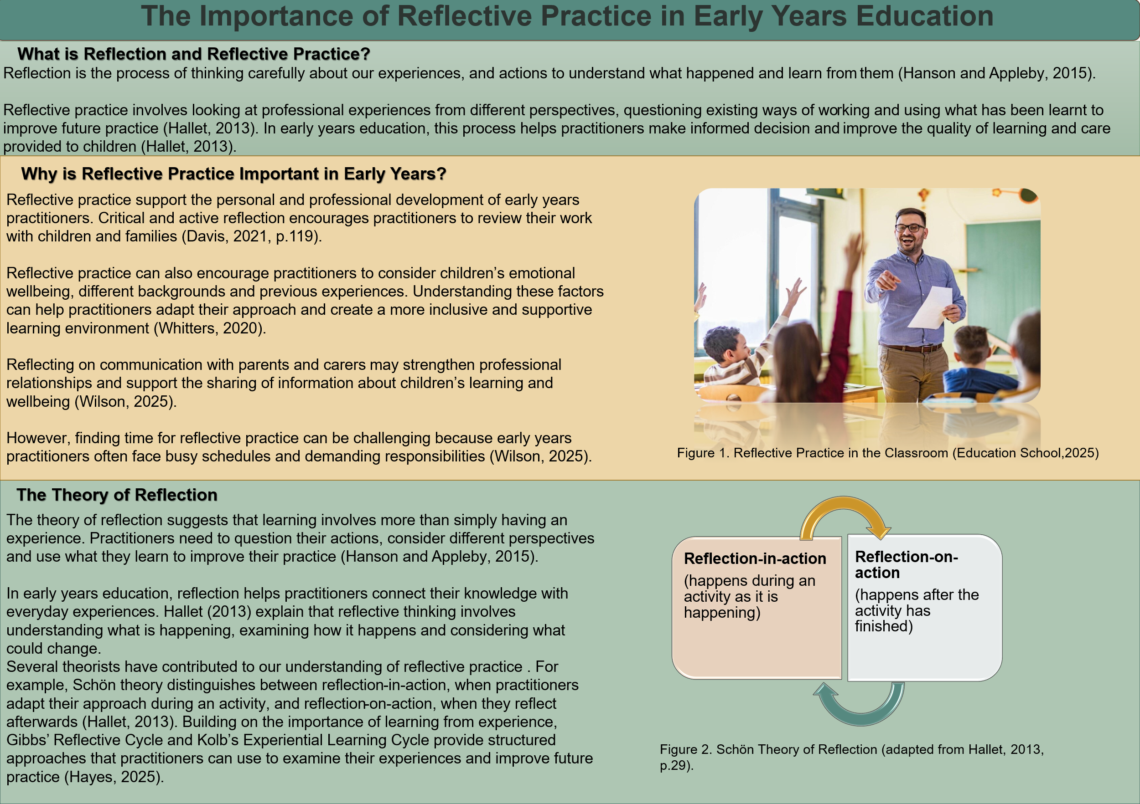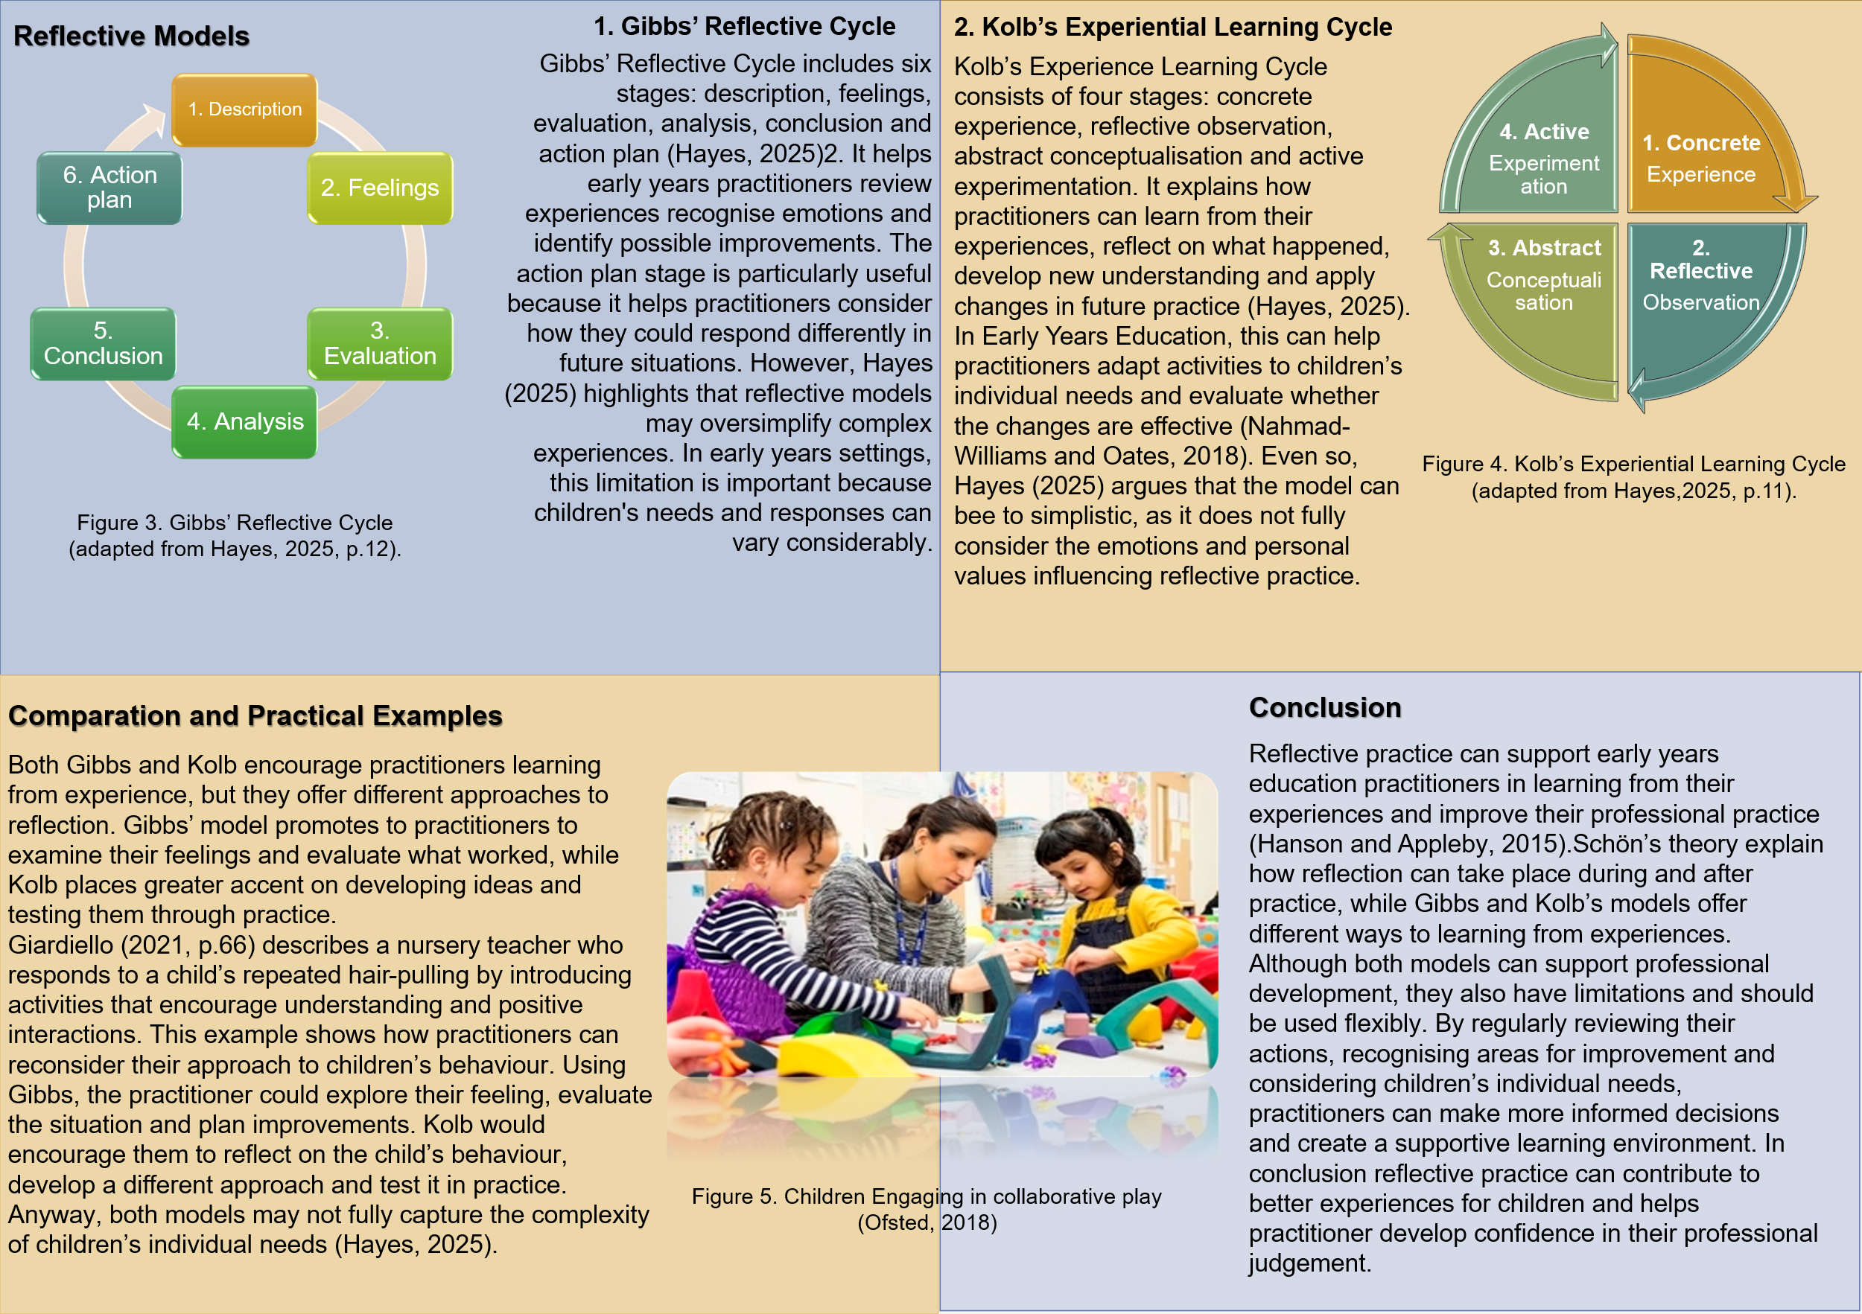

References
Davis, A. (2021) ‘Reflecting on practice’, in Dobson, J. and Melrose, A. (eds.) Working with children, families and young people: Professional dilemmas, perspectives and solutions. Routledge, pp. 119–134.
Education School (n.d.) Importance of reflective practice for teachers [Online image]. Available at: https://educationschool.co.uk/importance-of-reflective-practice-for-teachers/ .
Giardiello, P. (2021) ‘Cultivating a critical understanding of child development’, in Dobson, J. and Melrose, A. (eds.) Working with children, families and young people: Professional dilemmas, perspectives and solutions. Routledge, pp. 59–79.
Hallet, E. (2013) The reflective early years practitioner. SAGE Publications.
Hanson, K. and Appleby, K. (2015) ‘Reflective practice’, in Reed, M. and Walker, R. (eds.) A critical companion to early childhood. SAGE Publications, pp. 24–35.
Hayes, C. (2025) ‘The nature of reflective practice’, in Hayes, C., Daly, J., Duncan, M. and Hudson, R., Developing as a reflective early years professional. 3rd edn. Routledge, pp. 1–24.
Nahmad-Williams, L. and Oates, R. (2018) ‘Reflective practice’, in Johnston, J., Nahmad-Williams, L., Oates, R. and Wood, V., Early childhood studies: Principles and practice. 2nd edn. Routledge, pp. 467–500.
Ofsted (2018) Children engaging in collaborative play [Online image]. Available at: https://www.gov.uk/government/news/ofsted-early-years-pedagogy-and-practice-forum-members-announced.
Whitters, H.G. (2020) Adverse childhood experiences, attachment, and the early years learning environment: Research and inclusive practice. Routledge.
Wilson, T. (2025) Working with parents, carers and families in the early years: The essential guide. 2nd edn. Routledge.

Part 3. Understanding Professional Practice in Early Years Education
Introduction
Professional practice in Early Years Education involves using knowledge, skills and professional judgement to make decisions about children’s care, learning and development. A professional is expected to understand their responsibilities, follow relevant policies and treat children and families with respect. However, following procedures alone does not always mean that children’s individual needs are being met. Dyer (2019) discusses how professional values and relationships influence the way practitioners care for children and support their learning. Gasper (2015) also considers how early years professionals respond to changing expectations and work with others to support children and families. This essay examines communication and relationships, professional knowledge, safeguarding, partnership working, observation and planning. It also considers how children’s rights influence decisions and why practitioners need to recognise differences between children rather than use the same approach for everyone.
Communication and relationships
McEvoy (2019) explains that communication and language influence children’s learning and social development and emotional wellbeing. Children communicate in different ways, including through speech, gestures and movements, so practitioners need to recognise these differences when responding to individual needs. McEvoy (2019, p.110) describes the ‘Observe, Wait and Listen’ approach, which involves allowing children time to process language and respond without being rushed. This approach may be particularly useful for children who experience communication difficulties. Wilson (2025, pp. 114-115) also discusses supporting children who learn English as an additional language by valuing their home language while introducing new vocabulary. These examples show how practitioners can adjust their communication rather than expect all children to respond in the same way.
Bailey, Hunter and Marsden (2019, pp. 47-48) discuss how practitioners develop trusting relationships by listening to children’s verbal and non-verbal communication. This allows them to consider children’s preferences when responding to their needs. Relationships with parents and carers also contribute to professional practice. Wilson (2025, pp. 11-13) explains that working positively with families supports children’s learning and development. However, she also highlights the need to recognise differences between families rather than make assumptions about their circumstances. This suggests that listening to both children and parents may give practitioners a better understanding of individual needs and support more inclusive decisions.
Professional Knowledge and Safeguarding
Understanding children’s development informs professional decisions about learning, behaviour and inclusion. Dalton (2019) explains how practitioners can adapt activities and the learning environment for children with additional needs or disabilities. Knowledge of these differences allows staff to identify possible barriers to participation and consider appropriate adjustments. However, focusing only on developmental expectations may overlook personal circumstances and lead to inappropriate judgments.
Professional understanding also influences how safeguarding concerns are recognised and addressed. Crow and Watson (2019) discuss practitioners’ responsibilities for protecting children from harm and promoting their welfare. Safeguarding involves preventive measures, while child protection focuses on children who suffering, or are at risk of, significant harm (NSPCC, n.d.). Knowing this distinction allows staff to understand both their everyday protective responsibilities and the need to respond appropriately when concerns arise. Twigg (2018) explains that recognising neglect requires professional judgement, as signs of concern are not always direct to interpret. Changes in a child’s behaviour or development may raise concerns, but practitioners need to consider the wider circumstances rather than draw conclusions from a single sign.
In Wales, the Wales Safeguarding Procedures provide guidance on recognising and reporting concerns about children’s safety (Wales Safeguarding Procedures, 2019). The procedures explain that practitioners should record and report concerns, while social services and the police are responsible for investigating suspected abuse or neglect (Wales Safeguarding Procedures, 2019). Section 130 of the Social Services and Well-being (Wales) Act 2014 also requires specified organisations to report children at risk to the local authority. This knowledge supports appropriate professional decisions and reduces the risk of safeguarding concerns being overlooked or handled incorrectly.
Partnership and Multi-agency Working
Partnership working in early years education involves cooperation between practitioners with families, colleagues and other organisations to support children’s learning and development (Johnston and Szenasi, 2018). Welsh Government (2026) explains that Flying Start settings should involve parents in discussions about their children, maintain links with other agencies and share relevant information when support is needed. The guidance also encourages cooperation between childcare settings and education providers to support transitions. Johnston and Szenasi (2018) describe how some nurseries invite parents to spend time with their children in the early years setting. This approach may help children adjust to the new environment and make the transition from home to nursery easier.
Multi-agency working involves cooperation between professionals from education, health and social care to support children and families (Gasper, 2015). Hayes and Duncan (2025, pp. 228-230) explain that individual professionals may have different perspectives of a child’s situation, particularly when information is not shared effectively. They also discuss difficulties arising from differences in professional roles and the need to involve parents in multi-professional teams. Hayes and Duncan (2025, p. 230) report that some parents involved in multi-agency teams felt listened to but had limited influence over decisions. Their involvement therefore needs to be meaningful rather than simply a formal part of the process.

Observation and Planning
Observation, assessment and planning are connected processes that inform professional decisions based on what children demonstrate through their play, behaviour and interactions (Ryan, 2019). Observation involves gathering information about children’s abilities, interests and progress, which practitioners can use to assess their learning (Ryan, 2019, p. 96). In Wales, the Assessment arrangements for funded non-maintained nursery settings describes a cycle of noticing, analysing and responding to children’s development (Welsh Government, 2023). By examining what they have seen and heard, practitioners can identify achievements, recognise possible difficulties and consider appropriate next steps (Welsh Government, 2023).
Planning involves organising learning experiences that build on children’s previous achievements while allowing flexibility for their interests (Nahmad-Williams and Simmons, 2018). The authors explain that practitioners need to balance adult-led activities with opportunities for child-initiated play. Ryan (2019, p. 98) provides an example of how a child’s question about age could lead to planned activities involving measuring height, comparing photographs and recording results. This illustrates how children’s curiosity can influence the choice of activities.
Regularly reviewing observations and using them to inform future planning allows practitioners to adapt learning experiences according to children’s progress and individual needs (Welsh Government, 2023).
UNCRC and Professional Practice
The United Nations Convention on the Rights of the Child (UNCRC) provides principles that guide professional practice by recognising children’s rights and promoting their wellbeing. Article 2 establishes the principle of non-discrimination, while Article 3 requires children’s best interests to be a primary consideration in decisions affecting them (United Nations, 1989). Smith, Reid and Robinson (2018) explain that Article 12 recognises children’s right to express their views, although balancing their wishes with decisions about their welfare can be challenging. In Wales, the Welsh Government (2025) emphasises the need for adults to understand children’s rights so they can support children in exercising them. This approach encourages practitioners to consider children’s perspectives and provide opportunities for their participation.
Article 31 of the UNCRC recognises children’s right to play, making opportunities for play an important part of professional practice (United Nations, 1989). Yates (2018) explains that inclusive play environments should allow children to make choices and access suitable resources. The author describes a research project involving the development of two parks in Nottinghamshire, where children expressed a preference for play spaces shared with siblings of different ages (Yates, 2018). Yates (2018) also notes that this preference differed from the age-based organisation commonly used in public play areas. These findings highlight the value of considering children’s experiences when creating play provision, rather than relying only in adults’ ideas about what is appropriate for them.

Conclusion
Professional practice in early years education involves more than providing care and learning activities. Effective communication and positive relationships enable practitioners to work closely with children and families, while knowledge of child development and safeguarding supports informed and responsible decisions. Partnerships with other professionals can provide additional support when required. Observation and planning also allow practitioners to recognise children’s progress and adapt learning experiences accordingly. Furthermore, the principles of UNCRC encourage respect for children’s rights, views and opportunities to participate. Together, these aspects contribute to a safe, inclusive and supportive environment where each child’s development and wellbeing are considered.
References
Bailey, W., Hunter, J. and Marsden, F. (2019) ‘Listening and responding to children’s voice’, in McMahon, S. and Dyer, M. (eds.) Advanced Work-based Practice in the Early Years: A Guide for Students. Routledge, pp. 43–56.
Crow, A. and Watson, L. (2019) ‘Safeguarding in practice’, in McMahon, S. and Dyer, M. (eds.) Advanced Work-based Practice in the Early Years: A Guide for Students. Routledge, pp. 72–87.
Dalton, J. (2019) ‘The unique child’, in McMahon, S. and Dyer, M. (eds.) Advanced Work-based Practice in the Early Years: A Guide for Students. Routledge, pp. 29–42.
Dyer, M.A. (2019) ‘Ethical practice in the early years’, in McMahon, S. and Dyer, M. (eds.) Advanced Work-based Practice in the Early Years: A Guide for Students. Routledge, pp. 1–14.
Gasper, M. (2015) ‘Professional practice and early childhood today’, in Reed, M. and Walker, R. (eds.) A Critical Companion to Early Childhood. SAGE.
Hayes, C. and Duncan, M. (2025) ‘Reflecting on the multi-professional team’, in Hayes, C., Daly, J., Duncan, M. and Hudson, R. Developing as a Reflective Early Years Professional. 3rd edn. Routledge, pp. 224–245.
Johnston, J. and Szenasi, J. (2018) ‘Working together’, in Johnston, J., Nahmad-Williams, L., Oates, R. and Wood, V. Early Childhood Studies: Principles and Practice. 2nd edn. Routledge, pp. 501–532.
McEvoy, J. (2019) ‘Communication and language’, in McMahon, S. and Dyer, M. (eds.) Advanced Work-based Practice in the Early Years: A Guide for Students. Routledge, pp. 101–115.
Nahmad-Williams, L. and Simmons, H. (2018) ‘Early education’, in Johnston, J., Nahmad-Williams, L., Oates, R. and Wood, V. Early Childhood Studies: Principles and Practice. 2nd edn. Routledge, pp. 308–347.
NSPCC (n.d.) Getting started with safeguarding and child protection. Available at: https://learning.nspcc.org.uk/safeguarding-child-protection/getting-started-safeguarding-child-protection.
Ryan, A. (2019) ‘A creative curriculum’, in McMahon, S. and Dyer, M. (eds.) Advanced Work-based Practice in the Early Years: A Guide for Students. Routledge, pp. 88–100.
Smith, C., Reid, J. and Robinson, D. (2018) ‘Special educational needs and inclusion: policy and practice’, in Johnston, J., Nahmad-Williams, L., Oates, R. and Wood, V. Early Childhood Studies: Principles and Practice. 2nd edn. Routledge, pp. 370–404.
Social Services and Well-being (Wales) Act 2014, anaw 4. Available at: https://www.legislation.gov.uk/anaw/2014/4/section/130.
Twigg, E. (2018) ‘Safeguarding children’, in Johnston, J., Nahmad-Williams, L., Oates, R. and Wood, V. Early Childhood Studies: Principles and Practice. 2nd edn. Routledge, pp. 405–430.
United Nations (1989) Convention on the Rights of the Child. Available at: https://www.ohchr.org/en/instruments-mechanisms/instruments/convention-rights-child.
Wales Safeguarding Procedures (2019) Wales Safeguarding Procedures. Available at: https://www.safeguarding.wales/en/.
Welsh Government (2023) Assessment arrangements for funded non-maintained nursery settings. Available at: https://hwb.gov.wales/curriculum-for-wales/curriculum-and-assessment-arrangements-for-funded-non-maintained-nursery-settings/assessment-arrangements-for-funded-non-maintained-nursery-settings/.
Welsh Government (2025) Written Statement: Raising Awareness of Children’s Rights. Available at: https://www.gov.wales/written-statement-raising-awareness-childrens-rights.
Welsh Government (2026) Flying Start childcare: guidance. Available at: https://www.gov.wales/flying-start-childcare-guidance-html.
Wilson, T. (2025) Working with Parents, Carers and Families in the Early Years. 2nd edn. Routledge.
Yates, E. (2018) ‘Play’, in Johnston, J., Nahmad-Williams, L., Oates, R. and Wood, V. Early Childhood Studies: Principles and Practice. 2nd edn. Routledge, pp. 348–369.

