
University of Wales Trinity Saint David
School of Engineering

ACMA6011
Design & Analysis of Extended Surfaces

Steffan Rhys Lloyd
2220589
20/04/2026

Table of Contents
Table of Contents 2
1. Introduction 3
2. Task A - Investigation of Extended Surfaces in 4
2.1Historical Development of Fins in Automotive Design 4
2.2 Application of Extended Surfaces in Microprocessor Cooling 5
2.3 Recent Advances in Extended Surface Design and Their Advantages 6
3. Task B - Fin Performance Analysis 7
3.1 Theoretical Background 7
3.2 Methodology 7
3.3 Results and Analysis 8
3.4 Design Implications 9
4. Task C - Fin Analysis of Saucepan Handle 10
4.1 Theoretical Background 10
4.2 Material and Geometry Analysis 10
4.3 Temperature at the Free End 11
4.4 Temperature Distribution Along the Handle 12
4.5 Optimum Length and Comparison 13
5. Conclusion 15
6. References 16

Introduction
In thermal engineering, extended surfaces also referred to as fins are often used to improve heat transmission by increasing the surface area available for convection. Geometry, material traits, and configuration are some of the aspects that affect their efficacy. Increasing its surface area is one of the most reasonable and effective way to improve heat dissipation in many engineering applications, especially when convection to air is involved.
The use of fins to improve heat transfer efficiency will be assessed in the research. Historical summary of their purpose in automotive design. Comparing this to more modern designs will be looked at as well as how extended surfaces are used in microprocessor cooling systems.
The report will also focus on analytical and computational components, detailed numerical study of heat transfer and temperature distribution in finned systems utilising various materials and the use of Microsoft Excel to measure performance and characteristics. Additionally, the influence of different material behaviours on thermal performance will be compared to gain a better understanding of how fin design can be improved for engineering applications and improved efficiency.

2. Task A - Investigation of Extended Surfaces in

2.1Historical Development of Fins in Automotive Design
Over time, the use of fins in car design has changed significantly, mostly due to the requirement to continue effective engine running and improve heat dissipation. Most engines in early engineering were all air cooled, specifically in the late 19th and early 20th centuries. These designs largely depended on increased surfaces that surrounded engine cylinders in the form of basic cast fins. By increasing the outer surface area, the fins allow natural convection to transfer the heat during combustion to the air.
Early cars and motorcycles, for example the Volkswagen Beetle, often used air cooled engines. These designs used casting designs to create thick, widely spaced fin shapes. These systems though had drawbacks, specifically when it came to managing temperature under working loads, although they worked well when at lower power outputs. It became evident that more effective techniques were needed as engine performance increased (B Pratiksha. 2024).
A big development made in automobile thermal management was the switch to liquid cooled systems with tiny metal fins fastened to the tubes carrying the coolant, radiators emerged as a key part of the vehicles. This then allowed the surface area available for heat exchange between the coolant and the surrounding air to be increased in using these fins (B Pratiksha. 2024). In the process of improving heat transfer efficiency, radiator fins were usually manufactured from materials with high thermal conductivity, these consisted of copper and later aluminium, in contrast to early air-cooled fins.
Radiator fin design has been constantly improved through the years. Modern designs use particularly compact and complex fin arrangements, while earlier radiators used basic fin shapes. These include ribbed and louvred fins, these designs rise convective heat transfer coefficient therefore encouraging airflow turbulence. Increasing the surface area and the airflow increases heat transfer efficiency, this is consistent with typical heat sink design concepts (B Pratiksha. 2024).

2.2 Application of Extended Surfaces in Microprocessor Cooling
In the cooling of microprocessors, where efficient heat dissipation is essential to guarantee reliable operation and avoid overheating, the use of extended surfaces is equally important. The amount of heat supplied by electronic components has increased in line with computer science capability, requiring the use of more modern cooling methods.
The design and use of straightforward passive cooling techniques were acceptable for the reasonably low heat dissipation needs of early computing systems. Overheating, however, was a big problem as transistor density rose. Finned heat sinks, were then introduced as a result of this as these would boost surface area and improve convective heat transmission (B Pratiksha. 2024).
In contrast to numerous automotive applications, microprocessor cooling commonly uses forced convection, this is where fans are used to drive airflow over the fins. Superior performing systems are made possible by significant improvement to the rate of heat transfer. The growth of heat sink technology has been possible by the advancements and changes made in material selection, airflow control, and fin design to improve cooling performance (Hirasawa, T., Kawabata, K., & Oomi, M, 2005).
More advanced systems combine heat pipes and vapour chambers, this contributes in improving heat distribution across the fins. Advancement in designs of systems like this allow for more standardized cooling and reduces the risk of overheating. More modern research finds that electronic cooling now involves techniques such as microchannels and phase change systems (Zhang, Z. 2021).

2.3 Recent Advances in Extended Surface Design and Their Advantages
Extended surface design has changed considerably in recent years, with a major importance on improving thermal efficiency as well as simultaneously reducing weight both contributing to more complex and advanced designs. The effort in additive manufacturing has contributed the most in the advances in this field. Extremely precise fin structures that would not be possible to manufacture with standard manufacturing methods is now possible to be produced because to this method (Li, J., & Yang, L, 2023).
The ratio between surface area to volume is notably increased by the design of the lattice and porous structures. With both conduction and convection being improved, this then has a positive effect on heat transmission allowing it to become more efficient. In general, the focus of current heat sink design research is done on developing shape and increasing thermal performance, these are both contributing to these using advanced design techniques (Li, J., & Yang, L, 2023).
The use of microchannel heat sinks, which improve contact between the cooling fluid and the surface by using small flow vessels, is another significant innovation. Though these systems could present problems like higher pressure drop and production difficulty, they are exceptionally useful in high-performance electronics (Phillips, R. 1988).
These current surface designs provide multiple benefits like enhanced design freedom, reduced material usage, and improved heat transmission efficiency. All these advantages must be considered against negative of higher production costs and complexity, though.
Overall, extended surface technology is still developing due to the rising thermal requirements of contemporary engineering systems (Phillips, R. 1988).

3. Task B - Fin Performance Analysis

3.1 Theoretical Background
The relationship used for the plot was:

$$\frac{Q_{finite}}{Q_{infinite}}=tanh⁡(mL)$$
The normal solution for a uniform fin with an adiabatic tip boundary condition is the above equation, which shows how the finite-fin heat transfer rate approaches the infinite-fin value as mLin rises. This formula is where an infinite fin is considered the limiting situation and the normalised heat transfer rate for an adiabatic fin is expressed as tanhmL (Navalho, J. E. P. 2014).
The use of the factor mL is important in engineering analysis; this allows results to be general across various materials and fin geometries.
The equation also shows that the behaviour of heat transport is not linear in relation to fin length. It adheres to a weakening return trend, a critical design in extended surface design that is examined further by the task's outcomes (Subramanian, Dr. M. 2019).

3.2 Methodology
Using Microsoft Excel a table and graph was produced to confirm that optimum fin length is generally considered as $mL= 2.65$ for a finite length fin. The corresponding heat transfer ratios were calculated using the inflated line function, allowing for a consistent and precise dataset to be created. This can be seen in Figure 1.
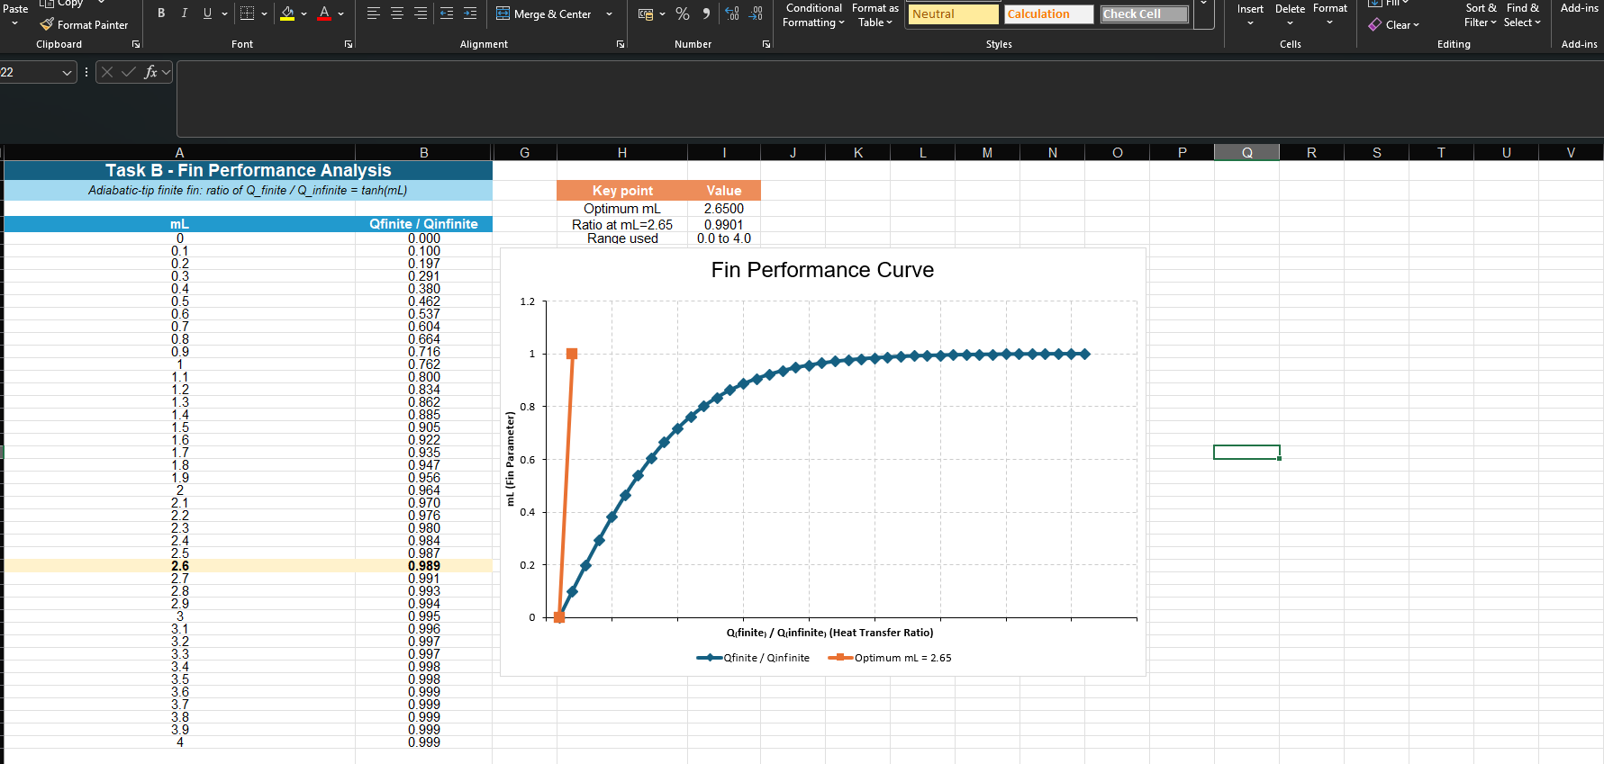

This procedure is consistent and reliable with traditional fin analysis procedures, which use graphic visual to better identify performance trends therefore being able to pinpoint crucial design elements. Additionally, using Excel permits actual calculation and visualisation, all combined to be helpful when working with several design factors (Yovanovich, M. 2011).

3.3 Results and Analysis
The non-linear relationship between mLand and the heat transfer ratio can be seen in the resultant graph. The ratio rises quickly at first, which suggests that small changes in fin length led to gains in heat transfer efficiency. This is all due to the convection to the surrounding fluid is improved by its larger surface area, this can all be seen in the Figure 1 below.

As the value of $mL$increases further, the rate of improvement begins to decrease, and the curve gradually flattens. This indicates that the additional fin length is wasting its ability to transmit heat. At approximately $mL=2.65$, the heat transfer ratio move towards unity, indicating that the performance of the finite fin is almost comparable to that of an infinitely long fin.

3.4 Design Implications
From the results you can clearly see that there is an ideal length of fin outside which further extension is not beneficial. The value of $m=2.65$ is then broadly accepted as a sensible model limit, this is due to it representing the maximum point where useful heat transfer has been achieved.
Looking from an engineering point of view, this is extremely significant due to the fact it highlights how important efficiency is in the design. Increasing the fin outside this point leads to increased material, extra weight, and greater costs, this all without giving a proportional improvement in its performance (Unknown 2014).

4. Task C - Fin Analysis of Saucepan Handle

4.1 Theoretical Background
The analysis is based on the standard fin parameter
$$m=\sqrt{\frac{hP}{kA}}$$
together with the tip temperature distribution

$$T(x)=T_{∞}+(T_{b}-T_{∞})\frac{cosh⁡[m(L-x)]}{cosh⁡(mL)}$$
and the subsequent fin heat-transfer equation

$$Q=\sqrt{hPkA}(T_{b}-T_{∞})tanh⁡(mL)$$
The equations above are used to show how heat is conducted along the fin and dissipated to the surrounding air through convection. They are in line with the adiabatic tip condition mentioned in the assignment brief and are frequently employed in heat transfer studies.
Using these equations is how both the temp distribution and total heat loss to be determined, in using these equations it becomes possible to calculate the efficacy of various materials under the same conditions (Navalho, J. E. P. 2014).

4.2 Material and Geometry Analysis
Using the handle dimensions provided, the cross-sectional area is:

Ac​ = wt = 0.03 × 0.005 = ${1.5 x 10}^{-4}m^{2}$
while the perimeter exposed to convection is:
P = 2(w+t) = 2(0.03+0.005) = 0.070m

These values are constant across all four materials, showing that any performance variations are solely attributed to variations in thermal conductivity (Knill, O. 2009).
The equation for the fin parameter is given by:
$$m=\sqrt{\frac{hP}{kAc}}$$

Since the fin parameter (m) is inversely related to the square root of thermal conductivity, materials with higher conductivity such as copper results in smaller m values, in comparison materials with lower conductivity like stainless steel led to larger m values. This deviation effects how heat applies near the fin and impacts its overall heat dissipation efficiency. (Knill, O. 2009).
This behaviour reflects the fundamental principle that fins are most effective when they are made from materials with high thermal conductivity, as this allows heat to be transferred along the entire length of the fin rather than being concentrated near the base (Unknown 2014)
Convection can remove heat from a surface faster than a low-k material can conduct heat to it. The surface cools quickly, but the inner does not supply heat fast enough, this then causes conduction to bottleneck all leading to limitations of its overall performance (Rodgers, 2013).

4.3 Temperature at the Free End

The calculated values from the equation of mLare for the original 200 mm handle length are roughly 0.603 for copper, 0.826 for aluminium, 1.189 for brass, and 3.055 for stainless steel. These workings show that although stainless steel is above the ideal value determined in Task B, copper, aluminium, and brass are all below it. The estimated end temperatures for copper, aluminium, brass, and stainless steel are 87.7°C, 79.3°C, 65.5°C, and 29.3°C, respectively.

Material | m (1/m) | mL | Free End Temperature (°C)
Copper | 3.015 | 0.603 | 87.7
Aluminium (2024) | 4.132 | 0.826 | 79.3
Brass | 5.946 | 1.189 | 65.5
Stainless Steel | 15.275 | 3.055 | 29.3
Table 1: Free end temperatures for all materials.

From the results materials with higher thermal conductivity cause higher temperatures at the free end. This happens due to heat is conducted more effectively along the length of the fin before being dissipated to the surrounding air. In contrast, materials with lower conductivity restrict heat flow, causing the temperature to drop more rapidly near the base (Rodgers, 2013).

4.4 Temperature Distribution Along the Handle
The change in temperature distribution along the handle can be seen to be affected significantly depending on which material is used. Copper and aluminium demonstrate a steady and gradual decrease in temperature, this showing efficient heat conduction along the fin. It can then be seen that brass shows a steeper decline than copper and aluminium showed, while stainless steel shows a much more extreme drop in temperature near the base followed by a relatively constant temperature (Subramanian, Dr. M. 2019).

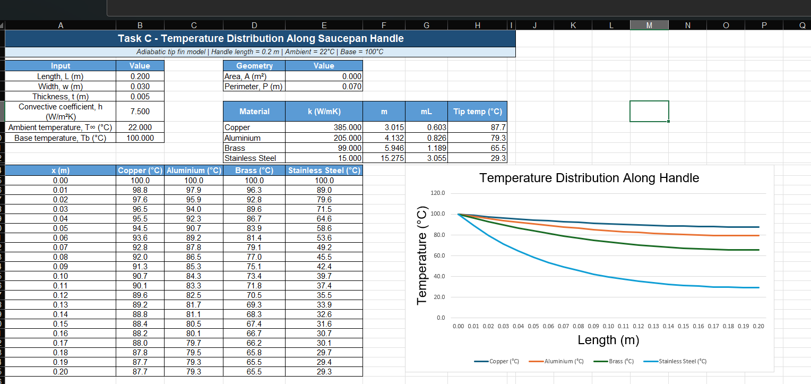
Figure 2: Temperature vs length for all materials.

Charting these allows comparison between materials, as well as providing a clear visual demonstration of how thermal conductivity effects heat transfer. The differences in the slope of the curves show the ability of each material to conduct heat (Yovanovich, M.M. 2011)

4.5 Optimum Length and Comparison
The equation for the heat transfer from the fin is given by:

$$qf​=\sqrt{hpkAc }​​θb ​tanh\left(mL\right)$$

The heat loss values for the original 200 mm handle are:

Material | Heat Loss (W)
Copper | 7.32
Aluminium (2024) | 6.72
Brass | 5.72
Stainless Steel | 2.67
Table 2: Heat loss for original handle length.

The optimum fin length is determined using the condition:
$$mL = 2.65$$

which gives:
$$Lopt=\frac{2.65}{m}$$
Applying this condition results in:

Material | Optimum Length (m) | Optimum Length (mm)
Copper | 0.879 | 879
Aluminium (2024) | 0.641 | 641
Brass | 0.446 | 446
Stainless Steel | 0.173 | 173

Table 3: Optimum lengths for each material.

When heat loss is recalculated using these optimum lengths:

Material | Heat Loss at Optimum (W)
Copper | 13.45
Aluminium (2024) | 9.81
Brass | 6.82
Stainless Steel | 2.65

Table 4: Heat loss at optimum lengths.

The optimum fin length is determined using the condition $mL=2.65$. Applying this condition results in different optimum lengths for each material, with higher conductivity materials requiring longer fins to reach this condition.

When heat loss is recalculated using these optimum lengths, it is observed that copper and aluminium show significant increases in heat transfer, while stainless steel shows very little change. This is because stainless steel is already operating near its optimum condition at the original length (Navalho, J. E. P. 2014).

5. Conclusion
The significance of expanded surfaces in improving heat transfer performance has been shown in this report. The study demonstrated how fin designs have evolved in electrical and automotive applications to increase efficiency in the face of rising thermal demands. Fin performance rises with length, but it reaches an optimum at about mL=2.65, after which additional extension offers little benefit, according to Task B. This emphasizes the value of effective design as opposed to merely growing. Task C demonstrated how material characteristics have a major impact on heat loss and temperature distribution by applying these concepts to a real-world scenario. Stainless steel provides a safer option for handling, whereas high conductivity materials increase heat transfer but also raise surface temperatures. In general, efficient fin design necessitates striking a balance between material selection, thermal performance and practical usability.

6. References
B., P. (2024, August 29). Mastering heat sink design: Key concepts and cutting-edge innovations. Thermistance Technologies Pvt. Ltd. https://www.thermistance.com/blog10.html
Hirasawa, T., Kawabata, K., & Oomi, M. (2005). Furukawa Review, no. 27 2005 2- 2. evolution process of Heatpipe. Evolution of the Heatsink Technology. https://www.furukawaelectric.com/review/fr027/fr27_06.pdf
Knill, O. (2009) Introduction to geometry and geometric analysis. Available at: https://people.math.harvard.edu/~knill/teaching/math109_1995/geometry.pdf (Accessed: 17 April 2026).
Li, J., & Yang, L. (2023, October 18). Recent development of heat sink and related design methods. MDPI. https://www.mdpi.com/1996-1073/16/20/7133
Navalho, J. E. P. (2014, February 13). Heat transfer computational laboratories heat transfer from extended surfaces. Exploring the role of geometrical and thermophysical design parameters on the n performance. http://web.tecnico.ulisboa.pt/~jorge.navalho/wordpress/wp-content/uploads/2018/11/HT_Clab1_completeVersion.pdf
Phillips, R. (1988). Microchannel reat sinks. https://archive.ll.mit.edu/publications/journal/pdf/vol01_no1/1.1.3.microchannelheatsinks.pd
Rodgers, T. (2013). Heat Transfer. [online] Available at: https://personalpages.manchester.ac.uk/staff/tom.rodgers/documents/HT_Notes.pdf.
Subramanian, Dr. M. (2019, October 14). Heat transfer conduction. Heat Transfer Conduction Fins. https://msubbu.in/ln/ht/HT-Lecture-05-Fins.pdf
Unknown (2014) 18.2 Heat Transfer From a Fin, 18.2 heat transfer from a fin. Available at: https://web.mit.edu/16.unified/www/FALL/thermodynamics/notes/node128.html (Accessed: 17 April 2026).
Yovanovich, M. (2011, March 11). Fins or Extended Surfaces. https://www.mhtlab.uwaterloo.ca/courses_old/me353/notes/cond/fins.pdf
Zhang, Z. (2021). Advances in Electrical Engineering, Electronics and Energy. A review of the state-of-the-art in electronic cooling. https://www.sciencedirect.com/science/article/pii/S2772671121000097

