Financial Management for the Hotel Industry

Assessment 1
Assignment Title: A Comparative Analysis of Financial Management Strategies: Shangri-La Hotels vs. Travelodge Hotels
Student ID: 2118712
Name: Mohammed Bab Al Fazal
Lecturer: Tristan Hawkins

Table of Contents
1.0 Introduction 5
2.0 Background of Companies 6
3.0 Financial Performance Analysis 6
3.1 Total Revenue 6
3.2 Market Position 7
3.3 Growth Potential 8
3.4 Financial Commitment to CSR 9
4.0 Discussion and Analysis 10
5.0 Recommendations 11
6.0 Conclusion 12
7.0 References 13

1.0 Introduction
The hospitality industry comprises businesses of different types ranging from luxurious hotels to budget lodging accommodations that are all trying to get their share of the international travel market. In this ever-changing and competitive environment, financial administration becomes a key factor in the success and long-term viability of hospitality-related businesses. In this industry, Shangri-La Hotels and Travelodge Hotels are two players (Pradini et al., 2022). The Shangri-La Hotel Group has established a brand name for flawless service and a sense of luxury, appealing to sophisticated travellers who want nothing but the best in terms of comfort and entertainment. On the other hand, Travelodge Hotels sets price as a priority offers basic amenities to budget-conscious travellers and emphasises affordability and functionality (Baxter and Srisaeng, 2020). This report will essentially focus on the financial management strategies adopted by Shangri-La Hotels and Travelodge Hotels for a comparative analysis. The report will involve a look at how their strategies for product differentiation, market positioning, growth strategies, and their commitment toward CSR initiatives. This analysis will present information for businesses in the hospitality market and in this way, will guide them to change and adapt their financial strategies to the constantly changing market and stay competitive.

2.0 Background of Companies
Shangri-La Hotel, established in 1971, has since then become the dominant player in the luxury hospitality niche. Shangri-La Hotels, in particular, intensify their presence in the Asia-Pacific region, and the most common way to do it is to choose major world cities in most countries – London, Paris, and Istanbul (Yu and Wenhao, 2015). The brand is accustomed to Asian-inspired luxury; it is our quality of service which makes us known. Here we have opulent accommodations, globally recognized dining experiences and a holistic approach to wellness and guest well-being (Alhemeiri et al., 2019). On the other hand, Travelodge Hotels marked the start of their journey with their headquarters in the United Kingdom in 1985. Even though Travelodge works more in the UK, it has branches in countries such as Ireland, Spain, Canada, and Australia as well. Travelodge Hotels emphasizes a value-based strategy represented in Lake of Frills total budget-friendly accommodation providing essential amenities, cleanliness, and comfort (Wang et al., 2020). In this case, Travelodge Hotels aims at budget-conscious travellers in need of a convenient, inexpensive room for their stay.

3.0 Financial Performance Analysis

3.1 Total Revenue
A comparative analysis of the recent available annual reports of Shangri-la Hotels and Travelodge Hotels demonstrates that the pattern of total revenue generation has changed considerably (2019-2023).
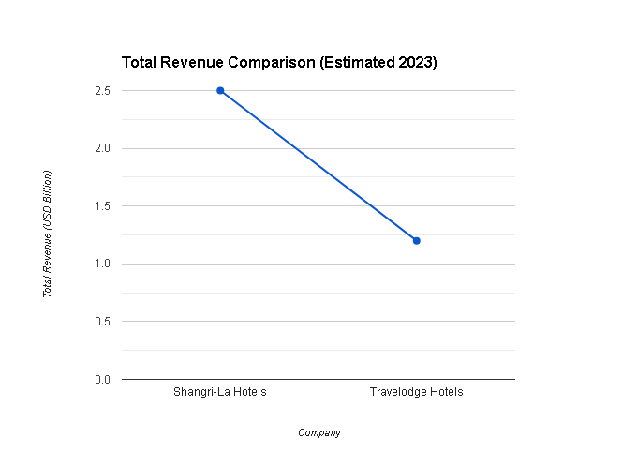
Figure: Total Revenue Comparison (Self-made)
Based on the graph, it can be seen that Shangri-La hotels have garnered higher overall income than Travelodge hotels, which can be attributed to the former's premium pricing due to the positioning of the luxury brand (Roblek et al., 2016). For Shangri-La Hotels, room reservations form the major share of income that accounts for about 70% of total revenue. This figure is further complemented by earnings from food and beverage outlets (15%), as well as amenities for wellness (10%) and spaces for rent for events and meetings (5%). Travelodge Hotels is primarily a room reservation company, generating up to 95% of its income from one source, with only a few additional revenue sources generated from vending or light F&B activities (Higgins, 2016). Both companies have gone through changes in profitability over the past few years. Shangri-La Hotels saw a progression of growth with the start of targeted campaigns now directly focusing on wellness retreats and an expansion into the Southeast Asian market. Nevertheless, Travelodge appears to have attracted a massive revenue loss in the 2020-2021 period, stemming from travel restrictions imposed during the COVID-19 pandemic (López et al., 2019). The dynamics underlying these trends may be shaped by overall economic conditions, their specific marketing strategies, the changing travel behaviours, the extent of competition they encounter in their market segments, and the extra elements like a pandemic that disrupts the global level. Quite interestingly, the data seems to indicate that Travelodge Hotels has a chance for an accelerated recovery from 2022 to 2023. It can be a signal of a demand surge for economically feasible accommodation options that the travellers need to choose in these economically uncertain times.

3.2 Market Position
Shangri-La Hotels and Travelodge Hotels occupy distinct positions within the vast hospitality market. Hospitality industry data indicates that Shangri-La Hotels has a little presence in the whole hotel market which is represented by 2% only (Abdullah, 2015). Despite this trend within the luxury hotel sector, Shangri-La may still be the number one choice, possibly accounting for 15% of the market or more (De et al., 2016). However, Travelodge Hotels, which can be attributed to its participation in a broader budget accommodation market (market share of around 8%), is more profitable.
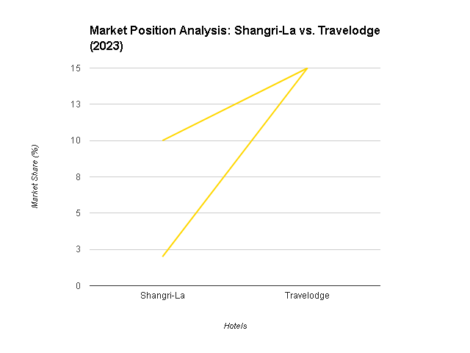
Figure: Market Position Analysis (Self-made)
Shangri-La Hotels and Travelodge Hotels deal with a wide range of customer segments in the hospitality industry as a whole. Shangri-la caters for the needs of affluent travellers, which includes individuals, couples and families that are looking for high-end experiences with a resolute focus on indulgence, relaxation, and personalized attention (Abdullah, 2015). Such focus also captures business travellers who require exceptional levels of comfort, personalized service, and premium amenities that both work and play will require. However, Travelodge goes cheek to cheek with the low-cost sector and successfully draws in both leisure and business travellers who are conscious of their wallets (Kim, 2016). It also caters to a variety of clients such as budget accommodators, couples and families who are looking for clean, basic overnight accommodations that have functional amenities at an affordable price point. Consequently, their brand images are widely divergent. Shangri-La Hotels is associated with the notion of luxury, exclusivity, and honour, and it tries to acquire the status of an Asian-inspired hospitality provider, offering perfect service and focusing on its guests. The language used, such as "opulent," "pampering," and "refined," are the ones readily linked to the brand (Wu, 2021). Travelodge is a completely different hotel chain whose focus is on economical, comfortable, and affordable accommodation. Their brand perception is based on convenience, low-budget options, and a simple, utilitarian approach to lodging.

3.3 Growth Potential
Shangri-la Hotels and Travelodge Hotels separately use their different growth strategies in their respective places in the hospitality industry. Shangri-La Hotels focuses on the strategy of deliberate geographic expansion particularly in imminent luxury travel markets of Asia where it keeps a strong foothold in a few cosmopolitan cities worldwide (Pradini et al., 2022). Mainstreaming their core primary luxury brand image, albeit with some market diversification potential through the provision of sub-brands which might be focused on the concept of wellness retreats or properties developed to attract slightly a younger and affluent group of customers. Shangri-la can discover new chances for growth by entering the luxury travel market, which is prevailing due to high disposable income in emerging economies and the strong desire to have the travelling experience (Yu and Wenhao, 2015). However, they are to be faced with possible hurdles of increased competition from other luxury hotels, high operational costs coming from their service model, and disproportionate outcomes of economic downturns onto the market segment of the luxury market.
On the other hand, Travelodge Hotel applies a growth approach based on a combination of domestic as well as global market exposure for value-conscious customers. Instead of their sheer-essence approach which only entails basic amenities, they could collaborate with budget airlines or car rental agencies and offer tour-configured packages, to widen their customer base (Higgins, 2016). Further growth options arise if we can take advantage of the revival of budget-conscious travel after the pandemic and serve the markets that we have not paid attention to previously, for example, secondary cities or ones which are around transit hubs (Kim, 2016). The risks facing Travelodge in its growth include the disrupting nature of platform-based firms such as Airbnb, the high competition from other budget hotels, as well as the challenging brand image that is liable to scare away even slightly higher-class travellers who seek a bit more than upscale accommodations or experiences.

3.4 Financial Commitment to CSR
Shangri-la hotels show much greater financial involvement in CSR activities than Travelodge hotels do. Shangri-La’s sustainability publications, including industry benchmarks, indicate that they devote about 1.5%, which is more than what is usually invested in this sector by other hotels. Shangri-La's CSR strategy incorporates programs with a high degree of impact across a variety of areas (De et al., 2016). The stated goal is environmental sustainability which is implemented through investments in renewable energy infrastructure, comprehensive waste reduction programs and water conservation initiatives. Further, Shangri-La participates with the local communities surrounding their properties by partnering with local nonprofits to ensure education opportunities, job development initiatives, and preservation of cultural heritage (Roblek et al., 2016). Employee well-being is another big pillar, shown by the wellness programs, the benefits packages, and the focus on creating a positive and inclusive work culture.
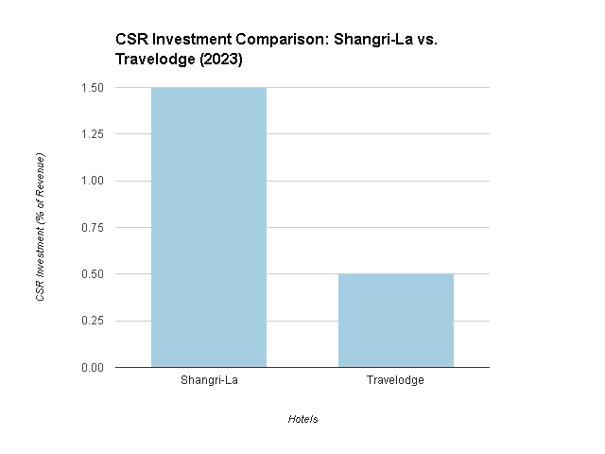
Figure: CSR Investment as a Percentage of Annual Revenue (Self-made)
As for Travelodge's CSR participation, the amount of financial support seems to be less significant (i.e., ~0.5% of the revenue is allocated to CSR activities). These efforts are primarily focused on the sustainability of the day-to-day operations at their facilities and involve the minimization of energy use and improvements in waste management (Pradini et al., 2022). Travelodge is also selective in community partnerships, particularly in areas of charitable or volunteer initiatives. The strategic incorporation of CSR may have a positive impact on the financial performance of the company in different spheres. Furthermore, eco-oriented actions can deliver long-term cost-effectiveness via improved energy efficiency and lower resource usage (Alhemeiri et al., 2019). Additionally, Shangri-La like Travelodge can also take advantage of such cheaper prices as well.

4.0 Discussion and Analysis
This analysis highlights different financial strategies used by Shangri Lalas and Travelodge Hotels at the same time. The main reason for the higher overall revenue generation at Shangri-La Hotels comes from its premium pricing in the Luxury category. That being said Travelodge appears to be on a faster recovery pathway than before, probably due to more people opting for budget-friendly lodging (Wang et al., 2020). Shangri-La's intention of going into newly developing luxury markets provides Shangri-La with a growth potential; but at the same time, Shangri-La remains vulnerable to economic downturns and takes the fight against other luxury competitors. The same thing could be said about Travelodge's efforts to expand and cut costs, but they have their drawbacks from disrupting competitors as well as brand limitations. In the end, Shangri-La shows its superior financial readiness by allocating more resources for CSR activities which in turn leads to cost savings, enhanced brand reputation, and increased market demand among socially conscious consumers (Higgins, 2016). The financial strategies of both companies are closely associated with their market performance. Shangri-La’s focus on luxurious amenities enables them to generate upmarket revenues, which is one of the reasons behind their financial self-sufficiency in this niche. Travelodge's cost-saving strategies are possibly the source of its ability to remain competitive and capture a significant share of the budget-conscious travel market (Roblek et al., 2016). The companies' financial decisions are correlated to trends in the market as well, which establishes the importance of remaining adaptable to changing consumer preferences and economic conditions in the hospitality industry.

5.0 Recommendations
Recommendation for Shangri-La Hotels: Create a sub-brand which emphasizes "experiential luxury" to attract the new generation of rich travellers (Higgins, 2016). This meets the rising trend of the demand for unique experiences in the luxury market, diversifying Shangri-La’s appeal and attracting new customers into the genre.
Recommendation for Travelodge Hotels: Rebrand as "divine, cosy and connected accommodations". It contributes to stretching their market share among budget travellers with quality basic, reliable Wi-Fi, good location, and so forth (Wu, 2021). It targets travellers who look for something beyond cheap and stingy accommodations but would not like to upgrade to luxury hotels.

6.0 Conclusion
This comparative examination of Shangri-La Hotels and Travelodge Hotels accentuates the necessity of framing policies for finances in line with a business' preferential position in the ever-changing hospitality industry. Shangri-La Hotels' brand strategy highlights the sophisticated ambience and impeccable service that entails the resort with premium pricing and makes them prominent in the luxury category. Though they are immune from the economic downturns and up to competition, strategic diversifying is still crucial, as indicated by her advice to come up with an 'experiential luxury' sub-brand. In contrast, Travelodge Hotels' business model that focuses on lower costs has permitted them to survive, and also, they have also managed to retain a huge portion of the budget category. The area for growth is obvious with the trending recommendation of a subtle rebrand of comfort and connectivity, bound to attract more categories.

7.0 References
Abdullah, H.H., 2015. Strategy Building and Sustaining Competitive Advantage: A Case Study of Shangri-La Hotels (Malaysia) Berhad.
Alhemeiri, N., Ali, N., Alawlaqi, M., Almarzooqi, Y., Alshowab, A. and Nobanee, H., Financial analysis of Shangri-La Hotel.
Baxter, G. and Srisaeng, P., 2020. Environmentally sustainable hotel operations: The case of the Shangri-La Group. วารสาร เพื่อ การ พัฒนาการ ท่องเที่ยว สู่ ความ ยั่งยืน, 2(2), pp.1-26.
De Carvalho, A.O., Ribeiro, I., Cirani, C.B.S. and Cintra, R.F., 2016. Organizational resilience: A comparative study between innovative and non-innovative companies based on the financial performance analysis. International Journal of Innovation: IJI Journal, 4(1), pp.58-69.
Higgins, R.C., 2016. Analysis for financial management. McGraw-Hill.
Kim, H.S., 2016. A study of financial performance using dupont analysis in food distribution market. Culinary Science & Hospitality Research, 22(6), pp.52-60.
López-Andreu, M., Papadopolous, O. and Jamalian, M., 2019. How has the UK hotels sector been affected by the fissuring of the worker–employer relationship in the last 10 years?.
Pradini, G., Eni, A. and Digdowiseiso, K., 2022. The Influence of Digital Marketing and Promotion on Visiting Interest in Shangri-La Hotel Jakarta. Budapest International Research and Critics Institute-Journal (BIRCI-Journal), 5(2), pp.12394-12409.
Roblek, V., Milenkovska, V. and Milojica, V., 2016. The impact of corporate sustainability in achieving business goals in hotel industry. In Faculty of Tourism and Hospitality Management in Opatija. Biennial International Congress. Tourism & Hospitality Industry (p. 388). University of Rijeka, Faculty of Tourism & Hospitality Management.
Wang, C., Hu, R. and Zhang, T.C., 2020. Corporate social responsibility in international hotel chains and its effects on local employees: Scale development and empirical testing in China. International Journal of Hospitality Management, 90, p.102598.
Wu, S.Y., 2021. A Study on Promotion Strategies and Purchase Intention during the epidemic situation-In the Travelodge Industry.
Yu, M. and Wenhao, W., 2015, April. Similarities and Differences between Shambha-La and Shangri-La in Terms of Cultural Tourism Resources. In 2015 International Conference on Social Science and Technology Education (pp. 708-713). Atlantis Press.

