Cybersecurity and Data Governance Policy Report

SteelForm Manufacturing Ltd Data Governance Policy and Cybersecurity

STUDENT NAME: METHUSELI NCUBE
STUDENT NUMBER: 2507567
COURSE: Certhe Computing Skills for Workplace.
MODULE: Network and Cybersecurity Essentials.
MODULE CODE: ACCA 4024
LECTURE: Muhammad Azeem Abbas

Table of Contents
Executive Summary 2
1. 3
Introduction 3
2. Identification of Threats 3
External Threats 3
Internal Threats 4
Case Study Insight 4
3. Security Policies 5
Congruence with Global Standards. 5
Data Governance Policies and Supply Chain. 5
IoT and ICS Security Policies 5
4. Mitigation Measures 6
Technical Controls 6
Human-Centred Controls 6
ICS Resilience Measures 7
5. Intrusion Detection and Response. 7
Continuous Monitoring 8
Incident Response Plan 8
6. Training and Awareness 9
Training Programmer Design 9
Awareness Initiatives 9
7. Conclusion and Recommendations 11
References 12
Appendix 15

Executive Summary

SteelForm Manufacturing Ltd (SFM), a medium-sized manufacturer that serves the automotive and aerospace industries, is going through a major digital change by adopting Industry 4.0 technologies. As much as this transition can be seen to improve operational efficiency, it also presents the organisations with sophisticated cybersecurity risks both in the information technology (IT) and operational technology (OT) environments. The recent cases of phishing and malware infections and hacking attempts provoke the need to consider the current cybersecurity stance of SFM as inadequate to counter the dynamic nature of the threat environment.

To provide a holistic cybersecurity and data governance policy, this report tackles five key areas, which include threat identification; security policy formulation, mitigation, monitoring, and incident response; staff training; and awareness. The report is based on advanced academic sources, regulatory frameworks, and real-life case studies in the UK to come up with a multi-layered security approach that incorporates technical measures, human-centred interventions, and governance. The suggestions will enhance the resilience of SFM, minimise operational interruptions, and instil a culture of cybersecurity awareness throughout the organisations.

1. Introduction

The digitalisation of manufacturing has completely transformed the risk profile in the sector. The technologies of Industry 4.0 establish interdependence between machines, networks, and cloud systems, exposing them to cyber threats. Babu emphasises that UK manufacturing companies are more dependent on big data and interconnected systems to enhance innovation, but they do not have a robust system of governance to handle the risks [1]. In the case of SFM, the implementation of smart manufacturing technologies created vulnerabilities in both OT and IT environments, especially when any of the legacy industrial control systems (ICS) were combined with the new IoT gadgets.

Note that IIoT retrofitting typically opens insecure communication channels and improperly sets up devices, which opens vulnerabilities to attackers [2]. The recent security incidents of SFM are not isolated and indicate a wider industry-wide trend, proving that the current state of cybersecurity preparedness is not appropriate to the sophisticated nature of recent manufacturing settings. The goal of this report is to establish a solid cybersecurity and data governance policy to meet the global requirements, the expectations of UK regulations, and best practices of manufacturing cybersecurity.

2. Identification of Threats

External Threats
SFM is exposed to various external threats, such as ransomware, malware, and supply chain attacks, as well as targeted intrusions and intellectual property theft. Alqudhaibi gives an extensive overview of the initiative-taking cybersecurity measures in Industry 4.0 and shows that ransomware-based attacks are becoming more popular as they focus on manufacturing systems, as their operational power is greater [3]. The attackers take advantage of the loopholes in the IoT devices, remote access systems, and out-of- Update the firmware and enter the production networks. Granata creates ICS threat models that expose structural vulnerability of network segmentation and access control to allow adversaries to navigate the OT environments once they have initial access [4].
The threats facing the SFM supply chain are especially important since it depends on its external suppliers and partners. Gokkaya claims that the UK regulatory framework of supply chain cybersecurity is still disjointed and that most organisations do not enforce strict security demands on vendors [5]. This leaves attackers open to breaches into third-party systems and utilises them as a pathway into the main manufacturing networks. This trend has been observed with the phishing campaigns already being run at SFM that target procurement employees since frequently social engineering is employed to obtain footholds in supply chain operations.

Internal Threats
Human error, misuse, and poor access controls by insiders constitute internal threats. And presents a techno-human vulnerability analysis methodology proving that ICS systems are especially vulnerable to misconfigurations, inadequate authentication, and low levels of security awareness among operators [6]. Production staff and engineers can inadvertently develop vulnerabilities by bypassing security measures to be more convenient or just by being unaware of malicious emails and links.

Case Study Insight
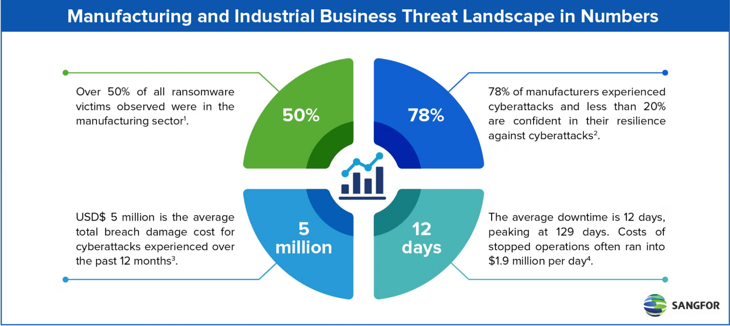
The case of the 2025 Jaguar Land Rover cyberattacks, discussed by McAuley, can be used to understand how an organisation of major scale in terms of manufacturing can be severely impacted by technical and human factors and cause a significant disruption in its operations and reputation [5]. The case is closely applicable to SFM, which works in the same industries, and highlights the importance of active threat detection and reduction.
Source: https://www.sangfor.com/sites/default/files/inline-images/manufacturing-anindustrial-business-threat-landscape-in-numbers.png

3. Security Policies

Congruence with Global Standards.
To target the threats identified, SFM will have to implement security policies that will be in line with international standards and those of the UK regulatory frameworks. ISO 27001 offers a detailed framework of information security management, including the control of access, cryptography, the management of assets, and incident response. The incorporation of ISO 27001 domains will help SFM to have a systematised approach in risk management. The NIST Cybersecurity Framework (CSF) also assists in the development of policies by its five core functions: Identify, Protect, Detect, Respond, and Recover. All the policy decisions should be based on the CIA Triad – confidentiality, integrity and availability. Data governance should be aligned with the needs of operations.

Data Governance Policies and Supply Chain.
Cybersecurity policies for supply chains should be enhanced. Gokkaya outlines the necessity of the security requirements of the contract, the risk evaluation, and ongoing monitoring of the compliance of third parties [5]. In the case of SFM, this entails setting minimum requirements for the suppliers in terms of the requirement of encryption and the secure development practices and incident reporting requirement. Pfeiffer highlights the importance of policy control for data spaces in Manufacturing￼X environments, emphasising the need for fine-grained access control, data usage policies, and audit mechanisms [8].

IoT and ICS Security Policies
Ontology-based IoT security modelling is suggested by Jarwar and can be used to assist SFM in formulating device authentication policy, firmware updates, and network segmentation policy [9]. Granata also emphasises the necessity to work out ICS-specific policies that would respond to pretesting, vulnerability scanning, and OT-IT integration [4].

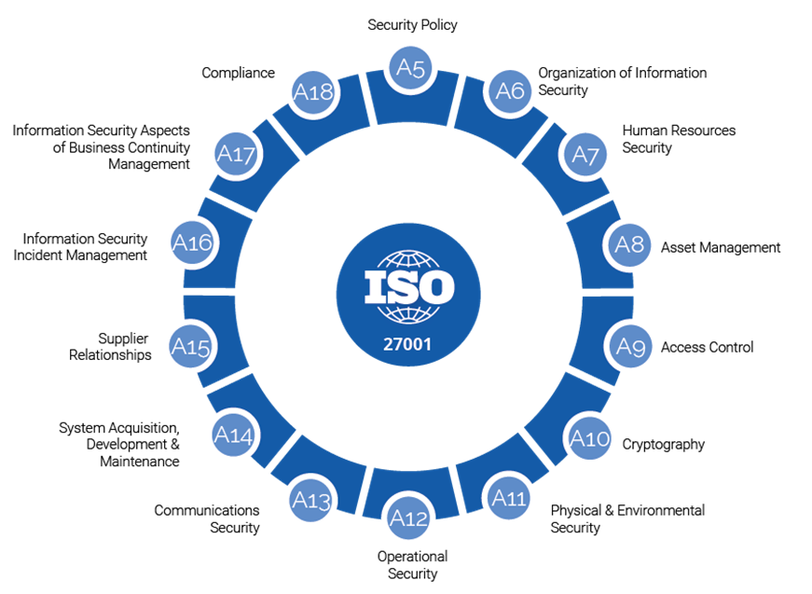
Source: https://adancorporate.com/assets/images/iso-27001-1.png

4. Mitigation Measures

Technical Controls
The mitigation measures should be interventions that involve technical and human interventions. SFM must adopt the use of multi-layered security measures that are firewalls, intrusion detection systems, intrusion prevention systems, and endpoint protection. To avoid lateral movement in case of attacks, segmentation of the network between the IT and OT environments is required. Cryptography of confidential information, a secure setup of the IoT devices, and frequent maintenance of the patches are essential in minimising exposure to external vulnerabilities. As Comert emphasises, IIoT retrofitting brings about new vulnerabilities, which need constant monitoring and safe integration practices [2].

Human-Centred Controls
And emphasise the importance of addressing techno-human vulnerabilities through role-based access control, multifactor authentication and behavioural monitoring. Frequent phishing exercises and compulsory cybersecurity education lessen the chances of human error [6].

ICS Resilience Measures
Staves suggest a cyber incident response and recovery model of ICS environments that encompasses redundancy planning, backup plans, and swift restoration plans. These measures will make SFM resilient in its operations [11].

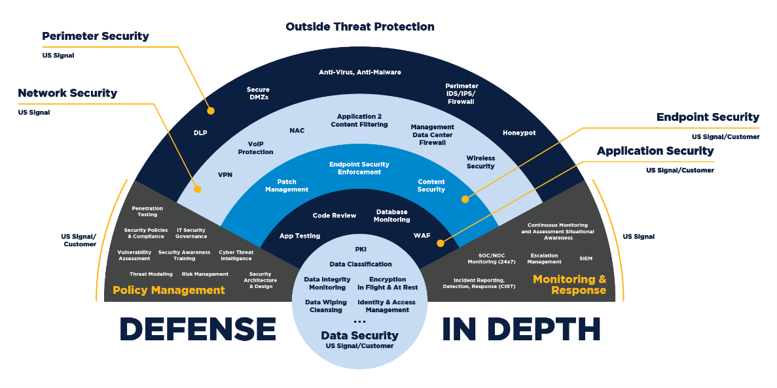
Source: https://liodeus.github.io/assets/imgs/CISSP/CH01/Defense-in-Depth-Graphic.png

5. Intrusion Detection and Response.

Continuous Monitoring
Constant surveillance is crucial in identification and control of cybersecurity attacks. SFM ought to implement Security Information and Event Management (SIEM) to gather and examine logs of the IT and OT environments. Detection tools to detect anomalies that are associated with cyber-attacks can be used. To prevent anomalies, Suhail suggests using digital twins to simulate the behaviour of cyber-physical systems and identify anomalies in advance [10].

Incident Response Plan

A good incident response plan should entail detection, containment, eradication, and recovery. It is detected using SIEM alerts, user reports, and automated anomaly detectors. Containment is the process of isolating systems which are affected to avoid additional spread. Malware needs to be eradicated, and vulnerabilities should be sealed. Recovery is designed to recover operations by restoring backups, ensuring the integrity of data and performing post-incident reviews. According to Staves, ICS environments have a severe issue of operational continuity that needs to be taken into consideration during the recovery planning [11].
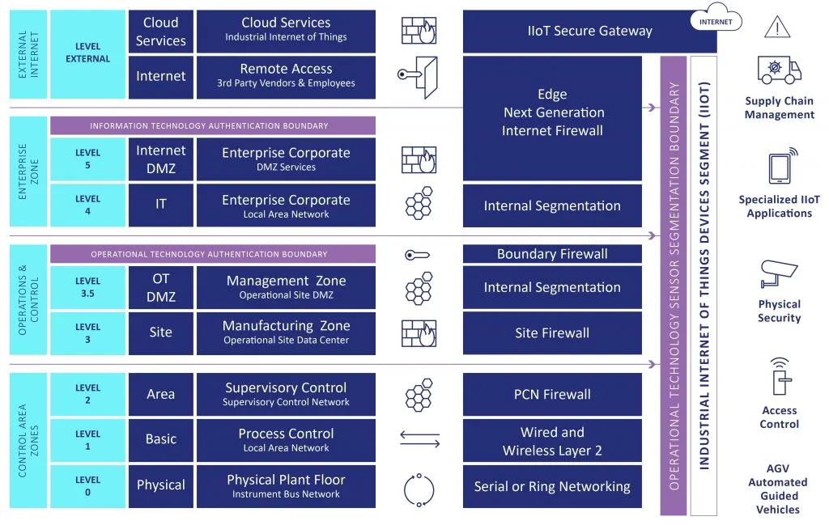

Source: https://industrialcyber.co/wp-content/uploads/2021/03/OT-Threat-Landscape-04_cut-1024x649-1.jpg

6. Training and Awareness

Training Programmer Design

Human behaviour remains one of the most enduring and impactful cybersecurity threats in manufacturing setups. SFM has invested in technical controls; however, current events in the organisations have shown that human-centred vulnerabilities like vulnerability to phishing, poor password hygiene and workarounds are still entrenched within the daily operations of the organisations. According to Charalambous, successful cybersecurity training should not be based on traditional, information-intensive training but should involve building practical skills, situational judgement, and behavioural change [12]. In the case of SFM, this implies the development of training programmes that are not generic but rather orient-orientated towards the unique duties of various staff, their level of exposure to risks and contexts of making decisions. Training is needed on how engineers should securely set up IoT devices and interact safely with ICS interfaces and on how procurement teams need specialised coursework on how to identify social engineering attacks and how to check the authenticity of suppliers.

Rahman has produced the Cyber4Me framework that focuses on personalised awareness measures that respond to the needs of individual learning and behavioural patterns. The training programmer could be incorporated into SFM by integrating this framework to enable the organisations to deliver more engaging, relevant, and impactful content [13]. As an example, more complicated situations could be offered to the staff, showing a higher level of competency, and further reinforcement offered to those students who have problems with the basics. Such an individualised strategy is especially necessary in the manufacturing environment where employees might possess different degrees of digital literacy and exposure to cyber-physical systems.

Awareness Initiatives

Constant reinforcement is needed to go hand in hand with training. A similar emphasis is on cybersecurity awareness campaigns at the national level, as they integrate learning with the maintenance of behavioural cues, cultural reinforcement, and exposure to fake threats [14]. SFM needs to follow the same philosophy and incorporate cybersecurity awareness into daily organisational life. It can also involve regular phishing drills, which replicate patterns of attack and attack in the real world, the use of reminder methods like posters and digital signage in production zones, and monthly cybersecurity newsletters, which illustrate the emergent threats applicable to the automotive and aerospace industries.

More importantly, awareness programmes should not be portrayed as a compliance activity but rather as a part of professional responsibility and organisational safety. Manufacturing environments are very dependent on continuous operations, and any mistake by a human can cause a series of failures in systems that are all connected. Thus, SFM must develop an organisational culture of cybersecurity as a common organisational value. On the role of leadership, the managers should be role models about demonstrating secure behaviour and taking part in awareness campaigns; this way the staff will internalise the essence of being vigilant. These efforts can over time normalise safe behaviours, minimise the occurrence of man-made incidents and enhance the overall security posture of SFM.

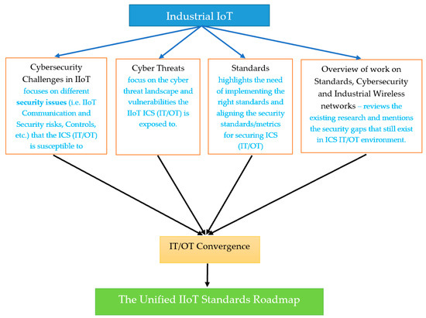7. Conclusion and Recommendations
Source: https://www.mdpi.com/sensors/sensors-21-03901/article_deploy/html/images/sensors-21-03901-g001-550.jpg

The shift to Industry 4.0 is the high point of the organisational development of SFM, which gives it great opportunities to optimise its operations, provide predictive maintenance and data-driven decision-making. Nonetheless, this change also puts the organisations at risk of an increased and more sophisticated cybersecurity threat environment. The accidents that SFM has had so far reveal that its existing controls are disjointed, reactive, and do not fully correspond to the realities of contemporary manufacturing ecosystems. The discussion in this report reveals that cyber threats to manufacturing companies are becoming increasingly complex, using vulnerabilities in IoT devices, old ICS, cloud services, and human behaviour. The lack of a coherent and integrated cybersecurity and data governance approach may cause SFM to face operational downtime, monetary loss, reputation loss, and possible regulatory non-compliance.

The support of the necessity to adopt a multi-layered and governance-based approach is supported by evidence based on the high-level academic literature and practical case studies. Technical controls would not suffice to safeguard the environment of SFM and need to be augmented with human-based interventions, ongoing monitoring, and a sense of shared accountability. The suggested recommendations, which include policies that are aligned with ISO 27001 and all the digital-twin-enhanced monitoring and behaviour-orientated training, offer a comprehensive system that has the potential of eliminating both existing and upcoming risks. This would require SFM to institutionalise routine reviews of its policies and risk assessment and integrate cybersecurity in strategic decision-making to guarantee long-term resilience. In this way, SFM will not merely enhance its defensive stance but also be established as a safe, trustworthy, and competitive producer in the automotive and aerospace industries

References

[1] M. M. Babu, M. Rahman, A. Alam, and B. L. Dey, “Exploring big data-driven innovation in the manufacturing sector: Evidence from UK firms,” Annals of Operations Research, vol. 333, Apr. 2021, doi: 10.1007/s10479-021-04077-1

[2] M. Comert, A. Ahmed, and H. Ahmed, “Identifying security challenges in the transition from traditional to smart manufacturing through IIoT retrofitting - White Rose Research Online,” Whiterose.ac.uk, Mar. 31, 2025. https://eprints.whiterose.ac.uk/id/eprint/225576/

[3] Adel Alqudhaibi et al., “Proactive cybersecurity in industry 4.0: A survey of cybersecurity threat prediction approaches in manufacturing systems,” International Journal of Information Security, vol. 25, no. 1, Dec. 2025, doi: 10.1007/s10207-025-01188-9 https://link.springer.com/article/10.1007/s10207-025-01188-9

[4] Granata, D., Iannaccone, A., Nardone, R. and Romano, L., “From Systematic Threat Search to Pentesting: Industrial Control Systems Threat Models. Computers & Security, 170, p.105000", 2026.
https://www.sciencedirect.com/science/article/pii/S0167404826001768

[5] B. Gokkaya, K. Spanaki, and E. Karafili, “Strengthening the UK regulatory framework: Enhancing cybersecurity in supply chains,” International Journal of Information Management Data Insights, vol. 5, no. 2, p. 100370, Sept. 2025, doi: 10.1016/j.jjimei.2025.100370
https://www.sciencedirect.com/science/article/pii/S2667096825000527

[6] U. D. Ani, J. Watson, H. He, Petar Radanliev, and G. Epiphaniou, “Minimising cybersecurity risk exposures in industrial control system environments: A techno-human vulnerability analysis approach,” Journal of Cyber Security Technology, pp. 1–40, Nov. 2024, doi:10.1080/23742917.2024.2421589 https://www.tandfonline.com/doi/abs/10.1080/23742917.2024.2421589.
https://link.springer.com/article/10.1007/s10479-021-04077-1
[7] T. C. McAuley, “JLR Cyberattack: Lessons from a Major Manufacturing Crisis,” The Security Brief, Sept. 28, 2025. https://the-security-brief.com/2025/09/28/jlr-cyberattack-lessons-from-a-major-manufacturing-crisis/

[8] Pfeiffer, J., Maisch, N., Friedl, S., Strljic, M.M., Lechler, A., Riedel, O. and Wortmann, A., “Eclarative Policy Control for Data Spaces: A DSL-Based Approach for Manufacturing-X", Procedia CIRP, 142, pp.1082-1087, https://www.sciencedirect.com/science/article/pii/S2212827126009844,

[9] M. A. Jarwar, J. Watson, and S. Ali, "Modelling Industrial IoT Security Using Ontologies: A Systematic Review,” IEEE Open Journal of the Communications Society, vol. 6, pp. 2792–2821, 2025, doi: 10.1109/ojcoms.2025.3532224.
https://ieeexplore.ieee.org/abstract/document/10847994/

[10] S. Suhail, M. Iqbal, K. McLaughlin, B. Lee, and B. Imtiaz, “A framework for enhancing cyber incident response with Security-Enhancing Digital Twins in Cyber-Physical Systems,” Internet of Things, p. 101547, Feb. 2025, doi: 10.1016/j.iot.2025.101547.
https://www.sciencedirect.com/science/article/pii/S2542660525000605

[11] A. Staves, T. Anderson, H. Balderstone, B. Green, A. Gouglidis, and D. Hutchison, “A Cyber Incident Response and Recovery Framework to Support Operators of ICS and Critical National Infrastructure,” International Journal of Critical Infrastructure Protection, vol. 37, p. 100505, Jan. 2022, doi: 10.1016/j.ijcip.2021.100505
https://www.sciencedirect.com/science/article/pii/S187454822100086X

[12] Charalambous, A., Piki, A. and Stavrou, E., “Redesigning cybersecurity awareness-raising and training programs: Insights from professionals on knowledge, skills and educational practices. Information & Computer Security, 34(2), pp.273-294,” 2026.
https://www.emerald.com/ics/article/doi/10.1108/ICS-04-2025-0163/1275195

[13] Rahman, M.A., Ibrahim, M., Ahmed, B., Refat, N., Wei, T.S. and Pillai, P., “A Quantitative Evaluation of Cyber4Me: A Holistic Framework for Enhancing Individual Cybersecurity Awareness. Computers, 15(7), p.418.,” 2026.
https://www.mdpi.com/2073-431X/15/7/418

[14] R. Shillair, P. Esteve-González, W. H. Dutton, S. Creese, E. Nagyfejeo, and B. von Solms, “Cybersecurity education, awareness raising, and training initiatives: National level evidence-based results, challenges, and promise,” Computers & Security, vol. 119, no. 0167–4048, p. 102756, Aug. 2022, doi: 10.1016/j.cose.2022.102756
https://www.sciencedirect.com/science/article/pii/S0167404822001511

Appendix
CYBER - presentation.pptx

