My Travel Wales Website
Web Design and Development Report
Module: ACCA4023
Student Number: 2533410
Course: CertHE Computing Skills for Workplace
Date: 7 July 2026

Table of Contents
Contents
Table of Contents 2
Introduction 3
Requirements 4
Implementation 5
Validation 8
Conclusion 9
Evaluation 11
References 13

Introduction

This Report describes the design, development and evaluation of a responsive website called My Travel Wales. The website was created using HTML [1] and CSS [2] and consists of three pages: Home, About and Contact. The purpose of the website is to promote Wales as a tourist destination by proving visitors with information about its attractions, landscapes and contact details. The report explains the website requirements, implementation process, validation results, usability, accessibility, search engine optimisation (SEO), and overall evaluation of the completed website.
The website was developed as part of the introduction to Web and Database Concepts module to demonstrate an understanding of modern we development principles and the use of HTML [1] and CSS [2]. During the planning stage, consideration was given to the overall appearance, navigation structure and target audience to ensure the website would be easy to use and visually appealing. A responsive layout was chosen so that visitors could access the website on desktop computer without affecting the user experience.
Throughout the development process, recognised web standards were followed to produce clean and well-structured code. HTML was used to create the content and structure of webpage, while CSS was used t control the visual appearance, including colours, fonts, spacing and page layout. Validation tools were also used to identify and correct coding errors to improve the quality and reliability of the final website [5]. This report explains each stage of the project, from planning and implementation to validation and evaluation, while reflecting on the overall effectiveness of the completed website.

Requirements

The aim of this project was to design and develop a responsive website using HTML and CSS [1],[2]. The website was created from scratch without using website builders or templates. It consists of three linked pages (Home, About and Contact) and can be viewed in a web browser by opening the index.html file. The website was designed to promote travel in Wales by providing useful information, attractive images and clear navigation. A consistent colour scheme, readable typography and responsive layout were used to improve the overall user experience.
The website was designed with the needs of the target audience in mind. Visitors should be able to find information quickly using a simple navigation menu and clear page structure. Each page was required to display correctly, include relevant images and provide clear, readable text about travelling in Wales. Consistency was an important requirement; therefore, the same colours, fonts and navigation were used across all three pages. This creates a professional appearance and helps users move around the website without confusion [4],[5].
Another important requirement was that the website should be responsive and accessible on different devices and web browsers. HTML was used to provide a logical structure for the content, while CSS controlled the visual appearance and responsive layout [1],[2]. Accessibility was considered by using meaningful headings, appropriate colour contrast and alternative text for images where required [3]. The website was expected to meet recognised web standards by successfully passing HTML and CSS validation.[5] Meeting these requirements ensured that the finished website was reliable, user-friendly and suitable for its intended audience.
In addition to these requirements, the website needed to be simple to maintain and update in the future. By separating the HTML structure from the CSS styling, changes can be made efficiently without affecting the entire website. This approach improves organisation, makes the code easier to understand and supports future development if additional page or features are required [1], [2].

Implementation

The website was developed using HTML5 and CSS3 in Visual Studio. Development began by creating the three required pages Home, About and Contact. A shared navigation bar was added to each page so users could move between them easily. A single CSS stylesheet was then created to ensure a consistent appearance across the website, including colours, fronts, spacing and responsive layout. Images and text relevant to tourism in Wales were added, and the website was tested throughout development to ensure all links and pages functioned correctly. The following figures show the completed website. During the implementation stage, each webpage was created individually before being linked together using a consistent navigation menu. The home page was designed as the main landing page and provides visitors with introduction to travelling to Wales. It contains a welcoming heading, a short description and an image that encourages users to explore the website further. The layout was intentionally kept simple so that visitors could quickly understand the purpose of the website without unnecessary distractions [1], [2], [6]
The about page was developed to provide more information about Wales and its attractions. Images were included to make the content more engaging and to support the written information. CSS styling was used to keep the same fonts, colours, spacing and navigation menu across every page. This created a more consistent and professional appearance throughout the website [1], [2]
The Contact page was created to provide visitors with a clear way of finding contact information. Although the page is simple, the information is presented in an organised and easy-to-read format. The same navigation bar appears at the top of the page so that users can move between the Home, About and Contact pages without difficulty [1], [2].
Throughout the implementation process, the website was tested regularly to make sure that links worked correctly, images displayed properly and the layout remained readable. The website was also checked at different screen sizes to confirm that the responsive design worked on desktop, computers, tablets and mobile devices. This testing helped identify problems early and improved reliability of the final website [5].
The implementation process focused on producing a website that was both functional and visually appealing. Each page was tested after changes were made to ensure that hyperlinks, images and test displayed correctly. Using a single CSS stylesheet ensured that all pages maintained a consistent appearance, making the website easier to navigate and more professional. The responsive layout allowed the content to automatically adjust to different screen sizes without affecting usability. Throughout development, small improvements were made to spacing, font sizes and image positioning to improve readability and create a better user experience. The navigation menu remained visible on every page, allowing users to move easily between sections with confusion. These implementation decisions resulted in a website that mees the original project requirements while remaining simple, clear and suitable for its intended audience [1], [2], [6].

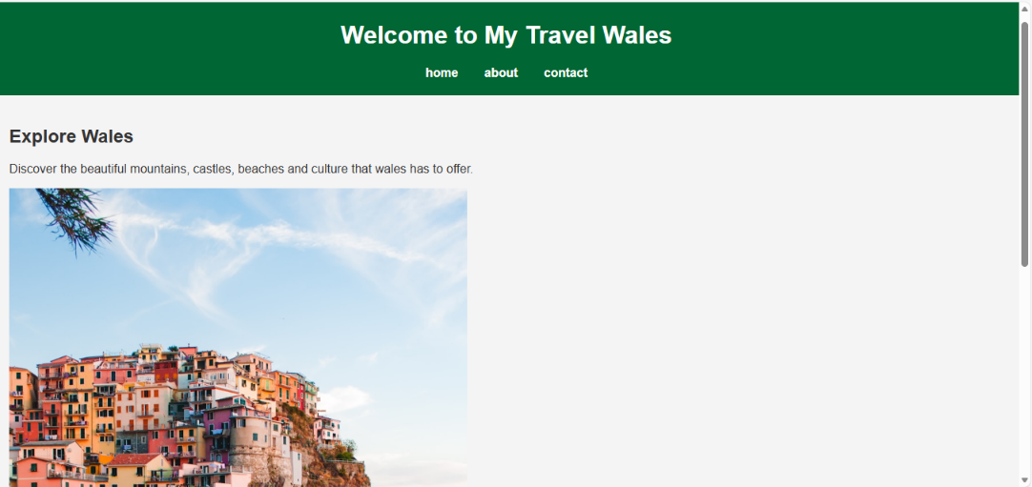
Figure 1: Homepage of My Travel Wales Website
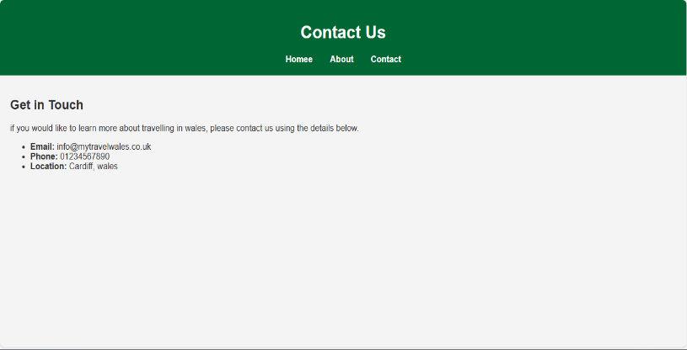
Figure 1: Contact page of My Travel Wales website
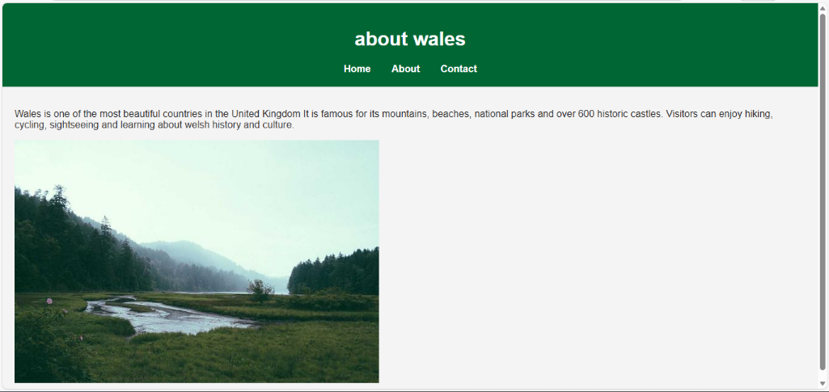
Figure: About page of My Travel Wales website.

Validation

The completed website was validated using the W3C HTML validator and the W3C CSS validator to ensure that the code followed web standards. Validation helps identify coding errors, improves compatibility across browsers and devices, and ensures the website meets recognised web development standards. Any validation errors that were identified were corrected before the final version of the website was completed. Screenshots of the validation results are provided below [7].

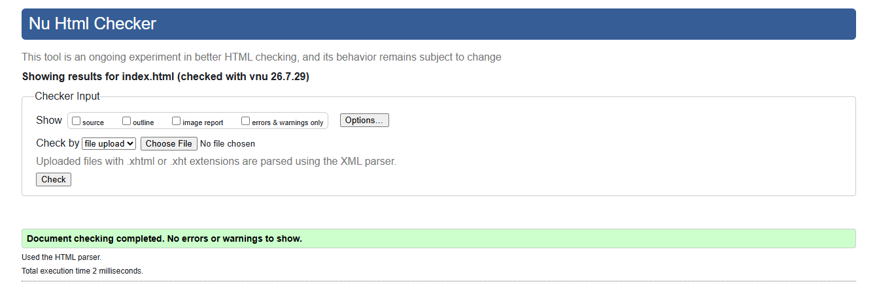
The HTML code for My Travel Wales website was validated using W3C HTML validator. The validation process confirmed that the website contained no HTML errors or warnings. This demonstrates that the code follows recognised web standards and is correctly structured, improving compatibility across different browsers and devices [7].

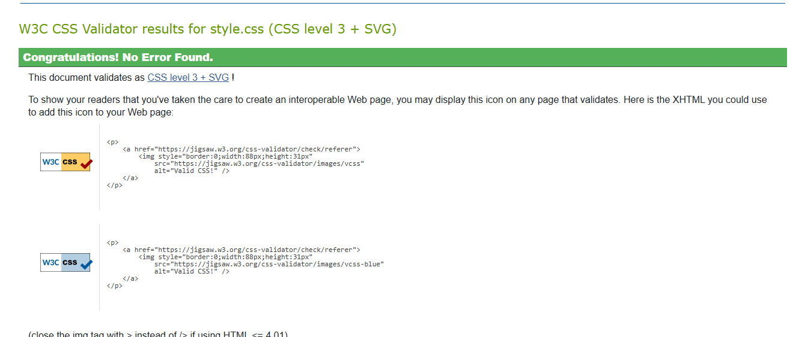
The completed website was validated using the W3C HTML Validator. Both the HTML and CSS code passed validation successfully with no errors. This confirms that the website follows web standards and is correctly structured, helping to improve compatibility across different web browsers [7].
Validation was an important stage of the development process because it confirmed that the website met recognised web standards before completion. Using the W3C HTML and CSS validators helped identify any coding issues during development, allowing them to be corrected before final version of the websites was submitted. Successfully passing both validation checks demonstrates that the HTML structure and CSS styling were written correctly and follow recognised standards. This helps improve browser compatibility, website performance and long-term maintainability. It also provides confidence that users will experience the website consistently across different devices and web browsers [7].

Conclusion
This project successfully achieved its aim of designing and developing a responsive website using HTML and CSS. The final website contains three linked pages that provide visitors with information about travelling in Wales while maintaining a consistent design throughout. HTML was used to create the structure of the website, while CSS was used to control the visual appearance, including colours, fonts, spacing and layout. Responsive design ensured that the website could be viewed on desktop computers, tablets and mobile devices without affecting usability or readability. Accessibility features, search engine optimisation techniques and validation testing all contributed to producing a website that is reliable, user-friendly and complaint with recognised web standards. The successful results from W3C HTML and CSS validators confirmed that the website contained no coding errors and followed good web development practice. Overall, this project improved m understanding of website planning, coding, testing and evaluation. If the website were developed further, additional feature such as interactive map, image gallery, booking links and contact form validation could be added to provide an even better user experience [1], [2], [6],[7].

Evaluation

On the My travel Wales website is easy to use because the same navigation menu appears on every page. It allows visitors to find information about the website. The consistent colours, fonts and layout make the website look neat and easy to read. The information is useful because it introduces visitors to different destinations. However, the website could be improved by adding mire destinations, larger images or an interactive map, which would make it more useful and engaging for users.
Search Engine Optimisation
Search engine optimisation helps a website appear more clearly in search-engine results. On My Travel Wales website, SEO as supported by using clear page titles, meaningful headings, descriptive text, and a logical website structure. Images include alternative (alt) text, and the HTML code uses semantic elements to help search engines understand the content. These techniques improve the visibility of the website and make it easier for potential visitors to discover information about travelling in Wales.
Research has shown that websites with clear page structures, relevant keywords and good accessibility practices are more likely to achieve better search engine rankings and provide a better experience for users. Applying these SEO techniques helps improve both website visibility and data usability [4].

Accessibility
Accessibility is an important part of web design because it ensures that people with different abilities can use a website effectively. The My Travel Wales website was designed with accessibility in mind by using a clear navigation menu, readable font sizes, good colour contrast and a simple page layout. These features help users find information quickly and make the website easier to understand. Images include alternative (alt) text where appropriate so that screen readers can describe the content to visually impaired users. The website also uses headings in logical order and semantic HTML elements to improve navigation for assistive technologies [3].
During development, accessibility was considered alongside usability to create a website that is easy to use for a wide range of visitors. A responsive layout also improves accessibility by allowing the website to work on desktops, tablets and mobile devices without losing readability or functionality. Research has shown that websites following recognised accessibility guidelines improve the user experience for all visitors, not only those with disabilities. Although the website meets the main accessibility requirements for this project, future improvements could include adding keyboard shortcuts, improving colour contrast further where necessary and carrying out testing with users who rely on assistive technologies.
According to recognised accessibility guidance, websites should be designed so they are perceivable, operable, understandable and robust for all users, including people with disabilities. Following these accessibility principles helps ensure that websites can be used b people with visual, hearing and physical impairments while also improving the experience for all visitors [3].
The My Travel Wales website follows these accessibility recommendations by using clear navigation, readable typography, appropriate colour contrast and responsive design. These features make the website easier to use across different devices and provide a better browsing experience for all users. [2]

References

[1] MDN Web Docs, HTML: Hypertext Markup Language, Mozilla Developer Network. Available: https://developer.mozilla.org/en-US/docs/web.HTML

[2] MDN Web Docs, CSS: Cascading Style Sheets, Mozilla Developer Network. Available: https://developer.mozilla.org/en-US/docs/web/CSS

[3] World Wide Web Consortium (W3C), Web Content Accessibility Guidelines (WCAG) 2.1. Available: https://www.w3.org/WAI/standards-guidelines/wcag/

[4] Google Search Central, Search Engine Optimization (SEO) Starter Guide. Available: https://developers.google.com/search/docs/fundamentals/seo-starter-guide

[5] Nielsen, J., 10 Usability Heuristics for user Interface Design. Nielsen Norman Group. Available: https://www.nngroup.com/articles/ten-usability-heuristics

[6] W3C. CSS Validation Service. Available: https://jigsaw.w3.org/css-validator/

[7] W3C, Nu HTML Checker ( HTML Validator). Available: https://validator.w3.org/nu/

